Design a java code to accept a value for n and calculate the total number of all possible squares in a square matrix

Code:

import java.util.Scanner;

public class squarematrix{

public static void main(String[] args) {

int n;

Scanner s = new Scanner(System.in);

System.out.print("Enter the value N");

n = s.nextInt();

if(n<=0)

{

System.out.print("Invalid Input");

}

else

{

int sum = 0;

int i = 1;

while(n>0)

{

sum += n*n;

int temp = n*n;

System.out.print("Number of matrix for "+ i+ '*' +i);

System.out.println(" Matrix are " + n*n);

n--;

i++;

}

System.out.println("The number of total matrix are " + sum);

}

}

}

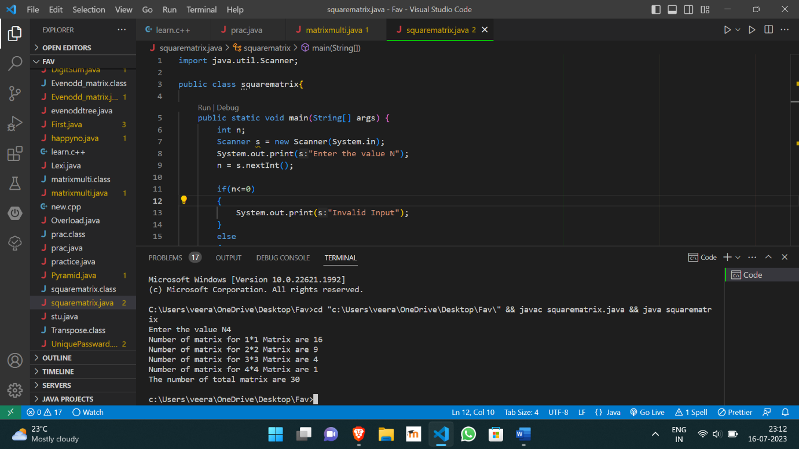

https://github.com/Veeragoutham04/Java_Lab/blob/main/Square%20matrix