Write a java program to find sum two digit number until the digit sum is less than 10

import java.util.Scanner;

public class DigitSum {

public void sum(int n)

{

int temp=n,digsum,rem;

while(temp>10)

{

System.out.println("\nTaking input as "+temp+"\nAfter addition of the digits:");

rem=temp%10;

temp=temp/10;

digsum=rem+temp;

if(digsum<10)

{

System.out.println(digsum+" is less than 10");

}

else

{

System.out.println(digsum+" is greater than 10");

}

temp=digsum;

}

}

public static void main(String[] args) {

int number;

Scanner scan=new Scanner(System.in);

System.out.println("Enter the two digit number:");

number=scan.nextInt();

DigitSum obj=new DigitSum();

obj.sum(number);

}

}

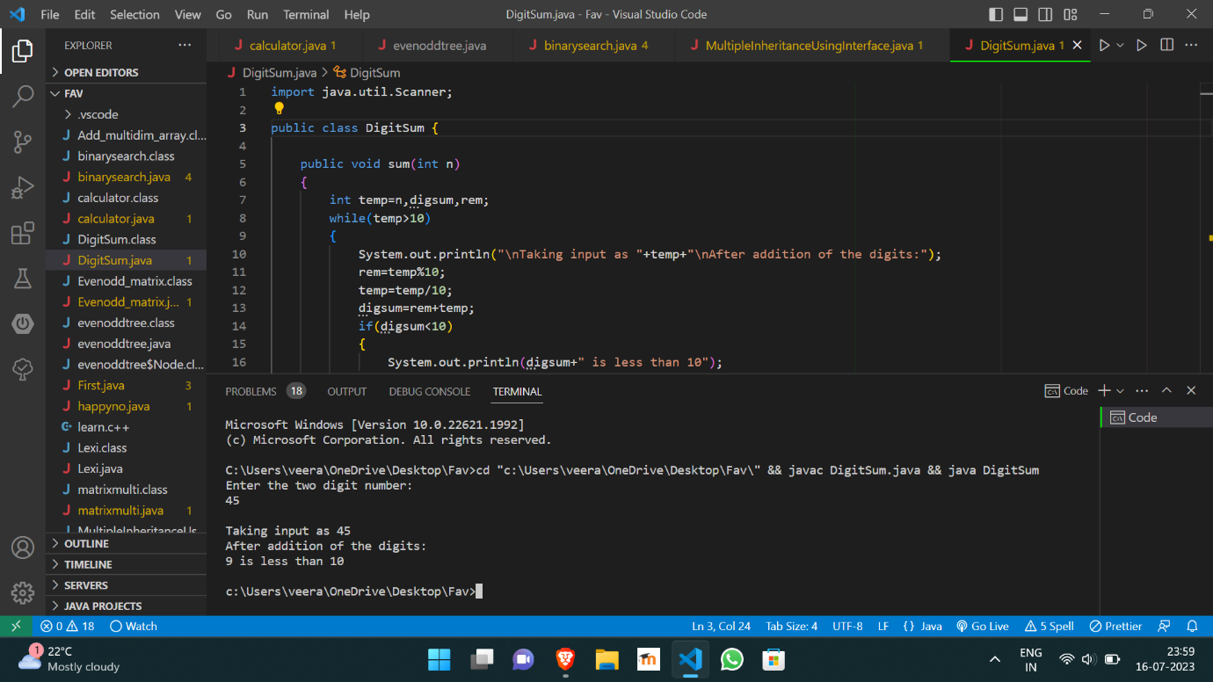

https://github.com/Veeragoutham04/Java_Lab/blob/main/Digit%20Sum