Design a java code for implementing binary search , pass array as parameter to the method

import java.util.Scanner;

public class binarysearch

{

public static void main(String[] args)

{

Scanner scan=new Scanner(System.in);

int low,mid,high;

System.out.println("enter the number of elements in the array\n");

int n;

n=scan.nextInt();

System.out.println("enter elements in sorted order");

int arr[]=new int[n];

int i;

for(i=0;i<n;i++)

{

arr[i]=scan.nextInt();

}

System.out.println("enter the element to search\n");

int num;

num=scan.nextInt();

int result=bs(arr,num,0,n-1);

if(result==-1)

{

System.out.println("element not found");

}

else{

System.out.println("element found at "+result);

}

}

static int bs(int arr[],int num,int low,int high)

{

if(high>=low)

{

int mid=(low+high)/2;

if(arr[mid]==num)

{

return mid;

}

else if(arr[mid]>num)

{

return bs(arr,num,low,mid-1);

}

else

{

return bs(arr,num,mid+1,high);

}

}

else{

return -1;

}

}

}

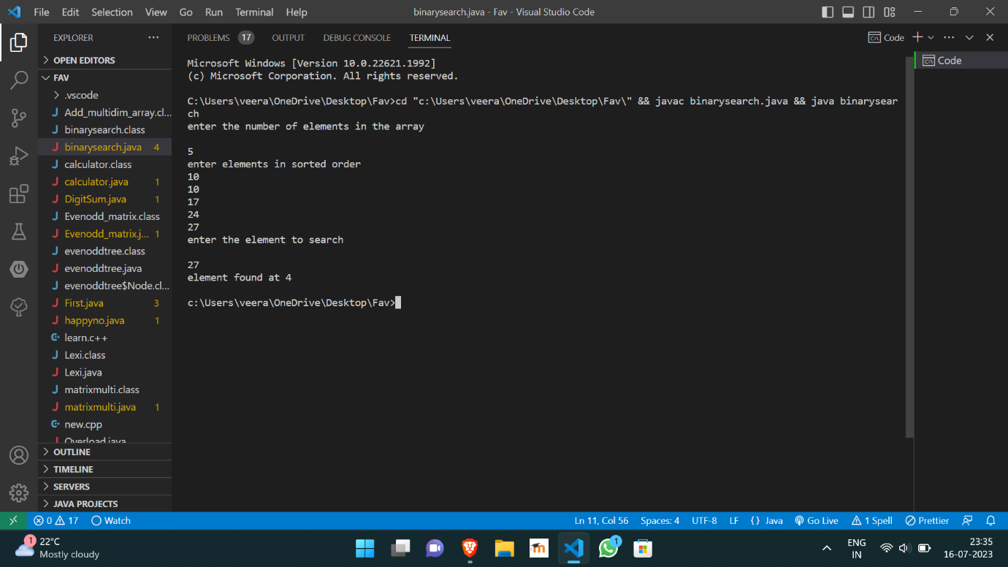

https://github.com/Veeragoutham04/Java_Lab/blob/main/Binarysearch