Design a java program to implement multiple inheritance using an interface

interface vehicleone{

int speed=90;

public void distance();

}

interface vehicletwo{

int distance=100;

public void speed();

}

class Vehicle implements vehicleone,vehicletwo{

public void distance(){

int distance=speed*100;

System.out.println("distance travelled is "+distance);

}

public void speed(){

int speed=distance/100;

}

}

class MultipleInheritanceUsingInterface{

public static void main(String args[]){

System.out.println("Vehicle");

Vehicle obj = new Vehicle();

obj.distance();

obj.speed();

}

}

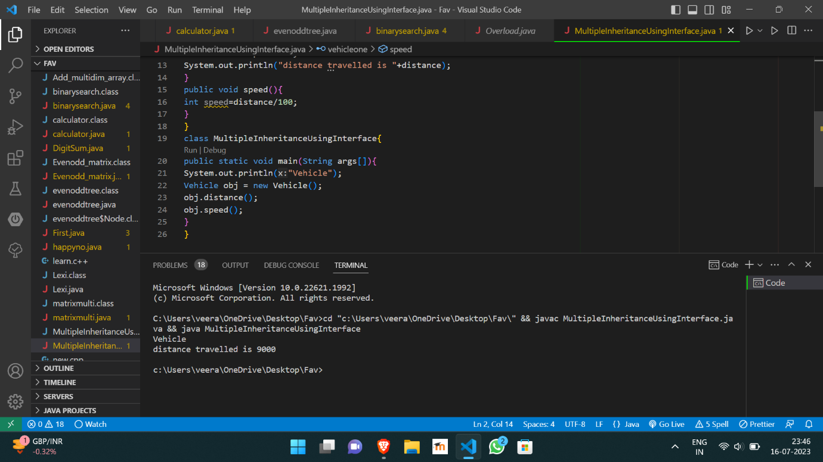

https://github.com/Veeragoutham04/Java_Lab/blob/main/Multiple%20inheritance