**Task:**

**Create Virtual network peering between 2 different regions.**

**Description:**

Create 2 Virtual networks and subnets in each along with Virtual machine in 2 different regions and try to ping the Virtual machine’s.

**Create a virtual network:**

* Create a two virtual networks :VNET1,VNET2.
* Give as per requirements and add different regions both of them.
* Add a subnet both of them.

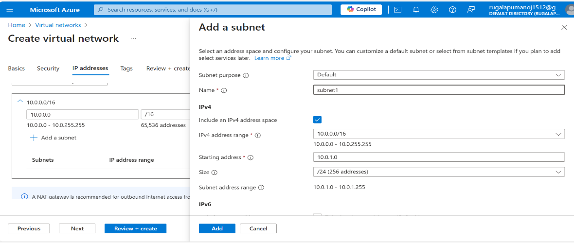

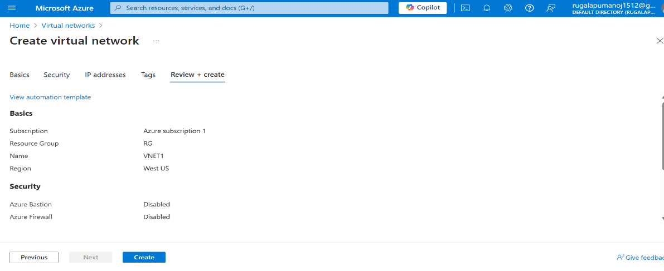

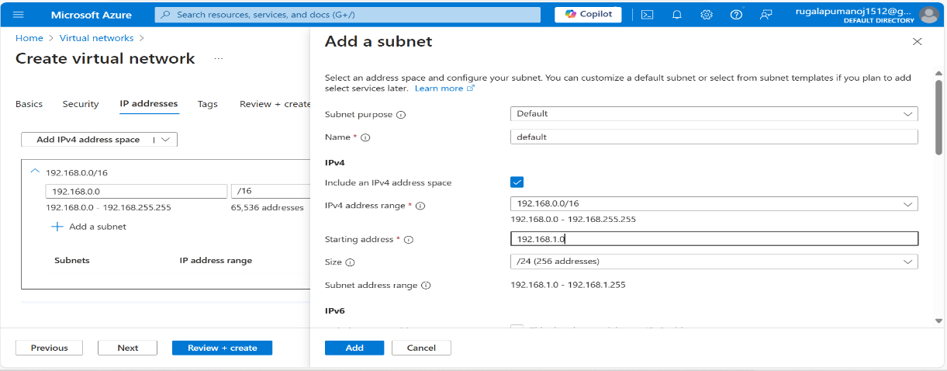

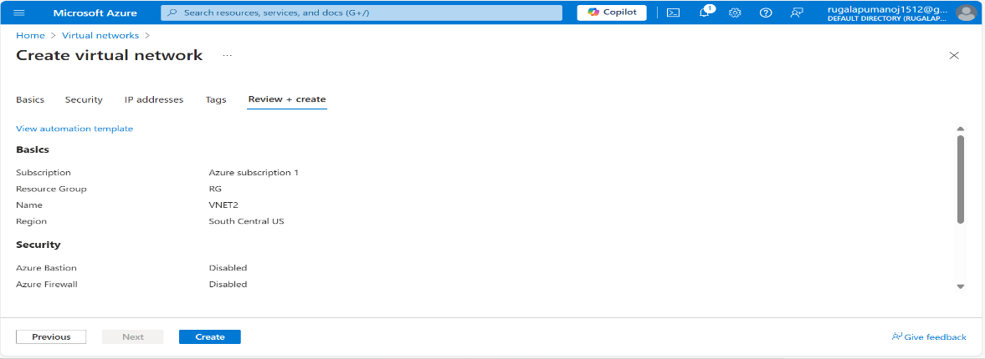

**Create a Virtual Machine:**

* Create a two virtual machines:VM11,VM2.
* Give as per requirements and add different regions both of them.

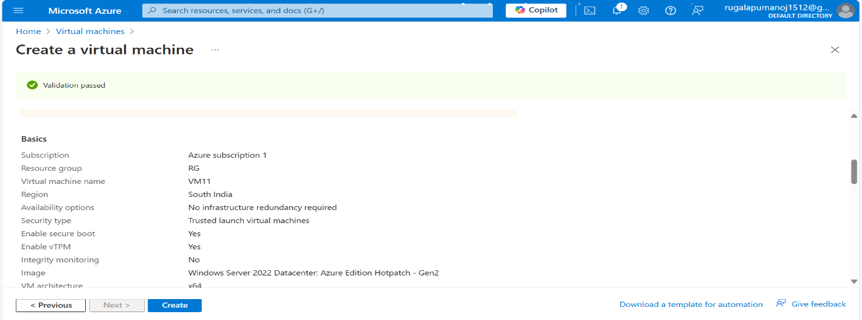

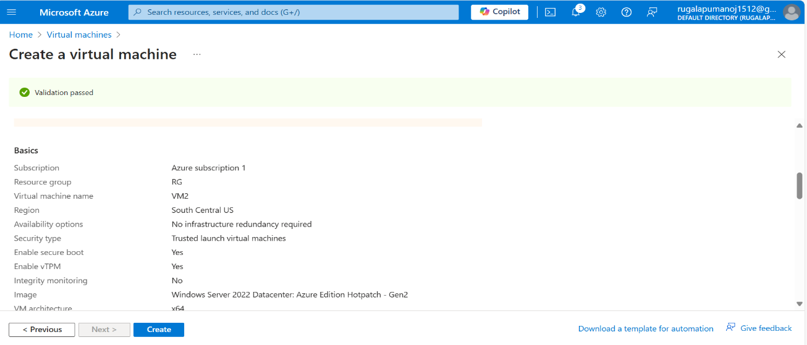

* Let’s I am Peering both of them Virtual Network.
* Open it virtual network and peering it.

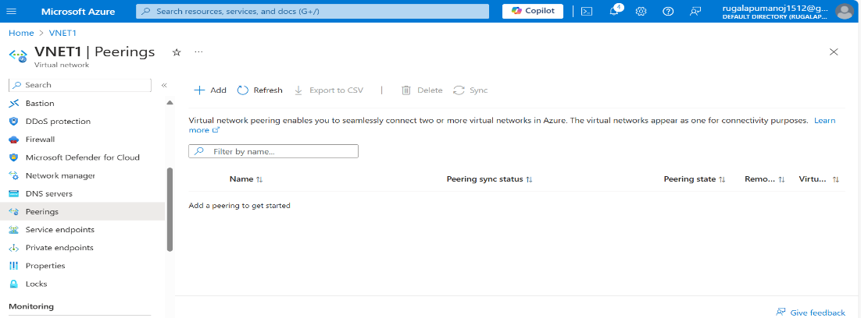

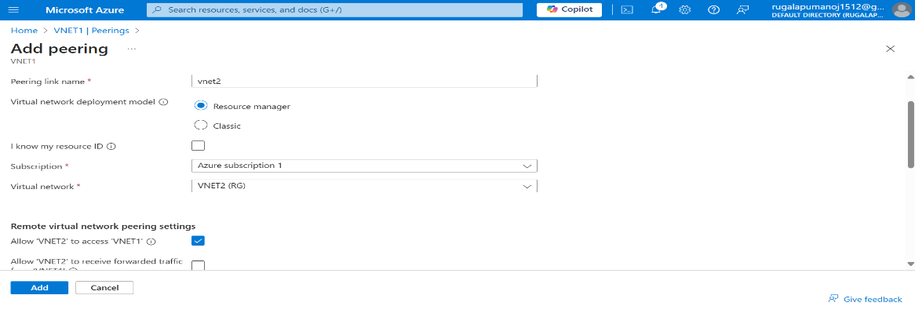

* It’s connected both of them peering.

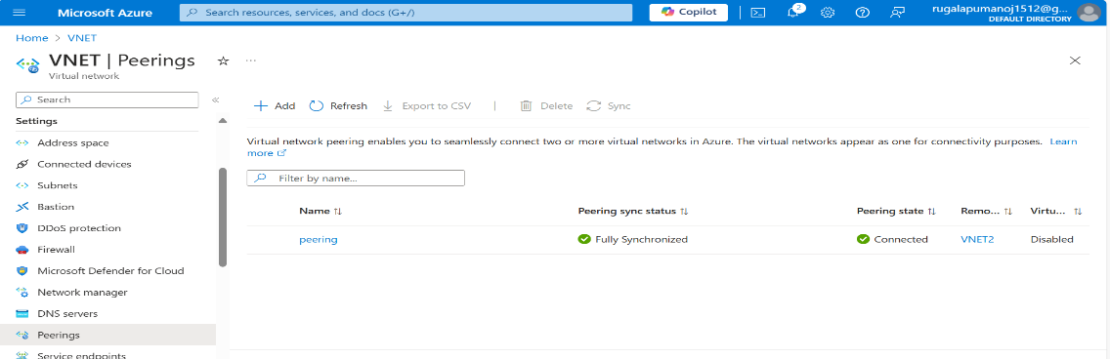

* Open Virtual machine in that download a RDP file of both of them.
* Access it as per permission given it.

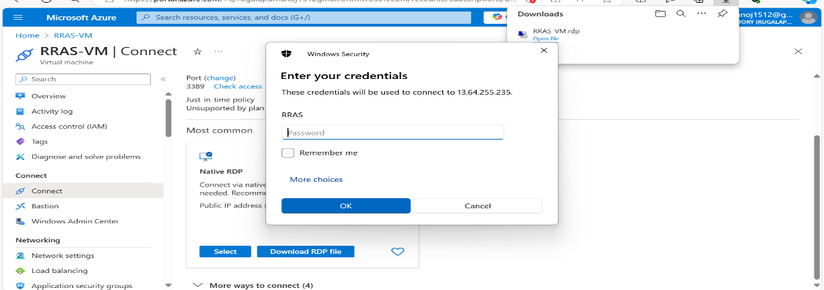

* Let’s Enable it (off) firewall both of them.
* Then use Power shell (or) CMD .
* We communicate both VM’s and ping it.

**OUTPUT:**

