**Digital Thermostat Simulation with W1209**

This project is a simulation of a digital thermostat system using the W1209 temperature controller module. The simulation generates random temperature values within a specified range and allows the user to set the desired temperature. The program then simulates the heating or cooling operation based on the temperature readings.

Architecture:

The W1209 is a popular thermostat module widely used in DIY projects and small-scale applications. It is based on a microcontroller and provides temperature control and display functionality. The architecture of the W1209 module can be described as follows:

1. Microcontroller: The W1209 module is built around a microcontroller, typically an STM8S003F3P6. This microcontroller serves as the brain of the thermostat system, handling tasks such as reading the temperature sensor, controlling the output (heater, cooler, etc.), and managing the user interface.

2. Temperature Sensor: The W1209 module incorporates a temperature sensor, often a NTC thermistor (negative temperature coefficient). The microcontroller reads the analog voltage from the temperature sensor and converts it to a temperature value using a lookup table or mathematical equation.

3. User Interface: The module features a compact user interface consisting of three tactile buttons and a 3-digit seven-segment LED display. The buttons allow users to navigate through the menu and adjust settings, while the display provides visual feedback on the temperature and other relevant information.

4. Relay Output: The W1209 module typically includes a relay output to control external devices such as heaters or coolers. The microcontroller uses the relay to turn the output on or off based on the temperature readings and control algorithm.

5. Power Supply: The module requires a power supply, usually ranging from 12V to 24V DC. It includes a voltage regulator to step down the input voltage to the required level for the microcontroller and other components.

6. PCB Layout: The W1209 module is implemented on a small printed circuit board (PCB). The PCB contains the microcontroller, temperature sensor, buttons, display, relay, power supply components, and other necessary circuitry. The layout is designed to fit within a compact form factor, making it suitable for various applications.

7. Programming: The microcontroller on the W1209 module is typically pre-programmed with firmware that handles the thermostat's functionality. The firmware includes temperature control algorithms, user interface management, and communication with the temperature sensor, display, and relay.

It's important to note that the W1209 module is typically designed as a ready-to-use solution, where the firmware is already flashed onto the microcontroller. However, depending on your requirements and expertise, you may have the option to modify or reprogram the firmware to tailor it to your specific needs.

Please keep in mind that the W1209 module may have variations or different versions available in the market, so it's always recommended to refer to the specific datasheet and documentation provided by the manufacturer for a detailed understanding of its architecture and functionality.

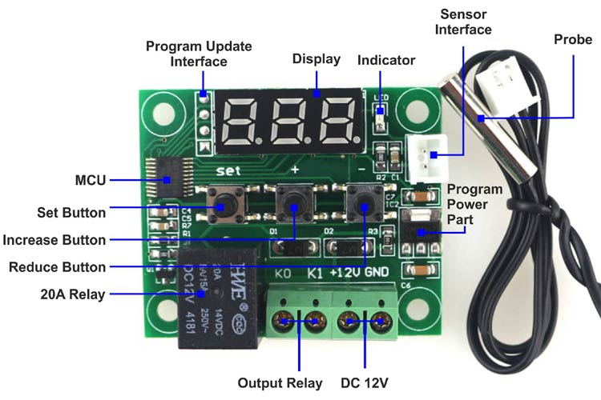

Design Decisions:

1. Random Temperature Simulation: To simulate temperature readings, the program generates random temperature values using the `generateTemperature()` function. This approach provides a basic simulation without the need for actual temperature sensors.

2. User Input: The program allows the user to set the desired temperature using the `scanf()` function. The user can enter a temperature value, and the program will use it for comparison with the current temperature.

3. Basic Control Logic: The control logic in the program compares the current and desired temperatures to determine the state of the heating or cooling system. It provides a simplified representation of a thermostat control algorithm.

Build and Run Instructions:

To build and run the simulation program, follow these steps:

1. Ensure that you have a C compiler installed on your system.

2. Open a command prompt or terminal and navigate to the directory where the program source code is saved.

3. Compile the program using the following command:

4. Once the compilation is successful, run the program using the following command:

5. The program will start the simulation and display the current and desired temperatures. Follow the on-screen instructions to set the desired temperature. Enter `0` to quit the program.

6. Monitor the console output to see the temperature readings and the state of the heating or cooling system.

Note: This simulation program does not interface with an actual W1209 module. It is a basic demonstration of a thermostat system using a simplified temperature simulation.