**Python** **Assignment**

**Prepared** **By** : Manoj A M **USN** : 1JS18CS406

1. **Write a function in python which detects whether the given two strings are anagrams or not**
2. def anagrams(s1 , s2):
3. str1 = "\nSting is anagram"
4. str2 = "\nSting is not a anagram"
5. if( sorted(s1) == sorted(s2) ):
6. return str1
7. else:
8. return str2
9. s1 = input("Enter string 1 : ")
10. s2 = input("\nEnter string 2 : ")
11. result = anagrams(s1 , s2)
12. print(result)

**Output :**

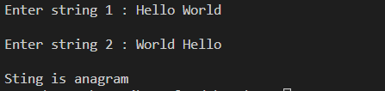

2. **Write a program in Python to reverse a string without using inbuilt function reverse string?**

Str = input("Enter The String To Be Revesed :")

print(Str[len(Str)::-1])

**Output :**

C:\Users\manoj\Pictures\cns\py.PNG

3. **Write a program to calculate number of upper case letters and number of lower case letters?**

def check(Str):

    ucount = 0

    lcount = 0

    for i in range(len(Str)):

        if Str[i].isupper():

            ucount += 1

        elif Str[i].islower():

            lcount += 1

    print("\nUpper Letter Count = ",ucount)

    print("\nLower Letter Count = ",lcount,"\n")

Str = input("Enter the String : ")

check(Str)

**Output** :

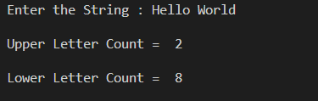

4. **Write a Python program to sort a list of elements using Gnome sort.**

k = 1

SortList = []

def Ggnome():

    global SortList

    global k

    while True:

        if SortList[k] < SortList[k-1]:

            swap()

            dec()

        else:

            inc()

        if k == (len(SortList)):

            break

    print("Sorted List : ",SortList)

def dec():

    global k

    if not k == 1:

        k = k - 1

    return

def inc():

    global k

    global SortList

    leg = (len(SortList))

    if not k == leg:

        k = k + 1

    return

def swap():

    global SortList

    global k

    temp = SortList[k]

    SortList[k] = SortList[k - 1]

    SortList[k - 1] = temp

n = int(input("Enter the number of Items you would like to insert : "))

print("Enter ",n," Number of valuee")

for i in range(n):

    ele = int(input())

    SortList.append(ele)

print("Unsorted List : ",SortList)

Ggnome()

**Output :**

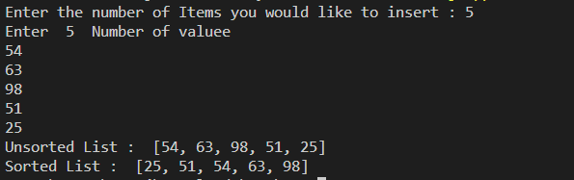

5. **Write a Python program to find the first duplicate element in a given array of integers. Return -1 If there are no such elements**

Find = []

def Dup():

    global Find

    for i in range((len(Find) - 1)):

        temp = Find[i]

        for i in range(( i + 1),(len(Find))):

            if( temp == Find[i]):

                return temp

    return -1

n = int(input("Enter the number of Items you would like to insert : "))

print("Enter ",n," Number of valuee")

for i in range(n):

    ele = int(input())

    Find.append(ele)

print(Find)

sol = Dup()

print("Duplicate Element in the array is : ",sol)

**Output :**

