POC26: Event-Driven Automation with S3 and Lambda

Step 1: Create S3 Bucket
Using AWS Console
- Go to S3
- Click Create bucket
- Bucket name: S3_lambda_trigger_event-driven
- Region: same as Lambda (important)
- Keep defaults → Create

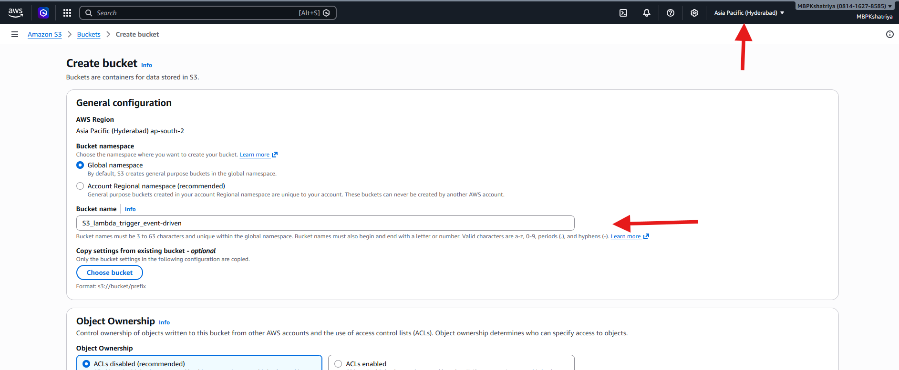
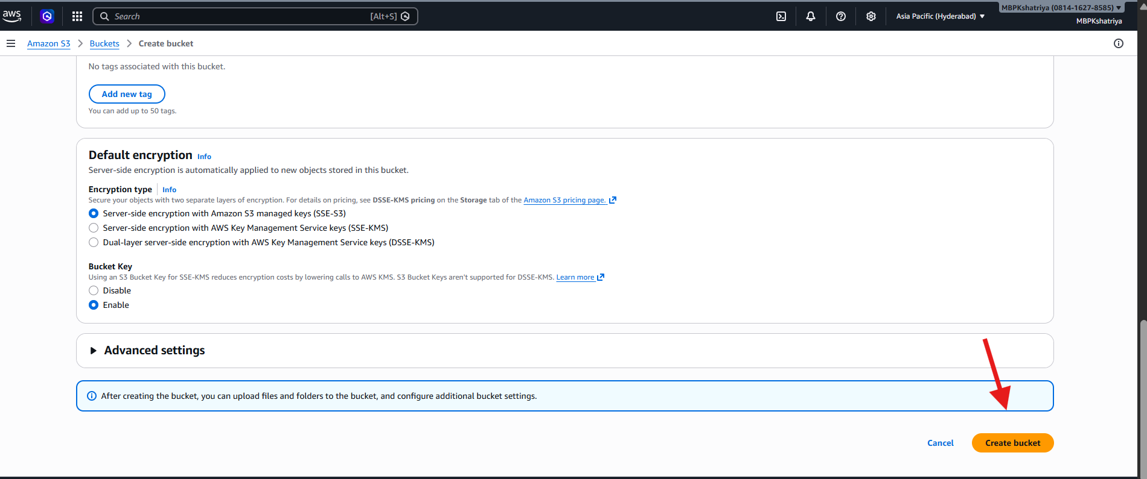
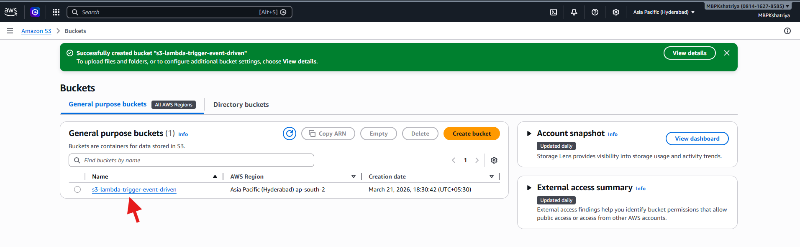

Step 2: Create IAM Role for Lambda
Lambda needs permission to:
- Write logs to CloudWatch
- (Optional) Access S3
Steps:
- Go to IAM → Roles → Create Role
- Select:
  - Trusted entity: AWS Service
  - Use case: Lambda
- Attach policies:
  - AWSLambdaBasicExecutionRole
  - (Optional) AmazonS3ReadOnlyAccess
- Role name:
    - lambda-s3-execution-role
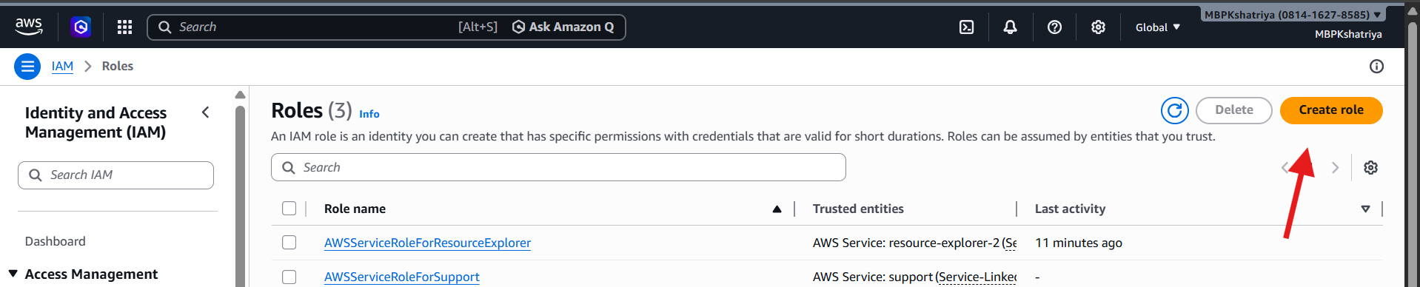

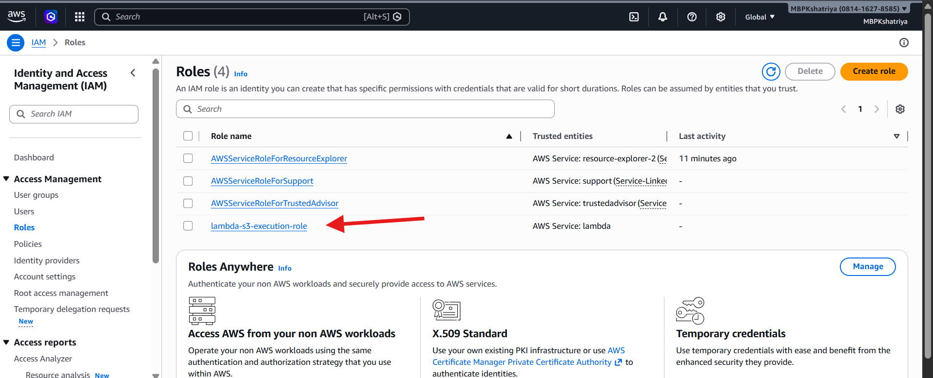

Step 3: Create Lambda Function
Option 1: Console (easy)
- Go to Lambda → Create function
- Select:
  - Author from scratch
- Fill:
  - Function name: s3-event-logger
  - Runtime: Python 3.12
    - Execution role: Use existing → select your role (lambda-s3-execution-role)
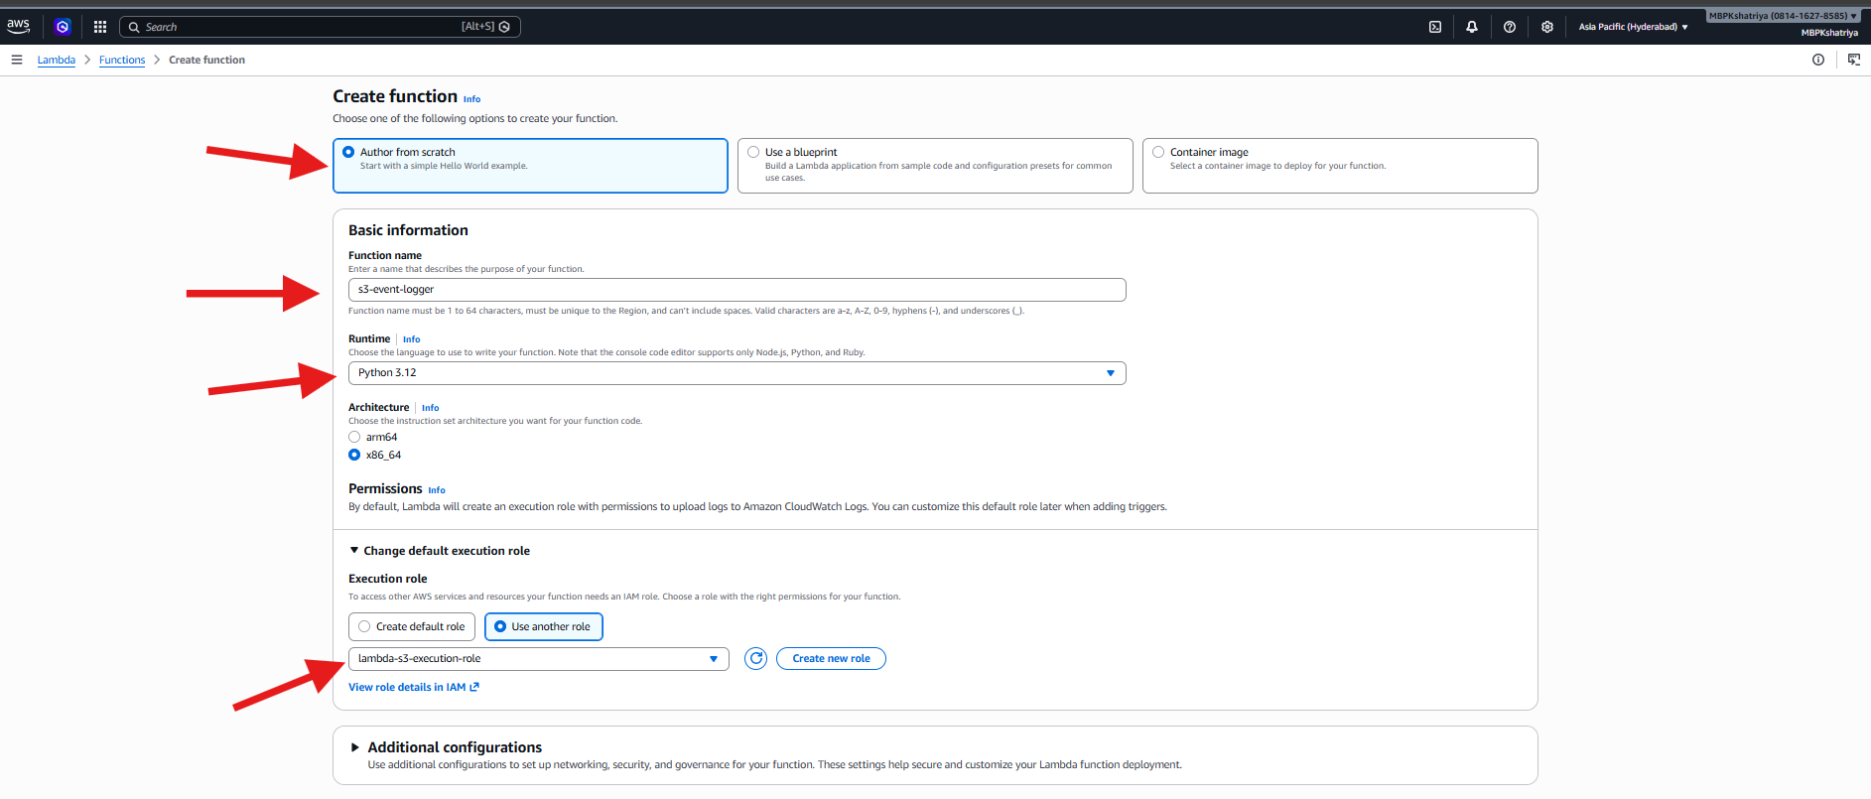
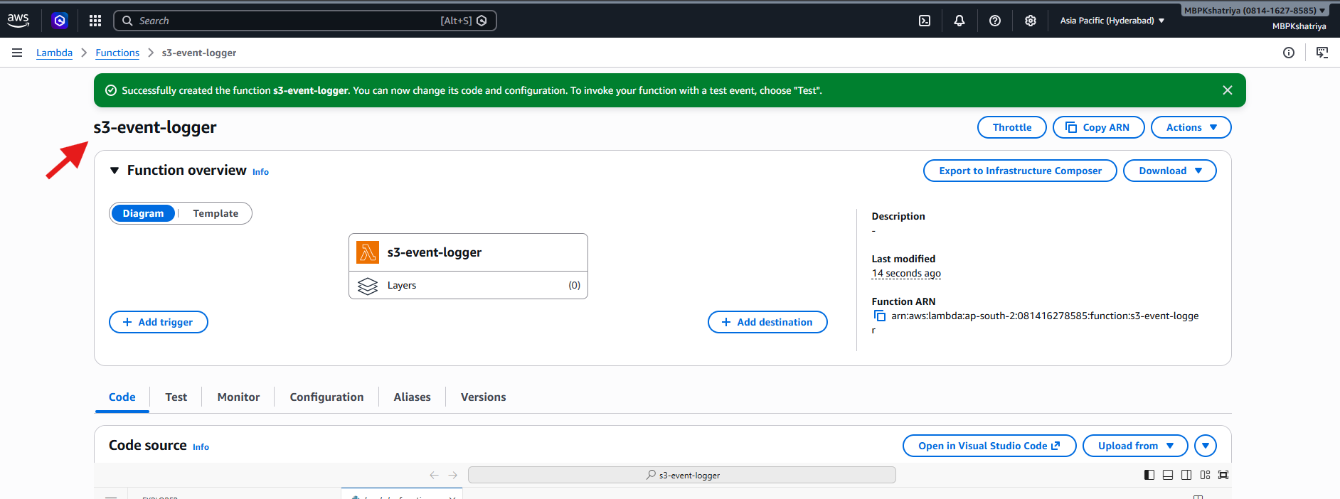

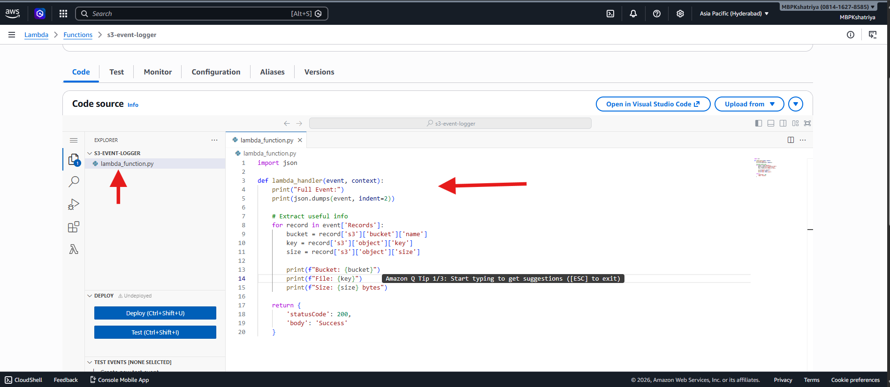

Step 4: Configure S3 Trigger
- Go to your S3 bucket
- Properties tab
- Scroll → Event notifications
- Click Create event notification
Fill:
- Name: s3-put-event
- Event types:
  - PUT (Object Created)
- Destination:
  - Lambda function → select s3-event-logger
Save
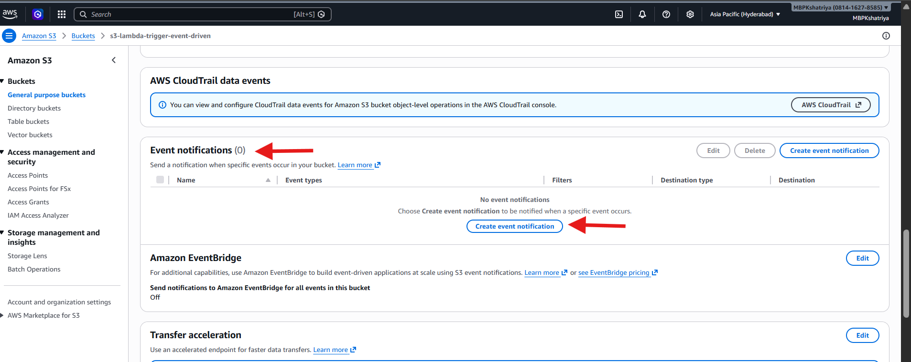
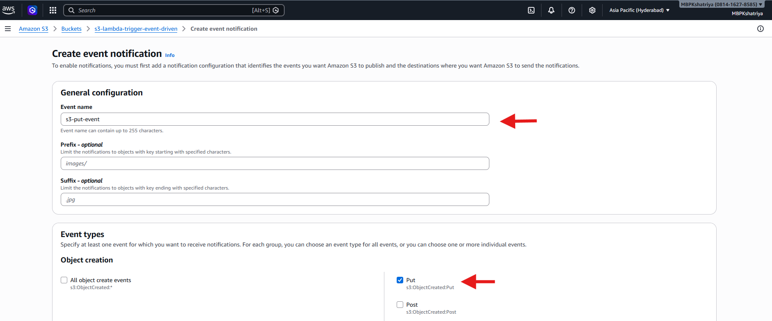
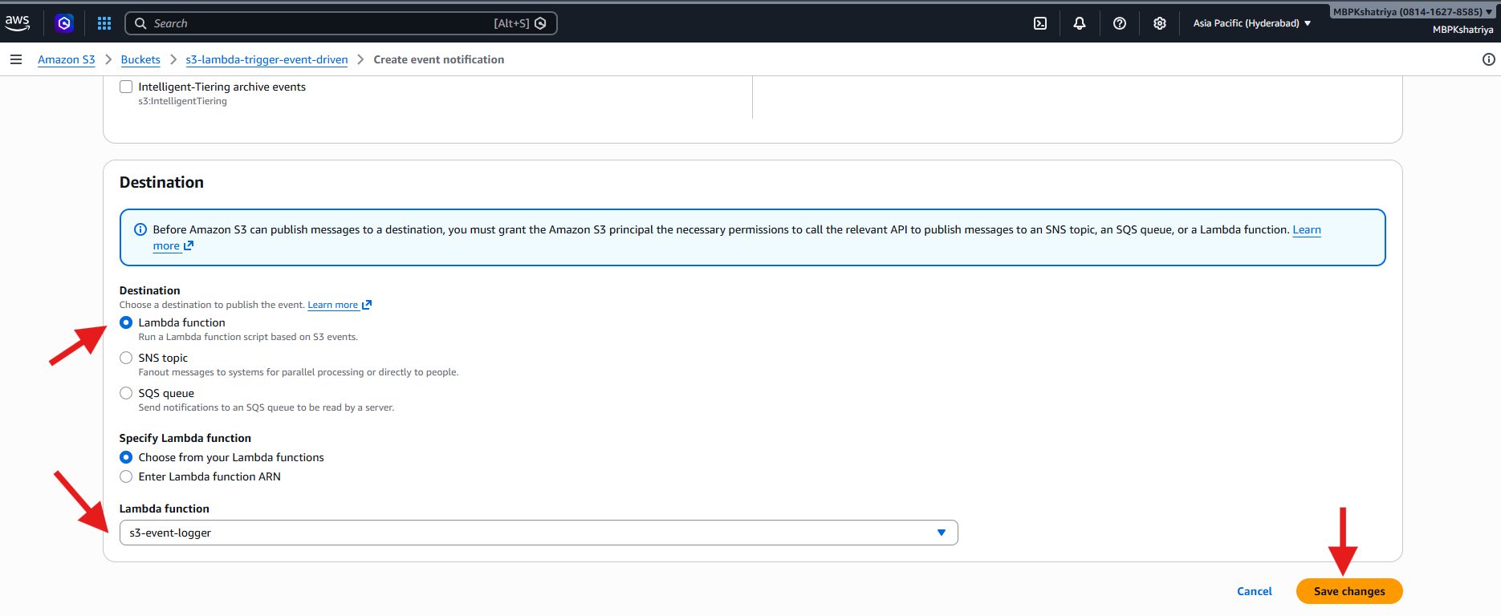
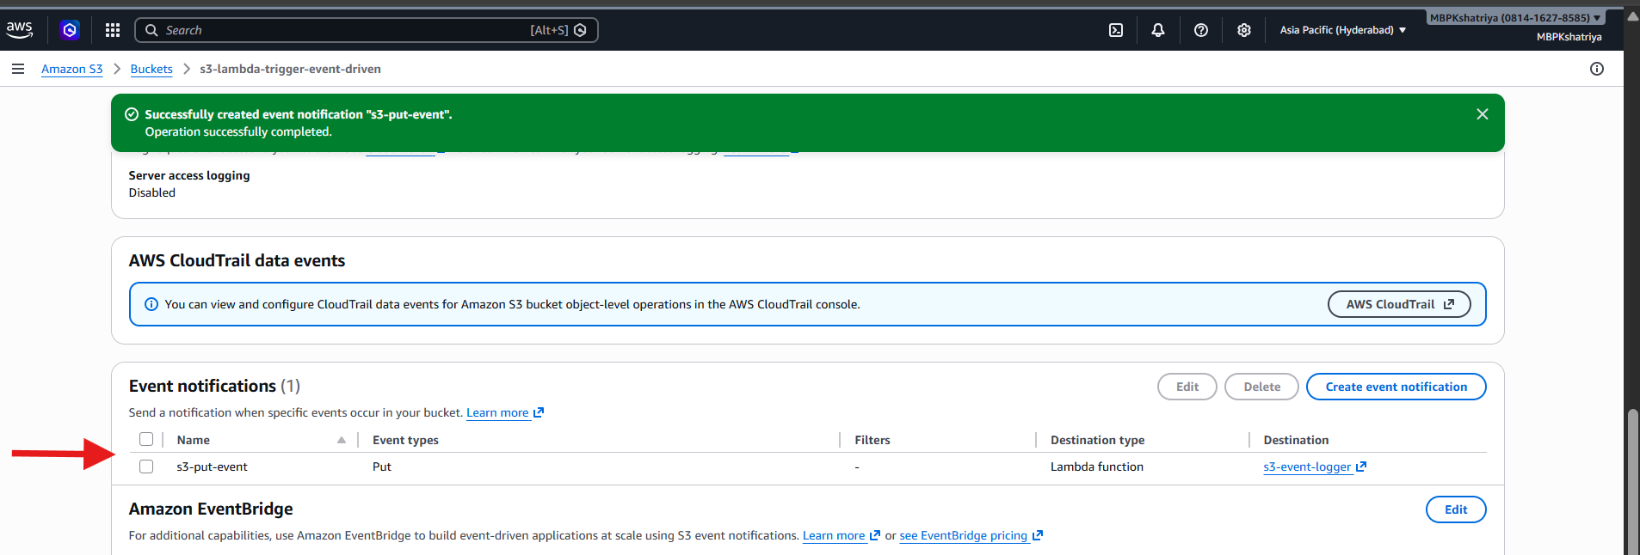

Step 5: Test the Flow
Upload file:
- Open S3 bucket
- Click Upload
- Upload any file (txt, jpg, etc.)
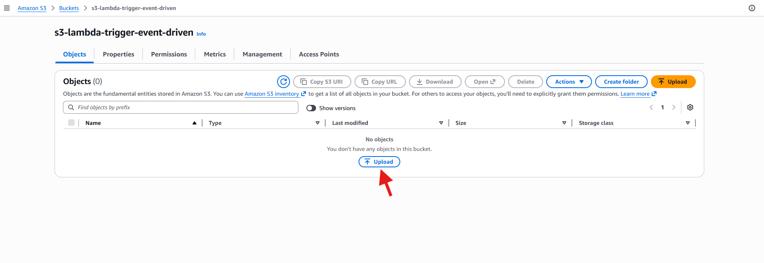
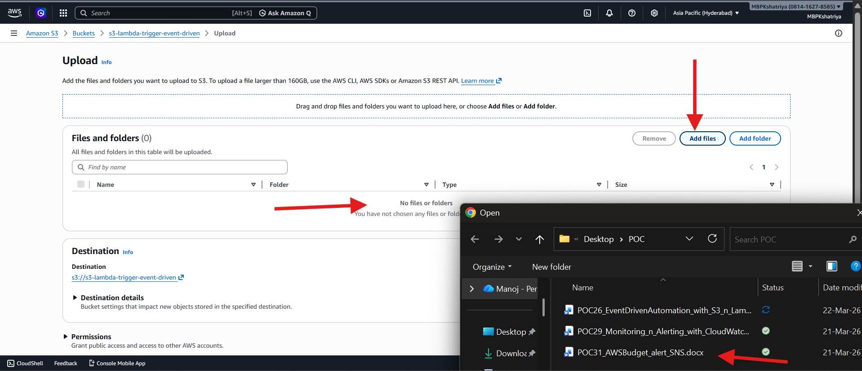
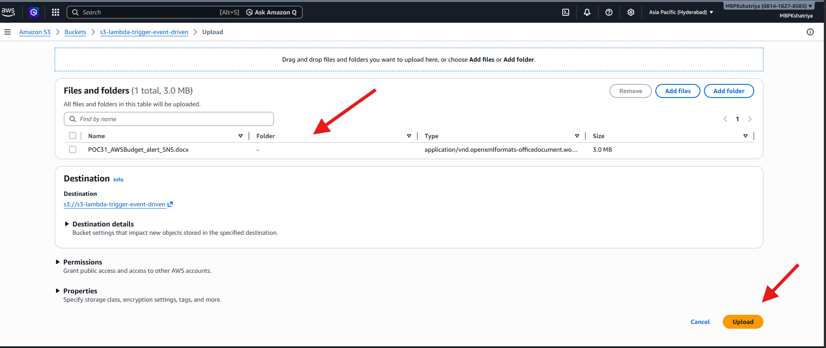
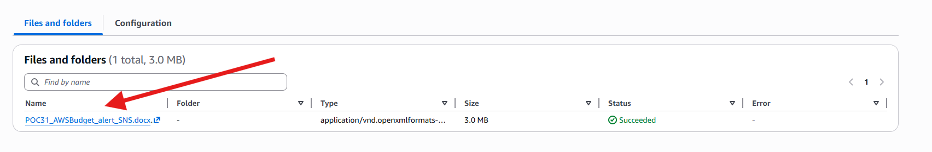

Step 6: Verify in CloudWatch Logs
- Go to CloudWatch → Logs
- Log group: /aws/lambda/s3-event-logger
- Open latest log stream

