POC 29 - Monitoring and Alerting with CloudWatch and SNS

Step1: Create SNS Topic
- Go to SNS → Topics → Create Topic
- Type: Standard
- Name: cpu_alert_topic
Subscribe Email
- Open topic → Create subscription
- Protocol: Email
- Enter your email
- Confirm subscription from inbox
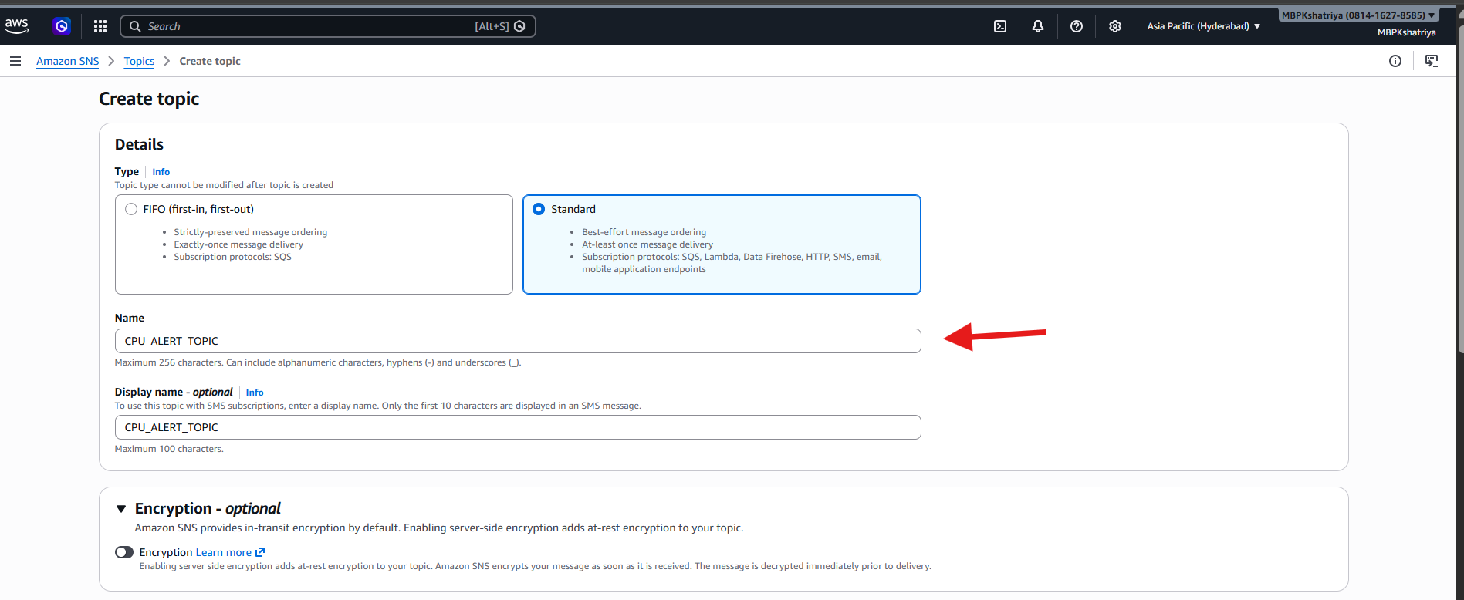

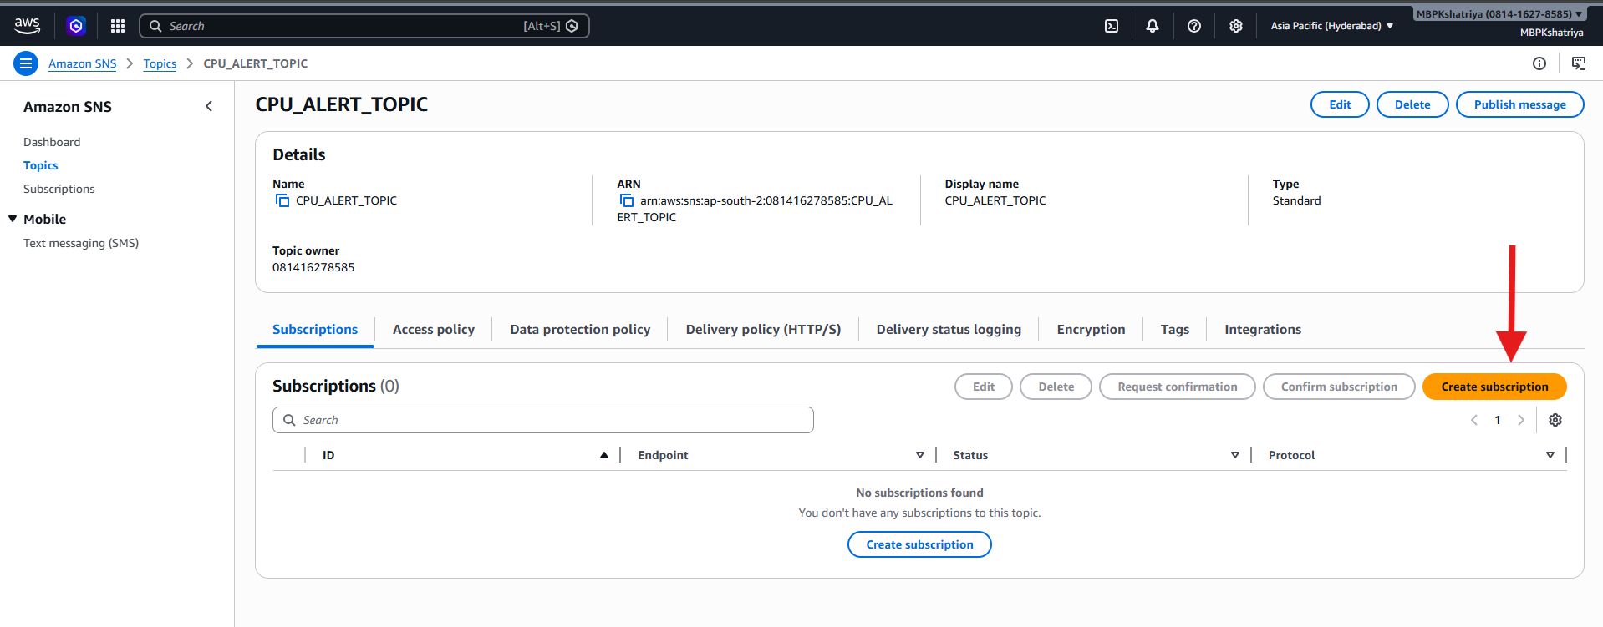

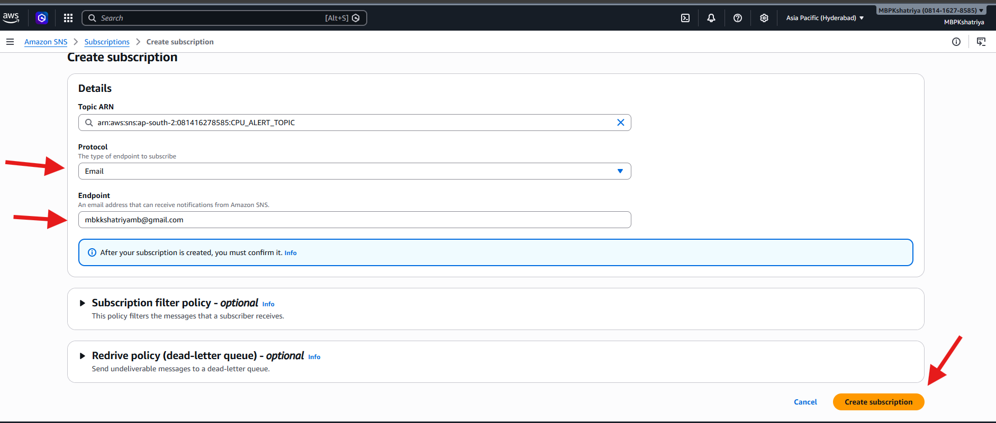

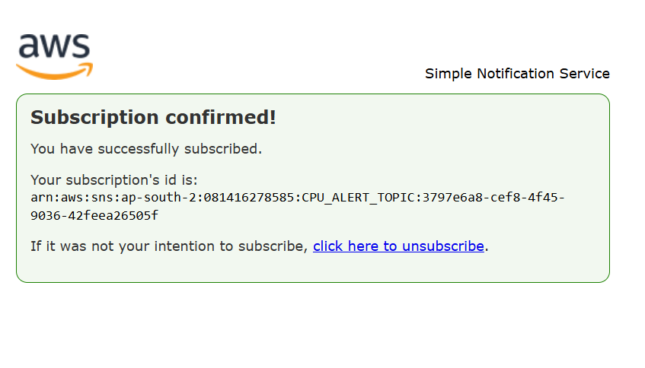
Step 2:
Create CloudWatch Alarm (CPU Utilization)
- Go to CloudWatch → Alarms → Create Alarm
- Select Metric:
  - EC2 → Per Instance Metrics → CPUUtilization
- Choose your instance
Configure Alarm
- Threshold type: Static
- Condition:
  - CPUUtilization > 70%
- Period: 1 minute
- Evaluation: 2 consecutive periods
Add Notification
- Select SNS Topic: cpu-alert-topic
Create alarm

