Step 1: Create SNS Topic (for Email Alerts)
- Go to SNS (Simple Notification Service)
- Click Create Topic
- Type: Standard
- Name: budget_alert_topic
Click Create
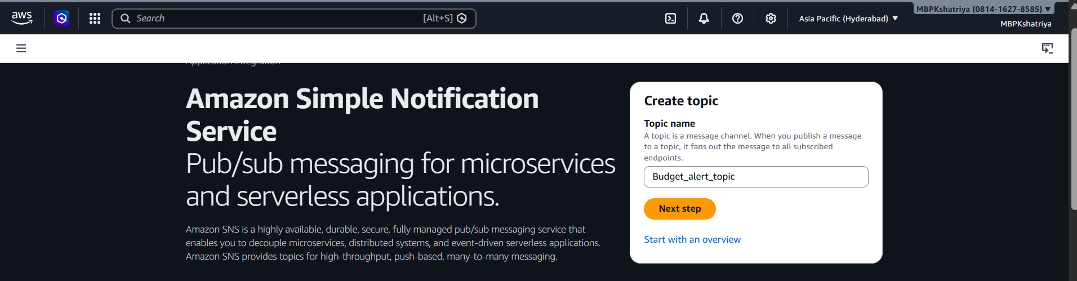
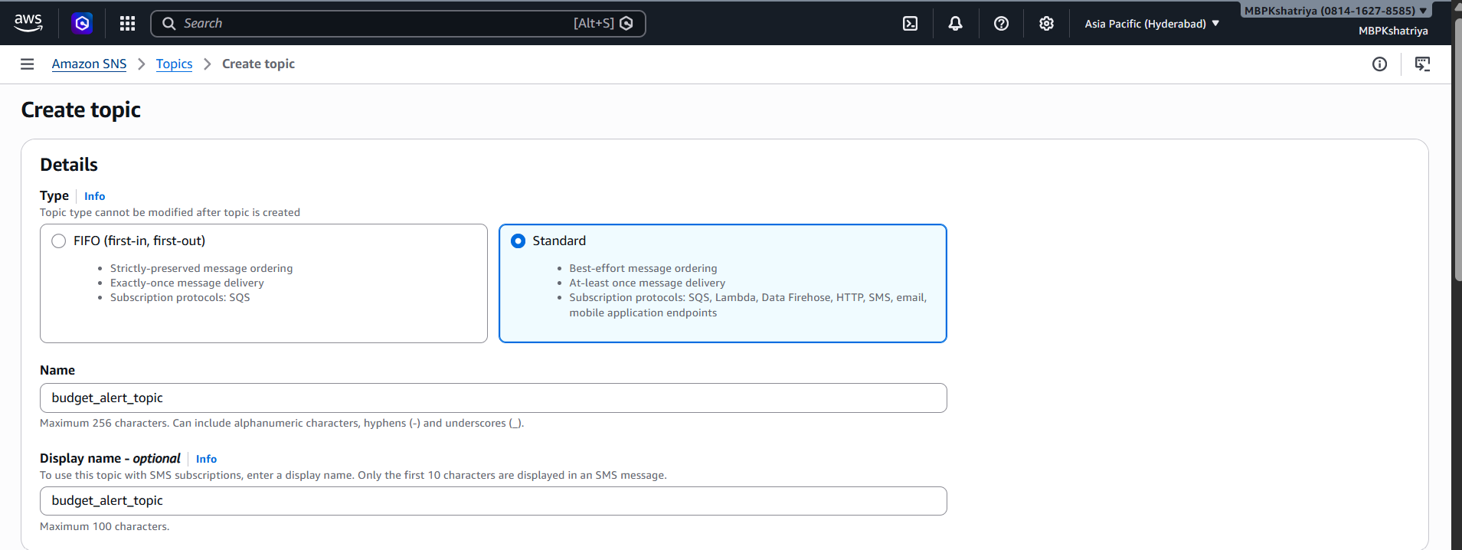
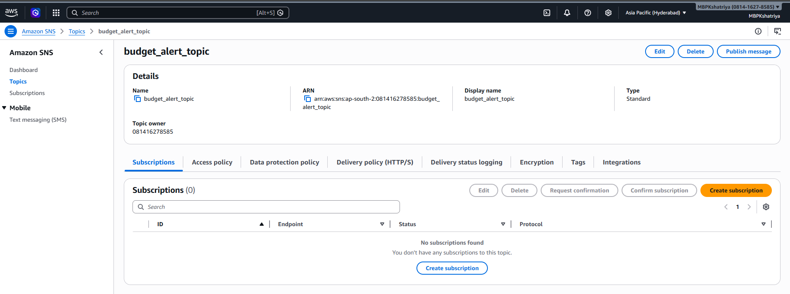

Step 2: Add Email Subscription
- Open the created topic
- Click Create Subscription
- Protocol: Email
- Endpoint: mbkshatriyamb@gmail.com
Click Create
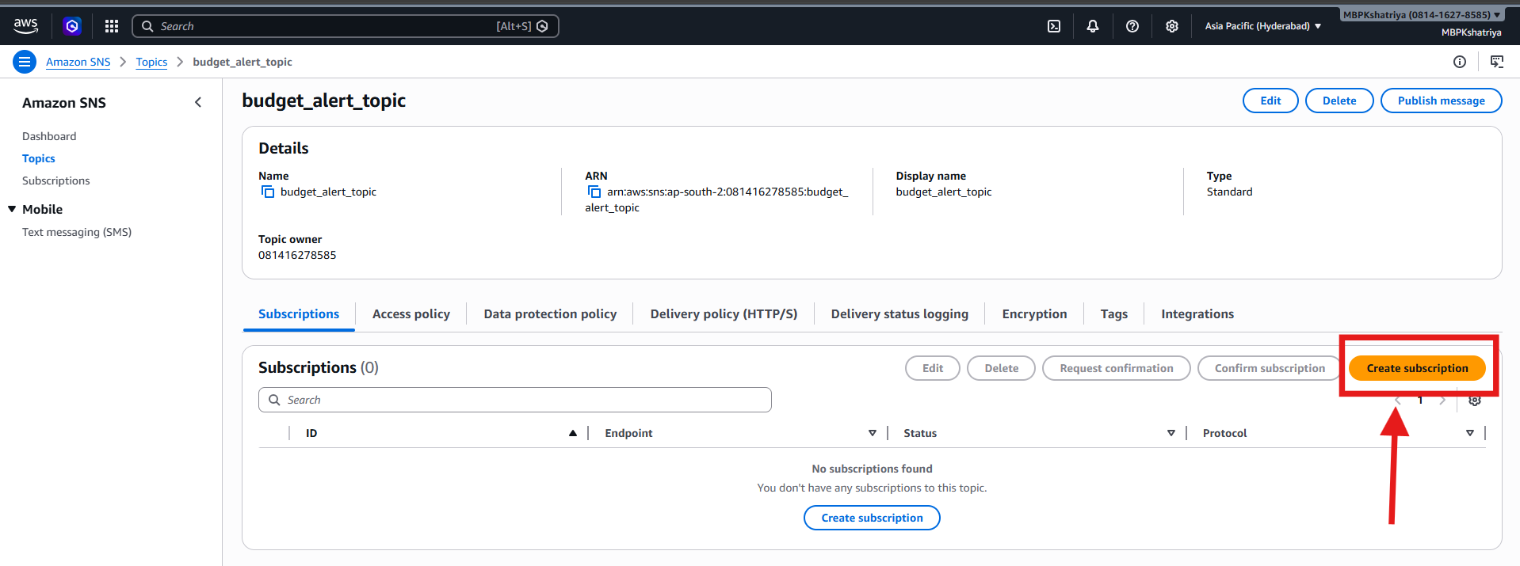
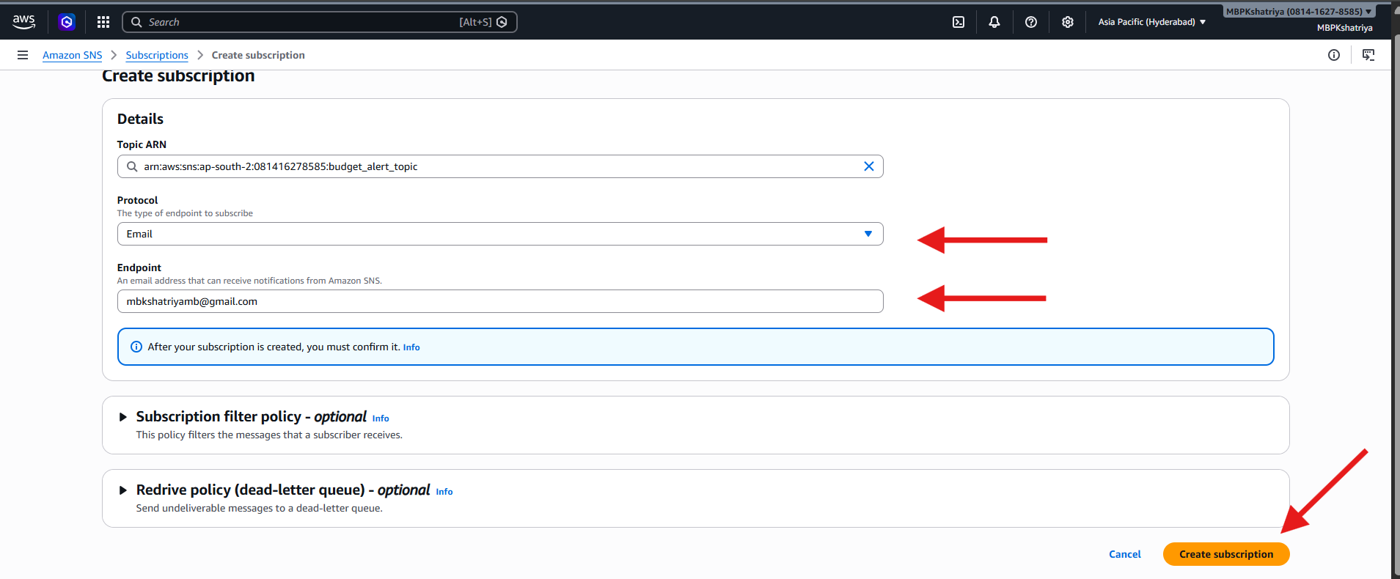

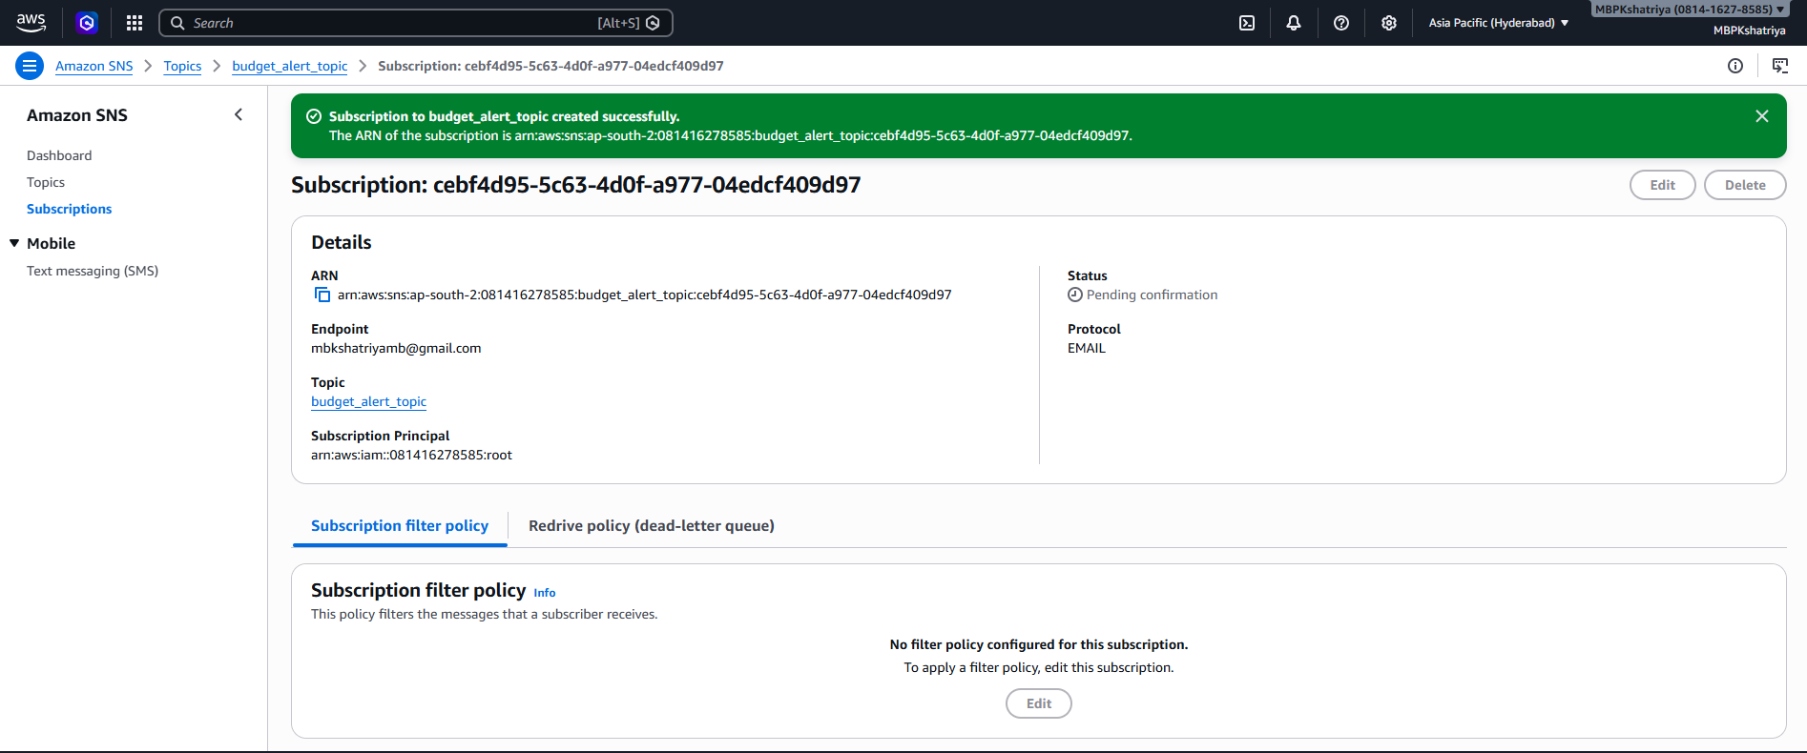
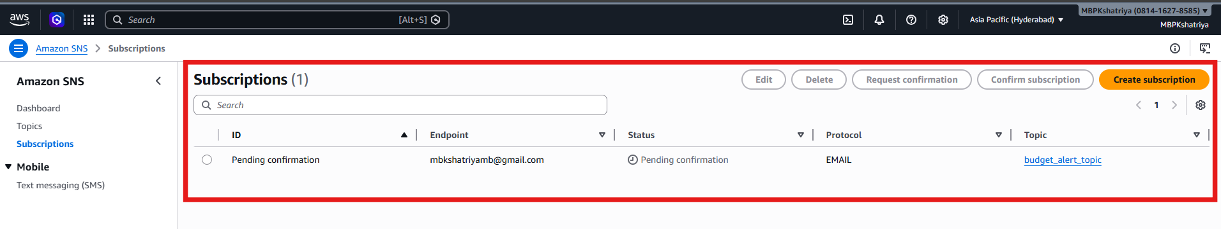

Check registered email for email confirmation.
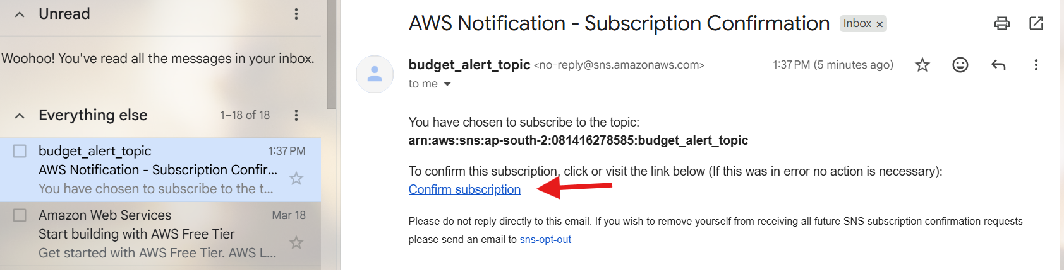
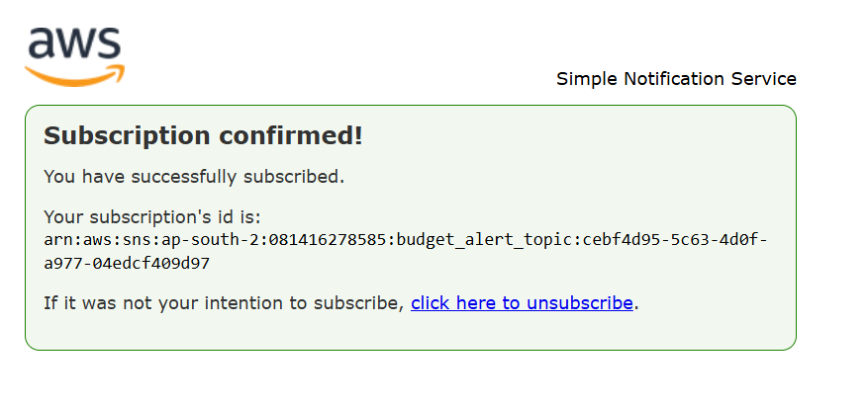

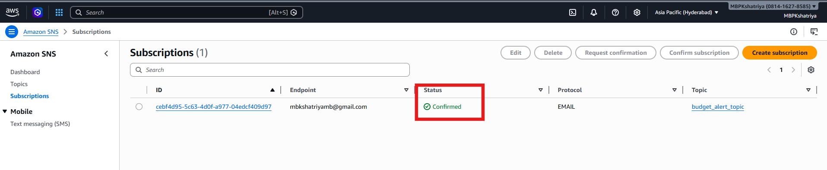

Step 3: Create Budget
- Go to AWS Budgets
- Click Create Budget
Choose:
- Budget Type: Cost Budget
- Name: test_budget
- Period: Daily (for testing purpose)

Set Budget Amount
Example:
- Budget: 0.01 USD (keep small for testing)
You can filter by:
- Tag → Environment = Sandbox
If not using tags now → skip (use overall cost)

Configure Alerts
Add alert:
- Threshold: 80%
- Notification type: Actual Cost
- SNS Topic: select budget-alert-topic
Add another:
- Threshold: 100%

Click Create Budget

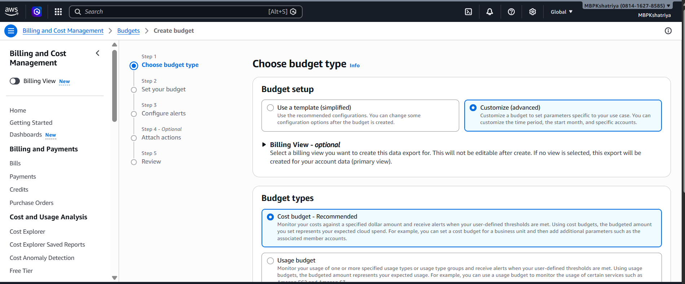
Click Next
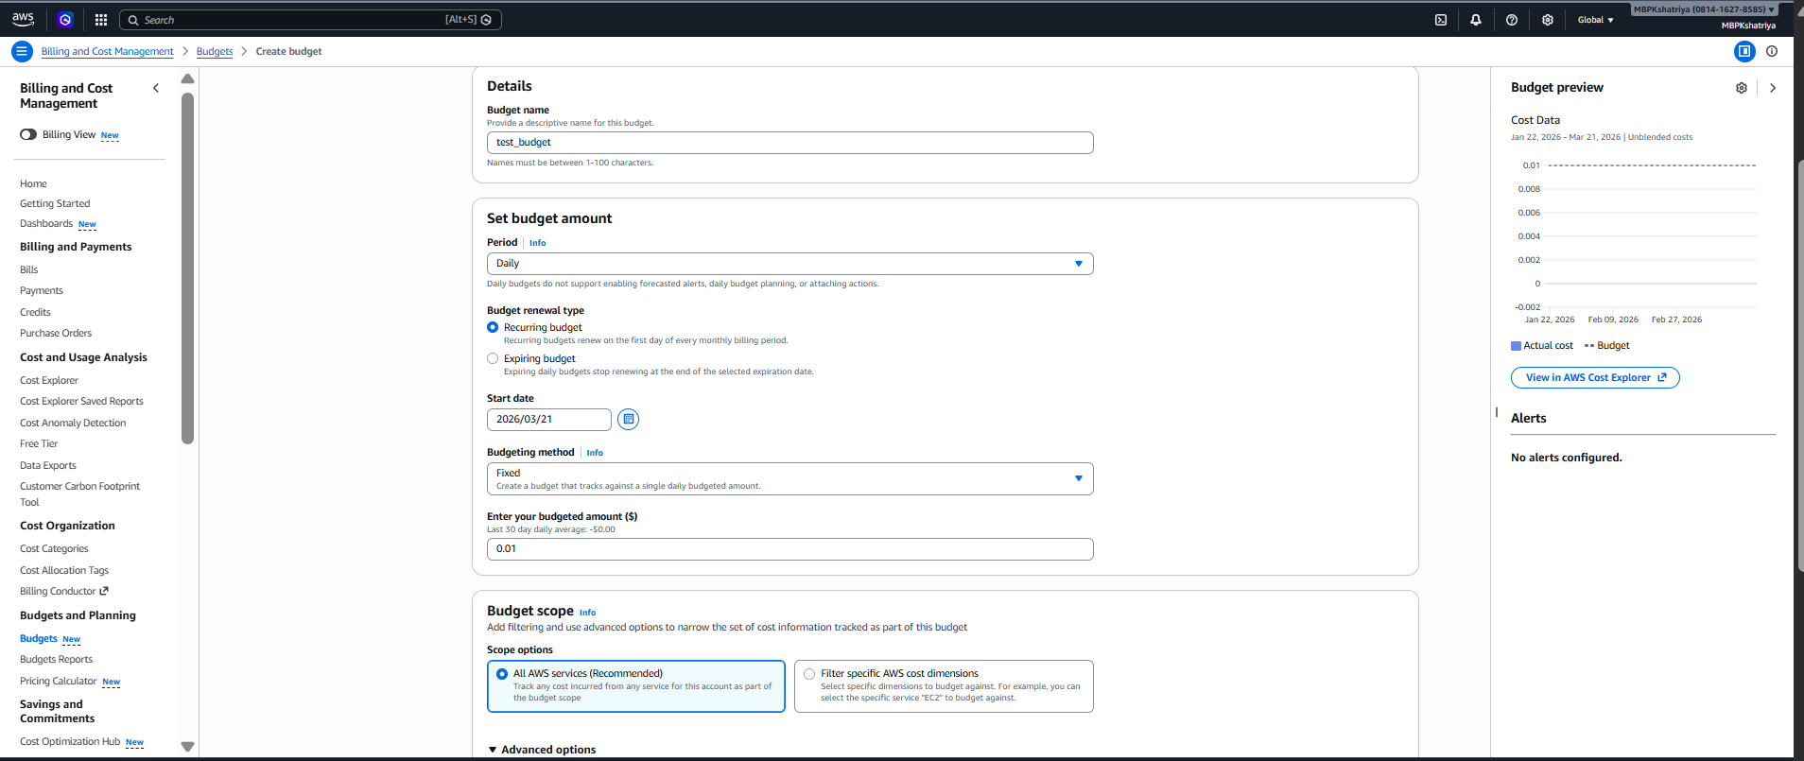

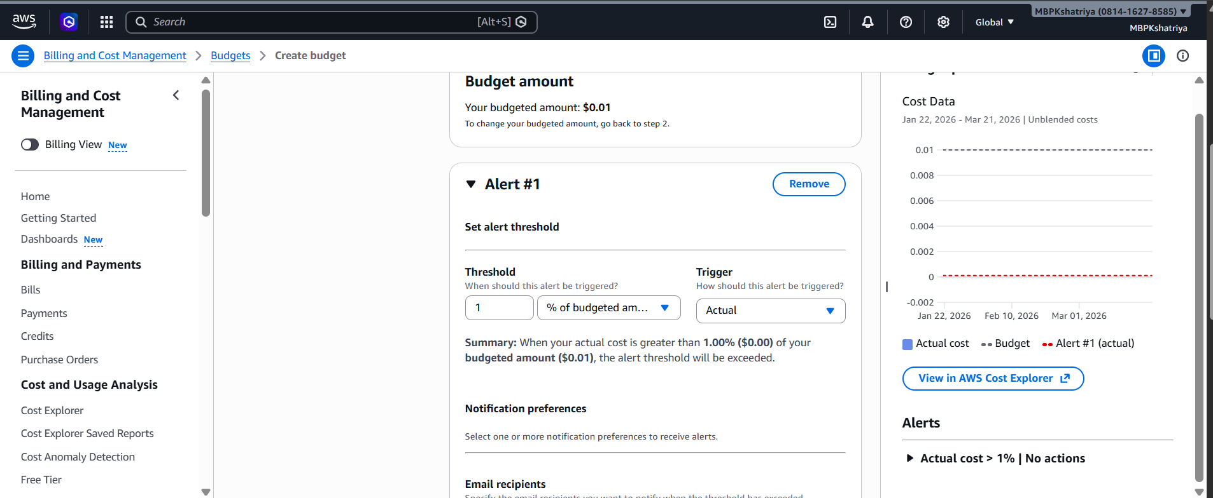

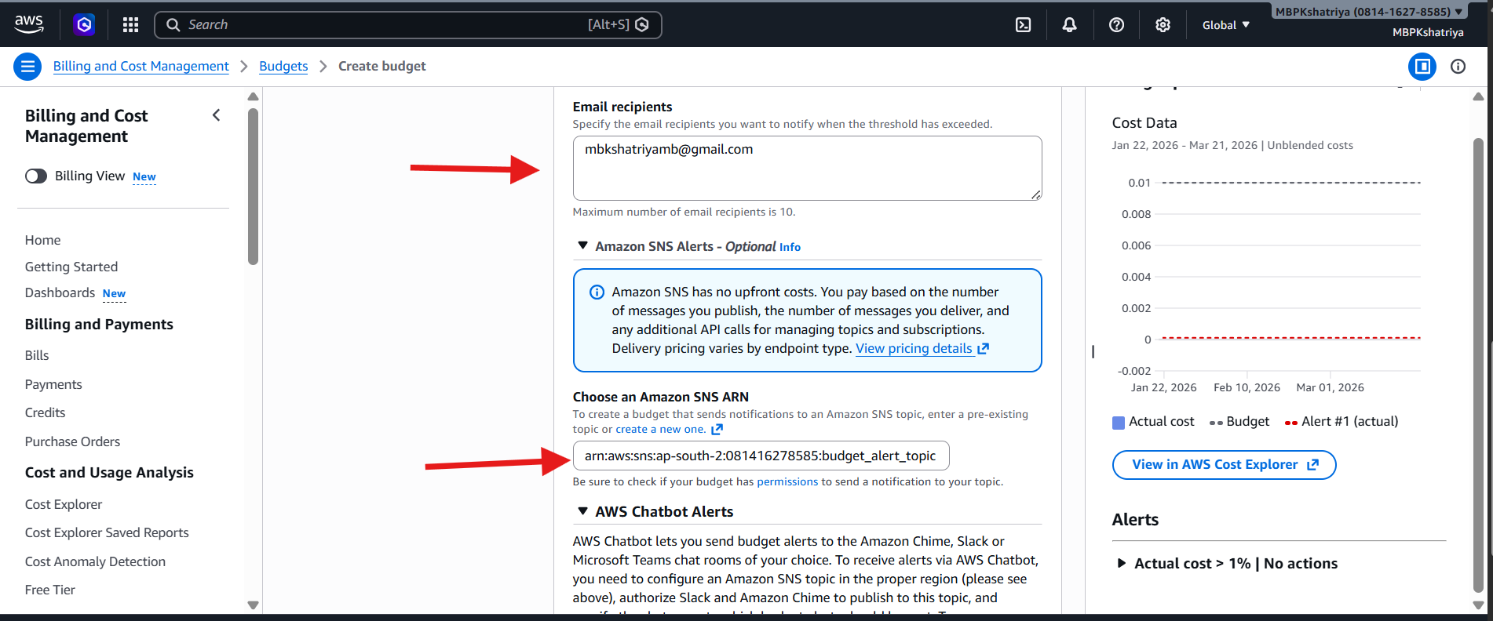

Another threshold for budget alert
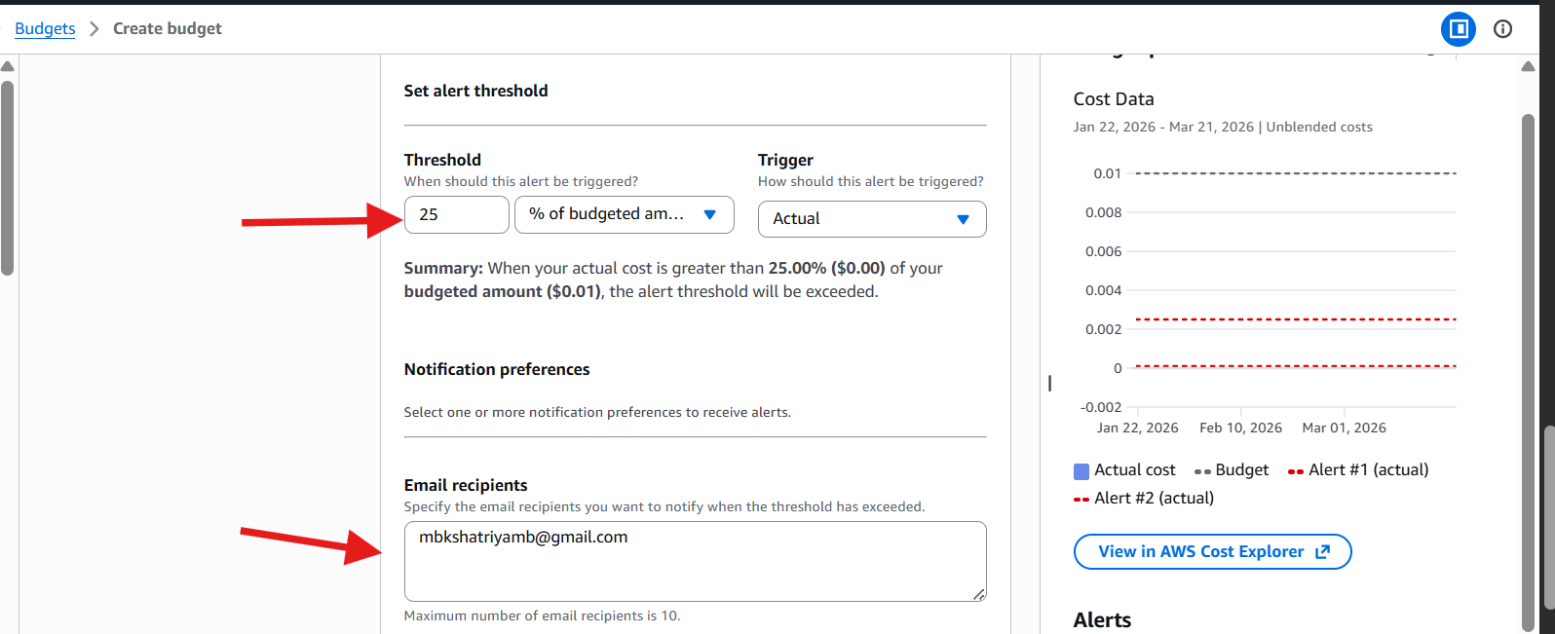

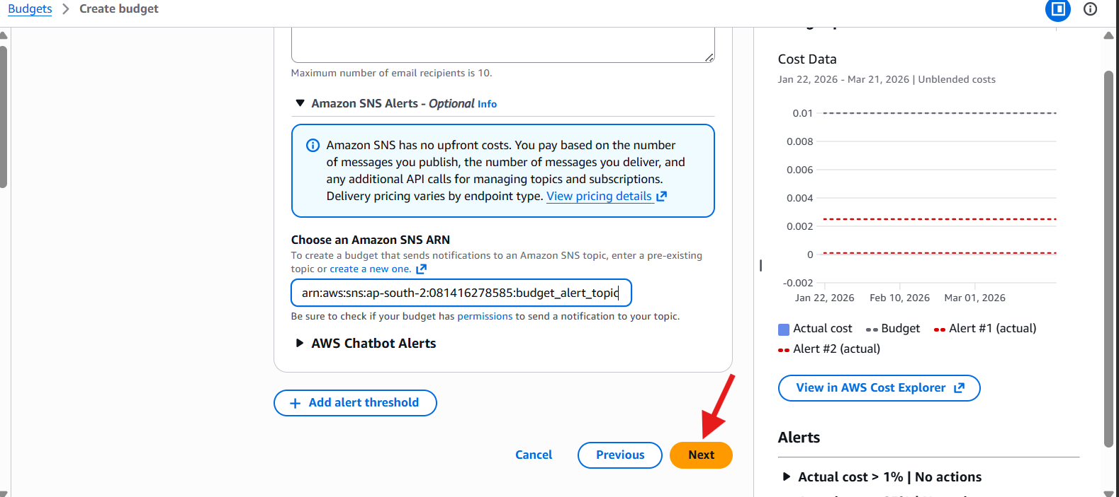

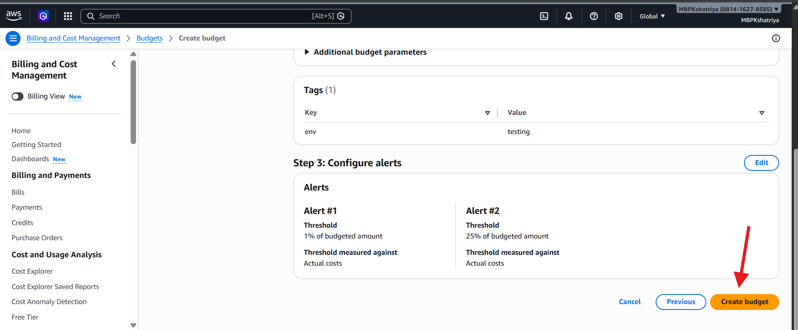
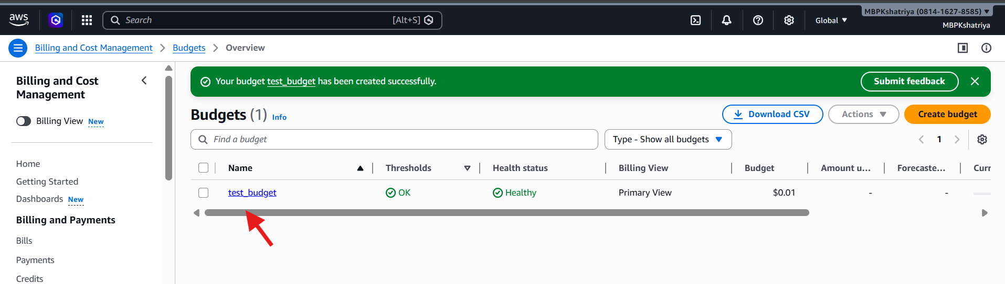
Alerts configuration:
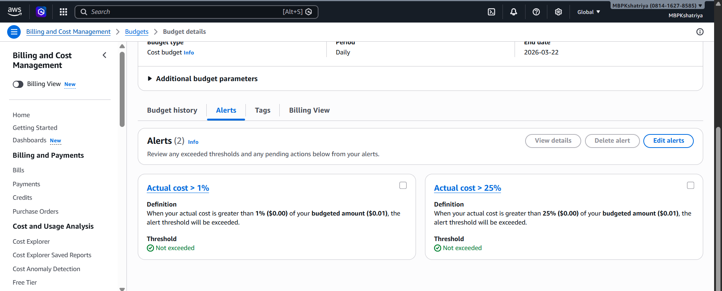

Alert 1:
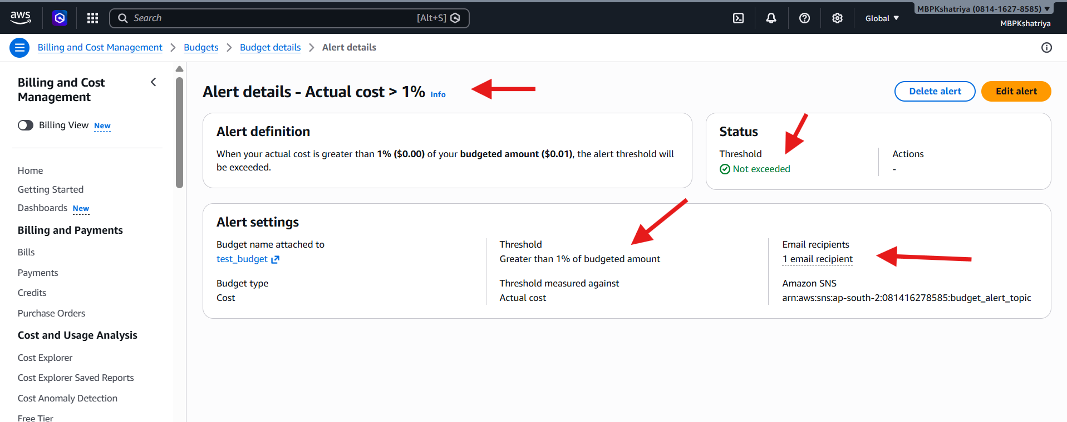

Alert 2 :
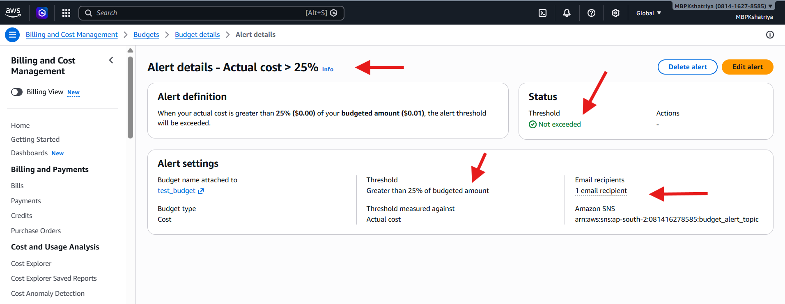

Execution:
1. Creating 15 EC2 instance to track the alerts.

