

Individual Work

CO4830 IT Project Management
Assignment – 1

Submitted by

Manoj M. Chalode

1 Introduction
This report consists of an individual work completed by referring the given scenario. The scenario covers up a web based order handling service which is intended to sell leather belts online. This web site will be owned by “Lizzie’s Leather Belts” company. They have given the contract to build this web site to a software development consultancy named “True Concepts”. The intention of this project is to expand the leather belt business by making the products available to the general public online, preferably within 3 months.

The report includes following points which were taken into the consideration for evaluation -
- Stakeholder analysis
- Requirements gathering
- Project life-cycle
- Scheduling
The evaluation is all about discussing the choices made to select the most suitable options for the project and how these options will help the project in achieving the final goal. Apart from it, possible alternative approaches are also discussed which could have been used.

At last but not the least, report focuses on few points like our team work, project management strategies as a project manager & potential professional and legal issues.

2 Stakeholder analysis
According to few review reports (Yang, R.J., 2014; Missonier, S. et al. 2014), the stakeholders play an important role in decision-making processes. The analysis provides information about all the potential groups of stakeholders which can impact the projects and their success.

Stakeholder analysis can be done using various methods. These methods use different parameters to set the stakeholders' position with respect to the project. “Construction stakeholder management” book explains a traditional stakeholder analysis (Bourne, L. et al. 2010). Usually, a two dimensional matrix is used to map stakeholders to appropriate groups. This is elaborated in fig 1.

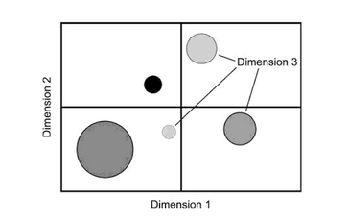

Figure 1: Traditional stakeholder mapping

The book also enlists some of the widely used dimensions to perform the mapping like power, support, influence, interest, attitude (Bourne, L. et al. 2010).

Evaluation
The reason behind choosing power/interest grid for stakeholder prioritization is the dimensions which are being used by this method. The article written by (Ackermann, F. et al. 2011) explains how this grid which uses power & interest as two of its dimensions, is proven to be efficient. The following figure (fig 2) clarifies this point.
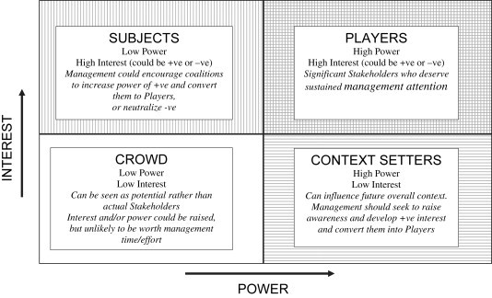

Figure 2: Outline stakeholder power-interest grid

In the above figure, it is clearly visible that more the interest or power of a stakeholder closer will be the stakeholder to the system and vice a versa. This relation made it easier for us to divide the potential stakeholders into different groups and enabled us to determine their impact on the system. Using this information, stakeholders were categorized in different roles by using the ‘Onion’ model technique.

We could have used influence as one of the dimensions for this analysis as it provides the impacts of different stakeholder groups on the system.

3 Requirements gathering
Requirement gathering is one of the most crucial and integral part of software development process(Cunha, A. et al. 2008). It provides a clear picture of expectations of stakeholders from the system. Gathering information from stakeholders gives us a brief idea of most suitable and usable features and their internal relationships. Following are one of the most useful techniques used for requirement gathering (Paetsch, F. et al. 2003) -
- Interviews
- Focus Groups
- Brainstorming
- Prototyping
- Observation and social analysis
- Surveys

Evaluation
We chose to use brainstorming and focus groups as requirement gathering techniques as the output of this combined exercise gave us precise information about the most important features. Brainstorming provided us ideas around different aspects of the projects because of involvement of different stakeholders. Focus groups on the other hand, allowed us to select specific subset among the shortlisted ideas (Erzah, 2017).
Apart from the selected requirement gathering techniques, surveys would have been really useful in figuring out the exact requirements as it involves system end users as its targeted stakeholder group. The feedback collected from general public i.e. the primary stakeholders would have given a lot more information about their expectations from the system. We should have planned to gather requirements while product development is in progress as it is equally important and it could provide additional ways to improve the product (Young, 2002).

4 Project life cycle
Product development involves different stages like requirement gathering, design, coding, testing, deployment & support. Following a process becomes very important as these stages are interdependent and sometimes are interlinked with each other. Project life cycle provides standard conversations and best practices which helps maintaining smooth product development by allowing optimum resources usage. It also allows to plan the work flow before starting the work which gives a better understanding of criticality of features and their priorities.

Evaluation
There are few famous life cycles widely used by different organizations. Some of them are conventional project life cycles like waterfall, prototyping & incremental life cycle. Others are agile life cycles like scrum, XP & DSDM. We chose to go for agile life cycles as it provides a lot of best practices and conventions to keep the project work on track. Apart from it, agile manifesto concentrates on value of the product and treats it as one of the success factors (Alahyari, 2017). Following figure (fig 3) gives a broader level picture of agile life cycle. Note that initially, only high level requirements are gathered as changes in few features might be expected after few sprints.

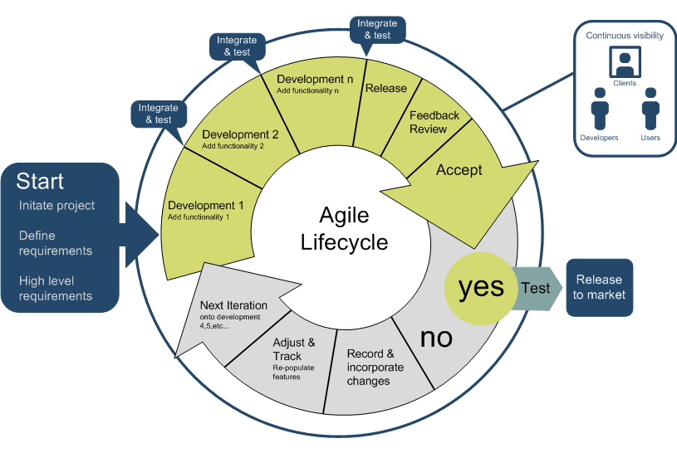
Figure 3: Agile life cycle

Being one of the agile methodologies, scrum provides a way to handle frequently changing product requirements by keeping time lines in tact. Apart from it, scrum ceremonies like sprint planning, daily stand up, sprint retrospective and sprint review helps team members to be in sync with product road map & work as a team.

As an alternative approach, we could have selected XP as the project life cycle. Being an agile methodology, XP follows few more important best practices which aren't implicitly followed by scrum. The practices like immediate code refactoring, test driven development & pair programming would have been effective. Being a short term project, test automation during release would have caught most of the minor bugs in the system.

5 Scheduling
Scheduling plays a vital role in software development process as it maps the features, their development time span as per priorities, effective resource management including staff as and other resources & a better visibility to everyone who is working on the project including clients. There are different scheduling techniques like critical path method, PERT chart, Gantt chart, risk multipliers, schedule compression, etc (Baskerville, 2015).

Evaluation
We decided to go for Gantt chart as it provided a good graphical representation of all the scheduled activities. It also gave a view of major tasks and milestones. It not only provided the information regarding staff availability but also considered buffer timings if required to derive the safe estimations. Parallel running tasks with no dependencies on each other were visible and easy to track using this chart. As per one of the articles, “a Gantt chart is a visualization of the steps it takes for your project to be completed” (DUFFY, 2016). Following figure (fig 4) gives a brief idea about Gantt chart. Note that the initial work in sprint 1 is being done in parallel as items are independent. Sprint 2 onwards items are picked serially.

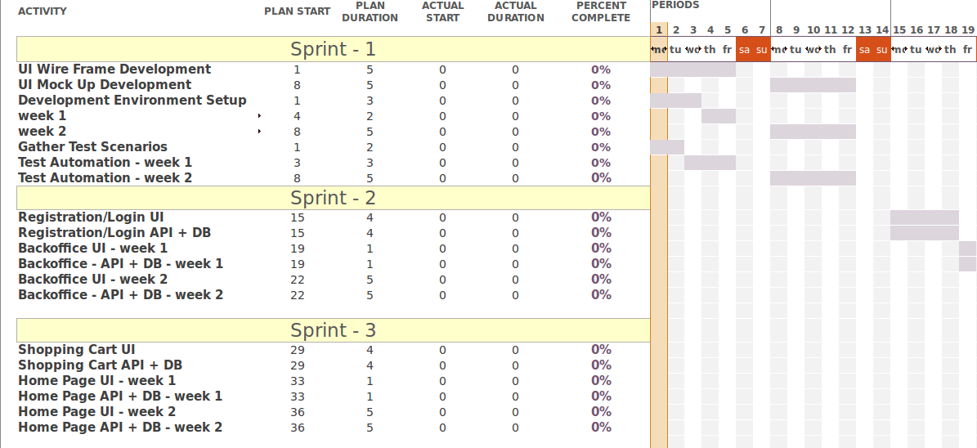
Figure 4: Gantt chart

Though the Gantt chart was a perfect choice for the project & we showed everything planned using scrum on the chart, we didn't show the sprint release plans on the it. Sprint wise releases should have been considered in the chart and we should have allocated specific time for release, testing and its showcase to the clients. We considered the parallel running tasks with staff allocation while working on the chart but couldn’t consider the buffer times to make sure we won't go out of schedule in case something goes wrong.

5 Strength and weaknesses of team
All the group members contributed equally in the group assignment task. We started working on the assignment early to make sure we finish it up well within time. This gave us an opportunity to revise the work to correct smaller mistakes. As frequent meetings were not possible, we planned to have at least one meeting in week so that we can plan for the week. During the meeting, we distributed the work among us and shared our findings in the next meeting. In case if any of the group members wasn't able to attend the meeting, we shared the minutes of the meeting on a video call which made it easier for everyone to be in sync with the work. We reviewed the work whenever required to make sure we are on the right path. A good mutual understanding between the members made it easier to distribute the work and get it done in less time. We distributed the work by identifying the skills e.g. member with good typing skill did most of the typing work.

However, there were few important things we missed while doing the group work. It could have been even better if we would have followed few conventions. We didn't bother do review the ideas of group members before putting them in the report. An individual review would have given us better approaches to write the report. Though we managed to finish up the report within time, we didn't go through it by sitting together. It would have helped us identifying some of the weak points in the report before submitting it.

6 My role as a project manager
A project manager is responsible person for a project. Almost all the activities carried out in the project come under project manager's surveillance. Project manager's role is mainly to plan, design, execute, monitor and control the project.

Having decided to follow the scrum methodology, ideally a project manager should not come into the picture. But according to an article, in some scenarios where scrum master is not involved in the project, project manager can take over the responsibilities of scrum master and product owner to a certain extent (Yanush, 2012). As the product development team doesn't have a dedicated scrum master, I would have conducted all the scrum ceremonies like daily stand up, sprint planning, sprint review meeting and sprint retrospective to make sure scrum is being used in proper way.

Apart from the scrum responsibilities, I would have kept an eye on the project health by monitoring the development rate, testing, releases and client demos periodically. To minimize dependency problems, team members would have been allocated different tasks possibly in every sprint. Development velocity would have been one of the criteria to measure project health and minimize in time delivery risks. Best practices which are not the part of scrum like test driven development and code refactoring would have been implemented to try to achieve bug free releases.

7 Professional and legal issues
Providing a good user interface with bug free features is not the only thing which makes a web site popular and reliable. Professionally and legally, the web site should follow the standard set of rules and regulations of different areas to which it corresponds. The web site should be genuine & secure enough in terms of information, transactions and service.

The web site should follow DDA (Disability Discrimination Act) which states that a person with disability should be treated equally like a normal person. The website should be user friendly not only for normal people but for disabled people as well.

Being related to one of the most sensitive issues, equality act deals with few problems like gender inequality, racism, nationality, etc. The site, in order to follow this code, should not display any kind of information which contradicts equality act.

In terms of security, as the site will be having online payment mode of money transfer, it becomes essential to make sure that the transfer is highly secure and it is compliant with standards like PADSS (payment application data security standard)

Site security in terms of the data displayed on it becomes critical if the data is associated with the users or if it's meant to be secure. By implementing SSL (secure socket layer) over HTTP protocol, site should be made secure to make sure

References
Yang, R.J., 2014. An investigation of stakeholder analysis in urban development projects: Empirical or rationalistic perspectives. International Journal of Project Management, 32(5), pp.838-849.

Missonier, S. and Loufrani-Fedida, S., 2014. Stakeholder analysis and engagement in projects: From stakeholder relational perspective to stakeholder relational ontology. International Journal of Project Management, 32(7), pp.1108-1122.

Bourne, L. and Weaver, P., 2010. Mapping stakeholders. Construction stakeholder management, pp.99-120.

Ackermann, F. and Eden, C., 2011. Strategic management of stakeholders: Theory and practice. Long range planning, 44(3), pp.179-196.

Cunha, A, & Canen, A 2008, 'Requirements gathering in information technology: a cross-cultural perspective', Inspec, EBSCOhost, viewed 20 April 2017.

Paetsch, F., Eberlein, A. and Maurer, F., 2003, June. Requirements engineering and agile software development. In Enabling Technologies: Infrastructure for Collaborative Enterprises, 2003. WET ICE 2003. Proceedings. Twelfth IEEE International Workshops on (pp. 308-313). IEEE.

Young, R.R., 2002. Recommended requirements gathering practices. CROSSTALK The Journal of Defense Software Engineering, 15(4), pp.9-12.

Linda Erzah, CBAP. 2017. DIFFERENCE BETWEEN A BRAINSTORM AND FOCUS GROUP. [ONLINE] Available at: http://www.modernanalyst.com/Community/CommunityBlog/tabid/182/ID/1904/Difference-between-a-Brainstorm-and-Focus-Group.aspx. [Accessed 15 March 2017].

Alahyari, H., Svensson, R.B. and Gorschek, T., 2017. A study of value in agile software development organizations. Journal of Systems and Software, 125, pp.271-288.

Baskerville, P. 2015, CBAP. 2017. Scheduling tools and techniques for Project Management. [ONLINE] Available at: http://www.skillmaker.edu.au/scheduling-tools-and-techniques-for-project-management/.

DUFFY, J 2016, 'Using Gantt Charts to Get Things Done', PC Magazine, pp. 133-138, Business Source Complete, EBSCOhost, viewed 22 April 2017.

Yanush, T. (2012). Implementing Scrum: How Does the Project Manager Fit In? - Scrum Alliance. [online] Scrumalliance.org. Available at: https://www.scrumalliance.org/community/articles/2012/january/implementing-scrum-how-does-the-project-manager-fi.

Figure References

No. | Title | Source / Reference
Figure 1 | Traditional stakeholder mapping | Bourne, L. and Weaver, P., 2010. Mapping stakeholders. Construction stakeholder management, pp.99-120. (book reference)
Figure 2 | Outline stakeholder power-interest grid | http://www.sciencedirect.com/science/article/pii/S0024630110000452
Figure 3 | Agile life cycle | http://sdc.net.au/media/1189/agile_lifecycle_large.png
Figure 4 | Gantt chart | Created using Microsoft project.

