Speech Is 3x Faster than Typing for English and Mandarin Text Entry on Mobile Devices

Experiment
The experiment consisted of two types of input methods. One is manual typing using a conventional keyboard whereas other method involves speech recognition. The experiment is carried out using two different English accents. British English (En-GB) and Indian English (En-IN).
The aim of this experiment was divided into two levels. Primary aim was to find out and compare the impacts of both the input methods on speed and accuracy. Secondary aim included a further discussion on areas of improvement based on the results of the experiment.

Participants
In all 30 participants were involved in the experiment. Out of 30, one participant was excluded as the speech recognition was not able to work properly on participant’s machine because of some limitations of the speech APIs. Another participant was rejected because misunderstanding the instructions to select appropriate language for the speech test.
Out of 28 selected participants, 14 participants were native British English speakers whereas remaining 14 were native Indian English speakers. In terms of technical experience based classification, half of the participants were university students and remaining half were working professionals.
Among the chosen student participants, half of the participants were from computer / software background and remaining half were chosen from non-technical background. In terms of language spoken, half of the students were English and remaining half were Indian.
In case of selected working professionals, half of the participants were native English and remaining half were Indian. Table 1 displays the entire distribution of participants.

Apparatus
Being a web based speech recognition project, the experiment used a light weight website developed using Angular web framework. The website used newly introduced HTML 5 speech recognition API to perform the speech recognition part of the experiment. The website was integrated with Google login to recognise authenticated users.
The user interface provided a paginated guide to explain the context of the experiment. The guide was divided into 4 parts viz. general instructions, typing task details, speech recognition task details & practice test.
The collected data and user login information was stored in Firebase which is an online database system developed by Google. Both the tasks were integrated with timer to display the elapsed time while taking the tests.
As a part of validations, actual task pages were made authenticated to make sure only logged in users would be able to take the tests. The text to be typed or spoken was displayed using an image to avoid unauthorised actions like copy and paste of the text. The website to change the detection language so that user could select appropriate language whilst taking the test.
The task pages viz. typing task page and speech task page were given a functionality to display the results in terms of different parameters such as word count, elapsed time, percentage accuracy and percentage error. As a part of data analysis, the web site also displayed the difference between the sample text and the text typed/spoken by the user at the end of the test. Image 1 shows an example of result & analysis of a sample typing test.

 | Students | Professionals | Total
English | 7 | 7 | 14
Indian | 7 | 7 | 14
Total | 14 | 14 | 28
Table 1 – Participants’ Distribution
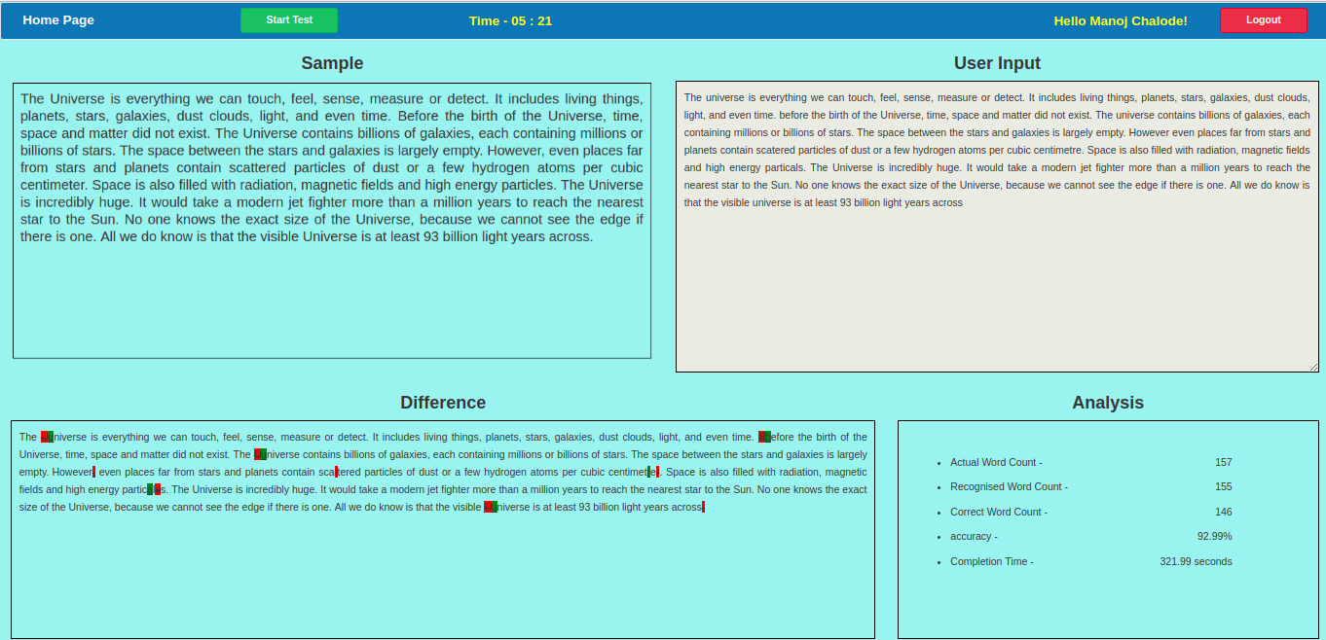
Image 1 – sample typing test

Procedure
In order to start with the experiment, the website URL was shared with all the participants. The website home page was provided with user guide consisting of following 4 instruction sets -
- General instructions
- Typing task instructions
- Speech task instructions
- Practice test

Out of all the instructions, first three were accessible to everyone whereas the practice test was made visible only after logging into the system. The practice test involved a sample text which was supposed to be read loudly in order to understand how speech recognition task is supposed to be done. To make sure everyone understands the speech recognition task, participants were restricted to access actual tasks until the practice test is cleared. The results of practice test were not considered in final calculations.
The main task was to refer to a sample text consisting of 157 words and type it in the text area in case of typing test and read it out loudly in case of speech recognition. As explained in the user guide, participants were supposed to press the start button to start the test and end button to finish the test.
Both the tasks were provided with a timer which was supposed to start as soon as participant presses the start button and stop after clicking the end button. Best results of first three trials were recorded as the final results.
Whilst taking the test, the results of individual participants were recorded, analysed and saved in the database. The analysed results composed of number of words attended, number of correct words, percentage accuracy and difference between the two etxts as shown in image 1.

