Pizza Sales SQL Analysis
A. KPI’s
1. Total Revenue:
SELECT SUM(total_price) AS Total_Revenue FROM pizza_sales;
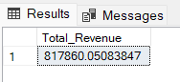
2. Average Order Value
SELECT (SUM(total_price) / COUNT(DISTINCT order_id)) AS Avg_order_Value FROM pizza_sales
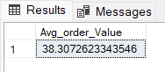
3. Total Pizzas Sold
SELECT SUM(quantity) AS Total_pizza_sold FROM pizza_sales
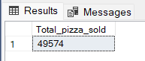
4. Total Orders
SELECT COUNT(DISTINCT order_id) AS Total_Orders FROM pizza_sales
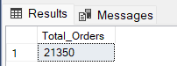
5. Average Pizzas Per Order
SELECT CAST(CAST(SUM(quantity) AS DECIMAL(10,2)) /
CAST(COUNT(DISTINCT order_id) AS DECIMAL(10,2)) AS DECIMAL(10,2))
AS Avg_Pizzas_per_order
FROM pizza_sales
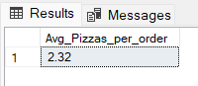
B. Daily Trend for Total Orders
SELECT TO_CHAR(order_date, 'Day') as order_day, COUNT(distinct(order_id)) as Total_Orders
from pizza_sales
group by TO_CHAR(order_date, 'Day')
order by MIN(order_date)
Output:
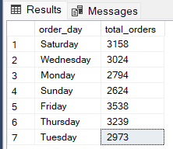

C. Hourly Trend for Orders
SELECT TO_CHAR(order_time, 'HH24:00') as hour_slot,
COUNT(DISTINCT(order_id)) as Total_Order
from pizza_sales
group by TO_CHAR(order_time, 'HH24:00')
order by MIN(order_time)
Output
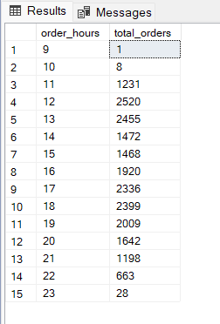
D. % of Sales by Pizza Category
SELECT
pizza_category,
SUM(total_price) AS revenue,
Round(SUM(total_price)*100 / SUM(SUM(total_price)) over(),
2) as PCT
FROM pizza_sales
where TO_CHAR(order_date, 'MM') = '02'
GROUP BY pizza_category
ORDER BY revenue DESC;
Output
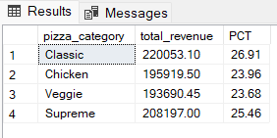

E. % of Sales by Pizza Size
SELECT
pizza_size,
SUM(total_price) AS revenue,
ROUND(SUM(total_price)*100 / SUM(SUM(total_price)) over(),
2) as PCT
FROM pizza_sales
where TO_CHAR(order_date, 'MM') = '02'
GROUP BY pizza_size
ORDER BY revenue DESC;
Output
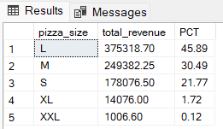

F. Total Pizzas Sold by Pizza Category
Select
pizza_category,
SUM(quantity) as pizza_sold
from pizza_sales
group by pizza_category
Output
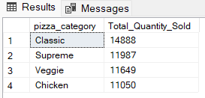

G. Top 5 Best Sellers by Total Pizzas Sold
Select
pizza_name as Pizza_Name,
COUNT(quantity) as Pizza_Sold
from pizza_sales
group by pizza_name
order by Pizza_Sold desc
limit 5
Output
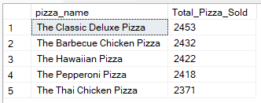

H. Bottom 5 Best Sellers by Total Pizzas Sold
Select
pizza_name as Pizza_Name,
count(quantity) as Pizza_Sold
from pizza_sales
group by pizza_name
order by Pizza_Sold asc
limit 5
Output
