SOS WOMEN SAFETY ANDROID APPLICATION

Dhilip Karthik M
Department of Computer Science & Engineering
Vellore Institute Of Technology, Chennai
Chennai, India
dhilipkarthik.m2019@vitstudent.ac.in

Manoj Darshan R
Department of Computer Science & Engineering
Vellore Institute Of Technology, Chennai
Chennai, India
manojdarshan.r2019@vitstudent.ac.in

Abstract— The main aim or objective of this application is to provide you with fastest and simplest way to contact your nearest help. In this system, the User needs to feed three (3) contact numbers (i.e. police, relatives, or people who they trust the most).In Case of any emergency, on moving the phone up and down thrice or by shaking it thrice, the system automatically sends SMSS and it also calls on one of the three numbers fed in the system with their current location. On calling if the person did not receive the call, it calls the second number and then the third. It keeps on dialing again and again. The special location sharing feature ensures that the exact and current location of the women with exact latitude and longitude map co-ordinates is shared to their loved ones and shares to emergency or security agencies like 901,100 or to the police control room etc. Auto enable and disable panic mode is the most advanced option/feature which helps in avoiding unnecessary calls to the contact and enables only when the women is in any danger or threat.

Introduction
When it comes to sexual violence against women, India is considered as one of the most dangerous country in the world. Many number of crimes against women as become common nowadays. In that, Rape has become one of the most common crimes. It is said that, according to National Bureau of Crime Records, for every 20 minutes, a women is getting Raped. The Crime Rate against women has been increased 3% from 2011 to 2012. Rape has now become the fourth most common crime that is taking place inIndia. According to 2019 report of NCRB about 32033 cases have been registered/ filed.
Nowadays, it is not safe for a woman to step out of the house after 11 pm. They cannot / are unable to carry on their works or move freely independently. The women might be mentally strong, but not as physically strong like men. They are always in need of help of a man for their security which is not possible in their routine life.
So, we created an app which is very useful for them. The women need a companion for their safety. Their mobile phone might be of use to them as they carry mobile phones wherever they go. This app might be of help to when they are in trouble. Description of how our app is useful is explained hereafter.

EXISTING SYSTEM
In the already existing system, the women has to take his/her phone and search for her closest ones contact and need to make a call to them which is very tedious in the dangerous situations . This consumes a lot of time when the women is in extreme danger and may not save from devils!
Then there comes all the apps which make it easy to call the loved ones immediately in no time when she is in danger by pre saving all important contacts in the app. Then by some means the app gets activated and sends calls and messages to the contacts saved in the app.
Then there also exists some apps which have added additional features in the app like instant messaging, location sharing of the victim to the most important contacts which are saved in the app itself.

LITERATURE SURVEY
Life craft: An Android based Application System for Women Safety[1]
Life craft is an application for android for women’s safety. It can be activated by voice command or SOS Key. An alert message with location is sent to the user defined numbers in every five minutes until the system is turned off. Audio recording option for evidence. Continuous location tracking. Directions to the nearby safe zone. Supports in the offline mode also.

Women’s safety system by Voice Recognition [2]
The app that tracks the current location of the victim and shares it with at most five registered contacts. First of all, the users need to fill their info within the application and they can edit their info anytime according to their convenience. The app gets activated by voice or by a click. Sound recording as a proof for the evidence. Sends alert messages to the nearby station house and to the registered contacts.
Safety solution for women using Smart Band and CWS App[3]
An IOT device along with an android app that can make women’s movement safer. Women can get swift and supreme safety support by pressing the device’s emergency switch. Real time location tracking and sharing it to the nearby police box and volunteer. Gets the location of the nearest safe zone. Functions in both online and offline mode.
‘Street smart ‘: Safe street App for women using Augmented Reality [4]
This paper presents a women safety Android application which is developed by using a number of features in smart phones like GPS navigation, digital camera, high-speed internet connectivity and many more. This proposed work helps the user to get articles and reviews about the place by just holding the camera at the location.
These articles and reviews are augmented with the real scene in the camera by integrating the augmented reality. The recommendation about the place such as ’Safe Street’ or ‘Unsafe Street’ is also provided to the user based on the available data. The user can send calls and messages with current location details to the police and the listed contact numbers using this app in case of emergency. The user can share his/ her experiences and reviews about the place through this app.
Athena: A Mobile Based Application for Women’s Safety with GPS tracking and Police Notification for Rizal Province.[5]
This study aims to develop a Mobile Based Application for Woman’s safety to help authorities track the criminals through the use of the said application by providing real-time SMS Notifications, GPS Tracking, and direct emergency call to nearby police stations inside the Rizal Province. It involves host server which accept and process complaints initiated by the users. This application utilizes agile methodology in Android platform. It also has an option of video and image capturing.

PROPOSED SYSTEM
Our app is a very useful and necessary app for women now-a-days. Our app has many handy features which lends the hand to the many women who are all in Danger. This SOS application has a motion Detection enabled app activation mode namely “ Just Shake Mode” which helps the women in Danger by getting activated when the women moves the phone up and down three times or Shake it thrice or more Vigorously.
Once the app gets activated, there will be instant calls and emergency messages sent to their favourite contacts and also to some emergency helpline numbers like police, fire service, ambulance, etc., with also the additional feature of sharing current location of the victim which makes it easy for their loved ones and for the security officials to save her/them from Danger. The feature of current location sharing will send exact map location with precise latitude and longitude co-ordinates in the form of hyperlinks through text messages.
Then there comes the most unique feature which avoids unnecessary confusions and unwanted Danger call alerts. The auto enable and disable panic mode helps the women to keep the mobile phone in panic mode in enabled condition only when she feels that she may face danger. This is one of the most important feature as this feature avoids the huge mess created by these kinds of apps which initiates unwanted calls and unnecessary messages to the contacts even women is not in any danger as they may get activated by simple motion of the device.
This feature has two modes namely duration mode and distance mode. During the Duration mode, we can enter the number of time period in which the app should remain active. The app will remain active for that specific period of time and gets deactivated after that period of time. During the distance mode, we can set the distance of destination to be reached i.e. in km, m and in cm also. As the location and motion is getting tracked, the app gets deactivated after specific distance which is entered is covered by the User.

PROPOSED ALGORITHM
Step1: START
Step2: User Registration
Then fill all required fields: -
a) Personal Details
b) Contact Details
Step3: Login
If (new user) then go to step2
Enter username and password
If (field is empty) then throw warning
If (field is not valid) then throw warning
If (matches) open the home page and start the session
Step4: Precious Contacts
Get 3 precious contacts from the user
Step5: Permission
Ask user to grant/allow call, location and messaging permissions.
Step6: App activation
If (Panic mode when panic button pressed)
Makes call to contacts and sends alert messages to the 3 contacts rapidly.
If (just shake mode)
Make call to contacts and send alert messages to the 3 selected contacts rapidly.
If (Auto enable panic mode)
If (Distance specific mode)
Enter Distance
If (Distance> specific distance)
Exit panic mode
If (Duration specific mode)
Enter duration
If (time> specific duration)
Exit panic mode
Step7: Optional Services
Give user the optional services like nearby police station’s number, location or nearby fire station’s number.
Step8: END

SYSTEM ARCHITECTURE
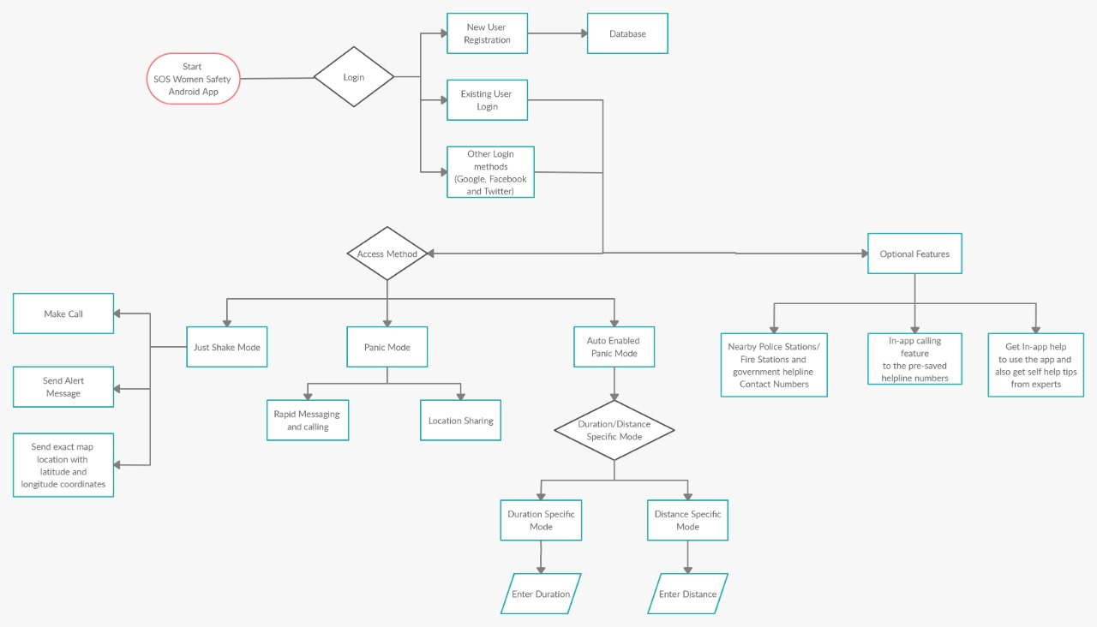

This is the mechanism of this app. The first is the SOS button or the start button. When we click/press this button, the app gets activated. It takes us to login page which displays the method of registration i.e. 1. New User registration, 2.Existing User Login, 3. Other Login methods (Google, Face book and twitter etc.,), 4. Guest user Login. In the new user login, we need to feed user’s database for Registration. In the Existing user login method or other login methods or through Guest login methods, we need to allow or give permission to the access methods. In the access methods, there are 3 modes i.e. 1. Just shake mode, 2. Panic mode, 3. Auto enable and disable panic mode. In just shake mode if we shake our mobile phone vigorously, the app automatically makes calls to the precious 3 contacts repeatedly until they attend the call. It automatically sends alert messages to that 3 contacts, to the emergency helplines like 100, 901, 108 etc. It also sends exact map location with accurate latitude and longitude co-ordinates to those 3 contacts and to emergency helplines. If we turn on the panic mode, rapid messaging and calling takes place to that 3 numbers and live location is shared to the helpline numbers and to that 3 number when the victim / person is in motion because of the danger or threat. Now comes the auto enable and disable panic mode. This is most unique feature in our app. These above features might cause confusions like it might make calls and send alert messages to our loved ones or to the emergency helplines as the person shakes the mobile phone by mistake while he/ she not in danger. To avoid all the unnecessary confusions and panic conditions, we have introduced a new feature i.e. Auto enable and disable panic mode. In this mode, we have two sub-modes like 1. Duration Specific mode and 2. Distance specific mode. In Duration specific mode, the user should set the time period or the duration of their travel. After the completion of the time that has been set, the app automatically gets disabled. In Distance specific mode, the user should set the specific distance of their travel. After covering the specified distance, the app automatically gets disabled. There are also some optional features present in the app. The app can detect the nearby police station, Fire station, and other government helpline contact numbers. There is also an In-app calling feature to the pre- saved helpline numbers. The user can also specific information or get self-help tips from experts in the In-app help feature as the person’s mind doesn’t work properly when they are in anxiety.

UML USE CASE DIAGRAM
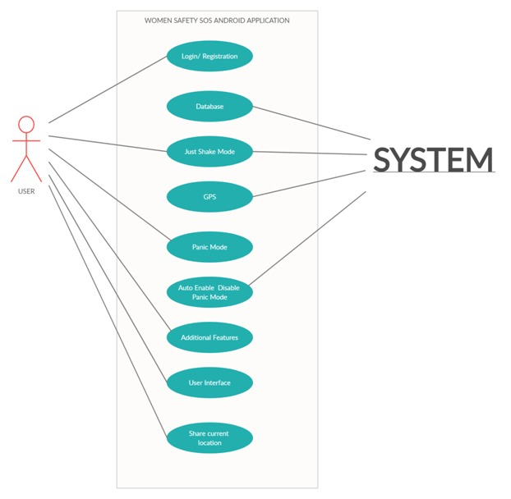
The above diagram represents the use case diagram of women safety SOS android application. This diagram represents the use case model of the life craft of the SYSTEM. Here in this diagram, the user has the access to login/ Registration, databases, GPS, just shake mode, Panic mode, auto enable and disable panic mode. It also has the access to the addition features, to the User Interfaces and for sharing current location of the user.

MODULES USED IN THE PROJECT
- Login module
- Menu module
- Register module
- Home Screen module
- Activity setting module
- Custom SMS setting module
- Emergency helpline module
- Government helpline module
- Information module
- Permission settings module
- Add favorite contacts module
- Main screen module
- Database modules

Login module:
This module enables the user to login into the app. In this module, we have defined mainly three features namely,
- Existing user login with email or name and the password.
- Direction to the new user Registration module.
- Other handy login methods like Google, Face book and Twitter.
- If the user doesn’t want his pre-saved details to be forever, he/she can get into the app through guest mode.
New User Registration Module:
- This module enables the first time user to register with the app.
- User needs to enter his name, a valid email and a password to register an account with the app.
- After successful verification and registration of the account, the user can enter into the app with his own email and password.
Menu Module:
- In this module, the user can view and edit his precious edit numbers.
- The emergency helpline numbers can be accessed and modified according to the user from here.
- The in-app calling feature to the government helpline numbers can be done from here.

Home Screen Module:
- The module includes the main home screen of the application.
- After successful saving of three contacts, the user can enable the app from the module.
- This module contains the 3 activation modes namely “just Shake mode”, “Panic mode” and the “Auto enable disable panic mode”.
- The phone can just be moved vigorously above threshold level to activate app or the user can just touch this panic button to activate this app.
- The two icons at the top corners indicate the duration specific mode and the distance specific mode respectively.
Setting Module:
- This module has the most import sections of the application.
- The user can edit his precious contacts numbers through the edit option and can also access the helpline numbers.
- The user can get information about how to use our app, self help tips from experts and can also see the info about us and the build version of our app through the info option.
- Then the user has an option to safe exit from the application through the edit option.
Favorite Contacts Module:
- The user can save the precious contacts through this module.
- The 3 contacts are mandatory for the working of the app.
- The user can even edit these contacts later.
- These contacts will be saved in the database and will also be linked with the account of the user.
Emergency Helpline Module:
- Here the user can add all his/her emergency helpline numbers to enable in-app calling feature.
- There are multiple provisions to get and save almost all helpline numbers.
- These numbers are saved in the application’s database and are also linked with the user’s account.
Government Helpline Module:
- Here the user can get the most important government helpline numbers of all the states in India.
- The call can be established within a matter of seconds using this module.
- The app establishes an in-built calling faculty to easily get in touch with the government helpline numbers.
Permission Setting Module:
- The module ensures whether the permissions required for the application are granted by the device.
- The user can check this module and enable the required permissions from here.
- After all permissions are granted the application can be launched successfully.
Information Module:
- This module includes the optional features of the app.
- The user can get self help from experts.
- The user gets the guidance and help on how to use this app.
- The user can see the build version and our details in the about section of the app.
Custom SMS Module:
- The module provides the template to the alert messages that is to be sent from the application.
- The user can edit these messages to his own message of interest.
- This module also integrates current map location with exact latitude and longitude to the message.

SAMPLE SCREENSHOTS

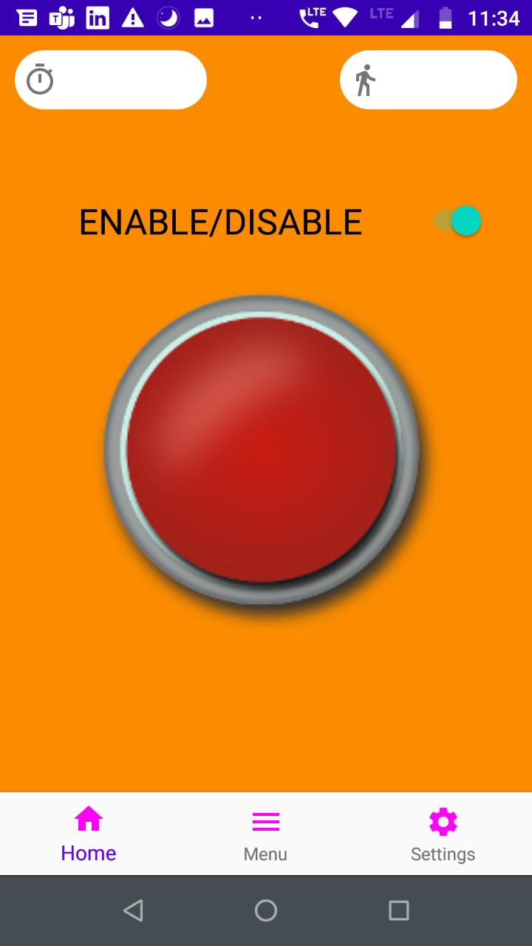

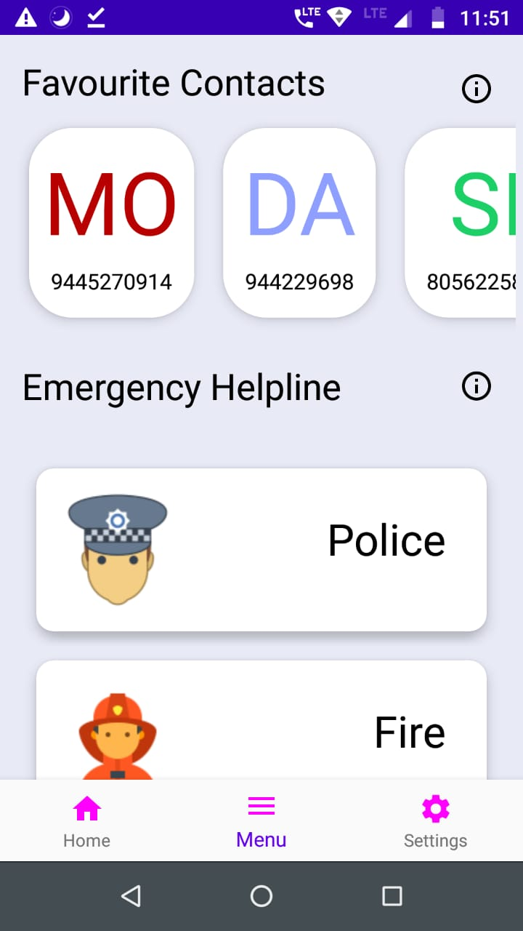

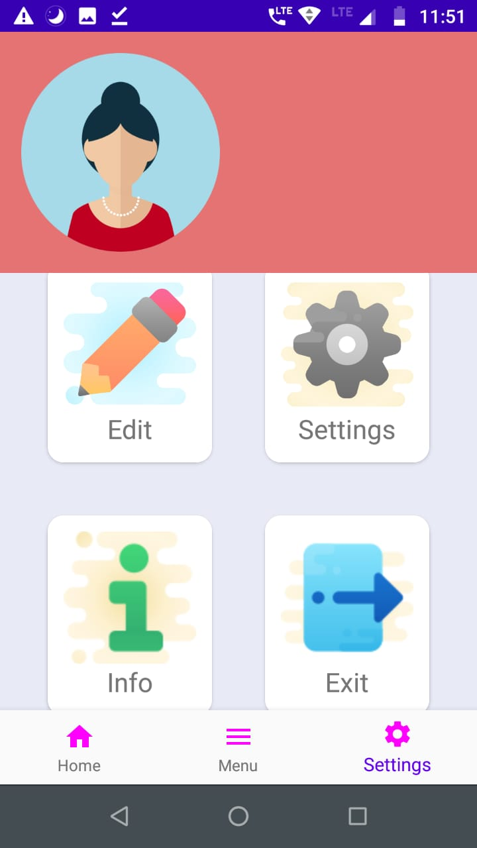

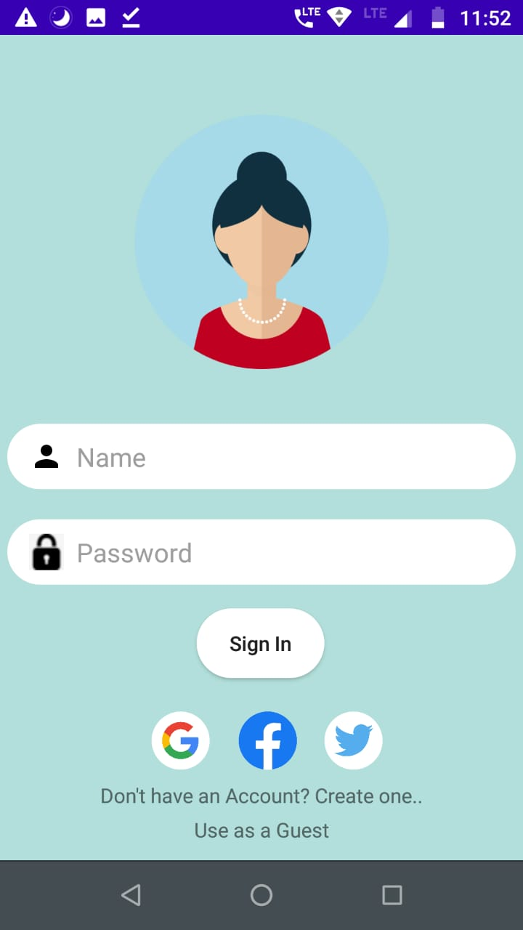

CONCLUSION
For the Government, the Safety and Security of women and children always poses a great concern. Our exertion behind this project is to create an android application which is easily accessible and provide a helping hand to women and children who are in danger. This app is like immunity for those people who are afraid of outside world’s day to day crimes. This application helps in raising the awareness on crime prevention against women. This app equips the law enforcement units which respond to the potential crimes that are taking place.

References

- R. R. Khandoker, S. Khondaker, Fatiha-Tus-Sazia, F. N. Nur and S. Sultana, "Lifecraft: An Android Based Application System for Women Safety," 2019 Sustainable Technologies for Industry 4.0 (STI), Dhaka, Bangladesh, 2019, pp. 1-6, doi: 10.1109/STI47673.2019.9068024.
- V. Mishra, N. Shivankar, S. Gadpayle, S. Shinde, M. A. Khan and S. Zunke, "Women’s Safety System by Voice Recognition," 2020 ,Electrical,Electronics and Computer Science (SCEECS), Bhopal, India, 2020, pp. 1-5, doi: 10.1109/SCEECS48394.2020.3.
- A. Z. M. Tahmidul Kabir, A. M. Mizan and T. Tasneem, "Safety Solution for Women Using Smart Band and CWS App," 2020, Electrical Engineering/Electronics, Computer, Telecommunications and Information Technology (ECTI-CON), Phuket, Thailand, 2020, pp. 566-569, doi: 10.1109/ECTI-CON49241.2020.9158134
- P. Chaudhari, R. Kamte, K. Kunder, A. Jose and S. Machado, "‘Street Smart’: Safe Street App for Women Using Augmented Reality," 2018, Fourth Computing Communication Control and Automation (ICCUBEA), Pune, India, 2018, pp. 1-6, doi: 10.1109/ICCUBEA.2018.8697863.
- P. Chaudhari, R. Kamte, K. Kunder, A. Jose and S. Machado, "‘Street Smart’: Safe Street App for Women Using Augmented Reality," 2018, Fourth Computing Communication Control and Automation (ICCUBEA), Pune, India, 2018, pp. 1-6, doi: 10.1109/ICCUBEA.2018.8697863.

