Session 2:

Agenda:

1. Version control system and its type
2. Git installation :

https://git-scm.com/downloads

1. Configuring git environment
2. Repository
3. Basic git commands

Version control system:

Is used to record changes to file or set of files over time and allow you to revert to any particular changes.

Who has done the changes

Why he has done the changes

When he has done the changes

1. Centralized version control sytem SVN

Advantage:

Easy to administer, everyone know what other developer is doing

Disadvantage: SPOF , offline

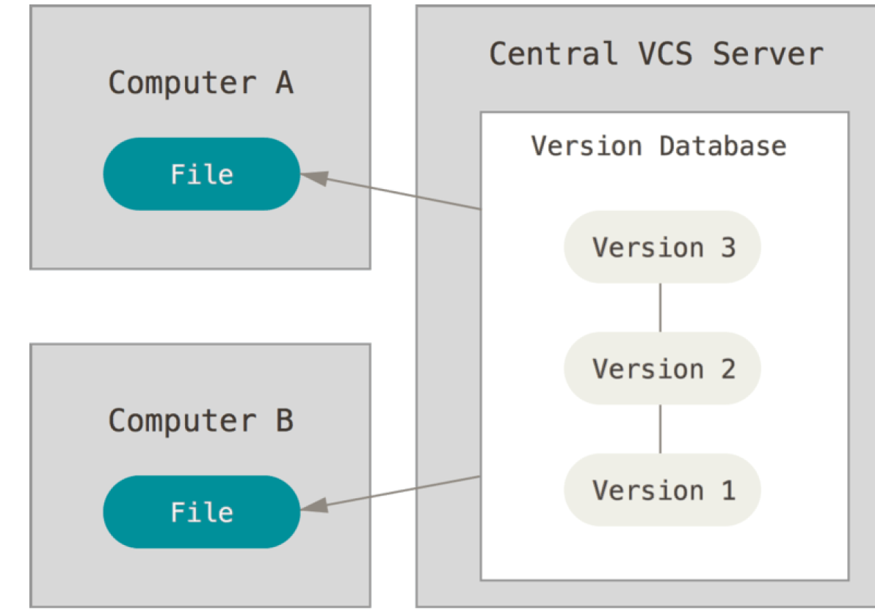

1. Distributed version control system GIT

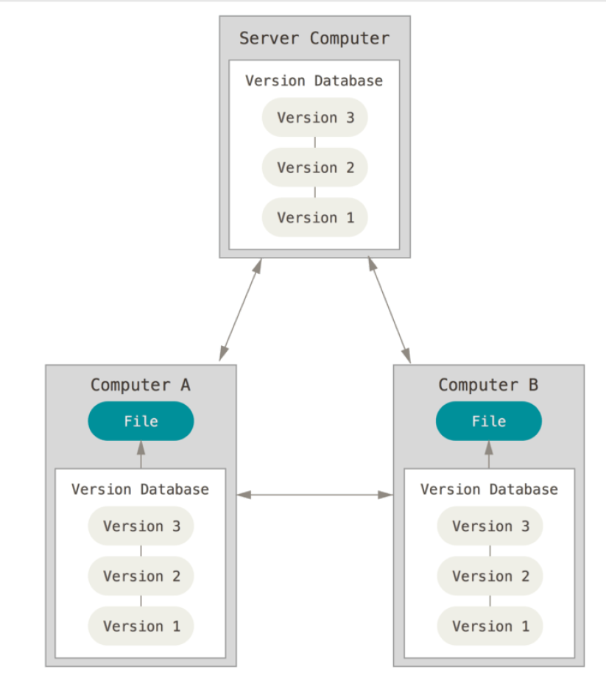

1. Fast operation
2. Distributed
3. Loss less compression technique to store data

Devops:

Dev: developer and ops means operation

Developer activity:

1. Write the coding
2. Compiling
3. Unit testing
4. Package .war or jar or ear

Testing team:

1. Test cases

Operations:

1. Creation servers [linux,windows]
2. Installation of package
3. Weblogic,apache, tomcat
4. Deploy the application on servers
5. To monitor the application

Project management : JIRA

Source code management: GIT

Virtual hosting platform: bitbucket/ github

Build tool: maven compile test package

Repository: nexus, artifcatory

Depolyment: docker/puppet/chef/ udeploy

Jenkins: Continous integration tool

CI/CD: continuous integration/ continuous delivery or deployment

Developer push code -> github -> checkout -> compile -> test -> package -> upload to nexus -> deploy to dev -> deploy to QA ->deplopy to prod

Continuous deployment: moving code from one env to other without approval for example: static website

Continuous delivery: moving code from one env to other using approval

Example: dynamic website

Git config:

It is used to set, unset and view the variable which are used to customize git

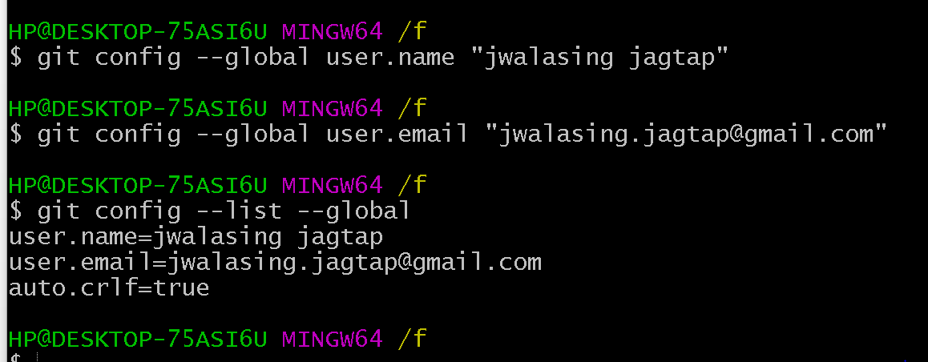

Repository:

1. Local repository

Git init:

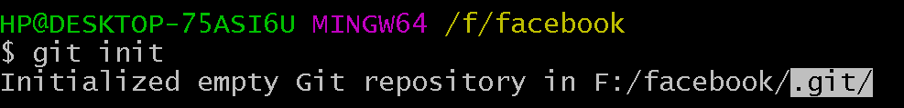

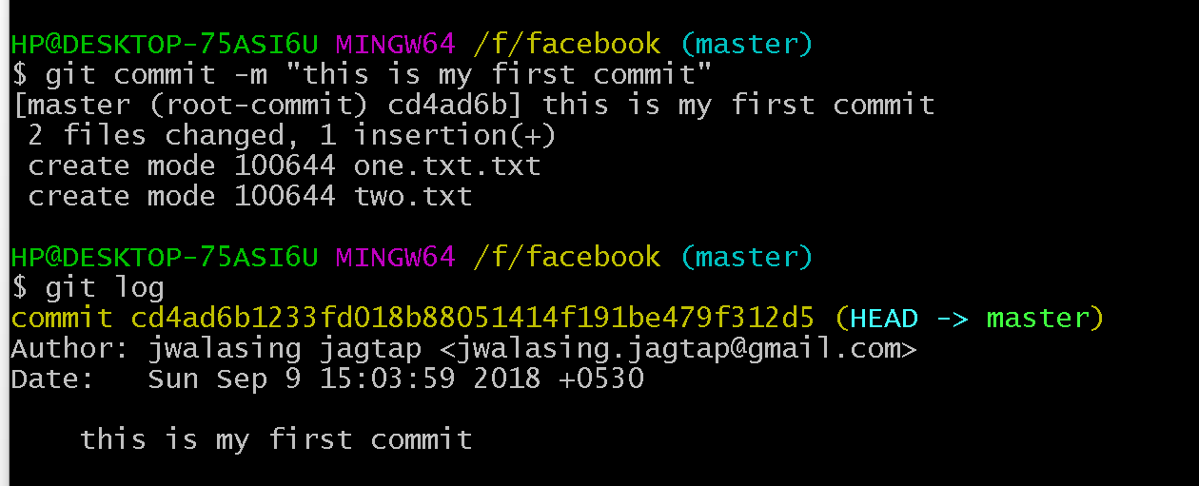

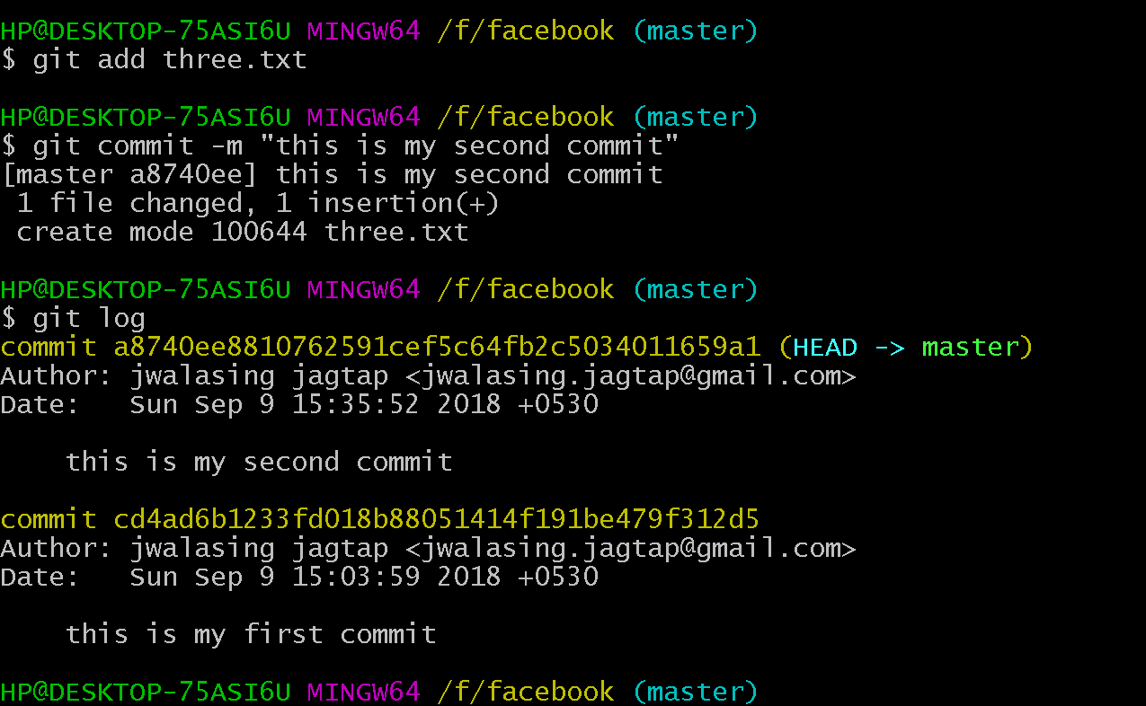

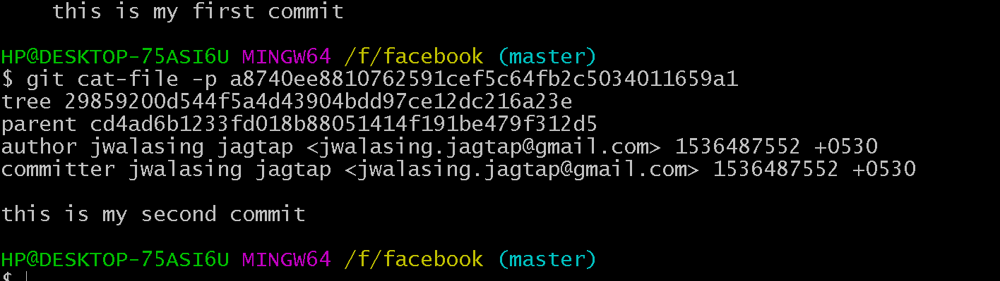

1. Remote repository

GIT URL: <https://www.tutorialspoint.com/git/>

