Session 3:

Agenda:

Basic git commands

1. Git config:

System :

gitconfig –system user.name “raj”

Git config –system user.email[raj@gmail.com](mailto:raj@gmail.com)

File location: C:\ProgramData\Git\config

2: User

gitconfig –global user.name “rohan”

/home/rohan/.git/config or C:/users/rajiv/.git/config

3.Repository:

git config –local user.name ”manoj”

Or

Git config user.name “raj”

.git/config

1. Git log:

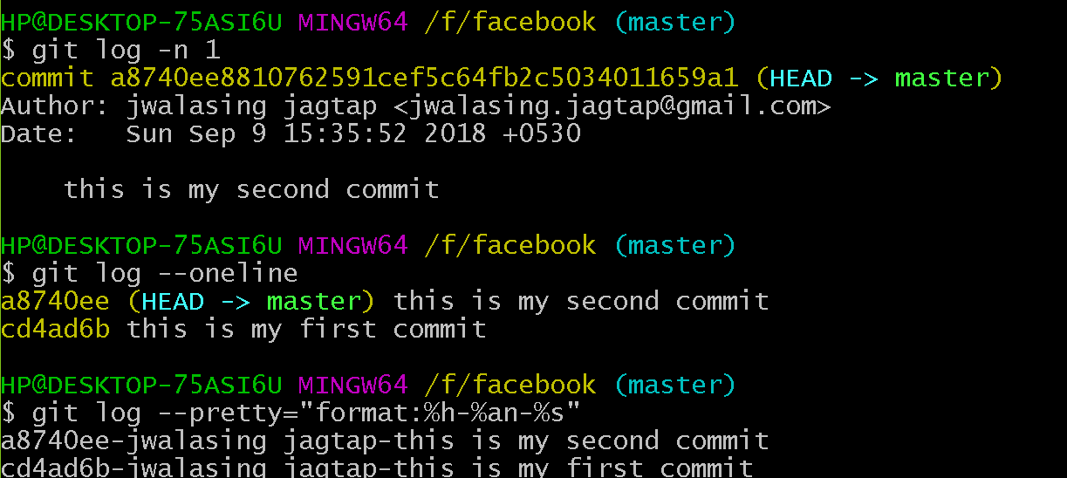

1. Git reset:

Is used to reset the head to the specified state.

Head

Master develop testing

Example:

1. git reset –soft HEAD~

2. git reset –mixed HEAD~ - default

3. git reset –hard HEAD~

1. File state:

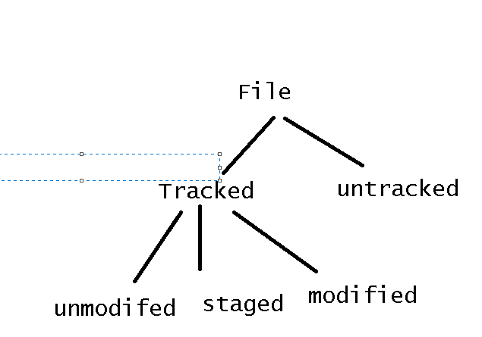

1. Git status: to check the status of file in working directory and staging area
2. Git diff : compare working and index

b. git diff –staged : compare index and head

c. git diff HEAD : compare HEAD and working directory

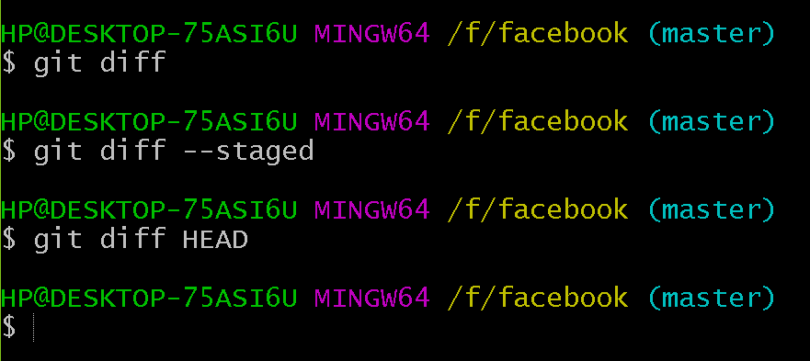

1. Git rm : to remove file

