Session4:

Agenda:

1. Branching and merging
2. Merging types
3. Github
4. How to work with remote repository

Branch :

Development code: it is continuous develop version.

Facebook

Feature1 feature2 feature3

Facebookv1.1

Facebook1.2

Feature4 and feature5

Branch: is a another line of development

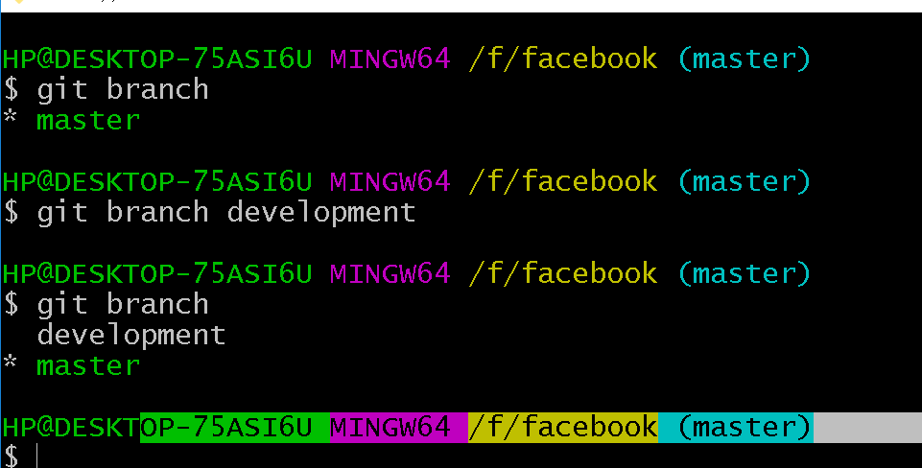

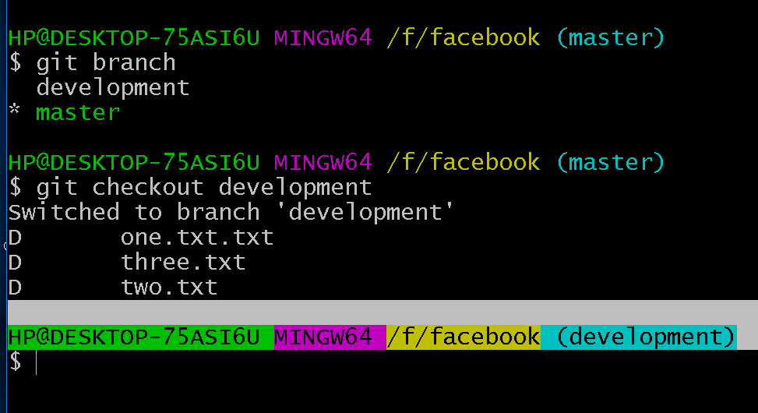

1. Git branch development

Git checkout development

Or

Git checkout –b development

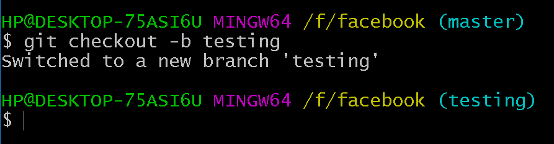

Deleting branch:

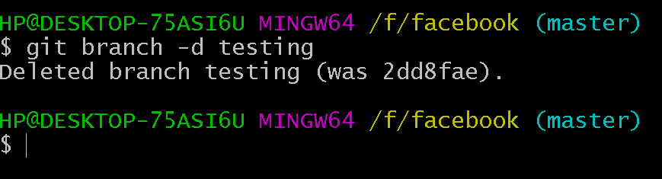

For forcefully deletion:

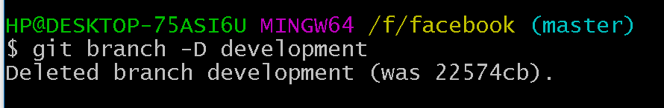

Production: facebookv1.1 : fixed or stable version

Master :

Merging types:

1. Fast forward merge
2. Recursive merge
3. Rebase

