Session 5:

1. Git tag
2. Git stash
3. Remote repository
4. Git tag:
5. Lightweight tag

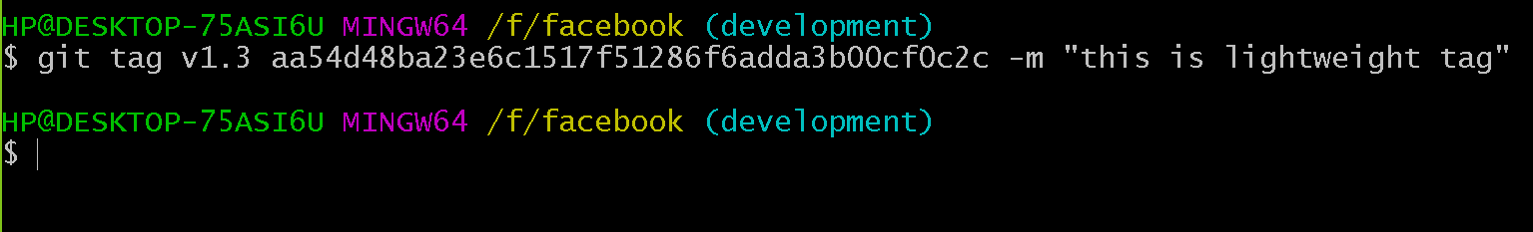

1. Annoted tag

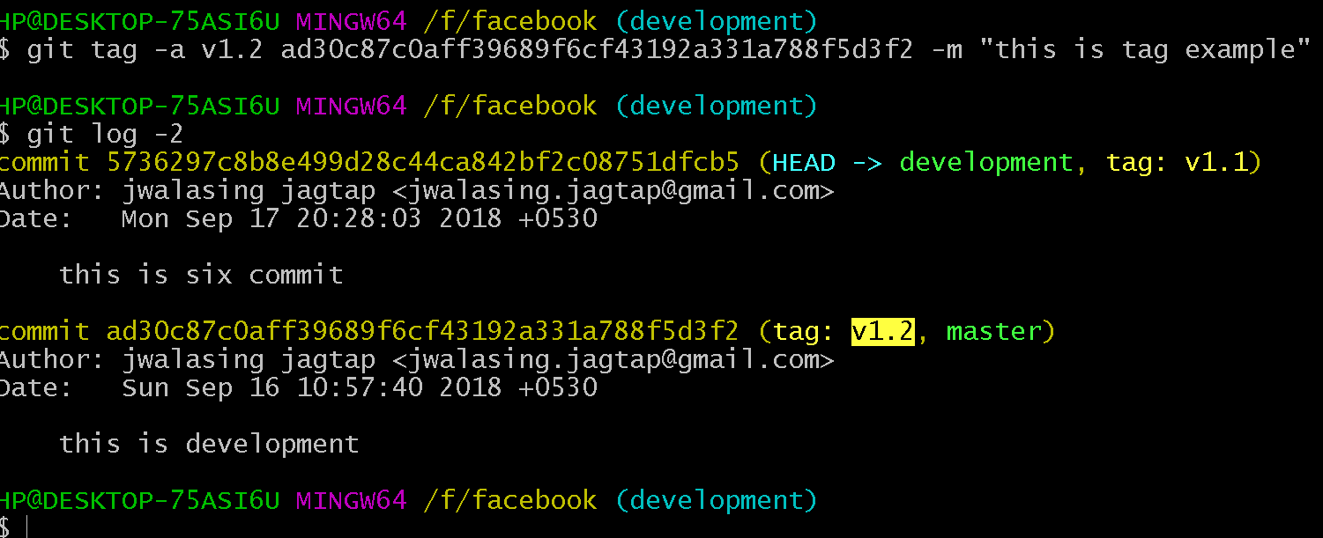

To show tag information:

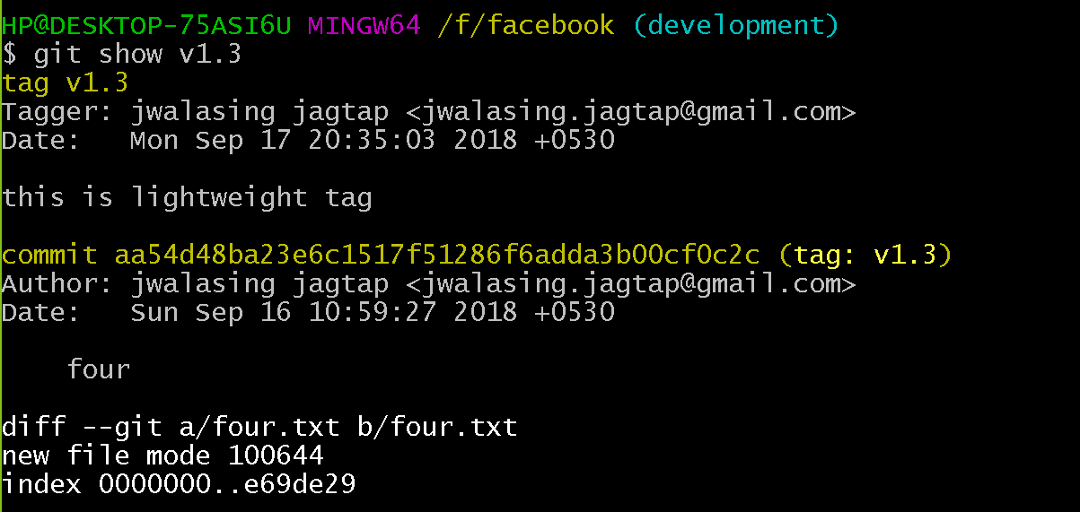

Git stash save: save index and working directory to Stash area



Git stash apply : apply data from stash area to index and working directory

To view the stash list:

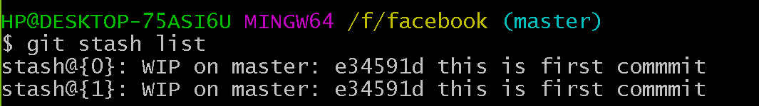

Git stash pop:

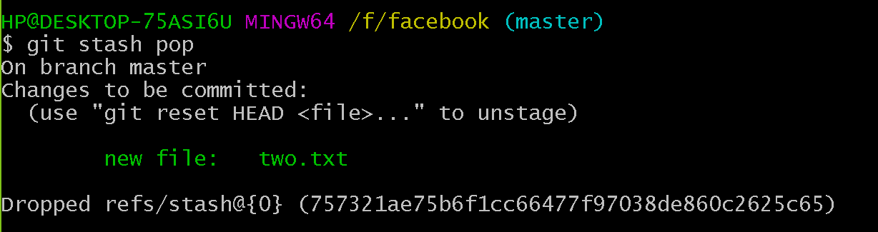

To apply the stash and remove it from stash list

Annotated tag contains tagger info:

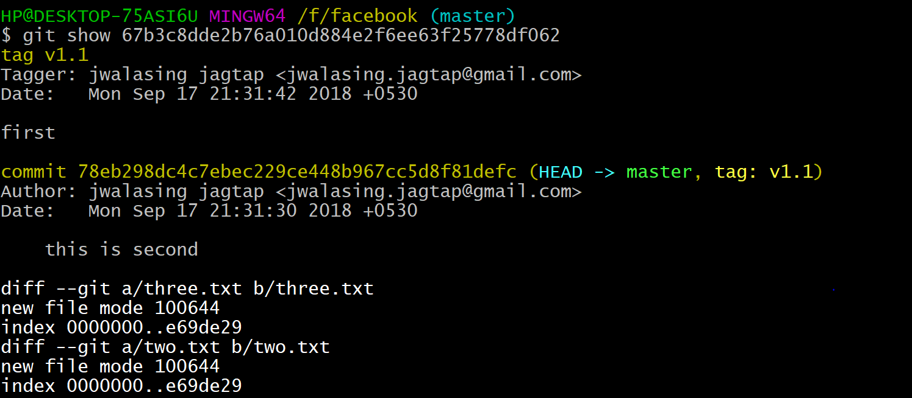

Lightweight tag doesnot contain tagger info:

