Manoj GM

**Assignment 2**

1. Creating a File using Touch Command two files are created “nano” and “file.txt”

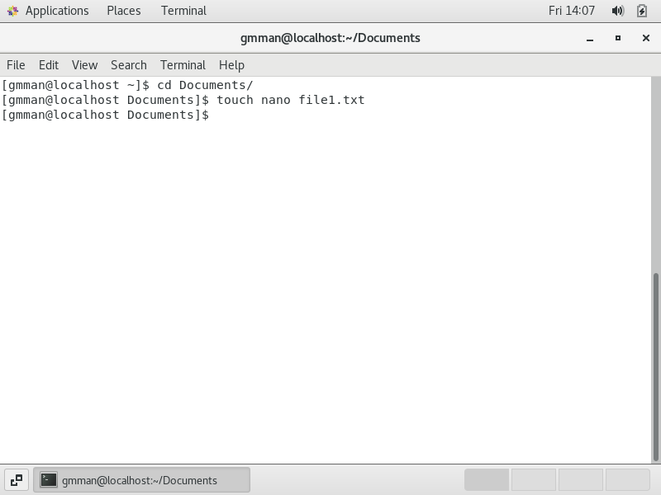

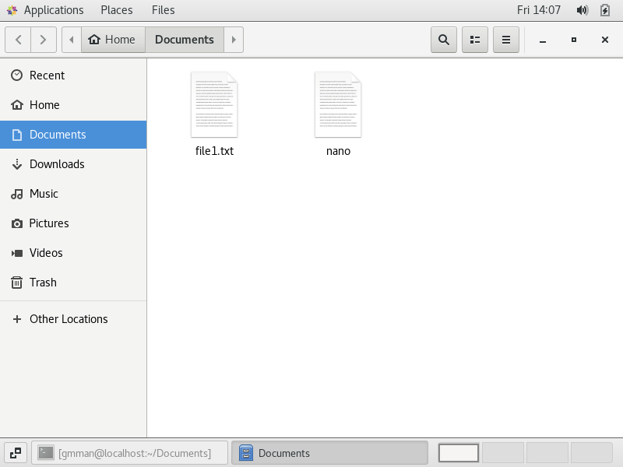

To Edit a file inside the terminal use command vim <filename>

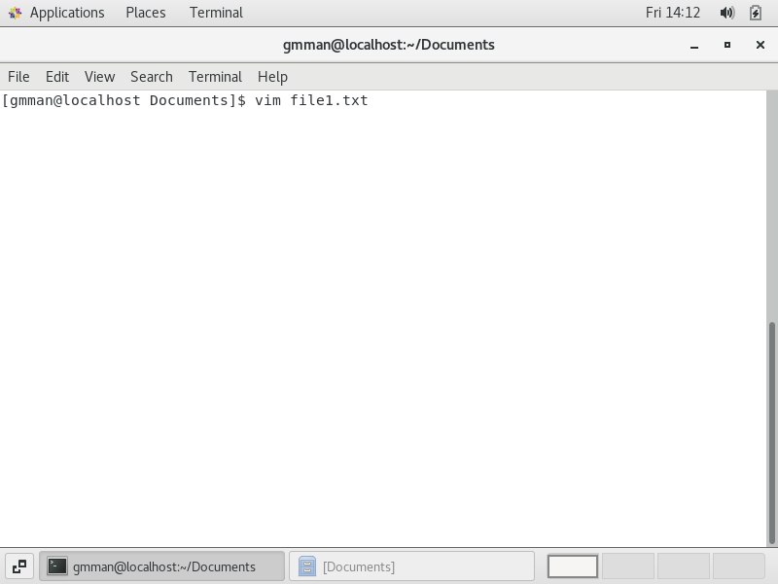

1. To copy the file from one file to another use cp <source_file> <destination_file>

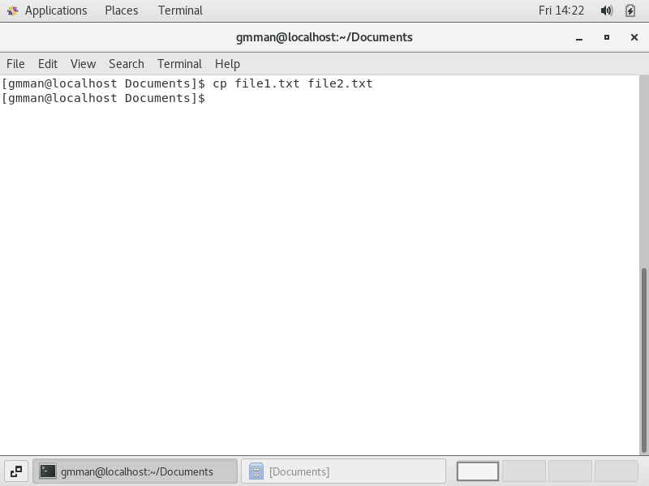

Here we have opened the destination file to check the contents of the file are copied or not

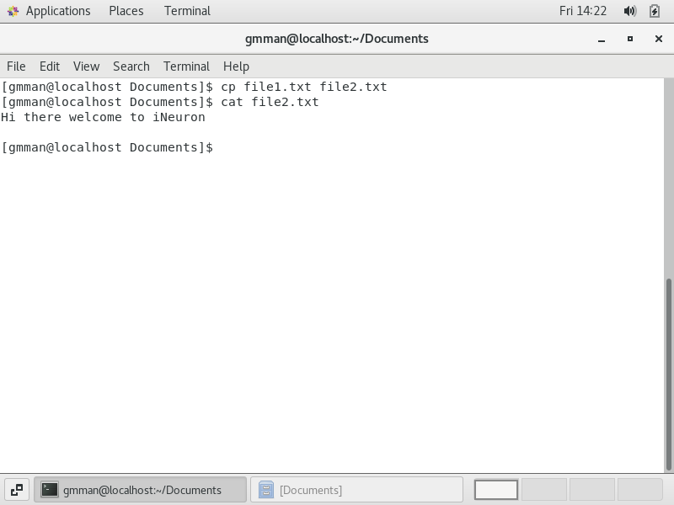

1. A file2.txt is created and moved to home folder

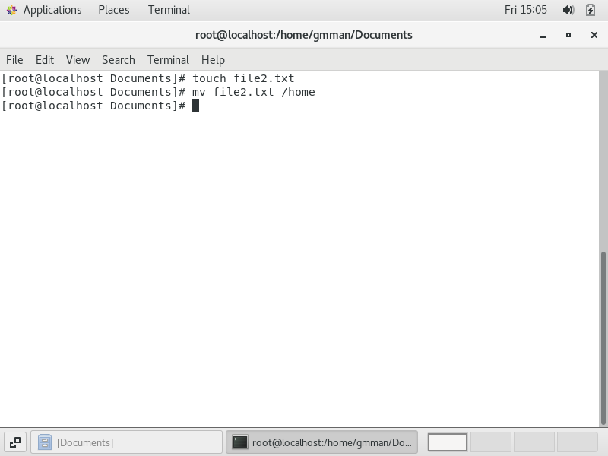

The file is moved to home folder as shown in the screenshot using ls command

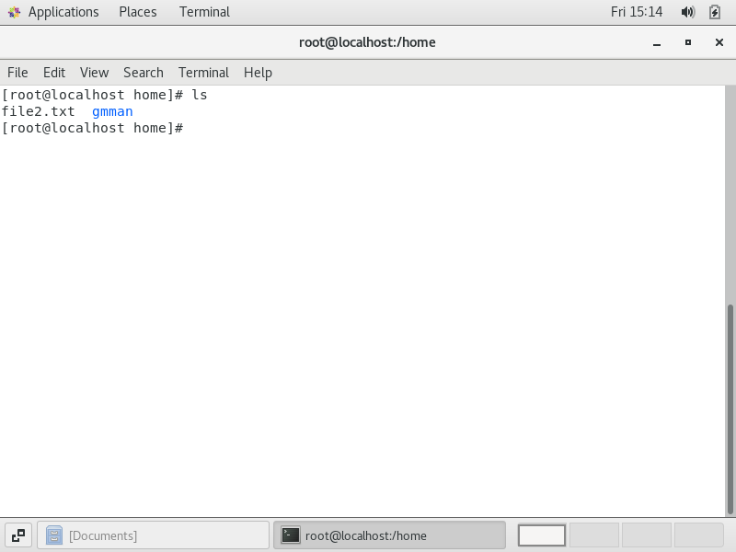

1. Two files are created using touch command file3.txt and file4.txt

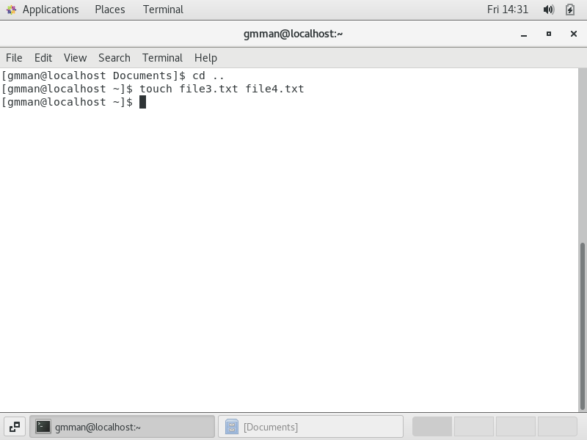

When we do echo “Hello I am newline” > file3.txt the file contains only “Hello I am newline” will be overwritten.

Where as >> used in file4.txt will append the text to the file which was saved.

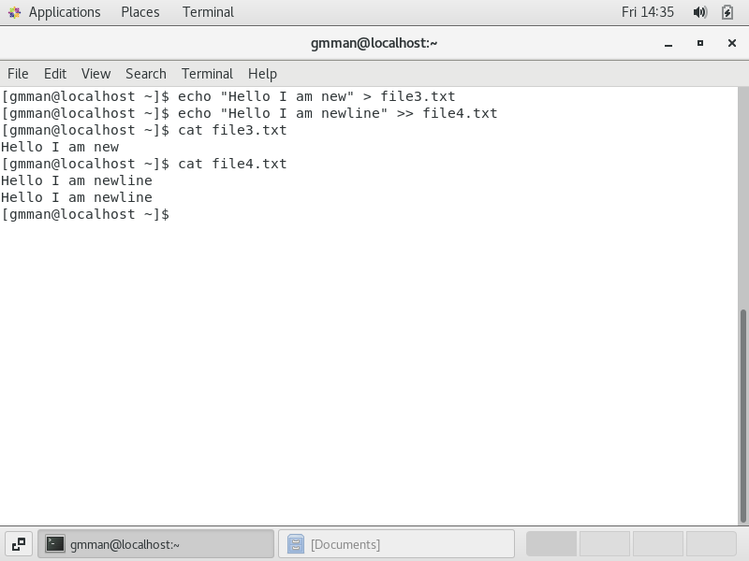

1. Here we have deleted file3.txt and file4.txt 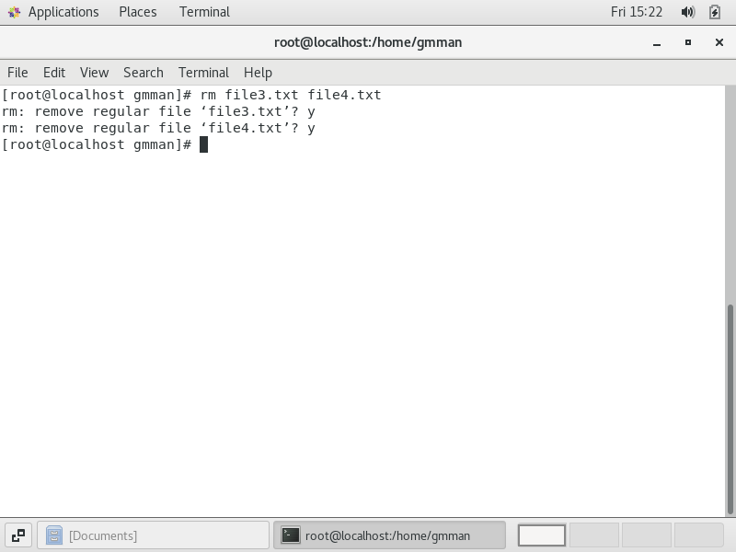

Now we have deleted Devops folder.

