**VISVESVARAYA TECHNOLOGICAL UNIVERSITY**

**“JnanaSangama”, Belgaum -590014, Karnataka.**



LAB REPORT

on

Machine Learning

***Submitted by***

MANOJ H A(1BM19CS087)

***in partial fulfillment for the award of the degree of***

**BACHELOR OF ENGINEERING**

***in***

COMPUTER SCIENCE AND ENGINEERING



B.M.S. COLLEGE OF ENGINEERING

**(Autonomous Institution under VTU)**

BENGALURU-560019

May-2022 to July-2022

B. M. S. College of Engineering,

**Bull Temple Road, Bangalore 560019**

(Affiliated To Visvesvaraya Technological University, Belgaum)

**Department of Computer Science and Engineering**



**CERTIFICATE**

This is to certify that the Lab work entitled “Machine Learning” carried out by **MANOJ H A(1BM19CS087),** who is bonafide student of **B. M. S. College of Engineering.** It is in partial fulfillment for the award of **Bachelor of Engineering in Computer Science and Engineering** of the Visvesvaraya Technological University, Belgaum during the year 2022. The Lab report has been approved as it satisfies the academic requirements in respect of a **Machine Learning - (20CS6PCMAL)** work prescribed for the said degree.

## SARITHA A. N **Dr. Jyothi S Nayak**

Assistant Professor Professor and HOD

Department of CSE Department of CSE

BMSCE, Bengaluru BMSCE, Bengaluru

**Index Sheet**

|  |  |  |
| --- | --- | --- |
| **Sl.**  **No.** | **Experiment Title** | **Page No.** |
| **1** | **Find-S** |  |
| **2** | **Candidate Elimination** |  |
| **3** | **Decision Tree** |  |
| **4** | **Naive Bayes** |  |
| **5** | **Linear Regression** |  |
|  |  |  |
|  |  |  |
|  |  |  |
|  |  |  |
|  |  |  |
|  |  |  |
|  |  |  |
|  |  |  |
|  |  |  |
|  |  |  |

Implement and demonstrate the FIND-S algorithm for finding the most specific hypothesis based on a given set of training data samples.

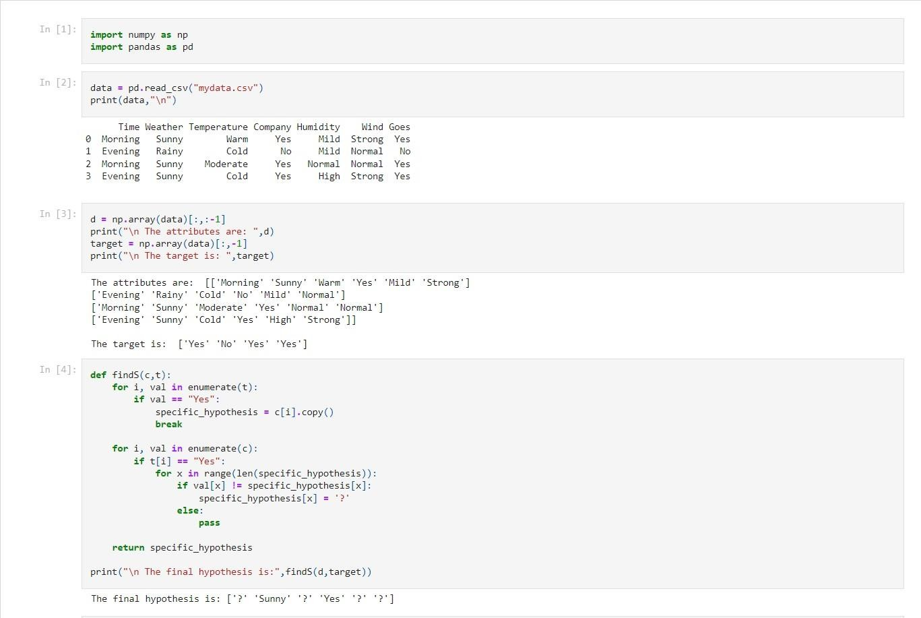

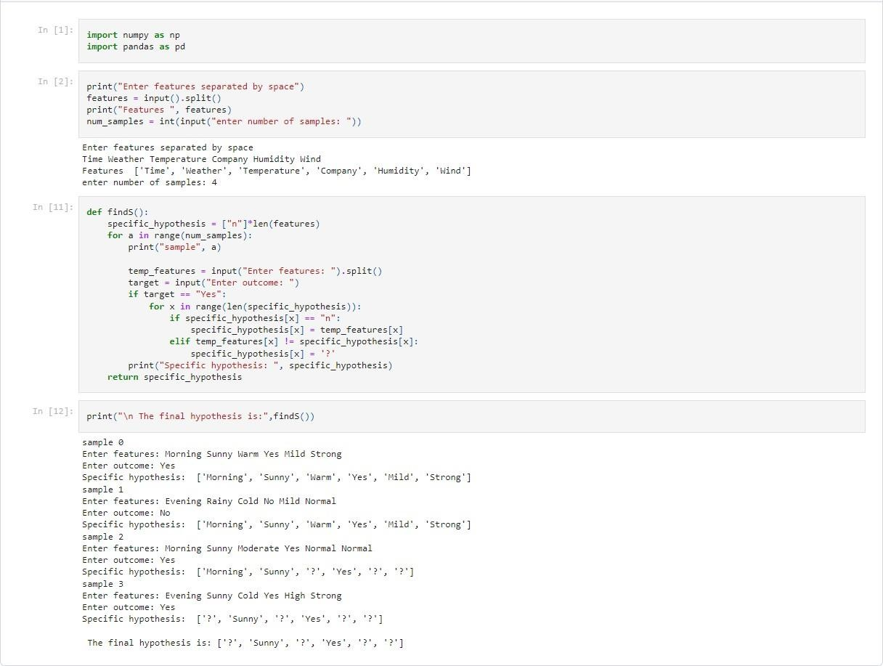

1. **For a given set of training data examples stored in a .CSV file, implement and demonstrate the Candidate-Elimination algorithm to output a description of the set of all hypotheses consistent with the training examples.**

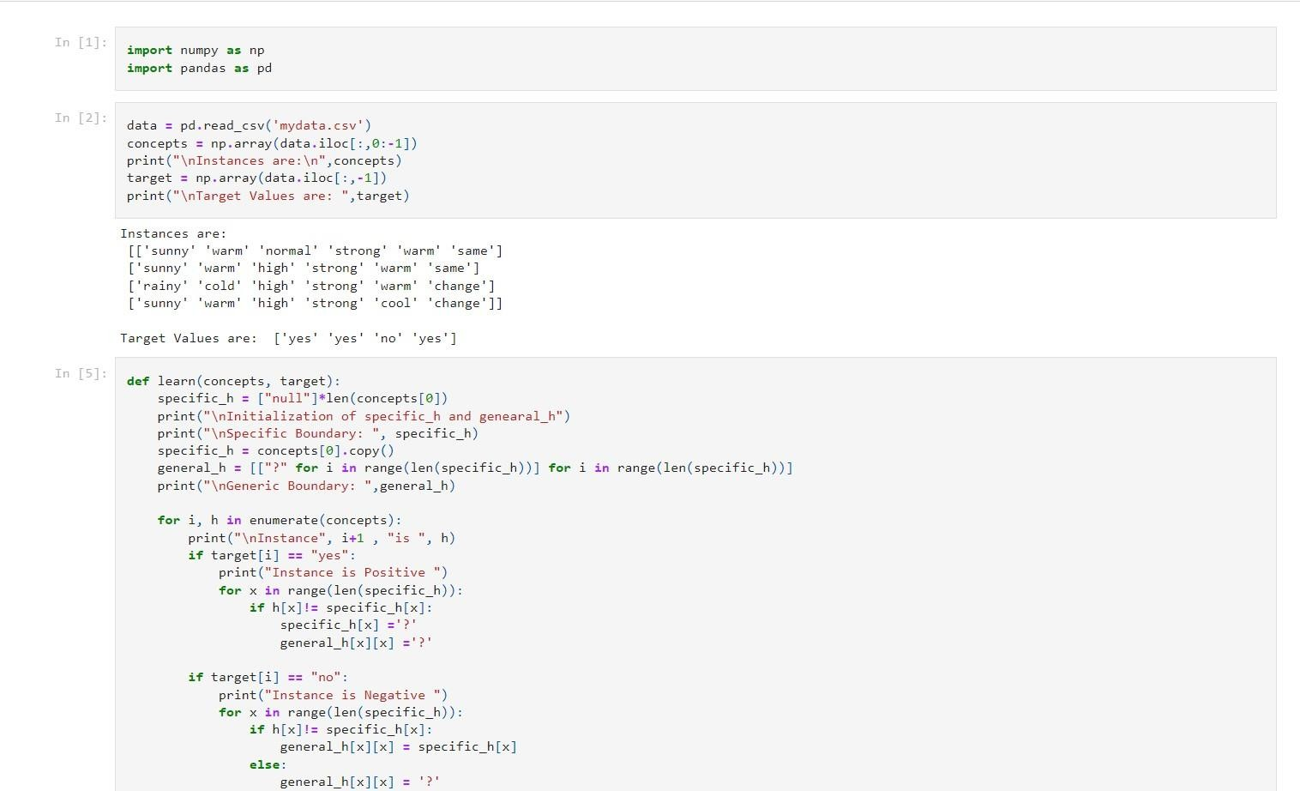

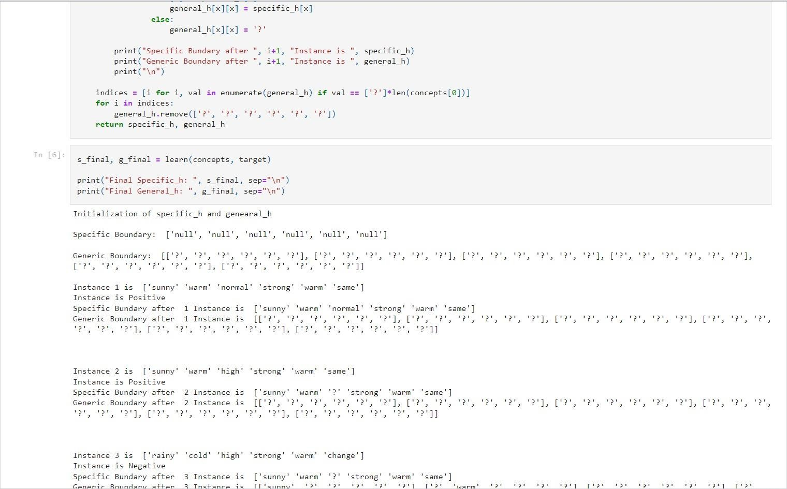

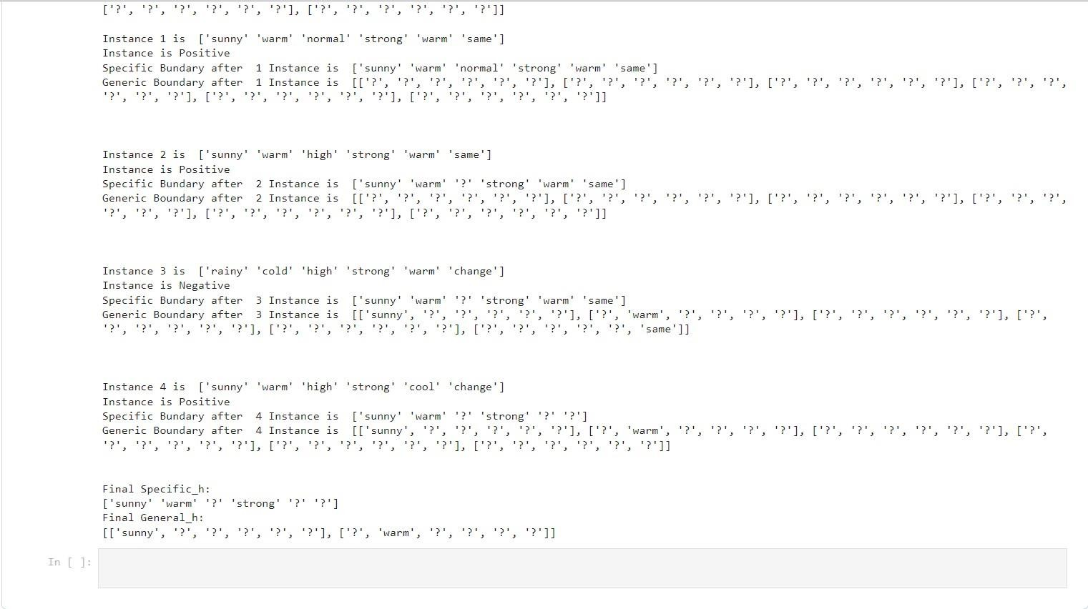

1. **Write a program to demonstrate the working of the decision tree based ID3 algorithm. Use an appropriate data set for building the decision tree and apply this knowledge to classify a new sample.**

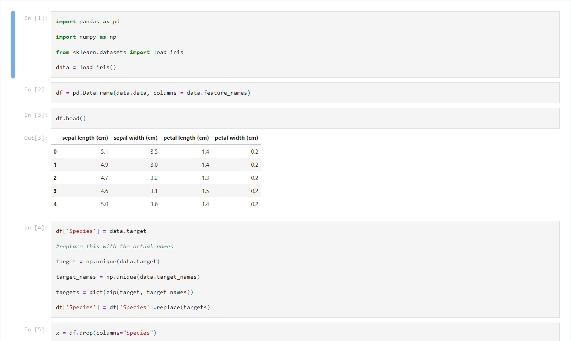

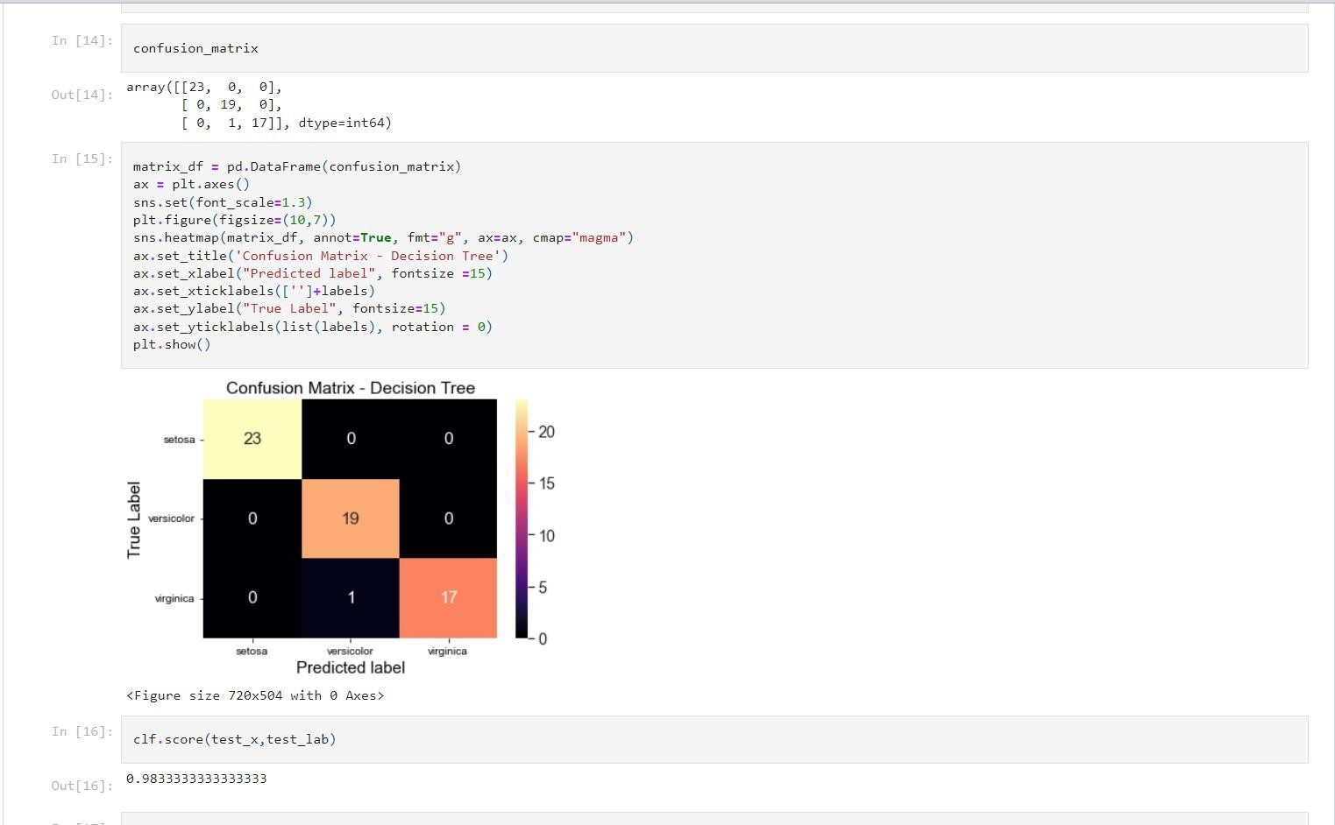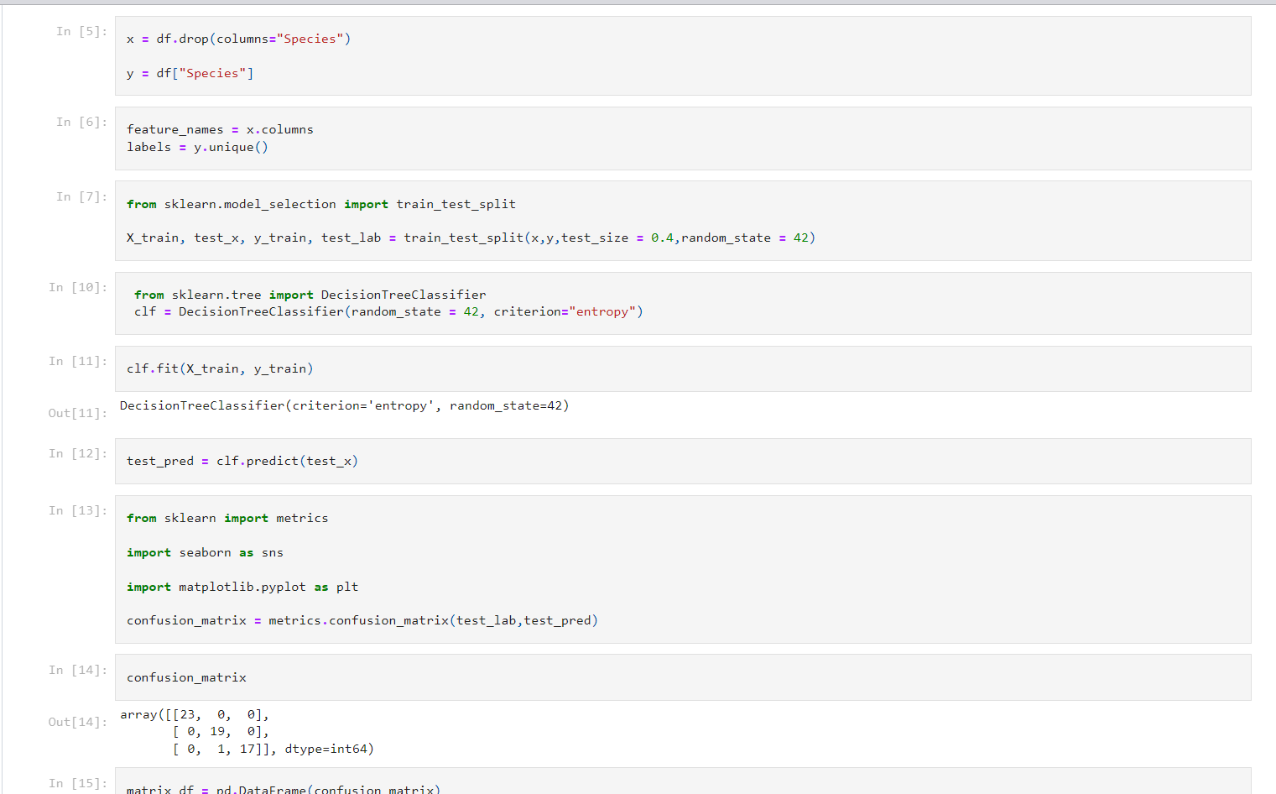

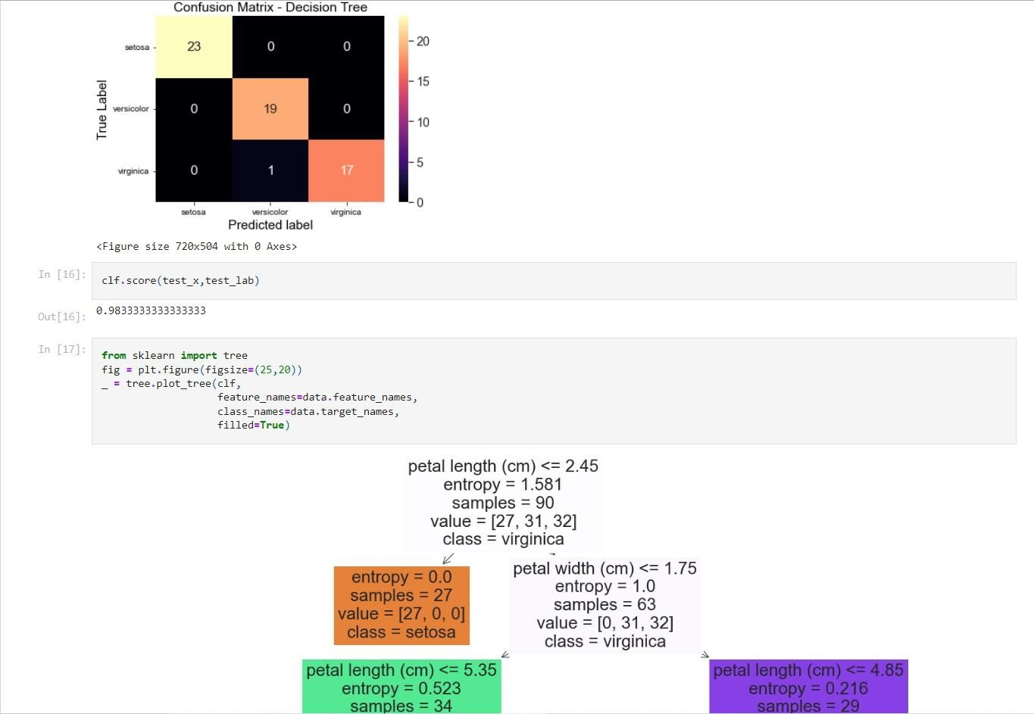

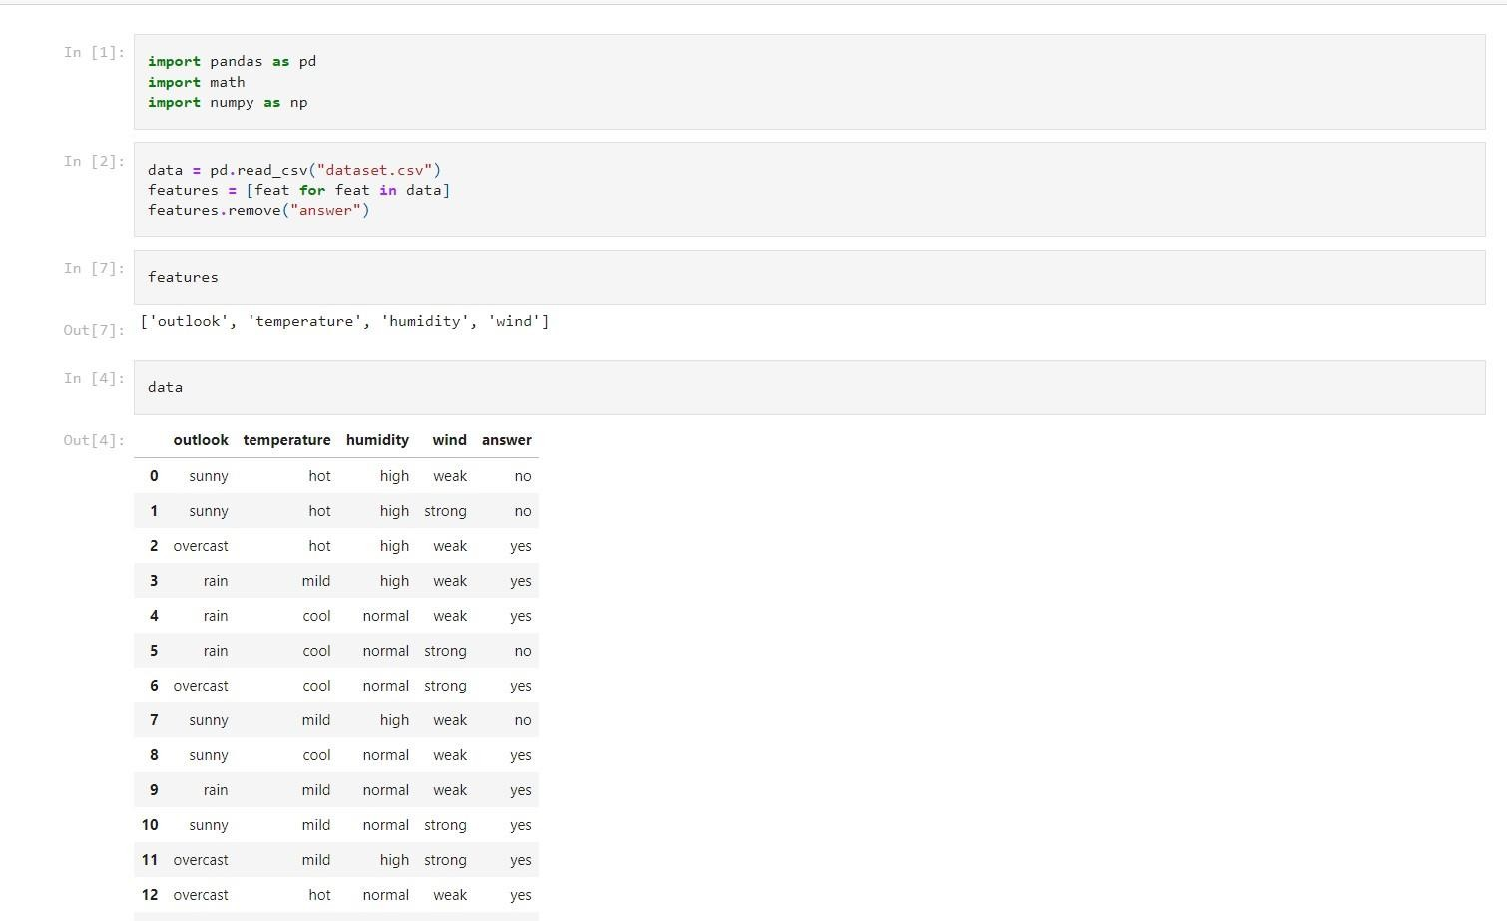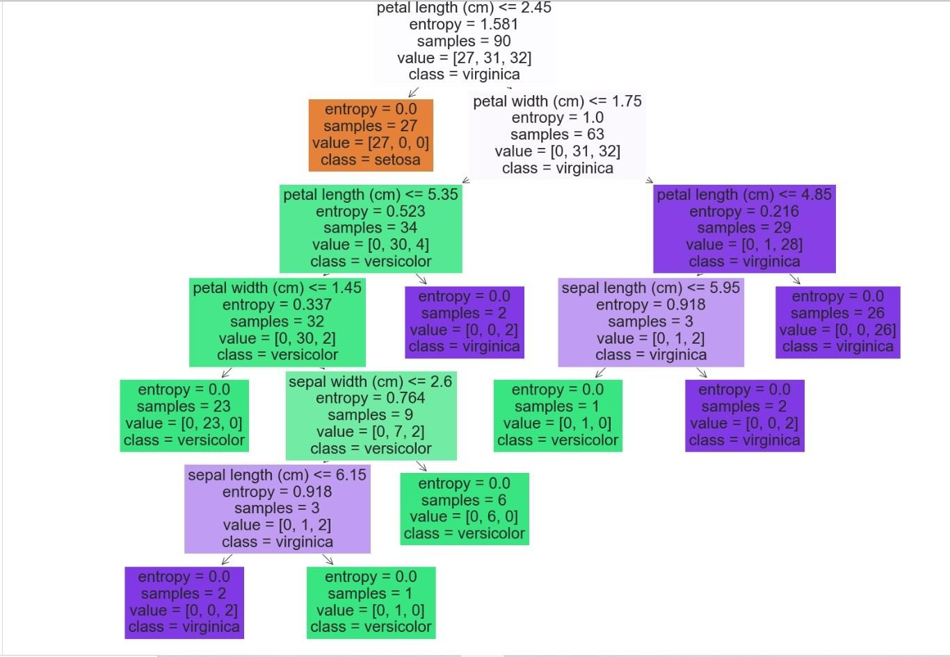

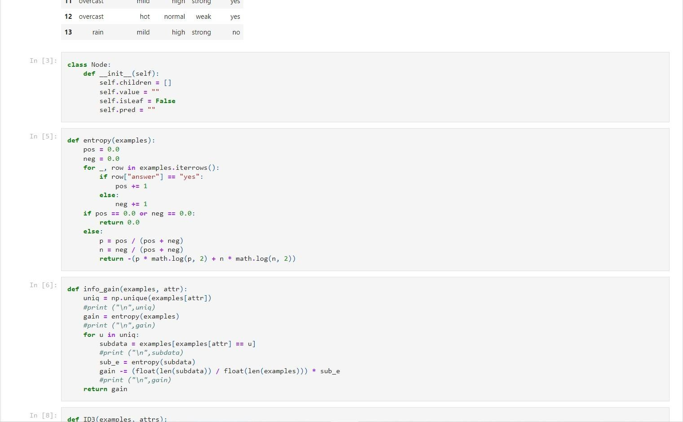

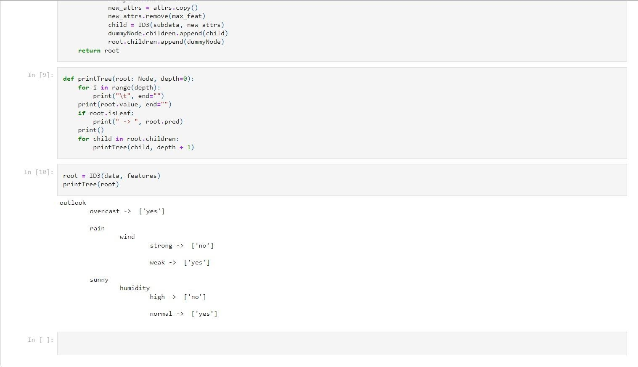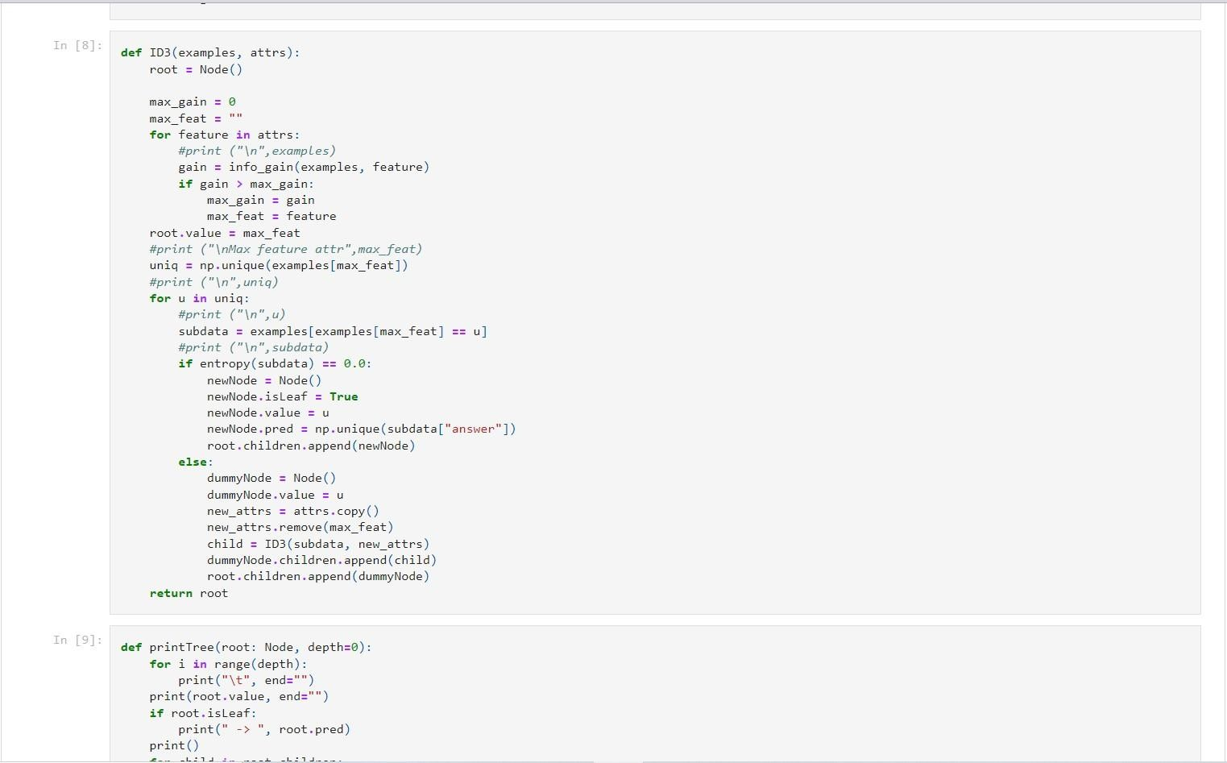

1. **Write a program to implement the naïve Bayesian classifier for a sample training data set stored as a .CSV file. Compute the accuracy of the classifier, considering few test data sets.**

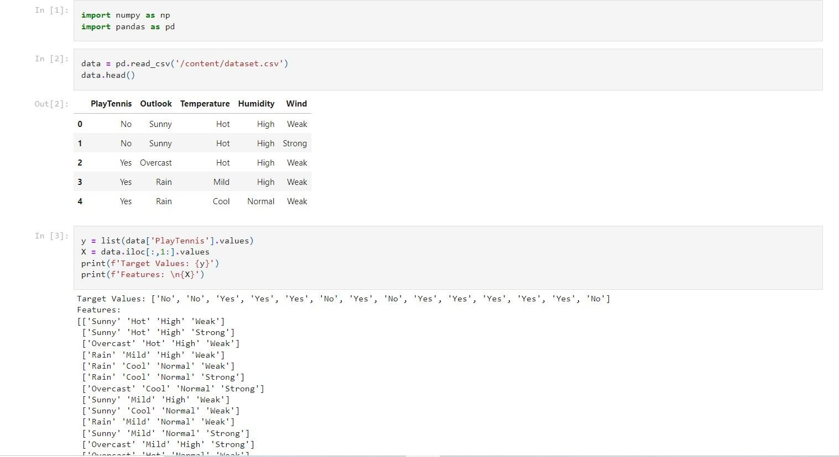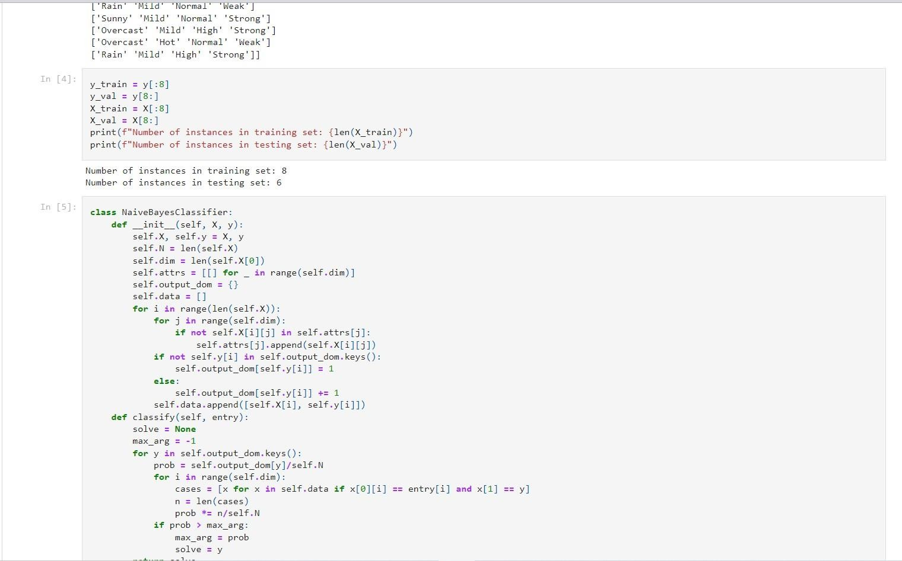

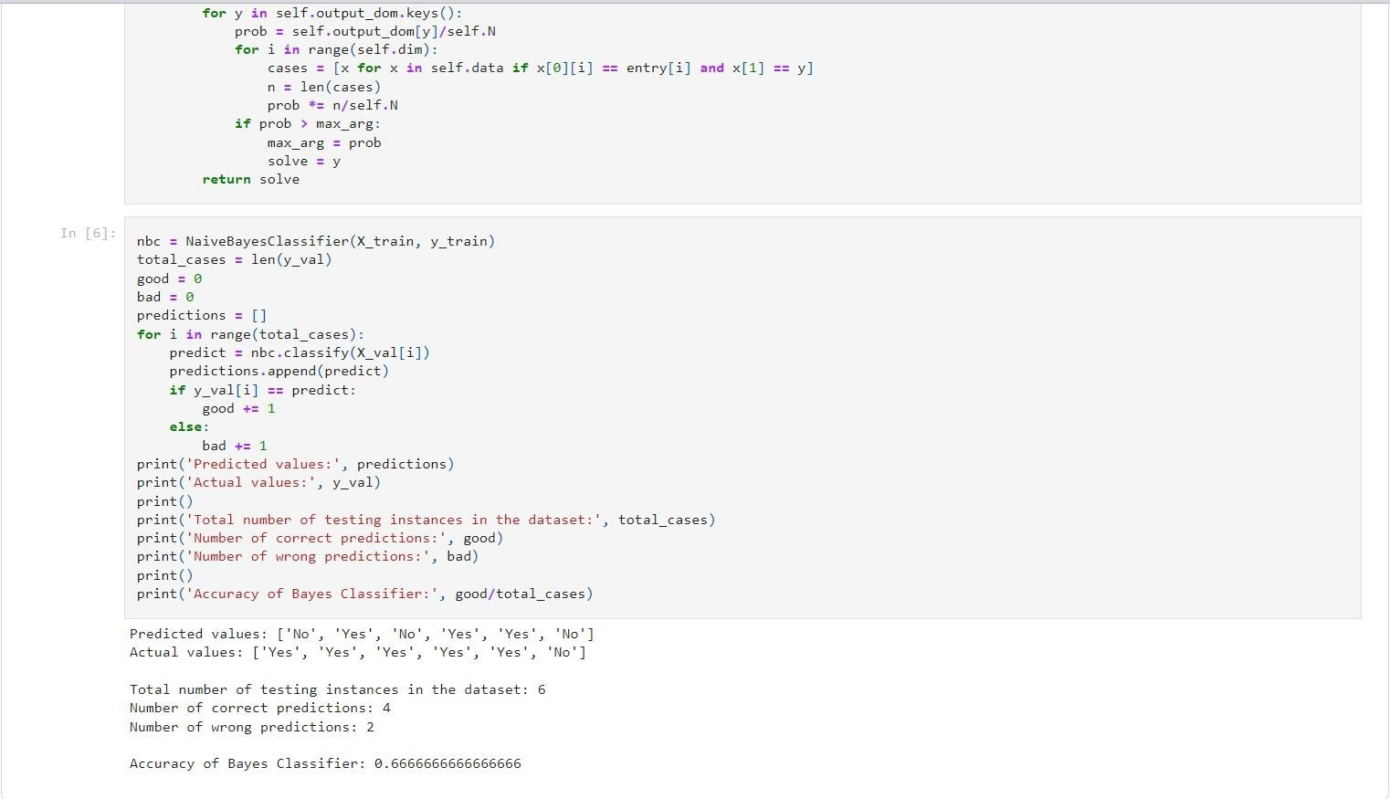

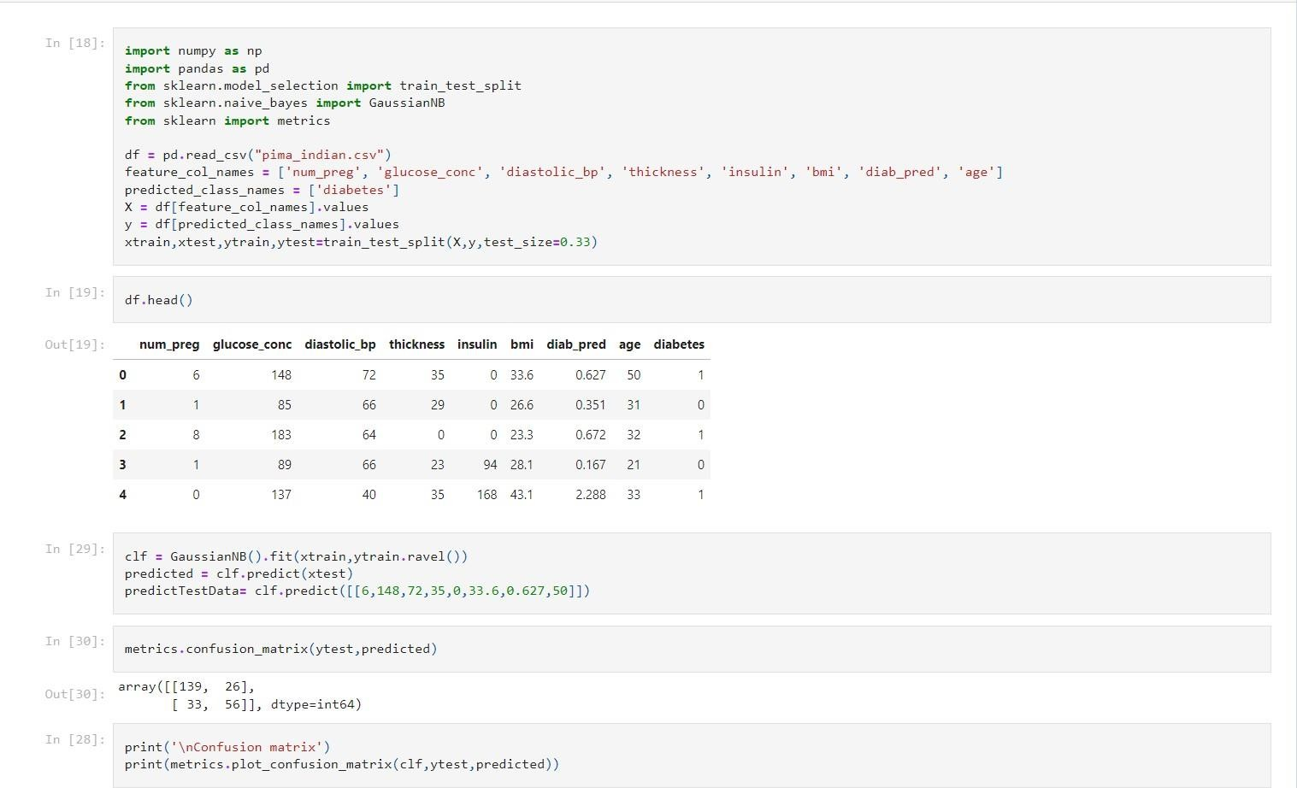

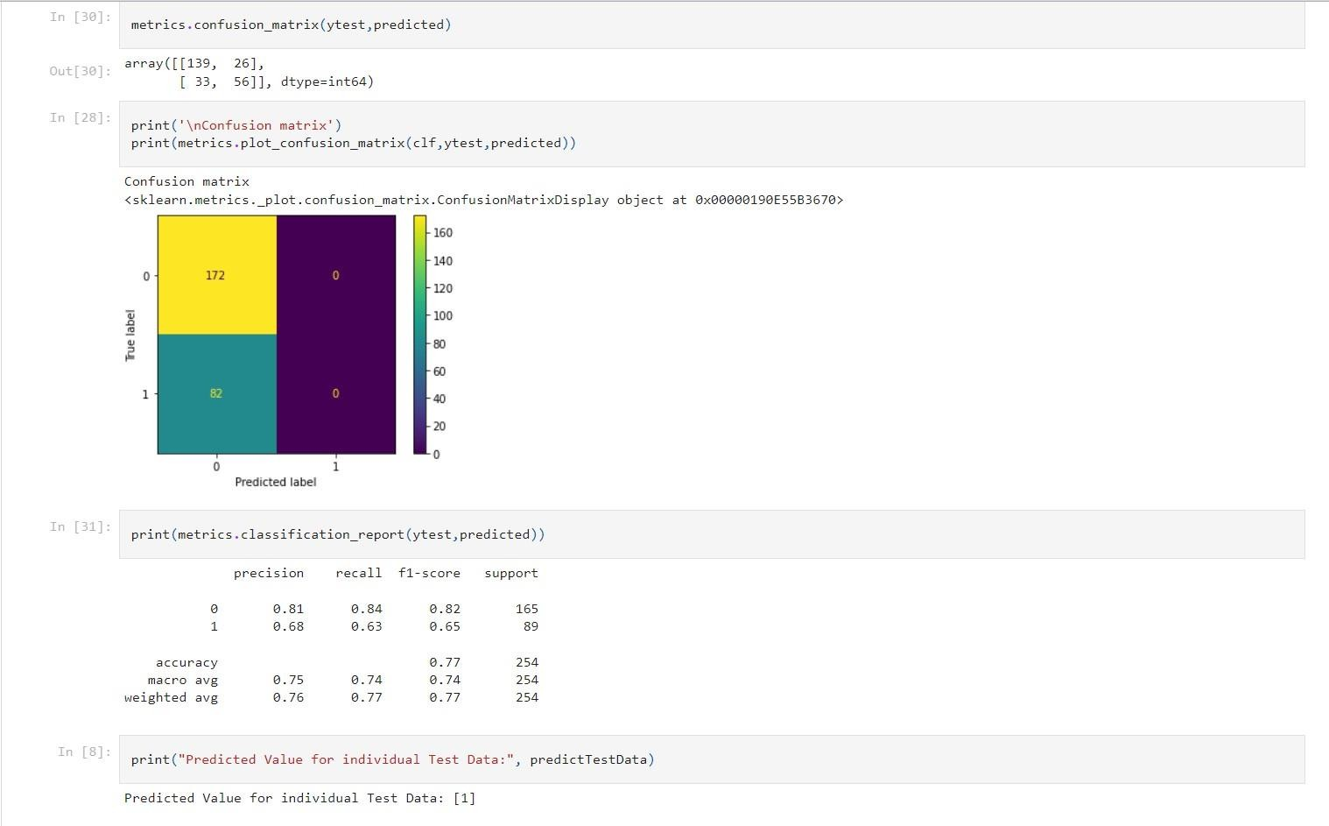

1. **Write a program to construct a Bayesian network considering training data. Use this model to make predictions.**

