DESIGN AND DEVELOPMENT OF AN AI –INTEGRATED WEBSITE FOR JOHI APPARELS

A PROJECT WORK
Submitted by
Manojkumar S
23ADR105
Lokesh N
23ADR097
Deban R
23ADR193
in partial fulfilment of the requirements for
the award of the degree of
BACHELOR OF TECHNOLOGY
IN
ARTIFICIAL INTELLIGENCE AND DATA SCIENCE
DEPARTMENT OF ARTIFICIAL INTELLIGENCE AND DATA SCIENCE
KONGU ENGINEERING COLLEGE
(Autonomous)
PERUNDURAI ERODE – 638 060
MARCH 2026
DESIGN AND DEVELOPMENT OF AN AI –INTEGRATED WEBSITE FOR JOHI APPARELS

A PROJECT WORK
Submitted by
Manojkumar S
23ADR105
Lokesh N
23ADR097
Deban R
23ADR193
in partial fulfilment of the requirements for
the award of the degree of
BACHELOR OF TECHNOLOGY
IN
ARTIFICIAL INTELLIGENCE AND DATA SCIENCE
DEPARTMENT OF ARTIFICIAL INTELLIGENCE AND DATA SCIENCE
KONGU ENGINEERING COLLEGE
(Autonomous)
PERUNDURAI ERODE – 638 060
MARCH 2026
DEPARTMENT OF ARTIFICIAL INTELLIGENCE AND DATA SCIENCE
KONGU ENGINEERING COLLEGE
(Autonomous)
PERUNDURAI ERODE – 638060
MARCH 2026

BONAFIDE CERTIFICATE
This is to certify that the project report entitled Design And Development of an AI Integrated Website For Johi Apparels is the bonafide record of project work done by Manojkumar S (Reg.No: 23ADR105), Lokesh N (Reg.No: 23ADR097), Deban R (Reg.No: 23ADL193) in partial fulfilment of the requirements for the award of the Degree of Bachelor of Technology in Artificial Intelligence and Data Science of Anna university Chennai during the year 2025 - 2026.

SUPERVISOR HEAD OF THE DEPARTMENT Date: (Signature with seal)

Submitted for the end semester viva voce examination held on ___________

INTERNAL EXAMINER EXTERNAL EXAMINER
DEPARTMENT OF ARTIFICIAL INTELLIGENCE AND DATA SCIENCE
KONGU ENGINEERING COLLEGE
(Autonomous)
PERUNDURAI ERODE – 638060
MARCH 2026
DECLARATION
We affirm that the Project Report titled Design And Development of an AI Integrated Website For Johi Apparels being submitted in partial fulfilment of the requirements for the award of Bachelor of Technology is the original work carried out by us. It has not formed the part of any other project report or dissertation on the basis of which a degree or award was conferred on an earlier occasion on this or any other candidate.
Date:
Manojkumar S
(23ADR105)

Lokesh N
(23ADR097)

Deban R
(23ADL193)

I certify that the declaration made by the above candidate is true to the best of my knowledge.

Date: Name and Signature of the Supervisor
ACKNOWLEDGEMENT
We express our sincere thanks and gratitude to Thiru.E.R.K.KRISHNAN M.Com., our beloved Correspondent and all other philanthropic trust members Kongu Vellalar Institute of Technology Trust who have always encouraged us in the academic and co-curricular activities.

I am grateful to ……………. for giving me an opportunity to learn new skills and technologies and enhance my knowledge by providing the necessary infrastructure
ABSTRACT
The Project “Johi Apparels” is a full-stack consultancy application developed to enhance and streamline the operations of apparel businesses. The system integrates three core modules—admin panel, backend, and frontend—to provide a unified platform for managing business processes efficiently. The admin module enables centralized control over users, system settings, and key business metrics, while the backend handles secure data processing, database management, and service integrations such as email notifications and PDF generation. The frontend offers a responsive and user-friendly interface designed to improve customer engagement through interactive components and seamless navigation.
The application leverages modern technologies including React, Node.js, Express.js, and MongoDB to ensure scalability, performance, and maintainability. Additionally, it incorporates analytics features that track user interactions and generate insights to support data-driven decision-making. By automating routine tasks and providing real-time information, Johi Apparels reduces operational complexity and enhances overall productivity.
This project demonstrates the practical implementation of a scalable web-based solution tailored for the apparel industry, focusing on improving efficiency, user experience, and business intelligence.

TABLE OF CONTENTS

CHAPTER No. | TITLE | PAGE No.
 | ABSTRACT | vi
 | LIST OF FIGURES | ix
 | LIST OF ABBREVIATIONS
1 | INTRODUCTION | 1
 | 1.1 General | 1
 | 1.2 Background of the Study | 2
 | 1.3 Problem Statement | 2
 | 1.4 Objectives of the Project | 3
 | 1.5 Scope of the Project | 3
 | 1.6 Organization of the Report | 4
2 | SYSTEM ANALYSIS | 5
 | 2.1 Existing System | 5
 | 2.2 Limitations of Existing System | 6
 | 2.3 Proposed System | 7
 | 2.4 Feasibility Study | 10
 | 2.5 System Requirement Analysis | 10
3 | SYSTEM DESIGN | 13
 | 3.1 System Architecture | 13
 | 3.2 Database Design | 14
 | 3.3 Workflow Design | 15
 | 3.4 User Interface Design | 17
4 | SYSTEM IMPLEMENTATION | 18
 | 4.1 Implementation Overview | 18
 | 4.2 Frontend Implementation | 18
 | 4.3 Backend Implementation | 19
 | 4.4 Database Implementation | 19
 | 4.5 AI Analytics Module Implementation | 20
5 | SYSTEM TESTING | 21
 | 5.1 Testing Strategy | 21
 | 5.2 Test Cases | 21
 | 5.3 Results and Discussion | 22

6 | CONCLUSION AND FUTURE ENHANCEMENTS | 23
 | 6.1 Conclusion | 23
 | 6.2 Future Enhancements | 23
 | APPENDICES | 24
 | REFERENCES | 43
 | MAPPING OF PROJECT GOALS TO SDG | 44

LIST OF FIGURES

FIG No. | TITLE | PAGE No.
2.1 | Existing Production Monitoring Process | 6
2.2 | Limitations of Existing System | 7
2.3 | Proposed System Overview | 9
2.4 | Use Case Diagram | 12
3.1 | System Architecture Diagram | 14
3.2 | Database Entity Relationship Diagram | 15
3.3 | System Workflow Diagram | 16
3.4 | User Interface Design | 17
A2.0 | Home Page | 39
A2.1 | About Page | 39
A2.2 | Services Page | 40
A2.3 | Quote Request Page | 40
A2.4 | Achievement Page | 41
A2.5 | Incoming Quote Request Page | 41
A2.6 | Quote Generator Page | 42
A2.7 | Quote Generator Result Page | 42

CHAPTER 1

INTRODUCTION
In today’s competitive market, apparel businesses must adopt digital solutions to efficiently manage operations, enhance customer engagement, and stay ahead of evolving industry trends. Traditional methods of handling business processes often lead to inefficiencies, lack of real-time insights, and limited scalability. To address these challenges, Johi Apparels is developed as a comprehensive consultancy application that integrates modern web technologies to streamline and optimize business operations.
Johi Apparels is a full-stack application designed with a modular architecture consisting of an admin panel, backend system, and frontend interface. The platform enables businesses to manage users, monitor key metrics, and configure system settings through an intuitive admin dashboard. The backend ensures secure data handling, efficient communication, and integration of essential services such as email notifications and PDF generation. Meanwhile, the frontend provides a responsive and interactive user experience, allowing customers to explore products, view testimonials, and engage with the business seamlessly.
The project utilizes technologies such as React for the user interface, Node.js and Express.js for server-side development, and MongoDB for database management. These technologies ensure that the application is scalable, maintainable, and capable of handling real-world business requirements. Additionally, the system incorporates analytics features that provide valuable insights into user behavior and business performance.
Overall, Johi Apparels aims to bridge the gap between traditional apparel business operations and modern digital solutions by offering an efficient, scalable, and user-friendly platform that supports growth and innovation in the industry.

1.1 BACKGROUND OF THE STUDY
The apparel industry is one of the most dynamic and competitive sectors, driven by rapidly changing fashion trends, customer preferences, and market demands. Traditionally, many apparel businesses have relied on manual processes or basic digital tools to manage operations such as inventory, customer interactions, and sales tracking. These methods often result in inefficiencies, data inconsistencies, and limited ability to scale as the business grows.
With the advancement of information technology, businesses are increasingly adopting digital solutions to automate processes and improve decision-making. Web-based applications, in particular, have become essential tools for managing business operations due to their accessibility, flexibility, and ability to integrate multiple functionalities into a single platform. Technologies such as full-stack development frameworks enable the creation of systems that handle both user interaction and backend processing efficiently.
Despite these advancements, many small and medium-sized apparel businesses still face challenges in implementing comprehensive systems that combine operational management, customer engagement, and analytics. Existing solutions are often either too complex, expensive, or not tailored to the specific needs of apparel businesses.
The Johi Apparels project is developed in response to these challenges. It aims to provide a unified and scalable platform that simplifies business operations while enhancing user experience. By integrating an admin panel, backend services, and a responsive frontend interface, the system addresses key gaps in traditional approaches. Furthermore, the inclusion of analytics and automation features enables businesses to make data-driven decisions and improve overall efficiency.
This study focuses on the design and development of such a system, highlighting how modern web technologies can be leveraged to transform traditional apparel business practices into a more streamlined and intelligent digital workflow.

1.2 PROBLEM STATEMENT
The apparel industry, particularly small and medium-sized businesses, faces significant challenges in managing daily operations efficiently. Many businesses continue to rely on manual processes or fragmented digital tools for handling tasks such as user management, customer engagement, order tracking, and data analysis. These traditional approaches often lead to inefficiencies, increased chances of human error, lack of real-time data access, and difficulty in scaling operations.
Additionally, the absence of an integrated system makes it challenging for business owners to monitor key performance metrics and make informed decisions. Customer engagement is also limited due to the lack of interactive and user-friendly platforms, resulting in reduced customer satisfaction and retention. Furthermore, existing solutions in the market are often either too costly or overly complex, making them unsuitable for smaller apparel businesses.
There is therefore a need for a comprehensive, cost-effective, and scalable solution that integrates business management, customer interaction, and analytics into a single platform. Such a system should automate routine processes, provide real-time insights, and offer an intuitive user interface to enhance both operational efficiency and customer experience.

1.3 OBJECTIVES OF THE PROJECT
The main objective of the Johi Apparels project is to design and develop a comprehensive web-based application that improves the overall efficiency and management of apparel business operations. The project aims to streamline routine processes by automating tasks such as user management, data handling, and report generation, thereby reducing manual effort and minimizing errors. It also focuses on enhancing customer engagement by providing a responsive and user-friendly frontend interface that allows users to interact with the system seamlessly.
Another important objective is to provide a centralized admin panel that enables effective monitoring and control over users, system configurations, and business data. The project emphasizes secure and efficient data management through a robust backend system, ensuring reliable storage and processing of information. Additionally, it aims to support data-driven decision-making by incorporating analytics features that offer valuable insights into user behavior and business performance. The system is designed to be scalable and flexible, allowing it to adapt to future business growth and changing requirements. Furthermore, the integration of additional services such as email notifications and PDF generation enhances communication and reporting capabilities, making the application a complete solution for modern apparel businesses.

1.4 SCOPE OF THE PROJECT
The scope of the Johi Apparels project encompasses the design and development of a full-stack web application aimed at improving the operational efficiency of apparel businesses. The system covers key functional areas including user management, business data handling, customer interaction, and analytics within a unified platform. It includes the development of a responsive frontend interface for customers, a centralized admin panel for management, and a robust backend system for processing, storage, and service integration.
The project focuses on enabling automation of routine tasks such as managing users, generating reports, and handling communication through email notifications and PDF generation. It also includes features for tracking user interactions and generating insights to support business decision-making. The application is designed to be scalable and adaptable, making it suitable for small to medium-sized apparel businesses seeking digital transformation.
However, the scope is limited to web-based implementation and does not include advanced features such as mobile application development, real-time inventory tracking with external hardware integration, or large-scale enterprise resource planning (ERP) functionalities. Future enhancements may extend the system to include these capabilities. Overall, the project provides a strong foundation for digitizing and optimizing apparel business operations within a manageable and practical scope.

1.5 ORGANIZATION OF THE REPORT
This report is organized into several chapters to provide a clear and systematic understanding of the Johi Apparels project. Each chapter focuses on a specific aspect of the system, from conceptual background to implementation and conclusions. The first chapter presents the Introduction, which includes the background of the study, problem statement, objectives, and scope of the project. It provides an overview of the need for the system and its significance in the apparel industry.
The second chapter covers the Literature Review, discussing existing systems, technologies, and methodologies relevant to the project. It helps in understanding current solutions and identifying gaps that the proposed system aims to address.The third chapter describes the System Analysis, including requirement analysis, feasibility study, and identification of system specifications. This chapter outlines the functional and non-functional requirements of the application.
The fourth chapter explains the System Design, detailing the architecture of the system along with design diagrams such as Data Flow Diagrams (DFD), Unified Modeling Language (UML) diagrams, and database design.The fifth chapter focuses on the Implementation, where the technologies used and the development process of the admin panel, backend, and frontend modules are discussed in detail.
The sixth chapter presents the Testing and Results, which includes various testing methods applied to ensure system reliability, along with the outcomes and performance evaluation.Finally, the last chapter provides the Conclusion and Future Enhancements, summarizing the project outcomes and suggesting possible improvements and extensions for future development.This structured organization ensures a comprehensive and logical presentation of the project, making it easier to understand and evaluate.

CHAPTER 2
SYSTEM ANALYSIS
2.1 EXISTING SYSTEM
In many apparel businesses today, existing systems for managing operations are often fragmented and limited in functionality. Traditional methods rely heavily on manual record-keeping, spreadsheets, or basic software tools that are primarily used for inventory tracking or sales recording. While these systems may handle certain tasks, they typically lack integration between key business areas such as inventory management, customer engagement, and data analytics. As a result, business owners often face challenges in tracking real-time stock levels, monitoring user interactions, generating automated reports, or obtaining actionable insights for decision-making.
Some existing software solutions offer partial automation, such as simple point-of-sale (POS) systems or basic online storefronts, but they generally do not provide advanced features like predictive analytics, quote intelligence, or performance monitoring. Additionally, many of these systems are either too expensive, too complex, or not scalable for small and medium-sized apparel businesses. The lack of a unified platform creates inefficiencies, increases the likelihood of errors, and limits the ability of businesses to respond quickly to customer demands and market trends.
These limitations highlight the need for a modern, integrated system like Johi Apparels, which combines inventory management, admin control, AI-driven analytics, and user-friendly frontend design into a single platform. Such a system addresses the gaps of existing solutions by providing automation, real-time monitoring, scalability, and actionable insights for better operational efficiency and customer satisfaction

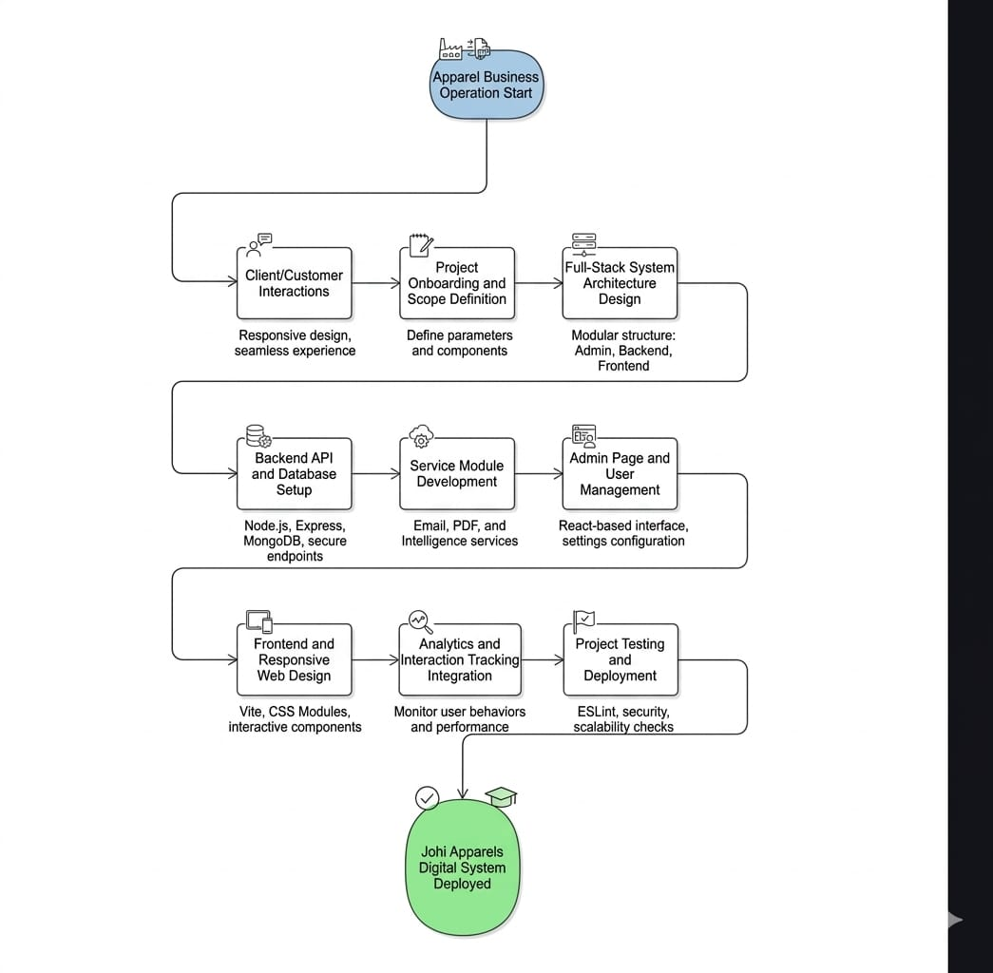
Fig 2.1 - Existing Production Monitoring Process

2.2 LIMITATIONS OF THE EXISTING SYSTEM
The existing systems used in many apparel businesses have several limitations that restrict efficiency, scalability, and decision-making. Firstly, most traditional systems rely heavily on manual processes or basic software tools, which are prone to human error and require significant time and effort to maintain. Secondly, these systems are often fragmented, handling only specific tasks such as inventory tracking, sales recording, or customer management, without providing integration between different business functions. This lack of integration makes it difficult for management to obtain a comprehensive view of operations or monitor real-time performance.
Additionally, existing systems generally lack advanced features such as predictive analytics, AI-driven insights, automated report generation, and intelligent quote management. Many solutions are also not scalable, making them unsuitable for growing businesses, and may be costly or complex to implement for small or medium-sized enterprises. Another limitation is the absence of effective customer engagement tools, which can result in a poor user experience and reduced customer satisfaction. These shortcomings highlight the need for a modern, integrated, and intelligent system like Johi Apparels, which addresses these challenges by providing automation, analytics, centralized control, and a seamless user interface.

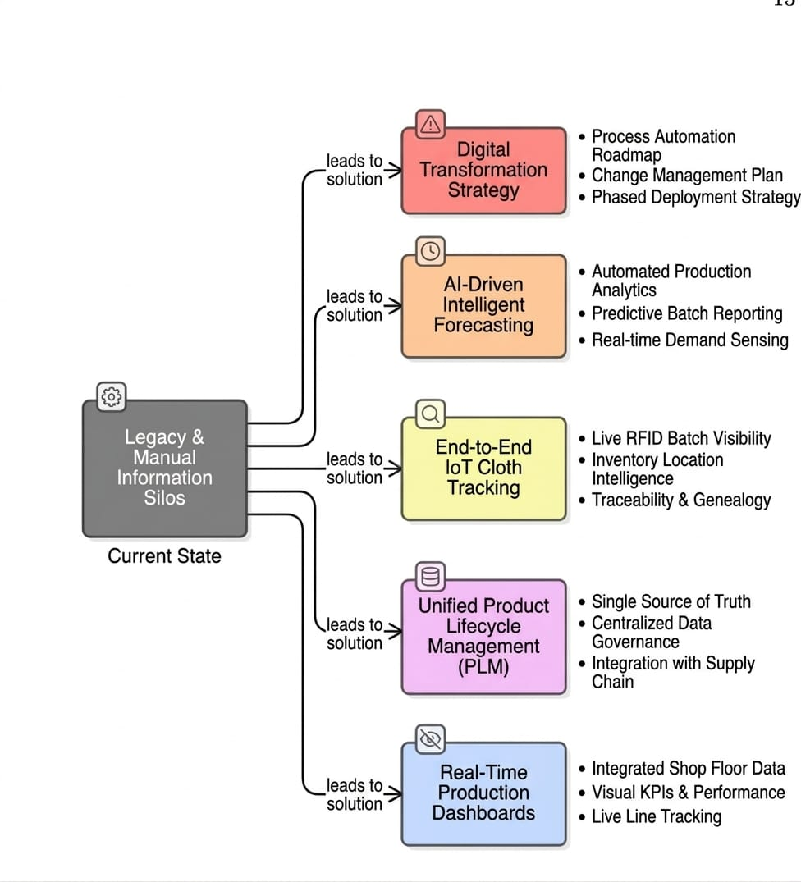
Fig 2.2 - Limitations of Existing System

2.3 PROPOSED SYSTEM
he proposed system, Johi Apparels, is a comprehensive full-stack web application designed to overcome the limitations of existing systems and provide a unified solution for apparel business operations. Unlike traditional fragmented systems, Johi Apparels integrates key business functions—including inventory management, user and customer management, order tracking, analytics, and reporting—into a single platform. The system is designed to automate routine tasks, reduce human error, and improve overall operational efficiency, allowing business owners to focus on strategic decision-making rather than manual processes.
The system consists of three main modules: the admin panel, which enables centralized control over users, settings, and business metrics; the backend, which handles secure data storage, server-side logic, and service integration such as email notifications, PDF generation, and AI-driven quote intelligence; and the frontend, which provides a responsive, interactive, and user-friendly interface for customers. Advanced features like predictive analytics, AI-powered insights, and real-time data tracking allow management to make informed decisions, optimize inventory, and enhance customer engagement.
Furthermore, Johi Apparels is designed with scalability and flexibility in mind, making it suitable for small, medium, and growing apparel businesses. By integrating automation, analytics, and intelligent features into a single platform, the proposed system not only addresses the gaps of existing systems but also improves productivity, customer satisfaction, and competitiveness in the apparel industry.
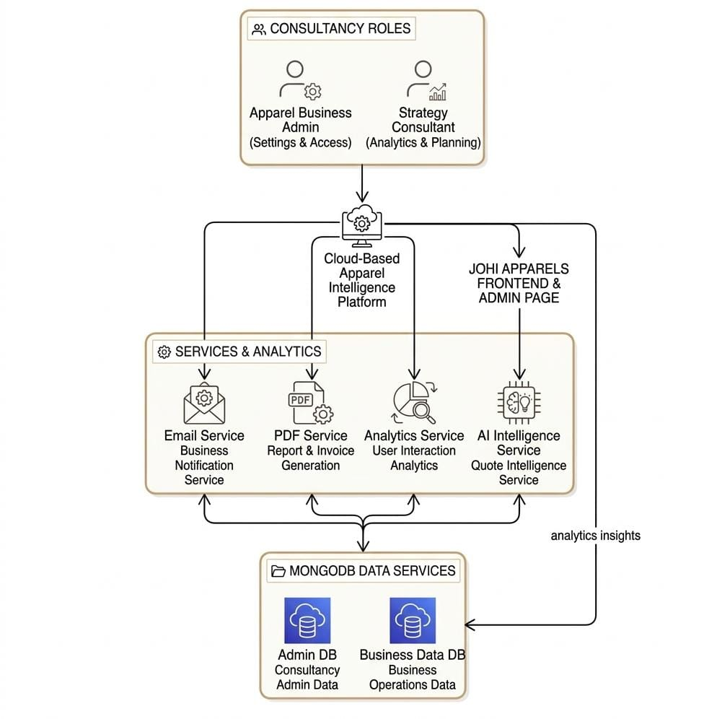
Fig 2.3 - Proposed System Overview

2.4 FEASIBILITY STUDY
Before implementing the proposed system, it is important to evaluate whether the system is practical and beneficial for the organization. A feasibility study helps determine the technical, economic, and operational viability of the project.
Technical Feasibility
Technical feasibility considers whether the required technologies, tools, and infrastructure are available to develop and implement the system. Johi Apparels utilizes widely adopted and modern technologies such as React for the frontend, Node.js and Express.js for the backend, and MongoDB for data storage. These technologies are reliable, scalable, and suitable for building a secure and efficient full-stack application.
Economic Feasibility
Economic feasibility assesses the cost-effectiveness of the system. Since Johi Apparels leverages open-source technologies and cloud-based or local hosting solutions, the development and maintenance costs are reasonable, especially for small to medium-sized apparel businesses. The automation of processes and reduction of manual work also contribute to long-term cost savings by improving operational efficiency
Operational Feasibility
Operational feasibility evaluates how well the system fits within the organization’s workflow and meets user requirements. Johi Apparels is designed to be user-friendly, providing an intuitive interface for administrators and customers alike. Its modular design allows businesses to adopt the system with minimal disruption while supporting scalability for future growth.

2.5 SYSTEM REQUIREMENT ANALYSIS
System requirement analysis identifies the hardware and software components necessary for implementing the proposed system. These requirements ensure that the system operates efficiently and meets the functional needs of the pharmacy.
Hardware Requirements
The system requires a computer or server with sufficient specifications to ensure smooth performance. Minimum hardware requirements include an Intel Core i3 processor or higher, 8 GB of RAM, and 250 GB of storage using either HDD or SSD. A stable internet connection is necessary to facilitate real-time communication between the frontend, backend, and database components. These specifications allow the system to handle multiple users, data processing, and analytics efficiently without performance delays or interruptions.
Software Requirements
The system is compatible with widely used operating systems such as Windows 10/11, Linux, or macOS. The frontend is developed using React, along with Vite and CSS Modules, to provide a responsive and interactive user interface. The backend uses Node.js and Express.js for server-side logic, while MongoDB serves as the database for efficient data storage and retrieval. Additional tools, such as ESLint, ensure code quality, and integrated services support functionalities like automated email notifications and PDF generation. These software requirements ensure that the system operates reliably, securely, and efficiently across different platforms.
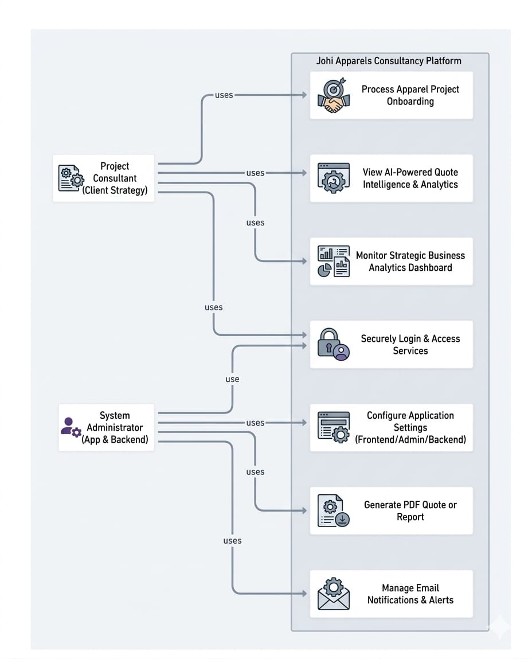
Fig 2.4 - Use Case Diagram

CHAPTER 3

SYSTEM DESIGN

3.1 SYSTEM ARCHITECTURE
The system is designed using a modular architecture that divides the application into three main components: the admin module, the backend module, and the frontend module. This structure ensures maintainability, scalability, and efficient communication between different parts of the system.
The admin module is responsible for managing the overall system. It allows administrators to monitor key metrics, configure settings, and manage users. This module serves as the control center, providing tools and insights for effective system management.
The backend module handles all server-side operations, including data processing, database management, and integration with external services. It provides secure API endpoints for communication with the frontend and admin modules. Services such as email notifications, PDF generation, and analytics are managed through this module to support automation and intelligent functionality.
The frontend module provides the user interface and interacts with the backend through APIs. It offers a responsive and interactive environment for users to browse products, view information, and engage with the system. User actions on the frontend are tracked and sent to the backend for processing and analytics.
Overall, this three-tier architecture ensures a clear separation of concerns, making the system modular, scalable, and easier to maintain. Each module communicates through defined interfaces, enabling efficient data flow, real-time updates, and a seamless user experience across all platforms.
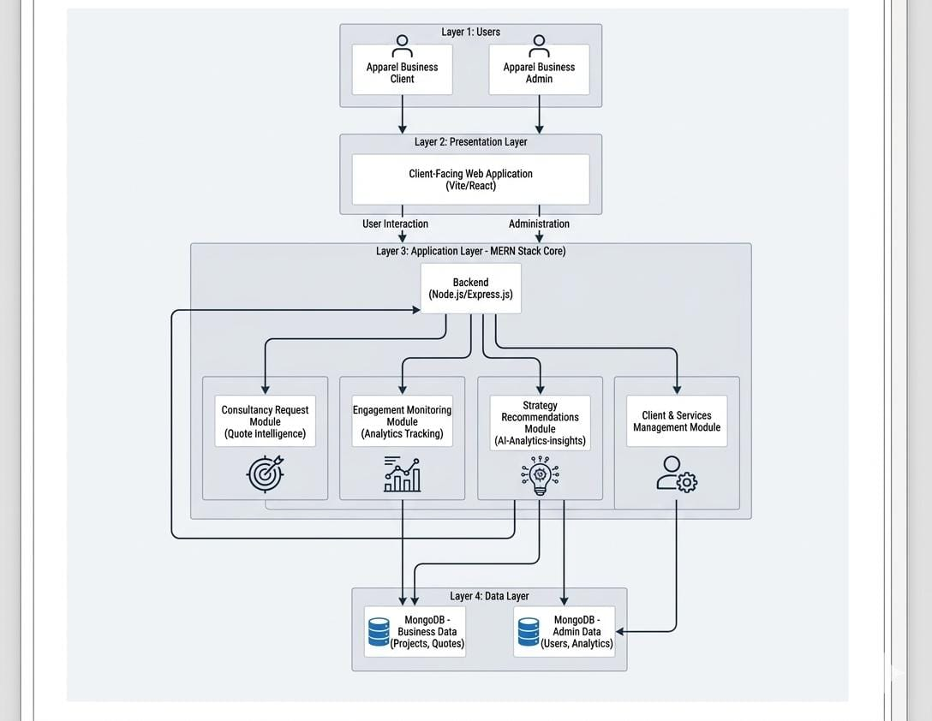
Fig 3.1 - System Architecture Diagram

3.2 DATABASE DESIGN
The system uses a structured database to store and manage all the information required for its operations. The database is designed using a document-oriented approach with collections to organize data efficiently. Key collections include users, products, orders, quotes, and analytics data. The users collection stores information about administrators and regular users, including credentials and access levels. The products collection contains details about each product, such as name, description, price, quantity, and category. The orders and quotes collections manage transactional data, including order status, quotation details, and customer information. The analytics collection captures data related to user interactions, product views, and other metrics used for generating insights and reports.
Relationships between collections are carefully structured to ensure data integrity and reduce redundancy. For example, orders and quotes reference users and products to maintain consistent linkage between customers and their transactions. Indexing is applied to frequently queried fields to improve performance and allow faster retrieval of information. The database is also designed to scale as the volume of data increases, making it suitable for growing business operations. By using a well-structured database, the system ensures reliable data storage, efficient query execution, and smooth integration with the backend and frontend modules.
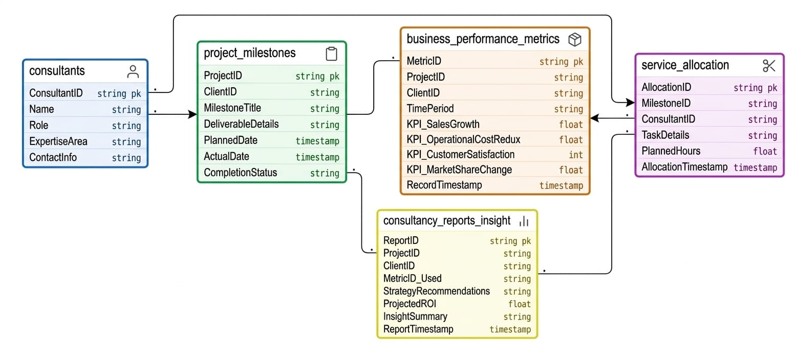
Fig 3.2 - Database Entity Relationship Diagram

3.3 WORKFLOW DESIGN
The system is designed with a clear workflow to ensure smooth and efficient operation across all modules. The process begins with the user or customer interacting with the frontend module, where they can browse products, view details, request quotes, or place orders. User actions are sent to the backend through API calls, where the data is processed and stored in the database. The backend also handles additional services such as generating PDFs for quotes or orders, sending email notifications, and updating analytics for reporting purposes.
Simultaneously, the admin module allows administrators to monitor system activities, manage users, configure settings, and review business metrics. Information from the frontend and backend is consolidated in the admin module to provide a centralized view of operations. Analytics data is continuously collected and processed to generate insights on user behavior, product performance, and overall system efficiency.
The workflow is designed to ensure that each module communicates seamlessly with others, enabling real-time updates and accurate tracking of business operations. By following this workflow, the system maintains data consistency, reduces errors, automates routine tasks, and provides a smooth experience for both administrators and users. This structured workflow also allows for scalability, making it easier to incorporate additional features or modules in the future.
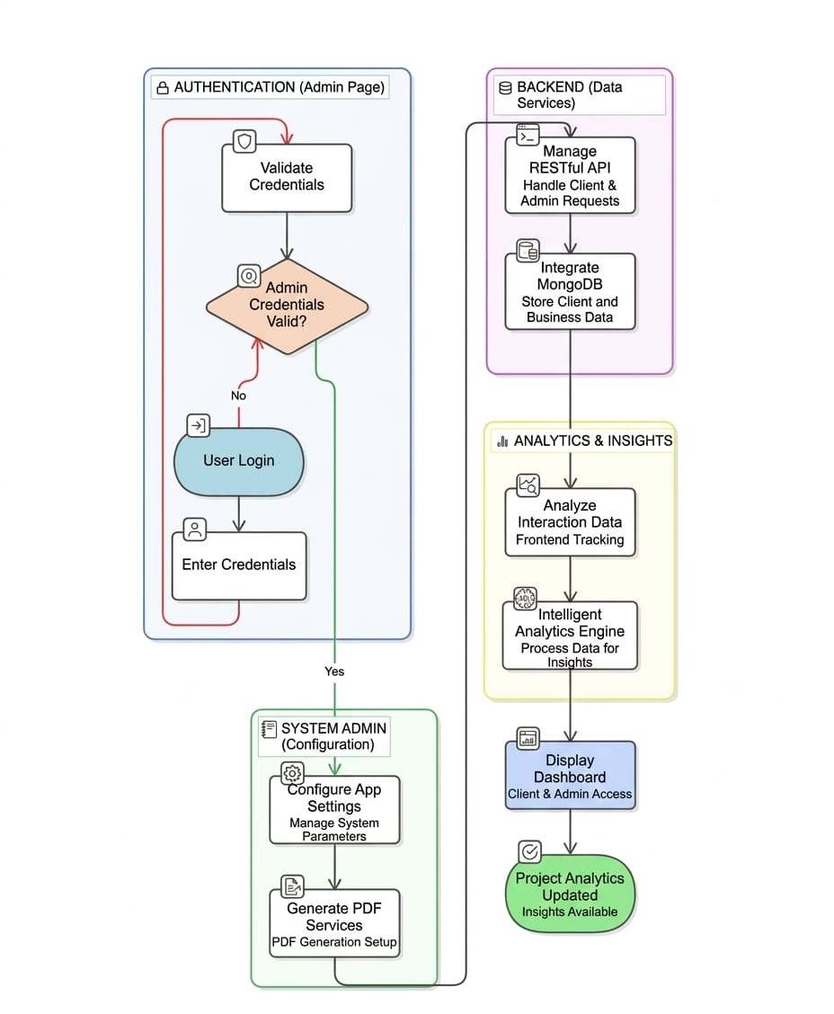
Fig 3.3 - System Workflow Diagram

3.4 USER INTERFACE DESIGN
The system is designed with a user-friendly and interactive interface to ensure a smooth experience for both administrators and users. The frontend is developed to be responsive, allowing it to function efficiently across various devices such as desktops, tablets, and smartphones. The interface is organized into clear sections, including product displays, quote and order forms, analytics dashboards, and user profile management, making it easy for users to navigate and access required information.
For the admin module, the interface provides dashboards with key metrics, user management tools, and system settings in an organized layout. Visual elements such as graphs, charts, and tables are used to present data in an intuitive and easily understandable manner. The user interface also incorporates interactive components, such as buttons, forms, and notifications, to facilitate user actions and provide immediate feedback.
Attention is given to simplicity, consistency, and clarity in design, ensuring that all users, regardless of technical expertise, can operate the system effectively. By combining responsive design, intuitive navigation, and visual analytics, the user interface supports efficient interactions, improves productivity, and enhances the overall user experience.
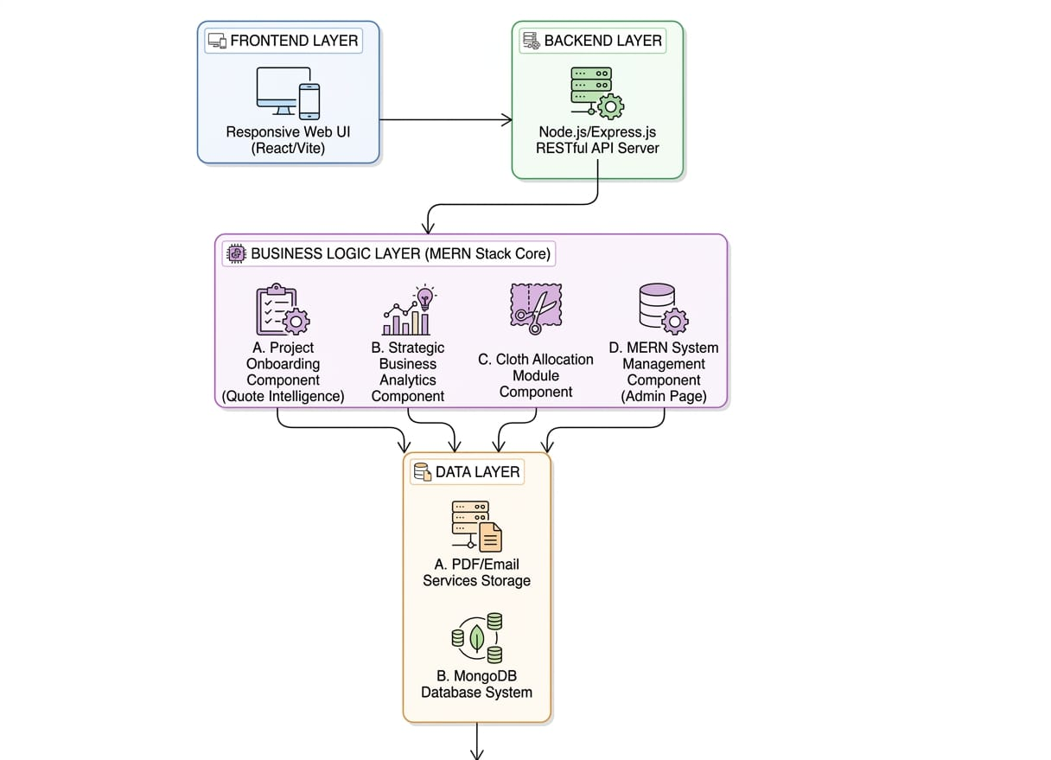
Fig 3.4 - User Interface Design

CHAPTER 4

SYSTEM IMPLEMENTATION
4.1 IMPLEMENTATION OVERVIEW
The system is implemented using a full-stack web application approach, integrating the frontend, backend, and database to provide a seamless and efficient platform. The implementation process begins with setting up the development environment, including installing necessary frameworks, libraries, and tools. The backend is developed using Node.js and Express.js to handle server-side logic, API endpoints, and integration with services such as email notifications, PDF generation, and analytics. MongoDB is used as the database for secure and efficient data storage and retrieval, ensuring smooth communication with the backend.
The frontend is implemented using React along with Vite and CSS Modules to create a responsive and interactive user interface that works across multiple devices. Components are designed to display product information, manage user interactions, and provide dashboards for analytics and reporting. The admin module is developed to manage users, configure system settings, and monitor key business metrics, providing a centralized control system.
The implementation process also includes testing at various stages to ensure the reliability, security, and performance of the system. Integration between modules is carefully managed to ensure real-time communication, data consistency, and smooth workflow. Overall, the implementation provides a robust and scalable platform that automates routine tasks, supports data-driven decision-making, and enhances both user and administrative experiences.

4.2 FRONTEND IMPLEMENTATION
The front end of the system is implemented using React along with Vite and CSS Modules to create a responsive, dynamic, and user-friendly interface. The implementation focuses on delivering an interactive experience for users, enabling them to browse products, view details, submit orders or quotes, and track their interactions seamlessly. Components are modular and reusable, which allows for easier maintenance and future updates.
The design prioritizes responsiveness, ensuring that the interface adapts smoothly to different screen sizes, including desktops, tablets, and smartphones. Interactive elements such as buttons, forms, and navigation menus are designed for intuitive use, providing immediate feedback to user actions. Data from the backend is fetched through secure API calls, allowing the frontend to display real-time information such as product availability, order status, and analytics metrics.
Additional features, such as galleries, testimonials, and analytics dashboards, are incorporated to enhance user engagement and provide a visually appealing interface. Overall, the front end implementation ensures that users have a smooth, efficient, and engaging experience while interacting with the system, while maintaining a clear and organized structure for scalability and maintainability.

4.3 BACKEND IMPLEMENTATION
The back end of the system is implemented using Node.js and Express.js, providing a robust and secure environment for server-side operations. It handles all core business logic, including data processing, API endpoints, authentication, and integration with external services such as email notifications and PDF generation. The backend communicates with the database, built using MongoDB, to store and retrieve information efficiently, ensuring data consistency and reliability across the system.
RESTful APIs are developed to facilitate seamless communication between the frontend and backend modules. These APIs handle requests such as user management, product updates, order processing, and analytics tracking. The backend also includes middleware for authentication, error handling, and input validation, enhancing security and system stability. Services such as quote intelligence and analytics are implemented on the server side, allowing for real-time data processing and generation of insights that support informed decision-making.
Overall, the backend implementation ensures that the system operates efficiently, securely, and reliably, providing a foundation for scalable growth. It manages the flow of data between modules, supports automated business processes, and enables integration with additional services, ensuring the system meets the functional and performance requirements of modern business operations.

4.4 DATABASE IMPLEMENTATION
The database is implemented using MongoDB, a NoSQL document-oriented database, to provide flexible and efficient data storage for the system. Collections are created to manage different types of information, including users, products, orders, quotes, and analytics data. Each collection is structured with relevant fields to store necessary attributes, such as user credentials, product details, order status, quotation information, and interaction metrics. References between collections are established to maintain relationships and ensure data consistency, such as linking orders and quotes to specific users and products.
Indexes are applied to frequently accessed fields to improve query performance, enabling fast retrieval of data even as the database grows. CRUD (Create, Read, Update, Delete) operations are implemented through the backend APIs, allowing seamless interaction between the application and the database. The database design also supports scalability, making it possible to accommodate increasing data volumes as the system expands.
By implementing a well-structured and optimized database, the system ensures secure, reliable, and efficient storage and retrieval of data. This enables smooth integration with the backend and frontend modules, supports automated processes, and allows real-time analytics and reporting, enhancing overall system performance.

4.5 AI ANALYTICS MODULE IMPLEMENTATION
The AI analytics module is implemented to provide intelligent insights and data-driven decision-making capabilities within the system. This module leverages machine learning algorithms to analyse historical data, such as user interactions, product popularity, order patterns, and quotations. By processing this data, the module can identify trends, predict customer behavior, and generate recommendations for optimizing operations, such as adjusting product offerings, improving pricing strategies, or enhancing customer engagement.
The module is integrated with the backend through API endpoints, allowing real-time access to updated data from the database. It processes incoming data continuously, updating dashboards and generating reports that provide actionable insights for administrators and decision-makers. Features such as predictive analytics for quote intelligence, trend analysis for products, and performance metrics for user engagement are all managed within this module.
By implementing the AI analytics module, the system not only automates the generation of insights but also supports proactive decision-making. This enhances operational efficiency, improves customer satisfaction, and provides a competitive advantage by enabling management to make informed, timely, and strategic business decisions based on accurate data analysis.

CHAPTER 5
SYSTEM TESTING
5.1 TESTING STRATEGY
He testing strategy for the system is designed to ensure that all modules, features, and functionalities operate correctly, efficiently, and securely. The testing process follows a combination of unit testing, integration testing, and system testing to identify and resolve errors at different levels of the application. Unit testing focuses on verifying the functionality of individual components, such as frontend forms, backend APIs, and database queries, to ensure each performs as intended. Integration testing examines the interaction between modules, such as the communication between the frontend, backend, and database, to verify that data flows correctly and operations are consistent across the system.
System testing evaluates the application as a whole, checking whether it meets the specified functional and non-functional requirements, including performance, reliability, and usability. Specific attention is given to critical modules such as user management, order and quote processing, inventory management, and the AI analytics module to ensure accuracy and efficiency. Testing also includes validation of security measures, such as authentication and data access controls, and checks for responsive design and cross-platform compatibility.
The strategy incorporates both manual and automated testing approaches to ensure thorough verification. Errors and inconsistencies identified during testing are recorded and addressed, and retesting is performed to confirm resolution. By following this comprehensive testing strategy, the system is validated to deliver reliable, secure, and efficient performance, ensuring a high-quality user experience and accurate business operations.

5.2 TEST CASES
Test cases are developed to systematically verify the functionality, reliability, and performance of different modules of the system. Each test case includes a description of the input, the expected output, and the actual output to ensure that the system behaves as intended. For example, in the user management module, test cases verify the ability to add, edit, and delete users, as well as checking access permissions for different user roles. In the product and inventory module, test cases ensure that products can be added, updated, and deleted correctly, and that stock levels are accurately reflected in the system.
For the order and quote module, test cases validate that quotations can be generated, saved, and retrieved, while order statuses are updated correctly throughout the process. Test cases are also designed for the AI analytics module to verify that data is correctly analyzed, trends are identified accurately, and predictive recommendations are generated based on historical data. Additionally, test cases cover system performance aspects, such as response time for API requests, frontend rendering speed, and cross-device compatibility, as well as security features, including authentication and access control.
By executing these test cases, any errors, inconsistencies, or unexpected behaviors are identified and corrected, ensuring that the system is reliable, secure, and efficient. Properly documented test cases also provide a reference for future maintenance and upgrades, supporting continuous improvement of the system.

5.3 RESULTS AND DISCUSSION
After the successful implementation and testing of the system, the results indicate that all modules function as intended and meet the specified requirements. The frontend provides a responsive and user-friendly interface, allowing users to easily browse products, submit quotes, and interact with the system. The backend processes requests efficiently, manages data accurately, and ensures secure communication between modules. The database stores and retrieves information effectively, maintaining data integrity and supporting real-time updates across the system.
The AI analytics module successfully generates actionable insights by analyzing historical data, predicting trends, and providing recommendations for business operations. Administrators are able to monitor key metrics, track orders and quotations, and make data-driven decisions with improved accuracy and efficiency. The testing process confirmed that the system is reliable, secure, and performs well under different scenarios, including multiple users and high data volumes.
Discussion of the results shows that the system addresses the limitations of existing methods by integrating inventory management, order tracking, user management, and intelligent analytics into a single platform. Automation of routine tasks reduces human error, improves productivity, and enhances customer satisfaction. The modular design ensures scalability and maintainability, allowing the system to adapt to future business needs. Overall, the results demonstrate that the system is an effective solution for modernizing operations, improving decision-making, and enhancing the overall efficiency of the business.

CHAPTER 6

CONCLUSION AND FUTURE ENHANCEMENTS
6.1 CONCLUSION
The project successfully demonstrates the development of a comprehensive system that integrates multiple business operations into a single, efficient platform. Through the implementation of modular design, the system effectively manages user interactions, product and inventory tracking, order and quotation processing, and data analytics. The AI analytics module adds intelligence to the platform, enabling predictive insights, trend analysis, and data-driven decision-making, which enhances operational efficiency and customer satisfaction.
Testing and evaluation confirm that the system is reliable, secure, and performs well under different scenarios. The modular and scalable architecture ensures that the system can accommodate future growth, additional features, and evolving business needs. By addressing the limitations of traditional systems, automating routine processes, and providing real-time insights, the system proves to be a valuable tool for modern business management. Overall, the project demonstrates the effectiveness of integrating advanced technologies, such as AI and analytics, with user-friendly interfaces to create a robust, intelligent, and practical solution for contemporary business operations.
6.2 FUTURE ENHANCEMENTS
There are several opportunities to further enhance the system to make it more advanced, efficient, and user-centric. One potential improvement is the integration of advanced artificial intelligence features, such as machine learning models for predictive inventory management, demand forecasting, and personalized customer recommendations. Implementing real-time analytics dashboards with more detailed visualizations can help administrators make faster and more informed decisions.
Another enhancement could be the addition of mobile application support, allowing users and administrators to access the system from smartphones and tablets, improving accessibility and convenience. Integration with third-party platforms, such as payment gateways, shipping services, and e-commerce marketplaces, can also streamline operations and expand business reach. Furthermore, implementing enhanced security measures, such as two-factor authentication and data encryption, can provide additional protection for sensitive business and user information.
Finally, features like virtual product showcases, automated marketing campaigns, and multi-language support can increase customer engagement and satisfaction.
APPENDIX 1 - SOURCE CODE
App.jsx
import Navbar from './components/Navbar';
import Hero from './components/Hero';
import About from './components/About';
import Services from './components/Services';
import Products from './components/Products';
import Process from './components/Process';
import Stats from './components/Stats';
import Team from './components/Team';
import Gallery from './components/Gallery';
import Testimonials from './components/Testimonials';
import FAQ from './components/FAQ';
import Newsletter from './components/Newsletter';
import Contact from './components/Contact';
import Footer from './components/Footer';
import WhatsAppButton from './components/WhatsAppButton';
import ScrollProgress from './components/ScrollProgress';
import BackToTop from './components/BackToTop';
import ToastContainer from './components/Toast';
import AnimatedCursor from './components/AnimatedCursor';
import { useToast } from './hooks/useToast';

function App() {
const { toasts, addToast, removeToast } = useToast();

return (
<>
<AnimatedCursor />
<ScrollProgress />
<Navbar />
<main>
<Hero />
<About />
<Services />
<Products />
<Stats />
<Process />
<Team />
<Gallery />
<Testimonials />
<FAQ />
<Newsletter />
<Contact />
</main>
<Footer />
<WhatsAppButton />
<BackToTop />
<ToastContainer toasts={toasts} removeToast={removeToast} />
</>
);
}

export default App;
index.css
@import url('https://fonts.googleapis.com/css2?family=Playfair+Display:ital,wght@0,400;0,500;0,600;0,700;0,800;1,400;1,500&family=Inter:wght@300;400;500;600;700&family=Outfit:wght@300;400;500;600;700&display=swap');

:root {
/* Primary Colors */
--color-primary: #C9A96E;
--color-primary-light: #E0C98F;
--color-primary-dark: #A88B4A;
--color-primary-rgb: 201, 169, 110;

/* Dark Theme */
--color-bg-dark: #0A0A0A;
--color-bg-card: #111111;
--color-bg-elevated: #1A1A1A;
--color-bg-surface: #141414;

/* Text Colors */
--color-text-primary: #FFFFFF;
--color-text-secondary: #B0B0B0;
--color-text-muted: #707070;
--color-text-accent: var(--color-primary);

/* Accent Colors */
--color-accent-warm: #D4A574;
--color-accent-cool: #7A8B9A;
--color-accent-success: #4CAF50;
--color-accent-danger: #E74C3C;

/* Gradients */
--gradient-gold: linear-gradient(135deg, #C9A96E 0%, #E0C98F 50%, #A88B4A 100%);
--gradient-dark: linear-gradient(180deg, #0A0A0A 0%, #141414 100%);
--gradient-card: linear-gradient(145deg, #1A1A1A 0%, #111111 100%);
--gradient-hero: linear-gradient(135deg, rgba(10,10,10,0.95) 0%, rgba(20,20,20,0.85) 50%, rgba(10,10,10,0.95) 100%);
--gradient-text: linear-gradient(135deg, #C9A96E, #E0C98F, #C9A96E);

/* Shadows */
--shadow-sm: 0 2px 8px rgba(0,0,0,0.3);
--shadow-md: 0 4px 20px rgba(0,0,0,0.4);
--shadow-lg: 0 8px 40px rgba(0,0,0,0.5);
--shadow-gold: 0 4px 30px rgba(201,169,110,0.15);
--shadow-glow: 0 0 40px rgba(201,169,110,0.1);

/* Typography */
--font-display: 'Playfair Display', Georgia, serif;
--font-body: 'Inter', -apple-system, BlinkMacSystemFont, sans-serif;
--font-heading: 'Outfit', -apple-system, sans-serif;

/* Spacing */
--section-padding: 100px 0;
--container-max: 1200px;
--container-padding: 0 24px;

/* Borders */
--border-subtle: 1px solid rgba(201,169,110,0.1);
--border-card: 1px solid rgba(255,255,255,0.06);
--border-gold: 1px solid rgba(201,169,110,0.3);
--radius-sm: 8px;
--radius-md: 12px;
--radius-lg: 20px;
--radius-xl: 30px;

/* Transitions */
--transition-fast: 0.2s cubic-bezier(0.4, 0, 0.2, 1);
--transition-smooth: 0.4s cubic-bezier(0.4, 0, 0.2, 1);
--transition-spring: 0.6s cubic-bezier(0.34, 1.56, 0.64, 1);
}

*, *::before, *::after {
margin: 0;
padding: 0;
box-sizing: border-box;
}

html {
scroll-behavior: smooth;
font-size: 16px;
-webkit-font-smoothing: antialiased;
-moz-osx-font-smoothing: grayscale;
}

body {
font-family: var(--font-body);
background-color: var(--color-bg-dark);
color: var(--color-text-primary);
line-height: 1.6;
overflow-x: hidden;
}

a {
text-decoration: none;
color: inherit;
transition: var(--transition-fast);
}

ul, ol {
list-style: none;
}

img {
max-width: 100%;
display: block;
}

button {
border: none;
outline: none;
cursor: pointer;
font-family: var(--font-body);
transition: var(--transition-smooth);
}

input, textarea {
border: none;
outline: none;
font-family: var(--font-body);
background: transparent;
}

::selection {
background: rgba(201, 169, 110, 0.3);
color: #fff;
}

::-webkit-scrollbar {
width: 8px;
}

::-webkit-scrollbar-track {
background: var(--color-bg-dark);
}

::-webkit-scrollbar-thumb {
background: rgba(201,169,110,0.3);
border-radius: 4px;
}

::-webkit-scrollbar-thumb:hover {
background: rgba(201,169,110,0.5);
}

/* Utility Classes */
.container {
max-width: var(--container-max);
margin: 0 auto;
padding: var(--container-padding);
}

.section-padding {
padding: var(--section-padding);
}

.text-gradient {
background: var(--gradient-text);
-webkit-background-clip: text;
-webkit-text-fill-color: transparent;
background-clip: text;
}

.glass {
background: rgba(255, 255, 255, 0.03);
backdrop-filter: blur(20px);
-webkit-backdrop-filter: blur(20px);
border: var(--border-card);
}

.gold-line {
width: 60px;
height: 2px;
background: var(--gradient-gold);
display: inline-block;
}

/* Section Header Common Styles */
.section-header {
text-align: center;
margin-bottom: 60px;
}

.section-label {
font-family: var(--font-heading);
font-size: 0.85rem;
font-weight: 600;
letter-spacing: 4px;
text-transform: uppercase;
color: var(--color-primary);
margin-bottom: 16px;
display: block;
}

.section-title {
font-family: var(--font-display);
font-size: clamp(2rem, 4vw, 3rem);
font-weight: 700;
color: var(--color-text-primary);
line-height: 1.2;
margin-bottom: 20px;
}

.section-desc {
font-size: 1.05rem;
color: var(--color-text-secondary);
max-width: 600px;
margin: 0 auto;
line-height: 1.8;
}
Main.jsx
import { StrictMode } from 'react'
import { createRoot } from 'react-dom/client'
import './index.css'
import App from './App.jsx'
import { initGA, logPageView } from './utils/analytics'

// Initialize Google Analytics
// Replace 'G-XXXXXXXXXX' with your actual Google Analytics Measurement ID
initGA('G-XXXXXXXXXX');

// Log initial page view
logPageView();

createRoot(document.getElementById('root')).render(
<StrictMode>
<App />
</StrictMode>,
)
Server.js
require('dotenv').config();
const express = require('express');
const mongoose = require('mongoose');
const cors = require('cors');
const http = require('http');
const { Server } = require('socket.io');

const quotesRouter = require('./routes/quotes');

const app = express();
const server = http.createServer(app);

// Socket.IO setup for real-time updates
const io = new Server(server, {
cors: {
origin: [
process.env.FRONTEND_URL || 'http://localhost:5173',
process.env.ADMIN_URL || 'http://localhost:5174'
],
methods: ['GET', 'POST']
}
});

// Make io accessible to routes
app.set('io', io);

// Middleware
app.use(cors({
origin: [
process.env.FRONTEND_URL || 'http://localhost:5173',
process.env.ADMIN_URL || 'http://localhost:5174'
],
credentials: true
}));
app.use(express.json());

// MongoDB Connection
mongoose.connect(process.env.MONGODB_URI)
.then(() => {
console.log('✅ Connected to MongoDB');
})
.catch((err) => {
console.error('❌ MongoDB connection error:', err);
process.exit(1);
});

// Socket.IO connection handling
io.on('connection', (socket) => {
console.log('🔌 Client connected:', socket.id);

socket.on('disconnect', () => {
console.log('🔌 Client disconnected:', socket.id);
});
});

// Routes
app.use('/api/quotes', quotesRouter);

// Health check
app.get('/api/health', (req, res) => {
res.json({
status: 'ok',
timestamp: new Date().toISOString(),
mongodb: mongoose.connection.readyState === 1 ? 'connected' : 'disconnected'
});
});

// Error handling middleware
app.use((err, req, res, next) => {
console.error('Error:', err);
res.status(500).json({
success: false,
message: 'Internal server error',
error: process.env.NODE_ENV === 'development' ? err.message : undefined
});
});

// Start server
const PORT = process.env.PORT || 5000;
server.listen(PORT, () => {
console.log(`
🚀 Server running on port ${PORT}
📡 API: http://localhost:${PORT}/api
🔌 WebSocket: ws://localhost:${PORT}
`);
});

APPENDIX 2 – SNAPSHOTS

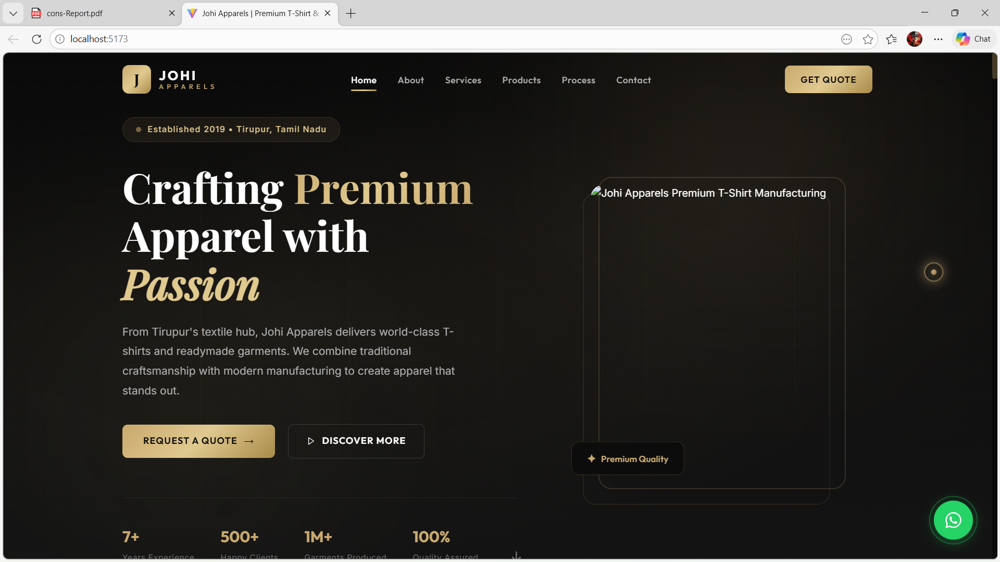
Fig A2.0 - Home Page

Fig A2.1 – About Page

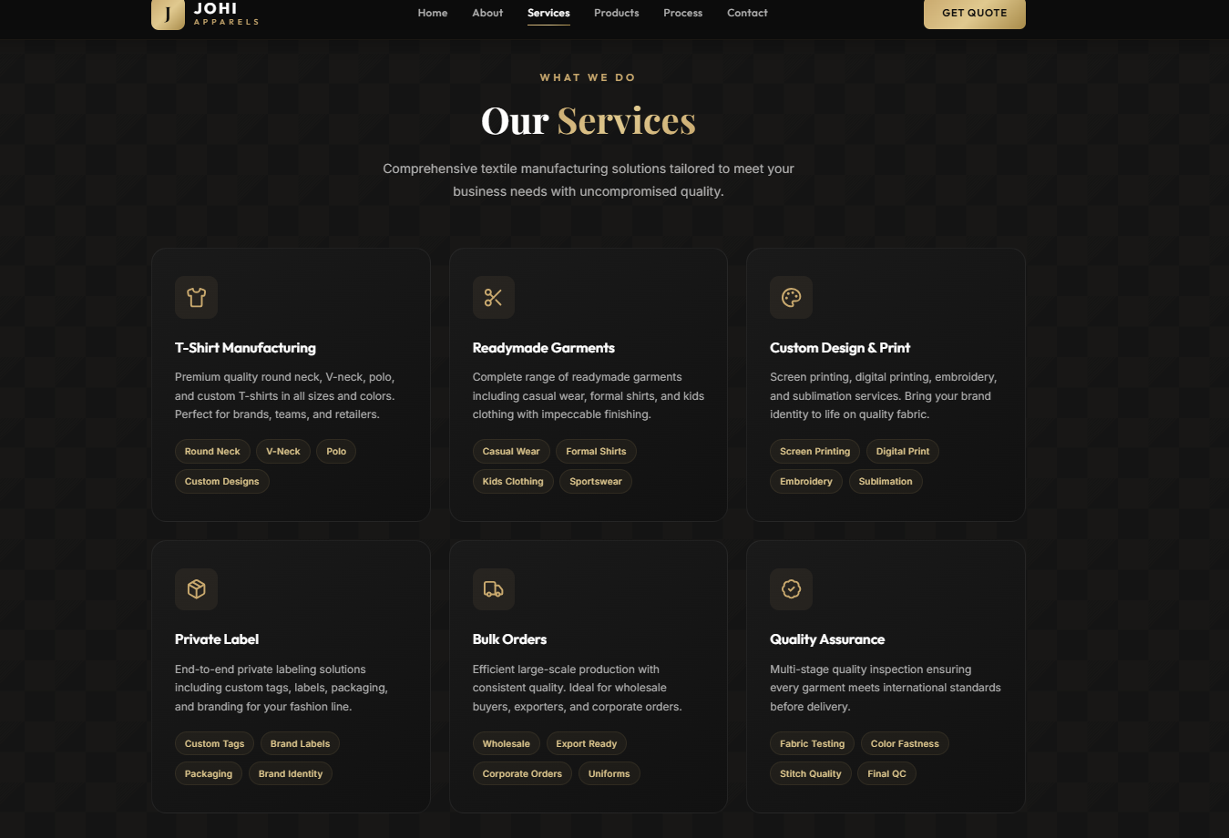
Fig A2.2 - Services Page
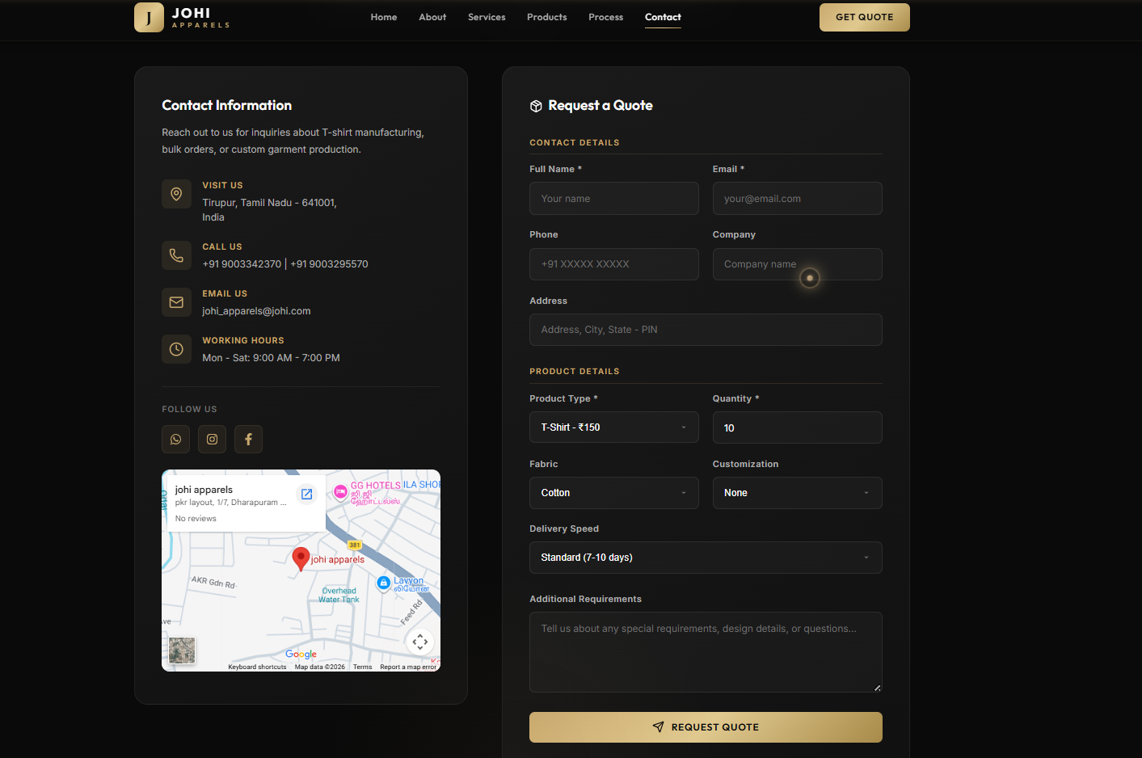
Fig A2.3 – Quote Request Page

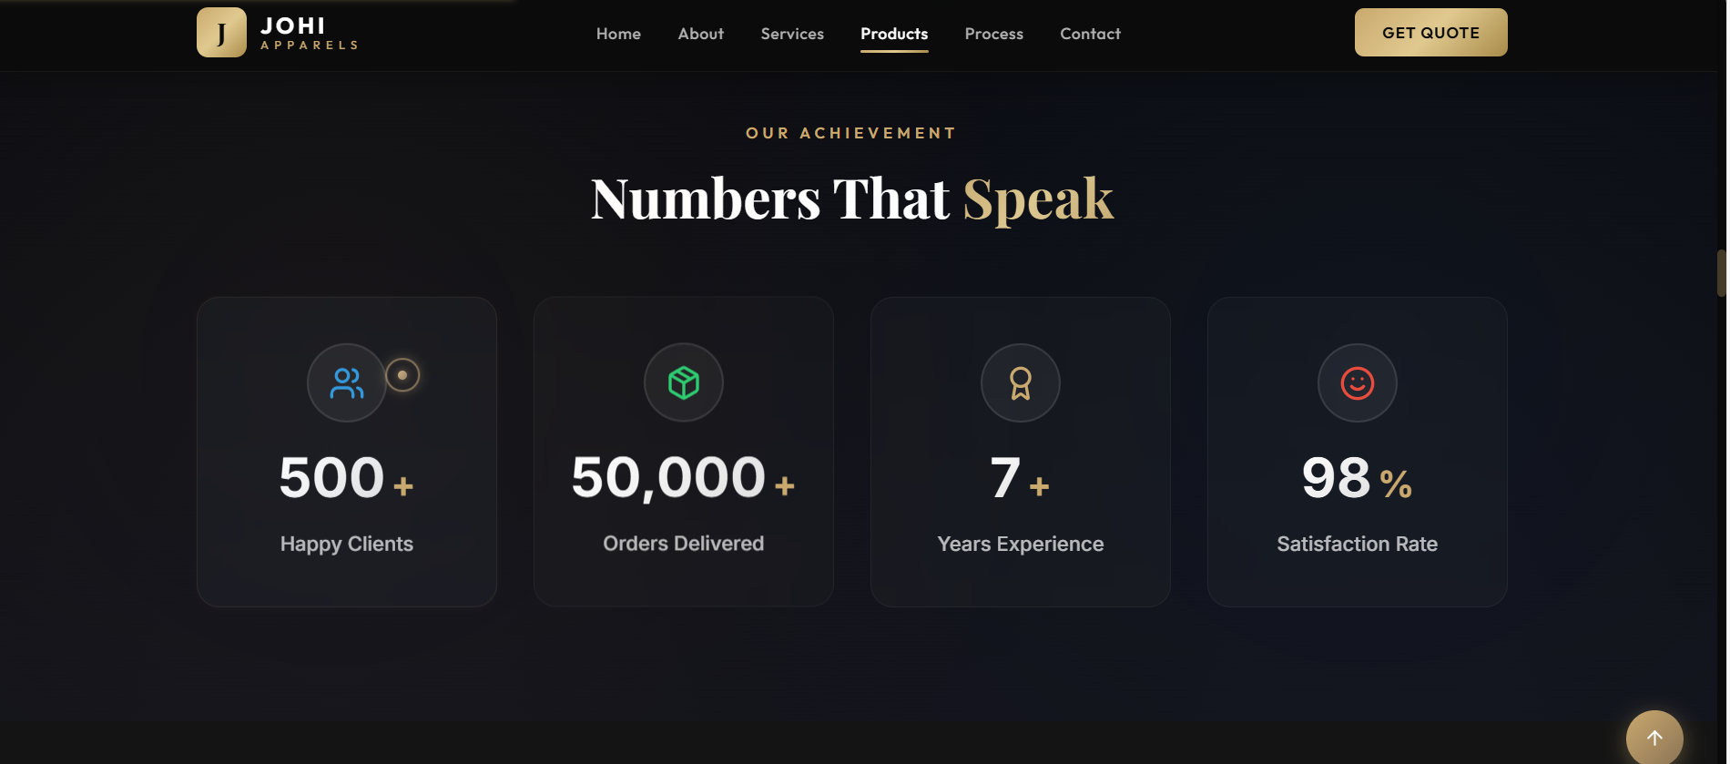
Fig A2.4 – Achievement Page

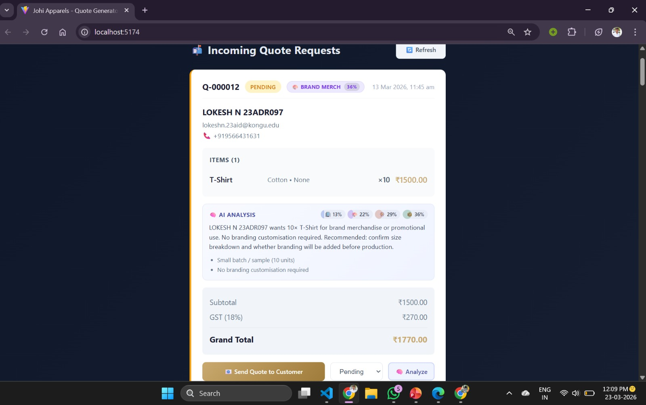
Fig A2.5 – Incoming Quote Request Page

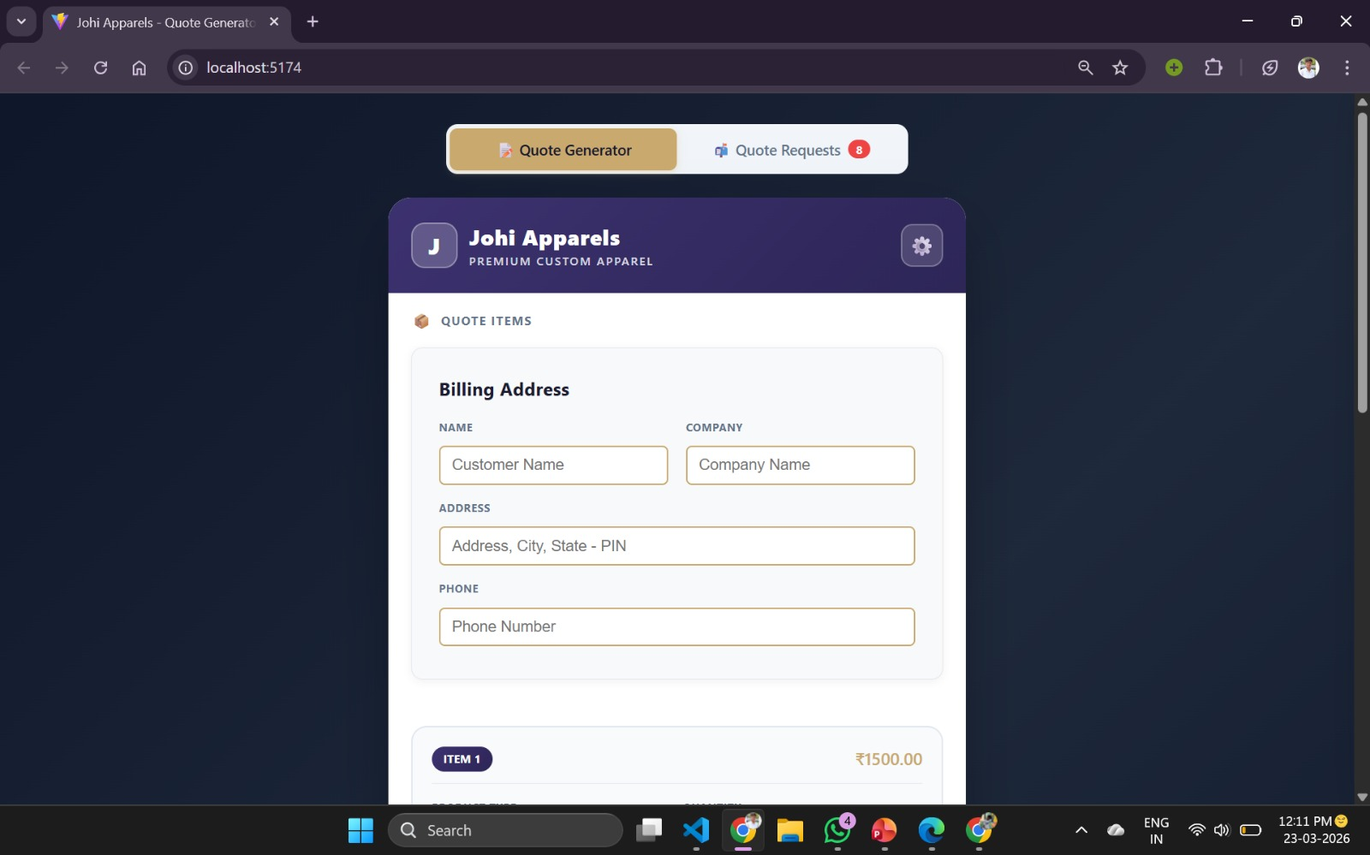
Fig A2.6 –Quote Generator Page

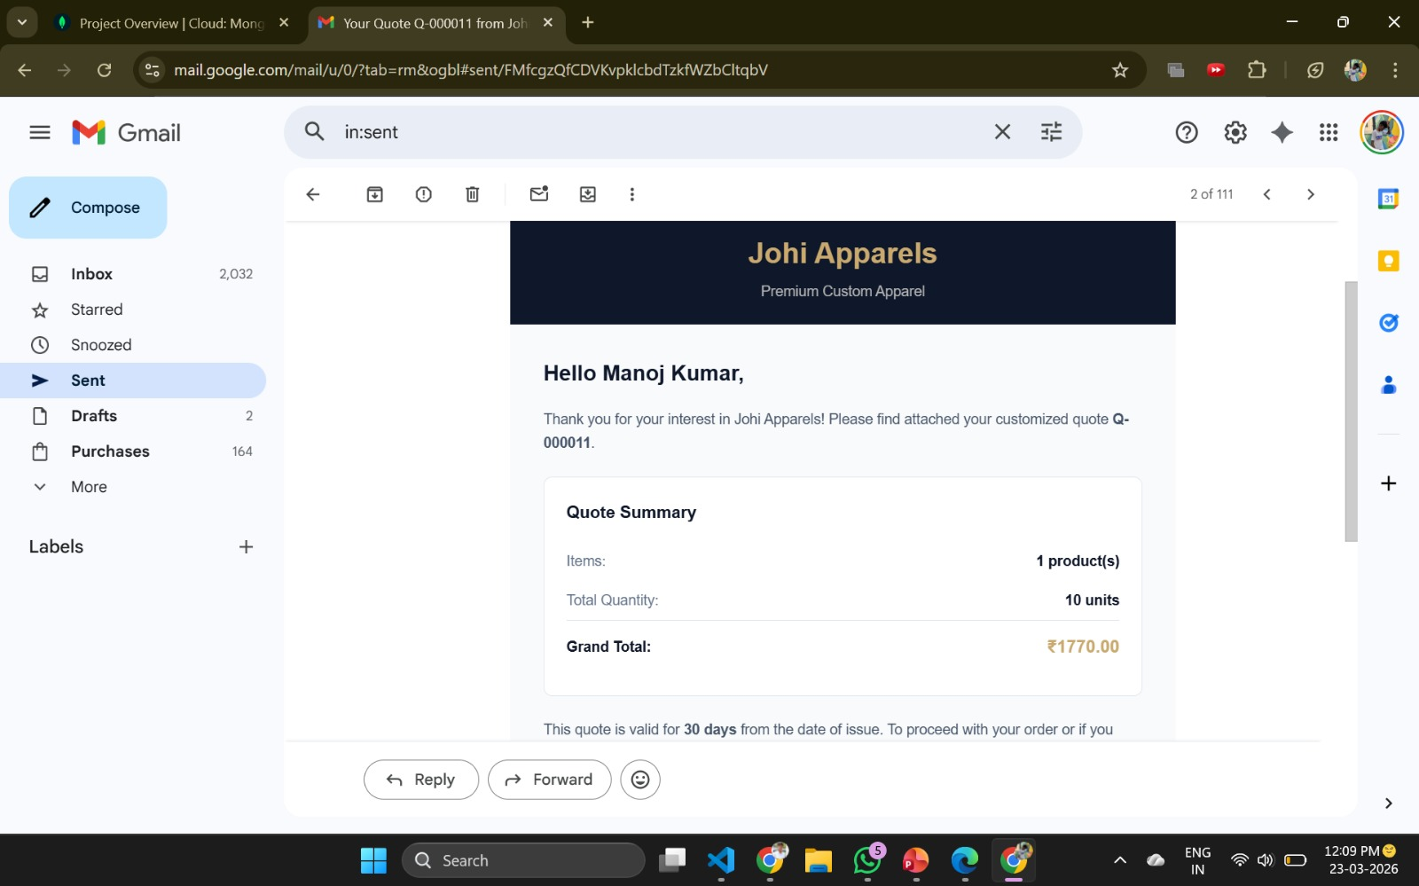
Fig A2.7 –Quote Generator Result Page

REFERENCES
- React Documentation (2024), “React – A JavaScript Library for Building User Interfaces”. Available at: https://react.dev/
- Vite Documentation (2024), “Next Generation Frontend Tooling”. Available at: https://vitejs.dev/guide/
- CSS Modules Documentation (2024), “Modular and Scoped CSS Styling”. Available at: https://github.com/css-modules/css-modules
- Node.js Documentation (2024), “Node.js JavaScript Runtime”. Available at: https://nodejs.org/en/docs
- Express.js Documentation (2024), “Fast, Unopinionated Web Framework for Node.js”. Available at: https://expressjs.com/
- MongoDB Documentation (2024), “NoSQL Database System”. Available at: https://www.mongodb.com/docs/
- Mongoose Documentation (2024), “MongoDB Object Modeling Tool”. Available at: https://mongoosejs.com/docs/
- REST API Tutorial (2024), “RESTful API Design Best Practices”. Available at: https://restfulapi.net/
- MDN Web Docs (2024), “JavaScript Reference Guide”. Available at: https://developer.mozilla.org/en-US/docs/Web/JavaScript
- ESLint Documentation (2024), “JavaScript Linting Utility”. Available at: https://eslint.org/docs/latest/
- Nodemailer Documentation (2024), “Email Sending Library for Node.js”. Available at: https://nodemailer.com/about/
- PDFKit Documentation (2024), “PDF Generation Library for Node.js”. Available at: https://pdfkit.org/
- Chart.js Documentation (2024), “JavaScript Charting Library”. Available at: https://www.chartjs.org/docs/latest/
- GitHub Documentation (2024), “Version Control and Collaboration Platform”. Available at: https://docs.github.com/
- Atlassian Agile Guide (2024), “Introduction to Agile Methodology”. Available at: https://www.atlassian.com/agile
- IBM Documentation (2024), “Software Engineering Concepts and Practices”. Available at: https://www.ibm.com/topics/software-engineering
- MDN Responsive Design (2024), “Responsive Web Design Principles”. Available at: https://developer.mozilla.org/en-US/docs/Learn/CSS/CSS_layout/Responsive_Design
- MongoDB Atlas (2024), “Cloud Database Service”. Available at: https://www.mongodb.com/atlas

MAPPING OF PROJECT GOALS TO SDG

The Sustainable Development Goals (SDGs) are a set of global objectives established by the United Nations to address key challenges such as innovation, infrastructure development, and sustainable industrialization.
The project titled “Johi Apparels Consultancy System” contributes to digital transformation in the apparel industry by integrating modern web technologies, real-time data handling, and intelligent business management solutions. The system enhances operational efficiency, reduces manual errors, and enables smarter decision-making.
SDG No. 9 – Industry, Innovation and Infrastructure
The proposed system supports industry modernization by digitizing traditional apparel business operations through a full-stack web application. The project introduces innovative digital solutions such as automated management systems, replacing manual processes. It strengthens business infrastructure by providing a scalable and structured platform for managing operations. The system enables real-time data access and analytics, improving productivity and operational efficiency. It promotes technological advancement in small and medium apparel businesses through the use of modern tools like React, Node.js, and MongoDB. The platform enhances decision-making capabilities using data-driven insights and analytics. It supports sustainable industrial growth by optimizing resources and reducing operational inefficiencies.
The implementation of this system helps transform traditional apparel business practices into a more innovative, efficient, and technology-driven ecosystem, aligning strongly with SDG 09 goals.

