A MULTI-AGENT SELF-REFLECTIVE AGENTIC RAG FRAMEWORK FOR ENHANCING THE RELIABILITY OF LARGE LANGUAGE MODELS
A PROJECT WORK
Submitted by
MANOJ KUMAR A
23ADR104
MEIYARASU S
23ADR106
MOHAMAD AADIL J
23ADR110
in partial fulfilment of the requirements for
the award of the degree of
BACHELOR OF TECHNOLOGY
IN
ARTIFICIAL INTELLIGENCE AND DATA SCIENCE
DEPARTMENT OF ARTIFICIAL INTELLIGENCE AND DATA SCIENCE

(Autonomous)
PERUNDURAI ERODE – 638 060
OCTOBER 2026
A MULTI-AGENT SELF-REFLECTIVE AGENTIC RAG FRAMEWORK FOR ENHANCING THE RELIABILITY OF LARGE LANGUAGE MODELS
A PROJECT WORK
Submitted by
MANOJ KUMAR A
23ADR104
MEIYARASU S
23ADR106
MOHAMAD AADIL J
23ADR110
in partial fulfilment of the requirements for
the award of the degree of
BACHELOR OF TECHNOLOGY
IN
ARTIFICIAL INTELLIGENCE AND DATA SCIENCE
DEPARTMENT OF ARTIFICIAL INTELLIGENCE AND DATA SCIENCE
(Autonomous)
PERUNDURAI ERODE – 638 060
OCTOBER 2026

DEPARTMENT OF ARTIFICIAL INTELLIGENCE AND DATA SCIENCE
KONGU ENGINEERING COLLEGE
(Autonomous)
PERUNDURAI ERODE – 638060
OCTOBER 2026
BONAFIDE CERTIFICATE
This is to certify that the project report entitled A Multi-Agent Self-Reflective Agentic RAG Framework for Enhancing the Reliability of Large Language Models is the bonafide record of project work done by Manojkumar A (Reg.No:23ADR104), Meiyarasu S (Reg.No:23ADR106), Mohamad Aadil J (Reg.No:23ADR110) in partial fulfilment of the requirements for the award of the Degree of Bachelor of Technology in Artificial Intelligence and Data Science of Anna university Chennai during the year 2026 - 2027.

SUPERVISOR HEAD OF THE DEPARTMENT Date: (Signature with seal)

Submitted for the end semester viva voce examination held on ___________

INTERNAL EXAMINER EXTERNAL EXAMINER
DEPARTMENT OF ARTIFICIAL INTELLIGENCE AND DATA SCIENCE
KONGU ENGINEERING COLLEGE
(Autonomous)
PERUNDURAI ERODE – 638060
OCTOBER 2026
DECLARATION
We affirm that the Project Report titled A Multi-Agent Self-Reflective Agentic RAG Framework for Enhancing the Reliability of Large Language Models being submitted in partial fulfilment of the requirements for the award of Bachelor of Technology is the original work carried out by us. It has not formed the part of any other project report or dissertation on the basis of which a degree or award was conferred on an earlier occasion on this or any other candidate.
Date:
MANOJKUMAR A
(23ADR104)

MEIYARASU S
(23ADR106)

MOHAMAD AADIL J
(23ADR110)

I certify that the declaration made by the above candidates is true to the best of my knowledge.

Date: Name and Signature of the Supervisor
ABSTRACT
The project A Multi-Agent Self-Reflective Agentic RAG Framework for Enhancing the Reliability of Large Language Models presents a document question-answering system designed to make the answers of large language models trustworthy and inspectable. Language models write fluent answers, but they can state unsupported or invented facts in the same confident tone as correct ones, and they seldom admit when the source material does not contain an answer. The proposed system answers only from documents uploaded by the user and checks its own work before presenting an answer as reliable. Documents in PDF, Word, Markdown, HTML and text form are parsed, split into sentence-aligned passages and indexed for both meaning-based and keyword search. For each question, the two rankings are merged with Reciprocal Rank Fusion and reordered by a cross-encoder whose relevance score also acts as a gate: when no passage is relevant, the system declines immediately without calling the language model. Otherwise, the model answers from six numbered passages and places a citation after every factual sentence. A claim-audit stage splits the answer into atomic claims and judges each one against its source, and its verdicts are cross-checked by independent local tests that confirm the quoted evidence really exists, that every number matches the source, that each claim is semantically grounded and that every citation points to a supporting passage. In Thorough mode, a self-consistency stage compares the answer with independent re-samples, and a self-reflective review stage critiques the answer for omissions, overclaims and reasoning errors. Six signals are combined into a calibrated confidence score with hard limits for contradictions, unsupported claims and invented citations. A routing layer paces requests to stay within rate limits, retries temporary failures and switches between local providers such as LM Studio and Ollama and cloud providers such as Groq, Gemini and OpenRouter, allowing the complete system to run offline on a laptop. A React interface streams the answer, its evidence, the claim audit and the confidence breakdown while they are produced. The system was evaluated on twenty questions about a research paper using local Llama 3.1 8B and Llama 3.2 3B models. It answered 93.3% of the answerable questions correctly in both modes; in Thorough mode it declined every unanswerable question, produced no unsupported claims and reached an expected calibration error of 0.042. The results show that combining retrieval grounding, multi-stage self-reflective verification and an honest option to decline produces answers whose reliability can be inspected rather than simply assumed.
ACKNOWLEDGEMENT
We express our sincere thanks and gratitude to Thiru. E. R. K. Krishnan M.Com., our beloved Correspondent and all other philanthropic trust members of Kongu Vellalar Institute of Technology Trust who have always encouraged us in academic and co-curricular activities.
We are extremely thankful with no words of a formal nature to the dynamic Principal Dr. R. Parameshwaran M.E., Ph.D., for providing the necessary facilities to complete our work.
We would like to express our sincere gratitude to our respected Head of the Department Dr. P. Natesan M.E., Ph.D., for providing the necessary facilities.
We sincerely express our gratitude to the Intel Unnati Centre of Excellence, Kongu Engineering College, for providing the necessary computational facilities and software resources that greatly supported the development and successful completion of our project.
We extend our thanks to our project coordinator Dr. K. S. Kalaivani M.E., Ph.D., Associate Professor, Department of Artificial Intelligence and Data Science, for her encouragement and valuable advice that made us carry out the project work successfully.
We extend our gratitude to our Supervisor Mr. N. Kannan B.E., M.E., PhD., Department of Artificial Intelligence and Data Science, for the valuable ideas and suggestions, which have been very helpful in the project. We are grateful to all the faculty members of the Artificial Intelligence and Data Science Department, for their support.
TABLE OF CONTENTS
CHAPTER No. | TITLE | PAGE No.
 | ABSTRACT | iv
 | LIST OF FIGURES | x
 | INTRODUCTION | 1
1 | 1.1 ABOUT THE PROJECT | 1
 | 1.2 OBJECTIVES OF THE PROJECT | 2
 | 1.3 SCOPE OF THE PROJECT | 3
 | 1.4 PROBLEM STATEMENT | 3
 | 1.5 MOTIVATION | 4
 | 1.6 CONTRIBUTIONS OF THE PROJECT | 4
 | 1.7 ORGANISATION OF THE REPORT | 5
 | LITERATURE SURVEY | 6
2 | 2.1 RELATED WORK | 6
 | 2.2 LITERATURE GAP | 7
 | 2.3 VERIFICATION AND CONFIDENCE APPROACHES FOR GROUNDED ANSWERS | 7
 | 2.4 RETRIEVAL-AUGMENTED GENERATION AND HYBRID SEARCH | 8
 | 2.5 HALLUCINATION DETECTION AND SELF-CONSISTENCY | 8
 | 2.6 SELF-REFLECTION AND CRITIQUE | 9
 | 2.7 CLAIM VERIFICATION AND CALIBRATION | 9
 | 2.8 SUMMARY OF THE SURVEY | 10
 | HARDWARE AND SOFTWARE DESCRIPTION | 11
3 | 3.1 FRAMEWORKS AND LIBRARIES USED | 11
 | 3.1.1 PYTHON AND FASTAPI | 12
 | 3.1.2 REACT AND VITE | 12
 | 3.1.3 SENTENCE-TRANSFORMERS AND RANK-BM25 | 12
 | 3.1.4 LM STUDIO AND LANGUAGE-MODEL PROVIDERS | 13
 | 3.1.5 PYDANTIC, HTTPX AND SQLITE | 13
 | 3.1.6 DOCUMENT PARSING LIBRARIES | 13
 | 3.1.7 PYTEST | 14
 | 3.2 HARDWARE REQUIREMENTS | 14
 | 3.3 SOFTWARE REQUIREMENTS | 16
 | 3.4 DEVELOPMENT AND DEPLOYMENT ENVIRONMENT | 16
 | EXISTING WORK | 17
4 | 4.1 EXISTING DOCUMENT QUESTION-ANSWERING SYSTEMS | 17
 | 4.2 DISADVANTAGES OF EXISTING SYSTEMS | 18
 | 4.3 BASE PAPER: CONFIDENCE INTROSPECTION | 19
 | 4.4 FIRST PROTOTYPE OF THE PROJECT | 19
 | 4.5 NEED FOR THE PROPOSED SYSTEM | 20
 | PROPOSED WORK | 21
5 | 5.1 SYSTEM ARCHITECTURE | 21
 | 5.2 DOCUMENT INGESTION AND CHUNKING | 22
 | 5.3 HYBRID RETRIEVAL AND RELEVANCE GATE | 22
 | 5.4 EVIDENCE-GROUNDED ANSWER GENERATION | 23
 | 5.5 CLAIM-LEVEL VERIFICATION | 24
 | 5.6 SELF-CONSISTENCY AND CRITICAL REVIEW | 25
 | 5.7 CONFIDENCE CALIBRATION | 25
 | 5.8 LANGUAGE-MODEL ROUTING AND IMPLEMENTATION WORKFLOW | 26
 | 5.9 QUESTION SUBMISSION AND ANSWER PRESENTATION | 28
 | 5.10 MULTI-AGENT VIEW OF THE PIPELINE | 28
 | 5.11 ALGORITHMS OF THE KEY STAGES | 29
 | 5.11.1 HYBRID RETRIEVAL ALGORITHM | 29
 | 5.11.2 CLAIM AUDIT ALGORITHM | 29
 | 5.11.3 CONFIDENCE CALIBRATION ALGORITHM | 30
 | 5.12 DATA STORAGE AND RUN HISTORY | 30
 | 5.13 APPLICATION PROGRAMMING INTERFACE | 30
 | 5.14 ERROR HANDLING AND RELIABILITY OF THE APPLICATION | 31
 | 5.15 SECURITY AND PRIVACY CONSIDERATIONS | 31
 | RESULTS AND DISCUSSION | 33
6 | 6.1 TESTING | 33
 | 6.2 EVALUATION OF ANSWERS AND CONFIDENCE | 34
 | 6.3 DISCUSSION OF SYSTEM FUNCTIONALITY | 36
 | 6.4 CASE STUDIES | 36
 | 6.5 PERFORMANCE ANALYSIS | 37
 | 6.6 COMPARISON WITH EXISTING APPROACHES | 37
 | 6.7 LIMITATIONS | 38
 | CONCLUSION AND FUTURE WORK | 39
7 | 7.1 CONCLUSION | 39
 | 7.2 FUTURE WORK | 40
 | REFERENCES | 41
 | APPENDICES | 43

LIST OF FIGURES
FIG No. | TITLE | PAGE No.
3.1 | IMPLEMENTATION COMPONENTS OF THE PROPOSED SYSTEM | 11
3.2 | FRONTEND AND BACKEND IMPLEMENTATION WORKFLOW | 15
3.3 | STORAGE LAYOUT OF RUNTIME DATA | 15
4.1 | CONVENTIONAL DOCUMENT QUESTION-ANSWERING WORKFLOWS | 17
4.2 | LIMITATIONS OF EXISTING APPROACHES | 18
5.1 | PROPOSED SYSTEM ARCHITECTURE | 21
5.2 | DOCUMENT INGESTION PIPELINE | 22
5.3 | HYBRID RETRIEVAL WITH RERANKING AND RELEVANCE GATE | 23
5.4 | ANSWER GENERATION AND VERIFICATION PIPELINE | 24
5.5 | CLAIM AUDIT PROCEDURE | 25
5.6 | CONFIDENCE SCORING WORKFLOW | 26
5.7 | LANGUAGE-MODEL ROUTER: PACING, RETRIES AND FAILOVER | 27
5.8 | FAST AND THOROUGH MODES | 27
5.9 | USE CASE DIAGRAM OF THE PROPOSED SYSTEM | 28
6.1 | FAST AND THOROUGH MODE COMPARISON | 34
6.2 | CONFIDENCE SCORE PER QUESTION | 35
6.3 | MEAN LATENCY PER QUESTION | 36
A2.1 | DOCUMENT LIBRARY AND QUESTION COMPOSER | 54
A2.2 | STREAMED ANSWER WITH INLINE CITATIONS AND PIPELINE TIMELINE | 54
A2.3 | CLAIM AUDIT WITH PER-CLAIM VERDICTS AND EVIDENCE QUOTES | 55
A2.4 | CONFIDENCE INSPECTOR WITH SIGNAL BREAKDOWN | 55
A2.5 | DECLINED ANSWER FOR A QUESTION NOT COVERED BY THE DOCUMENTS | 56

CHAPTER 1
INTRODUCTION

1.1 ABOUT THE PROJECT
The project titled A Multi-Agent Self-Reflective Agentic RAG Framework for Enhancing the Reliability of Large Language Models aims to make the answers of large language models trustworthy when they are used to read documents. Students, researchers and professionals increasingly paste a paper, a manual or a policy into a chat assistant and rely on the paragraph that comes back. Such answers usually mix sentences taken from the document with paraphrases and, occasionally, statements that the model has simply invented. Nothing on the screen shows which is which, and the model rarely says that the document does not contain the answer.
The proposed system addresses this by treating every answer as something that must be checked before it is presented as reliable. It finds evidence in the user's own documents, writes an answer that cites that evidence sentence by sentence, and then audits the answer: each claim is compared with the passage it cites, the question can be asked again to see whether the model agrees with itself, and a reviewer looks for omissions and overclaims. These results are combined into one confidence score that the user can open and inspect. When the documents do not contain the answer, the system declines instead of guessing. The application runs on an ordinary laptop with open models served by LM Studio and can also use free cloud APIs.
Large language models have become part of everyday academic and professional work within a very short time. They are used to summarise research papers, explain technical manuals, answer questions about regulations and draft reports. In each of these uses the reader usually has the original document at hand but does not have the time to check every sentence of the generated answer against it. The value of the assistant therefore depends entirely on whether its answer can be trusted, and at present that trust is given blindly.
The difficulty is not that language models are always wrong. In most cases their answers are correct, which makes the occasional error harder to notice. A model may report an accuracy of 95.72% when the paper states 95.27%, attribute a result to the wrong method, or add a plausible detail that appears nowhere in the document. Because these mistakes are written in the same fluent style as correct statements, the reader has no signal that anything is wrong. The project is built on the view that an assistant should not only answer, but should also show its evidence, check itself and say clearly when it is unsure or when the answer is not available.
The project is organised as a set of cooperating components, each responsible for one aspect of reliability. A retrieval component finds evidence, a generation component writes a cited answer, an auditing component checks each claim, a consistency component tests whether the answer is stable, a reflective review component critiques the answer, and a calibration component turns their findings into a single interpretable score. This multi-agent, self-reflective arrangement allows each check to be designed, tested and improved independently, while the user sees one coherent result.

1.2 OBJECTIVES OF THE PROJECT
The main objective of the project is to develop a question-answering system that answers only from the user's documents and places a citation after every factual sentence. To support this, the system aims to retrieve evidence reliably by combining semantic search, keyword search and cross-encoder reranking, and to decline clearly, without calling the language model, when no relevant evidence exists.
A further objective is to verify every claim of an answer against its source, using the language model as one judge among several rather than the only one, and to estimate confidence from several independent signals instead of a single self-rating. The project also aims to remain usable on a student laptop with free or local models, and to show the evidence, the audit and the reasons behind the score to the user while the answer is being produced.
In summary, the specific objectives of the project are: to build a library in which documents of common formats can be uploaded, parsed and indexed; to retrieve the most relevant passages for a question using hybrid search and reranking; to generate answers that are restricted to those passages and cited sentence by sentence; to audit each claim with both a language-model judge and independent local checks; to measure self-consistency and obtain a reflective critique; to combine these signals into a calibrated confidence score; to remain robust against rate limits and provider failures; and to evaluate the complete system with standard accuracy, abstention and calibration metrics.

1.3 SCOPE OF THE PROJECT
The scope of the project includes a web application in which users upload documents in PDF, Word, Markdown, HTML or plain-text form, up to 25 MB each, into a personal library and ask questions about them. The system covers document parsing and chunking, hybrid retrieval, cited answer generation, claim-level verification, self-consistency checking, critical review, confidence calibration, provider routing, real-time streaming of results and a stored history of every run.
The system is designed for questions whose answers are stated in the uploaded documents. It does not train or fine-tune a language model, and it does not answer from general world knowledge. Questions about a document as a whole, such as a request for a summary, are answered from the opening passages of each document. The framework is designed to support future extensions such as learned calibration, larger evaluations, answer repair and the verification of tables and figures.

1.4 PROBLEM STATEMENT
Given a collection of documents supplied by a user and a question expressed in natural language, conventional language-model tools can return answers that contain unsupported or contradicted statements, cite passages that do not support them, or answer confidently when the documents say nothing about the question. The user has no reliable way to distinguish a well-supported answer from a fabricated one, and the confidence the model expresses is not related to the evidence available.
The problem addressed by this project is therefore to design and implement a document question-answering system that answers strictly from retrieved evidence with sentence-level citations, declines when the evidence is insufficient, verifies every factual claim against its cited source using checks that do not depend solely on the language model, combines several independent signals into an interpretable and capped confidence score, and remains practical to run with free cloud models or entirely local models on a laptop.

1.5 MOTIVATION
The motivation for the project came from two observations. The first was practical: while studying with the help of chat assistants, the team repeatedly found answers that sounded correct but contained small factual errors that were only discovered by going back to the source. The second came from the base paper on confidence introspection, which showed that asking a model to reflect on its own answer can improve the usefulness of its confidence estimates. While reproducing this idea, it became clear that a model reflecting on itself can still be confidently wrong, because the same knowledge gaps that produced the error also affect the reflection.
These observations suggested that reliability should come from evidence rather than from the model's opinion of itself. If every claim must be traceable to a passage in the user's document, and if simple checks that do not use the model can confirm that the passage really says what the model claims, then the confidence score becomes something that can be explained and verified. Making such a system run on modest hardware with free models was an additional motivation, so that students and institutions without paid AI services could use it.

1.6 CONTRIBUTIONS OF THE PROJECT
The main contributions of the project are as follows. First, a hybrid retrieval pipeline that combines dense and BM25 search through Reciprocal Rank Fusion and cross-encoder reranking, with a relevance gate that declines off-topic questions before any model call. Second, an evidence-grounded generation stage that restricts the model to six numbered passages and requires a citation after every factual sentence. Third, a claim-level audit in which the verdicts of a language-model judge are cross-checked by verbatim-quote matching, number consistency, embedding grounding and citation correctness.
Fourth, self-consistency and self-reflective review stages that test the stability of an answer and critique it for omissions and overclaims. Fifth, a calibration method that combines six weighted signals, renormalises them when stages are skipped and applies hard caps for serious problems. Sixth, a language-model router with proactive rate limiting, retries, provider failover and automatic recovery of the local LM Studio server. Finally, a complete web application with real-time streaming, a stored audit trail of every run, 31 automated tests and a batch evaluation script that reports accuracy, abstention and calibration error.

1.7 ORGANISATION OF THE REPORT
The remainder of the report is organised as follows. Chapter 2 reviews the literature on retrieval-augmented generation, hallucination detection, self-reflection, claim verification and calibration, and identifies the gap addressed by the project. Chapter 3 describes the hardware and software used to build and run the system. Chapter 4 examines existing approaches, including the base paper and the team's first prototype, and lists their disadvantages.
Chapter 5 presents the proposed system in detail: its architecture, document ingestion, retrieval, answer generation, verification stages, confidence calibration, model routing, algorithms, data storage, interfaces and reliability features. Chapter 6 reports the testing and evaluation results, including case studies of individual questions and a performance analysis. Chapter 7 concludes the report and outlines future work. The appendices contain selected source code and screenshots of the application.

CHAPTER 2
LITERATURE SURVEY

2.1 RELATED WORK
Research on reliable language-model answers draws on work in retrieval, hallucination detection, self-critique and calibration. The Transformer architecture introduced by Vaswani et al. (2017) underlies both the generative models and the embedding and reranking models used in this project. Lewis et al. (2020) proposed Retrieval-Augmented Generation, in which a generator is conditioned on documents fetched from an index, and Karpukhin et al. (2020) showed that dense passage retrieval can outperform BM25 for open-domain question answering, while Robertson and Zaragoza (2009) describe the probabilistic framework behind BM25, which remains strong for exact terms. Cormack, Clarke and Büttcher (2009) proposed Reciprocal Rank Fusion for merging rankings by position only. Sentence-BERT (Reimers and Gurevych, 2019) and MiniLM (Wang et al., 2020) provide compact embedding models, and Nogueira and Cho (2019) showed that BERT cross-encoders trained on MS MARCO (Nguyen et al., 2016) greatly improve passage reranking.
Hallucination is surveyed by Ji et al. (2023) and, for large language models, by Huang et al. (2025), who separate errors of fact from errors of faithfulness to a given context. Wang et al. (2023) showed that sampling several answers and keeping the most consistent one improves accuracy, and Manakul, Liusie and Gales (2023) used disagreement between samples to detect hallucinations in SelfCheckGPT. Kuhn, Gal and Farquhar (2023) measured uncertainty over meanings rather than wording, and Kadavath et al. (2022) found that large models can partly judge whether their own answers are correct. Self-Refine (Madaan et al., 2023), Reflexion (Shinn et al., 2023) and Self-RAG (Asai et al., 2024) use self-critique to improve outputs. Fact verification was popularised by FEVER (Thorne et al., 2018); FActScore (Min et al., 2023) checks atomic facts against a source, ALCE (Gao et al., 2023) evaluates answers with citations, and RAGAS (Es et al., 2024) scores faithfulness in retrieval pipelines. Guo et al. (2017) showed that neural networks are often over-confident, and Naeini, Cooper and Hauskrecht (2015) described the binning approach behind the Expected Calibration Error.

2.2 LITERATURE GAP
Existing approaches address individual parts of the reliability problem, but few combine them in a system that a student can run and use. Self-reflection methods, including the base paper Confidence Introspection, rely on the model grading itself, so a confident error can still receive a high score. Sampling methods notice when a model wavers but not when it repeats the same mistake, and they do not consult the source documents. Standard retrieval pipelines ground the prompt in documents but do not check whether each sentence is supported, whether its citation is correct, or whether the retrieved passages were relevant in the first place.
Claim-level evaluators such as FActScore, ALCE and RAGAS are designed mainly for offline evaluation rather than as a warning shown to the reader at the moment of reading, and their judges are themselves language models that can fail in the same way as the answers they check. Very few systems support the judge with simple non-LLM checks, treat declining as a correct outcome, or remain usable on free API tiers whose rate limits interrupt multi-step pipelines. The proposed project addresses this gap by combining these elements in one application.

2.3 VERIFICATION AND CONFIDENCE APPROACHES FOR GROUNDED ANSWERS
Verification approaches differ in what they trust. Plain retrieval-augmented generation trusts the retriever and the generator; sampling-based methods trust agreement between outputs of the same model; and self-reflection trusts the model's assessment of itself. Each of these signals is useful but can fail in a way that the others would notice.
The proposed framework therefore uses them together and anchors each one to evidence. Claims are judged against the retrieved passages, the judge's quotes and numbers are checked locally, re-samples are compared with the original answer, and a reviewer looks for omissions and overclaims. The signals are combined with configurable weights and hard caps, so that a single strong signal cannot hide a contradiction. This aims to give a confidence score that tracks whether an answer can be trusted rather than how fluent it sounds.

2.4 RETRIEVAL-AUGMENTED GENERATION AND HYBRID SEARCH
Retrieval-augmented generation was introduced to give language models access to knowledge that is not stored in their parameters. In the formulation of Lewis et al. (2020), a retriever selects passages from a large index and a sequence-to-sequence generator conditions its output on them, which improved results on knowledge-intensive tasks such as open-domain question answering and allowed the knowledge source to be updated without retraining. Dense Passage Retrieval (Karpukhin et al., 2020) trained separate question and passage encoders so that relevant passages lie close to the question in a shared vector space.
Dense and lexical retrieval fail in different situations. Embedding models capture paraphrases and related concepts well but can confuse specific names, numbers and abbreviations, while BM25 (Robertson and Zaragoza, 2009) matches exact terms but misses paraphrases. Hybrid retrieval combines both, but their scores are on different scales; Reciprocal Rank Fusion (Cormack, Clarke and Büttcher, 2009) avoids this problem by combining only the rank positions. A second stage of reranking with a cross-encoder, which reads the question and passage together, further improves precision (Nogueira and Cho, 2019). The proposed system follows this two-stage design and additionally uses the reranker's output as a measure of whether any evidence exists at all.

2.5 HALLUCINATION DETECTION AND SELF-CONSISTENCY
Hallucination in natural language generation is commonly divided into intrinsic errors, where the output contradicts the source, and extrinsic errors, where it adds information that cannot be verified from the source (Ji et al., 2023). For large language models, Huang et al. (2025) further distinguish factuality hallucinations, which conflict with world knowledge, from faithfulness hallucinations, which deviate from the user's instructions or the provided context. Document question answering is mainly concerned with faithfulness: an answer may be true in the world and still be unsupported by the document.
Several detection methods rely on the observation that a model tends to vary its statements when it is uncertain. Self-consistency (Wang et al., 2023) samples several reasoning paths and selects the most common answer, and SelfCheckGPT (Manakul, Liusie and Gales, 2023) flags sentences that are not supported by other samples from the same model. Semantic entropy (Kuhn, Gal and Farquhar, 2023) groups samples by meaning before measuring uncertainty. These methods need no access to model internals, but they cannot detect an error that the model repeats consistently, which is why the proposed system uses consistency only as one signal among several.

2.6 SELF-REFLECTION AND CRITIQUE
Self-reflection methods ask a model to examine its own output. Kadavath et al. (2022) showed that large models can estimate, to some extent, the probability that their own answers are correct. Self-Refine (Madaan et al., 2023) alternates between generating feedback on an output and revising it, and Reflexion (Shinn et al., 2023) stores verbal reflections on failed attempts to guide later ones. Self-RAG (Asai et al., 2024) trains a model to emit special reflection tokens that decide when to retrieve and whether its output is supported by the retrieved passages.
The base paper of this project, Confidence Introspection, belongs to this family: it derives a confidence estimate from the model's reflection on its own response. The strength of these approaches is that they require only access to the model's outputs. Their weakness is that the reviewer and the author share the same knowledge and blind spots. In the proposed system the reflective review is therefore given the source passages, asked for specific issues with severities, and combined with external checks rather than trusted on its own.

2.7 CLAIM VERIFICATION AND CALIBRATION
Fact verification as a task was popularised by the FEVER dataset (Thorne et al., 2018), in which claims are labelled as supported, refuted or not having enough information with respect to evidence sentences. FActScore (Min et al., 2023) applied a similar idea to long generated texts by splitting them into atomic facts and checking each against a knowledge source. ALCE (Gao et al., 2023) evaluates whether the citations attached to each statement actually support it, and RAGAS (Es et al., 2024) provides automated metrics for the faithfulness and relevance of retrieval-augmented answers. The claim audit of the proposed system adopts the atomic-claim and verdict structure of this line of work and applies it at the moment the answer is shown.
Calibration concerns whether confidence values match observed accuracy. Guo et al. (2017) showed that modern neural networks are often over-confident and proposed simple post-hoc corrections, and Naeini, Cooper and Hauskrecht (2015) formalised calibration measurement through binning, which underlies the Expected Calibration Error. A well-calibrated assistant would allow a user to treat a score of 0.9 as a high probability of correctness; the evaluation in Chapter 6 measures how close the proposed system comes to this goal.

2.8 SUMMARY OF THE SURVEY
The surveyed work provides all of the individual building blocks needed for a reliable document assistant: hybrid retrieval and reranking, sampling-based uncertainty, self-reflection, atomic claim verification and calibration measurement. What is missing is their combination into one working system in which each signal compensates for the weaknesses of the others, in which the language model is never the only judge of its own output, and in which the user can inspect every step. The proposed framework is designed to provide this combination while remaining usable on ordinary hardware.

CHAPTER 3
HARDWARE AND SOFTWARE DESCRIPTION

3.1 FRAMEWORKS AND LIBRARIES USED
The proposed system combines a web frontend, a Python backend, local machine-learning models for search and verification, and language models accessed through a common router. React and Vite provide the interactive user interface, while Python, FastAPI and Uvicorn provide the backend services, the REST API and the streaming endpoint. Sentence-Transformers, PyTorch, NumPy and rank-bm25 support retrieval and grounding checks, and pypdf, python-docx and BeautifulSoup extract text from uploaded documents.
These technologies are organized into separate components so that the user interface, application logic, retrieval, verification and model access communicate through defined interfaces. The implementation components and their relationships are illustrated in Figure 3.1, Implementation Components of the Proposed System.
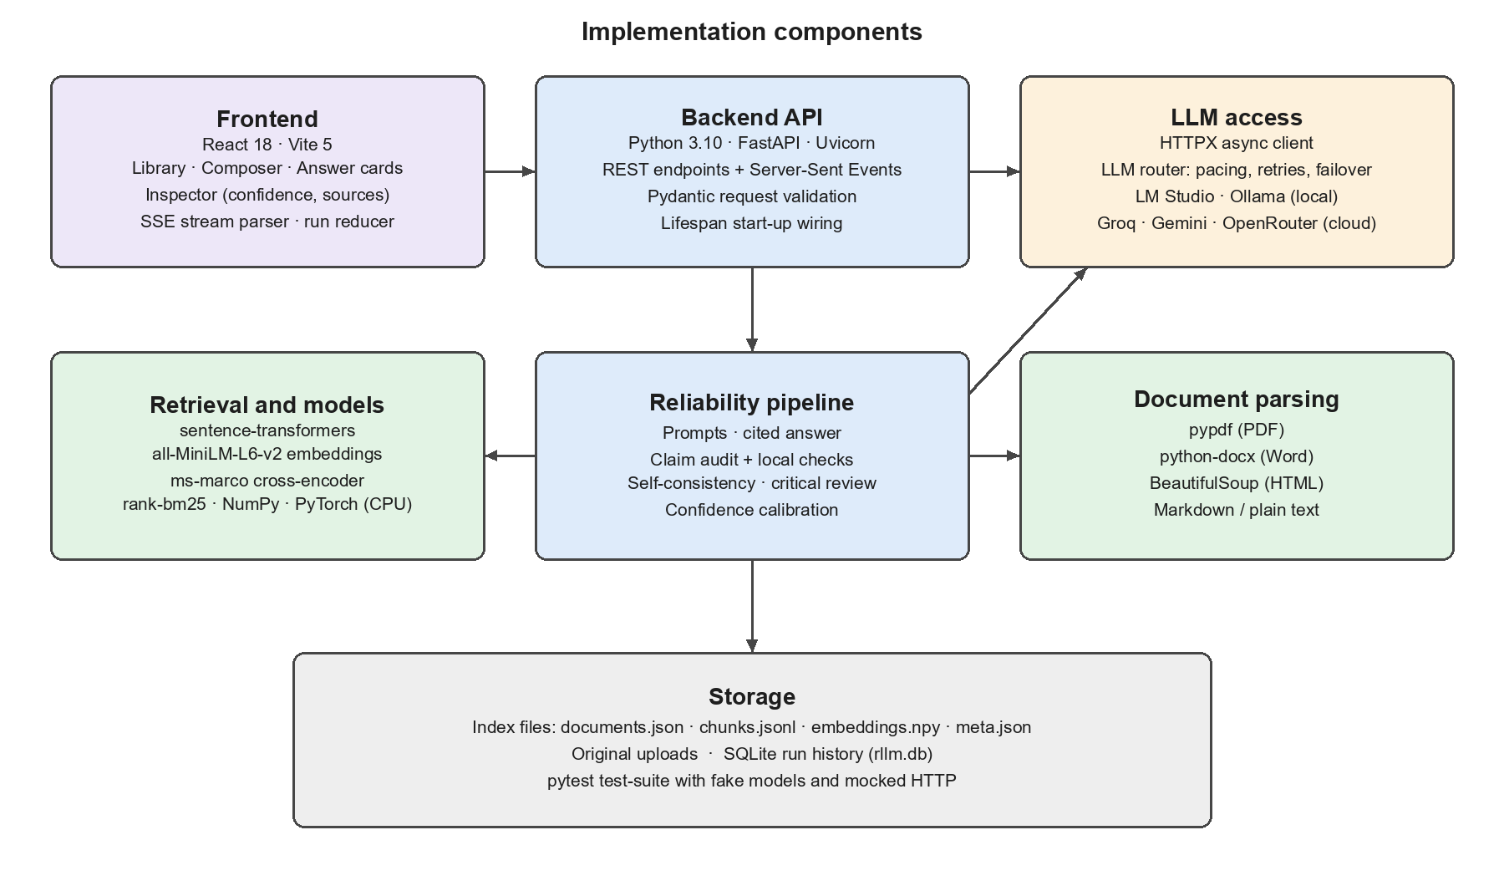
FIGURE 3.1 IMPLEMENTATION COMPONENTS OF THE PROPOSED SYSTEM

3.1.1 PYTHON AND FASTAPI
Python is used for the complete backend: document parsing, chunking, embedding, retrieval, the reliability pipeline, the language-model router, the API server, the evaluation script and the automated tests. FastAPI exposes the functionality through REST endpoints for the library, the run history and metrics, and through a Server-Sent Events endpoint that streams each stage of an answer to the browser.
Pydantic models validate requests, such as the question length, the answer mode and the optional document filter, and pydantic-settings loads every tunable value from a single configuration file. Because FastAPI is asynchronous, the claim audit, the self-consistency check and the critical review can run concurrently once the answer exists. Uvicorn serves the application and reloads it automatically during development.

3.1.2 REACT AND VITE
React is used to build the frontend as a set of components: the document library and run history, the question composer with Fast and Thorough modes, the streamed answer with clickable citations, the claim audit and review cards, and an inspector that shows the confidence gauge, the live pipeline timeline and the source passages. A reducer converts each streamed event into interface state, so live answers and answers reopened from history are displayed by the same components.
Vite provides the development server on port 3000 and forwards every request under /api to the backend on port 8000. The browser therefore talks to a single origin, which avoids cross-origin issues and keeps the backend address out of the frontend code.

3.1.3 SENTENCE-TRANSFORMERS AND RANK-BM25
The Sentence-Transformers library, running on PyTorch, loads two small models on the CPU. The all-MiniLM-L6-v2 bi-encoder converts passages, questions and claims into 384-dimensional vectors used for semantic search and for checking how closely each claim matches a sentence in the sources. The ms-marco-MiniLM-L-6-v2 cross-encoder reads a question and a passage together and returns a relevance score. Both models are loaded from the local cache, so start-up does not depend on an internet connection.
The rank-bm25 library provides the BM25 keyword ranking used alongside semantic search. BM25 is particularly effective for exact terms such as model names, numbers and abbreviations, which embeddings sometimes treat as interchangeable. NumPy stores the embedding matrix and computes similarities.

3.1.4 LM STUDIO AND LANGUAGE-MODEL PROVIDERS
Language models are accessed through plain HTTPS requests with the HTTPX library, without vendor-specific SDKs. LM Studio and Ollama run open-weight models locally, while Groq, Google Gemini and OpenRouter provide free hosted models. In the configuration used in this work, LM Studio serves Meta Llama 3.1 8B Instruct fully on the laptop GPU, and the backend starts the LM Studio server automatically if it has been stopped.
A router sits between the pipeline and the providers. It paces requests to stay within each provider's rate limit, retries temporary failures, and switches to the next provider when one is unavailable or exhausted. Run history is stored in SQLite, which is included with Python, and pytest runs the automated test-suite.

3.1.5 PYDANTIC, HTTPX AND SQLITE
Pydantic defines the data models for API requests and validates them automatically, so that, for example, a question longer than 4,000 characters or an unknown answer mode is rejected with a clear message before any processing begins. The pydantic-settings package reads all configuration values, such as model names, provider order, retrieval parameters and calibration weights, from a single environment file, which makes the system easy to reconfigure without changing code.
HTTPX is an asynchronous HTTP client used to communicate with every language-model provider, including streaming responses token by token. Because the system talks to providers through plain HTTP rather than vendor-specific libraries, adding a new OpenAI-compatible provider requires only a few lines of configuration. SQLite, which is included with Python, stores the complete record of every run in a single file without the need for a separate database server.

3.1.6 DOCUMENT PARSING LIBRARIES
Three libraries handle the conversion of uploaded files into text. pypdf extracts text from PDF documents page by page, which allows each passage to remember its page number for citation. python-docx reads Word documents, including paragraph styles that identify headings and the contents of tables. BeautifulSoup parses HTML pages and preserves their heading structure. Markdown and plain-text files are processed with simple rules that recognise headings and paragraph breaks.

3.1.7 PYTEST
Pytest runs the automated test-suite of the backend. The tests replace the embedding model with a deterministic hashing embedder, the language model with a scripted fake provider, and network calls with mocked HTTP transports. As a result, all 31 tests run in a few seconds without an internet connection and without consuming any API quota, which made it practical to run them after every change.

3.2 HARDWARE REQUIREMENTS
The hardware requirements depend mainly on whether the language model runs locally. With a cloud provider, only the embedding and reranking models run on the computer; they are small and work comfortably on a dual-core processor with 8 GB of RAM and about 5 GB of free storage for packages and models. A stable internet connection is then required for communication with the model provider.
Running the language model locally requires enough memory to hold the model weights. An 8-billion-parameter model in 4-bit quantisation needs about 4 GB, and a GPU greatly reduces generation time. The development and evaluation in this work were performed on a Windows 11 laptop with an NVIDIA GeForce RTX 3050 GPU with 6 GB of memory; 16 GB of RAM and about 15 GB of free storage are recommended for this configuration. The interaction between the frontend, backend and pipeline for one question is illustrated in Figure 3.2, Frontend and Backend Implementation Workflow, and the data kept by the system is shown in Figure 3.3, Storage Layout of Runtime Data.
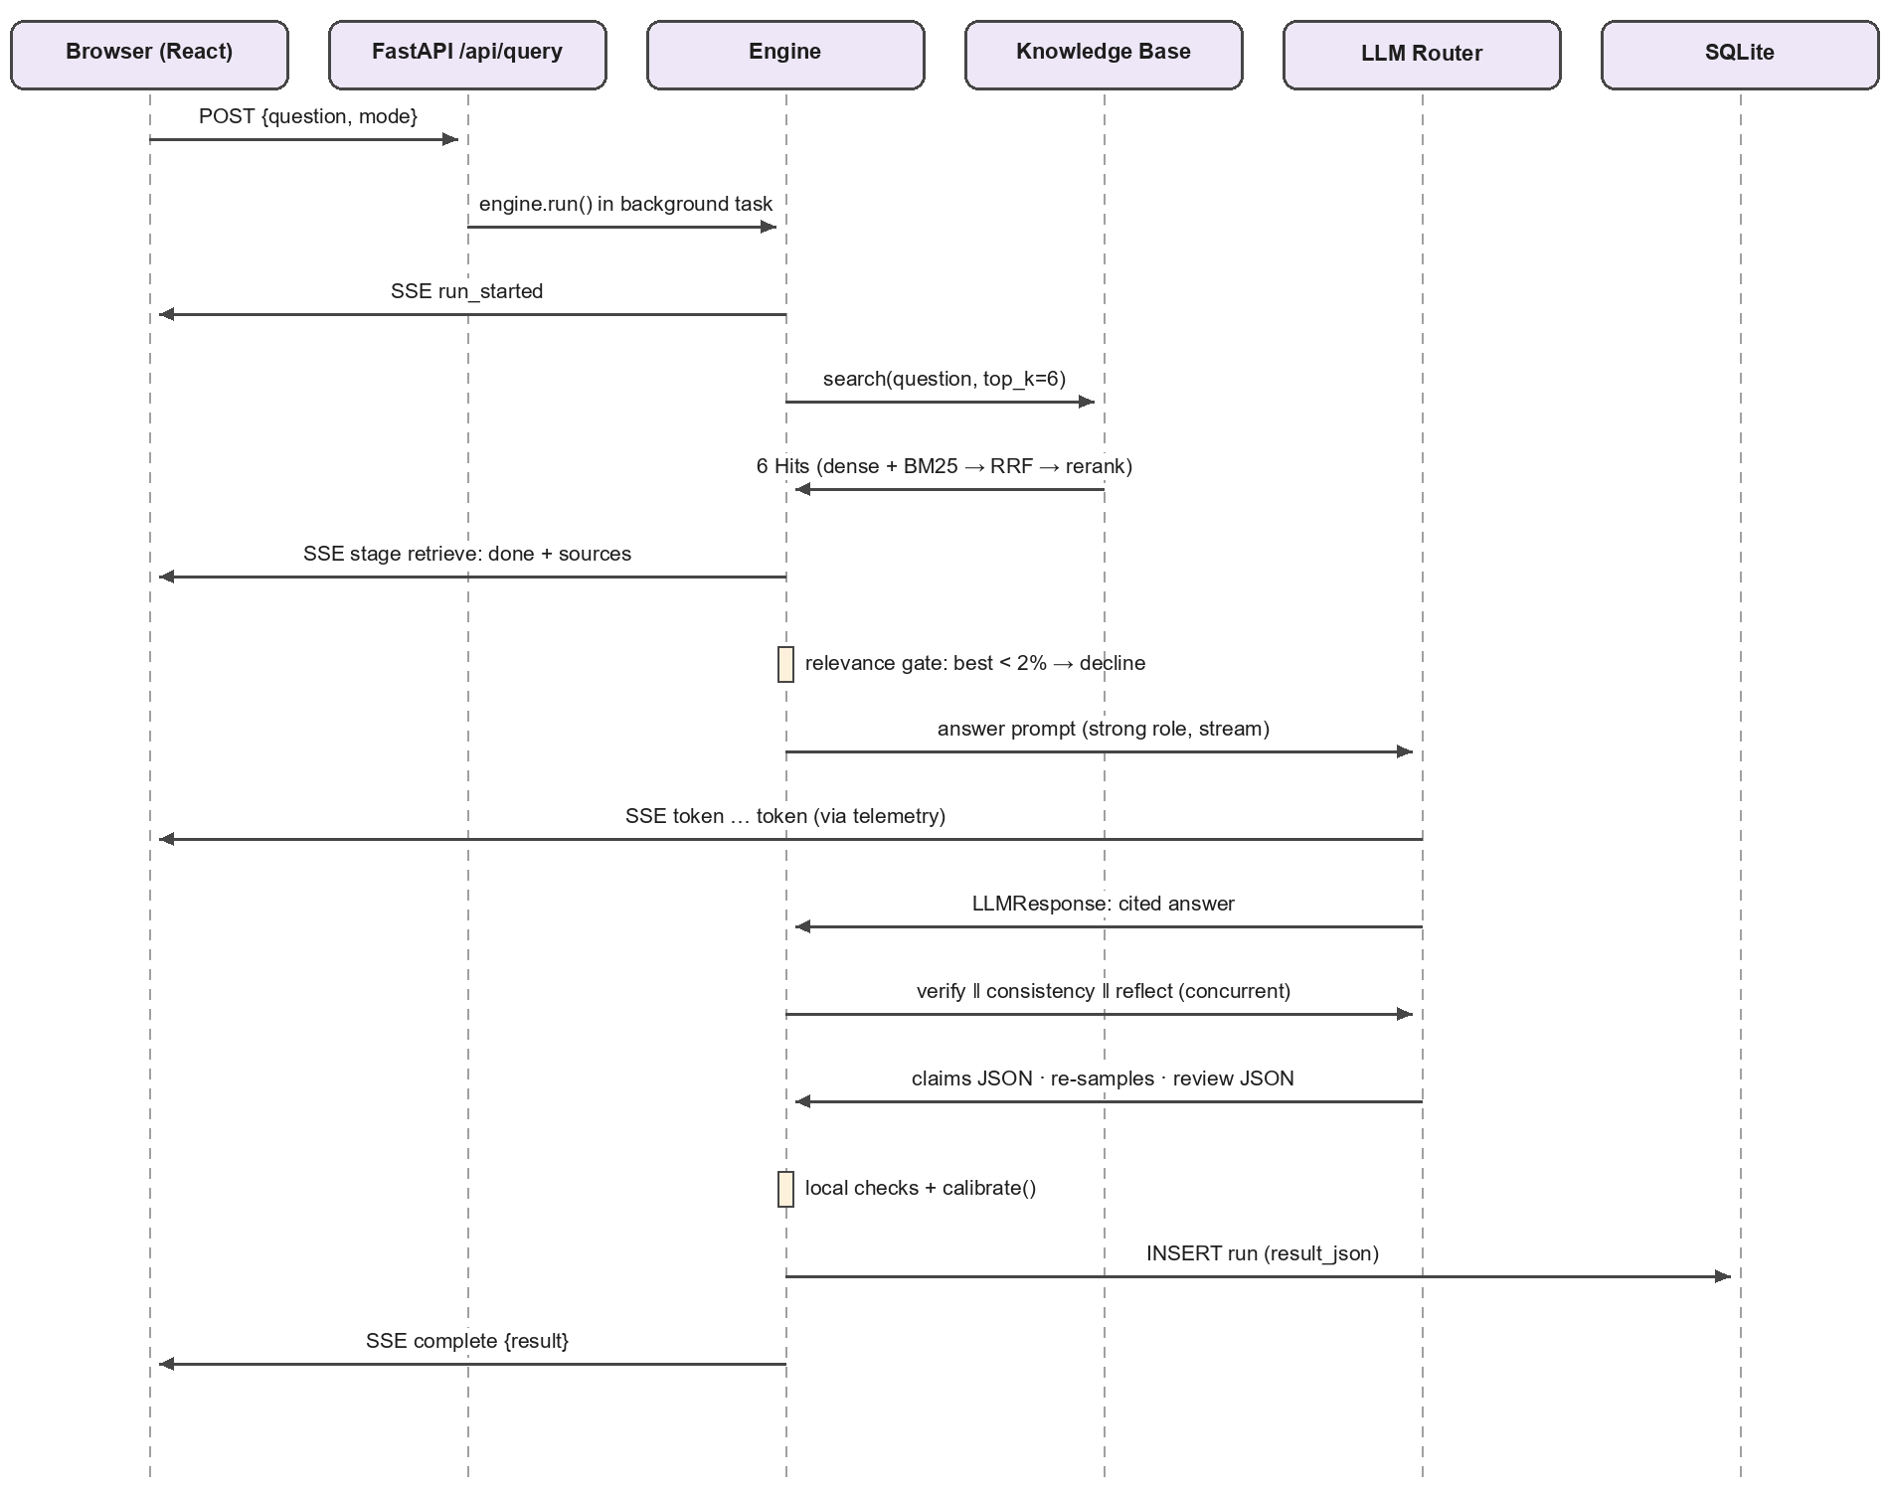
FIGURE 3.2 FRONTEND AND BACKEND IMPLEMENTATION WORKFLOW
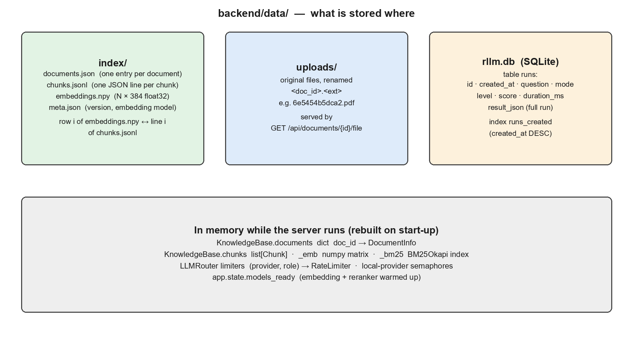
FIGURE 3.3 STORAGE LAYOUT OF RUNTIME DATA

3.3 SOFTWARE REQUIREMENTS
The software requirements of the system are modest. The backend requires Python 3.10 or later together with the packages listed in its requirements file, which are installed automatically into a virtual environment by the setup script. The frontend requires Node.js 18 or later and its packages are installed with npm. A modern web browser such as Chrome, Edge or Firefox is needed to use the interface.
At least one language-model provider must be available. For fully local operation, LM Studio or Ollama is installed and a model is downloaded once; for cloud operation, a free API key from Groq, Google Gemini or OpenRouter is placed in the configuration file. The two small models used for embedding and reranking are downloaded automatically on the first start, about 180 MB in total, and are then loaded from the local cache on every later start.

3.4 DEVELOPMENT AND DEPLOYMENT ENVIRONMENT
The project was developed and tested on Windows 11. A one-time setup script creates the Python virtual environment, installs the backend and frontend packages, creates the configuration file from a template and runs the test-suite. A start script then launches the backend on port 8000 and the frontend on port 3000 in separate windows and opens the application in the browser. When LM Studio is configured as the provider, the start script also starts the LM Studio server and loads the main model fully onto the GPU so that the first question does not wait for the model to load.
The source code is maintained in a Git repository. Runtime data, including uploaded documents, the search index and the run history, is stored in a data folder that is excluded from version control, so that personal documents and API keys are never committed. Equivalent setup and start scripts are provided for Linux and macOS.

CHAPTER 4
EXISTING WORK

4.1 EXISTING DOCUMENT QUESTION-ANSWERING SYSTEMS
Existing tools answer questions about documents in two main ways. In a general chat assistant the question, and sometimes the whole document pasted into the conversation, goes straight to the language model, which answers from its training and from the long context. There is no search step and no link between sentences of the answer and the parts of the document they came from. In a standard retrieval-augmented pipeline the document is cut into fixed-size chunks and stored in a vector index; the nearest chunks are placed in the prompt and the model answers, sometimes with chunk numbers as citations.
A third approach, followed by the base paper, estimates confidence by asking the model to reflect on its own answer. The project's first prototype extended this idea with a ten-step multi-agent pipeline that added fact-checking, consistency, reasoning and similarity agents, each making its own model call. These workflows are illustrated in Figure 4.1, Conventional Document Question-Answering Workflows. In each case the answer is either not checked against its source at all or checked by the same kind of model that produced it.
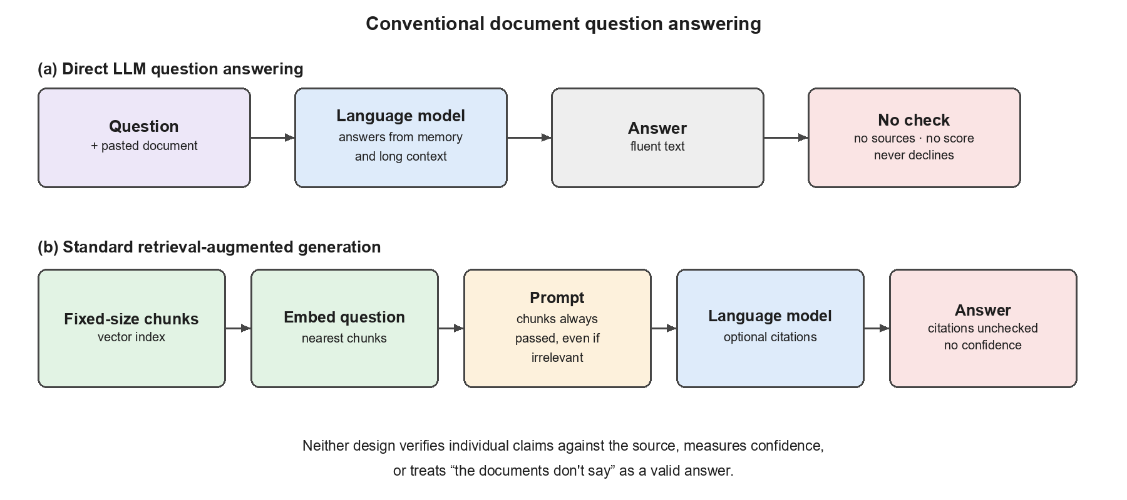
FIGURE 4.1 CONVENTIONAL DOCUMENT QUESTION-ANSWERING WORKFLOWS

4.2 DISADVANTAGES OF EXISTING SYSTEMS
Existing systems have several limitations when an answer must be relied upon. Answers can include facts that are not in the documents, and the reader cannot tell which sentences are supported. Citations, when present, are taken on trust and may point to a passage that says something else or to a passage that does not exist. Retrieved passages are passed to the model even when none of them is relevant, which pressures the model to answer from unrelated text, and answers are judged as a whole, so one unsupported sentence inside an otherwise correct answer goes unnoticed.
Confidence based only on self-reflection comes from the same model that made the mistake. Where several signals are combined, they are often averaged with fixed weights even when one is missing, and nothing prevents a high score when the answer contradicts its source. Pipelines that make one model call per agent or per claim exhaust free API quotas and stall on rate limits; in the first prototype one signal was silently broken and never contributed. Finally, the user sees only the final text, and runs are not stored for later review. These limitations are summarised in Figure 4.2, Limitations of Existing Approaches.
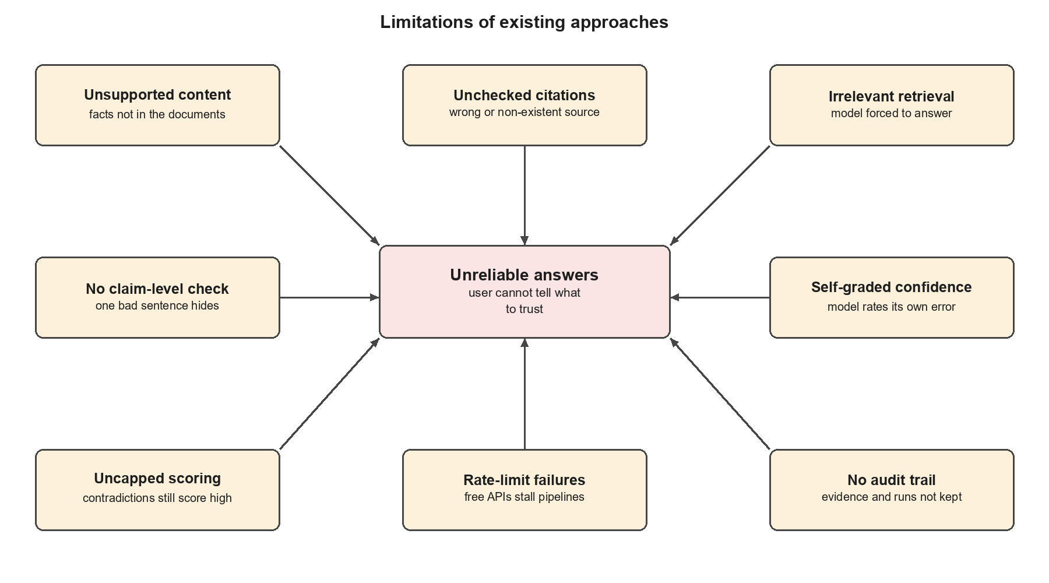
FIGURE 4.2 LIMITATIONS OF EXISTING APPROACHES

4.3 BASE PAPER: CONFIDENCE INTROSPECTION
The base paper of this project, Confidence Introspection: A Self-Reflection Method for Reliable and Helpful Large Language Models, proposes that a model can become more reliable and more helpful if it is trained or prompted to reflect on its own answers and to express a confidence that reflects this introspection. The approach is attractive because it needs only the model itself and can be applied to any question.
Its limitations motivated the present work. The confidence is derived from a single signal produced by the same model that wrote the answer, so an error that comes from a gap in the model's knowledge is likely to survive the reflection. The method does not retrieve external evidence, does not check individual claims, and does not provide a way for the user to see why a particular confidence was given. The proposed system keeps the idea of reflection but places it alongside retrieval, claim verification, consistency checking and calibration, so that it becomes one voice among several rather than the only judge.

4.4 FIRST PROTOTYPE OF THE PROJECT
Before building the present system, the team implemented a first prototype that extended the base paper with a ten-step multi-agent pipeline. It consisted of a BM25 retrieval agent, a response generator, a response sampler, a similarity calculator, a reflection agent, a fact-checking agent, a consistency checker, a reasoning checker, a confidence aggregator and a response improver that rewrote answers with low confidence. The confidence score was a fixed weighted sum of five signals, and the knowledge base was stored as a pickled vector index.
The prototype demonstrated that multiple signals give a more informative confidence than self-reflection alone, but it also revealed practical problems. Each agent made its own model call, so a single question required around ten calls and quickly exhausted the limits of free API tiers; the pipeline stalled for minutes when a provider returned rate-limit errors. Retrieval relied on keywords only, the fixed weights were applied even when a signal was missing, and an error in the consistency calculator was silently caught, so that signal never contributed to the score. These lessons directly shaped the design of the current system.

4.5 NEED FOR THE PROPOSED SYSTEM
The review of existing approaches shows a clear need for a system that grounds answers in the user's documents, verifies individual claims with checks that the model cannot simply talk its way past, treats declining as a correct outcome, and explains its confidence. It must also be dependable in practice: it should keep working when a free provider imposes rate limits, when the internet connection is unavailable or when a local model server is restarted.
The proposed system was designed around these needs. It reduces the number of model calls per question from about ten to five in Thorough mode and two in Fast mode, replaces keyword-only retrieval with hybrid retrieval and reranking, adds independent local checks to the claim audit, renormalises and caps the confidence score, and records every run so that results can be reviewed and evaluated.

CHAPTER 5
PROPOSED WORK

5.1 SYSTEM ARCHITECTURE
The proposed system follows a modular architecture that connects the user interface, the backend API, the knowledge base, the reliability pipeline, the language-model router and the run history. Users upload documents and ask questions through the web interface. The backend parses and indexes documents, and for each question runs a pipeline of six stages: evidence retrieval, cited answer generation, claim audit, self-consistency, critical review and confidence calibration.
A telemetry layer lets every stage report its progress, and the backend streams these events to the browser so that the answer, the sources and the audit appear while they are produced. Every completed run is stored with its sources, verdicts, timings and model calls. The overall architecture is illustrated in Figure 5.1, Proposed System Architecture.
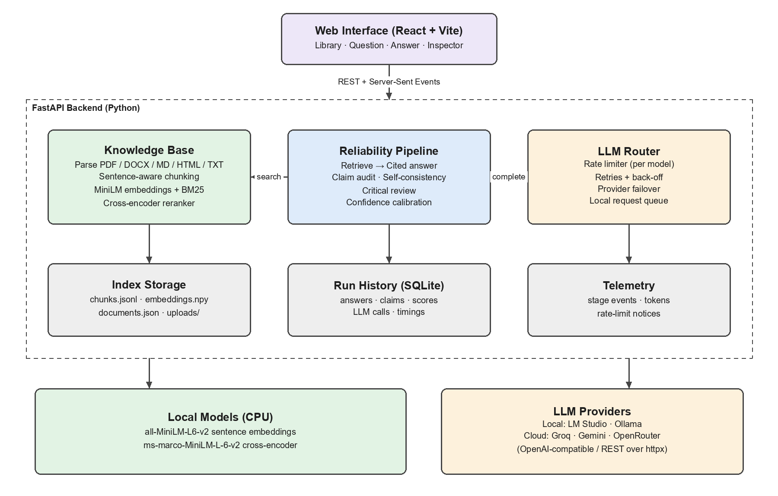
FIGURE 5.1 PROPOSED SYSTEM ARCHITECTURE

5.2 DOCUMENT INGESTION AND CHUNKING
Documents enter through the library panel, which accepts several files at once. Each file is checked for size and emptiness, and its SHA-256 hash is compared with the stored documents so that duplicates are rejected. A parser chosen by the file extension turns the file into text blocks annotated with their page number and section heading; PDF pages are read in order, Word headings and tables are preserved, and Markdown and HTML headings become section names.
The chunker groups blocks by page and section, splits them into sentences and accumulates sentences until a chunk reaches about 200 words, carrying the last 40 words into the next chunk so that facts spanning a boundary are not lost. A chunk never mixes two pages or two sections. Each chunk is embedded, the BM25 index is rebuilt, and the index is written to disk atomically. This process is shown in Figure 5.2, Document Ingestion Pipeline.
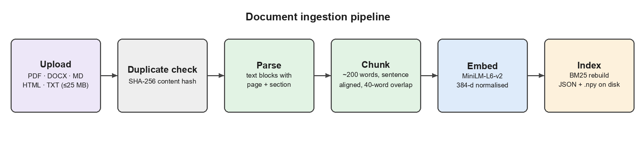
FIGURE 5.2 DOCUMENT INGESTION PIPELINE

5.3 HYBRID RETRIEVAL AND RELEVANCE GATE
For each question the system runs two searches. Dense search compares the embedded question with every chunk by cosine similarity, and sparse search scores every chunk with BM25. The two rankings are merged with Reciprocal Rank Fusion, in which each chunk receives the sum of 1/(60 + rank) over the rankings, and the best 24 candidates are re-scored by the cross-encoder. Because the cross-encoder was trained on web searches, the final relevance of a passage is the larger of its reranker probability and a normalised dense similarity, so that clearly on-topic passages are not pushed to zero by short questions.
The six most relevant passages are kept. Before any language-model call, a relevance gate examines the best relevance value; if it is below 2%, the documents do not cover the question and the system declines immediately. If the question is about a document as a whole, the opening passages of each document are used instead. The retrieval process is illustrated in Figure 5.3, Hybrid Retrieval with Reranking and Relevance Gate.
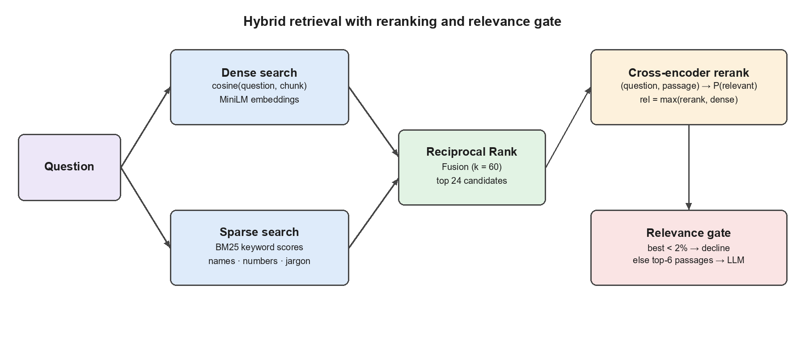
FIGURE 5.3 HYBRID RETRIEVAL WITH RERANKING AND RELEVANCE GATE

5.4 EVIDENCE-GROUNDED ANSWER GENERATION
The six passages are numbered and placed in the prompt with the question. The instructions tell the model to use only facts stated in the sources, never to add outside knowledge, to cite the supporting source numbers after every factual sentence, to answer the covered part and state what is missing when the sources are incomplete, and to begin with a fixed decline sentence when the sources do not contain the answer at all. The answer is generated at a low temperature and streamed to the interface token by token.
After generation, the citation markers are extracted and separated into valid citations and citations to passages that do not exist. A reply that opens with the decline sentence is recorded as declined, even if it goes on to mention related content, and is shown to the user as “Declined” rather than as a low-confidence answer. The answer generation and the verification stages that follow it are shown in Figure 5.4, Answer Generation and Verification Pipeline.
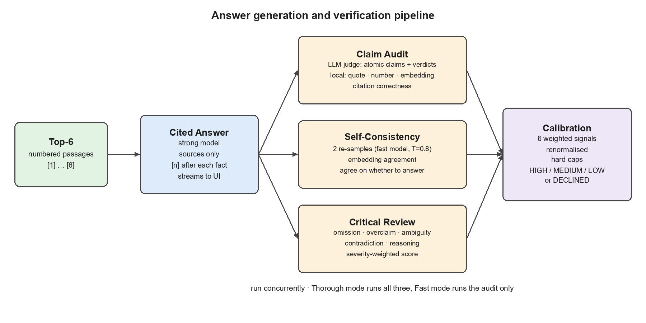
FIGURE 5.4 ANSWER GENERATION AND VERIFICATION PIPELINE

5.5 CLAIM-LEVEL VERIFICATION
The claim audit determines, for every factual statement in the answer, whether the sources support it. An LLM judge splits the answer into at most ten atomic claims and returns a verdict for each one, supported, partial, contradicted or not found, together with the best source number and a short verbatim quote. Because a judge can itself be wrong, every verdict is cross-checked locally. The quote must really appear in the cited source; every number in the claim must appear in the supporting passage; each claim is matched with its closest source sentence by embedding similarity; and the citation must point to a passage that supports the claim. A “supported” verdict that fails these checks is downgraded to “partial”.
If the judge is unavailable, the answer's sentences are verified with the local checks alone and the final score is capped. The audit produces four values used later in scoring: claim support, semantic grounding, citation accuracy and the unsupported-claim rate. The procedure is shown in Figure 5.5, Claim Audit Procedure.
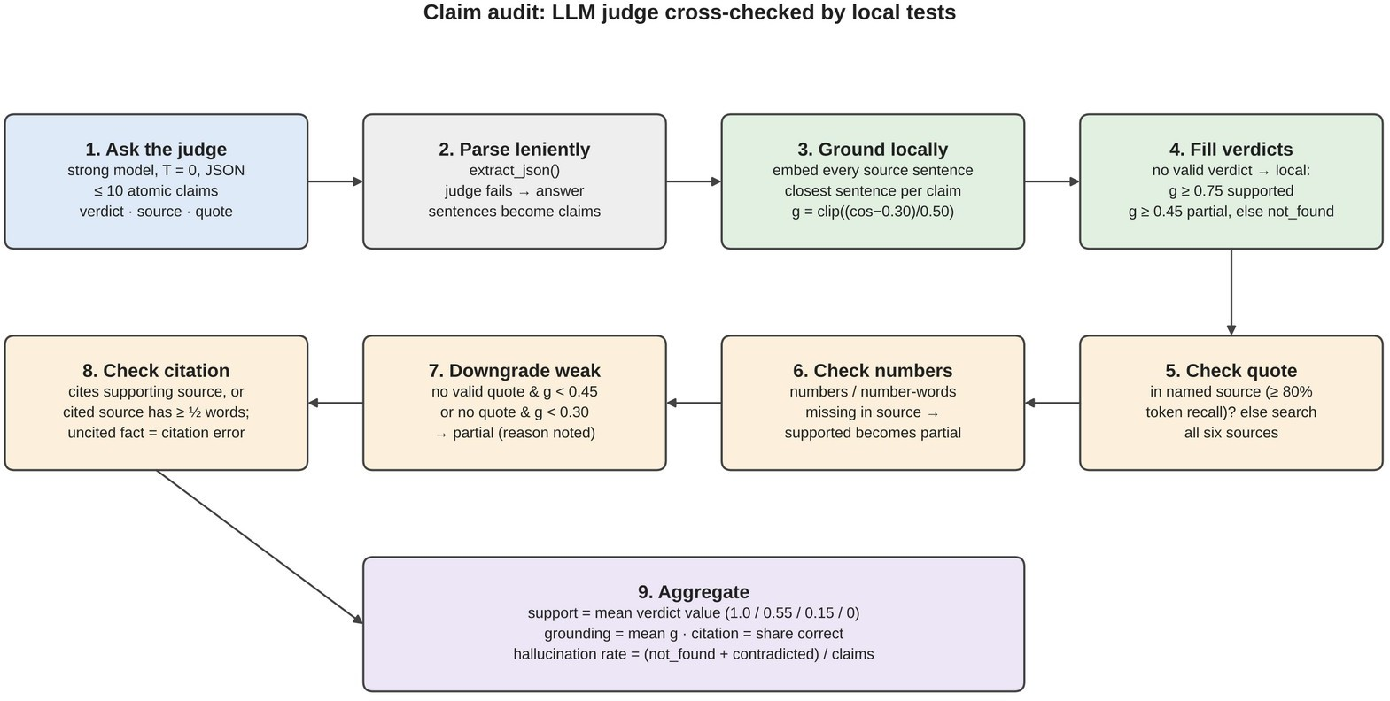
FIGURE 5.5 CLAIM AUDIT PROCEDURE

5.6 SELF-CONSISTENCY AND CRITICAL REVIEW
In Thorough mode the same question is asked twice more at a higher temperature. The answer and the re-samples are embedded and compared, so that paraphrases of the same answer score close to one, and the score is reduced when the re-samples disagree about whether the question can be answered at all. A model that is unsure of a fact tends to change it between samples, which this check exposes.
A reviewer prompt then critiques the answer against the sources without rewriting it. It reports whether the question was actually answered, an overall score, and a list of issues classified as omission, overclaim, ambiguity, contradiction, reasoning or irrelevance, each with a severity. The review score averages the reviewer's own score with a rule-based score derived from the severities, so that one inconsistent number from a small model cannot dominate.

5.7 CONFIDENCE CALIBRATION
The calibration stage combines six signals into one score: claim support with a weight of 0.35, semantic grounding 0.15, citation accuracy 0.10, self-consistency 0.15, critical review 0.15 and retrieval relevance 0.10. Because Fast mode skips two stages and a stage may fail, the weights are renormalised over the signals that were computed. Hard caps then prevent a high score in the presence of serious problems: a contradicted claim limits the score to 0.50, more than one third of unsupported claims to 0.55, a reviewer finding that the question was not answered to 0.60, and a citation to a non-existent source to 0.70.
The score is mapped to HIGH at 0.80 or above, MEDIUM at 0.60 or above and LOW otherwise, and answers scoring at least 0.60 are marked reliable. Declined answers are reported separately and count as reliable, since declining is the correct behaviour when the documents do not cover a question. A plain-language explanation names the strongest and weakest signals and any caps applied. The workflow is shown in Figure 5.6, Confidence Scoring Workflow.
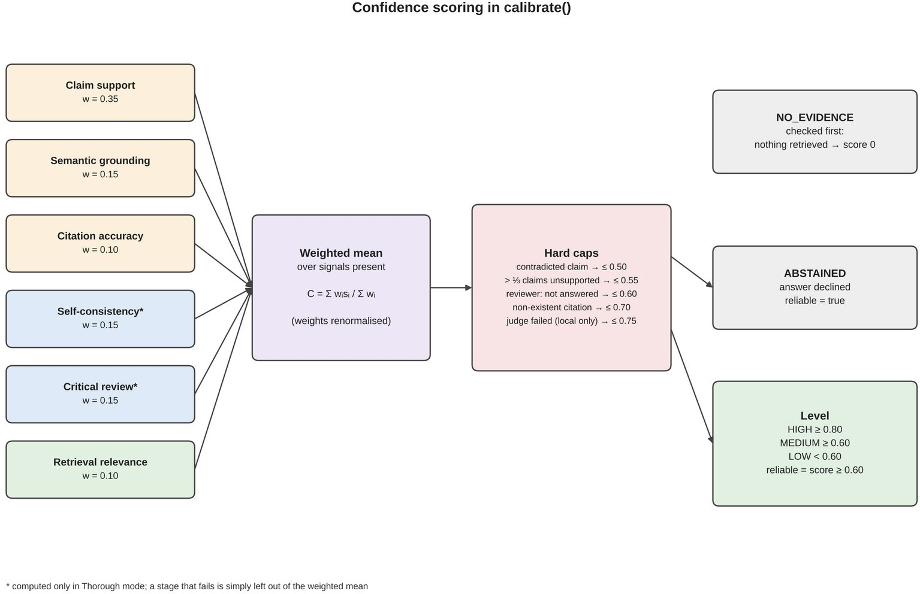
FIGURE 5.6 CONFIDENCE SCORING WORKFLOW

5.8 LANGUAGE-MODEL ROUTING AND IMPLEMENTATION WORKFLOW
Every model call passes through the router. Each request carries a role, strong for the answer, audit and review or fast for re-samples, so that providers can map roles to different models. A sliding one-minute rate limiter waits before a request would exceed a provider's limit; rate-limited and temporary errors are retried; and a provider whose wait is too long, whose daily quota is exhausted or whose key is rejected is replaced by the next one. Local servers process one generation at a time, so their calls are queued, and the LM Studio server is restarted automatically if it has stopped. The router is shown in Figure 5.7, Language-Model Router.
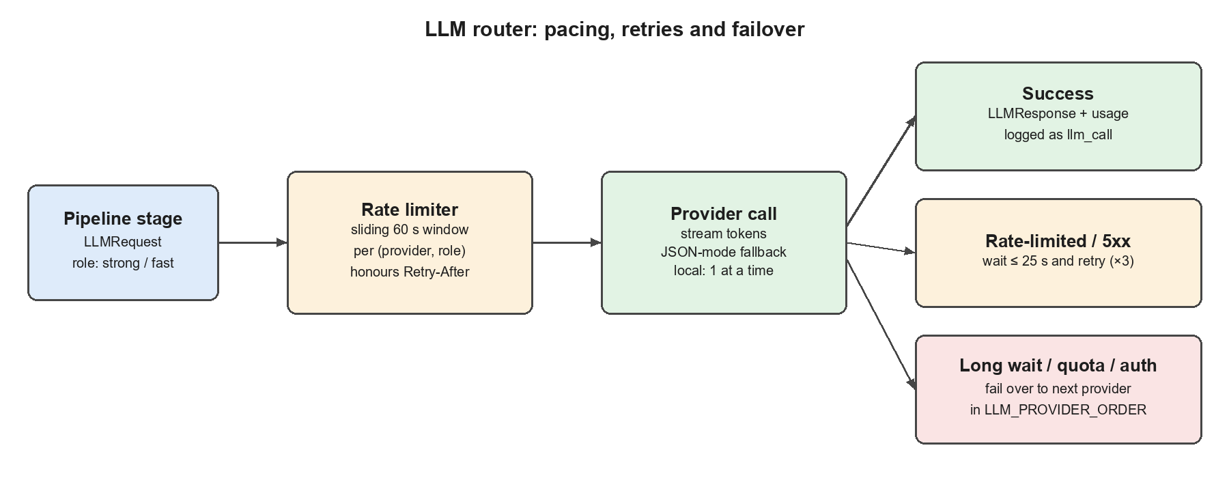
FIGURE 5.7 LANGUAGE-MODEL ROUTER: PACING, RETRIES AND FAILOVER
The two answer modes trade speed for depth. Fast mode runs retrieval, the cited answer and the claim audit with two model calls, while Thorough mode adds the re-samples and the critical review for a total of five calls. Their processing flows are compared in Figure 5.8, Fast and Thorough Modes.
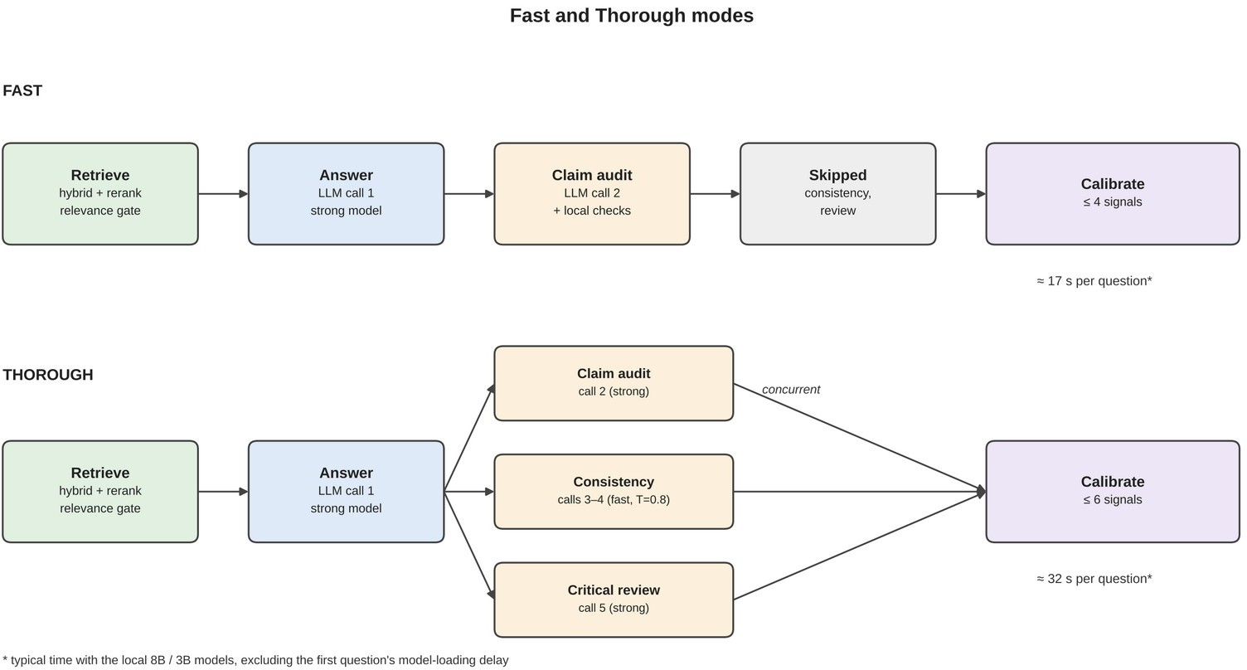
FIGURE 5.8 FAST AND THOROUGH MODES

5.9 QUESTION SUBMISSION AND ANSWER PRESENTATION
A user uploads documents through the library panel, chooses Fast or Thorough mode and types a question. The backend validates the request and starts the pipeline, streaming each event to the browser. The sources appear as soon as retrieval finishes, the answer appears word by word with clickable citation numbers that highlight the corresponding passage, and the claim audit, review and confidence breakdown are filled in as each stage completes. Rate-limit waits and provider switches are shown as notices so that the user understands any delay.
Every run is saved and can be reopened from the history list with exactly the same display. The application screenshots are provided in Appendix 2. The interactions of the user, the language-model provider and the evaluator with the system are summarised in Figure 5.9, Use Case Diagram of the Proposed System.
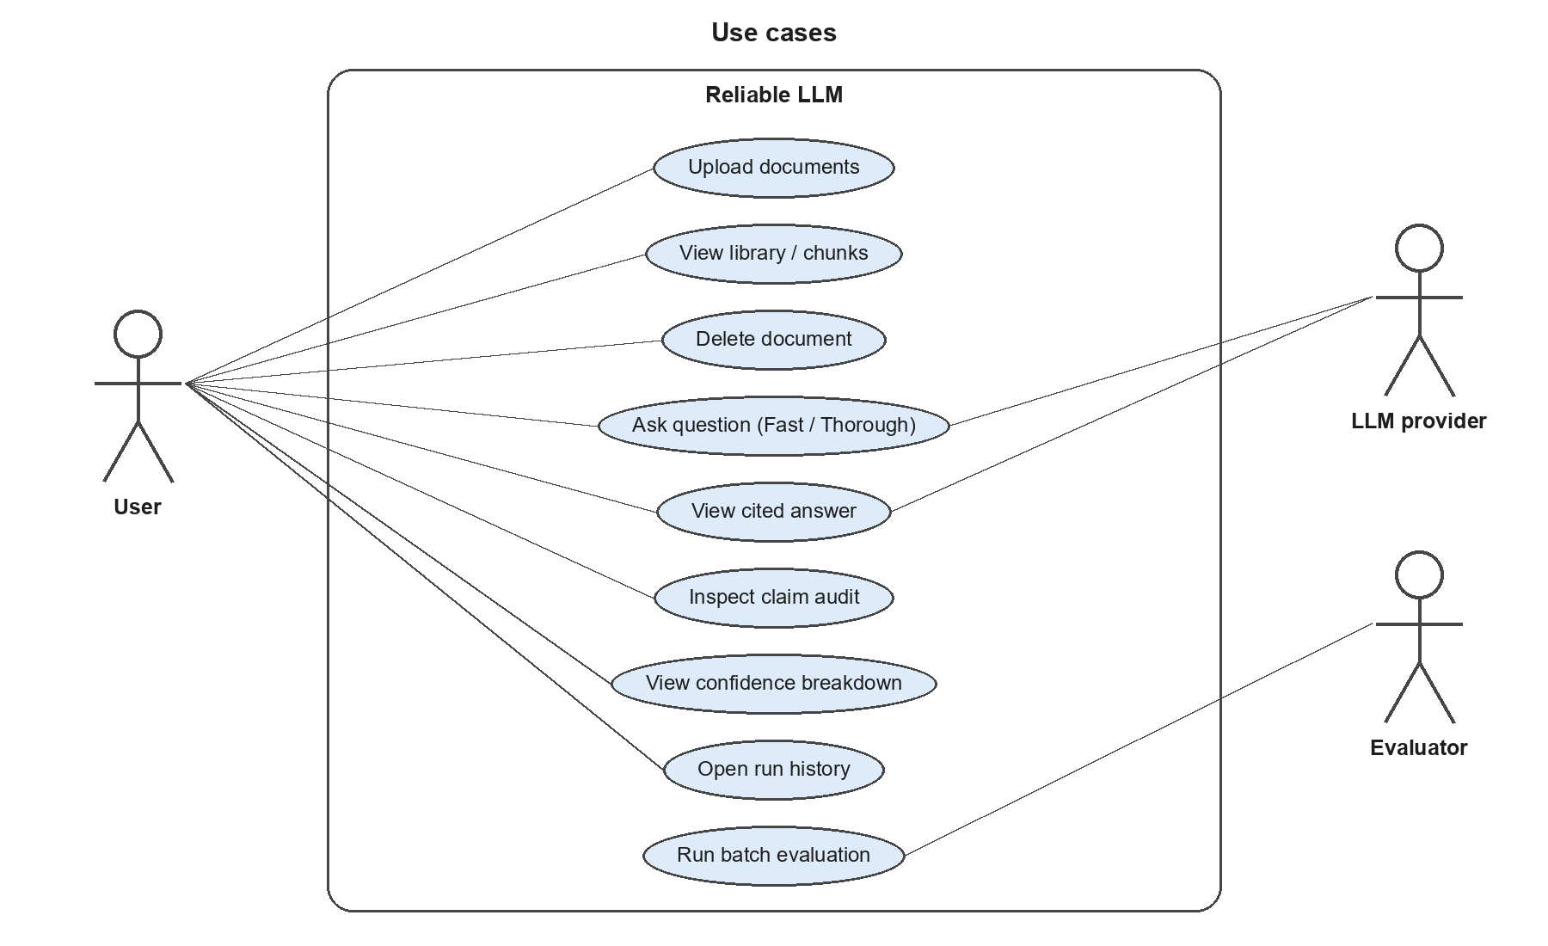
FIGURE 5.9 USE CASE DIAGRAM OF THE PROPOSED SYSTEM

5.10 MULTI-AGENT VIEW OF THE PIPELINE
The reliability pipeline can be understood as a team of specialised agents coordinated by an orchestrator. The retrieval agent searches the knowledge base and decides whether evidence exists. The answering agent writes a cited answer from that evidence. The auditing agent examines each claim against its source and is itself supervised by deterministic checks. The consistency agent re-asks the question independently to test whether the answer is stable. The reflective reviewer critiques the answer for omissions, overclaims, ambiguity and reasoning errors. The calibration agent combines all findings into a score and an explanation.
The orchestrator, implemented in the engine module, runs these agents in a fixed order with one important exception: once the answer exists, the auditing, consistency and review agents work concurrently because they do not depend on each other. Each agent reports its progress through a shared event channel, so the user can watch the agents work in real time. This division of responsibility makes the framework agentic and self-reflective while keeping every decision traceable.

5.11 ALGORITHMS OF THE KEY STAGES

5.11.1 HYBRID RETRIEVAL ALGORITHM
The retrieval algorithm takes a question, the number of passages to return and an optional list of documents. It first embeds the question and computes the cosine similarity with every passage, and separately computes the BM25 score of every passage. It then takes the top 24 passages from each ranking, assigns every passage the sum of 1/(60 + rank) over the rankings in which it appears, and keeps the 24 highest-scoring candidates. Each candidate is scored by the cross-encoder, the score is converted to a probability, and the final relevance is the larger of this probability and a normalised cosine similarity. The candidates are sorted by relevance and the top six are returned with all their scores.

5.11.2 CLAIM AUDIT ALGORITHM
The audit algorithm sends the passages, the question and the answer to the judge and asks for at most ten atomic claims with a verdict, a source number and a short verbatim quote for each. It then embeds every sentence of the six passages once and, for each claim, finds the closest sentence and computes a grounding score. The quote is searched for in the named source and, if it is not found there, in all six sources. Numbers in the claim are compared with numbers in the supporting passage. A verdict of supported is downgraded to partial when the numbers do not match or when the evidence is weak, and each claim's citation is marked correct only if it points to a supporting passage. Finally, the algorithm computes the mean claim support, mean grounding, citation accuracy and the share of unsupported claims.

5.11.3 CONFIDENCE CALIBRATION ALGORITHM
The calibration algorithm returns a score of zero with the level NO_EVIDENCE if nothing was retrieved. Otherwise it keeps only the signals that were computed, divides the weighted sum of their values by the sum of their weights, and applies the caps for contradictions, unsupported claims, an unanswered question, invalid citations and an unavailable judge, recording each cap that lowers the score. If the answer was a decline, the level is ABSTAINED; otherwise the score is mapped to HIGH, MEDIUM or LOW and a plain-language explanation naming the strongest and weakest signals is generated.

5.12 DATA STORAGE AND RUN HISTORY
All runtime data is stored in plain files under a single data folder. The search index consists of a JSON file describing each document, a JSON Lines file with one record per passage, a NumPy file containing the 384-value embedding of every passage in the same order, and a small metadata file recording the index version and the embedding model. The original uploaded files are kept so that they can be downloaded again. The BM25 index is rebuilt in memory whenever the library is loaded or changed, and the index is written through a temporary folder so that an interruption cannot leave it half-written.
Every completed run is stored in a SQLite table with the question, mode, confidence level, score and duration as separate columns for fast listing, and the complete result as a JSON document. The stored result includes the answer and its citations, the retrieved passages with their scores, every claim verdict, the consistency samples, the review, the confidence components, the duration of each stage and every language-model call. This audit trail allows any answer to be reopened and examined later, and supports aggregate metrics such as the distribution of confidence levels and the unsupported-claim rate.

5.13 APPLICATION PROGRAMMING INTERFACE
The backend exposes a REST interface that the frontend uses and that can also be used by other programs. Endpoints are provided to report the system status and configuration, to list, upload and delete documents, to inspect how a document was chunked, to download an original file, to list, open and delete past runs, and to obtain aggregate metrics. Interactive documentation of all endpoints is generated automatically and is available in the browser while the backend runs.
Questions are submitted to a streaming endpoint that returns Server-Sent Events. The stream reports the start of the run, the status of every stage with its results, each token of the answer, notices about rate-limit waits or provider switches, every model call, and finally the complete result. A non-streaming version of the same endpoint returns only the final result and is used by the evaluation script. If the browser disconnects while an answer is being produced, the run is cancelled so that no further model calls are made.

5.14 ERROR HANDLING AND RELIABILITY OF THE APPLICATION
Because the application depends on external services, it was designed to degrade gracefully. If the reranking model cannot be loaded, retrieval continues with hybrid scores alone. If the language-model judge fails or returns unreadable output, the claim audit falls back to local checks and the confidence is capped to reflect the weaker verification. If one of the concurrent verification stages fails, its signal is omitted and the weights of the remaining signals are renormalised, so that one failure does not stop the whole answer.
Provider problems are handled by the router, which classifies errors as rate limits, daily quota exhaustion, authentication failures, unknown models, server errors, network errors or empty responses, and reacts to each appropriately by waiting, retrying or switching provider. Two problems observed during development led to specific improvements: the local models are now loaded from the disk cache without contacting the internet, which reduced start-up from about two minutes to a few seconds on an unreliable connection, and the LM Studio server is restarted automatically when it has been stopped.

5.15 SECURITY AND PRIVACY CONSIDERATIONS
When the system runs with a local model through LM Studio or Ollama, the user's documents and questions never leave the computer, which makes it suitable for private or confidential material. When a cloud provider is used, only the question and the six retrieved passages are sent for each request, not the whole document.
API keys are stored only in the local configuration file, which is excluded from version control, and are never sent to the browser. Uploaded files are limited to supported formats and a maximum size of 25 MB, duplicate files are rejected by their content hash, and all requests are validated before processing. By default the backend listens only on the local machine, its cross-origin policy allows browser requests only from the configured frontend address, and the application is intended to run on the user's own machine rather than as a public service.

CHAPTER 6
RESULTS AND DISCUSSION

6.1 TESTING
Testing verified that the application operates according to its functional requirements. The backend includes an automated suite of 31 test cases that run offline with a deterministic stand-in for the embedding model, a scripted language model and mocked HTTP responses, so they consume no API quota. All 31 tests passed. They cover document parsing and chunking, index persistence, duplicate detection, router retries, failover and pacing, provider response handling, calibration caps, the relevance gate, whole-document questions, decline detection, automatic restart of the LM Studio server and the complete flow from upload to streamed answer and history.
One test checks that a judge which reports evidence that does not exist is caught: the judge's quote is not found in the source, its verdict is downgraded and the answer cannot reach HIGH confidence. Integration was also checked live against the running application with real documents and the local model, including answerable questions, off-topic questions that were declined in about three seconds without a model call, and on-topic questions whose answers are not in the document.
The test cases can be grouped into five categories. Knowledge-base tests check that Markdown, HTML, Word and text files are parsed with their sections, that chunks respect page and section boundaries, and that the index can be saved, reloaded and searched after a document is removed. Router tests check retries after rate limits, failover on long waits, daily quota and authentication errors, pacing to the configured request rate and the serialisation of calls to local servers. Provider tests check response parsing, streaming, the fallback when a model rejects JSON output, and the filtering of hidden reasoning text. Pipeline tests check calibration caps, abstention, the relevance gate, whole-document questions and the detection of declines. API tests exercise the complete flow from upload to streamed answer, history and metrics.

6.2 EVALUATION OF ANSWERS AND CONFIDENCE
The system was evaluated with its batch script on a research paper on fake-news detection, which was indexed into 30 passages. Twenty questions were prepared: fifteen with short expected answers covering numbers, model names, methods and dataset statistics, and five whose answers are not in the paper. Both modes were run on the same questions with local Llama 3.1 8B and Llama 3.2 3B models, so that Thorough mode differs from Fast mode only by the self-consistency and review stages.
Both modes answered 14 of the 15 answerable questions correctly according to the automatic metric, an accuracy of 93.3%. The single miss was an answer that named the classifiers by their abbreviations, which the word-overlap metric did not match; checked by hand, all fifteen answers were correct and every one carried a citation. In Thorough mode the system declined all five unanswerable questions, giving an abstention accuracy of 100%, and the claim audit found no unsupported claims among 24 claims. In Fast mode it declined three of the five; in the other two the model opened with the decline sentence but added a cited remark, which the code at that time did not count as a decline. This was corrected after the evaluation. Even then, both answers were scored LOW, below the reliability threshold. The main metrics are compared in Figure 6.1, Fast and Thorough Mode Comparison.
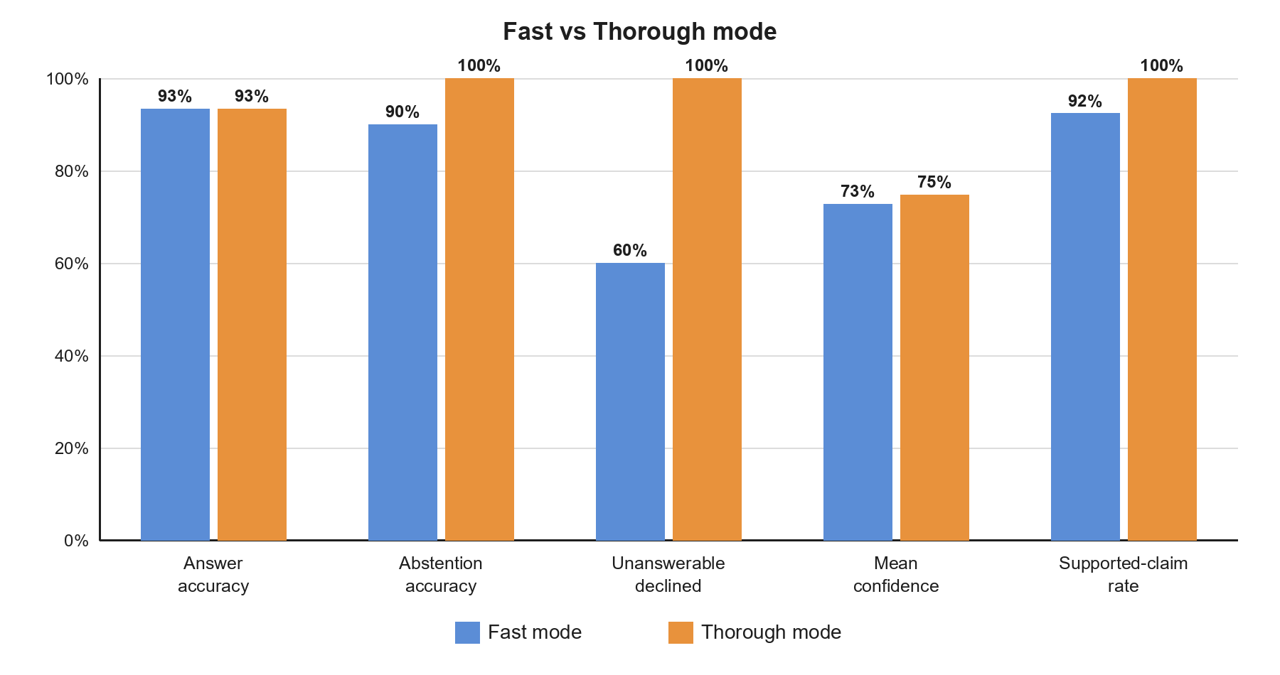
FIGURE 6.1 FAST AND THOROUGH MODE COMPARISON
The confidence score separated answerable from unanswerable questions clearly: answerable questions averaged 0.90 in Fast mode and 0.89 in Thorough mode, while unanswerable ones averaged 0.20 and 0.32. Calibration was better in Thorough mode, where the Expected Calibration Error fell from 0.092 to 0.042, meaning that the scores were on average within about four percentage points of the observed accuracy. The score of every question is shown in Figure 6.2, Confidence Score per Question.
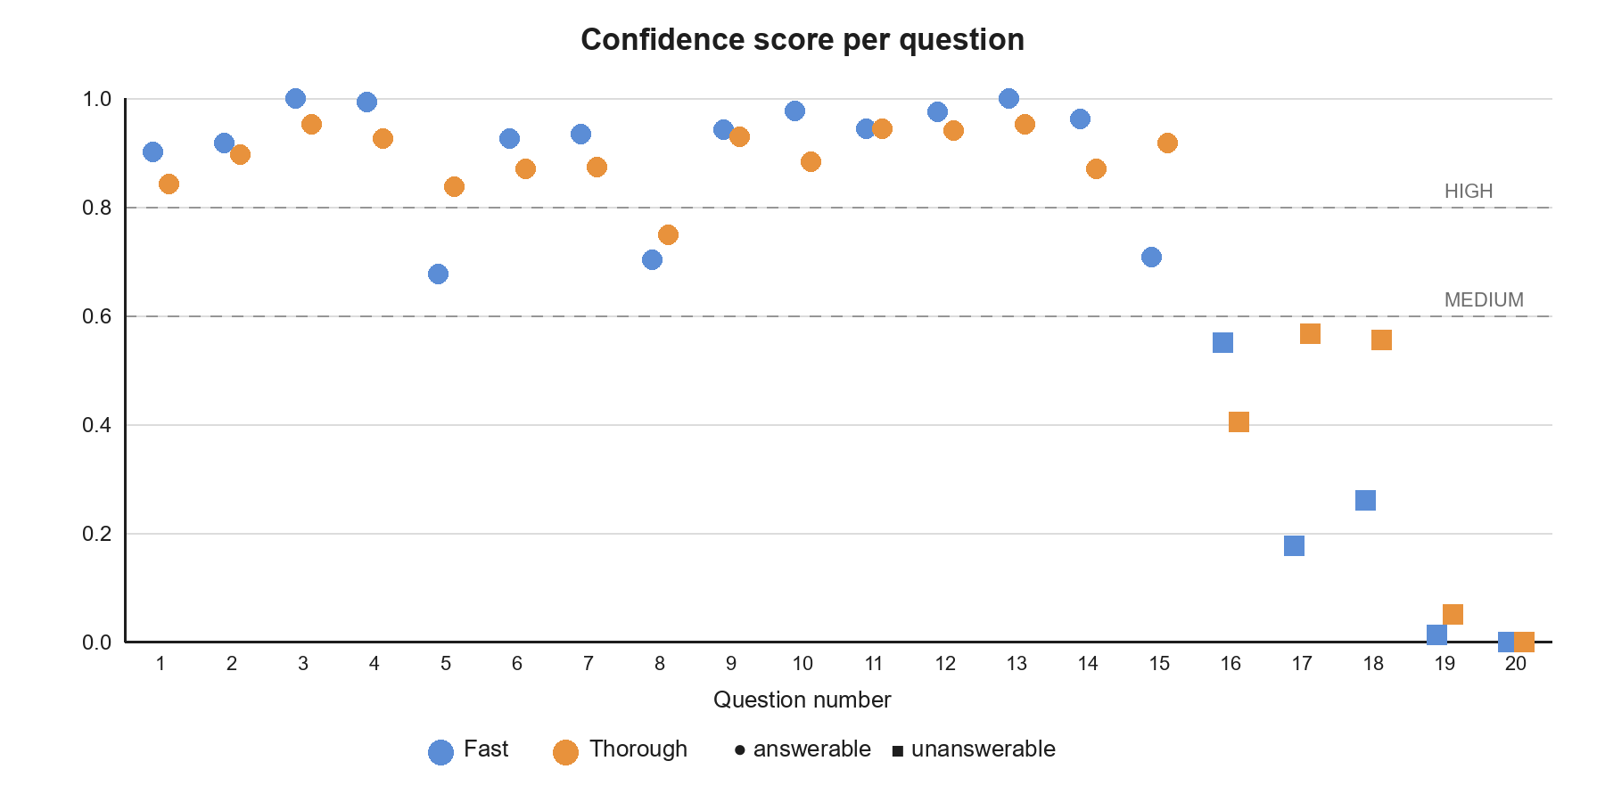
FIGURE 6.2 CONFIDENCE SCORE PER QUESTION
Speed is the main cost of the extra checking. Excluding the first question of each run, which included loading the model, Fast mode took 17.3 seconds per question and Thorough mode 31.6 seconds on the laptop. With the 8B model loaded fully on the GPU for both roles, later measurements gave about 12 to 15 seconds for Fast mode and about 30 seconds for Thorough mode. The latency results are shown in Figure 6.3, Mean Latency per Question.
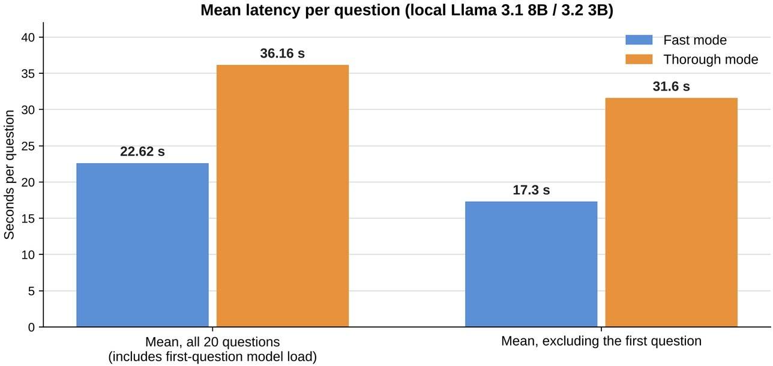
FIGURE 6.3 MEAN LATENCY PER QUESTION

6.3 DISCUSSION OF SYSTEM FUNCTIONALITY
The system integrates document management, hybrid retrieval, cited answer generation, claim-level verification and confidence scoring into one application. The evaluation showed that the pipeline works end to end on modest local hardware, answers correctly with citations, declines when it should, and produces confidence scores that track whether an answer can be trusted. In one case the paper itself was inconsistent, reporting the highest accuracy for a different model in two places; the answer reported both figures and its confidence fell to LOW (0.50), which is the intended behaviour.
The evaluation has clear limits. It used one document, twenty questions written by the team and a single run of each mode, and accuracy was measured by word overlap. With only fifteen labelled answers, the difference in calibration between the modes should be read as encouraging rather than conclusive. Larger and more varied question sets, several documents and repeated runs are needed before general conclusions can be drawn.

6.4 CASE STUDIES
Individual runs illustrate how the stages work together. For the question “Which machine learning models are used to detect fake news?” in Thorough mode, the system retrieved six passages with a best relevance of 100%, and the answer listed gradient boosting models, ensemble methods, a neural network, Random Forest and Logistic Regression with citations. The claim audit found six supported claims, two partially supported claims and one claim not found in the sources; the re-samples agreed fully with the answer; and the reviewer noted that a convolutional neural network with margin loss, mentioned in one of the sources, had been omitted. The final confidence was HIGH at 85%, and the explanation shown to the user named these findings.
For the question “What is RAG?”, the library contained no relevant passage: the best relevance was 0% and the system declined in about three seconds without calling the language model. For “Which GPU was used to train the models?”, the passages were on topic but did not contain the answer; the model itself began with the decline sentence and the system recorded the answer as declined. For “Which model achieved the highest accuracy?”, the paper reports 99.9% for a Decision Tree in one section and identifies CatBoost with 95.72% as the best model in another; the answer reported both figures and its confidence fell to LOW (0.50), correctly warning the user that the evidence was inconsistent.

6.5 PERFORMANCE ANALYSIS
The time taken by a question is dominated by the language-model calls. In a representative Thorough-mode run on the laptop GPU, retrieval took about 3 seconds, generating the answer about 3.5 seconds, the claim audit about 7.5 seconds, the critical review about 16 seconds and the self-consistency re-samples about 23 seconds, giving a total of about 30 seconds. Because the local server processes one generation at a time, the three verification stages are queued rather than run in parallel; with a cloud provider they would overlap and the total time would be closer to the duration of the slowest stage.
Several measures keep the system responsive. The relevance gate answers off-topic questions in about three seconds, declined answers skip the audit and review, Fast mode needs only two model calls, and the answer is streamed so that the user starts reading within a few seconds. Using the same 8-billion-parameter model for both roles on a 6 GB GPU avoided swapping models in and out of video memory, reducing a typical model call from 5–20 seconds to 3–9 seconds.

6.6 COMPARISON WITH EXISTING APPROACHES
Compared with a general chat assistant, the proposed system restricts every answer to the user's documents, shows the passages it used, and declines when they are insufficient. Compared with a standard retrieval-augmented pipeline, it adds a relevance gate, verifies each claim and its citation, and produces a calibrated confidence score instead of an unqualified answer. Compared with the base paper's self-reflection, it grounds the reflection in source passages and combines it with five other signals, two of which are computed without the language model.
Compared with the team's first prototype, the proposed system reduces the number of model calls per question by half or more, replaces keyword-only retrieval with hybrid retrieval and reranking, never silently ignores a failed signal, keeps working through rate limits and provider failures, and stores a complete audit trail of every run. These improvements made it possible to run the full verification pipeline on a laptop with free local models.

6.7 LIMITATIONS
The system has limitations that should be considered when interpreting the results. The model sees only the six most relevant passages, so answers that need information spread across many sections of a long document may be incomplete. The reranking model was trained on web-search queries and can under-score short or vague questions, although the dense-similarity floor reduces this effect. Content in tables, figures and scanned pages is not yet verified, and the claim audit can be no better than the passages it is given.
The evaluation itself was small: one document, twenty questions written by the team, a single run of each mode and an accuracy metric based on word overlap. Local models of 8 and 3 billion parameters are also weaker than large hosted models, so the results may differ with other models. Addressing these limitations is the main focus of the future work described in Chapter 7.

CHAPTER 7
CONCLUSION AND FUTURE WORK

7.1 CONCLUSION
The project, A Multi-Agent Self-Reflective Agentic RAG Framework for Enhancing the Reliability of Large Language Models, presents a question-answering system that does not ask its user to take answers on faith. It answers only from the user's documents, cites a source after every factual sentence, checks each claim against the passage it cites, compares the answer with fresh attempts, has a reviewer look for gaps, and turns these results into a confidence score that can be opened and examined. When the documents do not contain the answer, it says so.
Two design choices made the largest difference. Refusing to let the language model be the only judge allowed simple checks on quotes and numbers to catch mistakes that a model-based audit could miss, and the relevance gate stopped off-topic questions before the model saw them. The router turned a pipeline that stalled on free API tiers into one that runs reliably, including fully offline on a laptop. Compared with the first prototype, the system needs five model calls per question in Thorough mode and two in Fast mode instead of about ten, has 31 automated tests, and keeps a complete record of every run.
The project also showed the value of treating reliability as an engineering property that can be tested. Every rule of the system, from the relevance gate to the confidence caps, is implemented in a small, testable function, and the complete pipeline is covered by automated tests that run without a network. The batch evaluation script made it possible to measure the effect of design decisions with accuracy, abstention and calibration metrics instead of relying on impressions from a few examples.
From the user's point of view, the most important outcome is transparency. Instead of a single block of text, the user sees the passages behind the answer, a verdict and quote for every claim, the result of the consistency check, the reviewer's comments, and a confidence score with an explanation of how it was obtained. This allows the user to decide how much to rely on an answer, which is the central aim of the project.

7.2 FUTURE WORK
Future enhancements may include evaluation on public grounded question-answering benchmarks and on libraries with many documents, with repeated runs so that differences can be tested for significance. The signal weights and caps could be learned from a labelled validation set rather than chosen by hand, and a reranker trained on academic text could replace the web-search model. Answers that fail verification could be repaired by rewriting only the faulty sentences, and content in tables, figures and scanned pages could be extracted and verified with OCR and vision-language models. Support for multi-user deployment with authentication and per-user libraries would allow the system to be used by a class or a team.
In the longer term, the framework could be extended to support conversations in which follow-up questions refer to earlier answers, while keeping every answer grounded and audited. Multilingual documents and questions could be supported by replacing the embedding and reranking models with multilingual versions. The answer repair idea could be developed into a self-correcting loop in which sentences that fail verification are rewritten from the evidence and audited again before the answer is shown.
Integration with learning-management systems would allow students to ask questions about course materials with confidence that the answers come from those materials, and would let instructors see which parts of the material generate the most questions. Finally, a larger user study with students and researchers could measure whether the transparent audit actually changes how much people trust and check the answers, which is the ultimate test of a reliability-focused assistant.

REFERENCES
- Retrieval-Augmented Generation for Knowledge-Intensive NLP TasksPatrick Lewis et al. NeurIPS (2020), Introduces the foundational RAG architecture, combining a neural retriever with a language generator.
- Asai, A., Wu, Z., Wang, Y., Sil, A. and Hajishirzi, H. (2024). Self-RAG: Learning to Retrieve, Generate, and Critique through Self-Reflection. International Conference on Learning Representations (ICLR).
- Cormack, G. V., Clarke, C. L. A. and Büttcher, S. (2009). Reciprocal Rank Fusion Outperforms Condorcet and Individual Rank Learning Methods. Proceedings of the 32nd International ACM SIGIR Conference on Research and Development in Information Retrieval, 758–759.
- Dubey, A., et al. (2024). The Llama 3 Herd of Models. arXiv preprint arXiv:2407.21783.
- Es, S., James, J., Espinosa-Anke, L. and Schockaert, S. (2024). RAGAS: Automated Evaluation of Retrieval Augmented Generation. Proceedings of the 18th Conference of the European Chapter of the Association for Computational Linguistics: System Demonstrations, 150–158.
- Gao, T., Yen, H., Yu, J. and Chen, D. (2023). Enabling Large Language Models to Generate Text with Citations. Proceedings of the 2023 Conference on Empirical Methods in Natural Language Processing, 6465–6488.
- Guo, C., Pleiss, G., Sun, Y. and Weinberger, K. Q. (2017). On Calibration of Modern Neural Networks. International Conference on Machine Learning (ICML), 1321–1330.
- Huang, L., Yu, W., Ma, W., Zhong, W., Feng, Z., Wang, H., Chen, Q., Peng, W., Feng, X., Qin, B. and Liu, T. (2025). A Survey on Hallucination in Large Language Models: Principles, Taxonomy, Challenges, and Open Questions. ACM Transactions on Information Systems, 43(2).
- Ji, Z., Lee, N., Frieske, R., Yu, T., Su, D., Xu, Y., Ishii, E., Bang, Y. J., Madotto, A. and Fung, P. (2023). Survey of Hallucination in Natural Language Generation. ACM Computing Surveys, 55(12), 1–38.
- Kadavath, S., et al. (2022). Language Models (Mostly) Know What They Know. arXiv preprint arXiv:2207.05221.
- Karpukhin, V., Oguz, B., Min, S., Lewis, P., Wu, L., Edunov, S., Chen, D. and Yih, W. (2020). Dense Passage Retrieval for Open-Domain Question Answering. Proceedings of the 2020 Conference on Empirical Methods in Natural Language Processing, 6769–6781.
- Kuhn, L., Gal, Y. and Farquhar, S. (2023). Semantic Uncertainty: Linguistic Invariances for Uncertainty Estimation in Natural Language Generation. International Conference on Learning Representations (ICLR).
- Lewis, P., Perez, E., Piktus, A., Petroni, F., Karpukhin, V., Goyal, N., Küttler, H., Lewis, M., Yih, W., Rocktäschel, T., Riedel, S. and Kiela, D. (2020). Retrieval-Augmented Generation for Knowledge-Intensive NLP Tasks. Advances in Neural Information Processing Systems 33, 9459–9474.
- Madaan, A., et al. (2023). Self-Refine: Iterative Refinement with Self-Feedback. Advances in Neural Information Processing Systems 36.
- Manakul, P., Liusie, A. and Gales, M. J. F. (2023). SelfCheckGPT: Zero-Resource Black-Box Hallucination Detection for Generative Large Language Models. Proceedings of the 2023 Conference on Empirical Methods in Natural Language Processing, 9004–9017.
- Min, S., Krishna, K., Lyu, X., Lewis, M., Yih, W., Koh, P. W., Iyyer, M., Zettlemoyer, L. and Hajishirzi, H. (2023). FActScore: Fine-Grained Atomic Evaluation of Factual Precision in Long Form Text Generation. Proceedings of the 2023 Conference on Empirical Methods in Natural Language Processing, 12076–12100.
- Naeini, M. P., Cooper, G. and Hauskrecht, M. (2015). Obtaining Well Calibrated Probabilities Using Bayesian Binning. Proceedings of the AAAI Conference on Artificial Intelligence, 29(1).
- Nguyen, T., Rosenberg, M., Song, X., Gao, J., Tiwary, S., Majumder, R. and Deng, L. (2016). MS MARCO: A Human Generated Machine Reading Comprehension Dataset. arXiv preprint arXiv:1611.09268.
- Nogueira, R. and Cho, K. (2019). Passage Re-ranking with BERT. arXiv preprint arXiv:1901.04085.
- Reimers, N. and Gurevych, I. (2019). Sentence-BERT: Sentence Embeddings using Siamese BERT-Networks. Proceedings of the 2019 Conference on Empirical Methods in Natural Language Processing, 3982–3992.
APPENDIX 1
calibrate.py
Confidence calibration.
Six signals, each in [0, 1], are combined with configurable weights that are
renormalised over whichever signals are available (fast mode, or a stage
that failed, simply drops out). Hard caps then encode rules no weighted
average should be able to override — e.g. a contradicted claim.
from __future__ import annotations
from dataclasses import asdict, dataclass, field
from typing import List, Optional
from .stages import AnswerResult, ConsistencyResult, ReflectionResult, VerificationResult
COMPONENTS = [
("support", "Claim support", "Share of claims the auditor found backed by the sources"),
("grounding", "Semantic grounding", "How closely each claim matches a real source sentence (local embeddings)"),
("citation", "Citation accuracy", "Claims carry a citation, and it points at a source that backs them"),
("consistency", "Self-consistency", "Agreement between the answer and independent re-samples"),
("reflection", "Critical review", "Reviewer's score after penalising omissions and overclaims"),
("retrieval", "Retrieval relevance", "How relevant the cited passages are to the question"),
]

@dataclass
class Confidence:
score: float
level: str
headline: str
explanation: str
components: List[dict]
caps: List[str] = field(default_factory=list)
reliable: bool = Fals
def to_dict(self) -> dict:
return asdict(self)
def _level(score: float) -> str:
return "HIGH" if score >= 0.80 else "MEDIUM" if score >= 0.60 else "LOW"
def retrieval_signal(relevances_all: List[float], cited: List[int]) -> Optional[float]:
if not relevances_all:
return None
if cited:
vals = [relevances_all[i - 1] for i in cited if 1 <= i <= len(relevances_all)]
else:
vals = sorted(relevances_all, reverse=True)[:3]
return round(sum(vals) / len(vals), 4) if vals else None
def calibrate(settings, answer: Optional[AnswerResult], relevances: List[float],
verification: Optional[VerificationResult],
consistency: Optional[ConsistencyResult],
reflection: Optional[ReflectionResult],
threshold: float = 0.6) -> Confidence:
weights = {
"support": settings.W_SUPPORT, "grounding": settings.W_GROUNDING,
"citation": settings.W_CITATION, "consistency": settings.W_CONSISTENCY,
"reflection": settings.W_REFLECTION, "retrieval": settings.W_RETRIEVAL,
}
values = {
"support": verification.support if verification else None,
"grounding": verification.grounding if verification else None,
"citation": verification.citation if verification else None,
"consistency": consistency.score if consistency else None,
"reflection": reflection.score if reflection else None,
"retrieval": retrieval_signal(relevances, answer.citations if answer else []),
}
if not relevances:
return Confidence(
score=0.0, level="NO_EVIDENCE", headline="No supporting evidence",
explanation="Nothing relevant was retrieved from your documents, so no answer could be grounded.",
components=_components(values, weights), reliable=False,
)
present = {k: v for k, v in values.items() if v is not None and weights[k] > 0}
total_w = sum(weights[k] for k in present) or 1.0
score = sum(present[k] * weights[k] for k in present) / total_w
caps: List[str] = []
def cap(limit: float, reason: str):
nonlocal score
if score > limit:
score = limit
caps.append(reason)
if verification and verification.counts.get("contradicted"):
cap(0.50, "A claim contradicts the sources")
if verification and verification.hallucination_rate is not None and verification.hallucination_rate > 0.34:
cap(0.55, "Over a third of claims are not in the sources")
if reflection and reflection.answers_question is False:
cap(0.60, "Reviewer judged that the question was not actually answered")
if answer and answer.invalid_citations:
cap(0.70, "Answer cites sources that don't exist")
if verification and not verification.judge_ok and verification.claims:
cap(0.75, "Claims verified by local similarity only (auditor model unavailable)")
score = round(max(0.0, min(1.0, score)), 4)
if answer and answer.abstained:
agree = consistency.abstention_agreement if consistency else None
expl = "The documents don't appear to cover this question, so the system declined to guess."
if agree is not None:
expl += f" Re-samples agreed on declining {agree:.0%} of the time."
return Confidence(score=score, level="ABSTAINED", headline="Declined — not in your documents",
explanation=expl, components=_components(values, weights), caps=caps,
reliable=True)
level = _level(score)
return Confidence(
score=score, level=level, headline=_headline(level),
explanation=_explain(values, verification, consistency, reflection, caps),
components=_components(values, weights), caps=caps, reliable=score >= threshold,
)
def _components(values: dict, weights: dict) -> List[dict]:
present_w = sum(weights[k] for k, v in values.items() if v is not None) or 1.0
out = []
for key, label, desc in COMPONENTS:
v = values.get(key)
out.append({
"key": key, "label": label, "description": desc,
"value": None if v is None else round(v, 4),
"weight": round(weights[key] / present_w, 3) if v is not None else 0.0,
})
return out
def _headline(level: str) -> str:
return {
"HIGH": "Well supported by your documents",
"MEDIUM": "Partly supported — review flagged claims",
"LOW": "Weakly supported — verify before relying on it",
}[level]
def _explain(values, v: Optional[VerificationResult], c: Optional[ConsistencyResult],
r: Optional[ReflectionResult], caps: List[str]) -> str:
parts: List[str] = []
if v and v.claims:
n = len(v.claims)
sup = v.counts.get("supported", 0)
part = v.counts.get("partial", 0)
bad = v.counts.get("not_found", 0) + v.counts.get("contradicted", 0)
s = f"{sup} of {n} claim{'s' if n != 1 else ''} directly supported"
if part:
s += f", {part} partly"
if bad:
s += f", {bad} not backed by the sources"
parts.append(s + ".")
if c and c.score is not None:
if c.score >= 0.75:
parts.append(f"Independent re-samples agreed with the answer ({len(c.samples)} checked).")
elif c.score >= 0.45:
parts.append("Re-samples partly diverged from the answer.")
else:
parts.append("Re-samples gave noticeably different answers — a sign of uncertainty.")
if r and r.issues:
high = [i for i in r.issues if i["severity"] == "high"]
if high:
parts.append(f"Reviewer flagged: {high[0]['detail'].rstrip('.')}.")
else:
parts.append(f"Reviewer noted {len(r.issues)} minor issue{'s' if len(r.issues) != 1 else ''}.")
if caps:
parts.append(f"Capped: {caps[0].lower()}.")
return " ".join(parts) or "Confidence is based on retrieval relevance only."
store.py — KnowledgeBase.search()
def search(self, query: str, top_k: int = 6, pool: int = 24,
doc_ids: Optional[List[str]] = None) -> List[Hit]:
with self._lock:
n = len(self.chunks)
if n == 0 or not query.strip():
return []
chunks = self.chunks
emb = self._emb
bm25 = self._bm25
allowed = np.ones(n, dtype=bool)
if doc_ids:
wanted = set(doc_ids)
allowed = np.array([c.doc_id in wanted for c in chunks], dtype=bool)
if not allowed.any():
return []
q = self.embedder.encode([query])[0]
dense = emb @ q
sparse = np.array(bm25.get_scores(_tokens(query)), dtype=np.float64) if bm25 else np.zeros(n)
dense = np.where(allowed, dense, -np.inf)
sparse = np.where(allowed, sparse, -np.inf)
pool = max(top_k, min(pool, n))
dense_rank = np.argsort(-dense)[:pool]
sparse_rank = [i for i in np.argsort(-sparse)[:pool] if sparse[i] > 0]
rrf: Dict[int, float] = {}
for rank, i in enumerate(dense_rank):
if np.isfinite(dense[i]):
rrf[int(i)] = rrf.get(int(i), 0.0) + 1.0 / (60 + rank + 1)
for rank, i in enumerate(sparse_rank):
rrf[int(i)] = rrf.get(int(i), 0.0) + 1.0 / (60 + rank + 1)
candidates = sorted(rrf, key=rrf.get, reverse=True)[:pool]
if not candidates:
return []
rerank_scores = None
if self.reranker is not None and self.reranker.available:
try:
rerank_scores = self.reranker.score(query, [chunks[i].text for i in candidates])
except Exception as e:
log.warning("Rerank failed: %s", e)
# Newer sentence-transformers versions may already return probabilities.
already_prob = rerank_scores is not None and all(0.0 <= x <= 1.0 for x in rerank_scores)
hits: List[Hit] = []
for j, i in enumerate(candidates):
d = float(dense[i])
# MiniLM cosine: ~0.15 unrelated … ~0.7 strong match
dense_rel = max(0.0, min(1.0, (d - 0.15) / 0.55))
if rerank_scores is not None:
r = rerank_scores[j]
rr_rel = r if already_prob else _sigmoid(r)
# The ms-marco cross-encoder is trained on web queries and scores
# short / acronym questions ("what is RLLM?") near zero even when
# the passage is on-topic. Never let it drag relevance below what
# the embedding match already shows.
rel = max(rr_rel, dense_rel)
else:
rel = dense_rel
hits.append(Hit(chunk=chunks[i], relevance=rel, dense=d,
sparse=float(sparse[i]) if np.isfinite(sparse[i]) else 0.0,
rerank=None if rerank_scores is None else rerank_scores[j]))
if rerank_scores is not None:
hits.sort(key=lambda h: (h.relevance, h.rerank), reverse=True)
log.debug("rerank scores for %r: %s", query, [round(h.rerank, 2) for h in hits[:top_k]])
# (without a reranker, RRF order is kept)
hits = hits[:top_k]
for r, h in enumerate(hits, start=1):
h.rank = r
return hits
stages.py — generate_answer()
async def generate_answer(router: LLMRouter, question: str, hits: List[Hit],
on_token: Optional[TokenCallback] = None,
max_tokens: int = 1200) -> AnswerResult:
resp = await router.complete(LLMRequest(
prompt=prompts.answer_prompt(question, hits), system=prompts.ANSWER_SYSTEM,
temperature=0.2, max_tokens=max_tokens, role="strong", purpose="answer",
), on_token=on_token)
cites = parse_citations(resp.text)
valid = sorted({c for c in cites if 1 <= c <= len(hits)})
invalid = sorted({c for c in cites if not 1 <= c <= len(hits)})
return AnswerResult(
text=resp.text, citations=valid, invalid_citations=invalid,
# The prompt lets a decline add one cited sentence about what the sources
# do cover, so citations don't make it an answer.
abstained=is_abstention(resp.text),
provider=resp.provider, model=resp.model, latency_ms=resp.latency_ms,
)
app.py — streaming query endpoint
@app.post("/api/query")
async def query_stream(request: Request, body: QueryRequest):
engine: Engine = request.app.state.engine
question = body.question.strip()
loop = asyncio.get_running_loop()
queue: asyncio.Queue = asyncio.Queue()
DONE = object()
def emit(event: str, data: dict):
loop.call_soon_threadsafe(queue.put_nowait, (event, data))
async def producer():
try:
await engine.run(question, _opts(body), emit)
except PipelineError as e:
emit("error", {"message": e.message, "kind": e.kind})
except Exception as e:
log.exception("Pipeline crashed")
emit("error", {"message": f"Unexpected server error: {e}", "kind": "internal"})
finally:
loop.call_soon_threadsafe(queue.put_nowait, DONE)

async def stream():
task = asyncio.create_task(producer())
try:
yield ": connected\n\n"
while True:
try:
item = await asyncio.wait_for(queue.get(), timeout=15)
except asyncio.TimeoutError:
yield ": keep-alive\n\n" # holds the connection during rate-limit waits
continue
if item is DONE:
break
event, data = item
yield f"event: {event}\ndata: {json.dumps(data, ensure_ascii=False)}\n\n"
finally:
if not task.done():
task.cancel() # client went away — stop spending quota
return StreamingResponse(stream(), media_type="text/event-stream", headers={
"Cache-Control"
APPENDIX 2
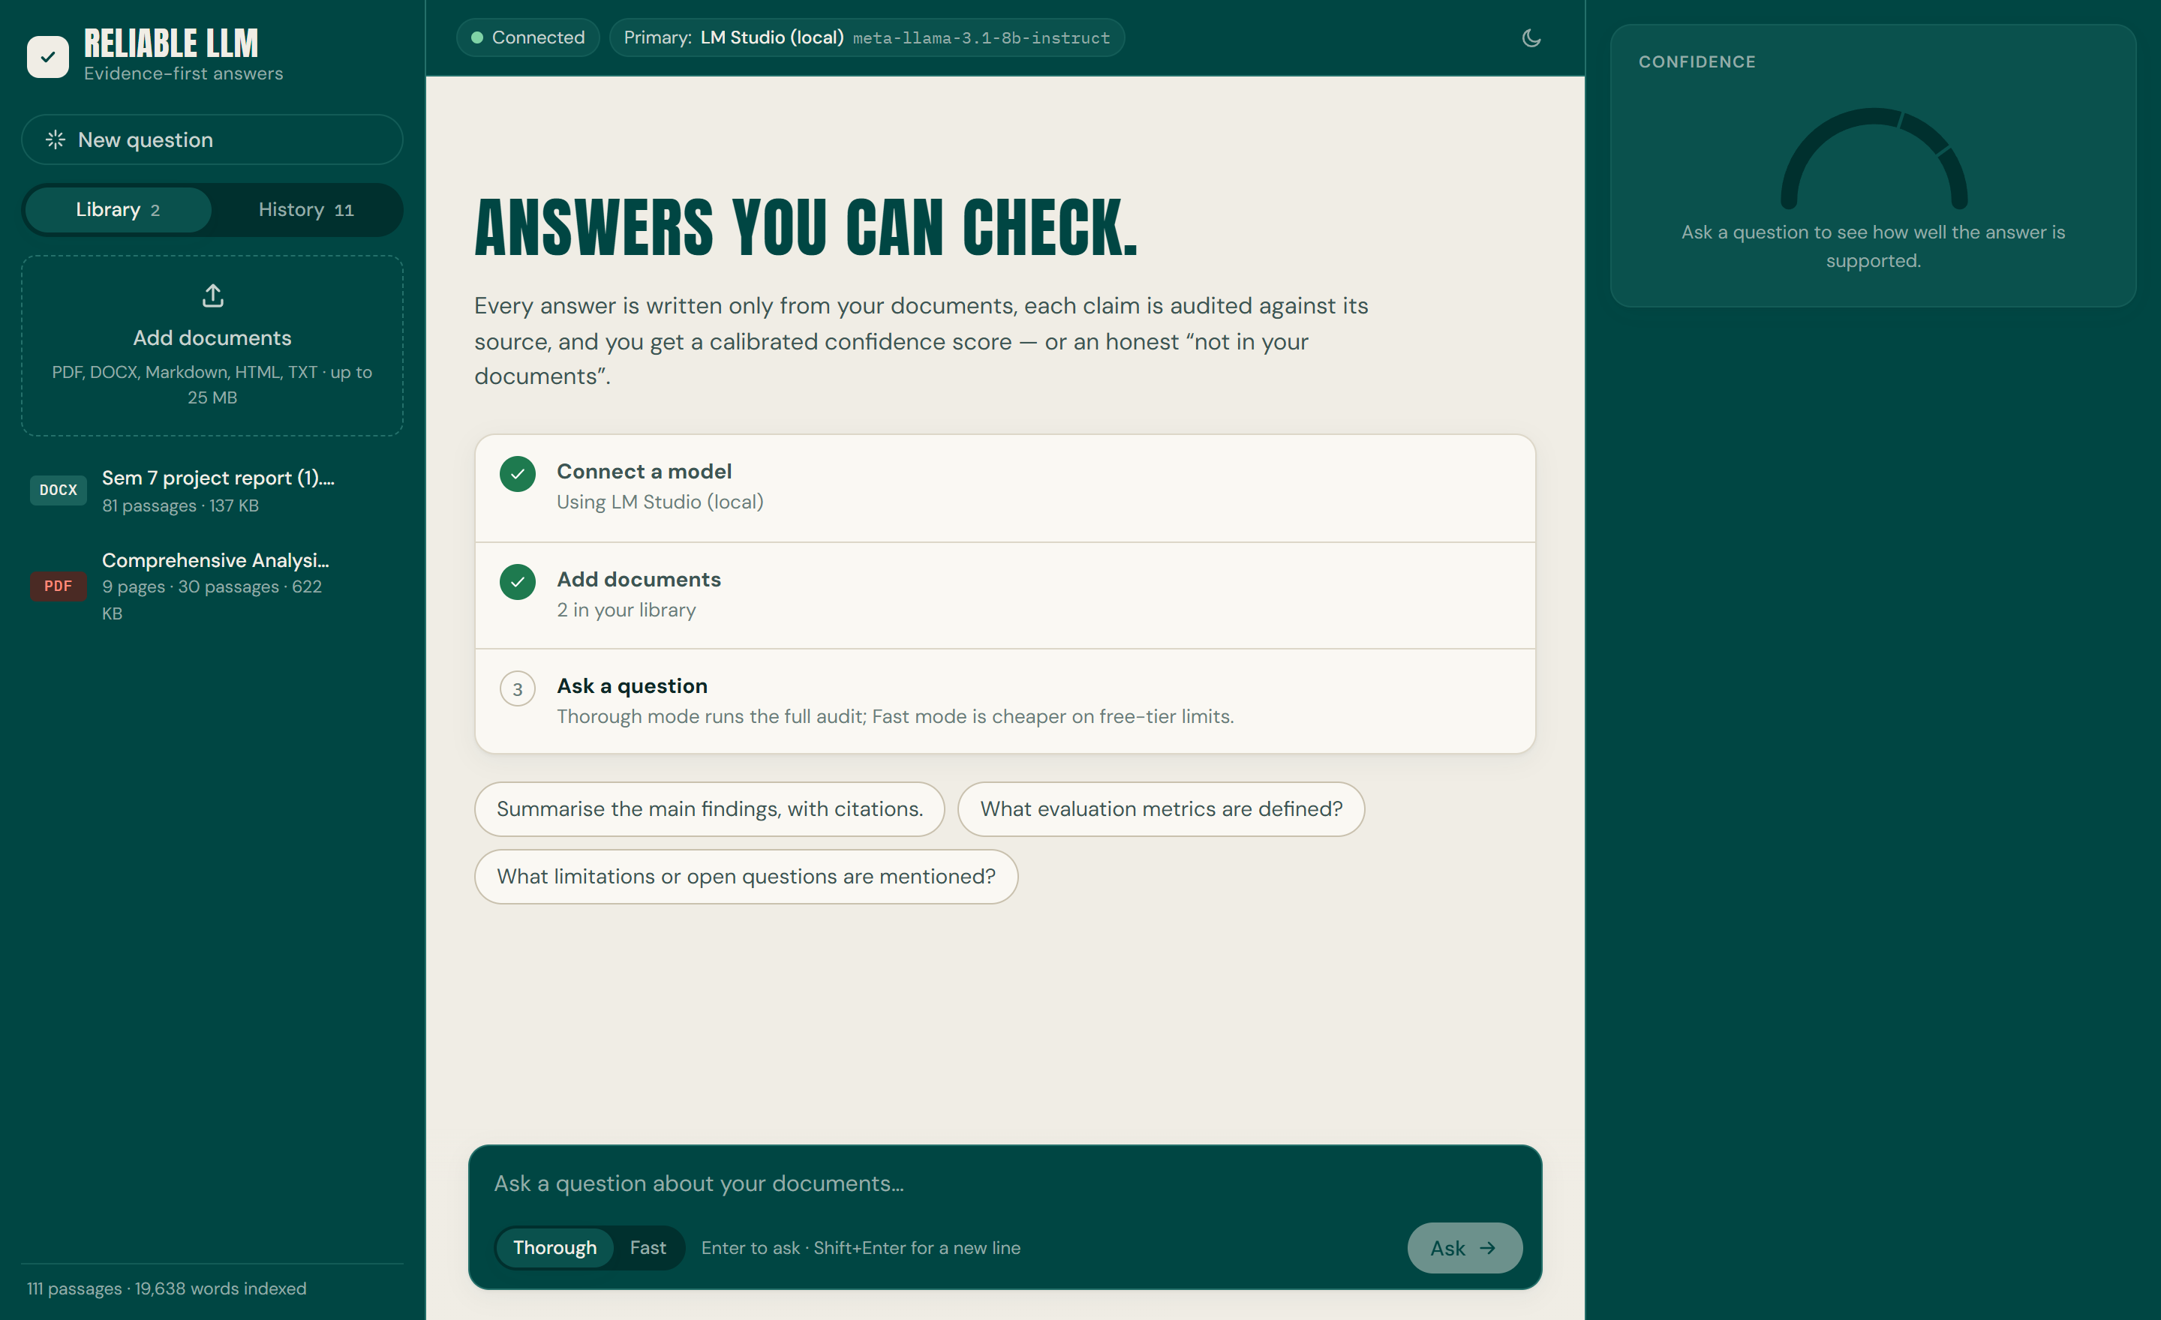FIGURE A2.1 DOCUMENT LIBRARY AND QUESTION COMPOSER
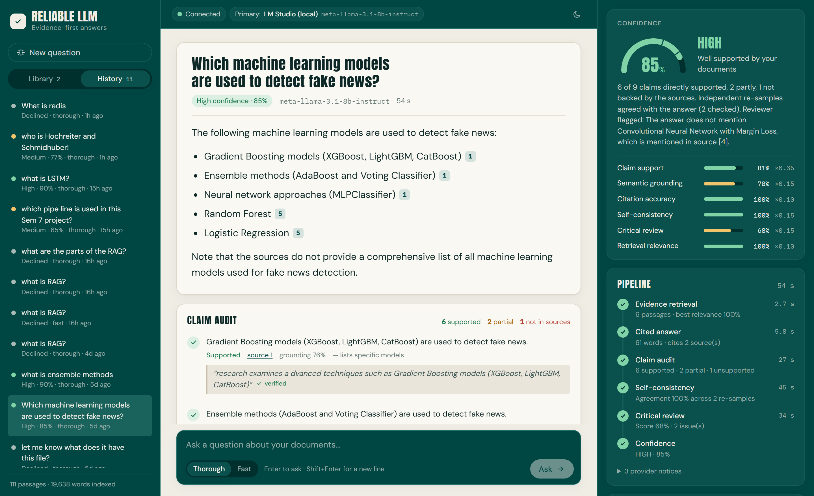FIGURE A2.2 STREAMED ANSWER WITH INLINE CITATIONS AND PIPELINE TIMELINE
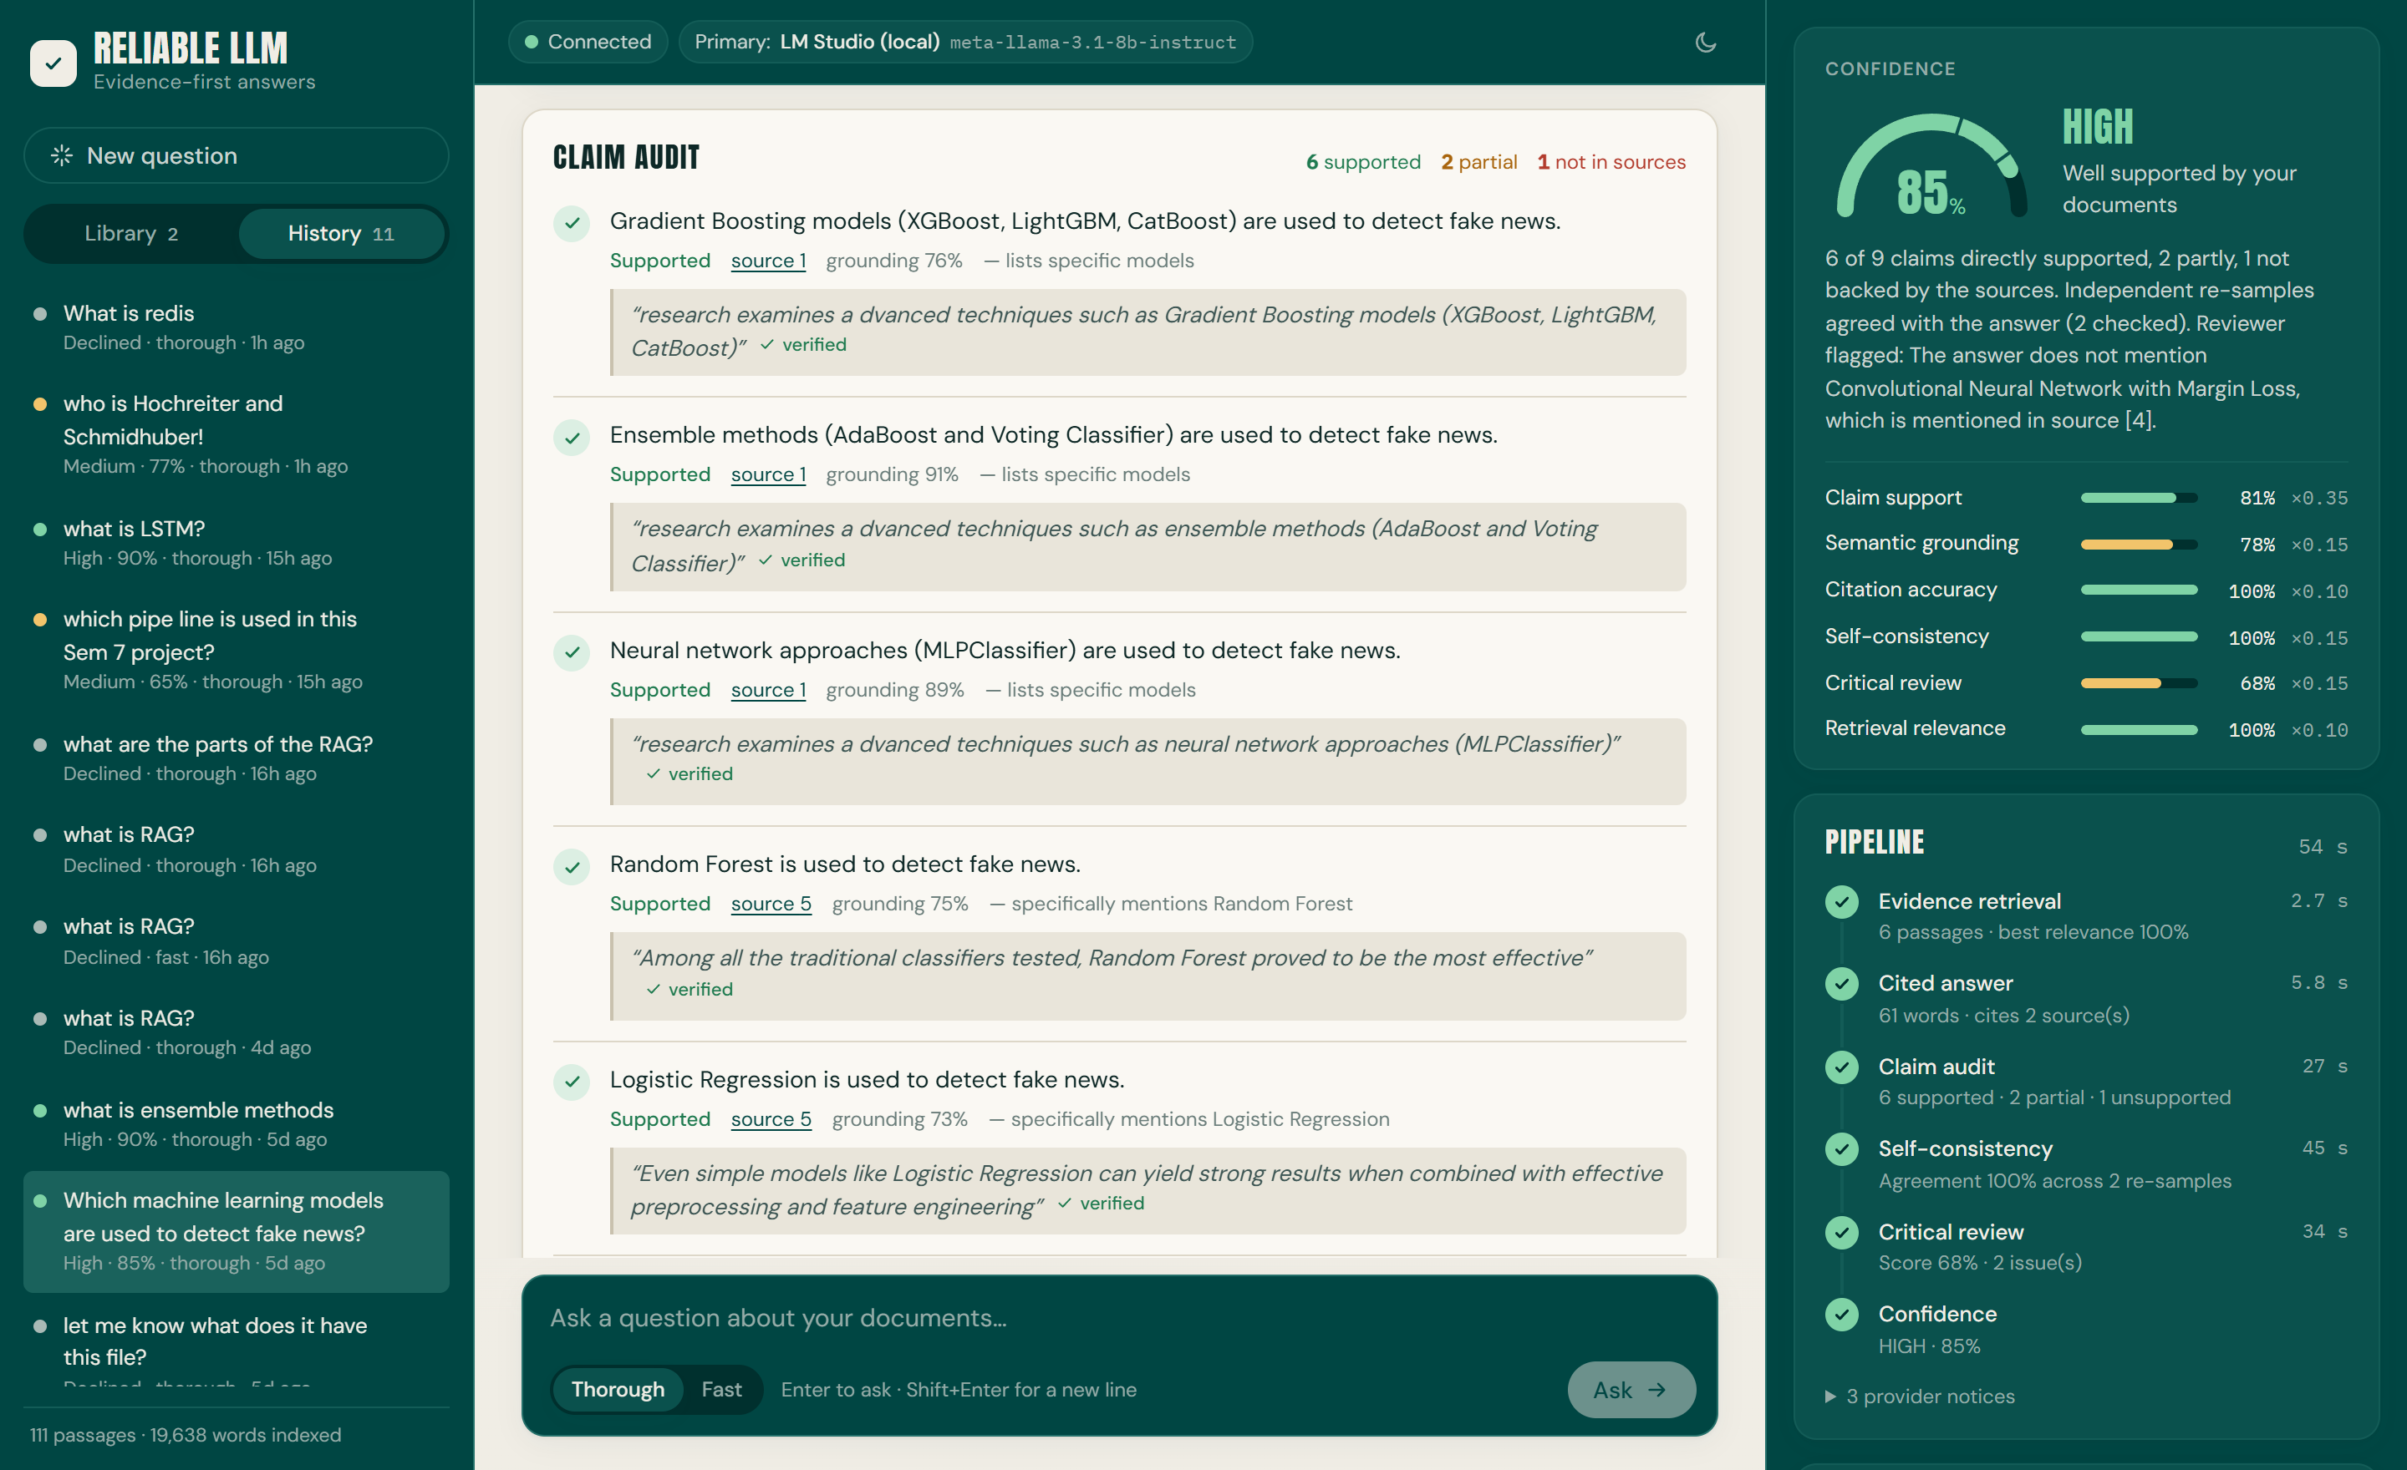FIGURE A2.3 CLAIM AUDIT WITH PER-CLAIM VERDICTS AND EVIDENCE QUOTES
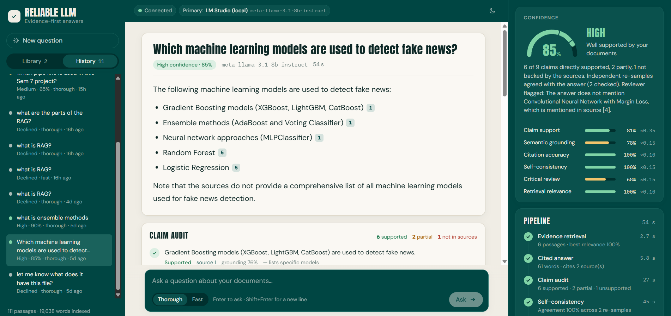FIGURE A2.4 CONFIDENCE INSPECTOR WITH SIGNAL BREAKDOWN
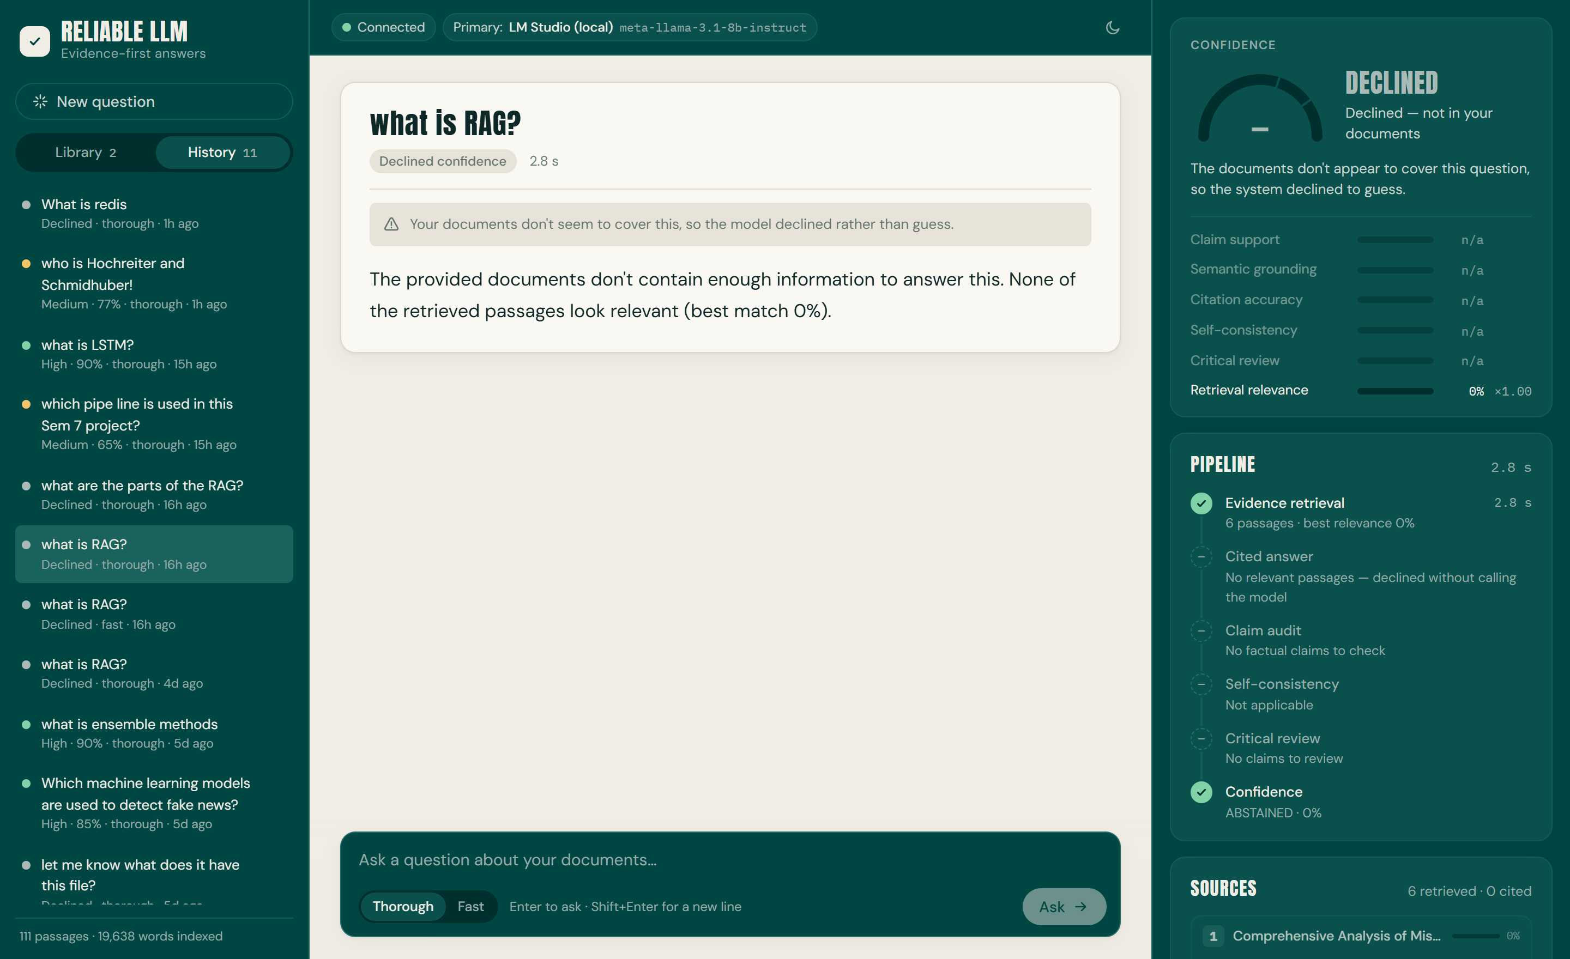FIGURE A2.5 DECLINED ANSWER FOR A QUESTION NOT COVERED BY THE DOCUMENTS
MAPPING OF PROJECT GOALS TO SDG
The Sustainable Development Goals (SDGs) are a set of universal goals adopted by United Nations Member States to tackle the greatest social, economic and environmental challenges facing the world. The project titled A Multi-Agent Self-Reflective Agentic RAG Framework for Enhancing the Reliability of Large Language Models applies artificial intelligence to make information drawn from documents more trustworthy, by grounding every answer in its source, verifying each claim and declining when the evidence is missing.
Under SDG No. 4 Quality Education, the system helps students and researchers study their own reading material more reliably. Every answer shows the passages it came from and a verdict for each claim, which encourages learners to check sources rather than accept fluent text, and the system openly says when the material does not contain an answer. Because it runs on a laptop with free or local models, it is accessible to institutions and students without paid AI services.
In SDG No. 9 Industry, Innovation and Infrastructure, the project contributes to responsible technological innovation by combining hybrid retrieval, claim-level verification and calibrated confidence in a modular architecture. Its provider router and local-model support show how dependable AI applications can be built on modest infrastructure, and its open design allows new models, documents and checks to be added.
So, the system turns a conventional chat assistant into an evidence-first tool whose answers can be inspected. Through grounded answering, claim verification and honest abstention, the project makes a notable contribution to SDG 4 Quality Education and SDG 9 Industry, Innovation and Infrastructure.

