RELIABLE LLM
Technical Documentation
Evidence-first question answering with claim-level verification and calibrated confidence
Covers: tech stack · architecture · business rules · request flow · answer pipeline ·
retrieval · verification · confidence scoring · LLM routing · data storage · API ·
frontend · configuration · testing · operations
Version 2.0 · October 2026

CONTENTS
1. OVERVIEW 1
1.1 KEY IDEAS IN ONE PAGE 1
1.2 TWO ANSWER MODES 2
2. TECHNOLOGY STACK 3
3. REPOSITORY STRUCTURE 4
4. SYSTEM ARCHITECTURE 5
4.1 WHAT HAPPENS AT START-UP 6
5. BUSINESS RULES 7
6. DOCUMENT INGESTION FLOW 9
7. QUESTION-TO-ANSWER FLOW (END TO END) 11
8. RETRIEVAL IN DETAIL 13
9. HOW THE ANSWER IS GENERATED 15
10. VERIFICATION PIPELINE 16
10.1 CLAIM AUDIT (VERIFY_ANSWER) 16
10.2 SELF-CONSISTENCY (CHECK_CONSISTENCY) 17
10.3 CRITICAL REVIEW (REFLECT) 17
11. CONFIDENCE SCORING 18
12. LLM LAYER: PROVIDERS AND ROUTER 19
12.1 REQUEST AND RESPONSE TYPES 19
13. STREAMING AND TELEMETRY 21
14. DATA STORAGE 22
14.1 INDEX FILES (BACKEND/DATA/INDEX) 22
14.2 RUN HISTORY (BACKEND/DATA/RLLM.DB) 23
15. API REFERENCE 24
16. FRONTEND 25
17. CONFIGURATION REFERENCE 26
18. TESTING, EVALUATION AND KNOWN LIMITATIONS 27
18.1 AUTOMATED TESTS 27
18.2 BATCH EVALUATION 27
18.3 KNOWN LIMITATIONS 27
19. RUNNING AND TROUBLESHOOTING 29
19.1 EVERYDAY COMMANDS (WINDOWS) 29
19.2 COMMON PROBLEMS 29
20. GLOSSARY 30

1. OVERVIEW
Reliable LLM is a web application that answers questions about documents a user uploads. What makes it different from a normal chatbot is that it never asks the user to simply trust an answer. Each answer is written only from passages found in the user's documents, carries a citation after every factual sentence, and is then checked: every claim is compared with the passage it cites, the question can be asked again to see whether the model agrees with itself, and a reviewer prompt looks for gaps. The results are combined into a confidence score that the user can open and inspect. If the documents do not contain the answer, the system declines.
This document explains how the whole system works, from the moment a file is uploaded to the moment a scored answer appears on the screen. It is written for developers who need to run, change or extend the project, and for anyone who wants to understand exactly where an answer comes from.

1.1 KEY IDEAS IN ONE PAGE
- Evidence first. The model only ever sees six numbered passages taken from the user's library and is told to use nothing else.
- Decline instead of guess. If search finds nothing relevant, the system declines before calling the model. If the model finds the passages insufficient, it starts its reply with a fixed decline sentence.
- Don't trust the judge blindly. Claims are judged by the language model, but every verdict is double-checked with simple local tests (does the quote exist, do the numbers match, is there a similar sentence in the source, does the citation point to the right passage).
- One score, many signals. Six signals are combined into a confidence score. Serious problems such as a contradiction put a hard ceiling on the score.
- Built for free and local models. A router paces requests to stay under rate limits, retries, and switches provider when one is unavailable. Everything can run offline with LM Studio or Ollama.
- Nothing hidden. Every stage streams its progress to the browser, and every run is stored with its sources, verdicts, timings and model calls.

1.2 TWO ANSWER MODES
Table 1.1 Answer modes
 | FAST | THOROUGH (DEFAULT)
Stages run | Retrieve, answer, claim audit, confidence | All six stages
LLM calls per question | 2 (answer + audit) | 5 (answer + audit + 2 re-samples + review)
Confidence signals | Up to 4 | Up to 6
Typical time (8B local model) | ≈ 17 s | ≈ 32 s
Use when | Quick look-ups | The answer matters

2. TECHNOLOGY STACK
Table 2.1 Technology stack
LAYER | TECHNOLOGY | WHY IT IS USED
Frontend UI | React 18 | Component-based interface; state driven by a reducer
Frontend build | Vite 5 | Fast dev server; proxies /api to the backend
Backend language | Python 3.10+ | ML ecosystem; async support
Web framework | FastAPI + Uvicorn | Async REST API and Server-Sent Events streaming
Validation / config | Pydantic, pydantic-settings | Request models; settings loaded from backend/.env
HTTP client | HTTPX (async) | Calls every LLM provider directly, including streaming; no vendor SDKs
Embeddings | sentence-transformers · all-MiniLM-L6-v2 | 384-d vectors for search and claim grounding
Reranker | cross-encoder · ms-marco-MiniLM-L-6-v2 | Relevance probability for each passage
ML runtime | PyTorch (CPU), NumPy | Runs the two small local models; vector maths
Keyword search | rank-bm25 (BM25Okapi) | Exact-term retrieval
Parsing | pypdf, python-docx, BeautifulSoup | PDF, Word and HTML text extraction
Run history | SQLite (Python stdlib) | Stores every run; no separate database server
Index storage | JSON, JSON Lines, .npy files | Plain, inspectable files instead of pickle
LLM providers | LM Studio, Ollama, Groq, Gemini, OpenRouter | Local or free cloud models
Tests | pytest | 31 offline tests with fake models and mocked HTTP

3. REPOSITORY STRUCTURE
reliable_llm/
├── setup.bat / setup.ps1 / setup.sh one-time setup (venv, packages, .env, tests)
├── start.bat / start.ps1 / start.sh start backend (:8000) + frontend (:3000)
├── README.md, SETUP.md usage and installation guides
├── backend/
│ ├── api/server.py ASGI entry point: uvicorn api.server:app
│ ├── .env / .env.example configuration (keys, models, tuning)
│ ├── requirements.txt
│ ├── rllm/ ← all application code
│ │ ├── config.py Settings (every tunable value)
│ │ ├── telemetry.py context-local event bus (stage/token/notice events)
│ │ ├── jsonutil.py tolerant JSON extraction from model output
│ │ ├── logging_setup.py
│ │ ├── api/app.py FastAPI routes, SSE streaming, start-up wiring
│ │ ├── knowledge/
│ │ │ ├── parsing.py PDF / DOCX / MD / HTML / TXT → text blocks
│ │ │ ├── chunking.py sentence-aware chunks with overlap
│ │ │ ├── models.py embedder + cross-encoder (lazy, CPU)
│ │ │ └── store.py KnowledgeBase: index, persistence, hybrid search
│ │ ├── llm/
│ │ │ ├── base.py LLMRequest / LLMResponse / LLMError kinds
│ │ │ ├── providers.py Gemini, OpenAI-compatible, Ollama adapters
│ │ │ └── router.py rate limiter, retries, failover
│ │ ├── pipeline/
│ │ │ ├── prompts.py all prompt templates (versioned)
│ │ │ ├── stages.py answer, claim audit, consistency, review
│ │ │ ├── calibrate.py confidence score, caps, levels
│ │ │ └── engine.py orchestrates one run end to end
│ │ └── storage/history.py SQLite run history + metrics
│ ├── scripts/evaluate.py batch evaluation (accuracy, ECE, abstention)
│ ├── tests/ offline test-suite
│ ├── data/ runtime data (git-ignored): index/, uploads/, rllm.db
│ └── src/, configs/, experiments/, main.py ← version-1 code, no longer used
└── frontend/
├── vite.config.js dev server on :3000, proxies /api → :8000
└── src/
├── main.jsx, App.jsx app shell, data loading, actions
├── api.js REST client + SSE stream parser
├── state.js run reducer (events → UI state)
└── ui/ Sidebar.jsx · Main.jsx · Inspector.jsx · bits.jsx

The version-1 code (backend/src, backend/configs, backend/experiments, backend/main.py and frontend/src/components) is kept only for reference. The script cleanup_legacy.sh moves it into a _legacy folder without deleting anything.

4. SYSTEM ARCHITECTURE
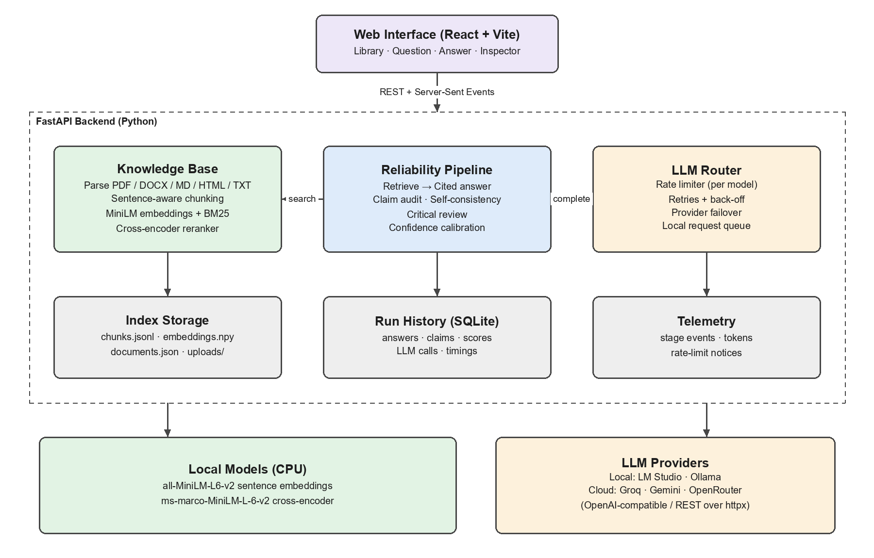
Figure 4.1 System architecture
The system has two processes. The React frontend runs on port 3000 (Vite dev server) and the FastAPI backend on port 8000. The browser only talks to port 3000; Vite forwards every /api request to the backend, so there are no cross-origin issues and no hard-coded backend address in the frontend code.
Table 4.1 Backend components and responsibilities
COMPONENT | FILE(S) | RESPONSIBILITY
App factory | rllm/api/app.py | Builds every component at start-up, defines routes, streams events
Settings | rllm/config.py | Reads backend/.env; single source of all tunable values
KnowledgeBase | rllm/knowledge/store.py | Adds/removes documents, persists the index, hybrid search
Parsers + chunker | parsing.py, chunking.py | Turn files into page/section-aware chunks
Embedder / Reranker | knowledge/models.py | Local MiniLM models, loaded lazily on CPU
Engine | pipeline/engine.py | Runs the six stages for one question and records everything
Stages | pipeline/stages.py | Answer generation, claim audit, self-consistency, review
Calibrator | pipeline/calibrate.py | Combines signals into score, level and explanation
LLM router | llm/router.py | Rate limiting, retries, provider failover, local queueing
Providers | llm/providers.py | HTTP adapters for each LLM service
Telemetry | rllm/telemetry.py | Lets deep layers send events to the browser
History | storage/history.py | Saves runs in SQLite; aggregate metrics

4.1 WHAT HAPPENS AT START-UP
When Uvicorn starts the app, the lifespan handler in app.py wires everything together in this order:
1. Create the SentenceEmbedder and, if RERANK_ENABLED, the Reranker. Neither model is loaded yet.
2. Create the KnowledgeBase and load the index from backend/data/index (documents.json, chunks.jsonl, embeddings.npy, meta.json). If meta.json names a different embedding model than the configured one, or the number of vectors does not match the number of chunks, every chunk is re-embedded and the index is saved again. The BM25 index is always rebuilt in memory.
3. Build the providers listed in LLM_PROVIDER_ORDER. A provider is skipped if it has no API key, or for Ollama and LM Studio if its *_ENABLED flag is false.
4. Create the LLMRouter, the HistoryStore (backend/data/rllm.db) and the Engine, and attach them to app.state.
5. Start a background task that loads both local models into memory (the first start downloads about 180 MB). When it finishes, app.state.models_ready becomes true and the log prints “Local models ready”.

5. BUSINESS RULES
These are the rules the system enforces. Each one is listed with where it lives in the code, so it can be found and changed.
Table 5.1 Library rules
RULE | VALUE / BEHAVIOUR | WHERE
Supported file types | .pdf .docx .md .markdown .txt .html .htm | knowledge/parsing.py
Maximum file size | 25 MB (MAX_UPLOAD_MB) | api/app.py
Empty file | Rejected: “File is empty” | api/app.py
Duplicate file | Same SHA-256 content hash → rejected as duplicate | store.add_document
File with no extractable text | Rejected: “Document produced no text chunks” | store.add_document
Chunk size | ≈ 200 words (CHUNK_WORDS), 40-word overlap | knowledge/chunking.py
Chunk boundaries | Never cross a page or a section heading | chunking.chunk_blocks
Original file | Kept as uploads/<doc_id>.<ext> for download | store.add_document
Deleting a document | Removes its chunks, vectors and original file | store.remove_document

Table 5.2 Answering rules
RULE | VALUE / BEHAVIOUR | WHERE
Empty library | Question refused: “Upload at least one document first” | engine._run
Question length | 1 – 4000 characters | QueryRequest
Passages given to the model | 6 (TOP_K) from a pool of 24 (CANDIDATE_POOL) | config.py
Relevance gate | If best passage relevance < 2% (MIN_RELEVANCE) → decline, no LLM call | engine._run
Source restriction | Only facts in the passages; no outside knowledge | prompts.ANSWER_SYSTEM
Citations | [n] after every factual sentence | prompts.ANSWER_SYSTEM
Partial answers | Answer the covered part and state what is missing | prompts.ANSWER_SYSTEM
Model decline | Reply starts with the fixed sentence “The provided documents don't contain enough information to answer this.” | prompts.ABSTAIN_PREFIX
Counted as declined | Reply opens with the decline sentence (a cited note on related content is allowed) | stages.generate_answer
Declined answers | Claim audit and review are skipped (nothing to verify) | engine._run
Whole-document questions | If the gate would decline but the question is about the document as a whole (“what is this file about”, “summarize”), the opening passages of each document are used instead | engine.is_overview_question, store.overview_hits
Invalid citation | Number outside 1–6 is recorded as invalid | stages.generate_answer
Answer temperature | 0.2 (strong model) | stages.generate_answer

Table 5.3 Verification and scoring rules
RULE | VALUE / BEHAVIOUR | WHERE
Claims per answer | At most 10 atomic claims | prompts.verify_prompt
Quote check | Judge's quote must match the source (≥ 80% token recall) | stages.verify_answer
Number check | Number missing from source → “supported” becomes “partial” | stages.verify_answer
Weak evidence | “Supported” with no valid quote and grounding < 0.45 (or no quote and < 0.30) → “partial” | stages.verify_answer
Uncited factual claim | Counts as a citation error | stages.verify_answer
Judge failure | Fall back to local grounding only; score capped at 0.75 | stages / calibrate
Re-samples | 2 (NUM_SAMPLES) at temperature 0.8, fast model, Thorough only | stages.check_consistency
Decline disagreement | Consistency × (0.5 + 0.5 × agreement) | stages.check_consistency
Review penalties | high 0.30 · medium 0.15 · low 0.05 (max 0.9) | stages.reflect
Contradiction cap | Score ≤ 0.50 | calibrate
> ⅓ claims unsupported | Score ≤ 0.55 | calibrate
Reviewer: not answered | Score ≤ 0.60 | calibrate
Non-existent citation | Score ≤ 0.70 | calibrate
Levels | HIGH ≥ 0.80 · MEDIUM ≥ 0.60 · LOW < 0.60; plus ABSTAINED, NO_EVIDENCE | calibrate._level
“Reliable” flag | score ≥ 0.60 (CONFIDENCE_THRESHOLD); declines count as reliable | calibrate

Table 5.4 Model-access rules
RULE | VALUE / BEHAVIOUR | WHERE
Provider order | LLM_PROVIDER_ORDER, first available wins | config / providers.build_providers
Roles | strong = answer, audit, review; fast = re-samples | LLMRequest.role
Pacing | Sliding 60 s window per (provider, role) at the configured RPM | router.RateLimiter
Rate-limited | Wait the advertised time and retry (up to 3 attempts) | router.complete
Long wait | If wait > 25 s (LLM_MAX_WAIT_SECS) and another provider exists → switch | router.complete
Daily quota | Provider cooled down 1 hour; switch | router.complete
Bad key / unknown model | Switch immediately; notice shown to user | router.complete
Local servers | One request at a time (queued) | max_concurrency = 1
LM Studio server off | Run “lms server start”, wait until it answers, retry once (at most every 30 s) | LMStudioProvider
JSON mode refused | Retry once without response_format | OpenAICompatProvider

6. DOCUMENT INGESTION FLOW
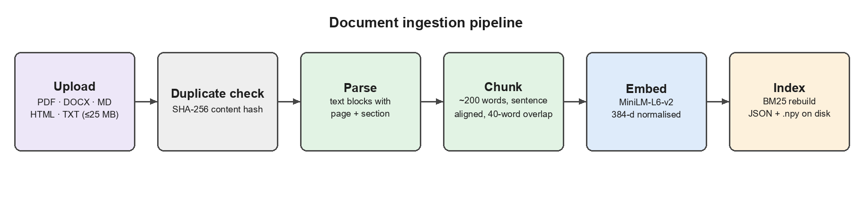
Figure 6.1 Document ingestion
Uploading happens through POST /api/documents (several files at once). For each file the backend runs:
1. Size and emptiness check in app._ingest_one. Files over the limit or with no bytes return an error result for that file without stopping the others.
2. Duplicate check. The SHA-256 hash of the bytes is compared with every stored document.
3. Parsing (parsing.parse_document) chooses a parser by extension and returns a list of Block(text, page, section). PDFs are read page by page with pypdf and words hyphenated across line breaks are re-joined. DOCX paragraphs are grouped under their heading styles and tables are read row by row. Markdown and HTML headings become section names. Text files are split on blank lines.
4. Chunking (chunking.chunk_blocks). Blocks are grouped by (page, section) and split into sentences. Sentences are added to the current chunk until it would exceed 200 words; the next chunk starts with the last ≤ 40 words of the previous one. A sentence longer than 200 words is hard-wrapped. A trailing chunk that is only overlap is dropped.
5. Embedding. Each chunk's embed_text (section title + text) is encoded into a normalised 384-dimensional vector. This is the slow step and runs outside the lock.
6. Indexing. Under a lock, the chunks are appended, the new vectors stacked under the embedding matrix, the DocumentInfo stored, the BM25 index rebuilt and the original file written to uploads/.
7. Saving. The whole index is written to a temporary folder and each file is then moved into place, so a crash mid-save cannot leave a half-written index.
The upload response contains one result per file with status added, duplicate or error, plus updated library statistics.

7. QUESTION-TO-ANSWER FLOW (END TO END)
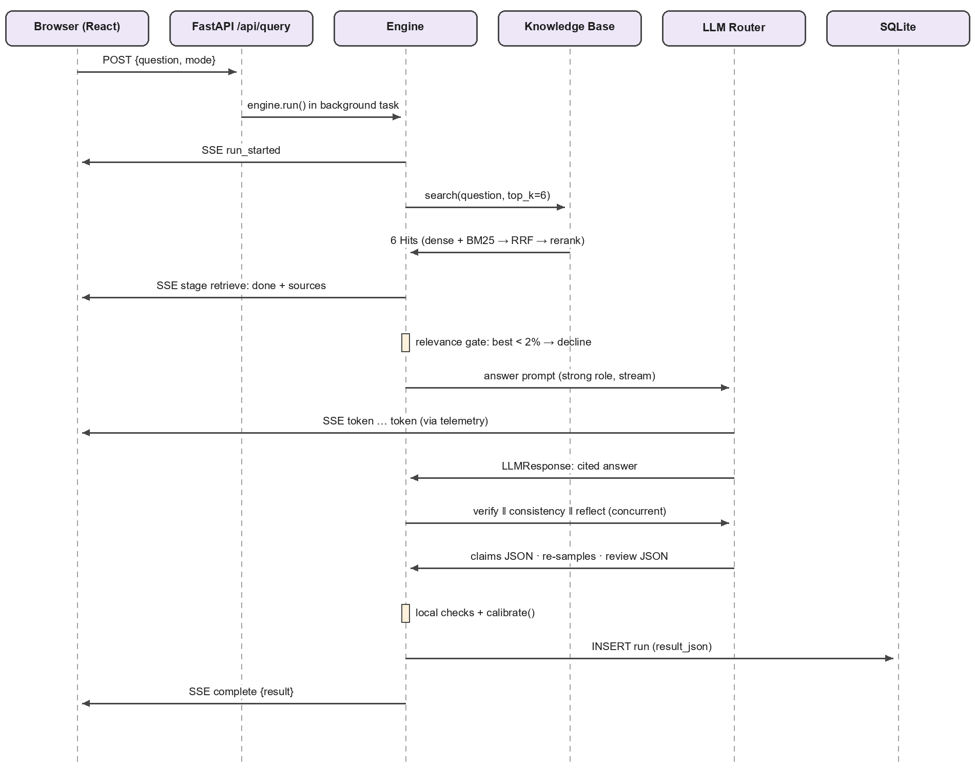
Figure 7.1 Sequence of one question
The diagram shows the messages exchanged for a single question in Thorough mode. Below, the same flow is described step by step with the code that performs each step.
1. Browser sends the question. App.jsx dispatches start to the run reducer and calls streamQuery() in api.js, which POSTs {question, mode, …} to /api/query and keeps the response open as a stream.
2. Backend opens the stream. query_stream in app.py creates an asyncio queue, starts engine.run() as a background task and returns a StreamingResponse. Every event the engine emits is put on the queue and written to the browser as an SSE message. A keep-alive comment is sent every 15 s so the connection survives long rate-limit waits. If the browser disconnects, the task is cancelled so no more model calls are made.
3. Run starts. The engine assigns a 12-character run id, binds a telemetry recorder and emits run_started with the list of stages. If the library is empty it stops with error kind empty_kb.
4. Retrieve. KnowledgeBase.search returns the top 6 hits (Section 8). The engine emits stage retrieve: done with the sources, which the browser shows immediately.
5. Gate. If no hit was found, or every hit has relevance below MIN_RELEVANCE, the engine writes the decline message itself, marks the answer stage as skipped and goes straight to calibration.
6. Answer. generate_answer sends the answer prompt through the router with streaming on. Each token is emitted as a token event and appended to the answer on screen. If a provider fails mid-stream, answer_reset clears the partial text before the next provider starts.
7. Verify, consistency, review. Three coroutines run with asyncio.gather. Each emits its own running/done/skipped/error stage events with its result attached. A failure in one of them does not stop the others; it is shown as an error stage and its signal is simply left out of the score.
8. Calibrate. calibrate() combines the available signals and emits stage calibrate: done with the confidence object.
9. Save and finish. The full result is saved to SQLite and sent as the complete event. The browser marks the run as done and refreshes the history list.

8. RETRIEVAL IN DETAIL
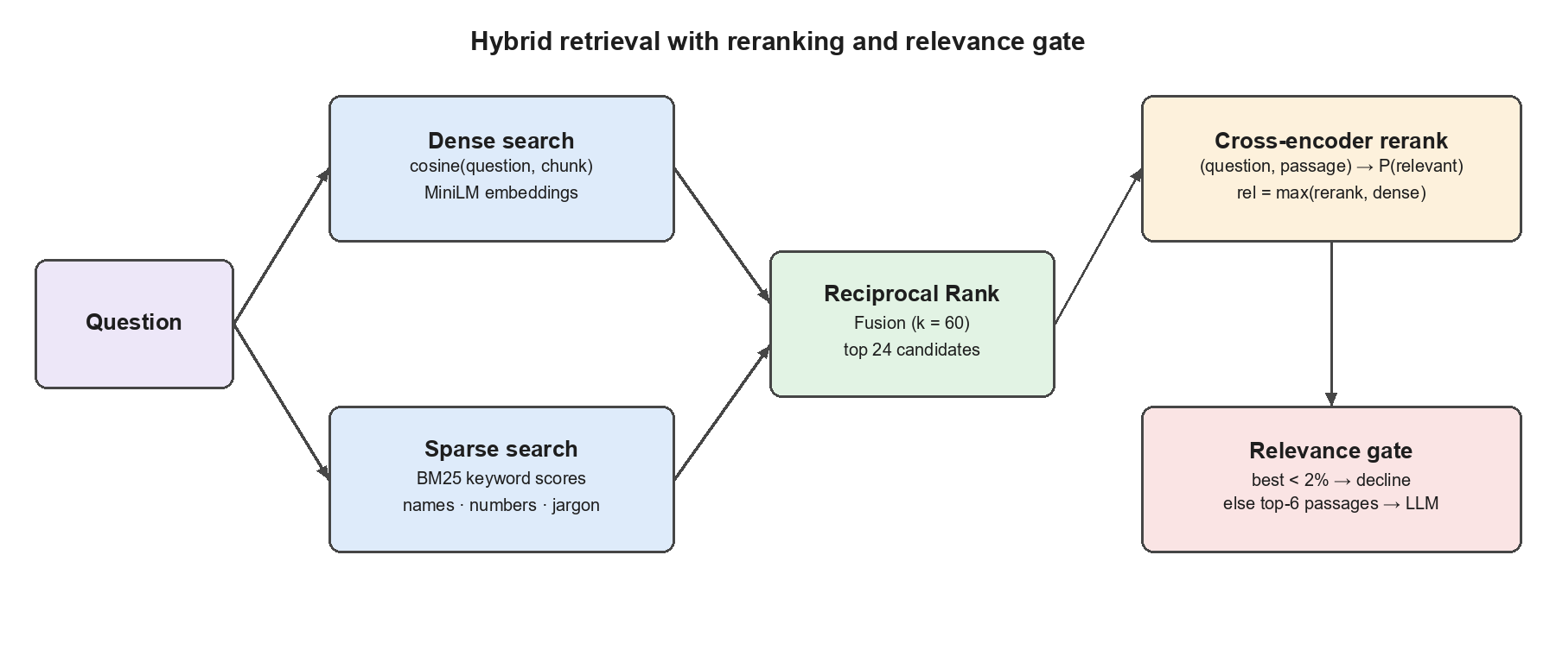
Figure 8.1 Hybrid retrieval
KnowledgeBase.search(question, top_k=6, pool=24, doc_ids=None) works as follows:
1. Optional filter. If doc_ids is given, chunks from other documents are excluded.
2. Dense scores. The question is embedded and multiplied with the embedding matrix; because all vectors are normalised this gives the cosine similarity of every chunk.
3. Sparse scores. BM25Okapi scores every chunk using lower-cased word tokens with common stop-words removed.
4. Fusion. The top 24 chunks of each ranking are merged with Reciprocal Rank Fusion: each chunk gets Σ 1/(60 + rank). BM25 entries with a score of 0 are ignored. The best 24 fused chunks are kept.
5. Rerank. The cross-encoder scores (question, chunk text) pairs. Raw logits are passed through a sigmoid (newer library versions already return probabilities, which is detected and handled).
6. Relevance. relevance = max(reranker probability, clip((cosine − 0.15) / 0.55, 0, 1)). The second term stops the reranker, which was trained on web-search queries, from pushing a clearly on-topic passage to zero for a short or acronym-heavy question.
7. Top-k. Chunks are sorted by (relevance, rerank) and the first 6 are returned as Hit objects with their dense, sparse, rerank and relevance values. Without a reranker the RRF order is kept.
Each hit is sent to the browser as a source object containing ref (1–6), chunk and document ids, a label such as “paper.pdf · p.4 · § Methodology”, the text and the four scores.

9. HOW THE ANSWER IS GENERATED
The answer prompt is built in prompts.py. The system message sets the rules; the user message contains the numbered passages and the question:
SYSTEM: You are a careful research assistant. You answer strictly from the numbered
sources you are given.
Rules:
- Use only facts stated in the sources. Never add outside knowledge ...
- After every sentence that states a fact, cite the supporting source number(s) in
square brackets, e.g. [1] or [2][4]. Only cite a source that actually says it.
- If the sources answer only part of the question, answer that part and state plainly
what they do not cover.
- If the sources do not contain the answer at all, begin your reply with exactly:
"The provided documents don't contain enough information to answer this." ...
- Be direct and concise ...

USER:
Sources:

[1] (paper.pdf · p.4 · § Methodology)
<chunk text, at most 1600 characters>

[2] (...)
...
Question: <question>

Answer (cite sources as [n]):

The request uses the strong role, temperature 0.2 and up to 1200 output tokens (ANSWER_MAX_TOKENS). After the reply arrives, generate_answer:
- extracts every [n] marker (including forms like [1, 3]) and splits them into valid citations (1–6) and invalid ones;
- detects the decline sentence in the first 220 characters (also accepting a few close variants);
- returns an AnswerResult with the text, valid and invalid citations, the abstained flag, provider, model and latency.
The prompt version (PROMPT_VERSION in prompts.py) is stored with every run, so results produced by different prompt versions can be told apart.

10. VERIFICATION PIPELINE
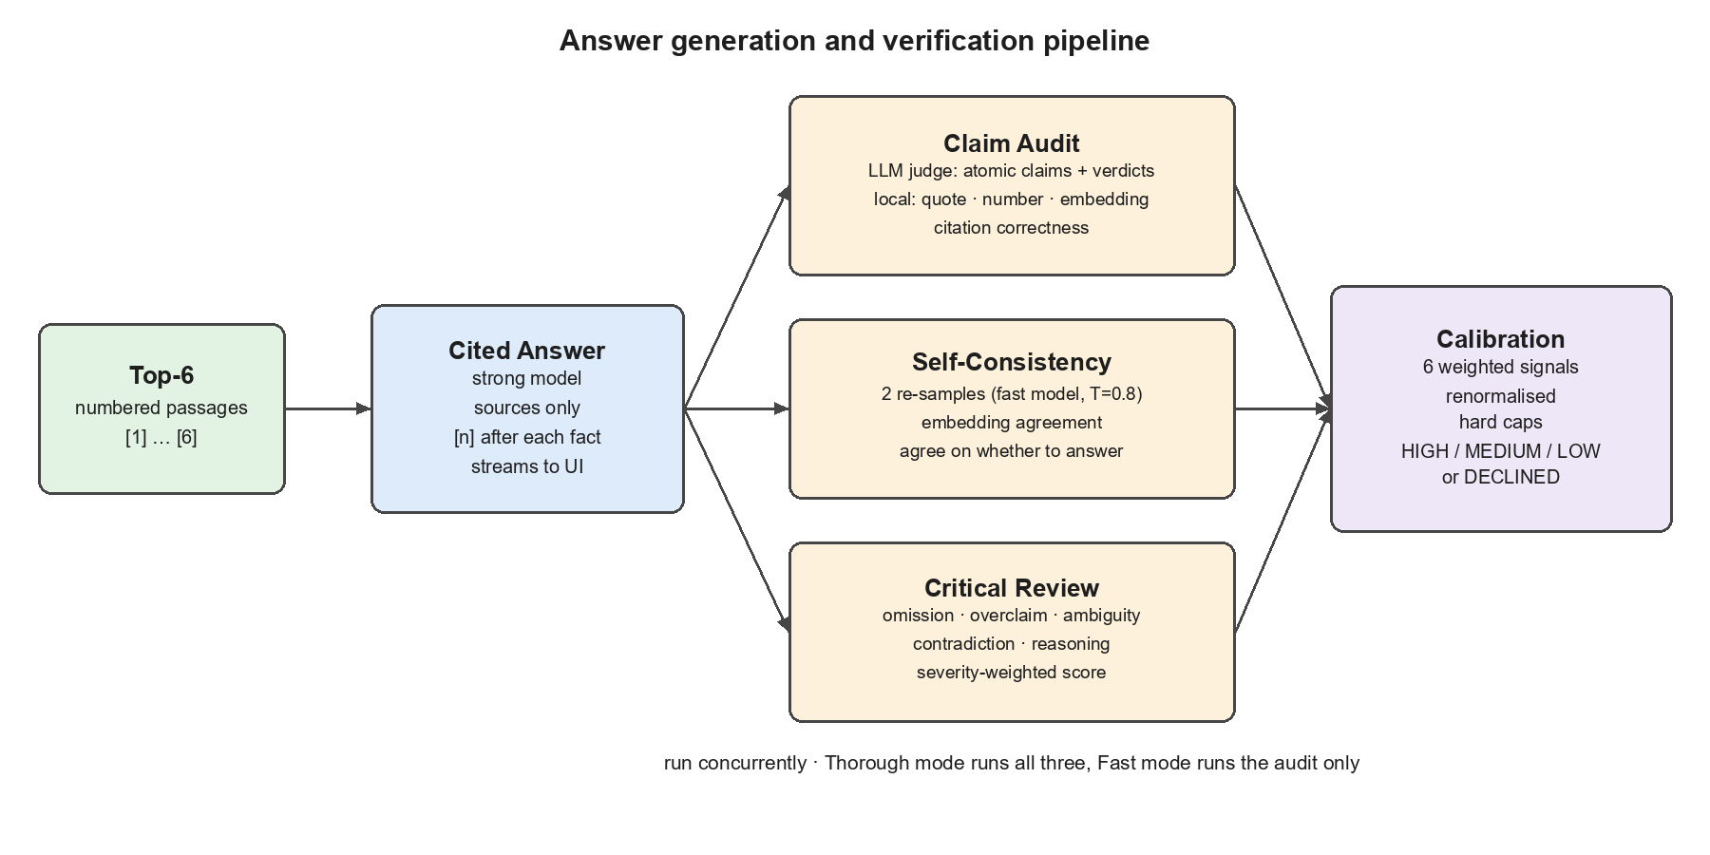
Figure 10.1 Verification stages

10.1 CLAIM AUDIT (VERIFY_ANSWER)
1. Ask the judge. The strong model receives the sources, the question and the answer, with temperature 0 and JSON mode. It must split the answer into at most 10 atomic claims and return, for each, the citations the answer used, a verdict (supported, partial, contradicted, not_found), the best source number, a verbatim quote of up to 25 words and a short note.
2. Parse leniently. jsonutil.extract_json finds the JSON even inside code fences or extra text. If the judge fails or returns nothing usable, the answer's sentences become the claims and judge_ok is false.
3. Ground locally. Every sentence of the six passages is embedded once. Each claim is matched with its closest sentence; the cosine is mapped to grounding = clip((cos − 0.30) / 0.50, 0, 1).
4. Fill missing verdicts. If the judge gave no valid verdict, grounding decides: ≥ 0.75 supported, ≥ 0.45 partial, otherwise not_found (judged_by = local).
5. Check the quote. The quote must appear in the named source (verbatim after normalisation, or ≥ 80% of its words). If not, all six sources are searched in case the judge used the wrong number.
6. Check numbers. Numbers in the claim (and the words zero to twelve) must appear in the supporting passage.
7. Downgrade weak “supported” verdicts as listed in Table 5.3, recording the reason in the note.
8. Check the citation. A citation is correct if it includes the supporting source, or if a cited source contains at least half of the claim's words. A supported or partial claim without any citation is a citation error.
9. Aggregate. support = mean verdict value (1.0 / 0.55 / 0.15 / 0); grounding = mean grounding; citation = share of correct citations; hallucination_rate = (not_found + contradicted) / claims.

10.2 SELF-CONSISTENCY (CHECK_CONSISTENCY)
Thorough mode only. The same answer prompt is sent twice more to the fast model at temperature 0.8 (600 tokens each). Citation markers are stripped, the original answer and the samples are embedded, and each sample's cosine with the answer is mapped to agreement = clip((cos − 0.50) / 0.40, 0, 1); paraphrases land near 1. The score is the mean agreement. If some samples decline while the answer does not (or the other way round), the score is multiplied by 0.5 + 0.5 × (share of samples that agree on answering).

10.3 CRITICAL REVIEW (REFLECT)
Thorough mode only. The strong model, at temperature 0.1 with JSON mode, reviews the answer against shorter versions of the sources (700 characters each). It returns answers_question (true/false), a score from 0 to 1, a list of issues (omission, overclaim, ambiguity, contradiction, reasoning, irrelevance) each with a severity, and a one-sentence summary. The final review score is the average of the reviewer's score and a rule score of 1 − (sum of severity penalties), so one odd number from a small model cannot dominate.

11. CONFIDENCE SCORING
Table 11.1 Signals
KEY | SIGNAL | COMES FROM | DEFAULT WEIGHT
support | Claim support | Mean claim verdict value | 0.35 (W_SUPPORT)
grounding | Semantic grounding | Mean claim grounding | 0.15 (W_GROUNDING)
citation | Citation accuracy | Share of correct citations | 0.10 (W_CITATION)
consistency | Self-consistency | Re-sample agreement | 0.15 (W_CONSISTENCY)
reflection | Critical review | Combined review score | 0.15 (W_REFLECTION)
retrieval | Retrieval relevance | Mean relevance of cited passages (top 3 if none cited) | 0.10 (W_RETRIEVAL)

The calculation in calibrate():
1. If nothing was retrieved, return level NO_EVIDENCE with score 0.
2. Keep only signals that were computed; score = Σ(weight × value) / Σ(weight) over those signals.
3. Apply the caps from Table 5.3 in order; each cap that lowers the score is listed in caps.
4. If the answer declined, return level ABSTAINED (“Declined — not in your documents”); reliable is true.
5. Otherwise map the score to HIGH / MEDIUM / LOW, set reliable = score ≥ 0.60 and write a plain-language explanation naming the strongest and weakest signals and any caps.
The result object contains score, level, headline, explanation, components (each signal's value and its effective weight after renormalisation), caps and reliable. The browser draws the gauge and the breakdown directly from it.

12. LLM LAYER: PROVIDERS AND ROUTER
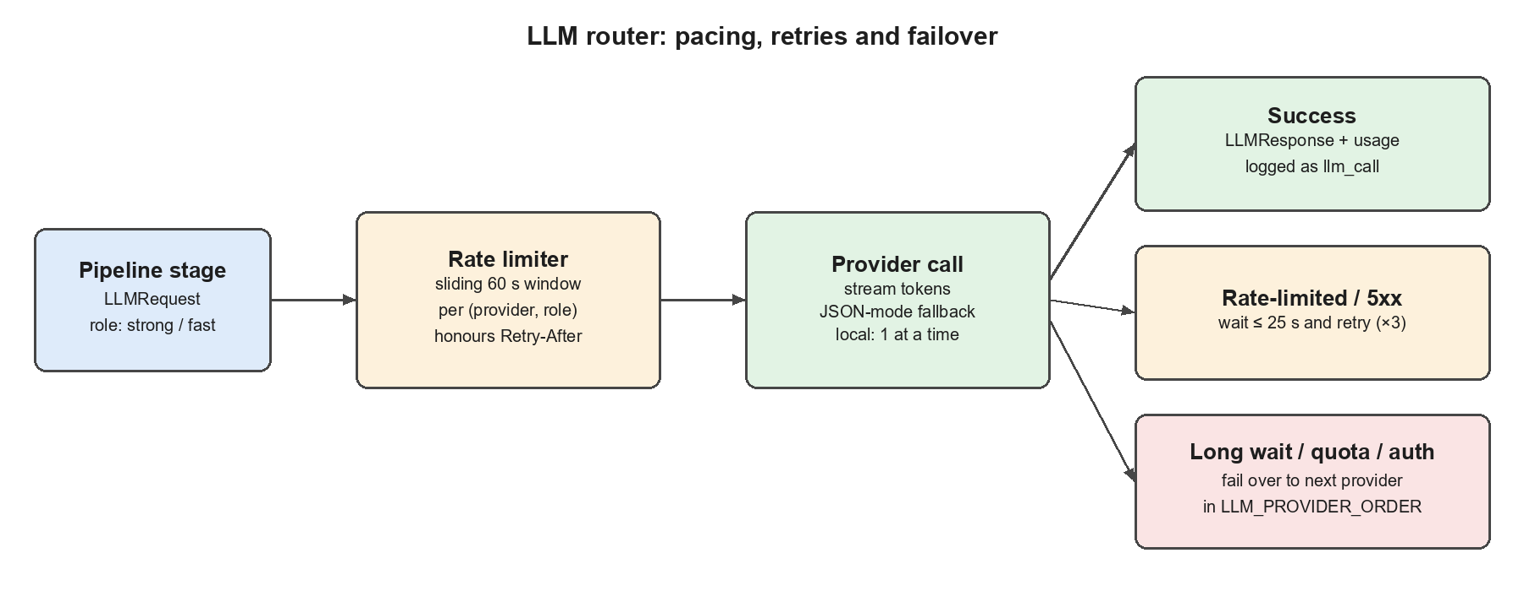
Figure 12.1 Router behaviour

12.1 REQUEST AND RESPONSE TYPES
LLMRequest(prompt, system=None, temperature=0.2, max_tokens=1024,
json_mode=False, role="strong" | "fast", purpose="answer" | "verify" | ...)
LLMResponse(text, provider, model, latency_ms, input_tokens, output_tokens, meta)
LLMError(kind, message, retry_after=None, provider, model)

Table 12.1 Providers
NAME | CLASS | ENDPOINT | ENABLED WHEN
gemini | GeminiProvider | generativelanguage.googleapis.com/v1beta | GEMINI_API_KEY set
groq | OpenAICompatProvider | api.groq.com/openai/v1 | GROQ_API_KEY set
openrouter | OpenAICompatProvider | openrouter.ai/api/v1 | OPENROUTER_API_KEY set
ollama | OllamaProvider | localhost:11434/api/chat | OLLAMA_ENABLED=true
lmstudio | OpenAICompatProvider | localhost:1234/v1 | LMSTUDIO_ENABLED=true

Table 12.2 Error kinds and router reaction
KIND | MEANING | ROUTER DOES
rate_limit | Per-minute limit (HTTP 429) | Cool down for the advertised delay, retry; switch if too long
daily_quota | Per-day limit used up | Cool down 1 hour, switch provider
auth | Bad or missing key | Switch provider, show notice
not_found | Model name not available | Switch provider, show notice
bad_request | Request invalid for this model | Switch provider
server | 5xx error | Back off (1.5 s × attempt, max 8 s) and retry
network | Timeout / connection refused | Back off and retry
empty | Model returned no text | Back off and retry
no_provider | Nothing configured | Fail with setup message
exhausted | Every provider failed | Fail with the last errors

Ollama has its own adapter because it needs settings that the OpenAI-style API does not expose: the context size (OLLAMA_NUM_CTX), a reply cap (OLLAMA_MAX_TOKENS), keep_alive so the model stays loaded between stages, and the think switch for reasoning models. Any <think>…</think> text a model produces is filtered out of the stream before it reaches the user. Gemini uses its native REST API so that thinking level, safety settings and JSON output can be controlled.

13. STREAMING AND TELEMETRY
telemetry.py holds a context variable with the current run's emitter. Any code running inside a run, however deep (the router, the rate limiter, a provider), can call emit() or notice() without the emitter being passed down through every function. Outside a run these calls do nothing, and an error inside the emitter can never break the pipeline.
Table 13.1 Server-Sent Events
EVENT | SENT WHEN | PAYLOAD
run_started | Run begins | run_id, question, mode, stages[]
stage | A stage changes state | id, status (running/done/skipped/error), summary, duration_ms, plus the stage result (sources, verification, consistency, reflection, confidence, model)
token | Answer text arrives | text
answer_reset | Streaming provider failed | reason
answer | Answer finished | text, citations, abstained
notice | Wait, failover, key or quota problem | level, message, provider, wait_secs
llm_call | Every model call (success or failure) | provider, model, purpose, latency_ms, tokens, attempt, ok, error
complete | Run finished | result (full run object)
error | Run failed | message, kind

14. DATA STORAGE
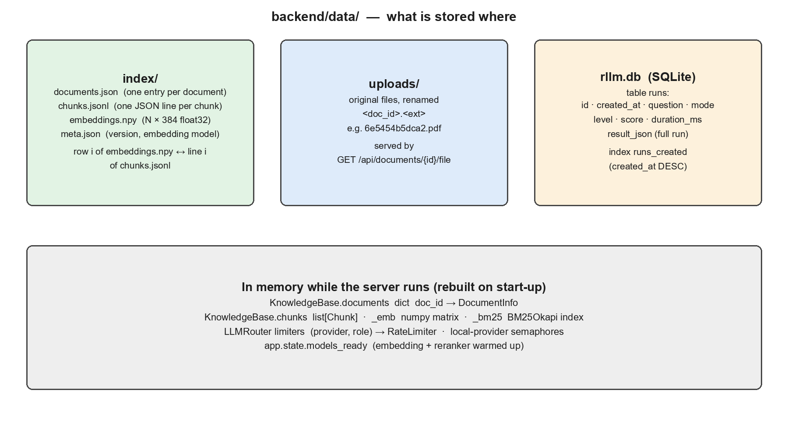
Figure 14.1 Storage layout
All runtime data lives under backend/data (DATA_DIR) and is git-ignored. A new machine starts with an empty library.

14.1 INDEX FILES (BACKEND/DATA/INDEX)
Table 14.1 documents.json — one object per document
FIELD | TYPE | EXAMPLE / MEANING
id | string (12 hex) | 6e5454b5dca2
name | string | Original file name
type | string | pdf, docx, md, txt, html
size_bytes | int | File size
sha256 | string | Content hash used for duplicate detection
chunks / words / pages | int | 30 / 5024 / 9
created_at | ISO-8601 string | Upload time (UTC)

Table 14.2 chunks.jsonl — one JSON line per chunk
FIELD | TYPE | EXAMPLE / MEANING
id | string | <doc_id>:<index>, e.g. 6e5454b5dca2:0
doc_id / doc_name | string | Owning document
index | int | Position within the document
text | string | Chunk text (≈ 200 words)
page | int | PDF page, 0 if not applicable
section | string | Heading the chunk falls under
words | int | Word count

embeddings.npy is a float32 matrix with one 384-value row per chunk; row i belongs to line i of chunks.jsonl. meta.json records the index format version (2), the embedding model name and the last update time. The BM25 index is not stored; it is rebuilt from the chunks whenever the library is loaded or changed.

14.2 RUN HISTORY (BACKEND/DATA/RLLM.DB)
CREATE TABLE IF NOT EXISTS runs (
id TEXT PRIMARY KEY, -- 12-character run id
created_at TEXT NOT NULL, -- ISO-8601 UTC
question TEXT NOT NULL,
mode TEXT NOT NULL, -- thorough | fast
level TEXT, -- HIGH | MEDIUM | LOW | ABSTAINED | NO_EVIDENCE
score REAL, -- 0..1
duration_ms INTEGER,
result_json TEXT NOT NULL -- the complete run object (below)
);
CREATE INDEX IF NOT EXISTS runs_created ON runs(created_at DESC);

The summary columns make the history list fast; everything else is in result_json:
{
"id", "created_at", "question", "mode", "duration_ms", "prompt_version",
"answer": { "text", "citations", "invalid_citations", "abstained", "provider", "model" },
"sources": [ { "ref", "chunk_id", "doc_id", "doc_name", "label", "page", "section",
"text", "relevance", "dense", "sparse", "rerank" } ],
"verification": { "claims": [ { "claim", "verdict", "cited", "source", "quote", "quote_found",
"grounding", "best_sentence", "best_sentence_source",
"citation_ok", "note", "judged_by" } ],
"support", "grounding", "citation", "counts", "hallucination_rate", "judge_ok" },
"consistency": { "score", "similarities", "samples", "abstention_agreement" },
"reflection": { "score", "judge_score", "answers_question", "issues", "summary" },
"confidence": { "score", "level", "headline", "explanation", "components", "caps", "reliable" },
"timings_ms": { "retrieve", "answer", "verify", "consistency", "reflect", "calibrate" },
"stages": { "<stage id>": { "status", "summary" } },
"llm_calls": [ { "provider", "model", "purpose", "latency_ms", "input_tokens",
"output_tokens", "attempt", "ok", "error" } ],
"notices": [ { "level", "message", "t_ms", ... } ]
}

GET /api/metrics aggregates the table: number of runs, count per level, mean confidence, total claims checked, unsupported-claim rate and median latency. SQLite access is serialised with a lock so the connection can be shared safely between request threads.

15. API REFERENCE
Interactive documentation is available at http://localhost:8000/docs while the backend is running.
Table 15.1 Endpoints
METHOD | PATH | PURPOSE | RESPONSE
GET | /api/health | Status and configuration | version, models_ready, library, llm_ready, providers, retrieval, pipeline, supported_types, max_upload_mb
GET | /api/documents | List library | documents[], stats
POST | /api/documents | Upload (multipart field files, many) | results[] (added/duplicate/error), stats
POST | /api/documents/ingest | Single upload (v1 compatible) | result; 422 on error
DELETE | /api/documents/{id} | Remove a document | deleted, stats; 404 if unknown
GET | /api/documents/{id}/chunks | Inspect chunking | document, chunks[] with labels
GET | /api/documents/{id}/file | Download original | file
POST | /api/query | Ask (streaming) | text/event-stream (Table 13.1)
POST | /api/query/sync | Ask (blocking) | full run object; 400 on pipeline error
GET | /api/runs?limit&offset | History list | runs[] (summary columns)
GET | /api/runs/{id} | One run | full run object
DELETE | /api/runs/{id} | Delete one run | deleted
DELETE | /api/runs | Clear history | deleted (count)
GET | /api/metrics | Aggregate metrics | runs, levels, mean_confidence, …

Query request body:
{
"question": "What accuracy did the Random Forest classifier achieve?", // 1-4000 chars
"mode": "thorough", // or "fast"
"top_k": 6, // optional, 1-20
"doc_ids": ["6e5454b5dca2"], // optional, restrict to these documents
"num_samples": 2 // optional, 0-5 consistency re-samples
}

16. FRONTEND
Table 16.1 Frontend files
FILE | WHAT IT DOES
App.jsx | Loads health, documents and history on start; polls health; handles upload, delete, ask, stop, open history item; theme and panel toggles; toast messages
api.js | fetch wrapper with readable errors; streamQuery() reads the response body and splits it into SSE events
state.js | runReducer: actions start, event, load, abort, fail, reset; applyEvent maps each SSE event to state
ui/Sidebar.jsx | Library (drag-and-drop upload, list, delete) and History (open, delete)
ui/Main.jsx | StatusBar (connection + provider), Welcome, Composer (question box, Fast/Thorough, stop), NoticeStrip, AnswerCard (streamed answer, clickable citations), ClaimsCard, ReviewCard
ui/Inspector.jsx | Confidence gauge and signal breakdown, live pipeline timeline, source passages, model call log
ui/bits.jsx | Icons, spinner, number/time formatting, level and verdict styles, small Markdown renderer that turns [n] into citation buttons

The run state is a single object (status, question, mode, stages, answer, sources, verification, consistency, reflection, confidence, notices, calls, error, timing). Live runs fill it event by event; opening a history item fills it in one step from the saved run object, so live and saved runs render with the same components. Clicking a citation number sets the active source, which highlights the passage in the inspector.

17. CONFIGURATION REFERENCE
All settings are read from backend/.env (or environment variables). Restart the backend after any change.
Table 17.1 Settings
SETTING | DEFAULT | MEANING
LLM_PROVIDER_ORDER | gemini,groq,openrouter,ollama | Providers to try, in order
GEMINI_API_KEY / _MODEL / _FAST_MODEL | — / gemini-3.6-flash / gemini-3.5-flash-lite | Gemini access
GEMINI_RPM / _FAST_RPM / _THINKING_LEVEL | 5 / 10 / low | Gemini pacing and thinking
GROQ_API_KEY / _MODEL / _FAST_MODEL | — / llama-3.3-70b-versatile / llama-3.1-8b-instant | Groq access
GROQ_RPM / _FAST_RPM | 30 / 30 | Groq pacing
OPENROUTER_API_KEY / _MODEL / _FAST_MODEL | — / llama-3.3-70b-instruct:free | OpenRouter access
OLLAMA_ENABLED / _BASE_URL | false / http://localhost:11434 | Ollama access
OLLAMA_MODEL / _FAST_MODEL | qwen3:4b / (same) | Ollama models
OLLAMA_NUM_CTX / _MAX_TOKENS / _THINK | 4096 / 700 / false | Ollama generation settings
LMSTUDIO_ENABLED / _BASE_URL | false / http://localhost:1234/v1 | LM Studio access
LMSTUDIO_MODEL / _FAST_MODEL | meta-llama-3.1-8b-instruct / (same) | LM Studio models
LLM_TIMEOUT_SECS / _MAX_RETRIES / _MAX_WAIT_SECS | 90 / 3 / 25 | Router behaviour
EMBEDDING_MODEL | sentence-transformers/all-MiniLM-L6-v2 | Embedding model
RERANK_ENABLED / RERANK_MODEL | true / cross-encoder/ms-marco-MiniLM-L-6-v2 | Reranker
TOP_K / CANDIDATE_POOL | 6 / 24 | Passages to model / rerank pool
MIN_RELEVANCE | 0.02 | Relevance gate (0 = always call the model)
CHUNK_WORDS / CHUNK_OVERLAP_WORDS | 200 / 40 | Chunking
NUM_SAMPLES / SAMPLE_TEMPERATURE | 2 / 0.8 | Self-consistency
ANSWER_MAX_TOKENS | 1200 | Answer length cap
CONFIDENCE_THRESHOLD | 0.60 | “Reliable” threshold
W_SUPPORT … W_RETRIEVAL | 0.35, 0.15, 0.10, 0.15, 0.15, 0.10 | Signal weights
DATA_DIR / MAX_UPLOAD_MB | data / 25 | Storage folder / upload limit
CORS_ORIGINS / LOG_LEVEL | localhost:3000 / INFO | Server settings

The current machine's .env uses LLM_PROVIDER_ORDER=lmstudio,groq,gemini with LM Studio enabled, meta-llama-3.1-8b-instruct as the strong model and llama-3.2-3b-instruct as the fast model.

18. TESTING, EVALUATION AND KNOWN LIMITATIONS

18.1 AUTOMATED TESTS
Run from backend/: ..\venv\Scripts\python -m pytest -q tests. The 31 tests use HashEmbedder (a dependency-free stand-in for the embedding model), a fake LLM and httpx.MockTransport, so they run in a few seconds without network access. They cover parsing and chunking, index persistence, router retries, failover and pacing, provider parsing (Gemini, OpenAI-compatible, Ollama, LM Studio), calibration caps, the hallucinating-judge guard, the relevance gate and the API end to end.

18.2 BATCH EVALUATION
cd backend
..\venv\Scripts\python scripts\evaluate.py data\eval\fake_news_questions.jsonl --mode thorough --out data\eval\results.json

Each line of the question file has a question, an optional expected answer and an optional answerable flag. The script reports accuracy (≥ 60% of expected-answer words present), abstention accuracy, unsupported-claim rate, mean confidence, expected calibration error (5 bins) and mean latency. On the fake-news paper with local 8B/3B models, Thorough mode reached 93.3% accuracy, 100% abstention accuracy, 0% unsupported claims and an ECE of 0.042.

18.3 KNOWN LIMITATIONS
- Decline detection (fixed): the evaluation in the project report was run before this fix. Earlier, an answer that declined and then cited related content was not counted as a decline; it now is.
- Whole-document questions: answered from the opening passages of each document. With several documents in the library the answer may describe all of them; remove unrelated documents for a focused answer.
- Six passages: the model never sees the rest of the document, so answers needing information spread across many sections may be incomplete.
- Reranker domain: the MS MARCO cross-encoder was trained on web searches; the dense-similarity floor reduces but does not remove its bias against short questions.
- Local speed: on CPU, each Thorough question takes tens of seconds; the first question after start-up also waits for LM Studio to load the model.

19. RUNNING AND TROUBLESHOOTING

19.1 EVERYDAY COMMANDS (WINDOWS)
Table 19.1 Commands
TASK | COMMAND
One-time setup | .\setup.bat
Start LM Studio server | lms server start
Start the app | .\start.bat (press Enter in that window to stop)
Backend only | cd backend; ..\venv\Scripts\python -m uvicorn api.server:app --reload --port 8000
Frontend only | cd frontend; npm run dev
Run tests | cd backend; ..\venv\Scripts\python -m pytest -q tests
App / API docs | http://localhost:3000 · http://localhost:8000/docs

19.2 COMMON PROBLEMS
Table 19.2 Troubleshooting
SYMPTOM | CAUSE / FIX
“Backend offline” in the top bar | Backend not running or crashed; check its window for the error
LM Studio unreachable (auto-restart failed) | Open LM Studio and click Start server in the Developer tab
“No LLM provider is configured” | Add a key or enable LM Studio/Ollama in backend/.env, then restart
Every question declined | Question too vague for the relevance gate; ask about specific content
Long “waiting” notices | Free-tier rate limits; add a second provider or use Fast mode
Model not found | Model name must match lms ls / ollama list exactly
Reranker download fails | Set RERANK_ENABLED=false; search still works
Port 8000 or 3000 in use | netstat -ano | findstr :8000, then taskkill /PID <pid> /F

20. GLOSSARY
TERM | MEANING
Abstain / decline | Answer “not in the documents” instead of guessing
BM25 | Keyword ranking function based on term frequency and rarity
Calibration | How well confidence scores match actual correctness
Chunk | A ≈ 200-word passage of a document; the unit of search
Claim | One atomic factual statement extracted from an answer
Cross-encoder | Model that scores a question and passage together for relevance
ECE | Expected Calibration Error: average gap between confidence and accuracy
Embedding | Vector representing the meaning of a text
Grounding | How closely a claim matches a sentence in the sources
Hit | A retrieved chunk with its scores
RRF | Reciprocal Rank Fusion: merging rankings by position
Run | One question processed end to end, stored in history
SSE | Server-Sent Events: one-way stream from server to browser
Strong / fast role | Which model a request should use (answer and checks vs re-samples)

