1. Electric charge is transferred to an irregular metallic disk as shown in figure. If $σ_{1},σ_{2},σ_{3}$ and $σ_{4}$ are charge densities at given points then, choose the correct answer from the opions given below:
(A) $σ_{1}>σ_{3};σ_{2}=σ_{4}$
(B) $σ_{1}>σ_{2},σ_{3}>σ_{4}$
(C) $σ_{1}>σ_{3}>σ_{2}=σ_{4}$
(D) $σ_{1}<σ_{3}<σ_{2}=σ_{4}$
(E) $σ_{1}=σ_{2}=σ_{3}=σ_{4}$
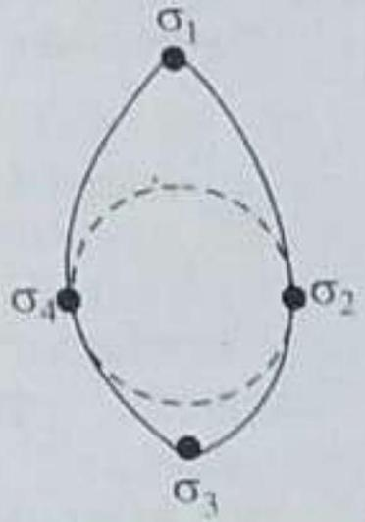
[April 8, 2025 (II)]
(A) A, B and C Only
(B) A and C only
(C) D and E only
(D) B and C only

