Part A (JEE Main)
Topic 1 – Electric charges and coulombs law
1) Multiple choice questions
[Question_start]
1. Electric charge is transferred to an irregular metallic disk as shown in figure. If $σ_{1},σ_{2},σ_{3}$ and $σ_{4}$ are charge densities at given points then, choose the correct answer from the opions given below:
(A) $σ_{1}>σ_{3};σ_{2}=σ_{4}$
(B) $σ_{1}>σ_{2},σ_{3}>σ_{4}$
(C) $σ_{1}>σ_{3}>σ_{2}=σ_{4}$
(D) $σ_{1}<σ_{3}<σ_{2}=σ_{4}$
(E) $σ_{1}=σ_{2}=σ_{3}=σ_{4}$
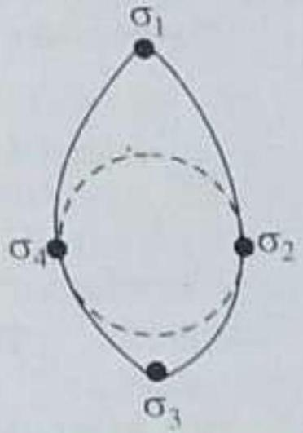
[April 8, 2025 (II)]
(A) A, B and C Only
(B) A and C only
(C) D and E only
(D) B and C only
[solution]
Option A
[Question_end]

[Question_start]
2. A small bob of mass 100 mg and charge $+10μC$ is connected to an insulating string of length 1 m . It is brought near to an infinitely long non-conducting sheet of charge density ' $σ$ ' as shown in figure. If string subtends an angle of ${45}^{∘}$ with the sheet at equilibrium the charge density of sheet will be :
(Given $ε_{0}=8.85×{10}^{-12}\frac{ F}{ m}$ add acceleration due to gravity, $g=10 m/s^{2}$ )
[April 2, 2025 (I)]
(A) $0.885nC/m^{2}$ (B) $17.7nC/m^{2}$
(C) $885nC/m^{2}$ (D) $1.77nC/m^{2}$
[solution]
Option A
[Question_end]

[Question_start]
3. A small uncharged conducting sphere is placed in contact with an identical sphere but having $4×{10}^{-8}C$ charge and then removed to a distance such that the force of repulsion between them is $9×{10}^{-3} N$. The distance between them is
(Take $\frac{1}{4πε_{0}}$ as $9×{10}^{9}$ in Sl units)
[Jan 24, 2025 (II)]
(A) 2 cm (B) 3 cm
(C) 4 cm (D) 1 cm
[solution]
Option A
[Question_end]

[Question_start]
4. Two identical conducting spheres $P$ and $S$ with charge $Q$ on each, repel each other with a force 16 N . A third identical uncharged conducting sphere $R$ is successively brought in contact with the two spheres. The new force of repulsion between P and S is :
[April 6, 2024 (II)]
(A) 4 N (B) 6 N
(C) 1 N (D) 12 N
[solution]
Option A
[Question_end]

[Question_start]
5. Force between two point charges $q_{1}$ and $q_{2}$ placed in vacuum at ' $r$ ' cm apart is $F$. Force between them when placed in a medium having dielectric $K=5$ at ' $r/5^{'}$ ' cm apart will be:
[Jan. 31, 2024 (II)]
(A) $F/25$ (B) 5 F
(C) $F/5$ (D) 25 F
[solution]
Option A
[Question_end]

[Question_start]
6. A $10μC$ charge is divided into two parts and placed at 1 cm distance so that the repulsive force between them is maximum. The charges of the two parts are :
[April 13, 2023 (II)]
(A) $9μC,1μC$ (B) $5μC,5μC$
(C) $7μC,3μC$ (D) $8μC,2μC$
[solution]
Option A
[Question_end]

[Question_start]
7. If two charges $q_{1}$ and $q_{2}$ are separated with distance ' $d$ ' and placed in a medium of dielectric constant $K$. What will be the equivalent distance between charges in air for the same electrostatic force?
[Jan. 24, 2023 (1)]
(A) $d\sqrt{K}$ (B) $K\sqrt{d}$
(C) $1.5d\sqrt{K}$ (D) $2d\sqrt{K}$
[solution]
Option A
[Question_end]

[Question_start]
8. Two identical metallic spheres A and B when placed at certain distance in air repel each other with a force of F . Another identical uncharged sphere $C$ is first placed in contact with A and then in contact with B and finally placed at midpoint between spheres A and B . The force experienced by sphere C will be :
[July 29, 2022 (II)]
(A) $3 F/2$ (B) $3F/4$
(C) F (D) 2 F
[solution]
Option A
[Question_end]

[Question_start]
9. Two identical positive charges $Q$ each are fixed at a distance of ' $2a$ ' apart from each other. Another point charge $q_{0}$ with mass ' $m$ ' is placed at midpoint between two fixed charges. For a small displacement along the line joining the fixed charges, the charge $q_{0}$ executes SHM. The time period of oscillation of charge $q_{0}$ will be :
[July 27, 2022 (I)]
(A) $\sqrt{\frac{4π^{2}v_{2}ma}{4a}}$ (B) $\sqrt{\frac{4⋅Q}{4π^{'}x_{1}mu^{'}}}$
(C) $\sqrt{\frac{2π^{2}π⋅ma^{3}}{q_{0}0}}$ (D) $\sqrt{\frac{8π^{2},π_{0}π^{2}}{90}}$
[solution]
Option A
[Question_end]

[Question_start]
10. A darge of $4μC$ is to be divided intotwo parts. The distance between the fwodivided charges is constant. The magnifude of the divided charges so that the force between them is maximum, will be:
[July 27, 2022 (II)]
(A) $IμC$ and $3μC$ (B) $2μC$ and $2μC$
(C) 0 and $4μC$ (D) $1.5μC$ and $2.5μC$
[solution]
Option A
[Question_end]

[Question_start]
11. Two point charges $Q$ each are placed at a distance $d$ apart. A third point charge $q$ is placed at a distance $x$ from mid-point on the perpendicular briector. The value of $x$ at which charge a will experience the muximum Coulomb's force is
[June 29, 2022 (II)]
(A) $1-d$ (B) $x=\frac{d}{2}$
(C) $x=\frac{d}{\sqrt{2}}$ (D) $1=\frac{d}{2\sqrt{2}}$
[solution]
Option A
[Question_end]

[Question_start]
12. Three identical charged balls each of charge 2 C are suspended from a common point $P$ by silk threads of 2 m each (as shown in figure). They form an equilateral triangle of side im. The ratio of net force on a charged ball to the force between any two charged balls will be :
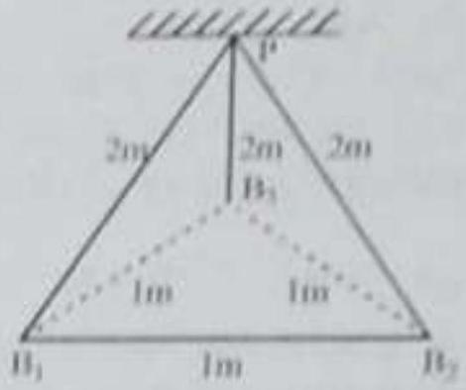
[June 27, 2022 (11)]
(A) $1:1$ (B) $1:4$
(C) $\sqrt{3}:2$ (D) $\sqrt{3}:1$
[solution]
Option A
[Question_end]

[Question_start]
13. Sixty four conducting drops sach of radius 0.02 m and each carrying a charge of $5μC$ are combined to form a bigger drop. The ratio of surface density of bigger drop to the smaller drop will be:
[June 26, 2022 (II)]
(A) $1:4$ (B) $4:1$
(C) $1:8$ (D) $8:1$
[solution]
Option A
[Question_end]

[Question_start]
14. Two identical charged particles each having a mass 10 g and charge $2.0=10$ C placed on a horizontal table with a separation of $L$ between then such that they stay in limited equilibrium. If the coefficient of friction between each particle and the table is 0.25 , find the value of $L$. [ Use g = $10{ ms}^{-2}$ ]
[June 24, 2022 (II)]
(A) 12 cm (B) 10 cm
(C) 8 cm (D) 5 cm
[solution]
Option A
[Question_end]

[Question_start]
15. Two particles A and B having charges $20μC$ and $-5μC$ respectively are held fixed with a separation of 5 cm . At what position a third chargod particle should be placed so that it does not experience a net electric force?
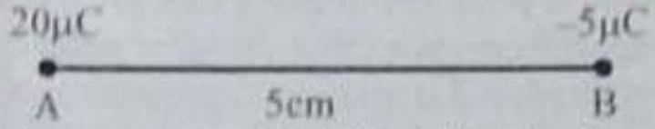
[Aug. 31, 2021 (I)]
(A) At 5 cm from $20μC$ on the left side of system
(B) At 5 cm from $-5μC$ on the right side
(C) At 1.25 cm from $-5μC$ between two charges
(D) At midpoint between two charges
[solution]
Option A
[Question_end]

[Question_start]
16. Two identical tennis balls each having mass ‘m’ and charge ‘q’ are suspended from a fixed point by threads of length ‘l’. What is the equilibrium separation when each thread makes a small angle '$θ$' with the vertical ?
[July 27, 2021 (II)]
(A) $d={\left(\frac{q^{2}t}{2πε_{0}mg}\right)}^{2}$ (B) $d={\left(\frac{9^{2}r}{2π{\text{ sing }}^{2}}\right)}^{1}$
(C) $d={\left(\frac{q^{2}/^{2}}{2πε_{0}{ m}^{2}g}\right)}^{\frac{1}{3}}$ (D) $d={\left(\frac{9^{2}γ^{2}}{2πx_{0}m^{2}k^{2}}\right)}^{'}$
[solution]
Option A
[Question_end]

[Question_start]
17. A certain charge $Q$ is divided into two parts $q$ mid if, How should the charges $Q$ and $q$ be divided so that Ge ( $Q$ - q) placed at a certain distance apari experiencesting electrostatic tepulsion?
[July 26 2021(II)]
(A) $Q=\frac{9}{2}$ (B) $Q=2a$
(C) $O=4π$ (D) $9=39$
[solution]
Option A
[Question_end]

[Question_start]
18. Three charjes + Q.9. Oare placed respotively at (Ry) $d/2$ and d from the origin. on the $x-2xis$. If the nutue experienced by $+Q$, placed at $x-0$, is zero, then value (1) is.
[9 Jan 2019 (I)]
(A) $-0/4$ (B) $+Q/2$
(C) $+Q/4$ (D) $O/2$
[solution]
Option A
[Question_end]

[Question_start]
19. Charge is distributed within a sphere of radius it which volume charge density $p(r)=\frac{A}{S}e^{-2t/4}$ where $Λ$ and $a$ constants. If $Q$ is the total charge of this that distribution, the radius $R$ is:
[9 Jan 2019 (I)]
(A) $alog⁡\left(1-\frac{Q}{2πaA}\right)$ (B) $\frac{a}{2}log⁡\left(\frac{1}{1-\frac{0}{2πaA}}\right)$
(C) $alog⁡\left(\frac{1}{1-\frac{Q}{2πaA}}\right)$ (D) $\frac{a}{2}log⁡\left(1-\frac{Q}{2raA}\right)$
[solution]
Option A
[Question_end]

[Question_start]
20. Two identical conducting spheres A and B, carry charge. They are separated by a distance much larger their diameter, and the force between them is F A identical conducting sphere, $C$, is uncharged. Sphere first touched to A, then to B, and then removed. Asar the force between A and B would be equal to
[Online April 16, 2018]
(A) $\frac{3F}{4}$ (B) $\frac{F}{2}$
(C) F (D) $\frac{34}{8}$
[solution]
Option A
[Question_end]

[Question_start]
21. Shown in the figure are two point charges $+Q$ and $-Q$ inside the cavity of a spherical shell. The charges are kept near the surface of the cavity on opposite sides of the centre of the shell.
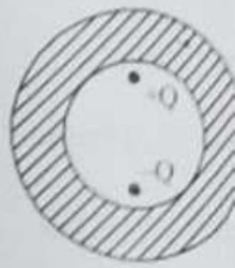
If $σ_{1}$ is the surface charge on the inner surface and charge on it and $σ_{2}$ the surface charge on the outer and $Q_{2}$ net charge on it then:
[Online April 10, 2015]
(A) $σ_{1}≠0,Q_{1}=0$
$σ_{2}=0,Q_{2}=0$
(B) $σ_{1}≠0,Q_{1}=0$
$σ_{2}≠0,Q_{2}=0$
(C) $σ_{1}=0,Q_{1}=0$
$σ_{2}=0,Q_{2}=0$
(D) $σ_{1}≠0,Q_{1}≠0$
$σ_{2}≠0,Q_{2}≠0$
[solution]
Option A
[Question_end]

2) Numeric value questions

[Question_start]
22. A positive ion $A$ and a negative ion $B$ has charges $6.67={10}^{19}C$ and $9.6×{10}^{111}C$, ind masses $19.2×{10}^{27} kg$ and $9={10}^{-27} kg$ respectively. At an instant, the ions are separated by a certain distance $r$. At that instant the ratio of the magnitudes of electrostatic force to gravitational force is $P={10}^{4}$, where the value of P is _____.
(Take $\frac{1}{4πε_{0}}-9×{10}^{9}{Nm}^{2}C^{-1}$ and universal gravitational constant as $6.67×{10}^{-11}{Nm}^{2}{ kg}^{3}$ )
[Jan 23, 2025 (I)]
[solution]
Option A
[Question_end]

[Question_start]
23. Two identical charged spheres are suspended by strings of equal lengths. The strings make an angle 0 with cacti other When suspended in water the angle remains the same. If density of the material of the sphere is $1.5 g/cc$, the dielectric constant of water will be _____. (Take density of water = 1 $g/cc$ )
[Feb, 1, 2024 (II)]
[solution]
Option A
[Question_end]

[Question_start]
24. Suppose a uniformly charged wall provides a uniform electric field of $2×{10}^{4} N/C$ normally: A charged particle of mass 2 g being suspended through a silk thread of length 20 cm and remain stayed at a distance of 10 cm from the wall. Then the charge on the particle will be $\frac{1}{\sqrt{x}}μC$ where $x=$ _____. [use $g=10 m/s^{2}$ ]
[Feb. 1, 2024 (II)]
[solution]
Option A
[Question_end]

[Question_start]
25. Two identical charged spheres are suspended by strings of equal lengths. The strings make an angle of ${37}^{∘}$ with each other. When suspended in a liquid of density $0.7 g/{cm}^{3}$, the angle remains same. If density of material of the sphere is $1.4 g/{cm}^{3}$, the dielectric constant of the liquid is _____. $\left(tan⁡{37}^{∘}-\frac{3}{4}\right)$
[Jan. 30, 2024 (II)]
[solution]
Option A
[Question_end]

[Question_start]
26. A thin metallic wire having cross sectional area of ${10}^{-4}{ m}^{2}$ is used to make a ring of radius 30 cm . A positive charge of $2π$ C is uniformly distributed over the ring, while another positive charge of 30 pC is kept at the centre of the ring. The tension in the ring is _____N. provided that the ring does not get deformed (neglect the influence of gravity).
(given, $\frac{1}{4πϵ_{0}}=9×{10}^{9}$ Slunits)
[Jan. 27, 2024 (I)]
[solution]
Option A
[Question_end]

[Question_start]
27. Three point charges $q,-2q$ and $2q$ are placed on $x$-axis at a distance $x=0,x=\frac{3}{4}R$ and $x=$ R respectively from origin a shown. If $q=2×{10}^{-6}C$ and $R=2 cm$, the magnitude of $n$ force experienced by the charge $-2q$ is _____N.
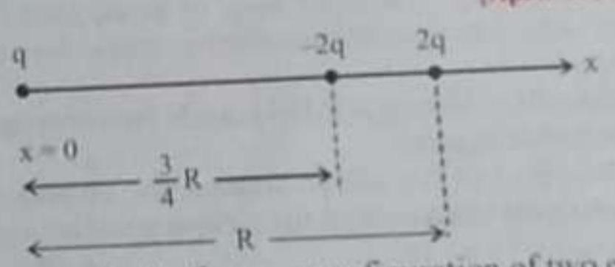
[April 13, 2023 (II)]
[solution]
Option A
[Question_end]

[Question_start]
28. As shown in the figure, a configuration of two equal $p$ charges $\left(q_{0}=+2μC\right)$ is placed on an inclined plane. Ma each point charge is 20 g . Assume that there is no fric between charge and plane. For the system of two charges to be in equilibrium (at rest) the heighth ${10}^{-3} m$. The value of $x$ is _____.
[April 11, 2022 (II)]
[solution]
Option A
[Question_end]

Part B (JEE Mains)
Topic 1 - Electric Charges and Coulomb's Law
1 MCQs with One Correct Answer
[Question_start]
1. Two beads, each with charge $q$ and mass $m$, are on a horizontal, frictionless, non - conducting, circular hoop of radius R . One of the beads is glued to the hoop at some point, while the other one performs small oscillations about its equilibrium position along the hoop. The square of the angular frequency of the small oscillations is given by [ $ε_{0}$ is the permittivity of free space.]
[Adv. 2024]
(A) $\frac{q^{2}}{\left(4πε_{0}R^{3}m\right)}$ (B) $\frac{q^{2}}{\left(32πε_{0}R^{3}m\right)}$
(C) $\frac{q^{2}}{\left(8πε_{0}R^{3}m\right)}$ (D) $\frac{q^{2}}{\left(16πε_{0}R^{3}m\right)}$
[solution]
Option A
[Question_end]

6 MCQs with One or More than One Correct Answer
[Question_start]
2. Two identical non-conducting solid spheres of same mass and charge are susponded in air from a common point by two nonconducting, massless strings of same length. At equilibrium, the angle between the strings is $α$. The splieres are now immersed in adieketric liquid of density $800{kgm}^{-3}$ and dielectric constant 21. If the angle between the strings remains the same affer the immersion, then
[Adv. 2020]
(A) electric force between the spheres remains unchanged
(B) electric force between the spheres reduces
(C) mass density of the spheres is $840 kg{ m}^{3}$
(D) the tension in the strings holding the spheres remains unchanged
[solution]
Option A
[Question_end]

[Question_start]
3. Four charges $Q_{1},Q_{2},Q_{3}$ and $Q_{4}$ of same magnitude are fixed along the $x$ axis at $x=2a,-a,+a$ and $+2a$, reppectively $A$ positive charge $q$ is placed on the positive $y$ axis at a distunce $b>0$. Four options of the signs of these charges are given in List-I. The direction of the forces on the charge $q$ is given in List-II. Match List-I with List-II and select the correct answer using the code given below the lists.
[Adv. 2014]
List-I | List-II
P) Q₁, Q₂, Q₃, Q₄ all positive | 1. $+x$
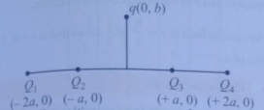
Q) $Q_{1},Q_{2}$ positive:  $Q_{3},Q_{4}$ negative | 2. $-x$
R) $Q_{1},Q_{4}$ positive:  $Q_{2},Q_{3}$ negative | 3. $+y$
S. $Q_{1},Q_{3}$ positive:  $Q_{2},Q_{4}$ tregative | 4. $-y$
Codes:
(A) $P-3,Q-1,R-4, S-2$
(B) $P-4,Q-2,R-3, S-1$
(C) $P-3,Q-1,R-2,S-4$
(D) P$-$4, Q$-$2, R$-$1, S$-$3
[solution]
Option A
[Question_end]

Topic 2 - Electric Field and Field Lines
1 MCQ- with One Correct Answer
[Question_start]
4. Charges $Q.2Q$ and $4Q$ are uniformly distributed in three dielectric solid spheres 1,2 and 3 of radii $R/2,R$ and $2R$ respectively, as shown in figure. If magnitude of the electric fields at point $P$ at a distance $R$ from the centre of sphere $I,2$ and $3areE_{1},E_{2}$ and $E_{3}$ respectively, then
[Adv, 2014]
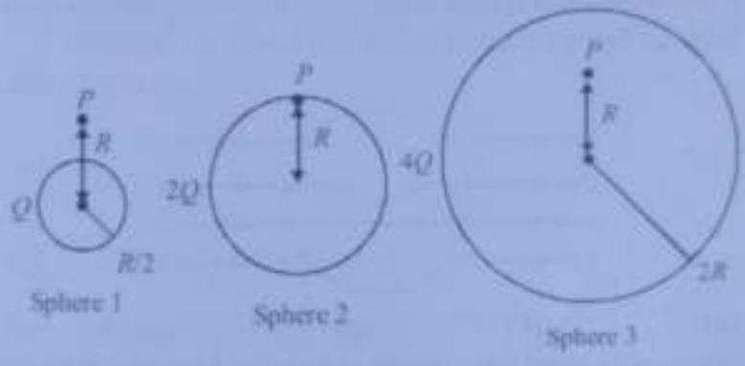
(A) $E_{1}>E_{2}>E_{3}$ (B) $E_{3}>E_{1}>E_{2}$
(C) $E_{2}>E_{1}>E_{3}$ (D) $E_{3}>E_{2}>E_{1}$
[solution]
Option A
[Question_end]

