**ABSTRACT**

This project “Academic knowledge Characterized Access” is developed to carry out the activities of the MCA department in a well planned and systematic manner. It sets up the platform for students to access the facilities of the application. It helps to manage information regarding students, staff, text books, model question papers, video links, subjects, syllabus, staff subjects etc. There is also a provision for students and lecturers to register themselves. There is also a provision to carry out mentorship activities.

**TABLE OF CONTENTS**

|  |  |  |
| --- | --- | --- |
| **Sl. no.** | **PARTICULARS** | **Page no.** |
| **1** | **Introduction**   * 1. Project Description   2. Company Profile | **1** |
| **2** | **Literature Survey**  2.1 Existing and Proposed System  2.2 Feasibility Study  2.3 Tools and Technologies used  2.4 Hardware and Software Requirements | **3** |
| **3** | **Software Requirements & Specification**  3.1 Users  3.2 Functional Requirements  3.3 Non-Functional Requirements | **9** |
| **4** | **System Design**  4.1 System Perspective(Architecture Diagram)  4.2 Context Diagram | **13** |
| **5** | **Detailed Design**  5.1 Use Case Diagram  5.2 Sequence Diagram  5.3 Activity Diagram  5.4 ER Diagram | **15** |
| **6** | **Implementation**  6.1 Screen Shots | **36** |
| **7** | **Software Testing**  7.1 Test Cases | **40** |
| **8** | **Conclusion** | **43** |
| **9** | **Future Enhancements** | **44** |
| **10** | **Appendix A**  Bibliography | **45** |

|  |  |  |
| --- | --- | --- |
| **SI no.** | **CONTENTS** | **Page no.** |
| 1 | FIG 4.1 SYSTEM PERSPECTIVE | 13 |
| 2 | FIG 4.2 CONTEXT DIAGRAM | 14 |
| 3 | FIG 5.1.1 USE CASE DIAGRAM OF ADMIN | 15 |
| 4 | FIG 5.1.2 USE CASE DIAGRAM OF LECTURER | 18 |
| 5 | FIG 5.2.2 SEQUENCE DIAGRAM FOR ADMIN | 21 |
| 6 | FIG 5.2.2 SEQUENCE DIAGRAM FOR LECTURER | 22 |
| **7** | FIG 5.3.1 ACTIVITY OF ADMIN | 23 |
| 8 | FIG 5.3.2 ACTIVITY OF LECTURER | 26 |
| 9 | FIG 5.3.3 ACTIVITY OF SYLLABUS | 28 |
| 10 | FIG 5.3.4 ACTIVITY OF SUBJECT MGMT | 29 |
| 11 | FIG 5.3.5 ACTIVITY OF STAFF SUBJECT MGMT | 29 |
| 12 | FIG 5.3.6 ACTIVITY OF BOOK MGMT | 30 |
| 13 | FIG 5.3.7 ACTIVITY OF NOTES MGMT | 31 |
| 14 | FIG 5.3.8 ACTIVITY OF QP MGMT | 32 |
| 15 | FIG 5.3.9 ACTIVITY OF VIDEO LINKS MGMT | 32 |
| 16 | FIG 5.3.10 ACTIVITY OF FEEDBACK | 33 |
| 17 | FIG 5.3.11 ACTIVITY OF SUGGESTION | 33 |
| 18 | FIG 5.3.12 ACTIVITY OF MENTORSHIP MGMT | 34 |
| 19 | F FIG 5.4 ER DIAGRAM | 35 |
| 20 | TABLE 7.1.1 TEST CASES 1-5 | 40 |
| 21 | TABLE 7.1.2 TEST CASES 6-10 | 41 |
| 22 | TABLE 7.1.3 TEST CASES 11-15 | 42 |

**LIST OF FIGURES AND TABLES**

**Chapter 1**

**Introduction**

**1.1 Project Description**

The application AKCA “Academic Knowledge Characterized Access” is developed to help students & staff of the departments. The current application is specifically developed for MCA department of KLEIT Hubballi.

The application allows students to download updated syllabus. Through this system students can receive notification from department regarding payment of fees, internal assessment schedule and many more.

The application allows lecturers as mentors to select their mentees and establish communication with them. This helps to address academic as well as other problems of the department. The users of this application need to register themselves to do the activities. They receive the login credentials from administration through an SMS.

The application is designed in such a way where materials can be provided to students’ semester wise. This enables students to prepare nicely for semester end exams.

In the application there is a quick channel through which the department can access important information of students and lecturers. With this system in place, they can not only access but can also update the information.

The administration is the one who directly or indirectly sets the platform for users such as lecturers, students and placement officer. The application allows administration to add a new student and lecturer. The administration can also delete the information of students and lecturers as and when required. The application allows administration to generate report of various vital data of students, lecturers and with respect to course and subjects.

**1.2 Company Profile**

**VENTURE WINGS GROUP**

VENTURE WINGS GROUP, an offshore IT outsourcing company in India, provides a range of IT outsourcing services and solutions to enable companies develop challenging and innovative software products as well as run their day-to-day operations. Outsourcing of IT tasks to VENTURE WINGS GROUP, helps firms provide 24/7 productivity and save on labour cost without compromising on quality. **Detail information on our offshore IT services can be found below**

* Business Application Development
* Web Designing and Training
* PHP Development
* Custom Software
* Web Hosting
* SMS Advertising
* SEO(Search Engine Optimization)
* Internship program for *Students*
* *Android* Application Development

***Why Us:-*** VENTURE WINGS GROUP mission is to alter the dynamics of the software industry by providing trusted, supportive and quality software development services to clients that view our partnership as a strategic driver for their success. When we take on your project, we take the stewardship of the project with you in the director's seat. As stewards of your project, we consider ourselves successful not when we deliver your final product but when the product meets your business objectives and that is our vision. More than just a “development house”, VENTURE WINGS GROUP will work with your company to develop a strategy that is specific to your industry to give your application the best chance of success. Building an application is more than just development; it needs to strike a balance between meeting your business needs while being compelling for your audience.

Venture Wings Group Official Website: http://www.vwingsgroup.com

**Chapter 2**

**Literature Survey**

**2.1 Existing and Proposed System**

In the present systems we can see students struggling to collect the vital data which plays a very important role in the preparation of exams which they face throughout the semester. In the current trend, students have to wait for a long time, almost a month, to get books from library. It affects academics of students.

If a student gets one book then we can see other students approaching that student and requesting him\her to lend a book for a day so that they can take a photocopy of it. In such cases there is high possibility of some students of not getting the books. Not only about text books, had same problem persisted with question papers, notes and other vital essentials. The students are unaware of the changes with respect to the syllabus and continue to refer the unaltered syllabus. This affects their preparation.

There is no channel in the current system where lecturer can provide essential materials semester wise such as PDF of textbooks and other materials. In the current system there is no quick channel where department administration can access important information of students. The administration goes through series of files to get information about a particular student. This consumes a lot of time and energy. The case is also similar when it comes to lecturers.

In the existing system, there is no facility through which the administration can convey notification to students like payment of fees, IA schedule etc. In the current system there is no facility to quickly update or edit the vital information of students and lecturers.

In the existing system there is no facility for mentors to communicate with their mentees personally the mentor has to approach their respective mentees in order to take their feedback. Some times when the mentors are busy then it is difficult for them to carry out the feedback session .Also there is no communication facility between admin and lecturers.

The proposed system is aimed to solve all the problems or loopholes present in the existing system. In the proposed system the lecturer can upload scanned copies of notes, PDF of textbooks, and question papers semester wise. The administration can add new subjects by removing the old subjects of MCA course. The administration can assign subjects to the teachers and also can replace the old syllabus with new syllabus. The administration sends login credentials to students and lecturers .The users that is lecturers and students receive login credentials from administration through an SMS.

The system also provides a facility where administration can quickly access the information of students and lecturers. It also provides a channel where administration can convey notification to each and every student. It also provides the facility to update or edit student and lecturer information .By this lots of paper work has been reduced. The proposed system ensures a channel through which admin can effectively communicate with lecturers and vice versa.

The system allows lecturers as mentor to select their respective mentee. Sometimes lecturers will be busy and may not go to each class to take the feedback from their mentees. So this system allows students to give feedback to their mentor. The proposed system allows the administration to generate reports on various vital data with respect to students, lecturers and most importantly with respect to subjects and course.

**2.2 Feasibility Study**

Feasibility study checks whether the user needs can be achieved with available tools and technologies. It also checks whether the given budget is sufficient or not to develop and implement the project. The feasibility study should not be costly and it is done at the beginning. Depending on the outcome the decision is made. Each and every proposed project undergoes feasibility test and finally gives the permission to proceed.

Facts considered in the application for feasibility study are:

* Behavioral feasibility
* Economic feasibility
* Technical feasibility

**2.2.1 Technical Feasibility**

Considering our project it is technically feasible with respect to the selected technology.”AKCA” concentrates on the complex requirements and committed to full fill these requirements. That is how the user’s can get the advantages is by, using the tools as PHP, JavaScript, HTML and MySql these are very popular as they are easy to use in the development.

**2.2.2 Economic Feasibility**

This study says whether the under taken project is economically feasible or not .In simple words it should be implemented within the allocated funds by client. As we all know when we switch from traditional process to automation, the cost will increase a bit. The main thing is it should give assurance that all the needs of users will be achieved within the allocated funds.

The economic feasibility should center along the following points

* Should be superior than old system and within allocated funds.
* Cost should not exceed too much.
* Estimation of durability of machines.

**2.2.3 Behavioral / Operational Feasibility**

This study involves whether the developed system will be able to sustain the operational environment or not. The operational environment involves users who are not flexible to change and will try to remain with the existing system. The developed system should make users to get accustomed with it and should encourage them to continue with it. This study is nothing but it finds out whether the system is going to do this or not.

**2.3 Tools and Technologies**

**2.3.1 PHP**

Other name is "Hypertext Preprocessor”. A Web language that is HTML-embedded. Where, PHP code can be written along with the html. When a PHP page is accessed, the PHP code is read or "parsed" by the server. The outputs from the PHP functions are always returned as HTML code, and the browser reads it. PHP code is converted into HTML before the page is loaded therefore users cannot view the PHP code on a page. This make PHP pages safe to access databases and other vital information.

PHP development was started in 1994 by Rasmus Lerdorf and he is known as the father of PHP. In the following situation, the admin enters the details of new subject in the form.

Admin Enters the subject name, description and the no of hours and later clicks on the submit button. All the entered data should get inserted in the respective table. To make this thing possible the php code is used. In that, first the connection with the database is established. All the form data, that is name, description, and the no of hours entered is collected through post variable. Then using the suitable SQL query the data is inserted into the subject table.

Using the php code, the existing information about a particular subject can be changed and similarly if required the information can be deleted. In this way PHP code, helps to do the same activities on different data.

**2.3.2 Html**

HTML (Hypertext Markup Language) is the set of symbols or codes used to display the contents of a file. Each markup symbol is called as an element usually people also refer to it as a tag. Some symbols are in pairs that indicate to some display and to begin and to end. The content of the page should be written in body tag and in the html structure the innermost tag will close first and followed by next.HTML was developed by Berners-Lee and is known as the father of HTML.

The html language is used to construct the forms and which acts as the channels through which data can be inserted. Consider the following instance where a form is created using this markup language. Let us design a form for login page with two labels, two text box and a submit button.

**2.3.3 Java Script**

It is a programming language that can be included in forms to make them more interactive. Used for checking or modifying the inputs of forms, change images, open new windows and write dynamic page content. The main purpose to use java script is to make validation for the entered data in the form.

Brendan Eich was developer of Java script by, who works at Mozilla. The real name is Mocha, named by the founder of Netscape. In 1995 the name got changed to Live Script, in the same year on December, java script was replaced.

The features of JS:

* Helps to detect user’s browser.
* Helps user to have control over the browser.
* Does simple manipulations on the client side.
* Helps to handle dates and times.
* Validating the users input.

**2.3.4 My SQL**

For creating the database and the tables for the database it is used. This helps to store the vital information of the application for longer time and can be accessed after few months or years. This is very much useful to keep the details for any of the information related to the lecturer or students.

**2.4 Hardware and Software Requirements**

**Hardware Requirements:**

**Client Side:**

* Operating System : Windows 7.
* Processor : 2.0 GHz or higher.
* RAM : 1 GB or more.

**Server Side:**

* Operating System : Windows 7.
* Processor : above Pentium 4.
* RAM : 1 GB and above.
* Hard Disk : 40GB and above.

**Software Requirements:**

* Operating System : Windows XP/2000/Vista.
* Front End : PHP, Android.(ADT bundle).
* Back End : MySql.
* Server : WAMP Server.

**Chapter 3**

**Software Requirement Specification**

**3.1 Users**

**3.1.1 Admin**

The admin can view the registered students and sends the login credentials to them through an SMS. Using the credentials the student’s can login. Students directly cannot access the materials present in the application, first they have to fill the registration form. Similarly the admin provides the login credentials for lecturers. The admin uploads the latest version of the syllabus of each and every subjects prescribed for MCA course. The admin can also update the syllabus and can delete the syllabus if required.

The admin can add new subjects, can update the things related to the subject and if required can delete the subjects. The admin can assign the subjects to the staff and can update the things related to staff subjects and can also deleted the details of staff subjects. The admin can assign each and every subject to a particular semester based on the university prescription. Suppose if a subject prescribed to a particular semester is replaced by a new subject then the admin can also make these changes with ease. The admin can view the staff list and can add a new staff. He can also update the details and if required can delete a staff.

The admin can upload the PDF files or the soft copies of the prescribed text books of each and every prescribed subject. The admin can also upload the soft copies of the notes and can upload the question papers of the current scheme. The admin can view the academic details of the students and if required can make changes to that information.

As we all know that notification issued by the department sometimes does not reach each and every student because of various students. So in order to overcome this hurdle the system allows the admin to convey notification to each and every student. The notification can be schedule of internal assessment, remainder of payment of exam fees etc. An SMS will be sent to each and every student regarding this. This ensures that each and every student is notified.

**3.1.2 Lecturer**

The lecturer after login can view his / her profile and if required can make changes to the profile. The lecturer can download the syllabus copies prescribed by the university. The lecturer can view the subjects assigned to him / her. The lecturer can add the new video links aimed to help students to learn new concepts as well as to make the things easier.

In mentorship process, every lecturer being mentor has to add few students of each and every semester as their mentee. The application allows the lecturer to add mentees under them. The students as mentee can convey the problem to their mentors associated with department or subjects. The mentors can respond to each and every grievance of their mentees. This saves the time and energy of the mentors and helps to enhance the communication between mentors and their mentees.

The lecturer can also view the academic details of the students with the help of the “usn” he/she can search the respective student. The Lecturer can also upload the books as the pdf file of the their respective subjects and if they have prepared some notes for their assigned subject that also they can upload which helps the students to download the notes, pdf’s of textbooks with Q- paper’s of their assigned subjects. Lecturer can also share the video links of the subjects or any useful information.

**3.2 Functional Requirements**

The following are the functionalities provided by the application

For admin

For lecturer

For mentorship

For notification

**3.2.1. For Admin**

The admin can view the registered students and sends the login credentials to them through an SMS. Using the credentials the student can login. Students directly cannot access the materials present in the application, instead first they have fill the registration form. Similarly the admin provides login credentials for lecturers. The admin uploads the latest version of the syllabus of each and every subjects prescribed for MCA course. The admin can also update the syllabus and can delete the syllabus if required. The admin can add new subjects, can update the things related to the subject and if required can delete the subjects. The admin can assign the subjects to the staff and can update the things related to staff subjects and can also delete the info of staff subjects. The admin can assign each and every subject to a particular semester based on the university prescription. Suppose if a subject prescribed to a particular semester is replaced by a new subject then the admin can also make these changes with ease. The admin can view the staff list and can add a new staff. He can also update the details and can also delete a staff. The admin can upload the PDF files or the soft copies of the prescribed text books of each and every prescribed subject. The admin can also upload the soft copies of the notes and can upload the question papers of the current scheme. The admin can view the academic details of the students and if required can make changes to that information.

**3.2.2. For Lecturer**

Lecturer after login can view his / her profile and if required can make changes to the profile. The lecturer can download the syllabus copies prescribed by the university. The lecturer can view the syllabus assigned to him / her. The lecturer can add the new video links aimed to help students to learn new concepts as well as to make the things easier.

**3.2.3. For Mentorship**

In mentorship process, every lecturer being mentor has to add few students of every semester as their mentee .The application allows the lecturer to add mentees under them. The students as mentee can convey the problem to their mentors associated with department. The mentors can respond to each and every grievance of their mentees. This saves the time and energy of the mentors and helps to enhance the communication between mentors and their mentees.

**3.2.4. For Notification**

As we all know that notification issued by the department sometimes does not reach each and every student because of various students. So in order to overcome this hurdle the system allows the admin to convey notification to each and every student. The notification can be schedule of internal assessment, remainder of payment of exam fees etc. An SMS will be sent to each and every student regarding this. This ensures that each and every student is notified.

**3.3 Non-Functional Requirements**

**3.3.1 Performance Requirement**

The proposed system interacts with the user and server. If a user performs any action then the system will return the results correctly and quickly. It will not hang up and it will not give incorrect results.

**3.3.2 Safety Requirement**

The database is like the backbone of the application. If the database becomes corrupt due to OS failure or virus attack then there must be a provision to take the back up of the data. This again helps to bring the application right on the required track.

**3.3.3 Security Requirement**

We have developed a secured database for the user .There are different categories of users. Depending upon the type of user the access functions are decided. It means if the user is a placement officer then he can enter company details and can send SMS to eligible candidates.

**3.3.4 Efficiency Requirement**

The application which is endeavored by the developer should ensure that all the tasks which the client tells should be there in the application. Apart from including these functionalities, they should yield correct output with respect to different input data. Thus efficiency is achieved. This ultimately reduces the complexity and enhances the performance of the system.

**Chapter 4**

**System Design**

**4.1 System Perspective**

**LOGIN**

**STAFF**

**ADMIN**

**STUDENT**

**PLACEMENT OFFICER**

DOWNLOAD SYLLABUS

ADD NEW SYLLABUS, SUBJECTS, STAFF’S

DOWNLOAD SYLLABUS, BOOKS, NOTES

VIEW STUDENT ACADEMIC DETAILS

ADD NOTES OF HIS/HER SUBJECT’S

GIVE FEEDBACK/ QUERY, VIEW SUGGESTION, GET VIDEO LINKS

ASSIGN STAFF’S SUBJECT

ADD COMPANY DETAILS

ADD QUESTION PAPER OF HIS/HER SUBJECT’S

ADD PDF OF BOOKS**/**NOTES, QUESTION PAPER**/**VIDEO LINKS

SEND ELIGIBLE CRITERIA TO STUDENTS

ENTER MARKS

COMMUNICATE WITH MENTOR

ADD NEW MENTEE/ VIEW SUGGESTION/ NEW VIDEO LINKS

VIEW ELIGIBLE STUDENTS OF GIVEN CRITERIA

VIEW QUERRIES/ GIVE SUGGESTION

VIEW STUDENT ACADEMIC DETAIL

VIEW STUDENT ACADEMIC DETAIL

**LOG OUT**

***Fig no.4.1.Architechtural diagram of Academic knowledge Characterized Access.***

**4.2 Context Diagram**

**DATABASE**

**AKCA**

**ADMIN**

**NOTIFICATION**

**QUERY**

**STAFF**

***Fig no.4.2 Context diagram of Academic knowledge Characterized Access.***

The above diagram shows the interaction of modules with the database, those are Admin, Staff, Query, and Notification is the modules of the Academic knowledge Characterized Access (AKCA).

**Chapter 5**

**Detailed Design**

**5.1 Use Case Diagrams**

**5.1.1 Admin**

**Tasks of admin**

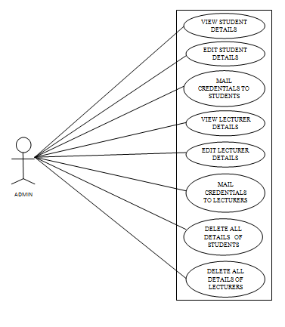

***5.1.1.1. Use case diagram of Admin.***

The above diagram shows the tasks performed by the admin, were admin can view student, lecturer, both and can also delete or edited if required.

**5.1.1.2 Admin Tasks of admin**

ADMIN

***5.1.1.2. Use case diagram of Admin.***

**5.1.1.3 Admin**

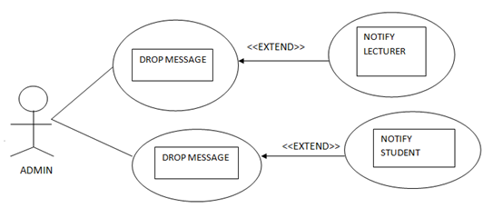

***5.1.1.3. Use case diagram of Admin.***

The above diagram shows the admin sending the message to the lecturer and student, other tasks performed by the admin.

**5.1.2 LECTURER**

**Tasks of lecturer**

LECTURER

***5.1.2. Use case diagram of Lecturer.***

The above diagram shows the tasks performed by the lecturer as listed, inserting personal details, add notes, question papers and adding the students as the mentee’s of the respective semester.

**5.1.2.1 LECTURER**

<<EXTEND>>

NOTIFY RESPECTIVE STUDENT

DROP MESSAGE

<<EXTEND>>

NOTIFY ADMIN

DROP MESSAGE

LECTURER

***5.1.2.1. Use case diagram of Lecturer.***

The above diagram shows the interaction of lecturer with the admin & the respective student.

**5.1.2.2 LECTURER**

INTERACT

ADMIN

SHARE VIDEO LINKS WITH STUDENTS

LECTURER

***5.1.2.2. Use case diagram of Lecturer.***

This above diagram shows the interaction of lecturer with the students and the admin.

**5.1.2.3 Lecturer as Mentor**

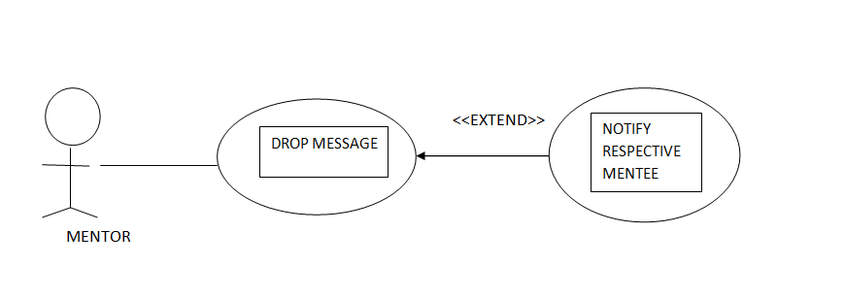

***5.1.2.3. Use case diagram of Lecturer (Mentor) to Student (Mentee).***

The above diagram shows the interaction of lecturer as a mentor with the student as mentee. Where the lecturer send the message to the student and it notifies to their respective mentee as student.

**5.1.3 Mentee as Student**

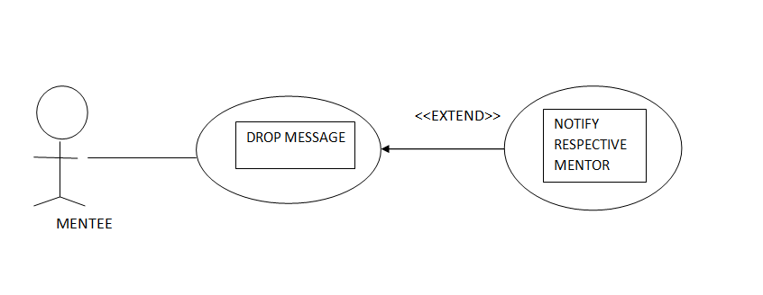

***5.1.3*. *Use case diagram of Student (Mentee) to Lecturer (Mentor).***

The above diagram shows the interaction of student as mentee with the lecturer as a mentor. Here the student responds to the notices of their respective mentee as lecturer.

**5.2 Sequence diagrams**

**5.2.1 Admin**

**DATABASE**

**AKCA**

**ADMIN:**

ENTER CREDENTIALS VERIFY

ADMIN PROFILE VALID

ADD SYLLABUS UPDATE SYLLABUS

ADD NEW SUBJECTS UPDATE SUBJECTS

ADD**/**REGISTER STAFF UPDATE STAFF

ADD STAFF SUBJECTS UPDATE STAFF SUBJECT

ADD BOOKS UPDATE BOOKS

ADD NOTES UPDATE NOTES

ADD QUESTION PAPER UPDATE QUESTION PAPER

ADD VIDEO LINKS UPDATE VIDEO LINKS

UPDATE MARKS OF STUDENT UPDATED

SEARCH STUDENT (USN) VERIFY

STUDENT INFORMATION FETCH INFORMATION

LOGOUT

HOMEPAGE

***5.2.1. Sequence diagram for Admin.***

The above diagram shows the sequential view of the admin; were he/she can do the following process.

**5.2.2 Staff**

**DATABASE**

**STAFF:**

**AKCA**

ENTER CREDENTIALS VERIFY

STAFF PROFILE VALID

UPDATE PROFILE UPDATED

ADD BOOKS UPDATE BOOKS

ADD NOTES UPDATE NOTES

ADD QUESTION PAPER UPDATE QUESTION PAPER

ADD VIDEO LINKS UPDATE VIDEO LINKS

ADD MENTEE UPDATE MENTEE

GIVE SUGGESTION UPDATE SUGGESTION

UPDATE MARKS OF STUDENT UPDATED

SEARCH STUDENT (USN) VERIFY

STUDENT ACADEMIC INFO FETCHES INFORMATION

LOGOUT

HOMEPAGE

***5.2.2. Sequence diagram for Staff.***

The above diagram shows the sequential view of staff: were he/she can do the following tasks respectively.

**5.3 Activity Diagrams**

**5.3.1 Admin**

•

Manage syllabus

Manage subjects

Manage staff subjects

Manage subjects of course

Manage staff

Manage video links

Manage question paper

Manage notes

Manage books

Send credentials

View registered

Update Marks

Give Suggestion

View feedback

***5.3.1. Activity diagram for Admin.***

The above diagram shows the activity involved in the admin, which has a starting point as from where it starts and till the end, as the activities involved in it.

**5.3.2 Lecturer**

•

Download syllabus

Add books

Add notes

Add question papers

Add video links

Give Suggestion

View feedback

Add mentee

***5.3.2. Activity diagram for Lecturer.***

The above diagram shows the activity involved in the lecturer, which has a starting point as from where it starts and till the end, as the activities involved in it.

**5.3.3 Syllabus**

•

Write syllabus name

Write Description

Select Subject

Browse file

Select staff

***5.3.3. Activity diagram for syllabus.***

The above diagram shows the activity involved in the syllabus, which has a starting point as from where it starts and till the end, as the activities involved in it.

**5.3.4 Subject management**

•

Enter duration

Enter description

Enter subject name

***5.3.4. Activity diagram for Subject Management.***

The above diagram shows the activity involved in the subject management, which has a starting point as from where it starts and till the end, as the activities involved in it.

**5.3.5 Staff Subject Management**

•

Select staff

Select subject

Enter Semester

***5.3.5. Activity diagram for Staff Subject Management.***

The above diagram shows the activity involved in the Staff Subject Management, which has a starting point as from where it starts and till the end, as the activities involved in it.

**5.3.6 Book Management**

•

Enter file type

Browse file

Enter file size

Enter file name

Select subject

Select date

Add name

***5.3.6. Activity diagram for Book Management.***

The above diagram shows the activity involved in the Book Management, which has a starting point as from where it starts and till the end, as the activities involved in it.

**5.3.7 Notes Management**

•

Select subject

Enter notes description

Browse file

Enter name

Select date

Enter chapter name

***5.3.7. Activity diagram for Notes Management.***

The above diagram shows the activity involved in the Notes Management, which has a starting point as from where it starts and till the end, as the activities involved in it.

**5.3.8 Question Paper Management**

•

Select subject

Browse file

Select year

***5.3.8. Activity diagram for Question Paper Management.***

The above diagram shows the activity involved in the Question Paper Management, which has a starting point as from where it starts and till the end, as the activities involved in it.

**5.3.9 Video Links Management**

•

Enter Link

Enter description

Enter video title

***5.3.9. Activity diagram for Video Link Management.***

The above diagram shows the activity involved in the Video LinkManagement, which has a starting point as from where it starts and till the end, as the activities involved in it***.***

**5.3.10 Feed Back**

•

Enter user name

Enter message

Select date

***5.3.10. Activity diagram for Feedback.***

The above diagram shows the activity involved in the Feedback, which has a starting point as from where it starts and till the end, as the activities involved in it***.***

**5.3.11 Suggestion**

•

Select feedback name

Enter username

Enter suggestion

Select date

***5.3.11. Activity diagram for Suggestion.***

**5.3.12 Mentorship Management**

•

Select Students

Select name

Select Semester

***5.3.12. Activity diagram for Mentorship Management.***

The above diagram shows the activity involved in the Mentorship Management, which has a starting point as from where it starts and till the end, as the activities involved in it***.***

**5.4 ER Diagram**

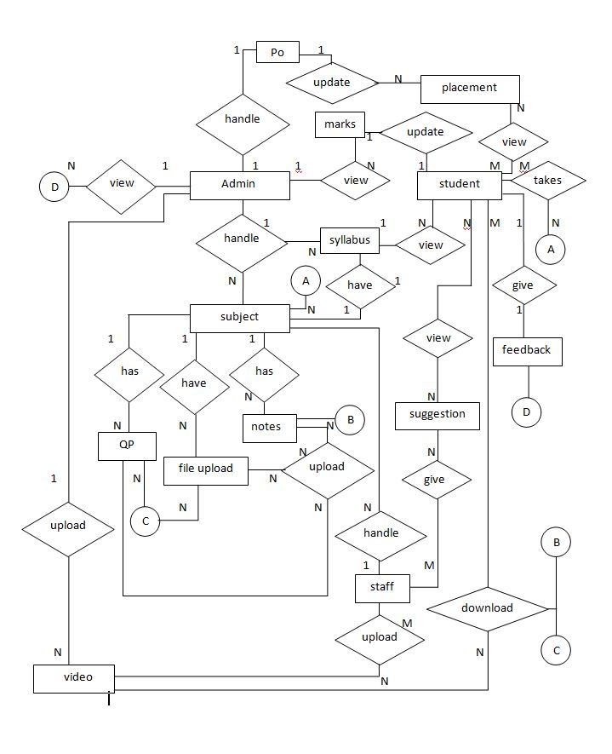

***5.4. ER diagram for AKCA.***

**Chapter 6**

**Implementation**

**6.1 Screen Shots**

**6.1.1 Admin**

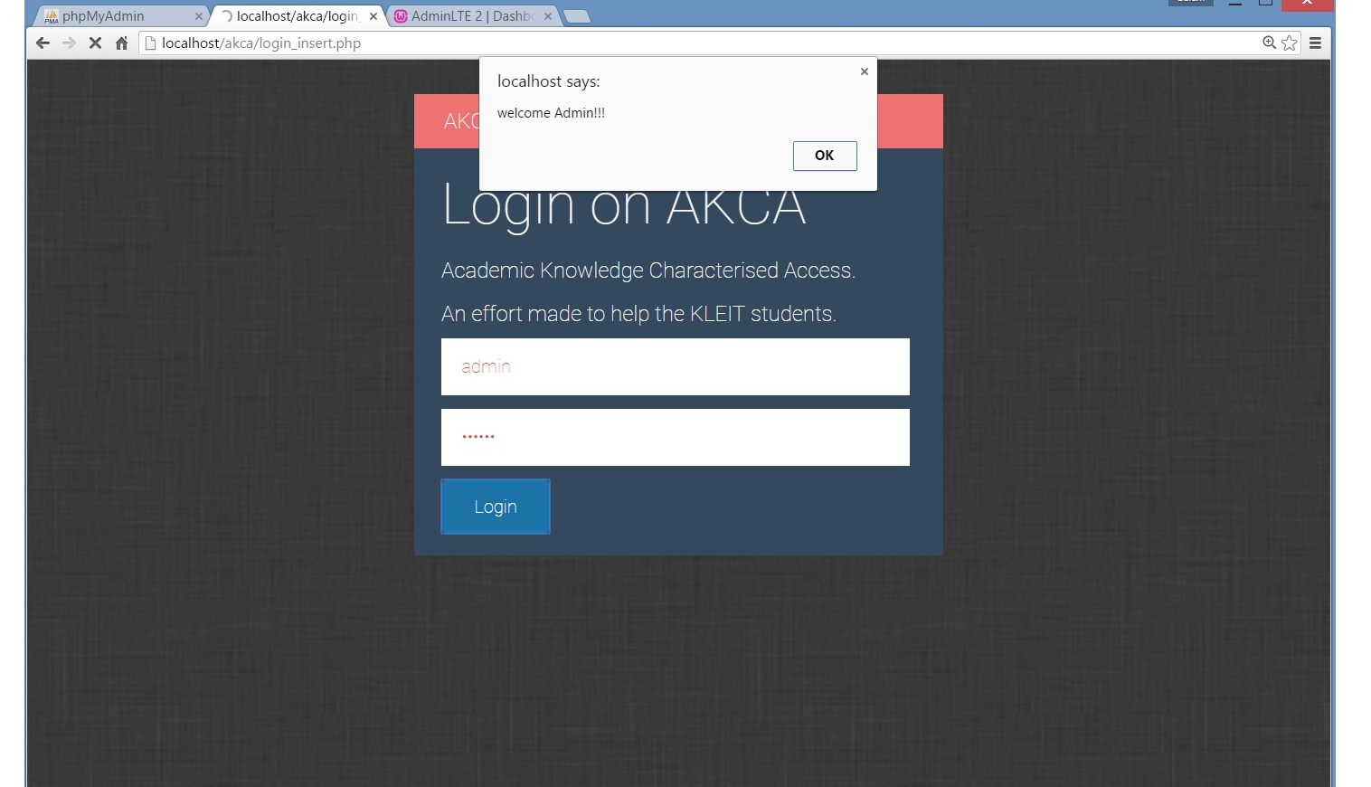

***6.1.1.1 Admin login.***

The above screen shows the login of admin. The user name & password is inserted. It shows the welcome address.

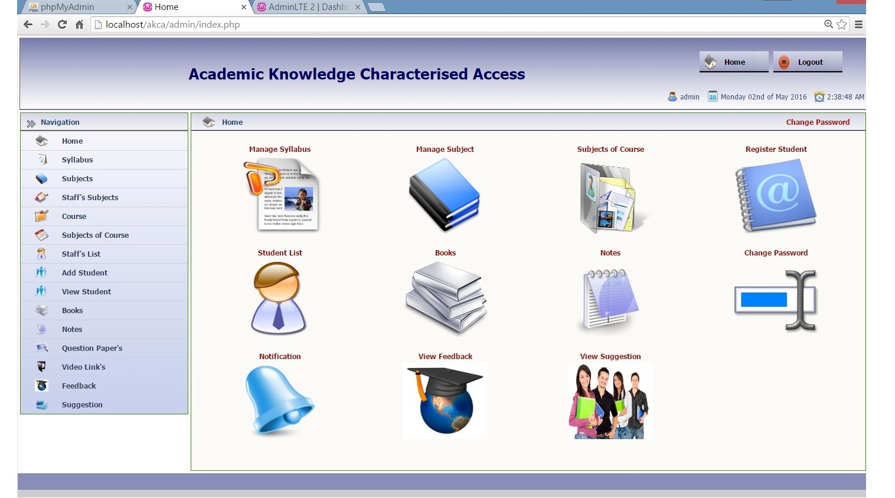

***6.1.1.2. Admin Menu.***

The above screen shows the admin menu which has the available tasks to be performed.

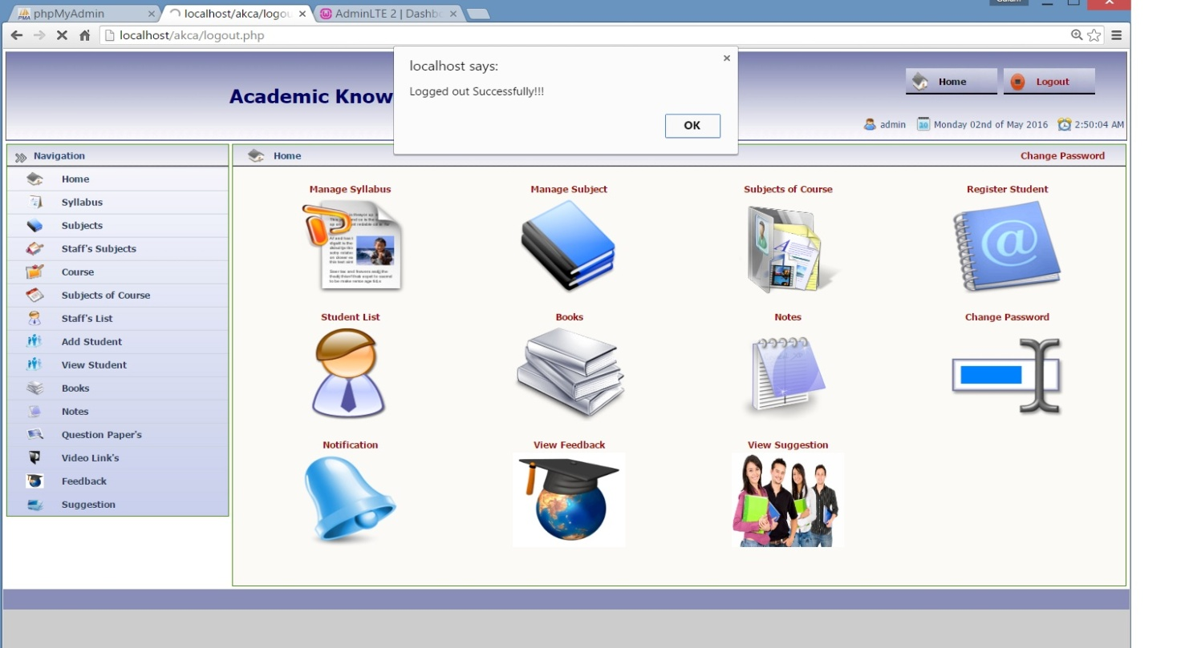

***6.1.1.3. Admin Logout.***

**6.1.2 Lecturer**

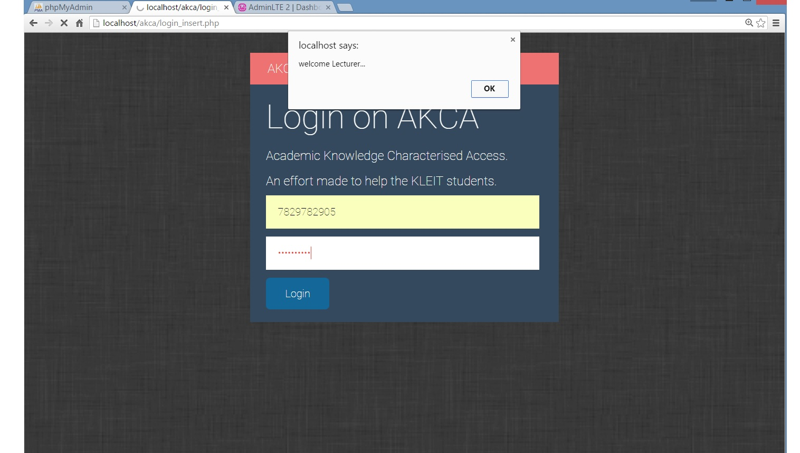

***6.1.2.1 Lecturer login.***

The above screen shows the login of lecturer. The user name & password is inserted. It shows the welcome address.

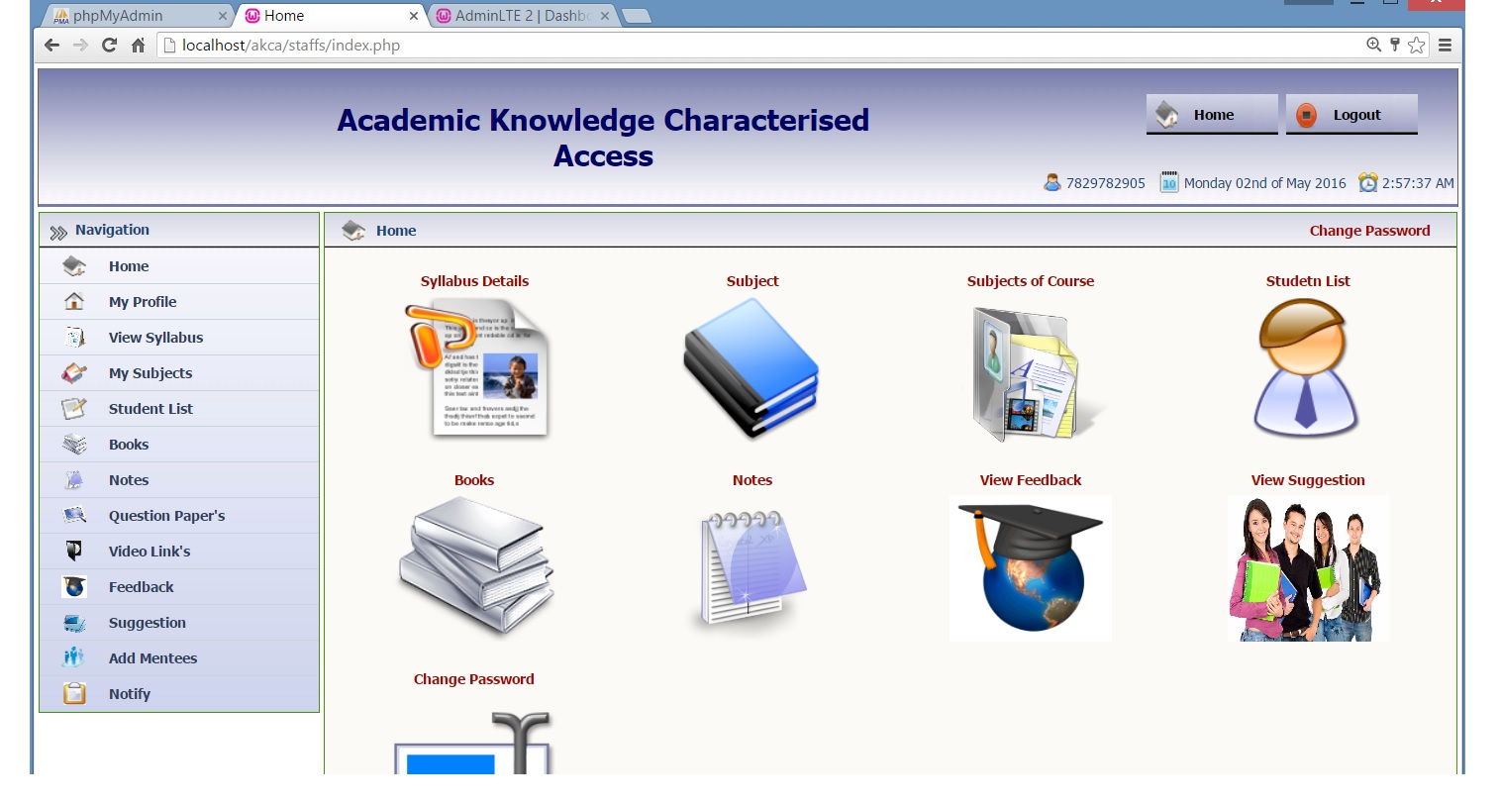

***6.1.2.2 Lecturer Menu.***

The above screen shows the available menu for the lecturer.

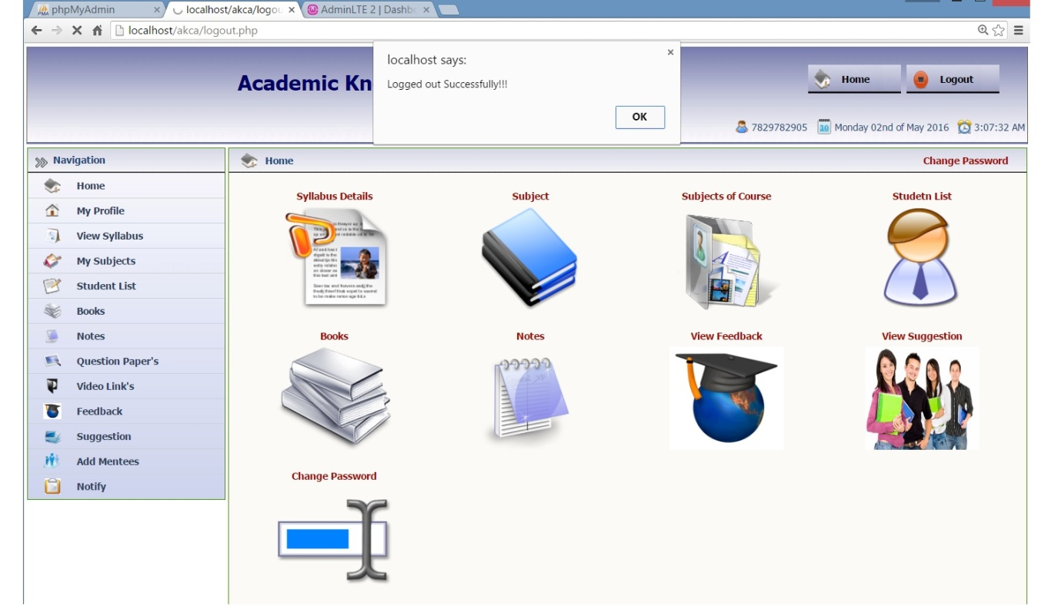

***6.1.2.3 Lecturer logout.***

**Chapter 7**

**Software Testing**

|  |  |  |  |  |
| --- | --- | --- | --- | --- |
| **Test Case** | **Input** | **Expected Output** | **Actual Output** | **Result** |
| **1** | Valid User-Name and Password | It should display respective page according to user type. | Respective Home is displayed. | **Passed.** |
| **2** | Add/Update/delete Member details | Add/Update/delete action is taken. | Added/Updated/deleted Member message Displayed. | **Passed.** |
| **3** | Invalid User-Name and Password | Appropriate error message as “Enter correct User-Name and Password”. | Error message Displayed. | **Passed.** |
| **4** | Insert PDF / Image file | Choose file option should prompt for selecting PDF / Image. | Select File is opened for selecting PDF / Image. | **Passed.** |
| **5** | Logout | It should logout correctly and should not go to the home page. | Logout message Displayed and login page is shown. | **Passed.** |

**7.1 Test Cases**

|  |  |  |  |  |
| --- | --- | --- | --- | --- |
| **Test Case** | **Input** | **Expected Output** | **Actual Output** | **Result** |
| **6** | Blank field while inserting/update | It should give appropriate error message as “Input some value”. | Displays Appropriate Error message. | **Passed.** |
| **7** | Valid Email-id with Specific Domain | It should insert the Email-id into the database while editing/ inserting. | Email-id is stored while editing/ inserting. | **Passed.** |
| **8** | Placement officer sends the credentials of company | It should receive an alert message by only eligible students. | SMS is sent successfully to the students message is displayed. | **Passed.** |
| **9** | Percentage for Total Marks of Semester | It should calculate the percentage as marks is inserted. | Calculates the percentage as total marks is inserted. | **Passed.** |
| **10** | Searching Semester wise information of students | It should display only those Semester Students. | Displays only Specific Semester Students. | **Passed.** |

|  |  |  |  |  |
| --- | --- | --- | --- | --- |
| **Test Case** | **Input** | **Expected Output** | **Actual Output** | **Result** |
| **11** | Registering Staff/Student | Respective Staff/Student information should be inserted. | Respective Staff/Student should receive credentials as SMS. | **Passed.** |
| **12** | Valid Mobile Number | It must take correct mobile number while inserting/updating. | Mobile Number is saved when inserting/updating. | **Passed.** |
| **13** | Invalid Mobile Number | It should give appropriate message as “Mobile Number entered is incorrect”. | It will display the Error message. | **Passed.** |
| **14** | Download Notes/Question paper After LOGIN | The Notes/Question paper should get Downloaded. | Notes/Question paper is Downloaded. | **Passed.** |
| **15** | Download Notes/Question paper without LOGIN | It should give appropriate error message as “Login/Sign-up”. | Displays Login/Sign-up page. | **Passed.** |

**Chapter 8**

**Conclusion**

In the application Admin can share official & important document with lecturers. The notice about the college/department can be easily sent to all the peoples of college. The newly updated copy of syllabus can be downloaded easily by the students from this application. Recent or old question paper can be downloaded by the students easily by using this application. Extra notes from any lecturer can be uploaded by the assigned lecturer for the subject. Any lecturer can view the academic details of the students. Placement officer can easily add the new company details as arrived with the eligibility criteria. If any queries are there from the students hence they can easily update their query which can be solved by any lecturer. All the process will be done with the help of smart phone and internet connection. Admin can send the notice to lecturer, students very easily by using this application. Admin can delete the student or lecturer if it’s not required.

**Chapter 9**

**FUTURE ENHANCEMENTS**

The admin of MCA department can interact with the admin of other departments. Sharing among other departments can be easily done by using this application. Admin or HOD can also send some useful information about the department to Principal or Dean. The lecturer can take disciplinary action on misbehaving students of the application by blocking them. Were these students cannot access the facilities of the application. Each lecturer can mutually interact with each other and can also share documents among them. Each lecturer can easily maintain their respective subject attendance list by using this application.

**Appendix A**

**BIBLIOGRAPHY**

**MySql Database:**

* *http://wamp /database/access*

**HTML:**

* [*http://www.w3school.com/*](http://www.w3school.com/)
* Tutorialspoint.com

**PHP:**

* [*http://en.wikipedia.org/wiki/****PHP***](http://en.wikipedia.org/wiki/PHP)
* [*http://www.hotscripts.com/categorys/*](http://www.hotscripts.com/categorys/)[***php****/*](http://www.hotscripts.com/category/php/)

**JavaScript:**

* [*http://www.javatpoint.com/*](http://www.javatpoint.com/)

**Reference books**

* Software Engineering by Ian Somerville, ninth edition.
* Data base management system by Shamkant Navathe, Ramez elmarsi.