1. Display default menu (unregistered users)
2. Registering User

* Existing user
* If new user > register the user
* Setting of customized preferences
* Or simply choosing from default menu
* Deleting the preference

1. Authentication / Authorization (Biometric)

* How can we store users date over here? (Database)
* Will create a table to store users’ data along with the preferences (crud operations) Delete, POST, GET
* Third party APIs

1. Preference selection (customized)
2. If any ingredient is out of stock, notify the admin team and user

Sequence Diagram of the COFTE

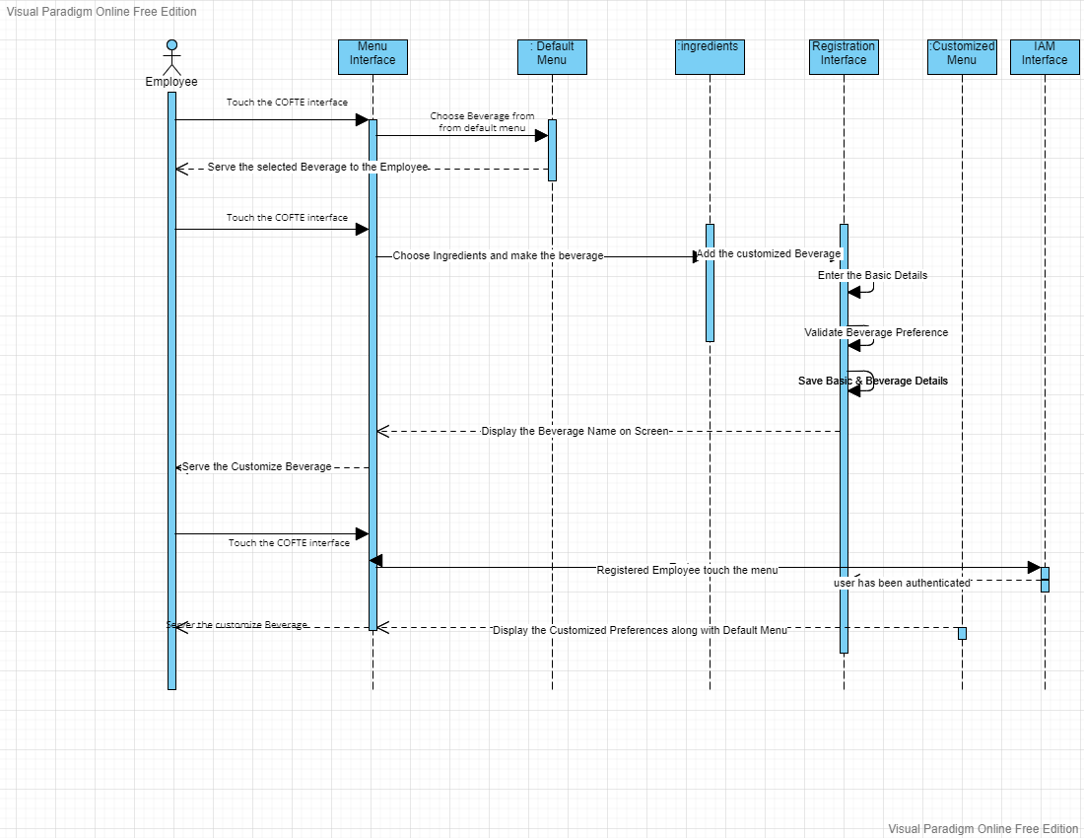

Class Diagram of the COFTE

