

|  |  |
| --- | --- |
| Employee Name: | MANOJ KUMAR YEKOLLU |
| Training Supervised by: | **SURYA** |
| Training Task #: | **Assignment 06112019** |
| Training Resource Materials: | <https://www.mkyong.com/spring-boot/spring-boot-jetty-as-embedded-server/> |
| Training Task Date: | **06/11/2019** |
| Task Due Date: | **06/11/2019** |
| Task Submitted Date: | **06/12/2019** |
| Github link: | <https://github.com/NightFury546/Egiants-Assignments/tree/master/student-services> |
| Technologies used for Training | **Spring-boot, tomcat, jetty, maven, java** |

**Task Description/Requirement:**

Creating a Spring boot application with jetty as embedded server.

**High Level Synopsis:**

There are 3 main embedded server

1. Tomcat
2. Jetty
3. Undertow

Steps:

1. Create a spring application with Tomcat as Embedded server.
2. Change the Embedded server as Jetty from Tomcat

Spring initializer always comes with Tomcat as Embedded server as default.

Creating a started spring boot project with Tomcat as embedded server.

1. Generate the spring boot starter project with web started package in start.spring.io
2. Excluded the tomcat in pom.xml and added jetty

<dependency>  
                <groupId>org.springframework.boot</groupId>  
                <artifactId>spring-boot-starter-web</artifactId>  
                <exclusions>  
                        <exclusion>  
                                <groupId>org.springframework.boot</groupId>  
                                <artifactId>spring-boot-starter-tomcat</artifactId>  
                        </exclusion>  
                </exclusions>  
        </dependency>

<dependency>  
                <groupId>org.springframework.boot</groupId>  
                <artifactId>spring-boot-starter-jetty</artifactId>  
        </dependency>

1. Run the application

**I acknowledge that this document can be supplied to USCIS in compliance with CPT/OPT/STEM OPT audit:**

**Manoj Kumar Yekollu**

**Output:**

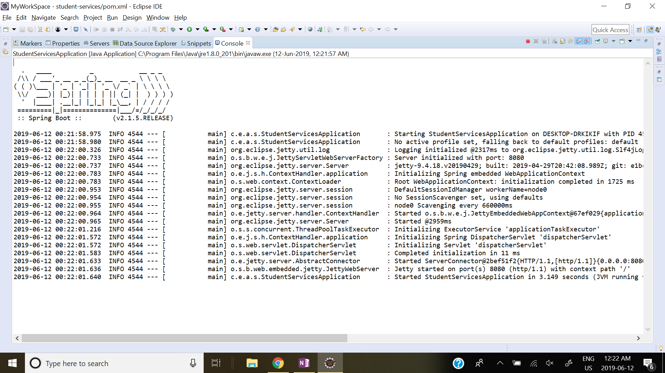

**End of Document**