|  |  |
| --- | --- |
| **Project Management** | [Previous](purchasequotation.htm)  Next |

**Project Management > Editorial**



You can enter the *Project Status* Project-wise if your organisation dose Projects and makes adjustments against the same. In other words, if the organisation implements a Pre/Post Editorial cycle in which Projects Assigned is adjusted against Project Tracker and the Projects needs to be tracked then you can enter the details using this Entry.

To Create, Modify, or Delete a *Project* Assigned, the *Project Management* menu provides the *Editorial Status* option. To use the option,

click *Project Management>Editorial*.

* On clicking the *Project Management* option, two options are displayed. The options are:
* **Project** **Assigned** This option can allow you Create Entry to Assign Task at various Level are Like:
  + **Managing Editor** (This Level allows Chief Editor to Assign Task to Managing Editor)
  + **Associate** **Editor** (This Level allows Managing Editor to Assign Task to Associate Editor)
  + **Author****/Writer** (This Level allows Chief Editor to Assign Task to Managing Editor)
  + **Fact Checker** (This Level allows Chief Editor to Assign Task to Fact Checker)
  + **DTP Head** (This Level allows Associate Editor to Assign Task to DTP HEAD)
  + **Graphic Designer** (This Level allows Associate Editor to Assign Task to Graphic Designer)
  + **Proof Reader** (This Level allows Associate Editor to Assign Task to Proof Reader)

***List*** Tab option allows you to View a list of all the ***Assigned* *Tasks*** of your Projects. On clicking the *List* tab, a *List of* ***Assigned* *Tasks*** appears.

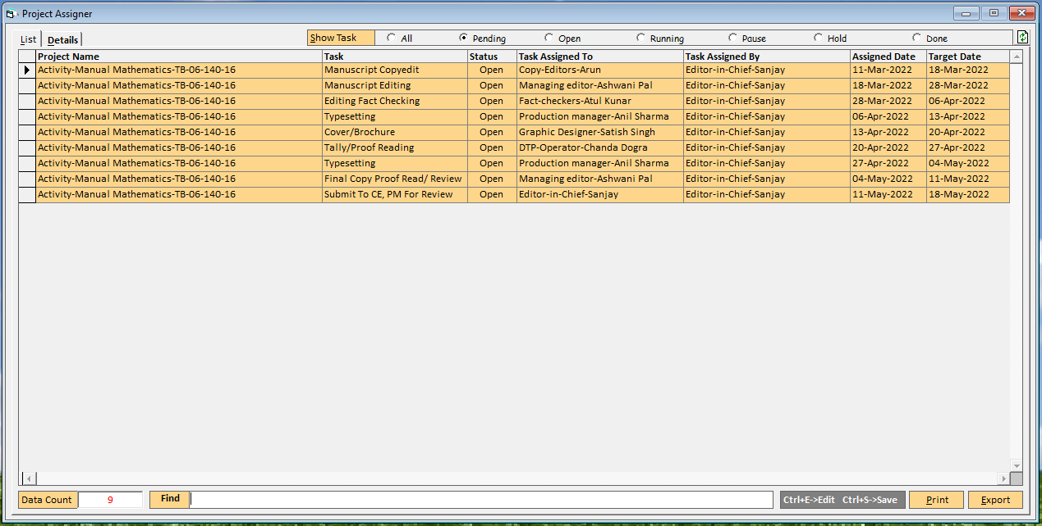

On pressing double click selected data in *List Tab*, **Detail Tab** displayed.

***Details*** Tab option allows you to View all details of the ***Assigned* *Tasks*** of your Projects. On clicking the *Detail* tab, a *Detail of* ***Assigned* *Tasks*** appears.

**In This window there are various data fields and grids. The data fields and grids are:**

* **User** **ID**: By default, the User Code based on the @ data field is displayed in this data field.



* **User** **Name**: By default, the User Code based on the @ data field is displayed in this data field.



* **Project** **Name**: By default, the User Code based on the @ data field is displayed in this data field.



* **Assigned** **On**: On pressing double click twice, Select the Date from the calendar that is displayed.

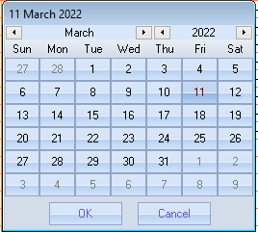

* **Status**: On pressing the *Alt + Down* OR Drop-Downkey, Select the Status for the task assignment from the list that is displayed in the data field.
* **Assignment Remark**: Specify the Remarks for the Task Assignment. You can specify a Remarks with maximum of 255 characters
* **Member**: On pressing the *Space* key, Select the Member whom to Assign Task. You can select the Member from the list that is displayed in the data field.
* **Target Date:** On pressing double click twice, Select the Date from the calendar that is displayed.
* **Start Date:** On pressing double click twice, Select the Date from the calendar that is displayed.
* **End Date:** That is displayed after task Closed.
* **Comments:** Specify the Comments for the Task Assignment. You can specify a Comments with maximum of 40 characters
* **Email:** That is displayed 'Sent', after Task Assignment info email to member.

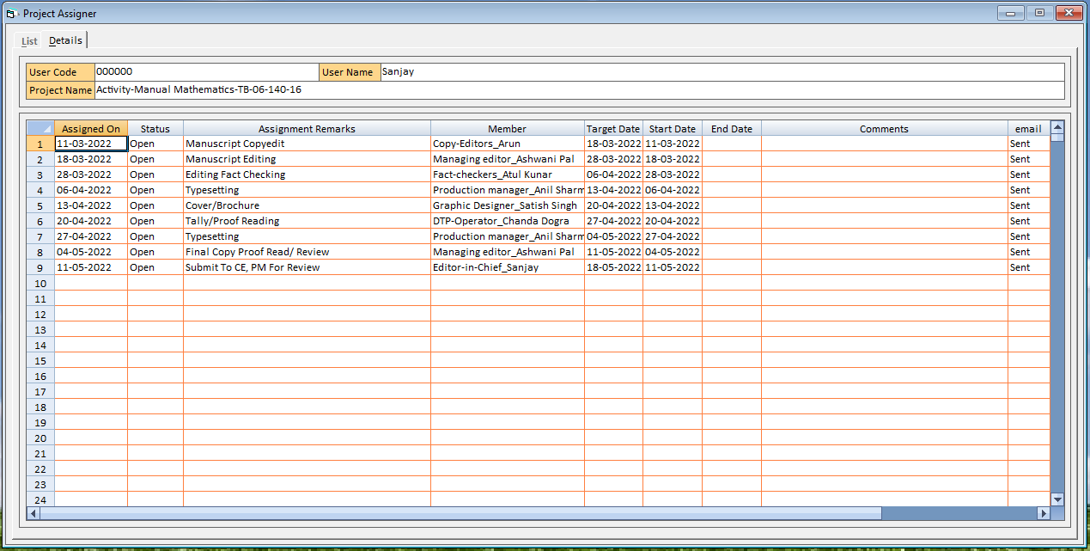

***Print*** Button option allows you to Print all details of the ***Assigned* *Tasks*** of your Projects. On clicking the *Print* button, a *Detail of* ***Assigned* *Tasks*** printed.

***Export*** Button option allows you to Export all details of the ***Assigned* *Tasks*** of your Projects. On clicking the *Export* button, a *Detail of* ***Assigned* *Tasks*** exported.

* **Project Tracker** *(This option allows you view Task Assigned to You or Assigned by you at various Level etc.)*
  + **Chief Editor** *(This option allows Chief Editor to view Task Assigned to You or Assigned by you at various Level etc.)*
  + **Man****aging Editor** *(This option allows Managing Editor View Task Assigned to You or Assigned by you at various Level etc.)*
  + **Associate** **Editor** *(This option allows Associate Editor View Task Assigned to You or Assigned by you at various Level etc.)*
  + **Author****/Writer** *(This option allows you View Task Assigned to You or Assigned by you at various Level etc.)*
  + **Fact Checker** *(This option allows you View Task Assigned to You or Assigned by you at various Level etc.)*
  + **DTP Head** *(This option allows you View Task Assigned to You or Assigned by you at various Level etc.)*
  + **Graphic Designer** *(This Level allows Associate Editor to Create Entry to Assign Task to Graphic Designer)*
  + **Proof Reader** *(This Level allows Associate Editor to Create Entry to Assign Task to Proof Reader)*

***List*** Tab option allows you to View a list of all the ***Assigned* *Tasks*** of your Projects. On clicking the *List* tab, a *List of* ***Assigned* *Tasks*** appears.



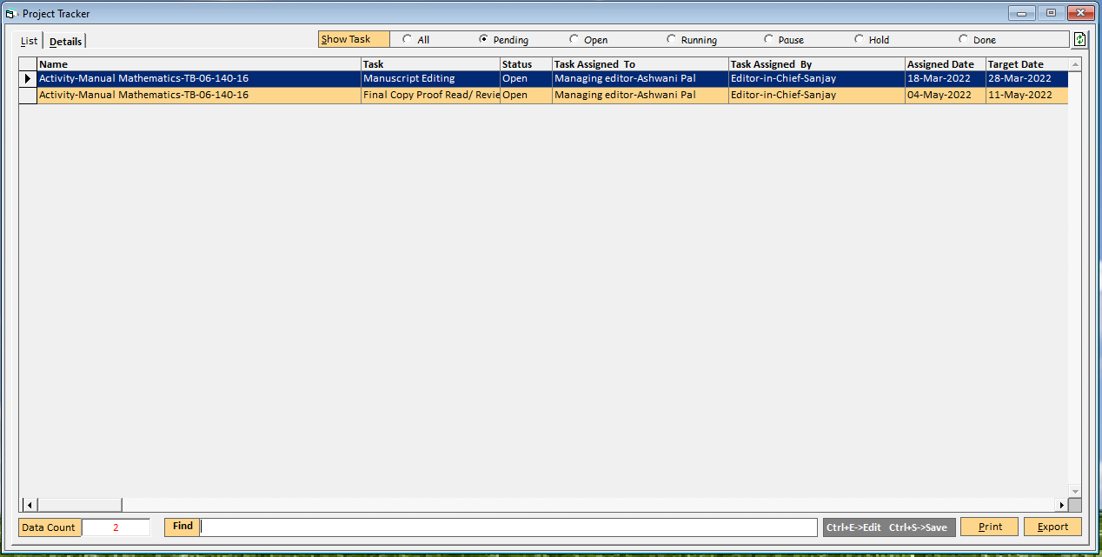

***Print*** Button option allows you to Print all details of the ***Assigned* *Tasks*** of your Projects. On clicking the *Print* button, a *Detail of* ***Assigned* *Tasks*** printed.

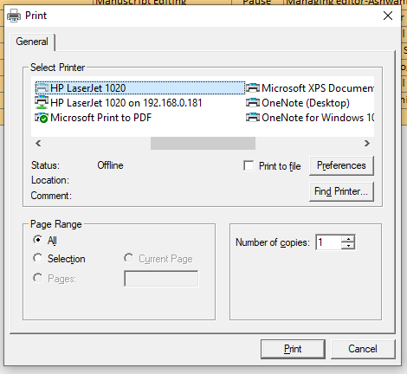

***Export*** Button option allows you to Export all details of the ***Assigned* *Tasks*** of your Projects. On clicking the *Export* button, a *Detail of* ***Assigned* *Tasks*** exported.

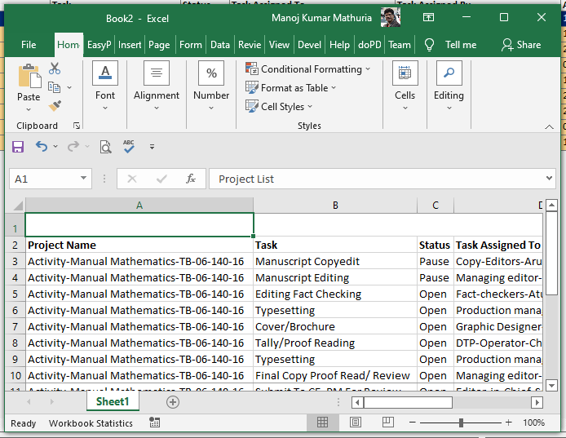

On pressing double click selected data in *List Tab*, **Detail Tab** displayed.

***Details*** Tab option allows you to View all details of the ***Assigned* *Tasks*** of your Projects. On clicking the *Detail* tab, a *Detail of* ***Assigned* *Tasks*** appears.

**In This window there are various data fields and grids. The data fields and grids are:**

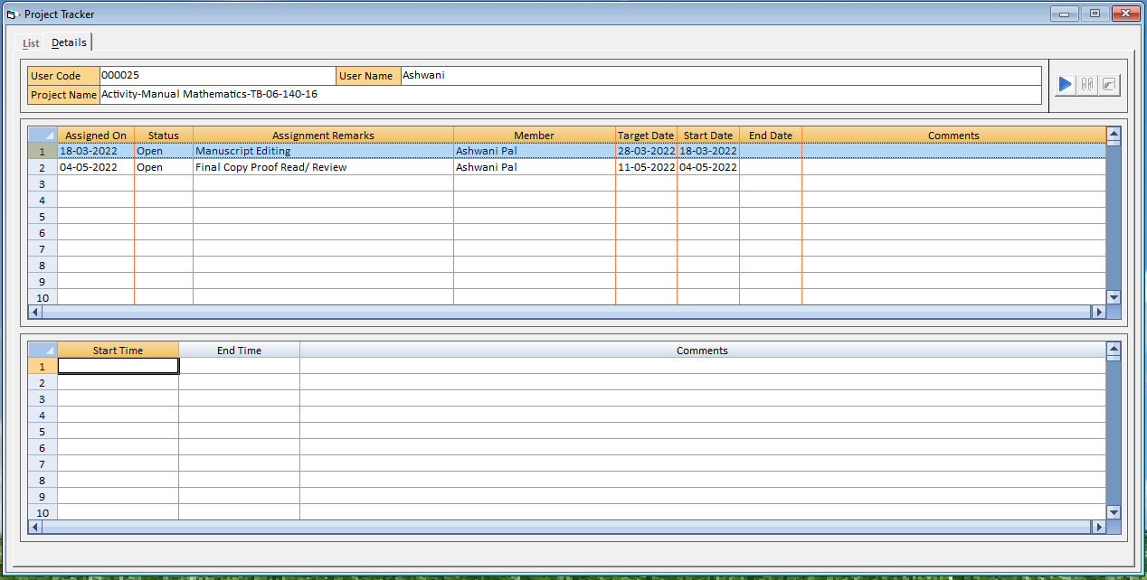

1. **Task Assignment Selection**: On pressing click, Select the task assignment from the list that is displayed in the data field.
2. **Start Task Assignment**: On pressing click Play Button, Start the task assignment displayed top right corner.

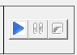

1. **Confirm Start Task Assignment**: On pressing click Play Button, Confirmation Start the task assignment displayed. Click on Yes to start task.

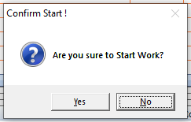

1. **Start Task Assignment**: On pressing click Yes Button, Task Assignment Start time displayed.

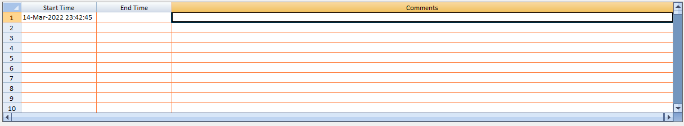

1. **Start Timer of Task Assignment**: On pressing click Yes Button, Task Assignment Start timer displayed.

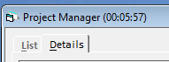

1. **Pause/Stop Task Assignment**: On pressing click Pause/Stop Button, Task Assignment Start timer stop displayed.

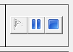

1. **Pause/Stop Task Assignment**: On pressing click Pause/Stop Button, Task Assignment Start timer stop displayed.
2. **Task Pause/Stop Comment Alert**: If Comment are blank then, on pressing click Pause/Stop Button, Error Data Incomplete displayed. Click on OK And write the comments with respect of Pause/Stop.

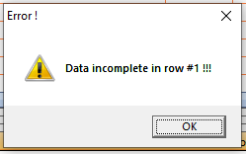

1. **Confirm Start Task Assignment**: On pressing click Pause/Stop Button, Confirmation Pause/Stop the task assignment displayed. Click on Yes to Pause/Stop task.

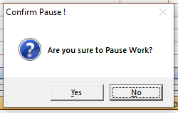

1. **End Time**: On pressing click Yes Button, Confirmation Pause/Stop the task assignment end time displayed.

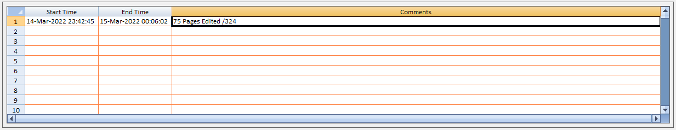

**Work Flow**

|  |  |  |  |  |  |  |  |  |  |  |  |  |  |  |  |  |  |  |  |  |  |  |  |  |  |  |  |  |  |
| --- | --- | --- | --- | --- | --- | --- | --- | --- | --- | --- | --- | --- | --- | --- | --- | --- | --- | --- | --- | --- | --- | --- | --- | --- | --- | --- | --- | --- | --- |
| |  |  |  | | --- | --- | --- | | **S. No.** | **Project Start** | **Task Assigned TO** | | 1 | Manuscript Copyedit | Copyeditor | | 2 | Editing Fact Checking | Editor | | 3 | Typesetting | DTP | | 4 | Cover/Brochure | Graphic Designer | | 5 | Tally/Proof Reading | Associate Editor | | 6 | Typesetting | DTP | | 7 | Final Copy Proof Read/ Review | Managing Editor For CRC | | 8 | Submit To CE, PM For Review |  | |  |  |

|  |  |
| --- | --- |
| **View Also** | **Back To Top** |
|  |  |

Copyright © Easy Info Solutions International, India

|  |  |  |
| --- | --- | --- |
|  |  |  |
|  |  |  |
|  |  |  |
|  |  |  |
|  |  |  |
|  |  |  |
|  |  |  |
|  |  |  |