**Login**



**Login**

**->>CLICK ON EASYPUBLISH.EXE OR SOFTWARE SHORTCUT**

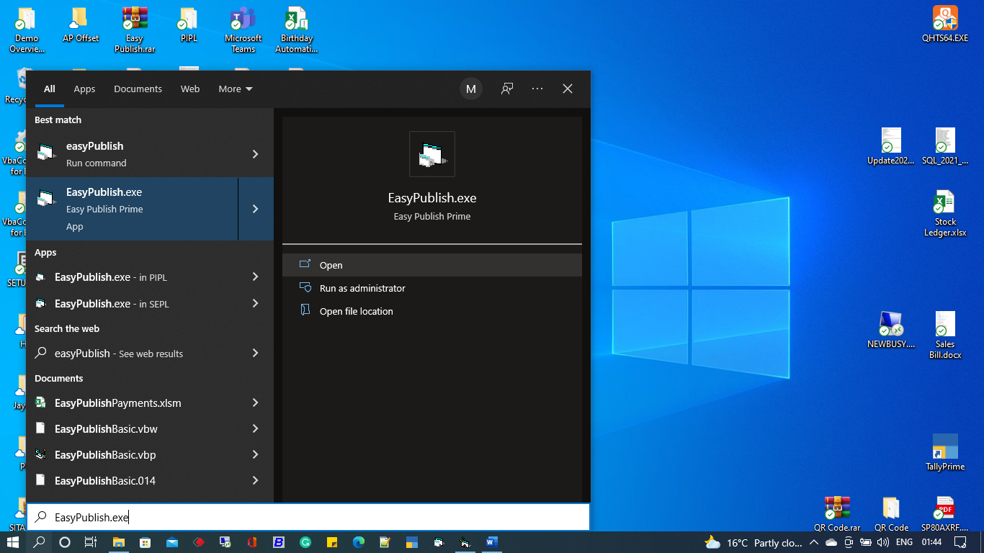

**->>CLICK ON OPEN**

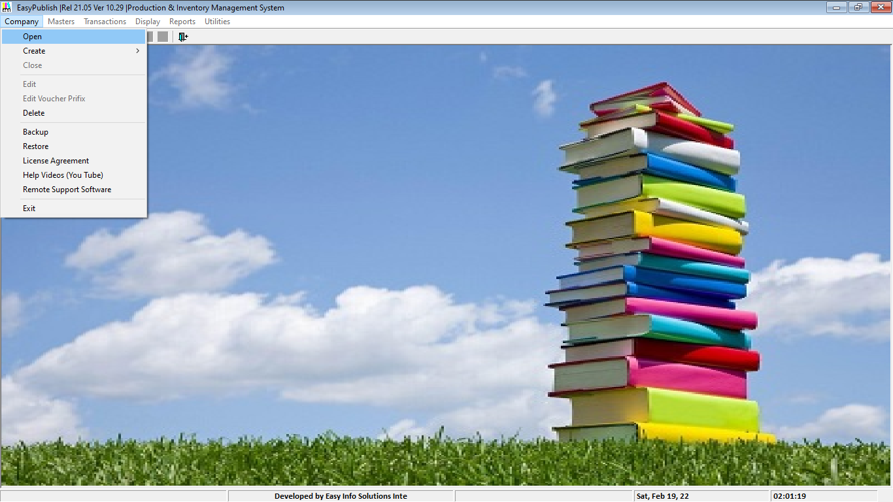

**->>LIST OF COMPANY WINDOWS WILL BE APPEARED**

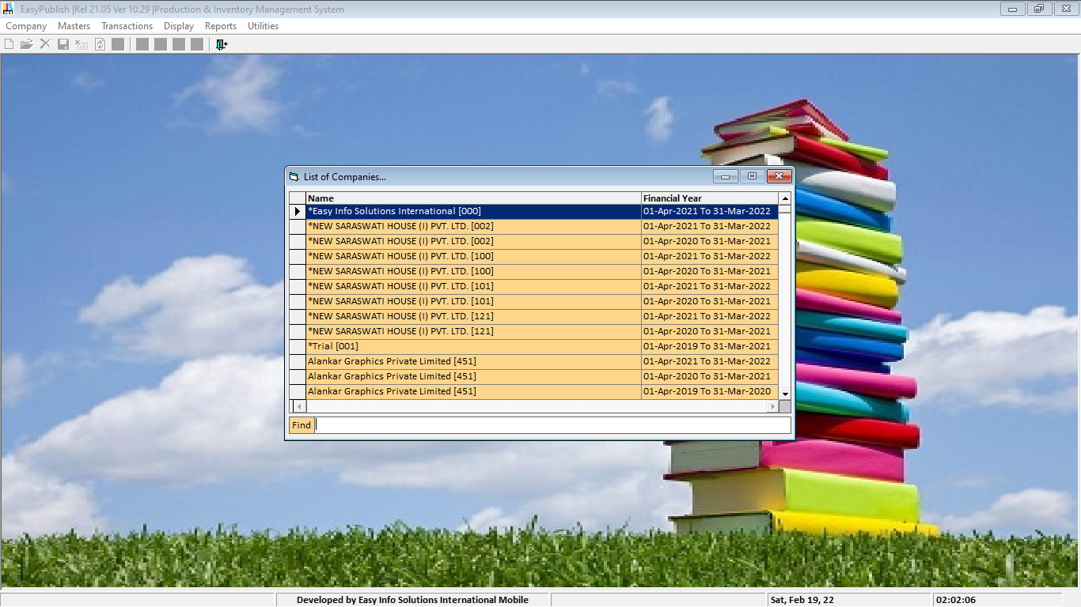

**->>TYPE COMPANY NAME IN FIND BOX**

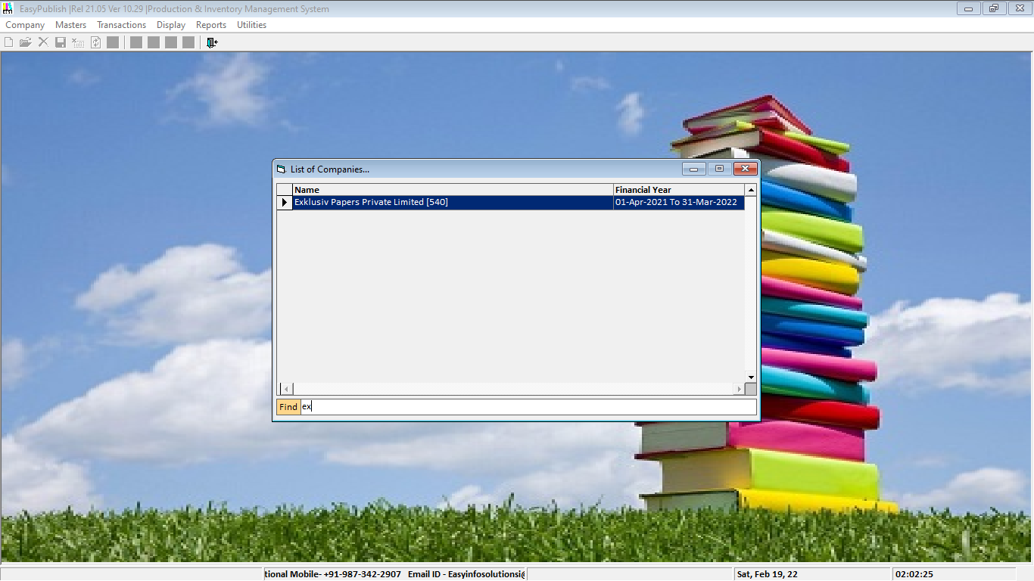

**->>SELECT COMPANY ->>PRESS ENTER->>LOGIN WINDOWS WILL BE APPEARED**

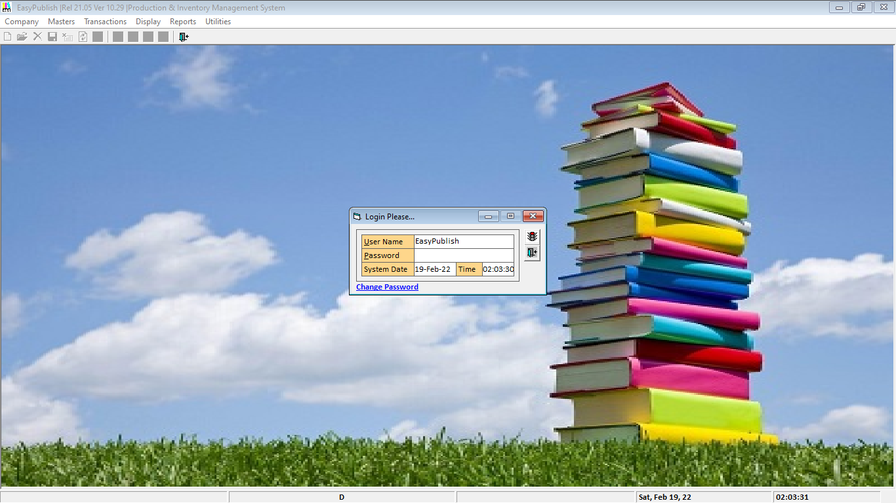

**->> TYPE USER NAME->>TYPE YOUR USER PASSWORD ->>PRESS ENTER->>PRESS ENTER AGAIN**

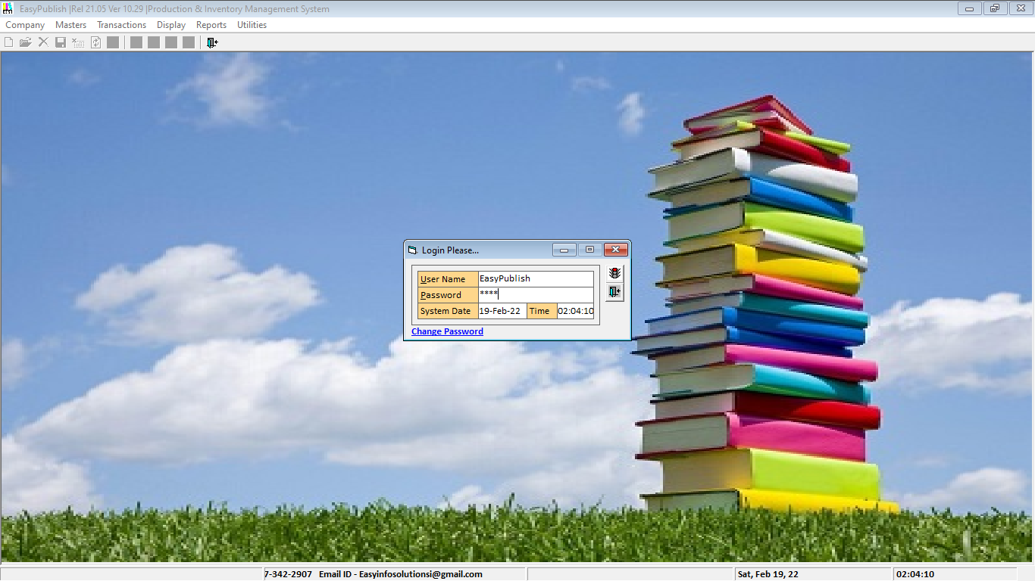

|  |  |
| --- | --- |
| **See Also** | **Back To Top** |
| **Administering a Company**  **Entering Transactions for a Company****,** **Users** |  |

 Copyright © Easy Info Solutions International, India