|  |  |
| --- | --- |
| **Transactions** | [Previous](purchasequotation.htm)  Next |

Transactions >



After you have created the masters for the company and defined the configuration settings, the next step is to enter transactions for the company. Entering transactions means recording of entries in vouchers such as Sale/Sales Return, Purchase/Purchase Return, Payment/Receipt, Material Issued/Received and so on. All the reports are based on the data entered in the vouchers.

Transaction’s menu allows you to add, modify and list different vouchers. For example, Smart Printing/Publishing, a Printer/Publisher manufacturer, made a sale of Books. To maintain accurate records the company will record this transaction in a Sales voucher. For recording different transactions, the Transactions menu provides the following options:

# **Purchase Indent**

### **BOM**

# **Purchase Quotation**

## **Job Work**

#### **Unit Cost** (This option Includes the Unit cost of plate, printing, paper, Fabrication etc.)

#### **Job Work** **Unit Cost** (This option Includes the Job work Unit cost of plate, printing, Fabrication etc.)

#### **Job Work** (This option Includes the Job work cost of plate, printing, Fabrication etc. in detailed)

## **Supply Inward**

#### **Supply** **Inward** (This option Includes the Unit cost of Finished Goods (FG) for trading)

* **Sales Quotation**
* **Job Work**
* ***Unit Cost*** *(This option Includes the Unit cost of plate, printing, paper, Fabrication etc.)*
* ***Job Work******Unit Cost*** *(This option Includes the Job work Unit cost of plate, printing, Fabrication etc.)*
* ***Job Work*** *(This option Includes the Job work cost of plate, printing, Fabrication etc. in detailed)*

* **Supply Outward**
* ***Supply*** ***Outward*** *(This option Includes the Unit cost of Finished Goods (FG) for trading)*

# **Purchase Order**

* **Job Work**
* ***FG(Item)*** *(This option Includes the Job work cost of plate, printing, paper, Fabrication etc. in detailed for Finished Goods (FG))*
* ***UFG(Items)*** *(This option Includes the Job work cost of plate, printing, Fabrication etc. in detailed for Finished Goods (UFG))*
* ***Digital*** *(This option Includes the Job work cost of printing, Fabrication etc. in detailed)*
* **Supply Inward**
  + ***Supply*** ***Inward*** *(This option Includes the Unit cost of Finished Goods (FG) for trading)*
* **Sales Order**
* **Job Work**
* ***FG(Item)*** *(This option Includes the Job work cost of plate, printing, paper, Fabrication etc. in detailed for Finished Goods (FG))*
* ***UFG(Items)*** *(This option Includes the Job work cost of plate, printing, Fabrication etc. in detailed for Finished Goods (UFG))*
* ***Digital*** *(This option Includes the Job work cost of printing, Fabrication etc. in detailed)*
* **Supply Outward**
  + ***Supply*** ***Outward*** *(This option Includes the Unit cost of Finished Goods (FG) for trading)*

# **Purchase**

* **Job Work**
* ***Unit Cost*** *(This option Includes the Unit cost of plate, printing, paper, Fabrication etc.)*
* ***Job Work******Unit Cost*** *(This option Includes the Job work Unit cost of plate, printing, Fabrication etc.)*
* ***Job Work*** *(This option Includes the Job work cost of plate, printing, Fabrication etc. in detailed)*
* **Supply Inward**
  + ***Supply*** ***Inward*** *(This option for trading)*

# **Purchase Return**

* + ***Supply*** ***Outward Return*** *(This option for Purchase Returns)*
* **Sales**
* **Job Work**
* ***Unit Cost*** *(This option Includes the Unit cost of plate, printing, paper, Fabrication etc.)*
* ***Job Work******Unit Cost*** *(This option Includes the Job work Unit cost of plate, printing, Fabrication etc.)*
* ***Job Work*** *(This option Includes the Job work cost of plate, printing, Fabrication etc. in detailed)*

* **Supply Outward**

* + ***Supply Outward****(This option for trading)*

# **Sales Return**

* + ***Supply Inward Return****(This option for Sales Returns)*

# **Finance**

## **Payment**

## **Receipt**

## **Journal**

## **Contra**

## **Debit Note**

## **Credit Note**

# **Stock Transfer**

* **Material IN** *(Mat. Revd. from Party)*
* **Job work**
* **Supply Inward**
* **Material Out** *(Mat. Issued to Party)*
* **Job work**

* **Supply Outward**

# **Item Processing Order** *(This option for Processing)*

# **Paper**

* **Purchase** **Order**
* **Issue**
* **Receipt**
* **Transfer**
* **Debit** **Note**
* **Credit Note**

# **Material Issue Order**

# **Bill OF Items (BOM) Movement**

# **Stock Journal**

* **Raw Materials**
* **Finished Goods (FG)**

# **Packing Slip**

# **Forms Received**

# **Forms Issued**

# **VAT Journal**

# **Adjust Excise Amounts**

# **Physical Stock**

Given here is a screenshot of the Transactions menu options.

**Transaction’s menu options**

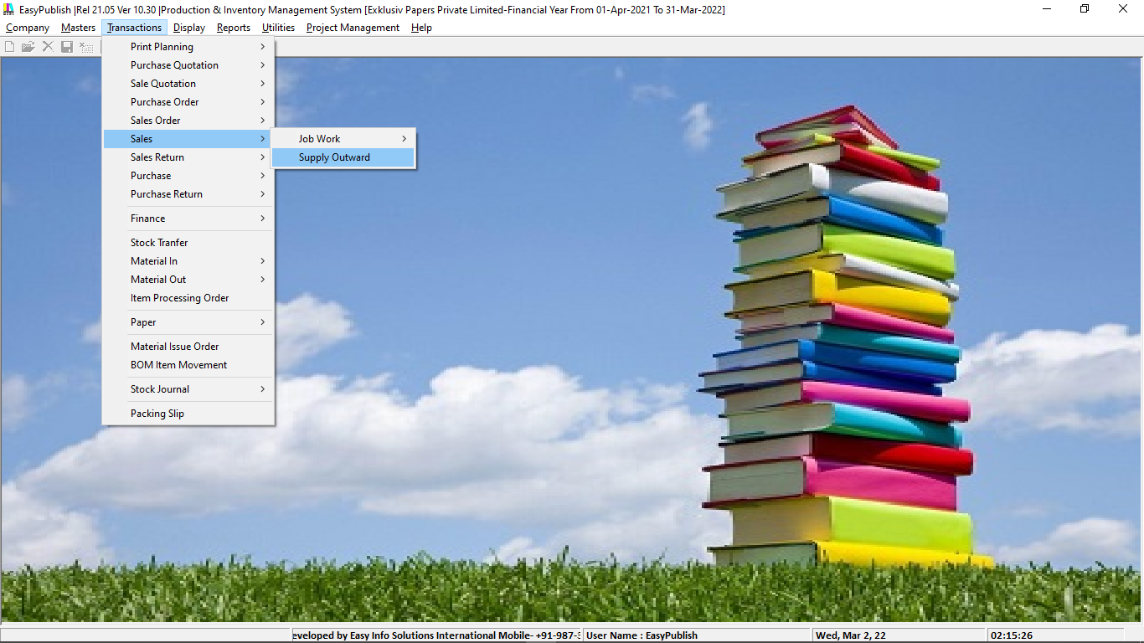

For information on the menu option, click the options. In all the vouchers in Easy Publish there are some common options and buttons used. We will now discuss such options and buttons that are common to all the vouchers in Easy Publish.

## Master Search in Voucher Grid

## Modify Caption

With this option, you can modify any voucher. To modify the voucher, shortcut key Ctrl + E is provided. On clicking this key combination, a window appears displaying all Details of voucher. You can change the details as per your requirement. Given below is a screenshot displaying all the details that appear in Sales Voucher window.

**Change Captions (Sales Voucher)**

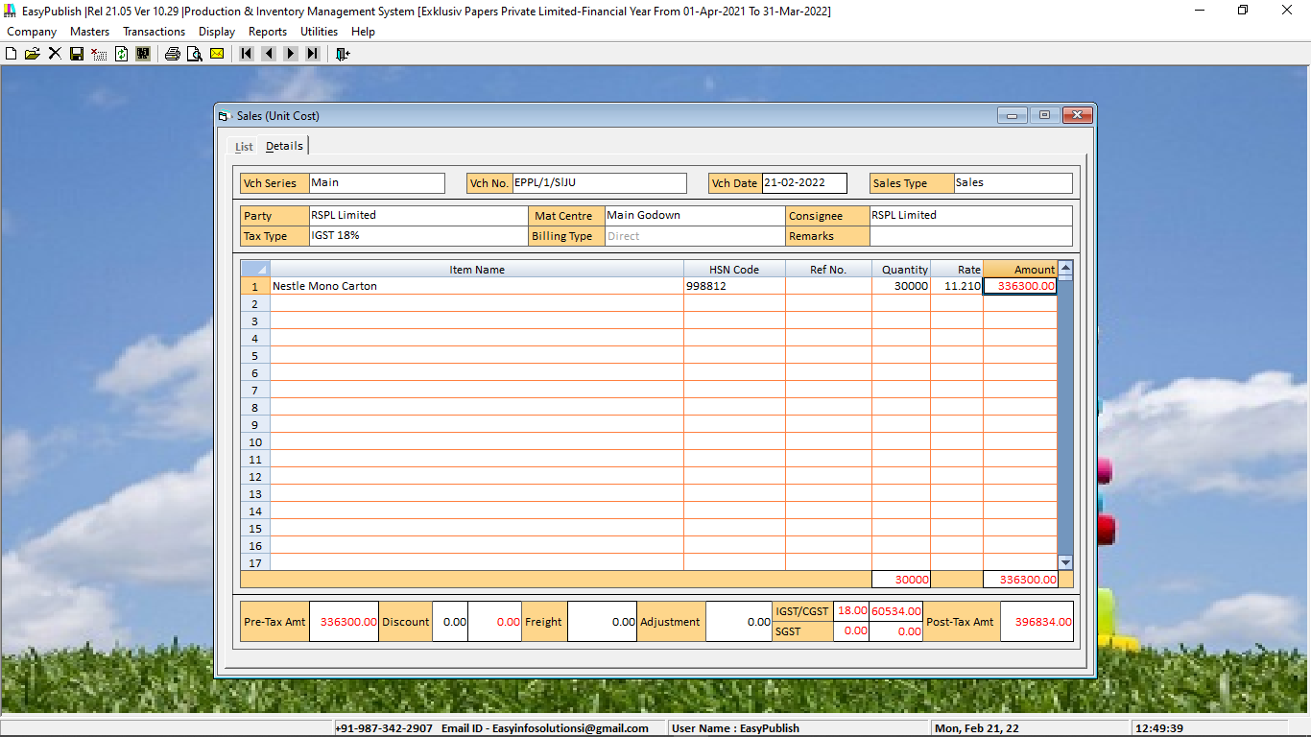

## Common Options

The common options appear when you click *Transactions* > Select a voucher > *List* option. On clicking the *List* View appears.

In the message box, there are two options:

|  |  |
| --- | --- |
| · | Screen - If you want the list of specific vouchers on the screen, Type Voucher in Find Box or Select the voucher on clicking. |

|  |  |
| --- | --- |
| · | Printer - If you want the list of specific vouchers to be printed, click the *Printer* button. |
| · | Refresh |

|  |  |
| --- | --- |
| · | Export |

|  |  |
| --- | --- |
| · | Print |

|  |  |
| --- | --- |
| · | Email |

For more information, click the buttons.

### Printer

On clicking the *Printer* button, a *Printing Options* window appears. Given here is a screenshot of the *Printing Options* window.

**Printing Options window**

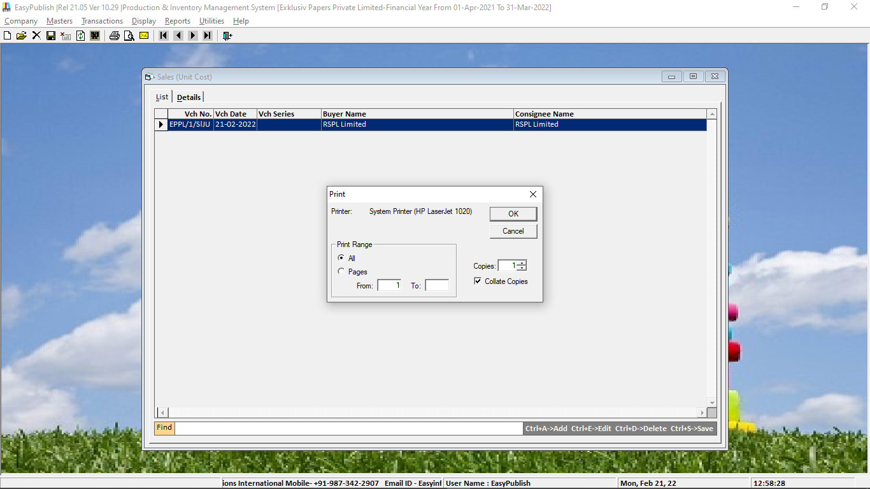

You need to enter the appropriate information in the data fields in the window. Some of the common data fields that appear are:

**Common Buttons**

The common buttons can be categorised in three categories. These categories are:



* **Add New (CTRL+A)**
* **Modify /Edit/Open (CTRL+E)**
* **Delete (CTRL+D)**
* **Save (CTRL+S)**
* **Cancel**
* **Refresh**
* **Search**
* **Print**
* **Preview**
* **Email**
* **First**
* **Previous**
* **Next**
* **Last**
* **Exit**

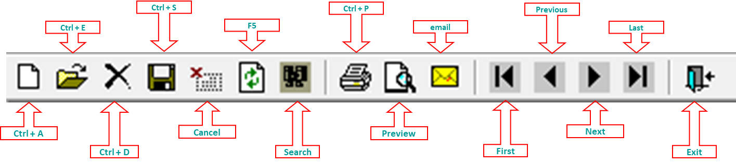

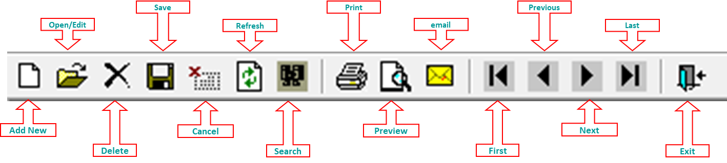

On selecting any of the three options under a voucher, certain buttons appear. Let us discuss these buttons category-wise.

**Add**

Given here is a screenshot of the *Add - Sales* *Voucher* window.

**Add - Sales Voucher window**

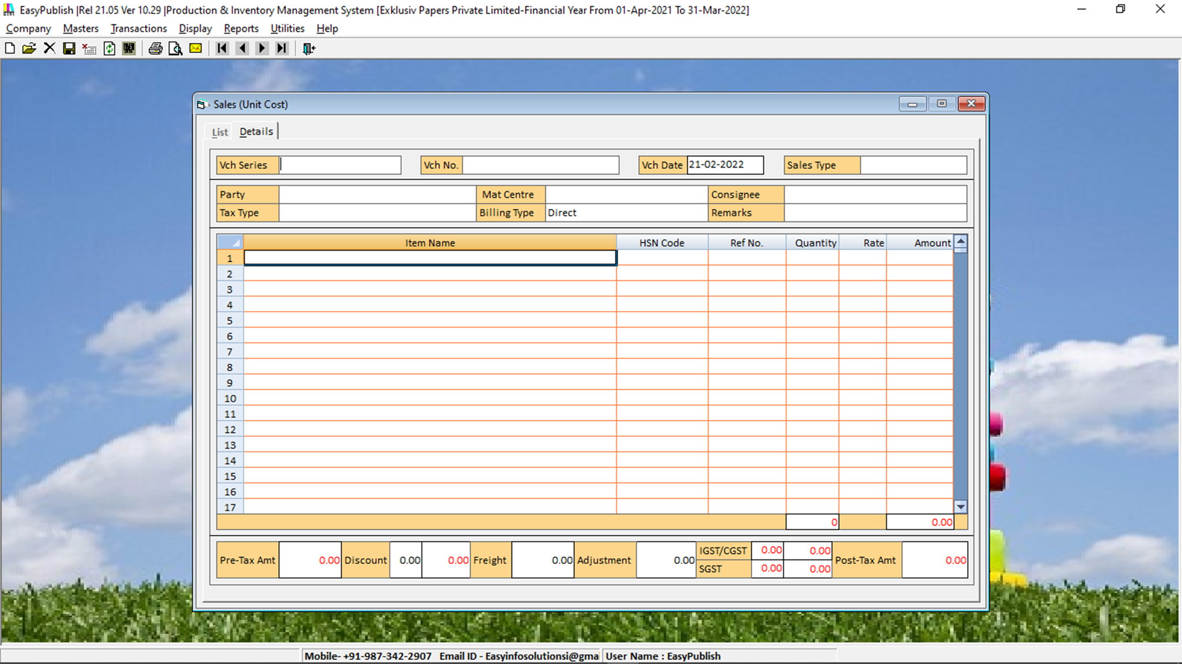

|  |  |
| --- | --- |
|  | If you have copied more than one voucher data to the clipboard and you click the *Paste* button then the last copied voucher data will be pasted to the new voucher. |

### Modify

Under the *Modify* option of all the vouchers, various buttons appear. The buttons and tabs are:

* **Delete**
* **List**
* **Copy**
* **Paste**
* **Print**
* **Email**
* **SMS**
* **Cancel**

Given here is a screenshot of the *Sales - Modify* window with various buttons.

**Sales - Modify window**

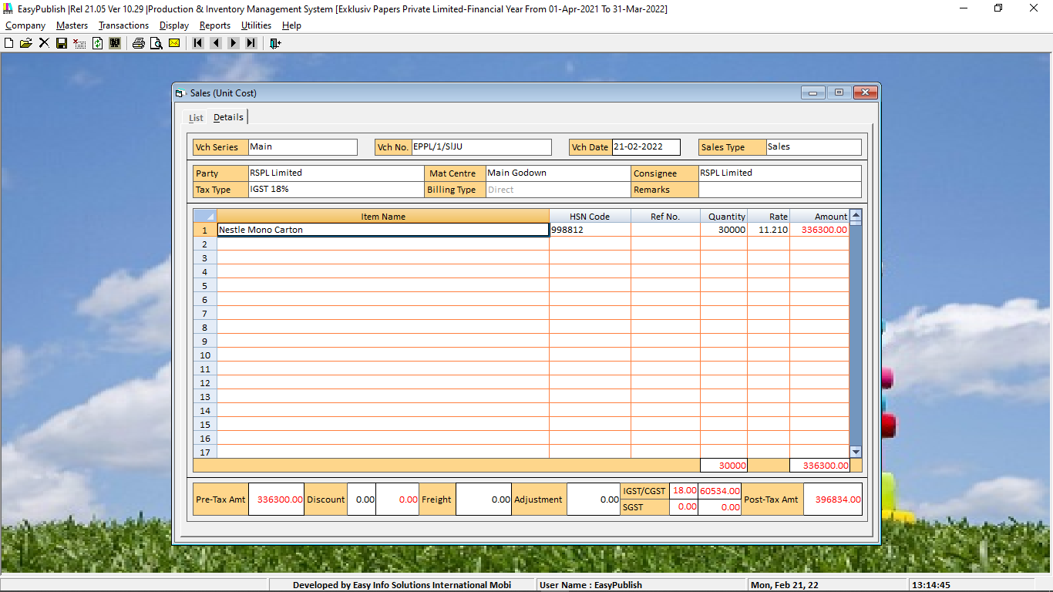

***Delete***

To delete a voucher, click the *Delete* button OR CTRL+D OR F8.

***List***

To generate a list of all the vouchers of a particular type in your company, click the *List* button. On clicking the *List* button, a *Register* window appears. Given here is a screenshot of the *Sales Register* window that appears on clicking the *List* button in the *Sales - Modify* window.

**Sales Register window**

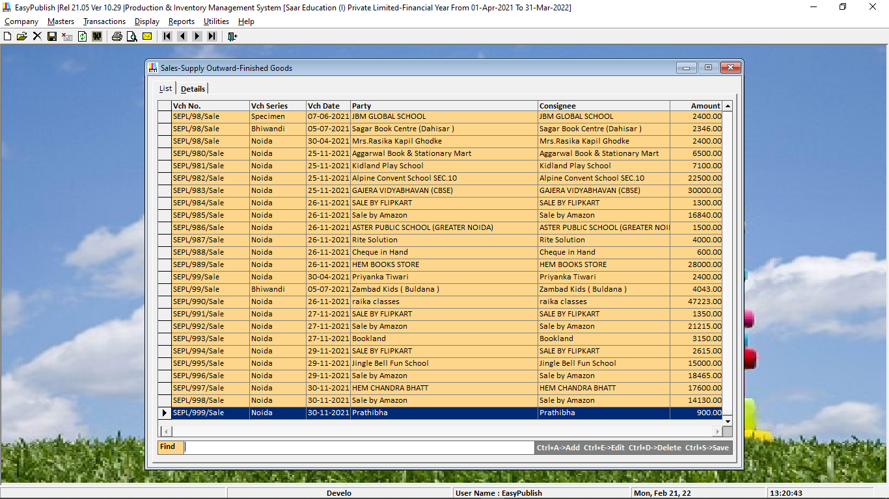

|  |  |
| --- | --- |
|  | If you want to view the details of a voucher in the Register window, select the voucher and press the *Enter* key and if you want to return to the *Voucher - Modify* window, press the *Esc* key. |

#### Copy

This button allows you to copy the data from an existing voucher to the clipboard or to duplicate a voucher. On clicking the button, a *Copy Data* message box appears with following two option:

|  |  |
| --- | --- |
| · | Duplicate Voucher - Click this button to create a duplicate voucher. |

|  |  |
| --- | --- |
| · | Copy to Clipboard - Click this button to copy data to the clipboard. |

#### Paste

This button allows you to paste the data from the clipboard to a new/existing voucher. On clicking this button, a *Paste Voucher* window appears. Click the *Yes* button to paste the data.

#### Print

This button allows you to print the voucher. On clicking this button, *Printing* message box appears asking you whether you want to print the invoice, invoice bar code, inventory, account voucher and so on.

|  |  |
| --- | --- |
| · | Click the *Yes* button depending on the document that you want to print. On clicking the *Yes* button, a *Printing Options* window appears. |

|  |  |
| --- | --- |
| · | Enter appropriate information in the data fields. |

|  |  |
| --- | --- |
| · | Click the *Ok* button. |

#### Email

This button allows you to Email voucher details to the party. On clicking this button, a *Send Email* window appears in which you can select the format according to which Email is to be sent.

#### SMS

This button allows you to SMS voucher details to the party. On clicking this button, a *Send SMS* window appears in which you can select the format according to which SMS is to be sent.

#### Cancel

Click this button to cancel the voucher. On clicking this button, only the header information of the voucher will be retained and all other details will be deleted. Cancelled vouchers will be reflected only in VAT Registers and Columnar Registers.

#### Activate

This button appears only in Cancelled vouchers. Click this button to activate the cancelled vouchers. Activating voucher means changing its status from cancelled to normal functioning voucher.

|  |  |
| --- | --- |
|  | Depending on the permission given to the User, the User can modify the vouchers. For information on permissions to User, please view the [User’s menu](../HelpFilesOld/users.htm) topic. |

### List

Under the *List* option of all the vouchers, four buttons appear. The buttons are:

|  |  |
| --- | --- |
| · | Refresh |

|  |  |
| --- | --- |
| · | Export |

|  |  |
| --- | --- |
| · | Print |

|  |  |
| --- | --- |
| · | Email |

Given here is a screenshot of the *List of Sales Vouchers* window with the four buttons.

**List of Sales Voucher window with four buttons**



#### Refresh

To refresh the information in the window, click the *Refresh* button.

#### Export

To export the information to another format such as HTML, MS Excel, and text file, click the *Export* button.

#### Print

To print the information, click the *Print* button. On clicking the *Print* button, a *Printing Options* window appears.

#### Email

To email the information, click the *Email* button.

For information on voucher, click the voucher in the *Transactions* menu options list.

|  |  |
| --- | --- |
| **See Also** | **Back To Top** |
|  |  |

Copyright © Easy Info Solutions International, India