|  |  |
| --- | --- |
| **Purchase Quotation** | Previous  [Next](Salesquotation.htm) |

**Transactions > Purchase Quotation**



You can enter the *Purchase Quotation* voucher if your organisation receives Purchase Quotation and makes adjustments against the same. In other words, if the organisation implements a pre-Purchase cycle in which Purchase is adjusted against quotation and the quotation needs to be tracked then you can enter the details using this voucher.

To create, modify, or delete a *Purchase Quotation* voucher, the *Transactions* menu provides the *Purchase Quotations* option. To use the option, click *Transactions > Purchase Quotation*.

* On clicking the *Purchase Quotation* option, three options are displayed. The options are:
* **Job Work**
  + **Unit Cost** (This option Includes the Unit cost of plate, printing, paper, Fabrication etc.)
  + **Job Work** **Unit Cost** (This option Includes the Job work Unit cost of plate, printing, Fabrication etc.)
  + **Job Work** (This option Includes the Job work cost of plate, printing, Fabrication etc. in detailed)
* **Supply Inward**

Let’ Start Unit Cost



# **Job Work**

## **Unit Cost**

* + **List**

*List* Tab option allows you to View a list of all the *Purchase Quotation* vouchers of your company. On clicking the *List* tab, a *List of* *Purchase Quotation* *Vouchers* appears.

**List Purchase Quotation Unit Cost**

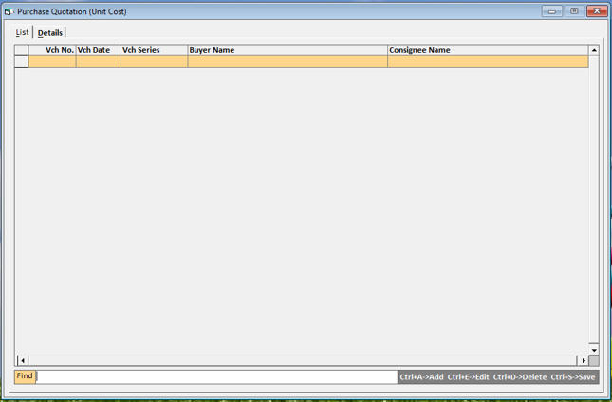

* **Add (CTRL+A)**

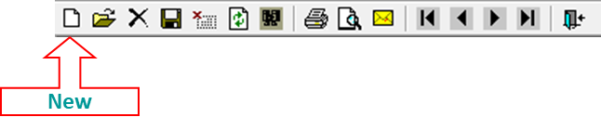

* On clicking the Add Button, an *Add* *Purchase Quotation* window appears. Given here is a screenshot of the *Purchase Quotation* window.
  + **Details**

*Details* Tab option allows you to View a list of all details of the *Purchase Quotation* vouchers of your company. On clicking the *Detail* tab, a *Detail of* *Purchase Quotation* *Vouchers* appears.

**Add Purchase Quotation Unit Cost**

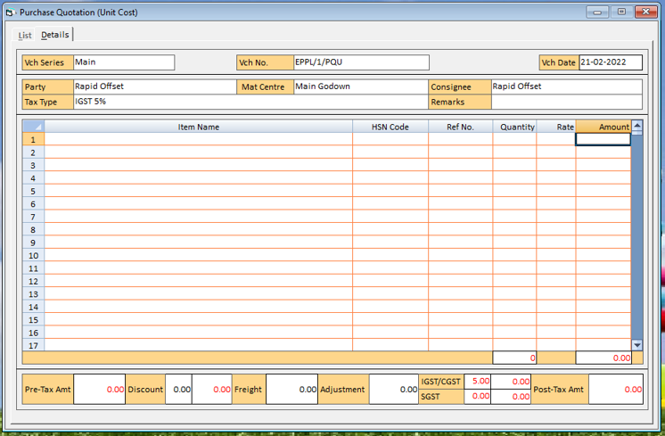

**In This window there are various data fields and grids. The data fields and grids are:**

* Series
* Vch. No.
* Date
* Party
* Mat. Centre
* Consignee
* Tax Type
* Remark
* Item Details
* HSN CODE
* Ref. No.
* Quantity
* Rate
* Discount
* Freight
* Adjustment

#### **Series**

On pressing the *Space* key, Select the series from the list that is displayed in this data field. The list of series depends on the configuration settings.

#### **Vch. No.**

Depending on the settings. You can enter the voucher number manually, automatically, or not enter the voucher number at all. As per the settings in *Voucher Configuration*, specify the voucher number.

#### **Date**

Specify the date of the Purchase Quotation.

#### **Party**

On pressing the *Space* key, Select the party/account to be affected in the *Purchase Quotation* voucher. You can select the party/account from the list that is displayed in the data field. In the list, the accounts that fall under the groups, Sundry Debtors, Sundry Creditors, Cash-in-Hand and Bank Accounts are displayed. On pressing the *Enter* key after selecting the party, selected in *Party* data field.

#### **Mat. Centre**

On pressing the *Space* key, Select the Material Centre from where the goods will be moved for Purchase. You can select the Material Centre from the list that is displayed in the data field.

#### **Consignee**

On pressing the *Space* key, Select the Consignee from where the goods will be moved for Purchase. You can select the Consignee from the list that is displayed in the data field.

#### **Tax Type**

On pressing the *Space* key, Specify the tax type of the Purchase Quotation.

#### **Remark**

Specify the Remarks for the Purchase Quotation transaction. You can specify a Remarks with maximum of 94 characters. On pressing the *Enter* key after specifying the Remarks, a *Notes* window appears. This window appears if you have enabled the *Maintain Notes with Inventory Voucher* option, Enter notes for the voucher in this data field and click the *Ok* button.

#### **Item Details**

In the Item Details grid, the data fields are:

• Item

• HSN CODE

• Ref No.

• Quantity

• Rate (Rs.)

• Amount (Rs.)

There are Two ways for *Purchase Quotation* item selection.

**First option** is displayed pressing F11 Key. This option showing you pending Against Cost Estimation:

**Pending List**

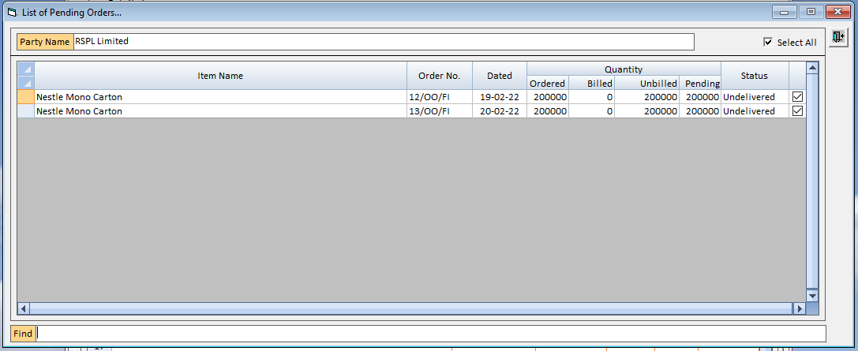

After Check/Uncheck of Check Box Press the Exit/Process Button, by default, all data field is displayed in this data Grid. You can change this value as per your requirement without affecting any other data field.

|  |  |
| --- | --- |
|  | You can use the Find box to search the pending items if pending list is too large. |

|  |  |
| --- | --- |
|  | You can also use select all check box to select all item in single check. |

**Pending List**

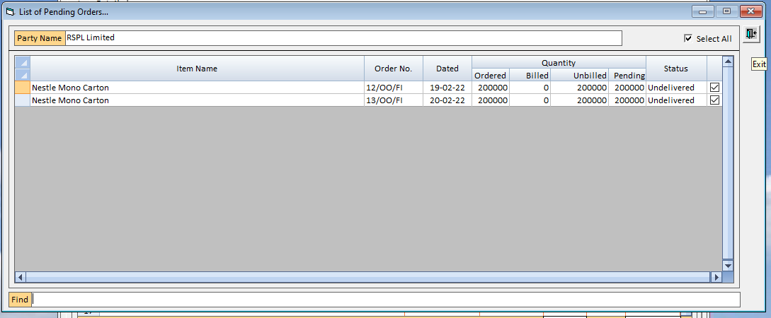

**Second option** is manual. IN This option select the all-data fields by pressing space bar manually:

**Item**

On pressing the *Space* key, Select the item for the Purchase Quotation from the list that is displayed in the data field.

**HSN CODE**

On pressing the *Space* key, Select the HSN CODE for the Purchase Quotation Item from the list that is displayed in the data field.

**Ref NO.**

Only, on pressing the *F11* key, Select the Ref. for the Purchase Quotation from the list that is displayed in the data field.

**Quantity**

Enter the quantity of the item for the Purchase Quotation.

**Rate**

Enter the Rate of the item for the Purchase Quotation.

**Amount (Rs.)**

By default, the amount calculated based on the value in the @ data field is displayed in this data field. You can change this value as per your requirement without affecting any other data field.

|  |  |
| --- | --- |
|  | *Quotation Ref. No.* does not appear if you have enabled the Second option. *References* appears while going with first *Option* window. In such a case, Quotation References are created automatically and the voucher number is treated as Quotation Reference number. |

|  |  |
| --- | --- |
|  | You can adjust the Purchase Quotation at the time of entering *Purchase* Order, *Material Issued to Party - Purchase Challan* or *Purchase* voucher. |

* **Edit (CTRL+E)**

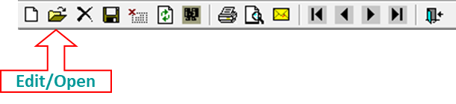

* On clicking the Edit Button, an *Edit* *Purchase Quotation* window appears. Given here is a screenshot of the *Purchase Quotation* window.

|  |  |  |  |
| --- | --- | --- | --- |
|  | | You can Edit the Exiting Purchase Quotation in this option. | |
|  |  | |

**Edit Purchase Quotation Unit Cost**

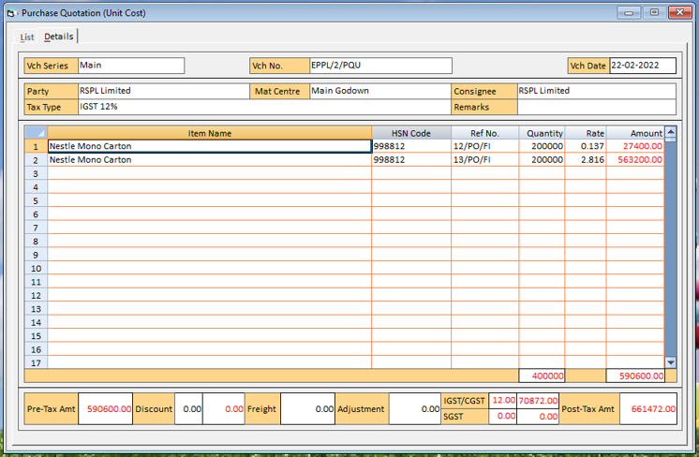

* **Save (CTRL+S)**

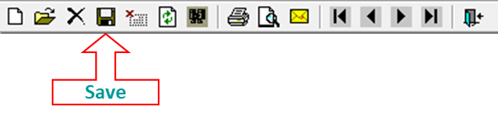

* On clicking the Save Button, a *Save* *Purchase Quotation* window appears. Given here is a screenshot of the *Purchase Quotation* window.

**Save Purchase Quotation Unit Cost**

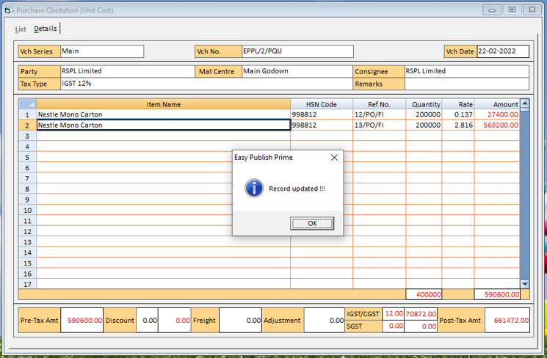

|  |  |
| --- | --- |
| · | Printer - If you want the Print of *Purchase Quotation* vouchers, click the ***Printer*** button. |

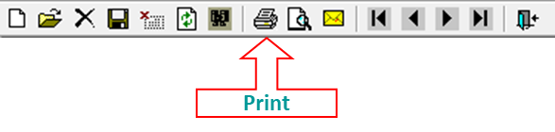

|  |  |
| --- | --- |
| · | Preview - If you want Preview the *Purchase Quotation* vouchers, click the ***Preview*** button. |

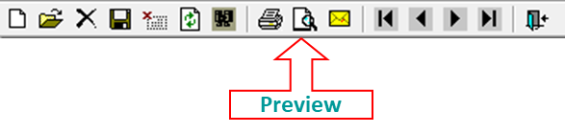

|  |  |
| --- | --- |
|  | Let’ Start Job Work Unit Cost |

## **Job work Unit Cost**

* + **List**

*List* Tab option allows you to View a list of all the *Purchase Quotation* vouchers of your company. On clicking the *List* tab, a *List of* *Purchase Quotation* *Vouchers* appears.

**List Purchase Quotation Job Work Unit Cost**

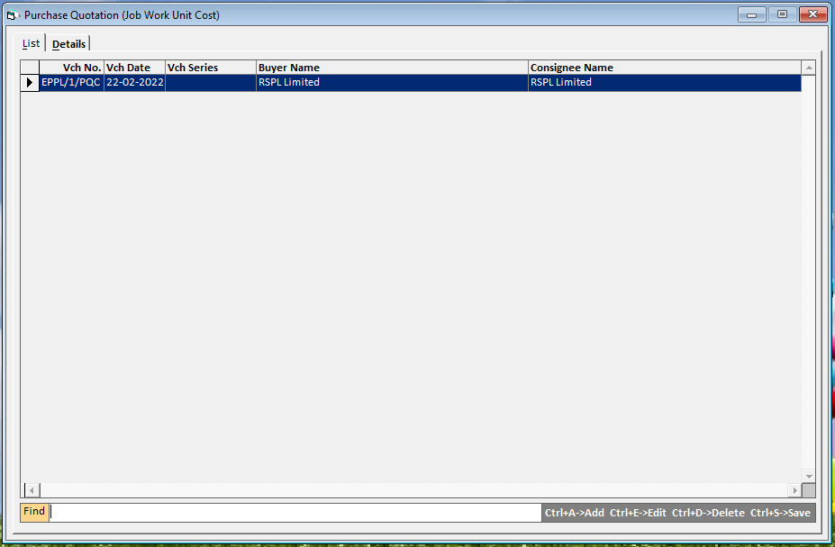

* **Add (CTRL+A)**



* On clicking the Add Button, an *Add* *Purchase Quotation* window appears. Given here is a screenshot of the *Purchase Quotation* window.
  + **Details**

*Details* Tab option allows you to View a list of all details of the *Purchase Quotation* vouchers of your company. On clicking the *Detail* tab, a *Detail of* *Purchase Quotation* *Vouchers* appears.

**Add Purchase Quotation Job Work Unit Cost**

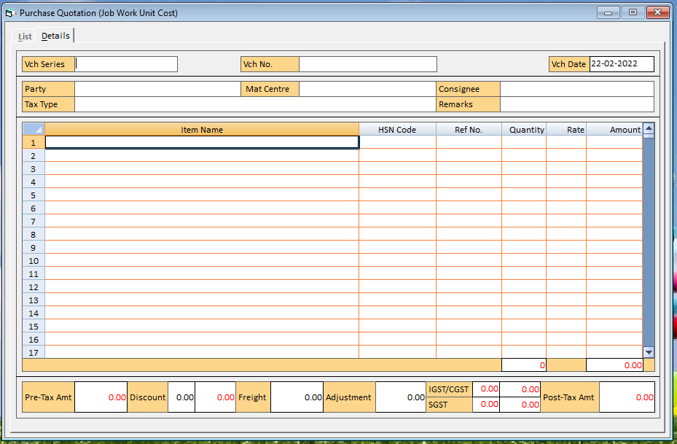

**In This window there are various data fields and grids. The data fields and grids are:**

* Series
* Vch. No.
* Date
* Party
* Mat. Centre
* Consignee
* Tax Type
* Remark
* Item Details
* HSN CODE
* Ref. No.
* Quantity
* Rate
* Discount
* Freight
* Adjustment

#### **Series**

On pressing the *Space* key, Select the series from the list that is displayed in this data field. The list of series depends on the configuration settings.

#### **Vch. No.**

Depending on the settings. You can enter the voucher number manually, automatically, or not enter the voucher number at all. As per the settings in *Voucher Configuration*, specify the voucher number.

#### **Date**

Specify the date of the Purchase Quotation.

#### **Party**

On pressing the *Space* key, Select the party/account to be affected in the *Purchase Quotation* voucher. You can select the party/account from the list that is displayed in the data field. In the list, the accounts that fall under the groups, Sundry Debtors, Sundry Creditors, Cash-in-Hand and Bank Accounts are displayed. On pressing the *Enter* key after selecting the party, selected in *Party* data field.

#### **Mat. Centre**

On pressing the *Space* key, Select the Material Centre from where the goods will be moved for Purchase. You can select the Material Centre from the list that is displayed in the data field.

#### **Consignee**

On pressing the *Space* key, Select the Consignee from where the goods will be moved for Purchase. You can select the Consignee from the list that is displayed in the data field.

#### **Tax Type**

On pressing the *Space* key, Specify the tax type of the Purchase Quotation.

#### **Remark**

Specify the Remarks for the Purchase Quotation transaction. You can specify a Remarks with maximum of 94 characters. On pressing the *Enter* key after specifying the Remarks, a *Notes* window appears. This window appears if you have enabled the *Maintain Notes with Inventory Voucher* option, Enter notes for the voucher in this data field and click the *Ok* button.

#### **Item Details**

In the Item Details grid, the data fields are:

• Item

• HSN CODE

• Ref No.

• Quantity

• Rate (Rs.)

• Amount (Rs.)

There are Two ways for *Purchase Quotation* item selection.

**First option** is displayed pressing F11 Key. This option showing you pending Against Cost Estimation:

**Pending List**



After Check/Uncheck of Check Box Press the Exit/Process Button, by default, all data field is displayed in this data Grid. You can change this value as per your requirement without affecting any other data field.

|  |  |
| --- | --- |
|  | You can use the Find box to search the pending items if pending list is too large. |

|  |  |
| --- | --- |
|  | You can also use select all check box to select all item in single check. |

**Pending List**



**Second option** is manual. IN This option select the all-data fields by pressing space bar manually:

**Item**

On pressing the *Space* key, Select the item for the Purchase Quotation from the list that is displayed in the data field.

**HSN CODE**

On pressing the *Space* key, Select the HSN CODE for the Purchase Quotation Item from the list that is displayed in the data field.

**Ref NO.**

Only, on pressing the *F11* key, Select the Ref. for the Purchase Quotation from the list that is displayed in the data field.

**Quantity**

Enter the quantity of the item for the Purchase Quotation.

**Rate**

Enter the Rate of the item for the Purchase Quotation.

**Amount (Rs.)**

By default, the amount calculated based on the value in the @ data field is displayed in this data field. You can change this value as per your requirement without affecting any other data field.

|  |  |
| --- | --- |
|  | *Quotation Ref. No.* does not appear if you have enabled the Second option. *References* appears while going with first *Option* window. In such a case, Quotation References are created automatically and the voucher number is treated as Quotation Reference number. |

|  |  |
| --- | --- |
|  | You can adjust the Purchase Quotation at the time of entering *Purchase* Order, *Material Issued to Party - Purchase Challan* or *Purchase* voucher. |

* **Edit (CTRL+E)**



* On clicking the Edit Button, an *Edit* *Purchase Quotation* window appears. Given here is a screenshot of the *Purchase Quotation* window.

|  |  |
| --- | --- |
|  | You can Edit the Exiting Purchase Quotation in this option. |

**Edit Purchase Quotation Job Work Unit Cost**

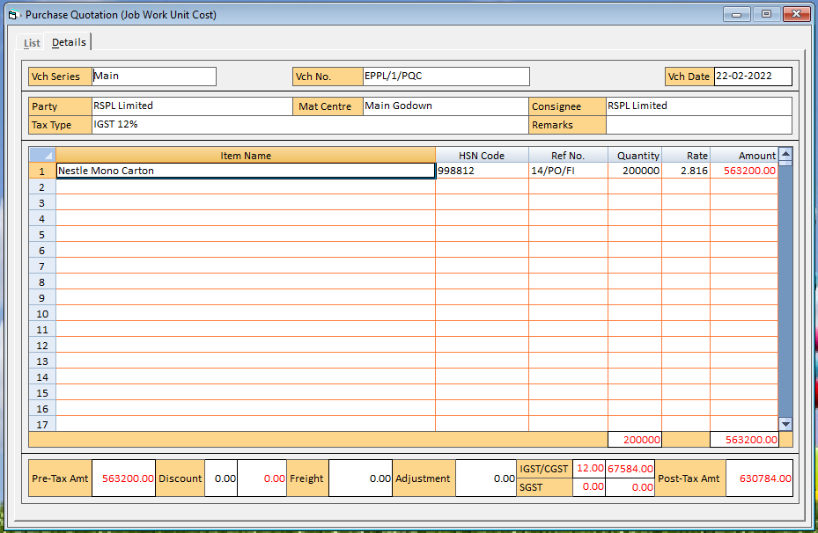

* **Save (CTRL+S)**



* On clicking the Save Button, a *Save* *Purchase Quotation* window appears. Given here is a screenshot of the *Purchase Quotation* window.

**Save Purchase Quotation Job Work Unit Cost**

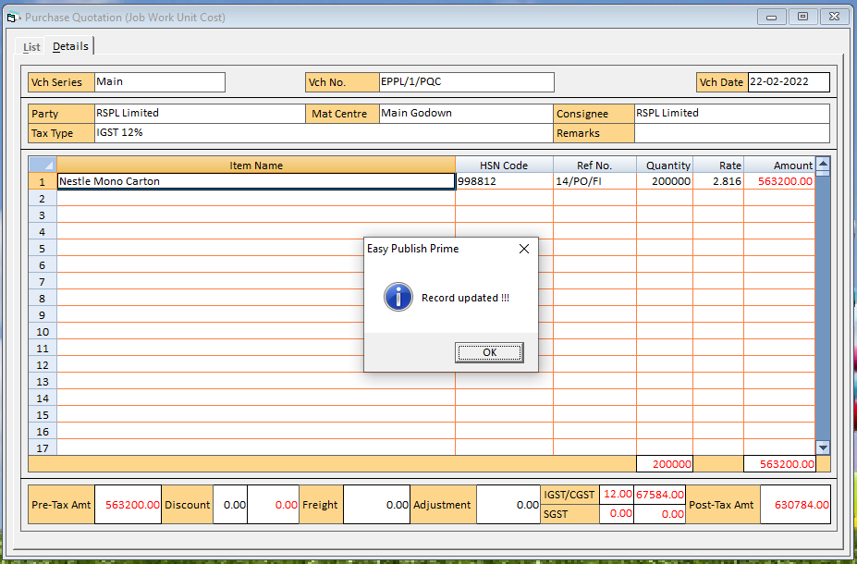

|  |  |
| --- | --- |
| · | Printer - If you want the Print of *Purchase Quotation* vouchers, click the ***Printer*** button. |



|  |  |
| --- | --- |
| · | Preview - If you want Preview the *Purchase Quotation* vouchers, click the ***Preview*** button. |



|  |  |
| --- | --- |
|  | Let’ Start Job Work |

## **Job work**

* + **List**

*List* Tab option allows you to View a list of all the *Purchase Quotation* vouchers of your company. On clicking the *List* tab, a *List of* *Purchase Quotation* *Vouchers* appears.

**List Purchase Quotation Job Work**

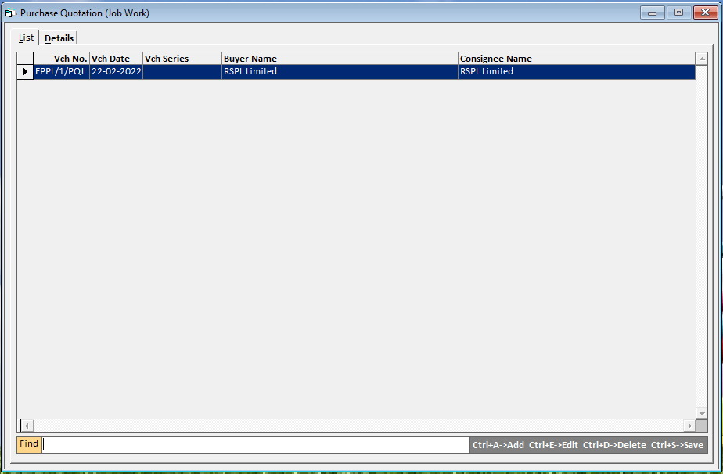

* **Add (CTRL+A)**



* On clicking the Add Button, an *Add* *Purchase Quotation* window appears. Given here is a screenshot of the *Purchase Quotation* window.

**Add Purchase Quotation Job Work**

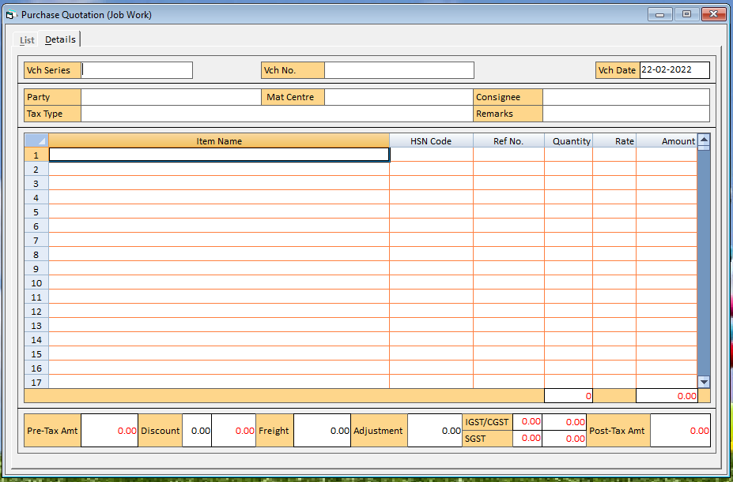

**In This window there are various data fields and grids. The data fields and grids are:**

* Series
* Vch. No.
* Date
* Party
* Mat. Centre
* Consignee
* Tax Type
* Remark
* Item Details
* HSN CODE
* Ref. No.
* Quantity
* Rate
* Discount
* Freight
* Adjustment

#### **Series**

On pressing the *Space* key, Select the series from the list that is displayed in this data field. The list of series depends on the configuration settings.

#### **Vch. No.**

Depending on the settings. You can enter the voucher number manually, automatically, or not enter the voucher number at all. As per the settings in *Voucher Configuration*, specify the voucher number.

#### **Date**

Specify the date of the Purchase Quotation.

#### **Party**

On pressing the *Space* key, Select the party/account to be affected in the *Purchase Quotation* voucher. You can select the party/account from the list that is displayed in the data field. In the list, the accounts that fall under the groups, Sundry Debtors, Sundry Creditors, Cash-in-Hand and Bank Accounts are displayed. On pressing the *Enter* key after selecting the party, selected in *Party* data field.

#### **Mat. Centre**

On pressing the *Space* key, Select the Material Centre from where the goods will be moved for Purchase. You can select the Material Centre from the list that is displayed in the data field.

#### **Consignee**

On pressing the *Space* key, Select the Consignee from where the goods will be moved for Purchase. You can select the Consignee from the list that is displayed in the data field.

#### **Tax Type**

On pressing the *Space* key, Specify the tax type of the Purchase Quotation.

#### **Remarks**

Specify the Remarks for the Purchase Quotation transaction. You can specify a Remarks with maximum of 94 characters. On pressing the *Enter* key after specifying the Remarks, a *Notes* window appears. This window appears if you have enabled the *Maintain Notes with Inventory Voucher* option, Enter notes for the voucher in this data field and click the *Ok* button.

#### **Item Details**

In the Item Details grid, the data fields are:

• Item

• HSN CODE

• Ref No.

• Quantity

• Rate (Rs.)

• Amount (Rs.)

There are Two ways for *Purchase Quotation* item selection.

**First option** is displayed pressing F11 Key. This option showing you pending Against Cost Estimation:

**Pending List**

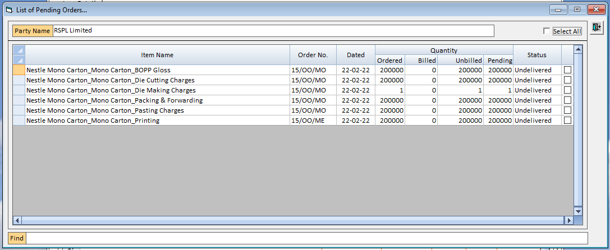

After Check/Uncheck of Check Box Press the Exit/Process Button, by default, all data field is displayed in this data Grid. You can change this value as per your requirement without affecting any other data field.

|  |  |
| --- | --- |
|  | You can use the Find box to search the pending items if pending list is too large. |

|  |  |
| --- | --- |
|  | You can also use select all check box to select all item in single check. |

**Pending List**

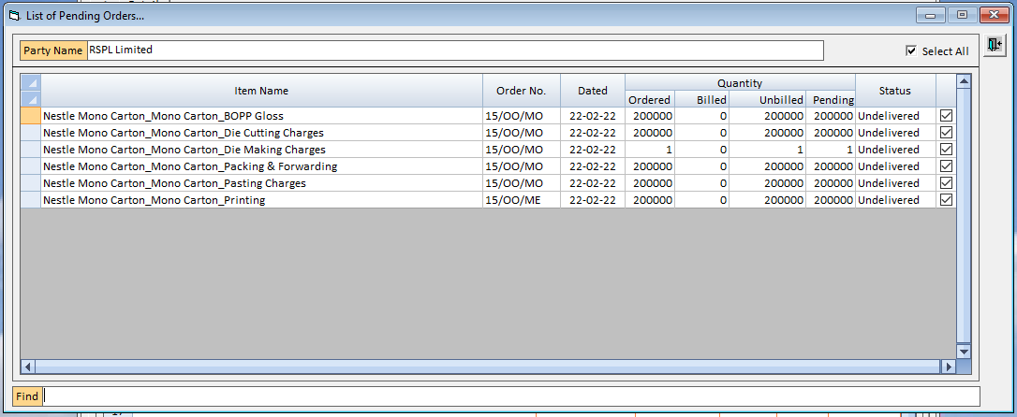

**Second option** is manual. IN This option select the all-data fields by pressing space bar manually:

**Item**

On pressing the *Space* key, Select the item for the Purchase Quotation from the list that is displayed in the data field.

**HSN CODE**

On pressing the *Space* key, Select the HSN CODE for the Purchase Quotation Item from the list that is displayed in the data field.

**Ref NO.**

Only, on pressing the *F11* key, Select the Ref. for the Purchase Quotation from the list that is displayed in the data field.

**Quantity**

Enter the quantity of the item for the Purchase Quotation.

**Rate**

Enter the Rate of the item for the Purchase Quotation.

**Amount (Rs.)**

By default, the amount calculated based on the value in the @ data field is displayed in this data field. You can change this value as per your requirement without affecting any other data field.

|  |  |
| --- | --- |
|  | *Quotation Ref. No.* does not appear if you have enabled the Second option. *References* appears while going with first *Option* window. In such a case, Quotation References are created automatically and the voucher number is treated as Quotation Reference number. |

|  |  |
| --- | --- |
|  | You can adjust the Purchase Quotation at the time of entering *Purchase* Order, *Material Issued to Party - Purchase Challan* or *Purchase* voucher. |

* **Edit (CTRL+E)**



* On clicking the Edit Button, an *Edit* *Purchase Quotation* window appears. Given here is a screenshot of the *Purchase Quotation* window.

|  |  |
| --- | --- |
|  | You can Edit the Exiting Purchase Quotation in this option. |

**Edit Purchase Quotation Job Work**

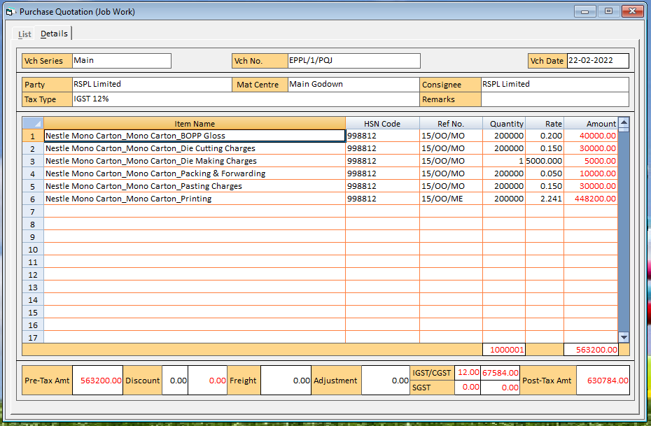

* **Save (CTRL+S)**



* On clicking the Save Button, a *Save* *Purchase Quotation* window appears. Given here is a screenshot of the *Purchase Quotation* window.

**Save Purchase Quotation Job Work**

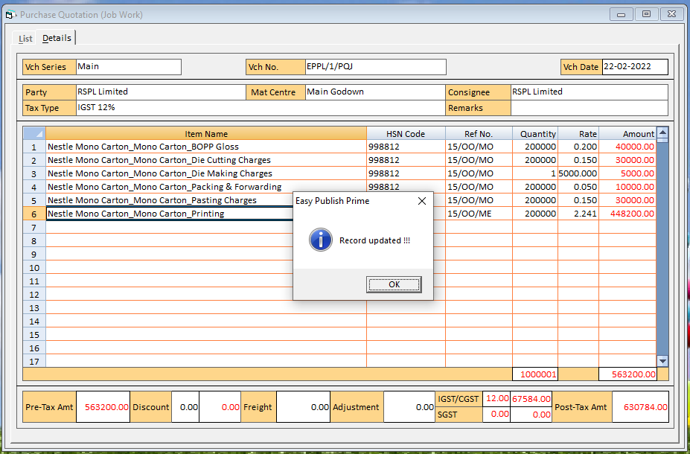

|  |  |
| --- | --- |
| · | Printer - If you want the Print of *Purchase Quotation* vouchers, click the ***Printer*** button. |



|  |  |
| --- | --- |
| · | Preview - If you want Preview the *Purchase Quotation* vouchers, click the ***Preview*** button. |



|  |  |
| --- | --- |
|  | Let’ Start Supply Inward |

# **Supply Inward**

* **Supply Inward** 
  + **List**

*List* Tab option allows you to View a list of all the *Purchase Quotation* vouchers of your company. On clicking the *List* tab, a *List of* *Purchase Quotation* *Vouchers* appears.

**List Purchase Quotation Supply Outward**

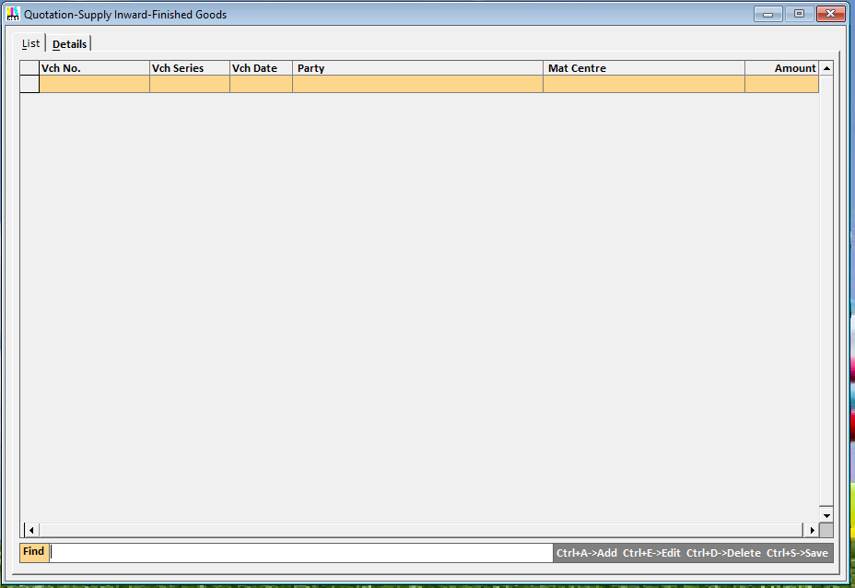

* **Add (CTRL+A)**



* On clicking the Add Button, an *Add* *Purchase Quotation* window appears. Given here is a screenshot of the *Purchase Quotation* window.
  + **Details**

*Details* Tab option allows you to View a list of all details of the *Purchase Quotation* vouchers of your company. On clicking the *Detail* tab, a *Detail of* *Purchase Quotation* *Vouchers* appears.

**Add Purchase Quotation Supply Inward**

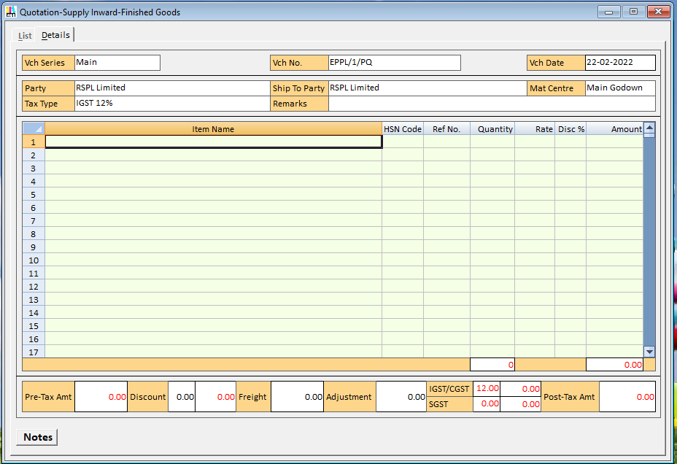

**In This window there are various data fields and grids. The data fields and grids are:**

* Series
* Vch. No.
* Date
* Party
* Consignee
* Mat. Centre
* Tax Type
* Remark
* Item Details
* HSN CODE
* Ref. No.
* Quantity
* Rate
* Discount (Item-wise)
* Amount
* Flat Discount
* Freight
* Adjustment

#### **Series**

On pressing the *Space* key, Select the series from the list that is displayed in this data field. The list of series depends on the configuration settings.

#### **Vch. No.**

Depending on the settings. You can enter the voucher number manually, automatically, or not enter the voucher number at all. As per the settings in *Voucher Configuration*, specify the voucher number.

#### **Date**

Specify the date of the Purchase Quotation.

#### **Party**

On pressing the *Space* key, Select the party/account to be affected in the *Purchase Quotation* voucher. You can select the party/account from the list that is displayed in the data field. In the list, the accounts that fall under the groups, Sundry Debtors, Sundry Creditors, Cash-in-Hand and Bank Accounts are displayed. On pressing the *Enter* key after selecting the party, selected in *Party* data field.

#### **Mat. Centre**

On pressing the *Space* key, Select the Material Centre from where the goods will be moved for Purchase. You can select the Material Centre from the list that is displayed in the data field.

#### **Tax Type**

On pressing the *Space* key, Specify the tax type of the Purchase Quotation.

#### **Remarks**

Specify the Remarks for the Purchase Quotation transaction. You can specify a Remarks with maximum of 94 characters. On pressing the *Enter* key after specifying the Remarks, a *Notes* window appears. This window appears if you have enabled the *Maintain Notes with Inventory Voucher* option, Enter notes for the voucher in this data field and click the *Ok* button.

#### **Item Details**

In the Item Details grid, the data fields are:

• Item

• HSN CODE

• Ref No.

• Quantity

• Rate (Rs.)

• Amount (Rs.)

There are Two ways for *Purchase Quotation* item selection.

**First option** is displayed pressing Space Key. This option showing you Stock List of selected Material Centre:

**Stock List**

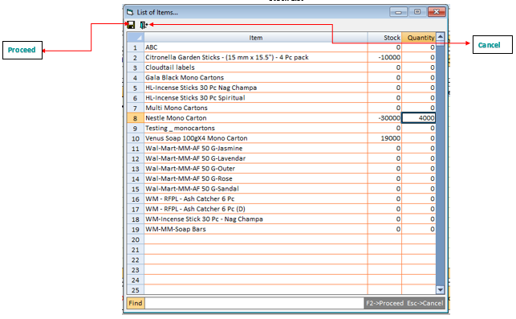

|  |  |
| --- | --- |
|  | You can use the F2 ->Proceed Esc ->Cancel. |

Enter the quantity of the item for the Purchase Quotation in Quantity Column. Press the **F2** Key to **Proceed** or **ESC** Key to **Cancel**, by default, all data field is displayed in this data Grid. You can change this value as per your requirement without affecting any other data field.

|  |  |
| --- | --- |
|  | You can use the Find box to search the Items, Enter the Item Name in Find box. |

**Stock List**

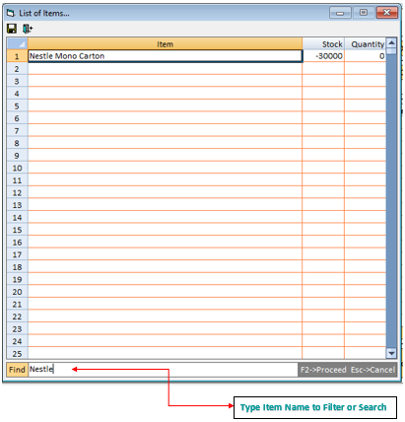

**Second option** is manual one to one Item Selection. IN This option select the Item one by one data fields by pressing F3 Key:

**Item**

On pressing the *F3* key, Select the item for the Purchase Quotation from the list that is displayed in the data Grid.

**HSN CODE**

By default, HSN CODE displayed after Item Selection, Select the HSN CODE for the Purchase Quotation Item from the list that is displayed in the data field if you have required changes.

**Ref NO.**

Only, on pressing the *F11* key, Select the Ref. for the Purchase Quotation from the list that is displayed in the data field.

**Quantity**

Enter the quantity of the item for the Purchase Quotation.

**Rate**

By default, Rate displayed after item selection Else Enter the Rate of the item for the Purchase Quotation.

**Amount (Rs.)**

By default, the amount calculated based on the value in the @ data field is displayed in this data field. You can change this value as per your requirement without affecting any other data field.

|  |  |
| --- | --- |
|  | *Quotation Ref. No.* does not appear if you have enabled the Second option. *References* appears while going with first *Option* window. In such a case, Quotation References are created automatically and the voucher number is treated as Quotation Reference number. |

|  |  |
| --- | --- |
|  | You can adjust the Purchase Quotation at the time of entering *Purchase* Order, *Material Issued to Party - Purchase Challan* or *Purchase* voucher. |

* **Edit (CTRL+E)**



* On clicking the Edit Button, an *Edit* *Purchase Quotation* window appears. Given here is a screenshot of the *Purchase Quotation* window.

|  |  |
| --- | --- |
|  | You can Edit the Exiting Purchase Quotation in this option. |

**Edit Purchase Quotation Supply Inward**

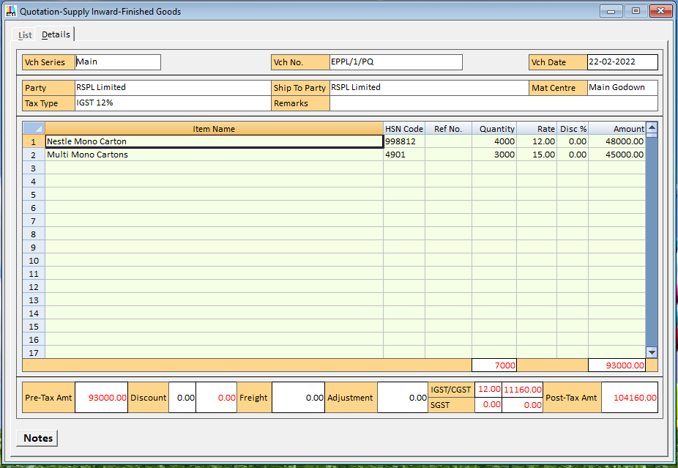

* **Save (CTRL+S)**



* On clicking the Save Button or Pressing CTRL+S Key, a***Transport Details***window appears. Given here is a screenshot of the ***Transport Details***window.

Enter the ***Transport Details*** data fields for the Purchase Quotation.

In ***Transport Details***window, the data fields are:

• Transport

• GR/RR No.

• GR/RR Date

• Vehicle No.

• Station

• e-Way Bill No.

• e-Way Bill Date

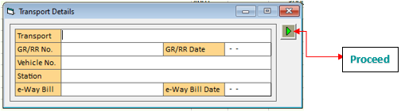

* On Pressing (CTRL+S), a *Save* *Purchase Quotation* window appears. Given here is a screenshot of the *Purchase Quotation* window.

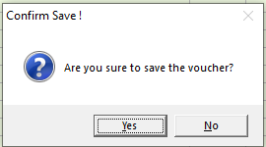

**Save Purchase Quotation Supply Inward**

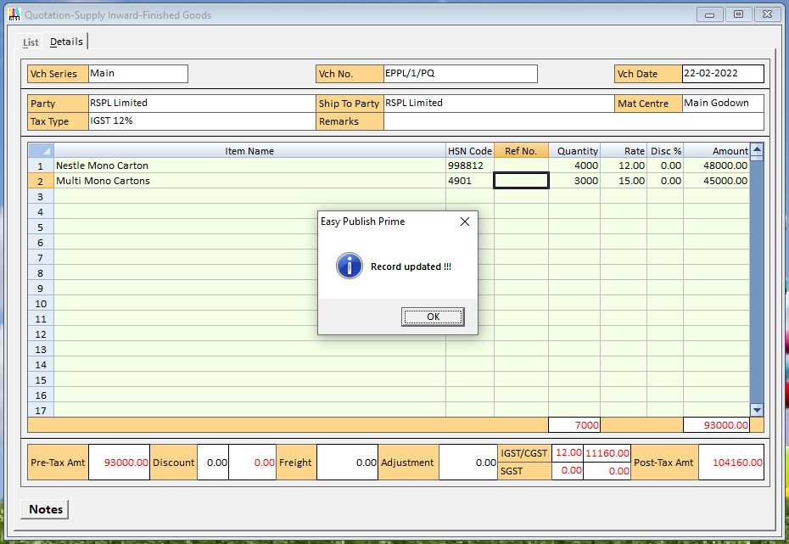

|  |  |
| --- | --- |
| · | Printer - If you want the Print of *Purchase Quotation* vouchers, click the ***Printer*** button. |



|  |  |
| --- | --- |
| · | Preview - If you want Preview the *Purchase Quotation* vouchers, click the ***Preview*** button. |



|  |  |
| --- | --- |
| **See Also** | **Back To Top** |
|  |  |

Copyright © Easy Info Solutions International, India