List down common HTTP status code (only 10) with means.

1. Status Code 200 – This is the standard “OK” status code for a successful HTTP request.
2. Status Code 201 – This is the status code that confirms that the request was successful and, as a result, a new resource was created.
3. Status Code 204 – This status code confirms that the server has fulfilled the request but does not need to return information.
4. Status Code 304 – The is status code used for browser caching. If the response has not been modified, the client/user can continue to use the same response/cached version.
5. Status Code 400 – The server cannot understand and process a request due to a client error.
6. Status Code 401 – This status code request occurs when authentication is required but has failed or not been provided.
7. Status Code 403 – Very similar to status code 401, a status code 403 happens when a valid request was sent, but the server refuses to accept it.
8. Status Code 404 – The most common status code the average user will see. A status code 404 occurs when the request is valid, but the resource cannot be found on the server.
9. Status Code 409 – A status code 409 is sent when a request conflicts with the current state of the resource. This is usually an issue with simultaneous updates, or versions, that conflict with one another.
10. Status Code 410 – Resource requested is no longer available and will not be available again.
11. Status Code 500 –The status code 500 happens when the server cannot fulfill a request due to an unexpected issue. Web developers typically have to comb through the server logs to determine where the exact issue is coming from.

Find network id and Broadcast for 150.10.20.30.

Network: 150.10.20.0/24

Broadcast: 150.10.20.255

Setup office vpn and access self learning platforms.

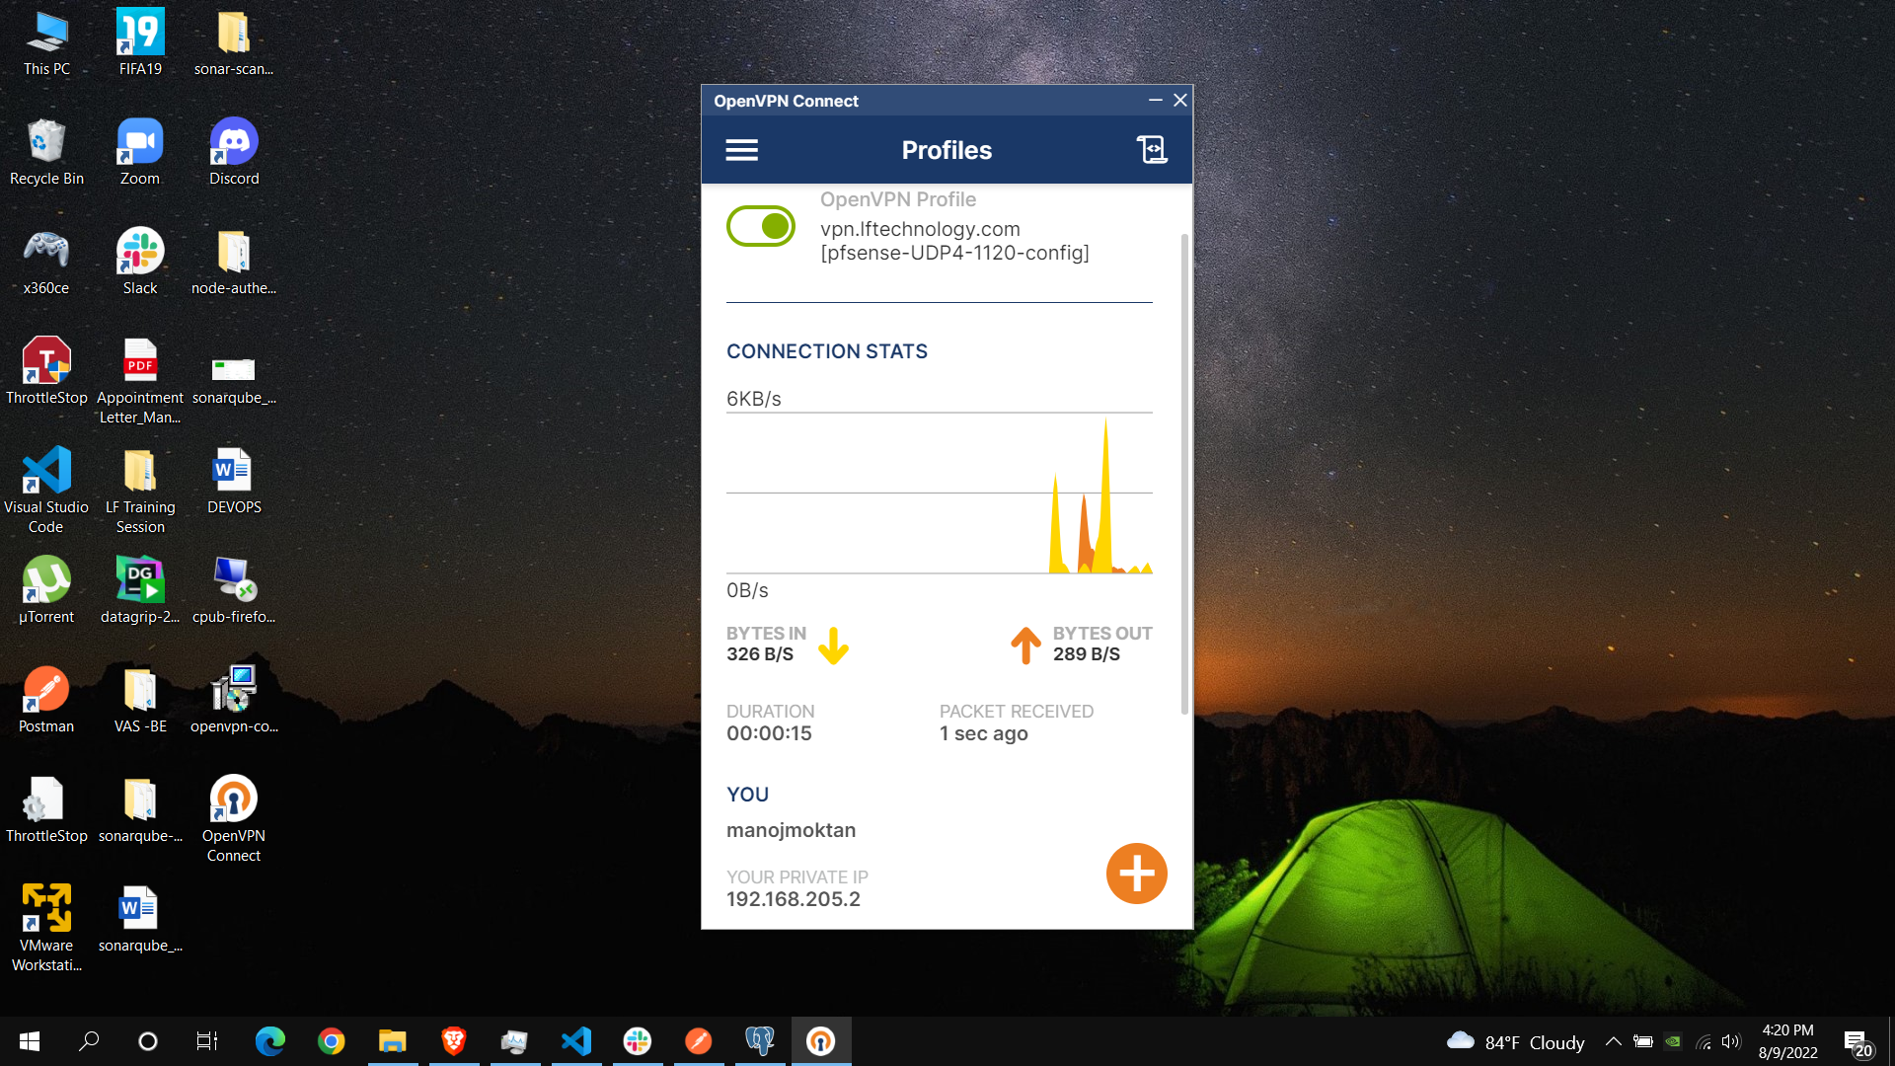

Launch an EC2 instance and login via ssh furthermore, install httpd(apache).

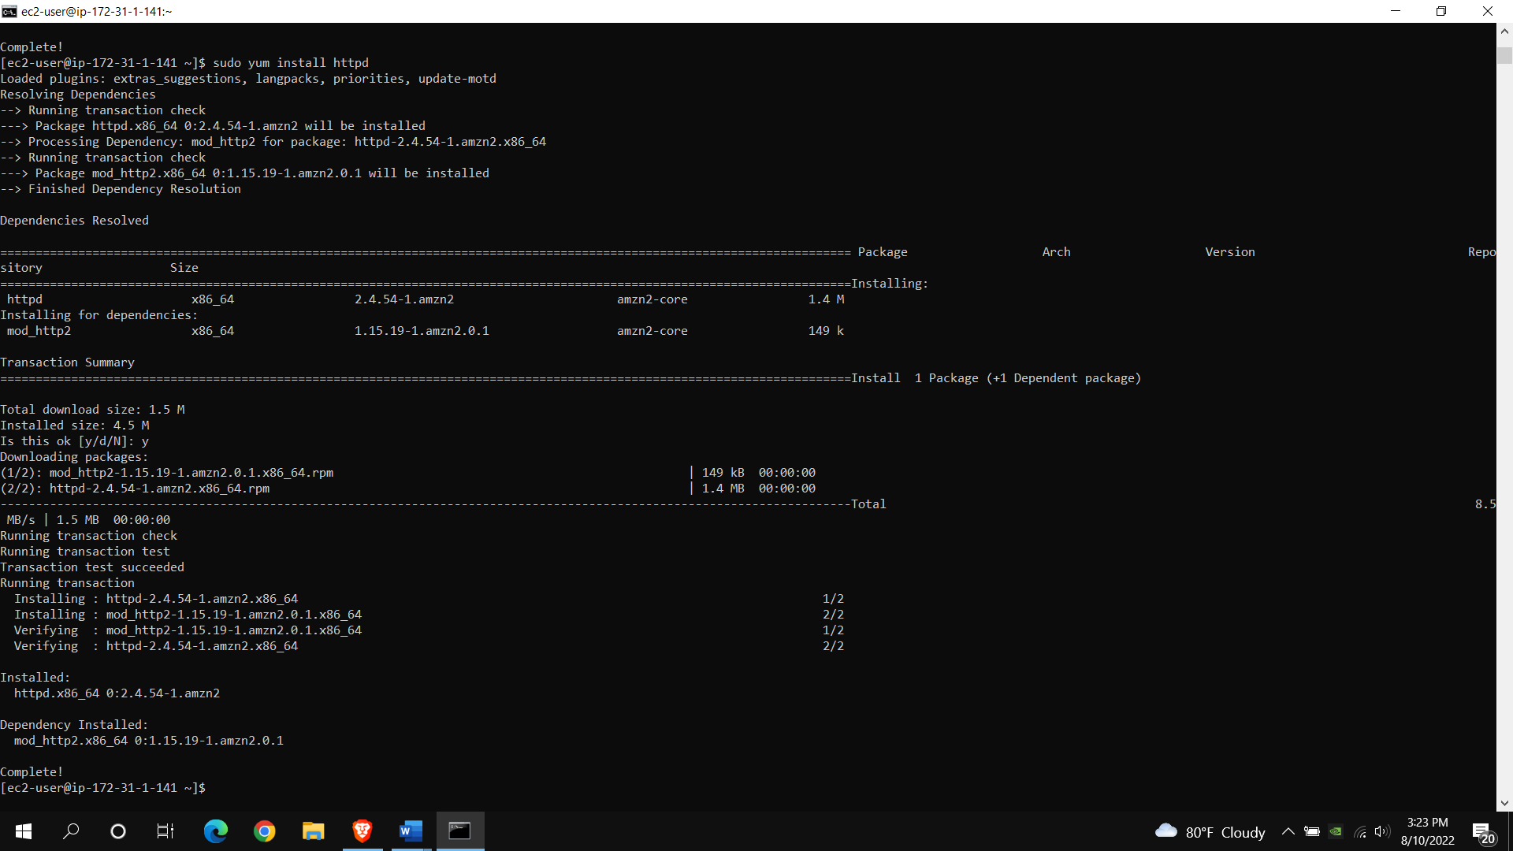

Create a Dockerfile for node js and react and push the created docker images to the docker hub repository.

