Phishing Email Detection & Awareness System
Introduction
Phishing is a cyber attack in which attackers use fraudulent emails, messages, or websites to trick users into revealing sensitive information such as passwords, banking details, or personal data. Phishing emails often appear to come from trusted organizations and use urgency or fear to persuade users to take immediate action.
The objective of this project is to analyze different types of emails, identify phishing indicators, classify emails as Safe, Suspicious, or Phishing, and provide awareness guidelines to help users protect themselves from email-based attacks.
Email Analysis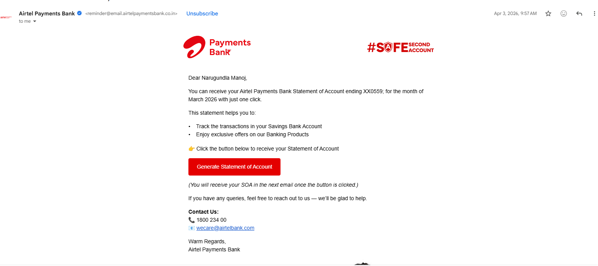
Email 1 – Safe Email
Sender: reminder@email.airtelpaymentsbank.co.in
Classification: Safe Email
Analysis
This email appears to be a legitimate communication from Airtel Payments Bank. The sender's email address is associated with the official Airtel Payments Bank domain. The email is professionally designed and addresses the recipient by name, which indicates personalization.
The message informs the user about generating a monthly account statement and does not request sensitive information such as passwords, OTPs, PINs, or banking credentials. Customer support contact details are also provided, which increases credibility.

Email 2 – Suspicious Email

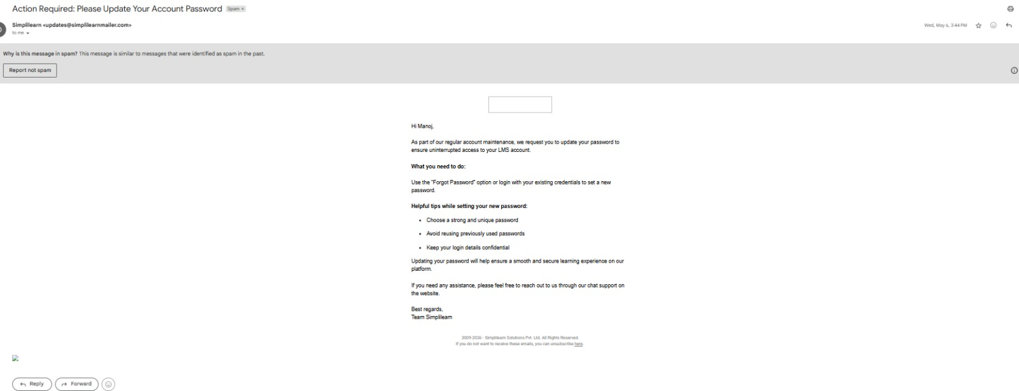
Classification: Suspicious
Analysis
This email requests the user to update their account password. Although the email appears professional and contains password security recommendations, Gmail has automatically marked it as spam. The subject line creates urgency by using the phrase "Action Required."
The sender domain appears related to Simplilearn, but users should verify whether it is an official communication channel. Since the email requests account-related action and was flagged as spam, caution is required.

Email 3 – Phishing Email
Sender: support@hdfc-security-update.com
Subject: Your Account Will Be Suspended
Classification: Phishing
Analysis
This email is a phishing attempt designed to trick users into revealing sensitive information. The sender's domain is not the official HDFC Bank domain and appears to imitate a trusted organization. The email creates urgency by warning that the account will be suspended if immediate action is not taken.
The email contains a suspicious link and attempts to pressure the user into clicking it. Such tactics are commonly used by cybercriminals to steal login credentials and personal information.

Comparison Table
Email Type | Indicators Found | Classification
Airtel Payments Bank | Official domain, professional content | Safe
Simplilearn Password Update | Spam folder, urgent request | Suspicious
Fake Bank Verification | Fake domain, suspicious link, urgency | Phishing

Awareness and Prevention Tips
- Verify the sender's email address.
- Do not click suspicious links.
- Never share passwords or OTPs through email.
- Check for spelling and grammar mistakes.
- Enable Multi-Factor Authentication (MFA).
- Report suspicious emails to the organization.
Conclusion
This project analyzed different email types and identified indicators that help distinguish between safe, suspicious, and phishing emails. Understanding these indicators can help users avoid phishing attacks and improve overall cybersecurity awareness.

