**SQL 101**

1)For different category of acquirers, what is the average number of months since the inception of the acquired company after which they are acquired

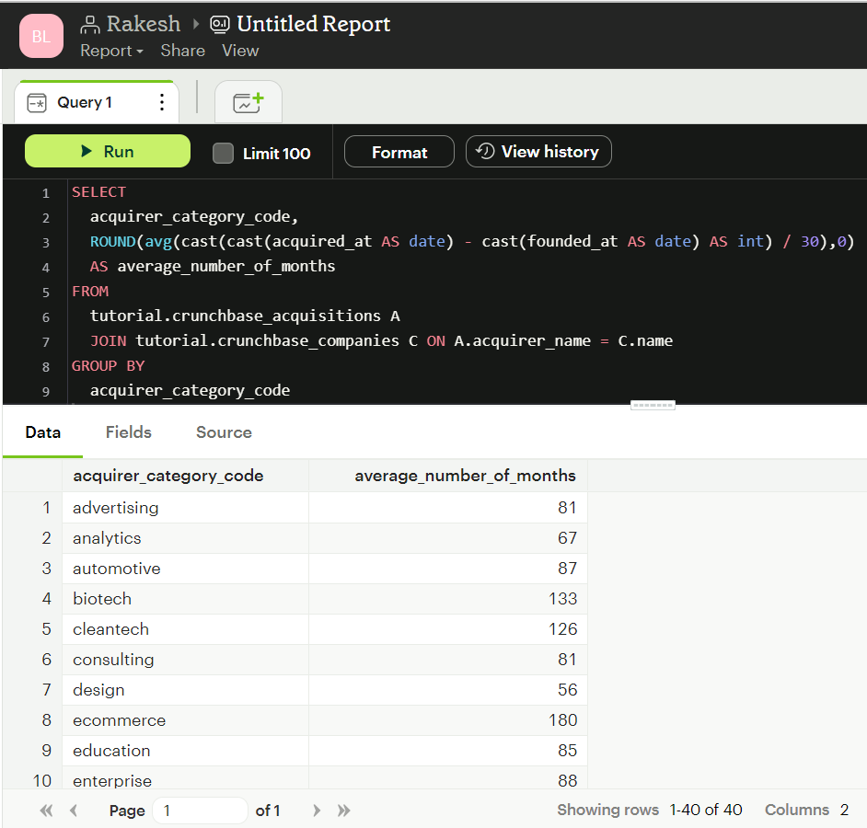

2) Is there any trend for quarters when more companies are acquired

3) For each company category code identify the average raised amount usd

4) Which investor (company) is more likely to invest in USA based companies?

5) For different type of funding rounds, what is the average raised amount per quarter

6) Identify companies that received an investment from Japan following an investment from Great Britain where investor is finance category company

7) Out of all 'operating' status companies, which category of companies have the highest average funding_total_usd?

8) For each category, what percent of companies received funding within 3 years of their founding?

9) Clean the 'last_funding_at' column (convert it to time stamp) and get the time difference with the current time.

10) Average funding based on the countries.

