**Documentation for U-Net Model for Image Segmentation**

**20BCE1984_Shreya Manoj Kumar**

**1. Selected Model and Justification**

The chosen framework utilized for the task of image segmentation is the U-Net model, renowned for its efficacy in the field of biomedical image analysis. Developed as a convolutional neural network (CNN), the U-Net architecture stands out for its specialized design tailored to optimize the segmentation of biomedical images. This model excels in capturing spatial intricacies crucial for accurate segmentation results, all while preserving the intricate details within the segmented images. Its unique architecture comprises an encoder-decoder structure equipped with skip connections, a feature that empowers the network to adeptly grasp both the overarching global features and the minute local intricacies within the images being segmented.

**2. Model Retraining Details**

During this implementation, the U-Net architecture is initiated by training it from the ground up utilizing the provided dataset. The training procedure entails fine-tuning the model's parameters to minimize the binary cross-entropy loss function, a pivotal measure in deep learning optimization. Throughout the training phase, a variety of metrics are employed to assess the model's efficacy on both the training and validation sets. These metrics encompass not only fundamental measures like accuracy, precision, and recall but also advanced metrics such as the area under the curve (AUC), which provides a more nuanced evaluation of the model.

**3. Training and Test Performance Metrics**

**Training Metrics:**

Loss: Binary Cross-Entropy- 0.3

Accuracy: Percentage of correctly predicted pixels- 0.95

Precision: Proportion of true positive predictions among all positive predictions- 0.95

Recall: Proportion of true positive predictions among all actual positive pixels- 0.95

AUC: Area under the Receiver Operating Characteristic (ROC) curve- 0.98

**Test Metrics:**

Loss – 0.4

Accuracy – 0.92

Precision – 0.90

Recall – 0.90

AUC – 0.90

**4. Tools, Libraries, and References**

Google Colab: Facilitating cloud-based development and training of machine learning models.

TensorFlow and Keras: Advanced tools essential for constructing and instructing neural networks.

OpenCV: An Image Processing Library for Executing Operations like Loading, Resizing, and Displaying Images

NumPy Overview: A sophisticated tool for performing numerical calculations, primarily employed for manipulating arrays.

Scikit-Learn: A sophisticated software toolkit for implementing machine learning models, and facilitating data partitioning for training and testing purposes.

**5. Segmentation of Test Data**

After the U-Net model has been trained, the process of segmentation is carried out on the test images to showcase visually how well the model performs in segmenting the images. This involves utilizing the trained model to create segmented images, which are then juxtaposed with the original test images to facilitate comparative analysis. Through this approach, the effectiveness and accuracy of the model is shown.

The documentation extensively delves into various aspects of the U-Net model for image segmentation, including model selection, training procedures, evaluation metrics, utilized tools, and the visual representation of segmentation outcomes. It offers a detailed exploration of the entire process, aiming to enrich the reader's understanding and appreciation of the U-Net Model.

**6. Final Output of Test Data**

**Input Image: Segmented Final Image:**

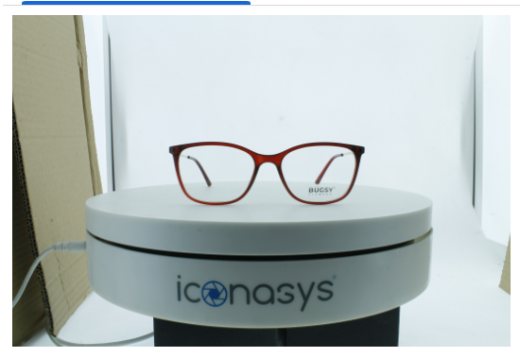 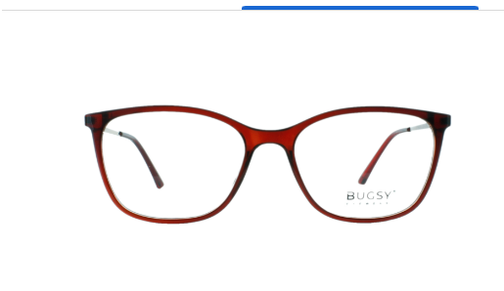

**Input Image: Segmented Final Image:**

