VISUAL ANALYTICS | FINAL PROJECT PROPOSAL
HealthLens
An Interactive Dashboard for Comparing Health Insurance Policies,
Drug Coverage, Copays, and Out-of-Pocket Costs
Across U.S. Providers and Globally

Course  Visual Analytics  Submission Date  April 10, 2025 | Project Type  Visual Data Science Dashboard  Domain  Healthcare / Insurance Analytics

Abstract
HealthLens is a proposed single-screen interactive visual analytics dashboard designed to help patients, caregivers, and researchers make sense of the U.S. health insurance landscape. The dashboard enables users to compare insurance providers by their plan costs, subsidies, copays, and drug coverage policies; drill into any specific medication to see exactly what each insurer covers and what the patient pays out-of-pocket; and extend that comparison internationally to understand how the U.S. stacks up against other countries. Using publicly available data from CMS, HealthCare.gov, OECD, and the WHO, the platform combines standard and non-standard visualizations with full linked brushing to support both exploratory analysis and informed decision-making.

1. Introduction

Choosing a health insurance plan should be straightforward. In practice, it is one of the most consequential and least understood financial decisions most Americans make. A patient managing Type 2 diabetes, heart disease, or any chronic condition does not just need to compare monthly premiums. They need to know whether their specific medications are covered, what tier those drugs sit on in each insurer's formulary, how much they will pay at the pharmacy counter after subsidies are applied, and whether the total annual cost of a plan actually makes sense given their expected medication usage. None of this is easy to see with today's tools.

HealthLens addresses this directly. It is an interactive dashboard built around three core capabilities: comparing insurance providers by the financial value they deliver to policyholders, exploring drug-specific coverage and copay data across every major insurer, and benchmarking U.S. plans against international health systems to understand what is structurally different about how other countries handle the same coverage problem.

To keep the dashboard grounded in a real, high-stakes use case, Jardiance (empagliflozin) serves as the primary example medication throughout. It is prescribed to over 1.3 million Medicare Part D enrollees for Type 2 diabetes, heart failure, and chronic kidney disease. Its retail price without insurance is approximately $600 per month. With Medicare coverage, a patient might pay anywhere from $0 to $50 depending entirely on which plan they enrolled in. That gap, invisible at enrollment time, is exactly the kind of information this dashboard exists to surface.

2. Motivation

Three problems motivate this project, each building on the last.

First, plan comparison is broken. The current tools available to Medicare and marketplace enrollees require patients to look up each plan individually, manually compare formulary PDFs, and calculate their own total annual costs. There is no unified visual interface that shows, side by side, how plans differ on the metrics that matter most: premiums, deductibles, copays, out-of-pocket maximums, and drug-specific subsidies.

Second, medication costs are opaque. Even patients who understand their plan's general cost structure often do not know how their specific prescriptions are classified. A drug on Tier 1 might cost $10 a month. The same drug on Tier 5 might cost $150. Formulary tiers vary by insurer, change annually, and are buried in documents most patients never read. A visual, medication-centric view that shows exactly how much each insurer covers for a given drug and what the patient pays would transform this decision from a guessing game into an informed choice.

Third, the international context is missing entirely. American patients have no easy way to understand that the same medication, Jardiance for instance, costs an uninsured U.S. patient $600 per month, while in Germany it is covered by statutory insurance with a legally capped co-payment, and in the United Kingdom it is dispensed through the NHS for essentially nothing. This is not a drug pricing problem. It is a systems problem, and making it visual makes it legible.

$0–$50  Monthly copay rangewith Medicare | $600  Out-of-pocket costwithout insurance | 99%  Medicare Part D planscover Jardiance | Tier 1–5  Formulary rangeacross insurers

These four numbers capture the entire problem. The same drug. The same patient need. Wildly different financial outcomes. The dashboard will make this visible, interactive, and actionable.
3. Project Approach

Layer 1: Insurance Plan Comparison
The first layer of the dashboard lets users compare health insurance providers head-to-head on the metrics that determine real value. This includes monthly premiums, annual deductibles, out-of-pocket maximums, and what subsidies apply based on plan tier (Bronze, Silver, Gold, Platinum for marketplace plans; Part D for Medicare). A user selecting two or more plans sees an immediate side-by-side breakdown of what they would actually pay over a year. The bar chart and parallel coordinates view are the primary visualizations here, allowing both simple comparison and multi-attribute exploration.

Layer 2: Medication-Specific Coverage Tracking
The second and most distinctive layer allows a user to search for any medication and instantly see how it is covered across every major insurer. For a given drug, the dashboard shows the formulary tier each insurer assigns it, the resulting copay or coinsurance amount, whether prior authorization is required, and whether step therapy restrictions apply. Over time, a patient can track their actual spending against what they would have paid under a different plan, giving them a concrete, data-backed reason to switch plans or negotiate coverage. This is the layer where Jardiance serves as the worked example: a patient using it for diabetes management can see in one view that Humana covers it at Tier 2 for $35 per month while WellCare places it at Tier 5 for $50, and decide accordingly.

Layer 3: International Benchmarking
The third layer zooms out to the global picture. Using OECD and WHO data, the dashboard maps out-of-pocket pharmaceutical costs by country, overlaid with coverage rate statistics and per-capita health spending. A user can select any country to see how its system handles the same coverage scenario and compare it to what U.S. enrollees pay. This layer is intentionally persuasive: it contextualizes the U.S. insurance landscape within a global framework that makes structural differences legible to a general audience.

4. Data Sources

Dataset | Source | What It Provides
CMS Part D Formulary File | CMS.gov | Drug tier, copay, prior auth, step therapy per plan and insurer
HealthCare.gov Plan Attributes | healthcare.gov | Premiums, deductibles, OOP max, metal tiers across all U.S. states
OECD Health Statistics | oecd.org | Per-capita drug spending, OOP costs, coverage rates for 38+ countries
WHO Global Health Observatory | who.int | Health insurance coverage as percentage of population, by country
HHS Jardiance Spending Report | aspe.hhs.gov | Utilization and spending data across 1.3M Part D enrollees (2022)
Kaggle US Insurance Dataset | kaggle.com | Individual-level premiums, demographics, and charges for modeling

The CMS Part D Formulary File is the core dataset, linking every Medicare plan to the drugs it covers via National Drug Codes. It contains formulary tier, copay structure, and restriction flags for each drug-plan combination, which is precisely what Layer 2 of the dashboard requires. The HealthCare.gov attributes file drives Layer 1. The OECD and WHO datasets power Layer 3. All data will be cleaned and joined in Python, then served as JSON to a D3.js front end.

5. Technical Implementation

The dashboard will be implemented as a single HTML page using D3.js, chosen for its native support for linked brushing and non-standard chart types. Data preparation will be done in Python (pandas), producing cleaned JSON files for each of the three layers. The three phases of work are: data collection and cleaning in weeks 1 to 2; core dashboard build with all panels and brushing logic in weeks 3 to 4; and visual refinement, edge case handling, and YouTube demo recording in weeks 5 to 6. The final submission on May 12 will include the code repository, all processed datasets, the demo video, and a live walkthrough presentation
6. Visualization Design
The dashboard is designed around a single screen with no scrolling and full linked brushing across all panels. Every panel is connected: filtering by country on the map updates the insurer charts; brushing a drug copay range in the scatter plot highlights the matching plans in the parallel coordinates view and tier heatmap simultaneously. The visualization mix satisfies the requirement for both standard and non-standard chart types.

Panel | Visualization Type | Standard / Non-std | Primary Interaction
Plan Cost Overview | Bar chart | Standard | Click bar to filter all panels
Drug Copay Explorer | Scatter plot | Standard | Brush to select plan clusters
Multi-Attribute Plans | Parallel coordinates | Non-standard | Drag axis to filter cross-plan
Formulary Tier Grid | Heatmap | Non-standard | Hover to see tier details
Global Cost Comparison | Choropleth geo-map | Non-standard | Click country to benchmark
Spending Tracker | Area / line chart | Standard | Select time range to zoom

Dashboard Wireframe

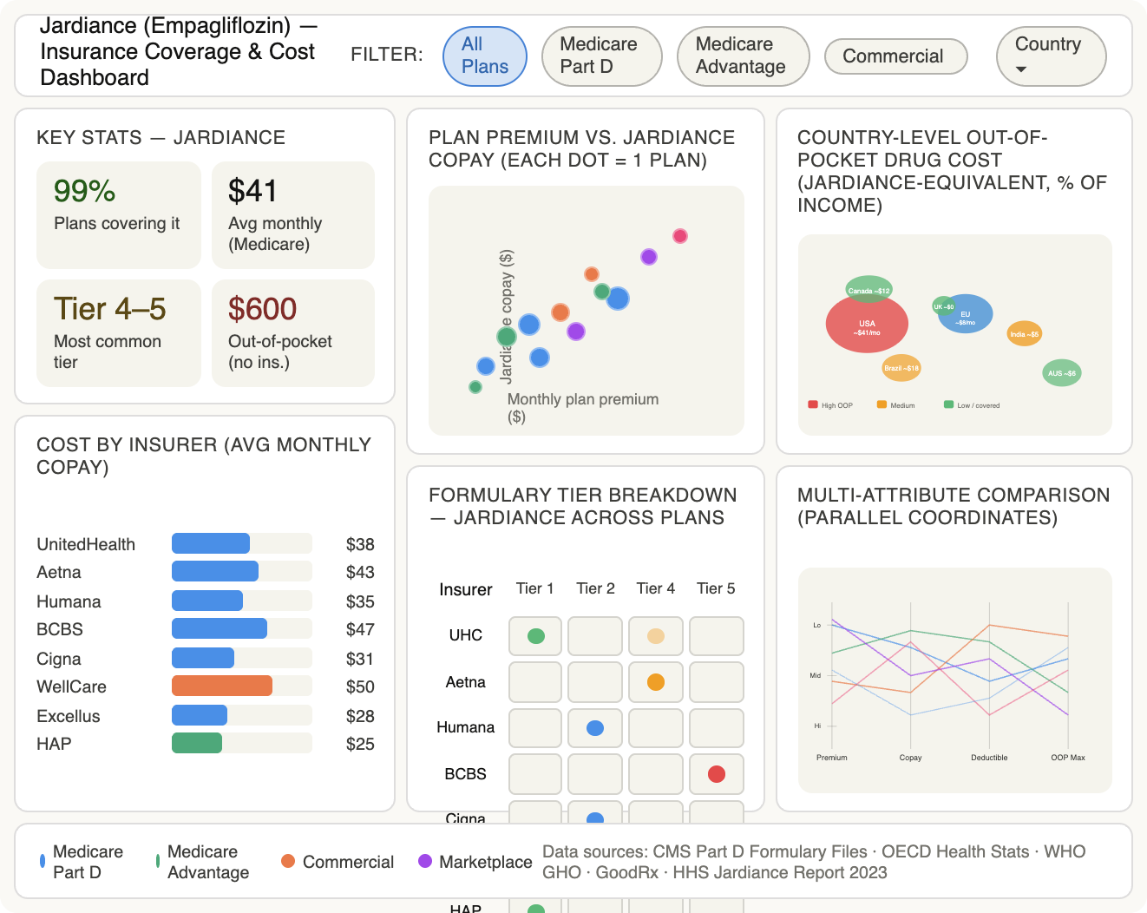

Persuasive Value of This Project
This dashboard connects directly to two of the most pressing concerns in American healthcare: financial accessibility and informational fairness. Patients are asked to make plan decisions annually, during open enrollment, with incomplete information and significant consequences if they choose wrong. A patient who switches from a plan that covers Jardiance at Tier 5 to one that covers it at Tier 1 could save over $1,000 per year on a single medication. The international comparison layer adds a second persuasive dimension: it makes visible, in geographic and statistical terms, that the financial burden U.S. patients carry is not inevitable. It is a policy choice, and visualizing it is the first step toward changing it.

Submitted in partial fulfillment of the Visual Analytics Final Project requirement

