Insights from the visualizations

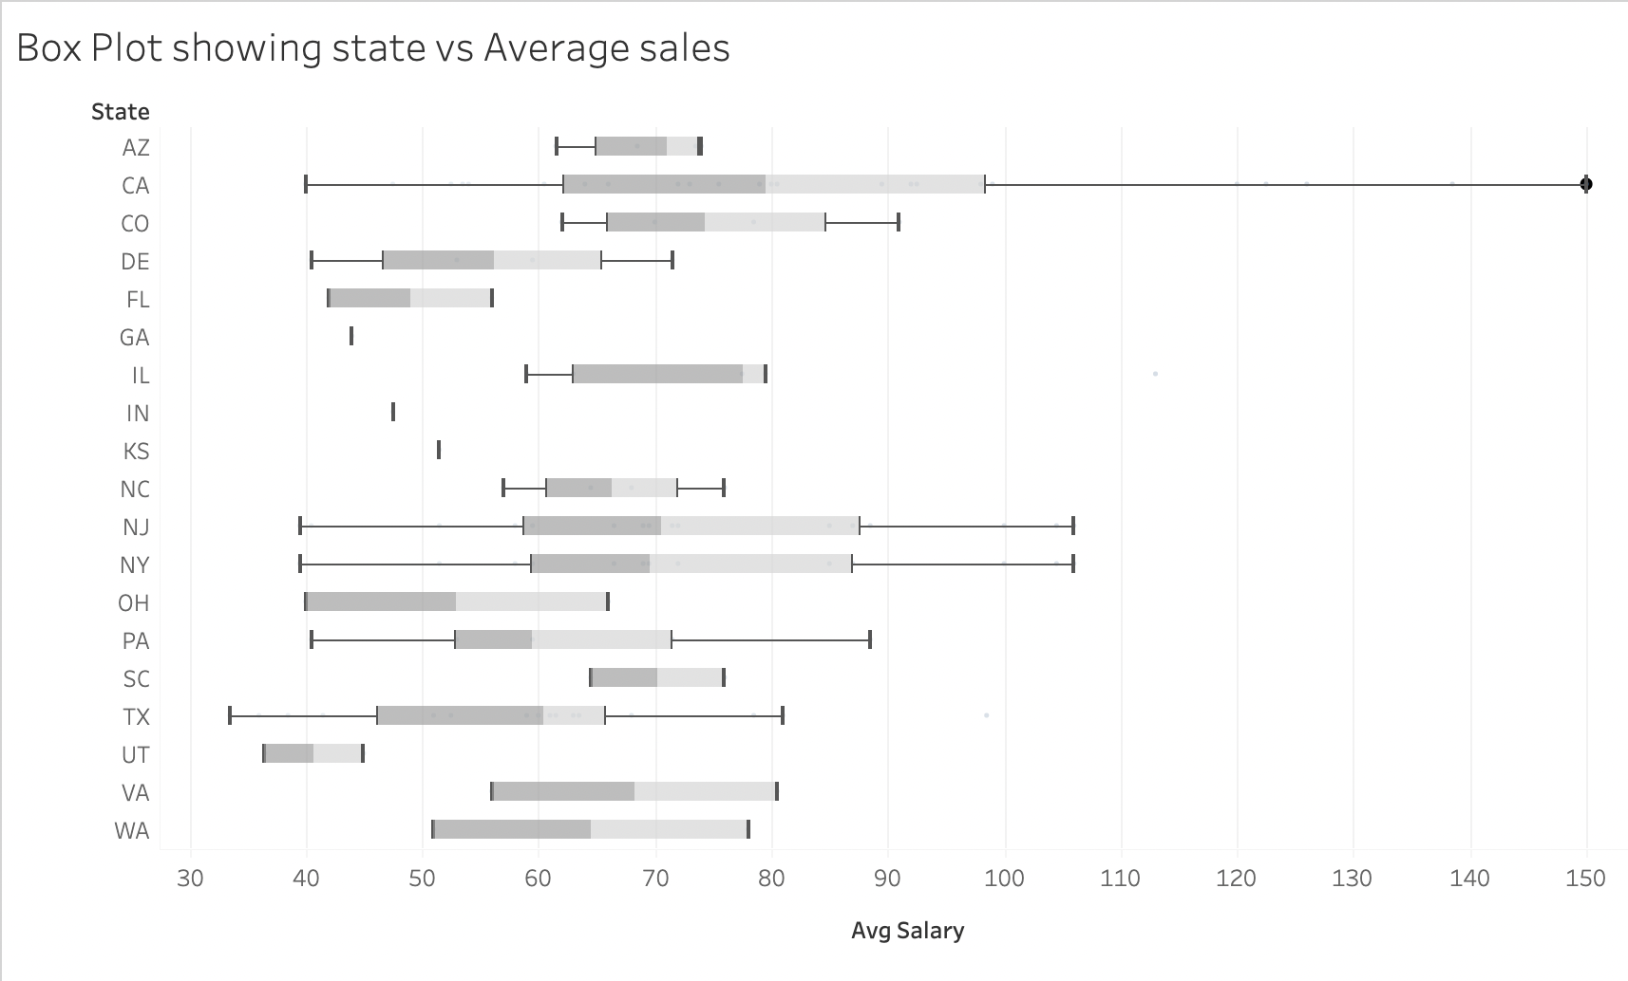

The Above plot clearly shows the state CA has the highest average salary of 150k which would be a potential outlier and in such cases, median would be good measure to compare the salaries among different states instead of mean.

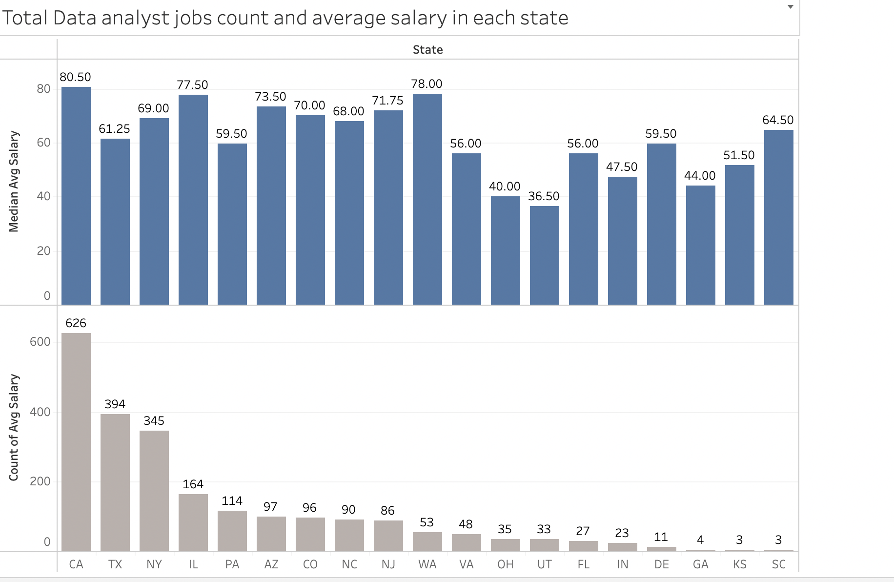

From the above plot, It is observed that California has the highest demand for Data Analysts and pay high salaries ( median of 80.5 K) whereas Washington doesn’t have much demand for the data analysts but still pays close to 78K.

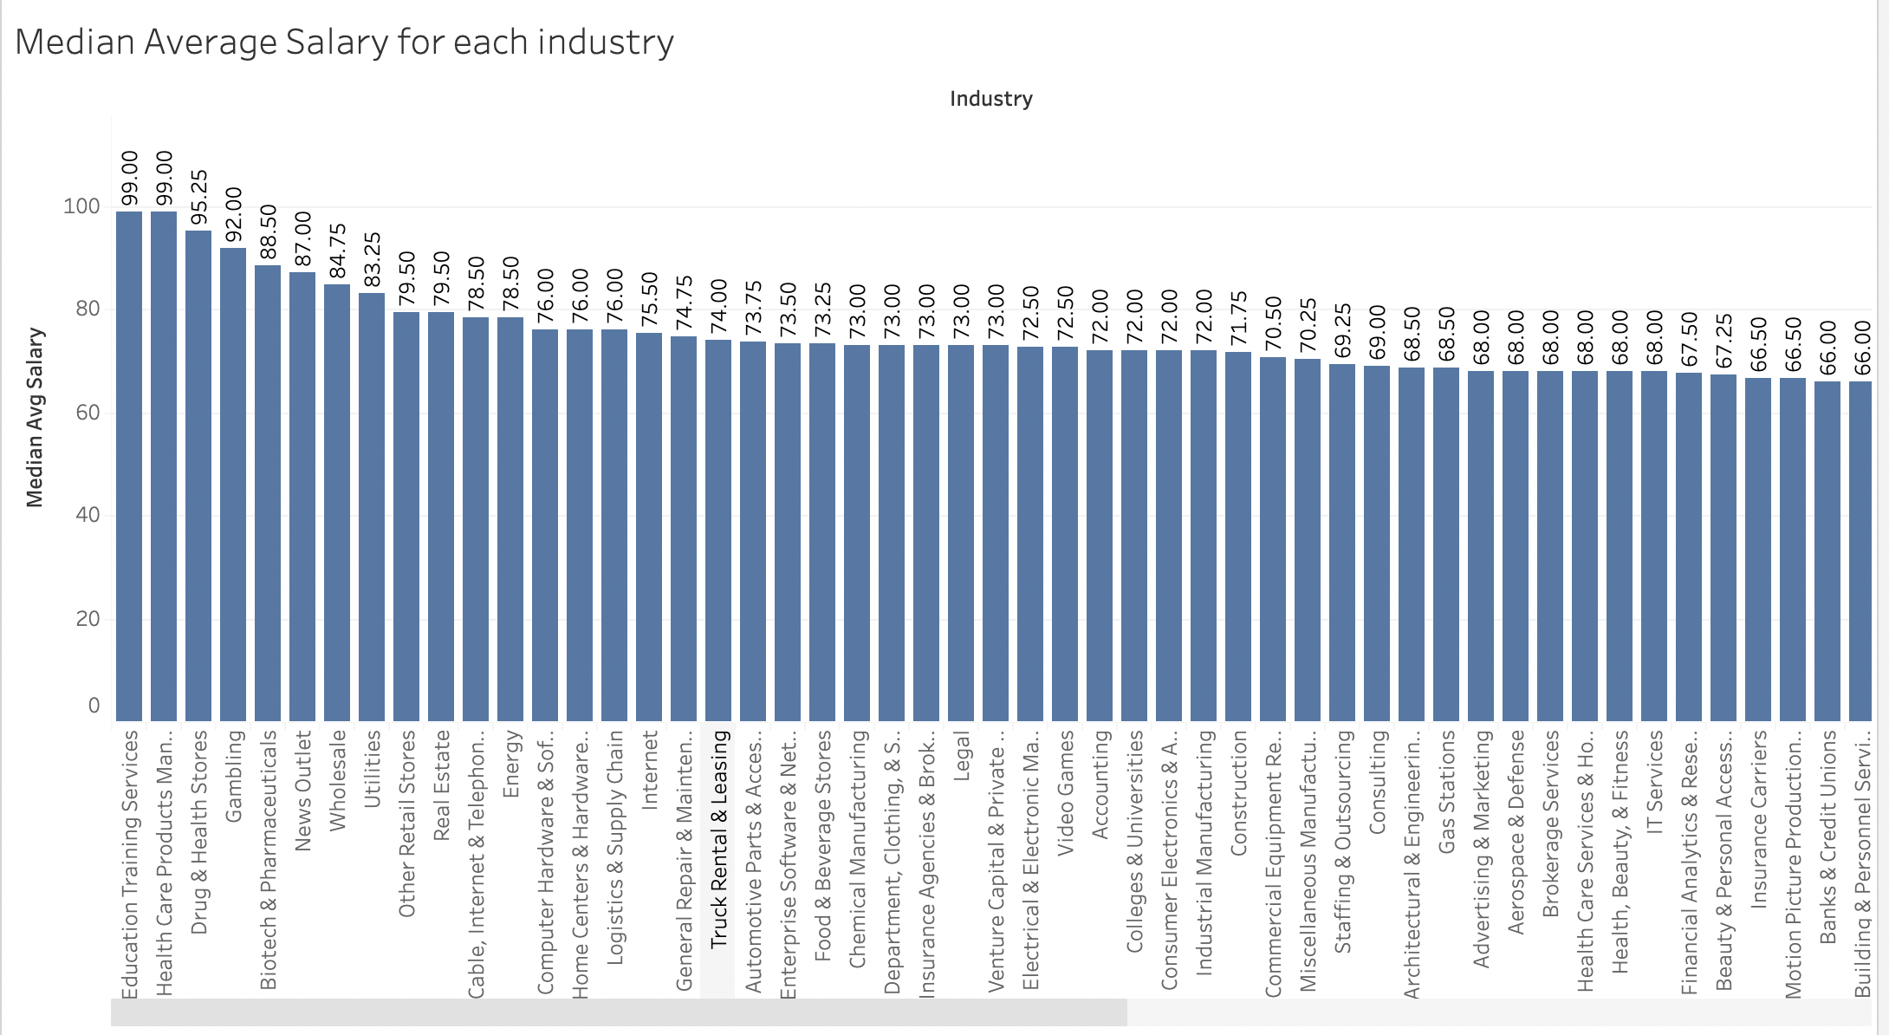

From the above plot which shows the median average salary of each industry, Education Training and Services offers the highest median salary of 99k and Grocery stores and super markets offers the lowest salaries with a median of 36K ( I Couldn’t show all the industries here, please refer to dashboard)

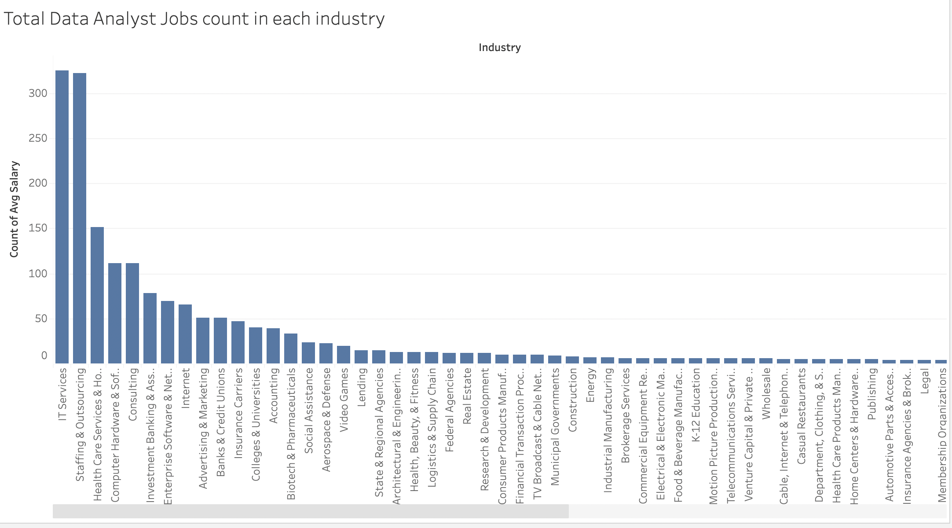

The Industries IT Services and Staffing & Outsourcing has the highest demand for Data Analysts in the market while Trucking, Truck Rentals, Stock Exchanges has the lowest demand for Data Analysts. While IT services has the highest demand, the median of salaries is close to 68 K which is very less than the highest median salary.

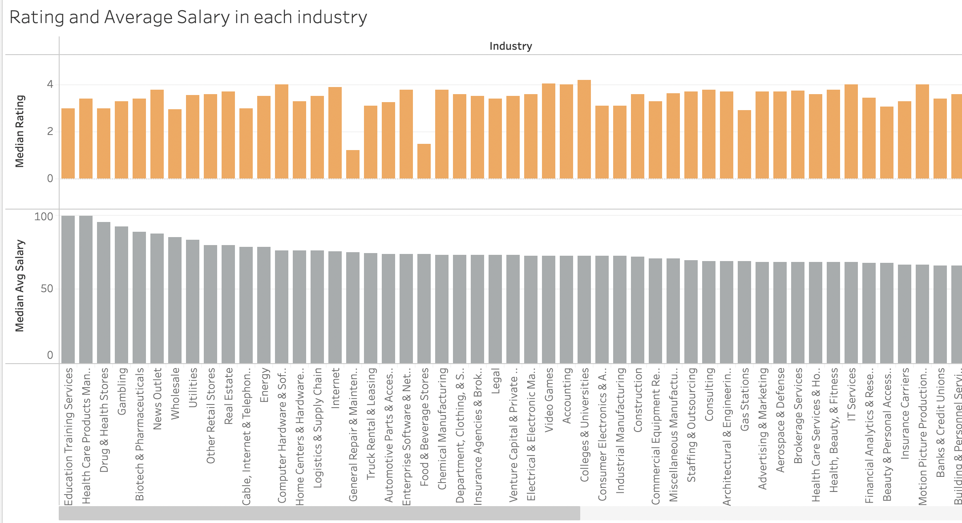

The above plot clearly shows that for each industry, the Rating doesn’t have impact on the average salaries. Education Training services and Health care products industries have same median average salaries but their rating is different. For Example, Accounting has more rating than General Repair Maintenance but less salary.