**Group Project Submission - 3**

**Domain Name:**  onlinegamemanagement.me

**Where we got it:** [www.namecheap.com](http://www.namecheap.com)

The screenshots showing how to update IP address:

**Step 1:**

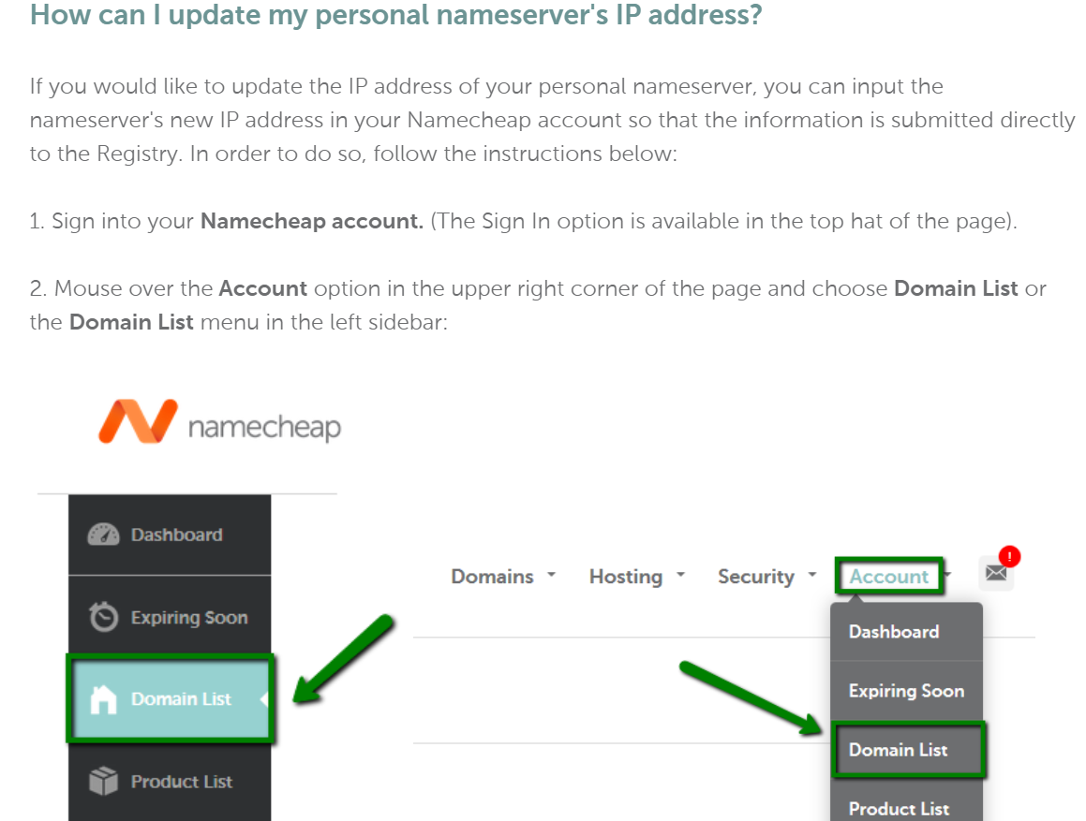

**Step 2:**

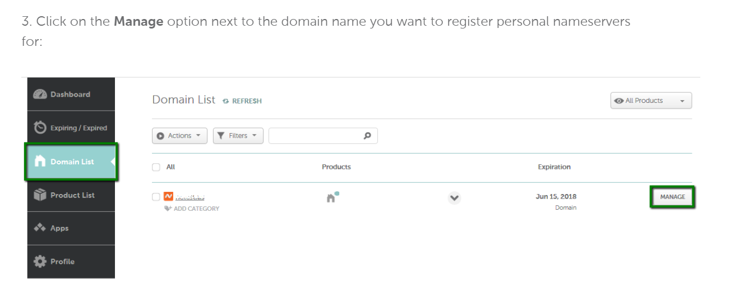

**Step 3:**

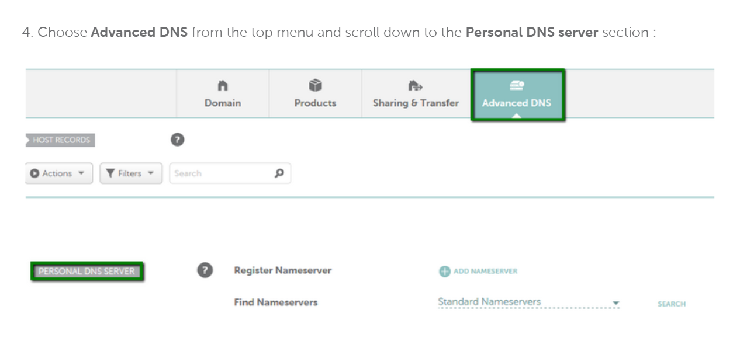

**Step 4:**

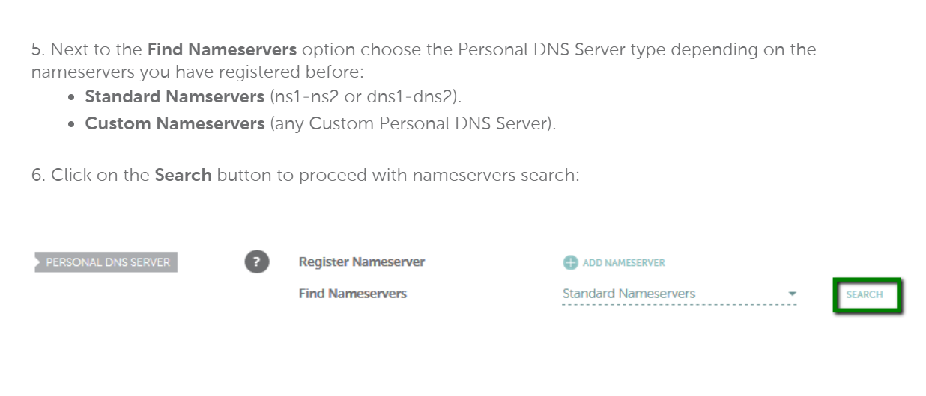

**Step 5:**

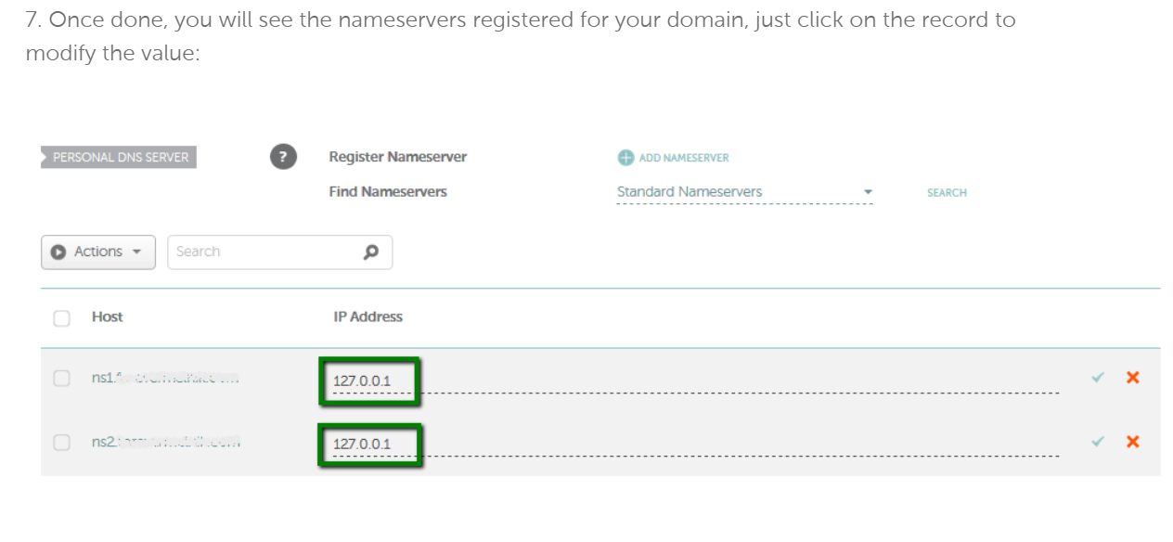

**Step 6**:

