**“Hospital Management System”**

**A PROJECT REPORT**

**Under the guidance of**

**\*\*\*\*\*Project Guide Name\*\*\*\*\***

**______________________________**

**\*\*\*\*\* NAME \*\*\*\*\***

**Roll No: ***** Roll number \*\*\*\*\***

______________________________

In partial fulfillment of the requirement

For the award of the degree

**Of**

**Master of Computer Application (MCA)**

CERTIFICATE

THIS IS TO CERTIFY THAT THE PROJECT REPORT ENTITLED

**“Hospital Management System”**

SUBMITTED IN PARTIAL FULFILMENT OF REQUIREMENT FOR THE DEGREE OF

**MASTER OF COMPUTER APPLICATION (MCA)**

Of

**University Name**

By

**\*\*\*\*\*\*NAME\*\*\*\*\***

**Registration No: ***** Roll Number \*\*\*\*\***

**Center Code: ***** Center Code \*\*\*\*\***

LC Co-coordinator

(Signature)

EXAMINER’S CERTIFICATION

THE PROJECT REPORT OF

**\*\*\*\*\* NAME \*\*\*\*\***

**“HOSPITAL MANAGEMENT SYSTEM”**

Is approved and is Acceptable in Quality and Form

Internal Examiner External Examiner

DECLARATION

I hereby declared that this project report entitled dissertation titled “HOSPITAL MANAGEMENT SYSTEM” submitted to University Name, India,  is a record of an original work done by me under the guidance ***** Project guide name ***** of in partial fulfillment for the award of Master of Computer Application (MCA) degree has been prepared by me during year ***** 2012-15 *****. The results embodied in this thesis have not been submitted to any other University or Institute for the award of any degree or diploma.

***** NAME *****

Reg. No: ***** **Roll Number \*\*\*\*\***

Place: ***** Place *****

Date: ***Submission Date***

**ACKNOWLEDGEMENT**

I would like to express my heartfelt thanks to ***Project Guide Name*** for guiding me to do this project. I take this opportunity to express my profound gratitude and deep regards to my guide (***Project Guide Name***) for his exemplary guidance, monitoring and constant encouragement throughout the course of this thesis. The blessing, help and guidance given by him time to time shall carry me a long way in the journey of life on which I am about to embark.

I am thankful to ***Project Guide Name*** for his cordial support, the valuable information and guidance, which helped me in completing this task through various stages.

*****NAME*****

Reg. No: **\*\*\*\*\*Roll Number\*\*\*\*\***

Place: *****Place*****

Date: ***Submission Date***

**Table of Contents**

**1. Introduction ---------------------------------------------------------------------------------------- 8-8**

**2. Abstract --------------------------------------------------------------------------------------------- 8-9**

**3. SCOPE AND FEATURES---------------------------------------------------------------------- 9-10**

**4. PROBLEM STATEMENTS & METHODOLOGIES ------------------------------------ 10-12**

**5. SYSTEM ANALYSIS --------------------------------------------------------------------------- 12-13**

**6. System design of Hospital Management System ------------------------------------ 13-17**

**7. DETAIL DESIGN -------------------------------------------------------------------------------- 18-20**

**8. HOSPITAL DATA DICTIONARY ------------------------------------------------------------ 20-25**

**9. SOFTWARE AND HARDWARE REQUIREMENT -------------------------------------- 25-26**

**10. DEVELOPMENT TOOLS AND TECHNOLOGIES ------------------------------------ 26-28**

**11. INTERFACES AND CODING --------------------------------------------------------------- 29-82**

**12. TESTING METHODOLOGIES & TESTING STRATEGY ---------------------------- 82-84**

**13. CONCLUSION AND FUTURE ENHANCEMENT -------------------------------------- 84-85**

**14. BIBLIOGRAPHY ------------------------------------------------------------------------------- 86-86**

1. **INTRODUCTION**

This “Hospital Management System” is developed in VB.NET. All the record stores in database. It manages inpatient, outpatient, doctors and employees record. This is the complete software application of Hospital management system. This project is designed & coded in **Visual Studio** & database management is handled by **MSSQL Server.** This software mainly focuses on basic operationsin a Hospital like Appointment module, Inpatient and Out patient module, Treatment module, Payment, billing module, Reports and statistics module.“Hospital management software” is a ASP.Net application written on 64-bit**,** Windows 7 operating system, designed to help, maintain, and organize hospital. This applicationis easy to use for both beginners and advanced users. It features a familiarand well thought-out, an attractive user interface, combined with strong searchinginsertion and reporting capabilities. The report generation facility of this applicationhelps to get the complete overview of hospital.

**2.** **ABSTRACT**

Maintaining records of application for patients, the manual system is too complex and cumbersome. Since time and resources available we have been proposed to develop an advance system.

The entire outset the application requirements were studied and analysis and design were carried out. The development platform and software tool were identified as VB.Net (As Front-End) and **SQL Server** (As Back-End) database. Using VB.Net programming, object are manipulated directly and also due to the feature of fast and easy prototyping and GUI building.

In the system analysis and design part, data is processed using query techniques and study of the existing system.

During the development phase various option are developed like master menu, overview modules, report generation, utility etc.

The detail of the programming steps followed and important clauses incorporated in the screen are described in documents.

**3. SCOPE AND FEATURES**

The main purpose of our system is to make hospital task easy and is to develop software that replaces the manual hospital system into automated hospital management system. This document serves as the unambiguous guide for the developers of this software system. It can be used in any Hospital, Clinic, Dispensary or Pathology labs for maintaining patient details and their test results.

**4. PROBLEM STATEMENTS & METHODOLOGIES**

**4.1 Requirements Summary**

**4.1.1 Business Requirements**

**Business requirements** describe why the organization is undertaking the project. They state some benefits that the developing organization or its customers expect to receive from the product. Business requirements may be delineated in several documents such as a project charter, business case, or in a project vision and scope statements. Business requirements bring the project owner, stakeholders and the project team on the same song sheet.  But you can’t build software from such high-level information. In the Requirement Suite, we consider the following business requirements.

* Problem Statement
* Project Vision
* Project Constraints (Budget, Schedule, and Resources)
* Project Objectives
* Project Scope Statements
* Business Process Analysis
* Stakeholder Analysis

The results from the business process analysis and stakeholder analysis activities are also considered business requirements. The purpose of the business process analysis is to determine how the business process will work.  It is often necessary to resolve deficiencies in the business process before trying to automate it.  Not dealing with the business process design first is like trying to pave a cow path; it might get you there, but it certainly won’t be the straightest most direct path. The stakeholder analysis is needed to determine who will be impacted by the system and how to engage the impacted people to get their user requirements.

**4.1.2 User Requirements**

**User requirements**, often referred to as user needs, describe what the user does with the system, such as what activities that users must be able to perform. User requirements are generally documented in a User Requirements Document (URD) using narrative text. User requirements are generally signed off by the user and used as the primary input for creating system requirements.

An important and difficult step of designing a software product is determining what the user actually wants it to do. This is because the user is often not able to communicate the entirety of their needs and wants, and the information they provide may also be incomplete, inaccurate and self-conflicting. The responsibility of completely understanding what the customer wants falls on the business analyst. This is why user requirements are generally considered separately from system requirements. The proposal is presented to the user for an endorsement by the user. The proposal is reviewed on user request and suitable changes are made. Business analyst carefully analyzes user requirements and carefully constructs and documents a set of high quality system requirements ensuring that that the requirements meet certain quality characteristics.

**4.1.3 System Requirements**

**Systems requirements** are the building blocks developers use to build the system. These are the traditional "shall" statements that describe what the system "shall do." System requirements are classified as either functional or supplemental requirements.  A functional requirement specifies something that a user needs to perform their work.  For example, a system may be required to enter and print cost estimates; this is a functional requirement.  Supplemental or non-functional requirements specify all the remaining requirements not covered by the functional requirements. Supplemental requirements are sometimes called quality of service requirements.

**5. SYSTEM ANALYSIS**

System analysis is a process of gathering and interpreting facts, diagnosing problems and the information to recommend improvements on the system. It is a problem solving activity that requires intensive communication between the system users and system developers. System analysis or study is an important phase of any system development process. The system is studied to the minutest detail and analyzed. The system analyst plays the role of the interrogator and dwells deep into the working of the present system. The system is viewed as a whole and the input to the system are identified. The outputs from the organizations are traced to the various processes. System analysis is concerned with becoming aware of the problem, identifying the relevant and decisional variables, analyzing and synthesizing the various factors and determining an optimal or at least a satisfactory solution or program of action.

A detailed study of the process must be made by various techniques like interviews, questionnaires etc. The data collected by these sources must be scrutinized to arrive to a conclusion. The conclusion is an understanding of how the system functions. This system is called the existing system. Now the existing system is subjected to close study and problem areas are identified. The designer now functions as a problem solver and tries to sort out the difficulties that the enterprise faces. The solutions are given as proposals. The proposal is then weighed with the existing system analytically and the best one is selected. The proposal is presented to the user for an endorsement by the user. The proposal is reviewed on user request and suitable changes are made. This is loop that ends as soon as the user is satisfied with proposal.

Preliminary study is the process of gathering and interpreting facts, using the information for further studies on the system. Preliminary study is problem solving activity that requires intensive communication between the system users and system developers. It does various feasibility studies. In these studies a rough figure of the system activities can be obtained, from which the decision about the strategies to be followed for effective system study and analysis can be taken.

# **6. System design of Hospital Management System**

The purpose of design phase is to plan a solution for problem specified by the requirements. System design aims is to identify the modules that should be in the system the specification of these modules and how they interact with each other to produce the desired result. The goal of the design process is to produce a module or representation of a system which can be used later to build that system. The produced model is called design of the system.

The most important phase of the software of the system is designing the different modules. The accurate planning and proper interconnections with the modules will give a good output in the implementation part.

**Application documents:**

As the project is user-friendly, it can be applied to large database with more information. This software can be used by Hospital, Clinic, Dispensary or Pathology labs for maintaining patient details and their test results. They can get information quickly as possible. It can handle large volume of data and present the report whenever required. In this project, we use SRS as the applicable documents.

**Function decomposition:**

Functional decomposition refers broadly to the process of resolving the functional relationship into constituent parts in such a way that original function can be reconstructed (i.e. recomposed) from those parts by function composition. In general, this process of decomposition is undertaken either for the purpose of gaining insight into the identity of constituent components (which may reflect individual physical processes of interest, for example) or for the purpose of obtaining a compressed representation of global function, a task which is feasible only when the constituent processes possess a certain level of modularity (i.e. independence or non-interaction).

**Functional component and assumption:**

* Appointment module
* Inpatient and Out patient module
* Treatment module
* Payment, billing module
* Reports and statistics module

**Context Flow Diagram:**

A Context Flow Diagram is 0th level DFD. It only contains one process node that generalizes the functions of the entire system in relationship to external entities. In Context Flow Diagram the entire system is treated as a single process and all its input, output sinks and source are identified and shown.

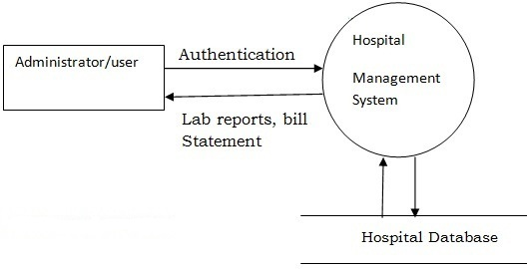

**Data Flow Diagram:**

A Data Flow Diagram is a graph showing the flow of data values from their source in objects through process that transform them to their destination in other objects.

DFD also knows as “Bubble charts” has the purpose of clarifying the system requirements and identifying major transformations that will become programs in system design. So it is the starting point of the design phase that functionally decomposes the requirements specifications down to the lowest level of details. A DFD consist s of a series of bubbles joined by lines.

DFD use a number of symbols to represent system. Most data flow modeling methods use 4 kinds of symbols to represent 4 kinds of system components: processes, data stores and external entities

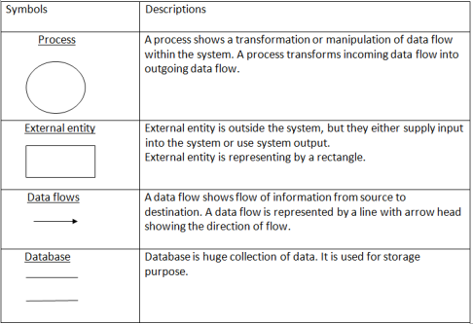

**1st level DFD**

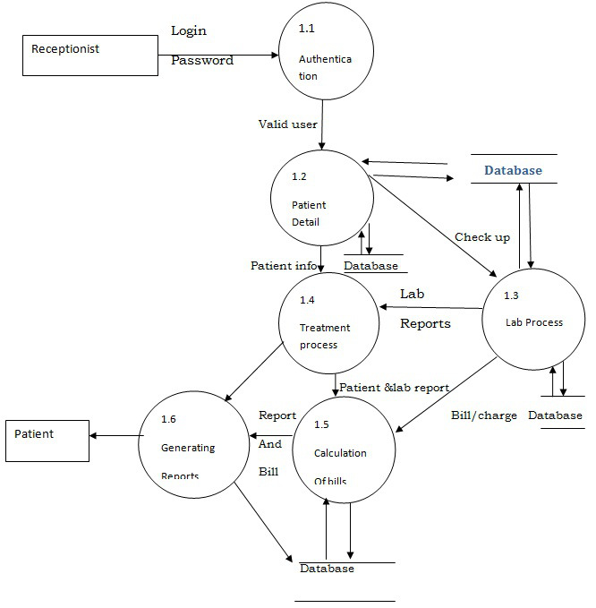

**2nd level DFD**

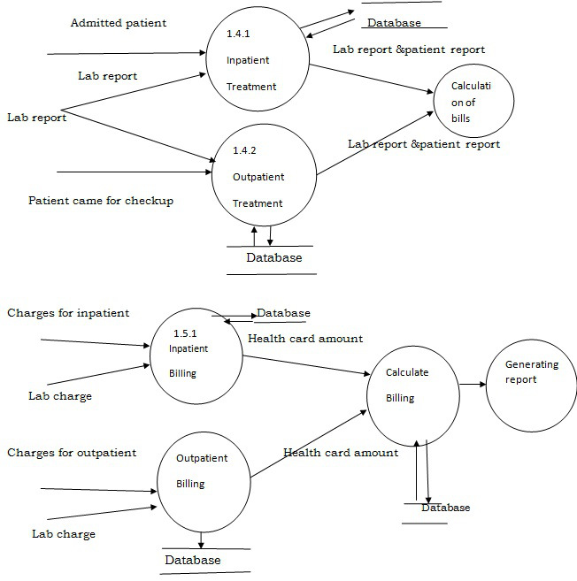

**Description of component:**

**Administration module:-**

* **Input: – User Name, Password**
* **Process Definition: – Login to the system**
* **Output: - If login is successful then administrator can view and update the records.**

**Inpatient module:-**

* **Input: – Inpatient detail**
* **Process Definition: – Information about the treatment given to the patients who are admitted.**
* **Output: – Information about the patient.**
* **Interface with other module: – The inpatient details are necessary for lab reports and billing.**

**Outpatient module:-**

* **Input: – Outpatient detail**
* **Process Definition: – This module has the information about the treatment given to the patient who are came to check up.**
* **Output: – Information about the patient.**
* **Interface with other module: – The outpatient details are necessary for lab reports and billing.**

**Lab module:-**

* **Input: – Patient ID, Category**
* **Process Definition:-Laboratory reports of the patient.**
* **Output: – Lab report and charge.**
* **Interface with other module: – This module requires information from inpatient and outpatient modules.**

**Billing module:-**

* **Input: – Patient ID**
* **Process Definition:-Calculates bill and deduct amount if any card facility is available.**
* **Output: – Bill.**
* **Interface with other module: – Billing module requires information from inpatient and outpatient modules.**

**7. DETAIL DESIGN**

This portion contains SRS documentation for Hospital Management System. The SRS is produced at the culmination of the analysis task. The function and performance allocated to software as part of the system engineering and refined by establishing a complete information description, a detailed functional description, a representation of system behavior, indication of performance requirements and design constrains, appropriate validation criteria and the other information related to requirements.

The SRS is technical specification of requirement of Hospital Management system. This specification describes what the proposed system should do without describing how it will do it. It also describes complete external behavior of proposed system.

**Purpose:-**

The main purpose of our system is to make hospital task easy and is to develop software that replaces the manual hospital system into automated hospital management system. This document serves as the unambiguous guide for the developers of this software system.

**Scope:-**

The document only covers the requirement specification for the hospital management system. This document does not provide any references to the other component of the hospital management system. All the external interfaces and the dependencies are also identified in this document.

**Feasibility Study:-**

The overall scope of the feasibility study was to provide sufficient information to allow a decision to be made as to whether the hospital management system project should proceed and so, its relative priority in the context of the other existing hospital management system.

**The feasibility study of this project had undergone through various steps which as describe as under:**

a) Identify the origin of the information at different level.

b) Identify the expectation of user from computerized system.

c) Analyze the drawback of existing system.

**Definition, Acronyms, Abbreviations:-**

CFD: – Context Flow Diagram

DFD: – Data Flow Diagram

IDE: – Integrated Development Environment

Java:-PlatformIndependent, Object_orientedprogramming language

SQL: – Structured Query Language

SRS: – Software Requirement Specification.

**Reference:-**

1) An integrated approach to software engineering, Third edition by Pankaj jalote

2) Java – Balaguruswamy

3) SQL server 2005 – JosephL Jordan

**Overview:-**

**Hospital Management System is a process of implementing all the activities of the hospital in a computerized automated way to fasten the performance.**

**This project is to maintain the patient details, lab reports and to calculate the bill of the patient. You can also manually edit any patient details and issue bill receipt to patient within few seconds.**

**OVERALL DESCRIPTION**

* **Product perspectives:-**

**This project gives the procedural approach how a patient gets treatment, details about date of treatment and finally depending on different criteria like room allocated, lab reports, treatment and medicine taken…..etc,how billing is calculated. During billing health card facility is also considered.**

* **Product Function:-**

**The data represented in hospital management application will perform the following major function:-**

* **Patient Details: – It includes inpatient and outpatient details.**
* **Lab reports**
* **Billing Details**

**This software will help to calculate the bill much quicker and simpler way. This enables the organization to keep the information in efficient and systematic way.**

* **User Characteristics:-**

**This software is developed such that total appearance of the product to make it more user friendly. The operator will be provided with loginid and password. General users with basic computer skills can use this software.**

* **General Constraints:-**

**Any update regarding the patients information from the hospital are to be recorded to have updated and correct values.**

* **Assumption and Dependencies:-**

**All the data entered will be correct and up_to_date.This software package is developed using java as front end which is supported by sun micro system, MS SQL server 2005 as the back end which is supported by Microsoft windows xp.**

* **Functional Requirements:-**
  + **Administration module**
  + **Patient module**
  + **Inpatient module**
  + **Outpatient module**
  + **Lab module**
  + **Billing module**
* **Performance Requirements:-**

**The capability of the computer depends on the performance of the software. The software can take any number of input provided the database size is large enough. This would depend on the available memory space.**

* **Design Constraints:-**

**This will help the doctors or users to view the records of the patients immediately whenever necessary. They can also calculate the bill of the particular patients. This software also has the ability to add, update and delete the record whenever needed. This project will help to smoother the process of the hospital activites.**

**8. HOSPITAL DATA DICTIONARY**

Hospital management system database design is describrd in this section. A database is a collection of information and is systematically stored in tables in the form of rows and columns. The table in the database has unique name that identifies its contents. The database in turn is further described in detail giving all the fields used with the data types, constraints available, primary key and foreign key.

Database design is used to manage large bodies of information. In this database we describe all the 4 tables available in the software, which are used to store all the records.

**Data types and its description:**

Fields in database table have a data type. Some of the data types used in database table are explained below.

**a) Integer:-**

One optional sign character (+ or -) followed by atleast one digit (0-9). Leading and trailing blanks are ignored. No other character is allowed.

**b) Varchar:-**

It is used to store alpha numeric characters. In this data type we can set the maximum number of characters upto 8000 ranges by default SQL server will set the size to 50 characters large.

**a) Date/Time:-**

Date/Time data type is used for representing data or time.

**Patient Table:**

|  |  |  |
| --- | --- | --- |
| **Fields** | **Data Type** | **Relationships** |
| Pid | Varchar(5) | Primary Key |
| name | Varchar(20) | Not Null |
| age | int | Not Null |
| weight | int | Not Null |
| gender | Varchar(10) | Not null |
| address | Varchar(50) | Not Null |
| phoneno | int | Not Null |
| disease | Varchar(20) | Not Null |
| doctorid | Varchar(5) | Not Null |

**Doctor Table:**

|  |  |  |
| --- | --- | --- |
| **Fields** | **Data Type** | **Relationships** |
| doctorid | Varchar(5) | Primary Key |
| doctorname | Varchar(15) | Not Null |
| dept | Varchar(15) | Not Null |

**Lab Table:**

|  |  |  |
| --- | --- | --- |
| **Fields** | **Data Type** | **Relationships** |
| labno | Varchar(5) | Primary Key |
| pid | Varchar(5) | Not Null |
| weight | int | Not Null |
| doctorid | Varchar(5) | Foreign Key |
| date | Date/Time | Not Null |
| category | Varchar(15) | Not Null |
| patient_type | Varchar(15) | Not Null |
| amount | int | Not Null |

**Inpatient Table:**

|  |  |  |
| --- | --- | --- |
| **Fields** | **Data Type** | **Relationships** |
| pid | Varchar(5) | Primary Key |
| room_no | Varchar(50) | Not Null |
| date_of_adm | Date/Time | Not Null |
| date_of_dis | Date/Time | Not Null |
| advance | int | Not Null |
| labno | Varchar(5) | Foreign Key |

**Outpatient Table:**

|  |  |  |
| --- | --- | --- |
| **Fields** | **Data Type** | **Relationships** |
| pid | Varchar(5) | Primary Key |
| date | Date/Time | Not Null |
| labno | Varchar(5) | Foreign Key |

**Room Table:**

|  |  |  |
| --- | --- | --- |
| **Fields** | **Data Type** | **Relationships** |
| room_no | Varchar(50) | Primary Key |
| room_type | Varchar(10) | Not Null |
| status | Varchar(10) | Not Null |

**Bill Table:**

|  |  |  |
| --- | --- | --- |
| **Fields** | **Data Type** | **Relationships** |
| bill_no | Varchar(50) | Primary Key |
| pid | Varchar(5) | Foreign Key |
| patient_type | Varchar(10) | Allow Null |
| doctor_charge | int | Not Null |
| medicine_charge | int | Not Null |
| room_charge | int | Not Null |
| oprtn_charge | int | Allow Null |
| no_of_days | int | Allow Null |
| nursing_charge | int | Allow Null |
| advance | int | Allow Null |
| health_card | Varchar(50) | Allow Null |
| lab_charge | int | Allow Null |
| bill | int | Not Null |

**E-R Diagram**

Entity relationship diagram is used in modern database software engineering to illustrate logical structure of database. It is a relational schema database modeling method used to model a system and approach. This approach commonly used in database design. The diagram created using this method is called E-R diagram.

**Hospital Management System**

The E-R diagram depicts the various relationships among entities considering each object as entity. Entity is represented as diamond shape and relationship is represented as rectangle. It depicts the relationship between data objects. The E-R diagram is the relation that is used to conduct the data modeling activity.

**Entity**

Entity is the thing which we want to store information. It is an elementary basic building block of storing information about business process. An entity represents an objects defined within the information system about which you want to store information.

**Relationship:-**

A relationship is named connection or association between entities used to relate two or more entities with some common attributes of meaningful interaction between the object.

**Attributes:-**

Attributes are the properties of the entities and relationship. Descriptor of the entity. Attributes are elementary pieces of information attached to an entity.

|  |  |
| --- | --- |
| Symbols | Meaning |
|  | Entity |
|  | Relationship |
|  | Attribute |
|  | Key Attribute |
| E1  R  E2 | Cardinality Ratio N: 1 for E1: E2 in R |

**E-R Diagram**

patient

Consults

doctor

Checks

lab Report

Decides

inpatient

outpatient

Admitted to to

room

issued_to

bill

**9. SOFTWARE AND HARDWARE REQUIREMENT**

**9.1 Software Requirements:**

* Windows XP or higher
* Microsoft Visual Studio 2008 or higher
* Microsoft SQL Server 2005 or higher

**9.2 Hardware Requirements:**

Minimum:

- Computer with a 1.6 GHz or faster processor

- 384 MB of RAM or more (768 MB of RAM or more for Windows Vista)

- 2.2 GB of available hard-disk space

- 5400 RPM hard drive

- **1366 × 768** or higher-resolution display

- DVD-ROM Drive

Recommended:

2.4 GHz or higher CPU, 1024 MB or more RAM, 1280x1024 display, 7200 RPM or higher hard disk.

**10. DEVELOPMENT TOOLS AND TECHNOLOGIES**

**10.1 Front End**

***VB.Net***

With the introduction of the .NET framework, Microsoft included a new language called VB. VB is designed to be a simple, modern, general-purpose, object-oriented programming language, borrowing key concepts from several other languages, most notably Java. VB could theoretically be compiled to machine code, but in real life, it's always used in combination with the .NET framework. Therefore, applications written in VB, requires the .NET framework to be installed on the computer running the application. While the .NET framework makes it possible to use a wide range of languages, VB is sometimes referred to as THE .NET language, perhaps because it was designed together with the framework. VB is an Object Oriented language and does not offer global variables or functions. Everything is wrapped in classes, even simple types like int and string, which inherits from the System. Object class.

**10.2 Back End**

***Database: MS SQL SERVER 2005:***

Microsoft SQL Server is a relational database management system developed by Microsoft. As a database, it is a software product whose primary function is to store and retrieve data as requested by other software applications, be it those on the same computer or those running on another computer across a network (including the Internet). There are at least a dozen different editions of Microsoft SQL Server aimed at different audiences and for different workloads (ranging from small applications that store and retrieve data on the same computer, to millions of users and computers that access huge amounts of data from the Internet at the same time).

**10.3 Development Environment**

***Visual Studio 2008:***

Visual Studio 2008 was released to MSDN subscribers on 19 November 2007 alongside .NET Framework 3.5. The source code for the Visual Studio 2008 IDE is available under a [shared source](http://en.wikipedia.org/wiki/Shared_source) license to some of [Microsoft](http://en.wikipedia.org/wiki/Microsoft)'s partners and [ISVs](http://en.wikipedia.org/wiki/Independent_software_vendor). Microsoft released Service Pack 1 for Visual Studio 2008 on 11 August 2008. The internal version number of Visual Studio 2008 is version 9.0 while the file format version is 10.0. Visual Studio 2008 is the last version to support targeting [Windows 2000](http://en.wikipedia.org/wiki/Windows_2000) for C++ applications.

Visual Studio 2008 is focused on development of [Windows Vista](http://en.wikipedia.org/wiki/Windows_Vista), 2007 Office system, and Web applications. For visual design, a new [Windows Presentation Foundation](http://en.wikipedia.org/wiki/Windows_Presentation_Foundation) visual designer and a new [HTML](http://en.wikipedia.org/wiki/HTML)/[CSS](http://en.wikipedia.org/wiki/CSS) editor influenced by [Microsoft Expression Web](http://en.wikipedia.org/wiki/Microsoft_Expression_Web) are included. Visual Studio 2008 requires .NET 3.5 Framework and by default configures compiled assemblies to run on .NET Framework 3.5, but it also supports multi-targeting which lets the developers choose which version of the .NET Framework (out of 2.0, 3.0, 3.5, [Silverlight Core CLR](http://en.wikipedia.org/wiki/Silverlight) or .NET Compact Framework) the assembly runs on. Visual Studio 2008 also includes new [code analysis](http://en.wikipedia.org/wiki/Code_analysis) tools, including the new [Code Metrics](http://en.wikipedia.org/wiki/Code_Metrics) tool (only in Team Edition and Team Suite Edition). For [Visual C++](http://en.wikipedia.org/wiki/Visual_C%2B%2B), Visual Studio adds a new version of [Microsoft Foundation Classes](http://en.wikipedia.org/wiki/Microsoft_Foundation_Classes) (MFC 9.0) that adds support for the visual styles and UI controls introduced with [Windows Vista](http://en.wikipedia.org/wiki/Windows_Vista). For native and managed code interoperability, Visual C++ introduces the STL/CLR, which is a port of the [C++](http://en.wikipedia.org/wiki/C%2B%2B) [Standard Template Library](http://en.wikipedia.org/wiki/Standard_Template_Library) (STL) containers and algorithms to [managed code](http://en.wikipedia.org/wiki/Managed_code). STL/CLR defines STL-like containers, [iterators](http://en.wikipedia.org/wiki/Iterator) and algorithms that work on [C++/CLI](http://en.wikipedia.org/wiki/C%2B%2B/CLI) [managed](http://en.wikipedia.org/wiki/Managed_code) objects.

Visual Studio 2008 features include an [XAML](http://en.wikipedia.org/wiki/XAML)-based designer (codenamed *Cider*), [workflow designer](http://en.wikipedia.org/wiki/Workflow_Foundation), [LINQ](http://en.wikipedia.org/wiki/Language_Integrated_Query) to [SQL](http://en.wikipedia.org/wiki/SQL) designer (for defining the type mappings and object encapsulation for SQL Server data), [XSLT](http://en.wikipedia.org/wiki/XSLT) debugger, [JavaScript](http://en.wikipedia.org/wiki/JavaScript) [Intelligence](http://en.wikipedia.org/wiki/Intellisense) support, JavaScript Debugging support, support for [UAC](http://en.wikipedia.org/wiki/User_Account_Control) [manifests](http://en.wikipedia.org/wiki/Manifest_%28.NET_Framework%29), a [concurrent](http://en.wikipedia.org/wiki/Concurrent_programming) build system, among others. It ships with an enhanced set of UI widgets, both for [Windows Forms](http://en.wikipedia.org/wiki/WinForms) and [WPF](http://en.wikipedia.org/wiki/Windows_Presentation_Foundation). It also includes a multithreaded build engine (MS Build) to compile multiple source files (and build the executable file) in a project across multiple [threads](http://en.wikipedia.org/wiki/Thread_%28computing%29) simultaneously.

The [Visual Studio debugger](http://en.wikipedia.org/wiki/Microsoft_Visual_Studio_Debugger) includes features targeting easier debugging of multi-threaded applications. In debugging mode, in the *Threads* window, which lists all the threads, hovering over a thread will display the stack trace of that thread in tooltips. The threads can directly be named and flagged for easier identification from that window itself. In addition, in the code window, along with indicating the location of the currently executing instruction in the current thread, the currently executing instructions in other threads are also pointed out. The [Visual Studio debugger](http://en.wikipedia.org/wiki/Microsoft_Visual_Studio_Debugger) supports integrated debugging of the .NET 3.5 Framework [Base Class Library](http://en.wikipedia.org/wiki/Base_Class_Library) (BCL) which can dynamically download the BCL source code and [debug symbols](http://en.wikipedia.org/wiki/Debug_symbol) and allow stepping into the BCL source during debugging.

**11. INTERFACES AND CODING**

**Main Page**

**Design**

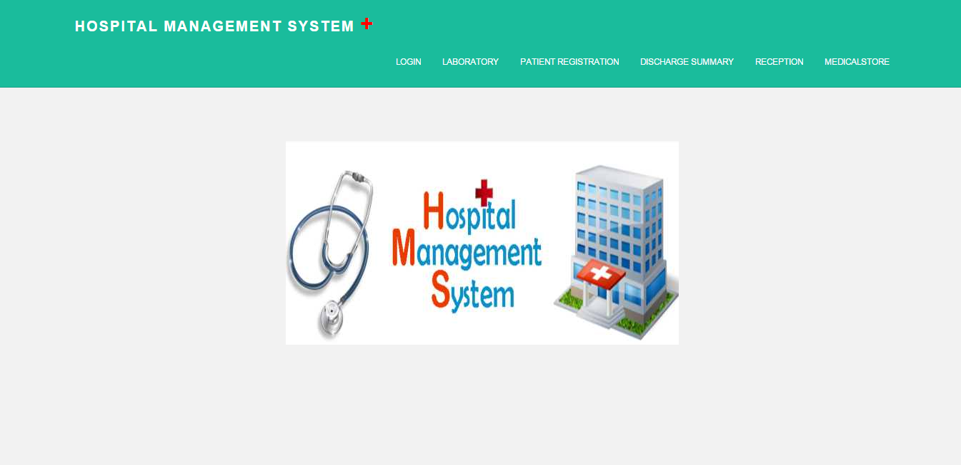

**Source**

<%@ Master Language="VB" CodeFile="MasterPage.master.vb" Inherits="MasterPage" %>

<!DOCTYPE html>

<html xmlns="http://www.w3.org/1999/xhtml">

<head runat="server">

<meta charset="utf-8"/>

<meta http-equiv="X-UA-Compatible" content="IE=edge"/>

<meta name="viewport" content="width=device-width, initial-scale=1.0"/>

<meta name="description" content=""/>

<meta name="author" content=""/>

<link rel="shortcut icon" href="../../docs-assets/ico/favicon.png"/>

<link href="assets/css/bootstrap.css" rel="stylesheet"/>

<link href="assets/css/main.css" rel="stylesheet"/>

<script src="https://code.jquery.com/jquery-1.10.2.min.js"></script>

<script src="assets/js/hover.zoom.js"></script>

<script src="assets/js/hover.zoom.conf.js"></script>

<title></title>

<asp:ContentPlaceHolder id="head" runat="server">

</asp:ContentPlaceHolder>

</head>

<body>

<form id="form1" runat="server">

<div>

<div class="navbar navbar-inverse navbar-static-top">

<div class="container">

<div class="navbar-header">

<button type="button" class="navbar-toggle" data-toggle="collapse" data-target=".navbar-collapse">

<span class="icon-bar"></span>

<span class="icon-bar"></span>

<span class="icon-bar"></span>

</button>

<a class="navbar-brand" href="Main.aspx">Hospital Management system <span style="font-size:xx-large; color:red;">+</span></a>

</div>

<div class="navbar-collapse collapse">

<ul class="nav navbar-nav navbar-right" style="font-size:smaller;">

<li><a href="Administration.aspx">Login</a></li>

<li><a href="laborataries.aspx">Laboratory</a></li>

<li><a href="registration.aspx">Patient Registration</a></li>

<li><a href="dischargesummary.aspx">Discharge Summary</a></li>

<li><a href="receptionhome.aspx">Reception</a></li>

<li><a href="pharmacy.aspx">Medicalstore</a></li>

</ul>

</div><!--/.nav-collapse -->

</div>

</div>

<!-- +++++ Welcome Section +++++ -->

<div id="ww">

<div class="container">

<div class="row">

<div class="col-lg-8 col-lg-offset-2 centered" style="min-height:500px;">

<%--<h1><a href="home.aspx">My Hospital Management System</a></h1>--%>

<%--<p>Hello everybody. I'm Stanley, a free handsome bootstrap theme coded by BlackTie.co. A really simple theme for those wanting to showcase their work with a cute & clean style.</p>

<p>Please, consider to register to <a href="http://eepurl.com/IcgkX">our newsletter</a> to be updated with our latest themes and freebies. Like always, you can use this theme in any project freely. Share it with your friends.</p>--%>

</div><!-- /col-lg-8 -->

</div><!-- /row -->

</div> <!-- /container -->

</div><!-- /ww -->

<div id="footer">

<div class="container">

<div class="row">

</div>

</div>

</div>

<script src="assets/js/bootstrap.min.js"></script>

<asp:ContentPlaceHolder id="ContentPlaceHolder1" runat="server">

</asp:ContentPlaceHolder>

</div>

</form>

</body>

</html>

**Code Behind**

Imports System.Data

Imports System.Configuration

Imports System.Collections

Imports System.Web

Imports System.Web.Security

Imports System.Web.UI

Imports System.Web.UI.WebControls

Imports System.Web.UI.WebControls.WebParts

Imports System.Web.UI.HtmlControls

Public Partial Class main

Inherits System.Web.UI.Page

Protected Sub Page_Load(sender As Object, e As EventArgs)

End Sub

End Class

**Login Page**

**Design**

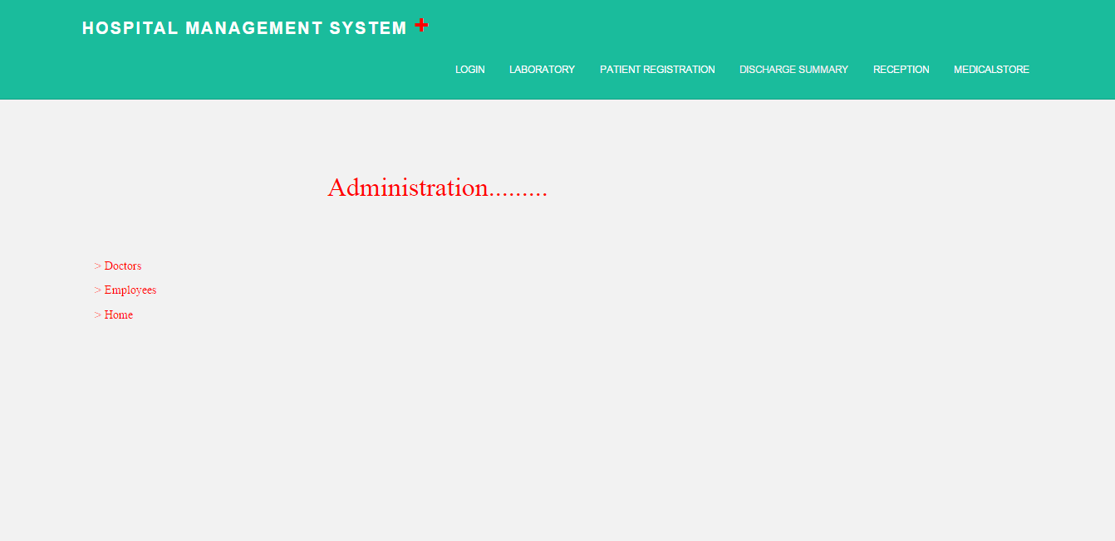

**Source**

<%@ Page Language="VB" MasterPageFile="~/MasterPage.master" AutoEventWireup="true" CodeFile="Administration.aspx.vb" Inherits="Administration" Title="Untitled Page" %>

<asp:Content ID="Content1" ContentPlaceHolderID="ContentPlaceHolder1" Runat="Server">

&nbsp;

<asp:Menu ID="Menu1" runat="server" Font-Bold="False" Font-Names="Modern" Font-Underline="False"

ForeColor="Red" Height="88px" Style="z-index: 102; left: 120px; position: absolute;

top: 312px" Width="96px">

<Items>

<asp:MenuItem Text="&gt; Doctors" Value="&gt; Doctors" NavigateUrl="~/doctorlogin.aspx"></asp:MenuItem>

<asp:MenuItem Text="&gt; Employees" Value="&gt; Employees" NavigateUrl="~/emplogin.aspx"></asp:MenuItem>

<asp:MenuItem NavigateUrl="~/home.aspx" Text="&gt; Home" Value="&gt; Home"></asp:MenuItem>

</Items>

</asp:Menu>

<asp:Label ID="Label1" runat="server" Font-Names="Modern" Font-Size="24pt" ForeColor="Red"

Style="z-index: 104; left: 400px; position: absolute; top: 208px" Text="Administration........."></asp:Label>

</asp:Content>

**Code Behind**

Imports System.Data

Imports System.Configuration

Imports System.Collections

Imports System.Web

Imports System.Web.Security

Imports System.Web.UI

Imports System.Web.UI.WebControls

Imports System.Web.UI.WebControls.WebParts

Imports System.Web.UI.HtmlControls

Public Partial Class Administration

Inherits System.Web.UI.Page

Protected Sub Page_Load(sender As Object, e As EventArgs)

End Sub

End Class

**Design**

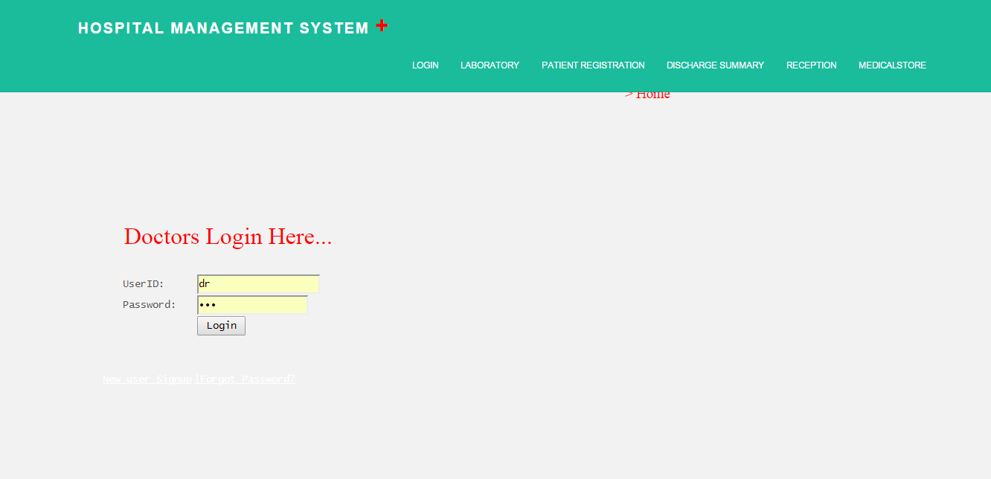

**Source**

<%@ Page Language="VB" MasterPageFile="~/MasterPage.master" AutoEventWireup="true" CodeFile="doctorlogin.aspx.vb" Inherits="doctorlogin" Title="Untitled Page" %>

<asp:Content ID="Content1" ContentPlaceHolderID="ContentPlaceHolder1" Runat="Server">

<asp:Label ID="Label1" runat="server" Text="Doctors Login Here..." style="z-index: 100; left: 167px; position: absolute; top: 296px" Font-Bold="False" Font-Names="Modern" Font-Size="24pt" ForeColor="Red"></asp:Label>

<table style="z-index: 100; left: 164px; position: absolute; top: 369px; font-family: 'Lucida Console';">

<tr>

<td style="width: 100px; height: 21px">

<span >UserID:</span></td>

<td style="width: 100px; height: 21px">

<asp:TextBox ID="lidtxt" runat="server"></asp:TextBox></td>

</tr>

<tr>

<td style="width: 100px">

<span >Password:</span></td>

<td style="width: 100px">

<asp:TextBox ID="pwdtxt" runat="server" TextMode="Password" Width="149px"></asp:TextBox></td>

</tr>

<tr>

<td style="width: 100px; height: 21px">

</td>

<td style="width: 100px; height: 21px">

<asp:Button ID="Button1" runat="server" Text="Login" Width="65px" OnClick="Button1_Click" /></td>

</tr>

</table>

<asp:Menu ID="Menu1" runat="server" Font-Underline="True" ForeColor="white" Orientation="Horizontal"

Style="z-index: 101; left: 138px; position: absolute; top: 501px; font-family: 'Lucida Console';">

<Items>

<asp:MenuItem Text="New user Signup" Value="New user Signup" NavigateUrl="~/doctorsignup.aspx"></asp:MenuItem>

<asp:MenuItem Text="|Forgot Password?" Value="|Forgot Password?" NavigateUrl="~/doctorforgot.aspx"></asp:MenuItem>

</Items>

</asp:Menu>

<asp:Label ID="pwdlb" runat="server" Text="" style="z-index: 102; left: 266px; font-family: 'Lucida Console'; position: absolute; top: 535px"></asp:Label>

<asp:Menu ID="Menu2" runat="server" style="z-index: 105; left: 840px; position: absolute; top: 113px" Font-Names="Modern" Font-Size="14pt" ForeColor="Red" Orientation="Horizontal">

<Items>

<asp:MenuItem NavigateUrl="~/home.aspx" Text="&gt; Home" Value="&gt; Home"></asp:MenuItem>

</Items>

</asp:Menu>

</asp:Content>

**Code Behind**

Imports System.Data

Imports System.Configuration

Imports System.Collections

Imports System.Web

Imports System.Web.Security

Imports System.Web.UI

Imports System.Web.UI.WebControls

Imports System.Web.UI.WebControls.WebParts

Imports System.Web.UI.HtmlControls

Imports System.Data.SqlClient

Public Partial Class doctorlogin

Inherits System.Web.UI.Page

Private cn As New SqlConnection("server=DEEP-PC;Integrated Security = True;database=Hospitalmanagement")

Private dr As SqlDataReader

Protected Sub Page_Load(sender As Object, e As EventArgs)

End Sub

Protected Sub Button1_Click(sender As Object, e As EventArgs)

cn.Open()

Dim qry As String

qry = ("select * from hospital_doctorsignup where loginid='" + lidtxt.Text & "' and password='") + pwdtxt.Text & "'"

Dim cmd As New SqlCommand(qry, cn)

dr = cmd.ExecuteReader()

If dr.Read() Then

Response.Redirect("doctorsden.aspx")

Else

pwdlb.Text = "Enter valid UserName/Password"

End If

End Sub

End Class

**Design**

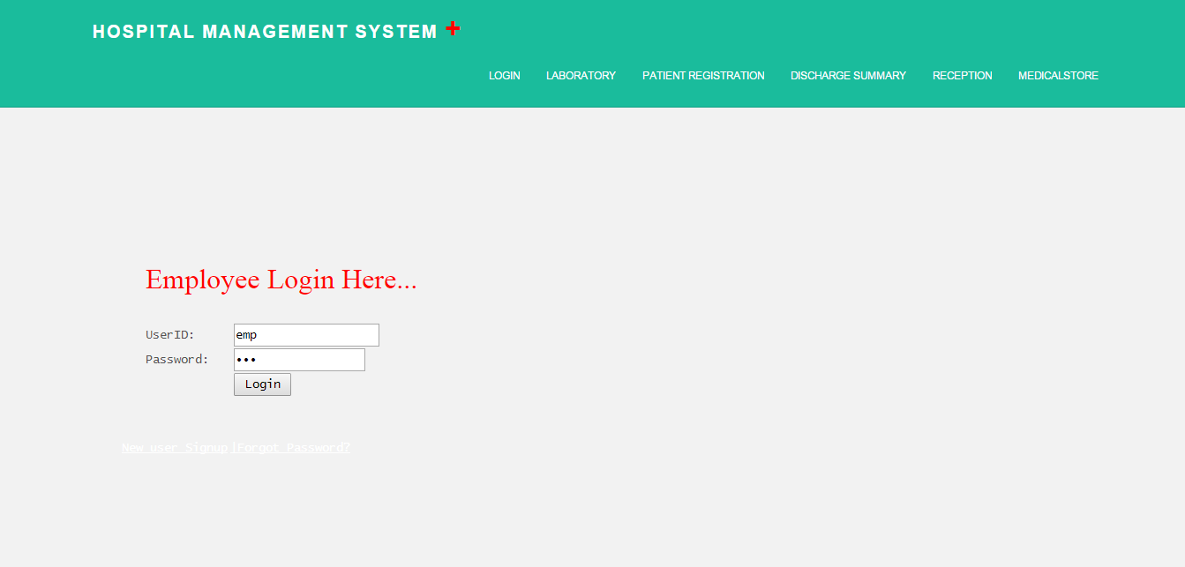

**Source**

<%@ Page Language="VB" MasterPageFile="~/MasterPage.master" AutoEventWireup="true" CodeFile="emplogin.aspx.vb" Inherits="userlogin" Title="Untitled Page" %>

<asp:Content ID="Content1" ContentPlaceHolderID="ContentPlaceHolder1" Runat="Server">

<asp:Label ID="Label1" runat="server" Text="Employee Login Here..." style="z-index: 100; left: 165px; position: absolute; top: 297px" Font-Bold="False" Font-Names="Modern" Font-Size="24pt" ForeColor="Red"></asp:Label>

<table style="z-index: 100; left: 164px; position: absolute; top: 369px; font-family: 'Lucida Console';">

<tr>

<td style="width: 100px; height: 21px">

<span >UserID:</span></td>

<td style="width: 100px; height: 21px">

<asp:TextBox ID="lidtxt" runat="server"></asp:TextBox></td>

</tr>

<tr>

<td style="width: 100px">

<span >Password:</span></td>

<td style="width: 100px">

<asp:TextBox ID="pwdtxt" runat="server" TextMode="Password" Width="149px"></asp:TextBox></td>

</tr>

<tr>

<td style="width: 100px; height: 21px">

</td>

<td style="width: 100px; height: 21px">

<asp:Button ID="Button1" runat="server" Text="Login" Width="65px" OnClick="Button1_Click" /></td>

</tr>

</table>

<asp:Menu ID="Menu1" runat="server" Font-Underline="True" ForeColor="white" Orientation="Horizontal"

Style="z-index: 101; left: 138px; position: absolute; top: 501px; font-family: 'Lucida Console';">

<Items>

<asp:MenuItem Text="New user Signup" Value="New user Signup" NavigateUrl="~/empsignup.aspx"></asp:MenuItem>

<asp:MenuItem Text="|Forgot Password?" Value="|Forgot Password?" NavigateUrl="~/empforgot.aspx"></asp:MenuItem>

</Items>

</asp:Menu>

<asp:Label ID="pwdlb" runat="server" Text="" style="z-index: 104; left: 265px; position: absolute; top: 531px; font-family: 'Lucida Console';"></asp:Label>

</asp:Content>

**Code Behind**

Imports System.Data

Imports System.Configuration

Imports System.Collections

Imports System.Web

Imports System.Web.Security

Imports System.Web.UI

Imports System.Web.UI.WebControls

Imports System.Web.UI.WebControls.WebParts

Imports System.Web.UI.HtmlControls

Imports System.Data.SqlClient

Public Partial Class userlogin

Inherits System.Web.UI.Page

Private cn As New SqlConnection("server=DEEP-PC;Integrated Security = True;database=Hospitalmanagement")

Private dr As SqlDataReader

Protected Sub Page_Load(sender As Object, e As EventArgs)

End Sub

Protected Sub Button1_Click(sender As Object, e As EventArgs)

cn.Open()

Dim qry As String

qry = ("select * from hospital_empsignup where loginid='" + lidtxt.Text & "' and password='") + pwdtxt.Text & "'"

Dim cmd As New SqlCommand(qry, cn)

dr = cmd.ExecuteReader()

If dr.Read() Then

Response.Redirect("emphome.aspx")

Else

pwdlb.Text = "Enter valid UserName/Password"

End If

End Sub

End Class

**Laboratory**

**Design**

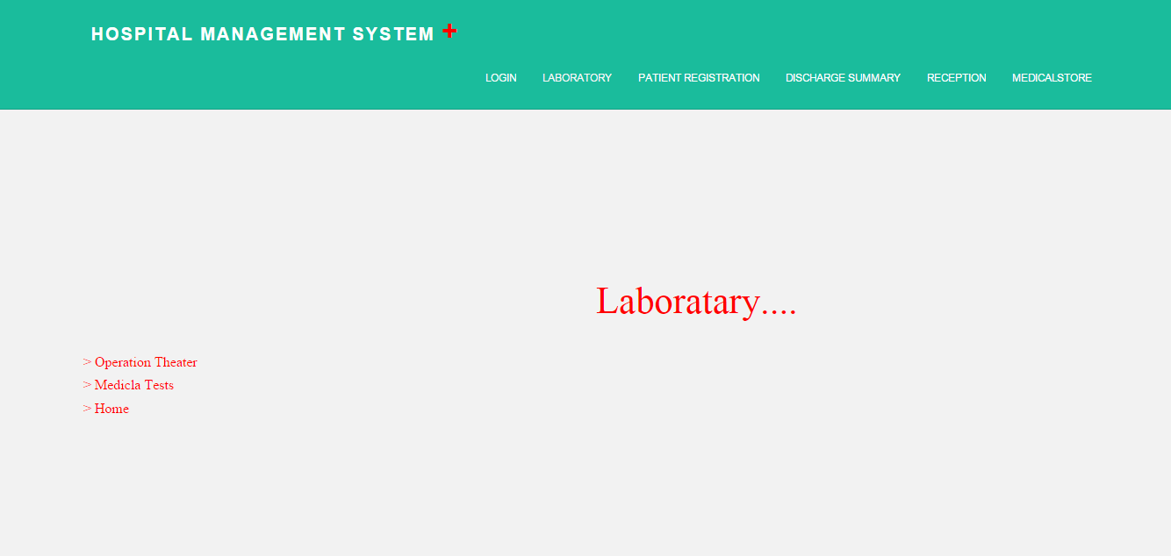

**Source**

<%@ Page Language="VB" MasterPageFile="~/MasterPage.master" AutoEventWireup="true" CodeFile="laborataries.aspx.vb" Inherits="laborataries" Title="Untitled Page" %>

<asp:Content ID="Content1" ContentPlaceHolderID="ContentPlaceHolder1" Runat="Server">

<asp:Label ID="Label1" runat="server" Text="Laboratary...." style="z-index: 100; left: 680px; position: absolute; top: 312px" Font-Names="Modern" Font-Size="32pt" ForeColor="Red"></asp:Label>

&nbsp;

<asp:Menu ID="Menu1" runat="server" style="z-index: 101; left: 96px; position: absolute; top: 400px" Font-Names="Modern" Font-Size="12pt" ForeColor="Red" Height="80px" Width="128px">

<Items>

<asp:MenuItem Text="&gt; Operation Theater" Value="New Item" NavigateUrl="~/operationth.aspx"></asp:MenuItem>

<asp:MenuItem Text="&gt; Medicla Tests" Value="&gt; Medicla Tests" NavigateUrl="~/medicaltests.aspx"></asp:MenuItem>

<asp:MenuItem Text="&gt; Home" Value="&gt; Home"></asp:MenuItem>

</Items>

</asp:Menu>

</asp:Content>

**Code Behind**

Imports System.Data

Imports System.Configuration

Imports System.Collections

Imports System.Web

Imports System.Web.Security

Imports System.Web.UI

Imports System.Web.UI.WebControls

Imports System.Web.UI.WebControls.WebParts

Imports System.Web.UI.HtmlControls

Public Partial Class laborataries

Inherits System.Web.UI.Page

Protected Sub Page_Load(sender As Object, e As EventArgs)

End Sub

End Class

**Design**

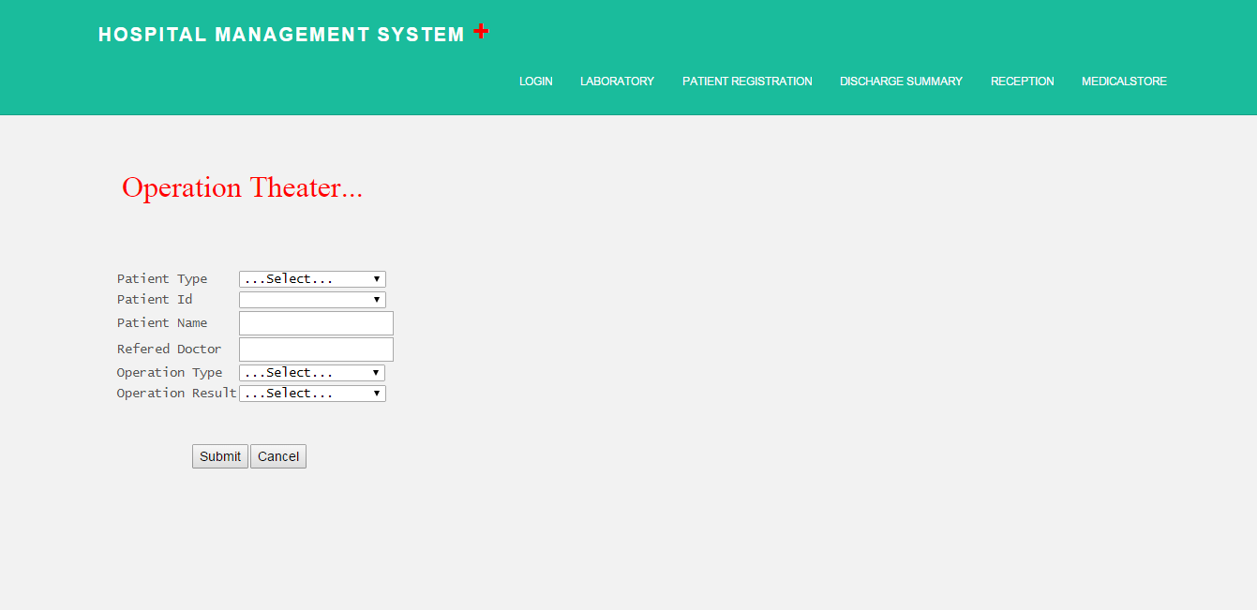

**Source**

<%@ Page Language="VB" MasterPageFile="~/MasterPage.master" AutoEventWireup="true" CodeFile="operationth.aspx.vb" Inherits="operationth" Title="Untitled Page" %>

<asp:Content ID="Content1" ContentPlaceHolderID="ContentPlaceHolder1" Runat="Server">

<asp:Label ID="Label1" runat="server" Text="Operation Theater..." style="z-index: 102; left: 130px; position: absolute; top: 179px" Font-Names="Modern" Font-Size="24pt" ForeColor="Red"></asp:Label>

<table style="z-index: 102; left: 124px; font-family: 'Lucida Console'; position: absolute; top: 289px" id="TABLE1">

<tr>

<td>

Patient Type

</td>

<td>

<asp:DropDownList ID="pttypeddl" runat="server" AutoPostBack="True" Width="157px" OnSelectedIndexChanged="pttypeddl_SelectedIndexChanged">

<asp:ListItem>...Select...</asp:ListItem>

<asp:ListItem>In-Patient</asp:ListItem>

<asp:ListItem>Out-Patient</asp:ListItem>

</asp:DropDownList>

</td>

</tr>

<tr>

<td>

Patient Id

</td>

<td>

<asp:DropDownList ID="pidddl" runat="server" AutoPostBack="True" Width="157px" OnSelectedIndexChanged="pidddl_SelectedIndexChanged">

</asp:DropDownList>

</td>

</tr>

<tr>

<td>

Patient Name

</td>

<td>

<asp:TextBox ID="pntxt" runat="server"></asp:TextBox>

</td>

</tr>

<tr>

<td>

Refered Doctor

</td>

<td>

<asp:TextBox ID="doctxt" runat="server"></asp:TextBox>

</td>

</tr>

<tr>

<td>

Operation Type

</td>

<td>

<asp:DropDownList ID="optddl" runat="server" Width="156px" >

<asp:ListItem>...Select...</asp:ListItem>

<asp:ListItem>Heart</asp:ListItem>

<asp:ListItem>Brain</asp:ListItem>

<asp:ListItem>Lungs</asp:ListItem>

<asp:ListItem>Bone</asp:ListItem>

</asp:DropDownList>

</td>

</tr>

<tr>

<td>

Operation Result

</td>

<td>

<asp:DropDownList ID="orddl" runat="server" Width="157px" OnSelectedIndexChanged="pttypeddl_SelectedIndexChanged">

<asp:ListItem>...Select...</asp:ListItem>

<asp:ListItem>Success</asp:ListItem>

<asp:ListItem>Fail</asp:ListItem>

</asp:DropDownList>

</td>

</tr>

</table>

<table style="z-index: 103; left: 204px; position: absolute; top: 475px">

<tr><td>

<asp:Button ID="sbtn" runat="server" Text="Submit" OnClick="sbtn_Click" /></td>

<td><asp:Button ID="canbtn" runat="server" Text="Cancel" /></td>

</tr>

</table>

</asp:Content>

**Code Behind**

Imports System.Data

Imports System.Configuration

Imports System.Collections

Imports System.Web

Imports System.Web.Security

Imports System.Web.UI

Imports System.Web.UI.WebControls

Imports System.Web.UI.WebControls.WebParts

Imports System.Web.UI.HtmlControls

Imports System.Data.SqlClient

Public Partial Class operationth

Inherits System.Web.UI.Page

Private cn As New SqlConnection("server=DEEP-PC;Integrated Security = True;database=Hospitalmanagement")

Protected Sub Page_Load(sender As Object, e As EventArgs)

If Not IsPostBack Then

End If

End Sub

Protected Sub pttypeddl_SelectedIndexChanged(sender As Object, e As EventArgs)

cn.Open()

If pttypeddl.SelectedItem.Value = "In-Patient" Then

Dim cmd As New SqlCommand("select patientid from hospital_inpatient", cn)

Dim da As New SqlDataAdapter(cmd)

Dim ds As New DataSet()

da.Fill(ds)

pidddl.DataSource = ds

pidddl.DataTextField = "patientid"

pidddl.DataBind()

pidddl.Items.Insert(0, "...Select...")

ElseIf pttypeddl.SelectedItem.Value = "Out-Patient" Then

Dim cmd As New SqlCommand("select patientid from hospital_outpatient", cn)

Dim da As New SqlDataAdapter(cmd)

Dim ds As New DataSet()

da.Fill(ds)

pidddl.DataSource = ds

pidddl.DataTextField = "patientid"

pidddl.DataBind()

pidddl.Items.Insert(0, "...Select...")

End If

cn.Close()

End Sub

Protected Sub pidddl_SelectedIndexChanged(sender As Object, e As EventArgs)

If pttypeddl.SelectedItem.Value = "In-Patient" Then

cn.Open()

Dim cmd As New SqlCommand("select patientname,doctor from hospital_inpatient where patientid='" + pidddl.Text & "'", cn)

Dim dr As SqlDataReader = cmd.ExecuteReader()

If dr.Read() Then

pntxt.Text = dr(0).ToString()

doctxt.Text = dr(1).ToString()

End If

cn.Close()

ElseIf pttypeddl.SelectedItem.Value = "Out-Patient" Then

cn.Open()

Dim cmd As New SqlCommand("select patientname,assigndoctor from hospital_outpatient where patientid='" + pidddl.Text & "'", cn)

Dim dr As SqlDataReader = cmd.ExecuteReader()

If dr.Read() Then

pntxt.Text = dr(0).ToString()

doctxt.Text = dr(1).ToString()

End If

cn.Close()

End If

End Sub

Protected Sub sbtn_Click(sender As Object, e As EventArgs) Handles sbtn.Click

cn.Open()

Dim cmd As New SqlCommand()

cmd.CommandType = CommandType.StoredProcedure

cmd.CommandText = "sp_hospital_operation"

cmd.Connection = cn

Dim p As New SqlParameter("@patienttype", SqlDbType.VarChar, 20)

p.Value = pttypeddl.Text

cmd.Parameters.Add(p)

Dim p1 As New SqlParameter("@patientid", SqlDbType.Int)

p1.Value = pidddl.Text

cmd.Parameters.Add(p1)

Dim p2 As New SqlParameter("@patientname", SqlDbType.VarChar, 20)

p2.Value = pntxt.Text

cmd.Parameters.Add(p2)

Dim p3 As New SqlParameter("@refdoctor", SqlDbType.VarChar, 20)

p3.Value = doctxt.Text

cmd.Parameters.Add(p3)

Dim p4 As New SqlParameter("@operationtype", SqlDbType.VarChar, 20)

p4.Value = optddl.Text

cmd.Parameters.Add(p4)

Dim p5 As New SqlParameter("@operatonresult", SqlDbType.VarChar, 20)

p5.Value = orddl.Text

cmd.Parameters.Add(p5)

cmd.ExecuteNonQuery()

cn.Close()

Response.Redirect("laborataries.aspx")

End Sub

End Class

**Design**

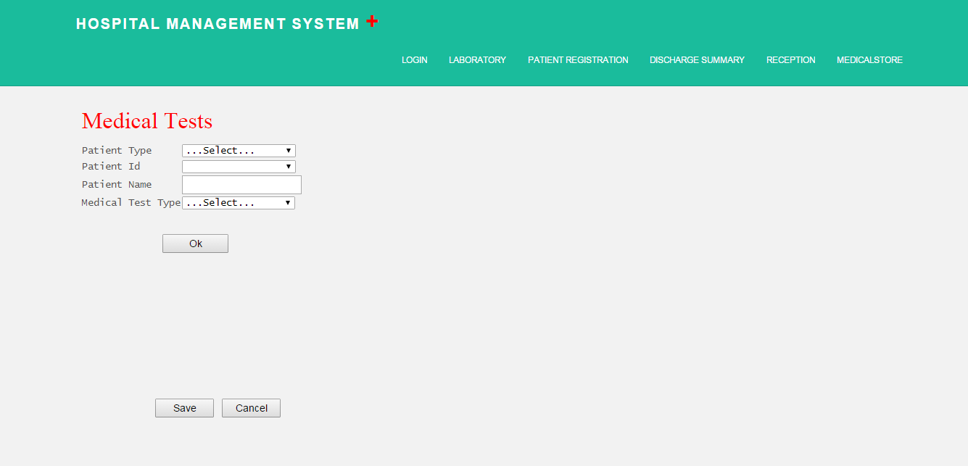

**Source**

<%@ Page Language="VB" MasterPageFile="~/MasterPage.master" AutoEventWireup="true" CodeFile="medicaltests.aspx.vb" Inherits="medicaltests" Title="Untitled Page" %>

<asp:Content ID="Content1" ContentPlaceHolderID="ContentPlaceHolder1" Runat="Server">

<%--<asp:Image ID="Image1" runat="server" style="z-index: 100; left: 588px; position: absolute; top: 240px" Height="249px" ImageUrl="~/pics/lab1.jpg" Width="327px"/>--%>

<asp:Label ID="Label1" runat="server" Text="Medical Tests" style="z-index: 101; left: 113px; position: absolute; top: 150px" Font-Names="Modern" Font-Size="24pt" ForeColor="Red"></asp:Label>

<table style="z-index: 102; left: 112px; font-family: 'Lucida Console'; position: absolute; top: 203px" id="TABLE1">

<tr>

<td>

Patient Type

</td>

<td>

<asp:DropDownList ID="pttypeddl" runat="server" AutoPostBack="True" Width="157px" OnSelectedIndexChanged="pttypeddl_SelectedIndexChanged">

<asp:ListItem>...Select...</asp:ListItem>

<asp:ListItem>In-Patient</asp:ListItem>

<asp:ListItem>Out-Patient</asp:ListItem>

</asp:DropDownList>

</td>

</tr>

<tr>

<td>

Patient Id

</td>

<td>

<asp:DropDownList ID="pidddl" runat="server" AutoPostBack="True" Width="157px" OnSelectedIndexChanged="pidddl_SelectedIndexChanged">

</asp:DropDownList>

</td>

</tr>

<tr>

<td>

Patient Name

</td>

<td>

<asp:TextBox ID="pntxt" runat="server"></asp:TextBox>

</td>

</tr>

<tr>

<td>

Medical Test Type

</td>

<td>

<asp:DropDownList ID="mttddl" runat="server" AutoPostBack="True" Width="156px" OnSelectedIndexChanged="mttddl_SelectedIndexChanged">

<asp:ListItem>...Select...</asp:ListItem>

<asp:ListItem>Blood Test</asp:ListItem>

<asp:ListItem>Urin Test</asp:ListItem>

</asp:DropDownList>

</td>

</tr>

</table>

<asp:Button ID="Button1" runat="server" Text="Ok" style="z-index: 105; left: 224px; position: absolute; top: 329px" OnClick="Button1_Click" Width="91px" />

<asp:Panel ID="Panel1" runat="server" Height="200px" Width="200px" style="z-index: 103; left: 115px; position: absolute; top: 368px; font-family: 'Lucida Console';">

<table style=" font-family: 'Lucida Console'; width: 353px;" >

<tr>

<td>

Blood Group

</td>

<td>

<asp:TextBox ID="bgtxt" runat="server"></asp:TextBox>

</td>

</tr>

<tr>

<td>Haemoglobin</td>

<td>

<asp:TextBox ID="hmtxt" runat="server"></asp:TextBox>

</td>

</tr>

<tr>

<td>

Blood sugar

</td>

<td>

<asp:TextBox ID="bstxt" runat="server"></asp:TextBox>

</td>

</tr>

<tr>

<td>

Serum Uric Acid

</td>

<td>

<asp:TextBox ID="suatxt" runat="server"></asp:TextBox>

</td>

</tr>

<tr>

<td>

Report Description

</td>

<td>

<asp:TextBox ID="rd1txt" runat="server"></asp:TextBox>

</td>

</tr>

</table>

</asp:Panel>

<asp:Panel ID="Panel2" runat="server" Height="200px" Width="200px" style="z-index: 104; left: 116px; position: absolute; top: 373px; font-family: 'Lucida Console';">

<table style=" font-family: 'Lucida Console'; width: 353px;" >

<tr>

<td style="height: 26px">

Color

</td>

<td style="height: 26px">

<asp:TextBox ID="colortxt" runat="server"></asp:TextBox>

</td>

</tr>

<tr>

<td>Clarity</td>

<td>

<asp:TextBox ID="clartxt" runat="server"></asp:TextBox>

</td>

</tr>

<tr>

<td>

Odor

</td>

<td>

<asp:TextBox ID="odtxt" runat="server"></asp:TextBox>

</td>

</tr>

<tr>

<td>

Specific gravity

</td>

<td>

<asp:TextBox ID="sgtxt" runat="server"></asp:TextBox>

</td>

</tr>

<tr>

<td>

Glucose

</td>

<td>

<asp:TextBox ID="gltxt" runat="server"></asp:TextBox>

</td>

</tr>

<tr>

<td>

Report Description

</td>

<td>

<asp:TextBox ID="rd2txt" runat="server"></asp:TextBox>

</td>

</tr>

</table>

</asp:Panel>

<table style="z-index: 103; left: 213px; width: 184px; position: absolute; top: 555px">

<tr><td>

<asp:Button ID="Button2" runat="server" Text="Save" Width="81px" OnClick="Button2_Click" /></td>

<td><asp:Button ID="Button3" runat="server" Text="Cancel" Width="81px" OnClick="Button3_Click" /></td></tr>

</table>

</asp:Content>

**Code Behind**

Imports System.Data

Imports System.Configuration

Imports System.Collections

Imports System.Web

Imports System.Web.Security

Imports System.Web.UI

Imports System.Web.UI.WebControls

Imports System.Web.UI.WebControls.WebParts

Imports System.Web.UI.HtmlControls

Imports System.Data.SqlClient

Public Partial Class medicaltests

Inherits System.Web.UI.Page

Private cn As New SqlConnection("server=DEEP-PC;Integrated Security = True;database=Hospitalmanagement")

Protected Sub Page_Load(sender As Object, e As EventArgs)

If Not IsPostBack Then

Panel1.Visible = False

Panel2.Visible = False

End If

End Sub

Protected Sub mttddl_SelectedIndexChanged(sender As Object, e As EventArgs)

End Sub

Protected Sub Button1_Click(sender As Object, e As EventArgs)

If mttddl.SelectedValue = "Blood Test" Then

Panel1.Visible = True

Else

Panel2.Visible = True

End If

End Sub

Protected Sub pidddl_SelectedIndexChanged(sender As Object, e As EventArgs)

cn.Open()

If pttypeddl.SelectedItem.Value = "In-Patient" Then

Dim cmd As New SqlCommand()

cmd.CommandType = CommandType.StoredProcedure

cmd.CommandText = "sp_hospital_medicaltest"

cmd.Connection = cn

Dim p As New SqlParameter("@pid", SqlDbType.Int)

p.Value = pidddl.SelectedValue.ToString()

cmd.Parameters.Add(p)

Dim dr As SqlDataReader = cmd.ExecuteReader()

If dr.Read() Then

pntxt.Text = dr(0).ToString()

End If

ElseIf pttypeddl.SelectedItem.Value = "Out-Patient" Then

Dim cmd As New SqlCommand()

cmd.CommandType = CommandType.StoredProcedure

cmd.CommandText = "sp_hospital_medicaltestout"

cmd.Connection = cn

Dim p As New SqlParameter("@pid", SqlDbType.Int)

p.Value = pidddl.SelectedValue.ToString()

cmd.Parameters.Add(p)

Dim dr As SqlDataReader = cmd.ExecuteReader()

If dr.Read() Then

pntxt.Text = dr(0).ToString()

End If

End If

cn.Close()

End Sub

Protected Sub pttypeddl_SelectedIndexChanged(sender As Object, e As EventArgs)

cn.Open()

If pttypeddl.SelectedItem.Value = "In-Patient" Then

Dim qry As String

qry = "select patientid from hospital_inpatient"

Dim da As New SqlDataAdapter(qry, cn)

Dim ds As New DataSet()

da.Fill(ds, "hospital_inpatient")

pidddl.DataSource = ds

pidddl.DataTextField = "patientid"

pidddl.DataBind()

pidddl.Items.Insert(0, "...Select...")

ElseIf pttypeddl.SelectedItem.Value = "Out-Patient" Then

Dim qry As String

qry = "select patientid from hospital_outpatient"

Dim da As New SqlDataAdapter(qry, cn)

Dim ds As New DataSet()

da.Fill(ds, "hospital_outpatient")

pidddl.DataSource = ds

pidddl.DataTextField = "patientid"

pidddl.DataBind()

pidddl.Items.Insert(0, "...Select...")

Else

Response.Write("excute")

End If

cn.Close()

End Sub

Protected Sub Button2_Click(sender As Object, e As EventArgs)

If Panel1.Visible = True Then

cn.Open()

Dim cmd As New SqlCommand()

cmd.CommandType = CommandType.StoredProcedure

cmd.CommandText = "sp_hospital_bloodtest"

cmd.Connection = cn

Dim p As New SqlParameter("@patienttype", SqlDbType.VarChar, 20)

p.Value = pttypeddl.Text

cmd.Parameters.Add(p)

Dim p1 As New SqlParameter("@patientid", SqlDbType.Int)

p1.Value = pidddl.Text

cmd.Parameters.Add(p1)

Dim p2 As New SqlParameter("@patientname", SqlDbType.VarChar, 20)

p2.Value = pntxt.Text

cmd.Parameters.Add(p2)

Dim p3 As New SqlParameter("@mediclatestype", SqlDbType.VarChar, 20)

p3.Value = mttddl.Text

cmd.Parameters.Add(p3)

Dim p4 As New SqlParameter("@bloodgroup", SqlDbType.VarChar, 20)

p4.Value = bgtxt.Text

cmd.Parameters.Add(p4)

Dim p5 As New SqlParameter("@haemoglobin", SqlDbType.VarChar, 20)

p5.Value = hmtxt.Text

cmd.Parameters.Add(p5)

Dim p6 As New SqlParameter("@bloodsugar", SqlDbType.VarChar, 20)

p6.Value = bstxt.Text

cmd.Parameters.Add(p6)

Dim p7 As New SqlParameter("@sacid", SqlDbType.VarChar, 20)

p7.Value = suatxt.Text

cmd.Parameters.Add(p7)

Dim p8 As New SqlParameter("@description", SqlDbType.VarChar, 20)

p8.Value = rd1txt.Text

cmd.Parameters.Add(p8)

cmd.ExecuteNonQuery()

cn.Close()

ElseIf Panel2.Visible = True Then

cn.Open()

Dim cmd As New SqlCommand()

cmd.CommandType = CommandType.StoredProcedure

cmd.CommandText = "sp_hospital_urintest"

cmd.Connection = cn

Dim p As New SqlParameter("@patienttype", SqlDbType.VarChar, 20)

p.Value = pttypeddl.Text

cmd.Parameters.Add(p)

Dim p1 As New SqlParameter("@patientid", SqlDbType.Int)

p1.Value = pidddl.Text

cmd.Parameters.Add(p1)

Dim p2 As New SqlParameter("@patientname", SqlDbType.VarChar, 20)

p2.Value = pntxt.Text

cmd.Parameters.Add(p2)

Dim p3 As New SqlParameter("@mediclatestype", SqlDbType.VarChar, 20)

p3.Value = mttddl.Text

cmd.Parameters.Add(p3)

Dim p4 As New SqlParameter("@color", SqlDbType.VarChar, 20)

p4.Value = colortxt.Text

cmd.Parameters.Add(p4)

Dim p5 As New SqlParameter("@clarity", SqlDbType.VarChar, 20)

p5.Value = clartxt.Text

cmd.Parameters.Add(p5)

Dim p6 As New SqlParameter("@odor", SqlDbType.VarChar, 20)

p6.Value = odtxt.Text

cmd.Parameters.Add(p6)

Dim p7 As New SqlParameter("@specificgravity", SqlDbType.VarChar, 20)

p7.Value = sgtxt.Text

cmd.Parameters.Add(p7)

Dim p8 As New SqlParameter("@glucose", SqlDbType.VarChar, 20)

p8.Value = gltxt.Text

cmd.Parameters.Add(p8)

Dim p9 As New SqlParameter("@description", SqlDbType.VarChar, 40)

p9.Value = rd2txt.Text

cmd.Parameters.Add(p9)

cmd.ExecuteNonQuery()

cn.Close()

End If

Response.Redirect("laborataries.aspx")

End Sub

Protected Sub Button3_Click(sender As Object, e As EventArgs)

Response.Redirect("laborataries.aspx")

End Sub

End Class

**Patient Registration**

**Design**

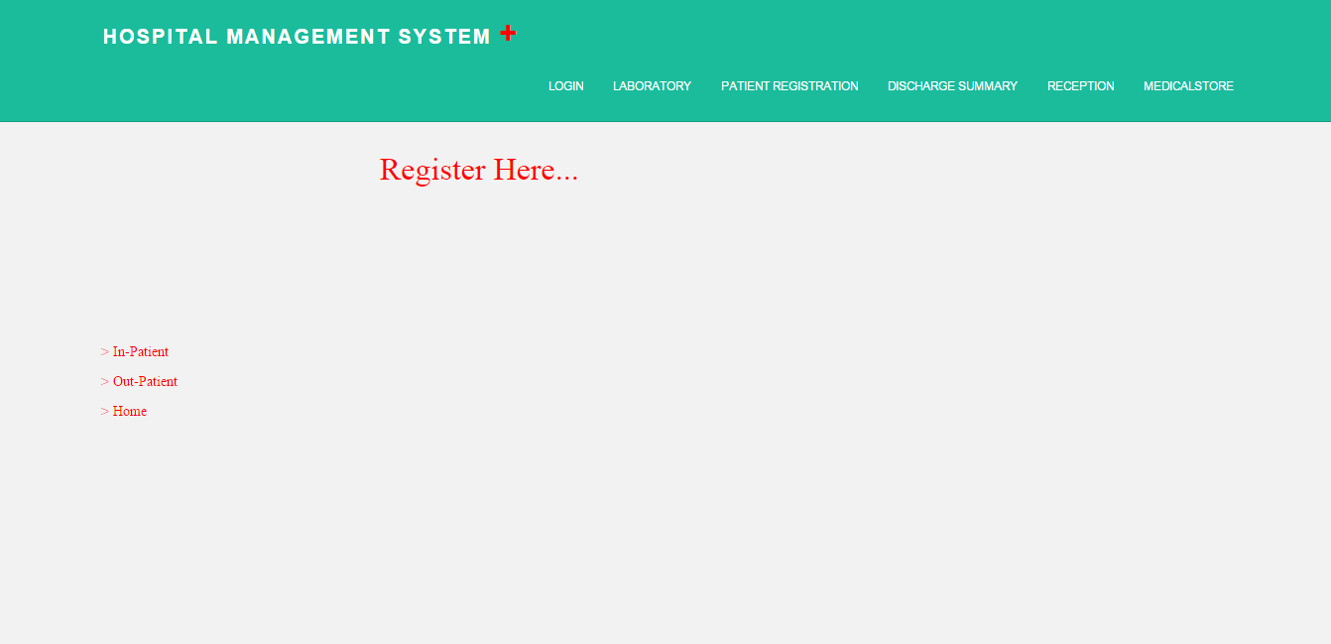

**Source**

<%@ Page Language="VB" MasterPageFile="~/MasterPage.master" AutoEventWireup="true" CodeFile="registration.aspx.vb" Inherits="registration" Title="Untitled Page" %>

<asp:Content ID="Content1" ContentPlaceHolderID="ContentPlaceHolder1" Runat="Server">

<asp:Label ID="Label1" runat="server" Text="Register Here..." style="z-index: 102; left: 384px; position: absolute; top: 150px" Font-Names="Modern" Font-Size="24pt" ForeColor="Red"></asp:Label>

<asp:Menu ID="Menu1" runat="server" style="z-index: 104; left: 103px; position: absolute; top: 343px" Font-Names="Modern" ForeColor="Red" Height="89px">

<Items>

<asp:MenuItem NavigateUrl="~/ipregister.aspx" Text="&gt; In-Patient" Value="&gt; In-Patient">

</asp:MenuItem>

<asp:MenuItem NavigateUrl="~/outpatient.aspx" Text="&gt; Out-Patient" Value="&gt; Out-Patient">

</asp:MenuItem>

<asp:MenuItem NavigateUrl="~/home.aspx" Text="&gt; Home" Value="&gt; Home"></asp:MenuItem>

</Items>

</asp:Menu>

</asp:Content>

**Code Behind**

Imports System.Data

Imports System.Configuration

Imports System.Collections

Imports System.Web

Imports System.Web.Security

Imports System.Web.UI

Imports System.Web.UI.WebControls

Imports System.Web.UI.WebControls.WebParts

Imports System.Web.UI.HtmlControls

Public Partial Class registration

Inherits System.Web.UI.Page

Protected Sub Page_Load(sender As Object, e As EventArgs)

End Sub

End Class

**Design**

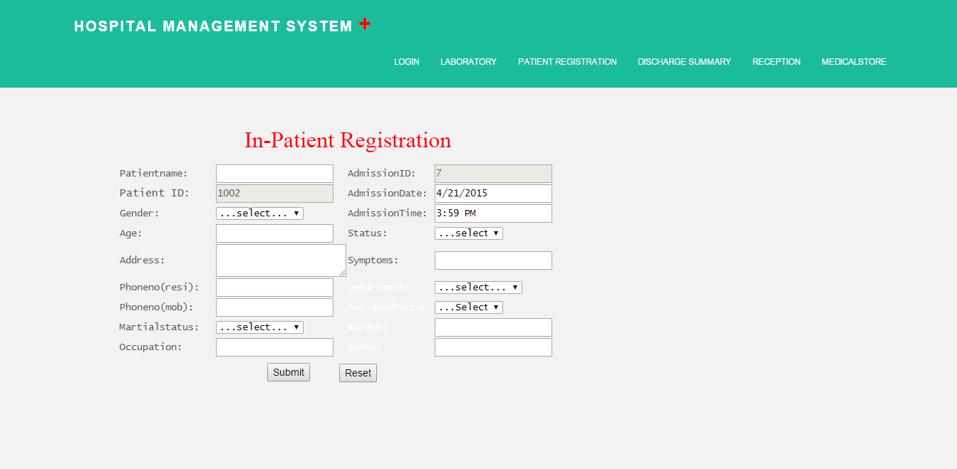

**Source**

<%@ Page Language="VB" Debug ="true" MasterPageFile="~/MasterPage.master" AutoEventWireup="true" CodeFile="ipregister.aspx.vb" Inherits="ipregister" Title="Untitled Page" %>

<asp:Content ID="Content1" ContentPlaceHolderID="ContentPlaceHolder1" Runat="Server">

<table style="z-index: 102; left: 168px; font-family: 'Lucida Console'; position: absolute;

top: 232px">

<tr>

<td style="width: 135px">

<span style=" font-family: Lucida Console">Patientname:</span></td>

<td style="width: 100px">

<asp:TextBox ID="TextBox1" runat="server"></asp:TextBox></td>

<td style="width: 100px">

<span style=" font-family: Lucida Console">AdmissionID:</span></td>

<td style="width: 100px">

<asp:TextBox ID="TextBox8" runat="server" Enabled="false"></asp:TextBox></td>

</tr>

<tr>

<td style="width: 135px">

<span style="font-size: 11pt; font-family: Lucida Console">Patient ID:</span></td>

<td style="width: 100px">

<asp:TextBox ID="TextBox2" runat="server" Enabled="false"></asp:TextBox></td>

<td style="width: 100px">

<span style=" font-family: Lucida Console">AdmissionDate:</span></td>

<td style="width: 100px">

<asp:TextBox ID="TextBox9" runat="server" ></asp:TextBox></td>

</tr>

<tr>

<td style="width: 135px">

<span style=" font-family: Lucida Console">Gender:</span></td>

<td style="width: 100px">

<asp:DropDownList ID="DropDownList1" runat="server">

<asp:ListItem>...select...</asp:ListItem>

<asp:ListItem>Male</asp:ListItem>

<asp:ListItem>Female</asp:ListItem>

</asp:DropDownList></td>

<td style="width: 100px">

<span style=" font-family: Lucida Console">AdmissionTime:</span></td>

<td style="width: 100px">

<asp:TextBox ID="TextBox10" runat="server"></asp:TextBox></td>

</tr>

<tr>

<td style="width: 135px; height: 26px">

<span style=" font-family: Lucida Console">Age:</span></td>

<td style="width: 100px; height: 26px">

<asp:TextBox ID="TextBox3" runat="server"></asp:TextBox></td>

<td style="width: 100px; height: 26px">

<span style=" font-family: Lucida Console">Status:</span></td>

<td style="width: 100px; height: 26px"><asp:DropDownList ID="DropDownList4" runat="server" Width="96px">

<asp:ListItem>...select...</asp:ListItem>

<asp:ListItem>Starting</asp:ListItem>

<asp:ListItem>Mild</asp:ListItem>

<asp:ListItem>Serious</asp:ListItem>

</asp:DropDownList></td>

</tr>

<tr>

<td style="width: 135px">

<span style=" font-family: Lucida Console">Address:</span></td>

<td style="width: 100px">

<asp:TextBox ID="TextBox4" runat="server" TextMode="MultiLine"></asp:TextBox></td>

<td style="width: 100px">

<span style=" font-family: Lucida Console">Symptoms:</span></td>

<td style="width: 100px">

<asp:TextBox ID="TextBox12" runat="server"></asp:TextBox></td>

</tr>

<tr>

<td style="width: 135px">

<span style=" font-family: Lucida Console">Phoneno(resi):</span></td>

<td style="width: 100px">

<asp:TextBox ID="TextBox5" runat="server"></asp:TextBox></td>

<td style="width: 100px">

<span style="color: #ffffff">Department:</span></td>

<td style="width: 100px"><asp:DropDownList ID="DropDownList3" runat="server">

<asp:ListItem>...select...</asp:ListItem>

<asp:ListItem>Cardiology</asp:ListItem>

<asp:ListItem>Orthopedic</asp:ListItem>

<asp:ListItem>Gynacology</asp:ListItem>

<asp:ListItem>Dental</asp:ListItem>

<asp:ListItem>Opthology</asp:ListItem>

</asp:DropDownList></td>

</tr>

<tr>

<td style="width: 135px">

<span style=" font-family: Lucida Console">Phoneno(mob):</span></td>

<td style="width: 100px">

<asp:TextBox ID="TextBox6" runat="server"></asp:TextBox></td>

<td style="width: 100px">

<span style="color: #ffffff">AssignedDoctor:</span></td>

<td style="width: 100px">

<asp:DropDownList ID="DropDownList5" runat="server" Width="96px">

<asp:ListItem>...select...</asp:ListItem>

</asp:DropDownList></td>

</tr>

<tr>

<td style="width: 135px">

<span style=" font-family: Lucida Console">Martialstatus:</span></td>

<td style="width: 100px">

<asp:DropDownList ID="DropDownList2" runat="server">

<asp:ListItem>...select...</asp:ListItem>

<asp:ListItem>Married</asp:ListItem>

<asp:ListItem>Unmarried</asp:ListItem>

</asp:DropDownList></td>

<td style="width: 100px">

<span style="color: #ffffff">Wardno:</span></td>

<td style="width: 100px">

<asp:TextBox ID="TextBox14" runat="server"></asp:TextBox></td>

</tr>

<tr>

<td style="width: 135px">

<span style=" font-family: Lucida Console">Occupation:</span></td>

<td style="width: 100px">

<asp:TextBox ID="TextBox7" runat="server"></asp:TextBox></td>

<td style="width: 100px">

<span style="color: #ffffff">Bedno:</span></td>

<td style="width: 100px">

<asp:TextBox ID="TextBox15" runat="server"></asp:TextBox></td>

</tr>

</table>

<asp:Label ID="Label1" runat="server" Font-Names="Modern" Font-Size="24pt" ForeColor="Red"

Style="z-index: 100; left: 344px; position: absolute; top: 176px" Text="In-Patient Registration"></asp:Label>

<table style="z-index: 103; left: 376px; position: absolute; top: 512px">

<tr>

<td style="width: 100px">

<asp:Button ID="Button1" runat="server" OnClick="Button1_Click" Style="z-index: 100;

left: 0px; position: absolute; top: 0px" Text="Submit" />

</td>

<td style="width: 100px">

<asp:Button ID="Button2" runat="server" Text="Reset" /></td>

</tr>

</table>

</asp:Content>

**Code Behind**

Imports System.Data

Imports System.Configuration

Imports System.Collections

Imports System.Web

Imports System.Web.Security

Imports System.Web.UI

Imports System.Web.UI.WebControls

Imports System.Web.UI.WebControls.WebParts

Imports System.Web.UI.HtmlControls

Imports System.Data.SqlClient

Public Partial Class ipregister

Inherits System.Web.UI.Page

Private cn As New SqlConnection("Data Source=DEEP-PC;database=Hospitalmanagement;Integrated Security = True")

Protected Sub Page_Load(sender As Object, e As EventArgs)

If Not Page.IsPostBack Then

filldrop()

DropDownList5.Items.Insert(0, "...Select...")

End If

Dim dt As String = DateTime.Now.ToShortDateString()

Dim dtm As String = DateTime.Now.ToShortTimeString()

TextBox9.Text = dt

TextBox10.Text = dtm

cn.Open()

Dim pid As Integer = 0

Dim b As Integer = 0

pid = Convert.ToInt32(New SqlCommand("select patientid from hospital_inpatient order by 1 desc", cn).ExecuteScalar().ToString()) + 1

b = Convert.ToInt32(New SqlCommand("select admid from hospital_inpatient order by 1 desc", cn).ExecuteScalar().ToString()) + 1

TextBox2.Text = pid.ToString()

TextBox8.Text = b.ToString()

cn.Close()

End Sub

Private Sub filldrop()

cn.Open()

Dim qry As String = "select name from hospital_doctorsignup"

Dim da As New SqlDataAdapter(qry, cn)

Dim ds As New DataSet()

da.Fill(ds, "hospital_doctorsignup")

DropDownList5.DataSource = ds

DropDownList5.DataTextField = "name"

DropDownList5.DataBind()

cn.Close()

End Sub

Protected Sub Button1_Click(sender As Object, e As EventArgs)

cn.Open()

Dim cmd As New SqlCommand()

cmd.CommandType = CommandType.StoredProcedure

cmd.CommandText = "sp_hospital_inpatient"

cmd.Connection = cn

Dim p As New SqlParameter("@patientname", SqlDbType.VarChar, 20)

p.Value = TextBox1.Text

cmd.Parameters.Add(p)

Dim p1 As New SqlParameter("@gender", SqlDbType.VarChar, 20)

p1.Value = DropDownList1.Text

cmd.Parameters.Add(p1)

Dim p2 As New SqlParameter("@age", SqlDbType.Int)

p2.Value = TextBox3.Text

cmd.Parameters.Add(p2)

Dim p3 As New SqlParameter("@address", SqlDbType.VarChar, 20)

p3.Value = TextBox4.Text

cmd.Parameters.Add(p3)

Dim p4 As New SqlParameter("@phoneres", SqlDbType.BigInt)

p4.Value = TextBox5.Text

cmd.Parameters.Add(p4)

Dim p5 As New SqlParameter("@phonemob", SqlDbType.BigInt)

p5.Value = TextBox6.Text

cmd.Parameters.Add(p5)

Dim p6 As New SqlParameter("@maritual", SqlDbType.VarChar, 20)

p6.Value = DropDownList2.Text

cmd.Parameters.Add(p6)

Dim p7 As New SqlParameter("@occupation", SqlDbType.VarChar, 20)

p7.Value = TextBox7.Text

cmd.Parameters.Add(p7)

Dim p8 As New SqlParameter("@admid", SqlDbType.Int)

p8.Value = TextBox8.Text

cmd.Parameters.Add(p8)

Dim p9 As New SqlParameter("@admdate", SqlDbType.DateTime)

p9.Value = TextBox9.Text

cmd.Parameters.Add(p9)

Dim p10 As New SqlParameter("@admtime", SqlDbType.DateTime)

p10.Value = TextBox10.Text

cmd.Parameters.Add(p10)

Dim p11 As New SqlParameter("@status", SqlDbType.VarChar, 20)

p11.Value = DropDownList4.Text

cmd.Parameters.Add(p11)

Dim p12 As New SqlParameter("@symtoms", SqlDbType.VarChar, 20)

p12.Value = TextBox12.Text

cmd.Parameters.Add(p12)

Dim p13 As New SqlParameter("@department", SqlDbType.VarChar, 20)

p13.Value = DropDownList3.Text

cmd.Parameters.Add(p13)

Dim p14 As New SqlParameter("@wardno", SqlDbType.Int)

p14.Value = TextBox14.Text

cmd.Parameters.Add(p14)

Dim p15 As New SqlParameter("@bedno", SqlDbType.Int)

p15.Value = TextBox15.Text

cmd.Parameters.Add(p15)

Dim p16 As New SqlParameter("@doctor", SqlDbType.VarChar, 20)

p16.Value = DropDownList5.Text

cmd.Parameters.Add(p16)

cmd.ExecuteNonQuery()

cn.Close()

Response.Redirect("doctorsden.aspx")

End Sub

End Class

**Design**

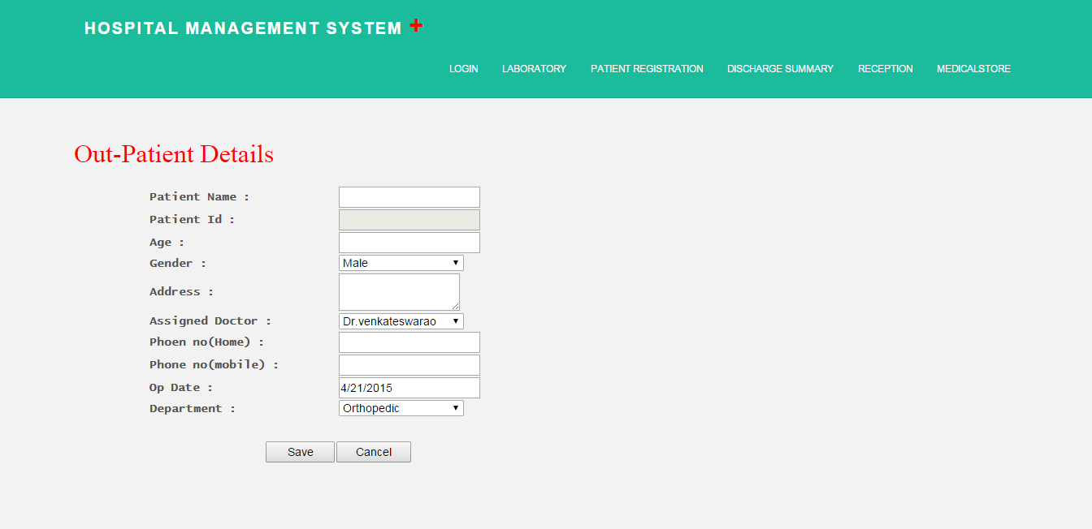

**Source**

<%@ Page Language="VB" MasterPageFile="~/MasterPage.master" AutoEventWireup="true" CodeFile="outpatient.aspx.vb" Inherits="doctorsignup" Title="Untitled Page" %>

<asp:Content ID="Content1" ContentPlaceHolderID="ContentPlaceHolder1" Runat="Server">

<asp:Label ID="Label1" runat="server" Font-Bold="False" Font-Names="Modern" Font-Size="24pt"

ForeColor="Red" Style="z-index: 102; left: 92px; position: absolute; top: 171px"

Text="Out-Patient Details "></asp:Label>

<table style="font-weight: bold; width: 755px; z-index: 103; left: 184px; position: absolute; top: 233px;" >

<tr>

<td style="width: 210px"><span style=" font-family: Lucida Console;">Patient Name :</span></td><td style="width: 468px"><asp:TextBox ID="pntxt" runat="server"></asp:TextBox></td>

</tr>

<tr>

<td style="width: 210px"><span style=" font-family: Lucida Console;">Patient Id :</span></td><td style="width: 468px"><asp:TextBox ID="pidtxt" Enabled="false" runat="server"></asp:TextBox></td>

</tr>

<tr>

<td style="width: 210px"><span style=" font-family: Lucida Console;">Age :</span></td><td style="width: 468px"><asp:TextBox ID="agetxt" runat="server"></asp:TextBox></td>

</tr>

<tr>

<td style="width: 210px"><span style=" font-family: Lucida Console;">Gender :</span></td><td style="width: 468px"><asp:DropDownList ID="gddl" runat="server" Width="154px">

<asp:ListItem>Male</asp:ListItem>

<asp:ListItem>Female</asp:ListItem>

</asp:DropDownList></td>

</tr>

<tr>

<td style="width: 210px; height: 40px;"><span style=" font-family: Lucida Console;">Address :</span></td><td style="width: 468px; height: 40px;"><asp:TextBox ID="addtxt" runat="server" TextMode="MultiLine" Width="149px"></asp:TextBox></td>

</tr>

<tr>

<td style="width: 210px; height: 24px;"><span style=" font-family: Lucida Console;">Assigned Doctor :</span></td><td style="width: 468px; height: 24px;"><asp:DropDownList ID="doctorddl" runat="server" Width="154px">

<asp:ListItem>Dr.venkateswarao</asp:ListItem>

<asp:ListItem>Dr.Ramarao</asp:ListItem>

<asp:ListItem>Dr.Teja</asp:ListItem>

<asp:ListItem>Dr.Chinnareddy</asp:ListItem>

</asp:DropDownList></td>

</tr>

<tr>

<td style="width: 210px; height: 26px;"><span style=" font-family: Lucida Console;">Phoen no(Home) :</span></td><td style="width: 468px; height: 26px;"><asp:TextBox ID="restxt" runat="server"></asp:TextBox></td>

</tr>

<tr>

<td style="width: 210px"><span style=" font-family: Lucida Console;">Phone no(mobile) :</span></td><td style="width: 468px"><asp:TextBox ID="mobtxt" runat="server"></asp:TextBox></td>

</tr>

<tr>

<td style="width: 210px"><span style=" font-family: Lucida Console;">Op Date :</span></td><td style="width: 468px"><asp:TextBox ID="optxt" runat="server"></asp:TextBox></td>

</tr>

<tr>

<td style="width: 210px"><span style=" font-family: Lucida Console;">Department :</span></td><td style="width: 468px"><asp:DropDownList ID="depddl" runat="server" Width="154px">

<asp:ListItem>Orthopedic</asp:ListItem>

<asp:ListItem>Pediatric</asp:ListItem>

<asp:ListItem>Neurology</asp:ListItem>

<asp:ListItem>Urology</asp:ListItem>

<asp:ListItem>Cardiology</asp:ListItem>

</asp:DropDownList></td>

</tr>

</table>

<table style="z-index: 102; left: 327px; position: absolute; top: 547px">

<tr>

<td style="width: 82px; height: 26px"><asp:Button ID="Button1" runat="server" Text="Save" Width="85px" OnClick="Button1_Click" /></td>

<td style="width: 67px; height: 26px"><asp:Button ID="Button2" runat="server" Text="Cancel" Width="92px" /></td>

</tr>

</table>

</asp:Content>

**Code Behind**

Imports System.Data

Imports System.Configuration

Imports System.Collections

Imports System.Web

Imports System.Web.Security

Imports System.Web.UI

Imports System.Web.UI.WebControls

Imports System.Web.UI.WebControls.WebParts

Imports System.Web.UI.HtmlControls

Imports System.Data.SqlClient

Public Partial Class doctorsignup

Inherits System.Web.UI.Page

Private cn As New SqlConnection("server=DEEP-PC;Integrated Security = True;database=Hospitalmanagement")

Private dt As String = DateTime.Now.ToShortDateString()

Protected Sub Page_Load(sender As Object, e As EventArgs)

optxt.Text = dt

End Sub

Protected Sub Button1_Click(sender As Object, e As EventArgs)

cn.Open()

Dim cmd As New SqlCommand()

cmd.CommandType = CommandType.StoredProcedure

cmd.CommandText = "sp_hospital_outpatient"

cmd.Connection = cn

Dim p As New SqlParameter("@patientname", SqlDbType.VarChar, 20)

p.Value = pntxt.Text

cmd.Parameters.Add(p)

Dim p1 As New SqlParameter("@gender", SqlDbType.VarChar, 20)

p1.Value = gddl.Text

cmd.Parameters.Add(p1)

Dim p2 As New SqlParameter("@age", SqlDbType.Int)

p2.Value = agetxt.Text

cmd.Parameters.Add(p2)

Dim p3 As New SqlParameter("@address", SqlDbType.VarChar, 20)

p3.Value = addtxt.Text

cmd.Parameters.Add(p3)

Dim p4 As New SqlParameter("@assigndoctor", SqlDbType.VarChar, 20)

p4.Value = doctorddl.Text

cmd.Parameters.Add(p4)

Dim p5 As New SqlParameter("@phoneres", SqlDbType.BigInt)

p5.Value = restxt.Text

cmd.Parameters.Add(p5)

Dim p6 As New SqlParameter("@phonemob", SqlDbType.BigInt)

p6.Value = mobtxt.Text

cmd.Parameters.Add(p6)

Dim p7 As New SqlParameter("@opdate", SqlDbType.DateTime)

p7.Value = optxt.Text

cmd.Parameters.Add(p7)

Dim p8 As New SqlParameter("@department", SqlDbType.VarChar, 20)

p8.Value = depddl.Text

cmd.Parameters.Add(p8)

cmd.ExecuteNonQuery()

cn.Close()

Response.Redirect("outpatient.aspx")

End Sub

End Class

**Discharge Summary**

**Design**

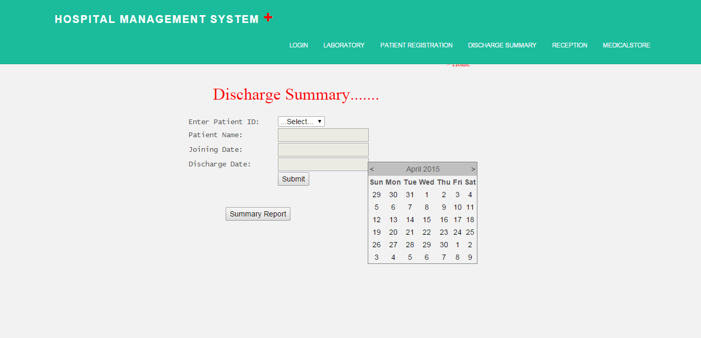

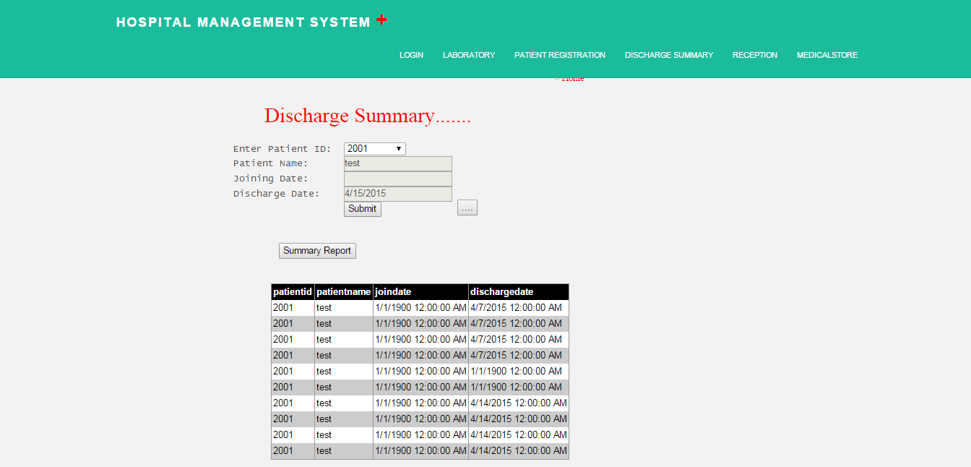

**Source**

<%@ Page Language="VB" MasterPageFile="~/MasterPage.master" AutoEventWireup="true" CodeFile="dischargesummary.aspx.vb" Inherits="dischargesummary" Title="Untitled Page" %>

<asp:Content ID="Content1" ContentPlaceHolderID="ContentPlaceHolder1" Runat="Server">

<%--<asp:Image ID="Image1" runat="server" ImageUrl="~/pics/000000265324[1].jpg" Style="z-index: 100;

left: 96px; position: absolute; top: 160px" />--%>

<asp:Label ID="Label1" runat="server" Font-Names="Modern" Font-Size="24pt" ForeColor="Red"

Style="z-index: 101; left: 408px; position: absolute; top: 160px" Text="Discharge Summary......."></asp:Label>

<table style="z-index: 101; left: 360px; position: absolute; top: 224px">

<tr>

<td style="width: 171px">

<span style=" font-family: Lucida Console">Enter Patient ID:</span></td>

<td style="width: 100px">

<asp:DropDownList ID="PID" runat="server" AutoPostBack="True" OnSelectedIndexChanged="PID_SelectedIndexChanged">

</asp:DropDownList></td>

</tr>

<tr>

<td style="width: 171px">

<span style=" font-family: Lucida Console">Patient Name:</span></td>

<td style="width: 100px">

<asp:TextBox ID="TextBox1" Enabled ="false" runat="server"></asp:TextBox></td>

</tr>

<tr>

<td style="width: 171px">

<span style=" font-family: Lucida Console">Joining Date:</span></td>

<td style="width: 100px">

<asp:TextBox ID="TextBox2" Enabled ="false" runat="server"></asp:TextBox></td>

</tr>

<tr>

<td style="width: 171px">

<span style=" font-family: Lucida Console">Discharge Date:</span></td>

<td style="width: 100px">

<asp:TextBox ID="TextBox3" Enabled ="false" runat="server"></asp:TextBox></td>

</tr>

<tr>

<td style="width: 171px">

</td>

<td style="width: 100px">

<asp:Button ID="Button1" runat="server" Text="Submit" OnClick="Button1_Click" />

<asp:Button ID="Button3" runat="server" OnClick="Button3_Click" Style="left: -100px;

position: relative; top: 41px" Text="Summary Report" /></td>

</tr>

</table>

<asp:Button ID="Button2" runat="server" Style="z-index: 102; left: 704px; position: absolute;

top: 312px" Text="...." OnClick="Button2_Click" />

<asp:Calendar ID="Calendar1" runat="server" Style="z-index: 103; left: 704px; position: absolute;

top: 312px" Height="1px" Width="1px" OnSelectionChanged="Calendar1_SelectionChanged"></asp:Calendar>

<asp:GridView ID="GridView1" runat="server" style="z-index: 104; left: 418px; position: absolute; top: 441px" BackColor="White" BorderColor="#999999" BorderStyle="Solid" BorderWidth="1px" CellPadding="3" ForeColor="Black" GridLines="Vertical">

<FooterStyle BackColor="#CCCCCC" />

<SelectedRowStyle BackColor="#000099" Font-Bold="True" ForeColor="White" />

<PagerStyle BackColor="#999999" ForeColor="Black" HorizontalAlign="Center" />

<HeaderStyle BackColor="Black" Font-Bold="True" ForeColor="White" />

<AlternatingRowStyle BackColor="#CCCCCC" />

</asp:GridView>

<asp:Menu ID="Menu1" runat="server" style="z-index: 106; left: 854px; position: absolute; top: 115px" Font-Names="Modern" ForeColor="Red">

<Items>

<asp:MenuItem NavigateUrl="~/home.aspx" Text="&gt; Home" Value="&gt; Home"></asp:MenuItem>

</Items>

</asp:Menu>

</asp:Content>

**Code Behind**

Imports System.Data

Imports System.Configuration

Imports System.Collections

Imports System.Web

Imports System.Web.Security

Imports System.Web.UI

Imports System.Web.UI.WebControls

Imports System.Web.UI.WebControls.WebParts

Imports System.Web.UI.HtmlControls

Imports System.Data.SqlClient

Public Partial Class dischargesummary

Inherits System.Web.UI.Page

Private cn As New SqlConnection("server=DEEP-PC;Integrated Security = True;database=Hospitalmanagement")

Protected Sub Page_Load(sender As Object, e As EventArgs)

If Not Page.IsPostBack Then

cn.Open()

Dim qry As String = "select patientid from hospital_outpatient"

Dim da As New SqlDataAdapter(qry, cn)

Dim ds As New DataSet()

da.Fill(ds, "hospital_outpatient")

PID.DataSource = ds

PID.DataTextField = "patientid"

PID.DataBind()

cn.Close()

Calendar1.Visible = False

PID.Items.Insert(0, "...Select...")

End If

End Sub

Protected Sub Button2_Click(sender As Object, e As EventArgs)

Calendar1.Visible = True

End Sub

Protected Sub Calendar1_SelectionChanged(sender As Object, e As EventArgs)

TextBox3.Text = Calendar1.SelectedDate.ToShortDateString()

Calendar1.Visible = False

End Sub

Protected Sub PID_SelectedIndexChanged(sender As Object, e As EventArgs)

cn.Open()

Dim Cmd As New SqlCommand("select patientname,opdate from hospital_outpatient WHERE patientid ='" + PID.SelectedValue & "'", cn)

Dim dr As SqlDataReader = Cmd.ExecuteReader()

If dr.Read() Then

TextBox1.Text = dr(0).ToString()

TextBox2.Text = dr(1).ToString()

End If

dr.Close()

cn.Close()

End Sub

Protected Sub Button1_Click(sender As Object, e As EventArgs) Handles Button1.Click

cn.Open()

Dim cmd As New SqlCommand()

cmd.CommandType = CommandType.StoredProcedure

cmd.CommandText = "sp_hospital_dischargesummary"

cmd.Connection = cn

Dim p As New SqlParameter("@patientid", SqlDbType.Int)

p.Value = PID.Text

cmd.Parameters.Add(p)

Dim p1 As New SqlParameter("@patientname", SqlDbType.VarChar, 20)

p1.Value = TextBox1.Text

cmd.Parameters.Add(p1)

Dim p2 As New SqlParameter("@joindate", SqlDbType.VarChar, 20)

p2.Value = TextBox2.Text

cmd.Parameters.Add(p2)

Dim p3 As New SqlParameter("@dischargedate", SqlDbType.VarChar, 20)

p3.Value = TextBox3.Text

cmd.Parameters.Add(p3)

cmd.ExecuteNonQuery()

cn.Close()

End Sub

Protected Sub Button3_Click(sender As Object, e As EventArgs)

cn.Open()

Dim qry As String = "select * from hospital_dischargesummary"

Dim da As New SqlDataAdapter(qry, cn)

Dim ds As New DataSet()

da.Fill(ds)

GridView1.DataSource = ds

GridView1.DataBind()

cn.Close()

End Sub

End Class

**Reception**

**Design**

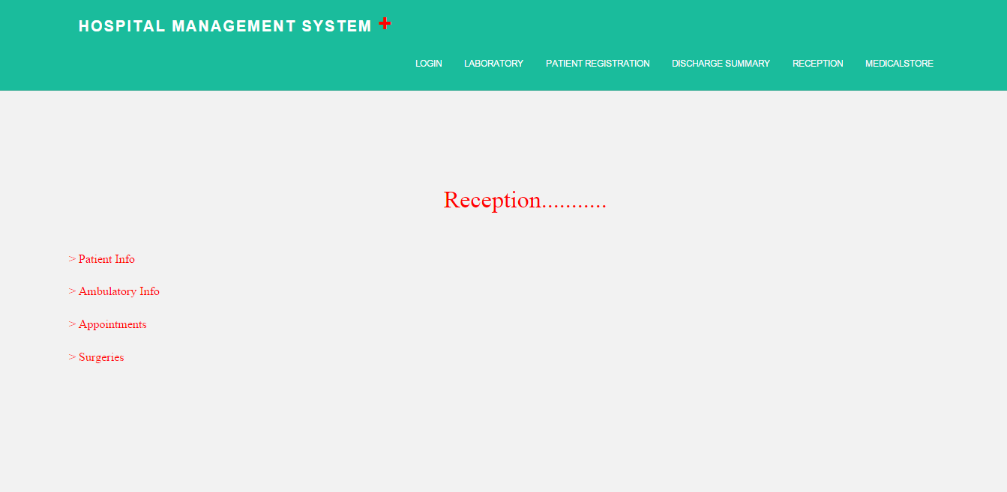

**Source**

<%@ Page Language="VB" MasterPageFile="~/MasterPage.master" AutoEventWireup="true" CodeFile="receptionhome.aspx.vb" Inherits="receptionhome" Title="Untitled Page" %>

<asp:Content ID="Content1" ContentPlaceHolderID="ContentPlaceHolder1" Runat="Server">

<asp:Label ID="Label1" runat="server" Font-Names="Modern" Font-Size="24pt" ForeColor="Red"

Style="z-index: 102; left: 592px; position: absolute; top: 248px" Text="Reception..........."

Width="232px"></asp:Label>

<asp:Menu ID="Menu1" runat="server" Font-Names="Modern" Font-Size="12pt" ForeColor="Red"

Style="z-index: 104; left: 92px; position: absolute; top: 329px" Height="174px">

<Items>

<asp:MenuItem Text="&gt; Patient Info" Value="&gt; Patient Info" NavigateUrl="~/patientinfo.aspx"></asp:MenuItem>

<asp:MenuItem Text="&gt; Ambulatory Info" Value="&gt; Ambulatory Info" NavigateUrl="~/ambulatoryinfo.aspx"></asp:MenuItem>

<asp:MenuItem NavigateUrl="~/appointments.aspx" Text="&gt; Appointments" Value="&gt; Appointments">

</asp:MenuItem>

<asp:MenuItem Text="&gt; Surgeries" Value="&gt; Surgeries" NavigateUrl="surgeries.aspx">

</asp:MenuItem>

</Items>

</asp:Menu>

</asp:Content>

**Code Behind**

Imports System.Data

Imports System.Configuration

Imports System.Collections

Imports System.Web

Imports System.Web.Security

Imports System.Web.UI

Imports System.Web.UI.WebControls

Imports System.Web.UI.WebControls.WebParts

Imports System.Web.UI.HtmlControls

Public Partial Class receptionhome

Inherits System.Web.UI.Page

Protected Sub Page_Load(sender As Object, e As EventArgs)

End Sub

End Class

**Patient Information**

**Design**

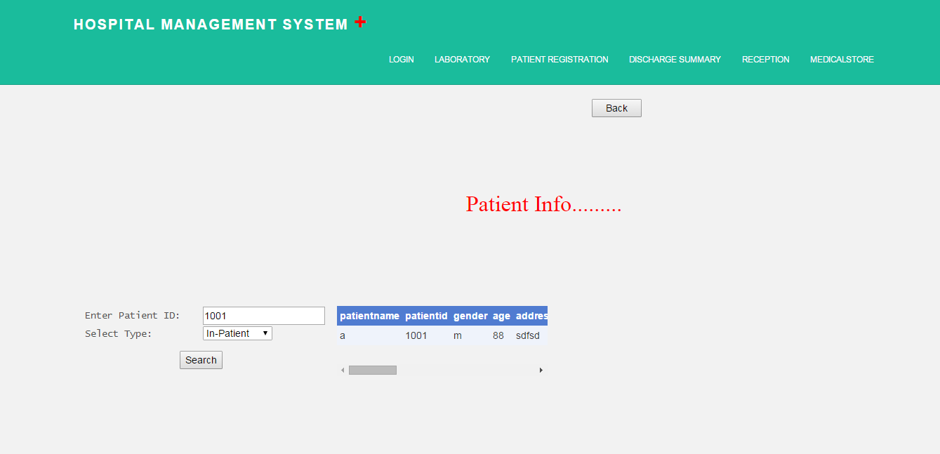

**Source**

<%@ Page Language="VB" MasterPageFile="~/MasterPage.master" AutoEventWireup="true" CodeFile="patientinfo.aspx.vb" Inherits="patientinfo" Title="Untitled Page" %>

<asp:Content ID="Content1" ContentPlaceHolderID="ContentPlaceHolder1" Runat="Server">

&nbsp;

<asp:Label ID="Label1" runat="server" Font-Names="Modern" Font-Size="24pt" ForeColor="Red"

Style="z-index: 102; left: 664px; position: absolute; top: 272px" Text="Patient Info........."></asp:Label>

<table style="z-index: 101; left: 120px; width: 344px; position: absolute; top: 440px;

height: 48px">

<tr>

<td style="width: 262px">

<span style=" font-family: Lucida Console">Enter Patient ID:</span></td>

<td style="width: 100px">

<asp:TextBox ID="TextBox1" runat="server"></asp:TextBox></td>

</tr>

<tr>

<td style="width: 262px">

<span style=" font-family: Lucida Console">Select Type:</span></td>

<td style="width: 100px">

<asp:DropDownList ID="type" runat="server" AutoPostBack="True" >

<asp:ListItem>....select....</asp:ListItem>

<asp:ListItem>In-Patient</asp:ListItem>

<asp:ListItem>Out-Patient</asp:ListItem>

</asp:DropDownList></td>

</tr>

</table>

<asp:Button ID="Button1" runat="server" OnClick="Button1_Click" Style="z-index: 103;

left: 256px; position: absolute; top: 504px" Text="Search" />

<div style="width:300px;height:100px;overflow:auto;top:440px;z-index: 105; left: 480px;position: absolute">

<asp:GridView ID="GridView1" runat="server" CellPadding="4" ForeColor="#333333" GridLines="None" >

<FooterStyle BackColor="#507CD1" Font-Bold="True" ForeColor="White" />

<PagerStyle BackColor="#2461BF" ForeColor="White" HorizontalAlign="Center" />

<SelectedRowStyle BackColor="#D1DDF1" Font-Bold="True" ForeColor="#333333" />

<HeaderStyle BackColor="#507CD1" Font-Bold="True" ForeColor="White" />

<AlternatingRowStyle BackColor="White" />

<RowStyle BackColor="#EFF3FB" />

<EditRowStyle BackColor="#2461BF" />

</asp:GridView></div>

<asp:Button ID="Button2" runat="server" Text="Back" style="z-index: 105; left: 843px; position: absolute; top: 145px" OnClick="Button2_Click" Width="71px" />

</asp:Content>

**Code Behind**

Imports System.Data

Imports System.Configuration

Imports System.Collections

Imports System.Web

Imports System.Web.Security

Imports System.Web.UI

Imports System.Web.UI.WebControls

Imports System.Web.UI.WebControls.WebParts

Imports System.Web.UI.HtmlControls

Imports System.Data.SqlClient

Public Partial Class patientinfo

Inherits System.Web.UI.Page

Private cn As New SqlConnection("Data Source=DEEP-PC;database=Hospitalmanagement;Integrated Security = True")

Protected Sub Page_Load(sender As Object, e As EventArgs)

End Sub

Protected Sub Button1_Click(sender As Object, e As EventArgs)

If type.SelectedItem.Value = "In-Patient" Then

Dim Da As New SqlDataAdapter("select * from hospital_inpatient where patientid=" + TextBox1.Text & "", cn)

'SqlCommandBuilder Cmd = new SqlCommandBuilder(Da);

Dim Ds As New DataSet()

Da.Fill(Ds, "hospital_inpatient")

GridView1.DataSource = Ds.Tables(0)

GridView1.DataBind()

Else

Dim Da As New SqlDataAdapter("select * from hospital_outpatient where patientid=" + TextBox1.Text & "", cn)

'SqlCommandBuilder Cmd = new SqlCommandBuilder(Da);

Dim Ds1 As New DataSet()

Da.Fill(Ds1, "hospital_outpatient")

GridView1.DataSource = Ds1.Tables(0)

GridView1.DataBind()

End If

End Sub

Protected Sub Button2_Click(sender As Object, e As EventArgs)

Response.Redirect("doctorsden.aspx")

End Sub

End Class

**Appointments**

**Design**

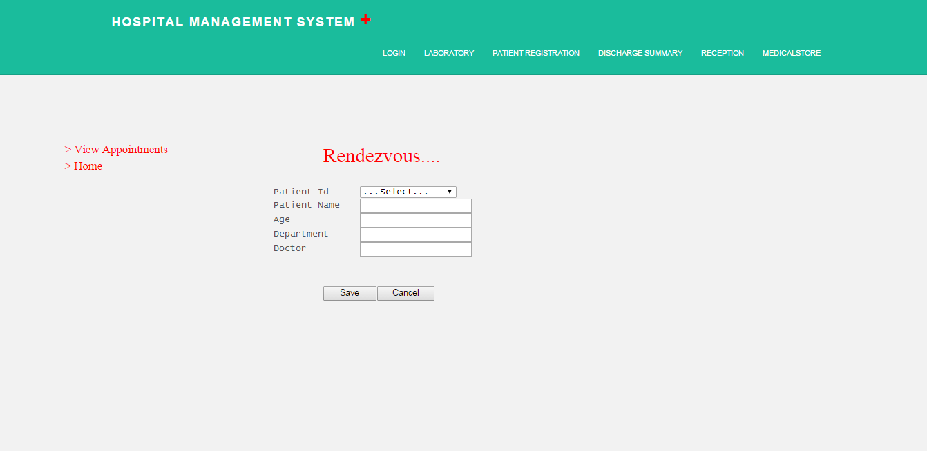

**Source**

<%@ Page Language="VB" MasterPageFile="~/MasterPage.master" AutoEventWireup="true" CodeFile="appointments.aspx.vb" Inherits="reception" Title="Untitled Page" %>

<asp:Content ID="Content1" ContentPlaceHolderID="ContentPlaceHolder1" Runat="Server">

<asp:Label ID="Label1" runat="server" Font-Bold="False" Font-Names="Modern" Font-Size="24pt"

ForeColor="White" Style="z-index: 100; left: 520px; position: absolute; top: 232px; color: red;"

Text="Rendezvous...."></asp:Label>

<table style="width: 320px; z-index: 101; left: 440px; position: absolute; top: 304px; font-family: 'Lucida Console';">

<tr>

<td style="width: 682px; height: 20px">

Patient Id

</td>

<td style="width: 94px; height: 20px">

<asp:DropDownList ID="pidddl" runat="server" Width="155px" AutoPostBack="True" OnSelectedIndexChanged="pidddl_SelectedIndexChanged" >

</asp:DropDownList>

</td>

</tr>

<tr>

<td style="width: 682px; height: 20px">

Patient Name</td>

<td style="width: 94px; height: 20px">

<asp:TextBox ID="pntxt" runat="server"></asp:TextBox>

</td>

</tr>

<tr>

<td style="width: 682px; height: 20px">

Age

</td>

<td style="width: 94px; height: 20px">

<asp:TextBox ID="agtxt" runat="server"></asp:TextBox>

</td>

</tr>

<tr>

<td style="width: 682px; height: 20px">

Department

</td>

<td style="width: 94px; height: 20px">

<asp:TextBox ID="deptxt" runat="server"></asp:TextBox>

</td>

</tr>

<tr>

<td style="width: 682px; height: 20px">

Doctor

</td>

<td style="width: 94px; height: 20px">

<asp:TextBox ID="doctxt" runat="server"></asp:TextBox>

</td>

</tr>

</table>

<table style="z-index: 102; left: 520px; position: absolute; top: 464px">

<tr>

<td style="width: 83px; height: 26px">

<asp:Button ID="Button1" runat="server" Text="Save" Width="85px" OnClick="Button1_Click" />

</td>

<td style="width: 67px; height: 26px">

<asp:Button ID="Button2" runat="server" Text="Cancel" Width="92px" OnClick="Button2_Click" />

</td>

</tr>

</table>

<asp:Menu ID="Menu1" runat="server" Font-Names="Modern" Font-Size="14pt" ForeColor="Red"

Style="z-index: 103; left: 104px; position: absolute; top: 232px">

<Items>

<asp:MenuItem NavigateUrl="~/viewappointments.aspx" Text="&gt; View Appointments"

Value="&gt; View Appointments"></asp:MenuItem>

<asp:MenuItem NavigateUrl="~/doctorsden.aspx" Text="&gt; Home" Value="&gt; Home">

</asp:MenuItem>

</Items>

</asp:Menu>

</asp:Content>

**Code Behind**

Imports System.Data

Imports System.Configuration

Imports System.Collections

Imports System.Web

Imports System.Web.Security

Imports System.Web.UI

Imports System.Web.UI.WebControls

Imports System.Web.UI.WebControls.WebParts

Imports System.Web.UI.HtmlControls

Imports System.Data.SqlClient

Public Partial Class reception

Inherits System.Web.UI.Page

Private cn As New SqlConnection("server=DEEP-PC;Integrated Security = True;database=Hospitalmanagement")

Protected Sub Page_Load(sender As Object, e As EventArgs)

If Not Page.IsPostBack Then

filldrop()

pidddl.Items.Insert(0, "...Select...")

End If

End Sub

Private Sub filldrop()

cn.Open()

Dim qry As String

qry = "select patientid from hospital_inpatient"

Dim da As New SqlDataAdapter(qry, cn)

Dim ds As New DataSet()

da.Fill(ds, "hospital_inpatient")

pidddl.DataSource = ds

pidddl.DataTextField = "patientid"

pidddl.DataBind()

cn.Close()

End Sub

Protected Sub pidddl_SelectedIndexChanged(sender As Object, e As EventArgs)

cn.Open()

Dim cmd As New SqlCommand()

cmd.CommandType = CommandType.StoredProcedure

cmd.CommandText = "sp_hospital_patientinfo"

cmd.Connection = cn

Dim p As New SqlParameter("@pid", SqlDbType.Int)

p.Value = pidddl.Text

cmd.Parameters.Add(p)

Dim p1 As New SqlParameter("@patientname", SqlDbType.VarChar, 20)

p1.Direction = ParameterDirection.Output

cmd.Parameters.Add(p1)

Dim p2 As New SqlParameter("@age", SqlDbType.Int)

p2.Direction = ParameterDirection.Output

cmd.Parameters.Add(p2)

Dim p3 As New SqlParameter("@department", SqlDbType.VarChar, 20)

p3.Direction = ParameterDirection.Output

cmd.Parameters.Add(p3)

cmd.ExecuteReader()

pntxt.Text = cmd.Parameters("@patientname").Value.ToString()

agtxt.Text = cmd.Parameters("@age").Value.ToString()

deptxt.Text = cmd.Parameters("@department").Value.ToString()

cn.Close()

End Sub

Protected Sub Button1_Click(sender As Object, e As EventArgs)

cn.Open()

Dim cmd As New SqlCommand()

cmd.CommandType = CommandType.StoredProcedure

cmd.CommandText = "sp_hospital_patientinfoenter"

cmd.Connection = cn

Dim pd As New SqlParameter("@pid", SqlDbType.VarChar, 20)

pd.Value = pidddl.SelectedItem.Text

cmd.Parameters.Add(pd)

Dim pname As New SqlParameter("@patientname", SqlDbType.VarChar, 20)

pname.Value = pntxt.Text

cmd.Parameters.Add(pname)

Dim age As New SqlParameter("@age", SqlDbType.Int)

age.Value = agtxt.Text

cmd.Parameters.Add(age)

Dim dep As New SqlParameter("@department", SqlDbType.VarChar, 20)

dep.Value = deptxt.Text

cmd.Parameters.Add(dep)

Dim doct As New SqlParameter("@doctor", SqlDbType.VarChar, 20)

doct.Value = doctxt.Text

cmd.Parameters.Add(doct)

cmd.ExecuteNonQuery()

cn.Close()

Response.Redirect("receptionhome.aspx")

End Sub

Protected Sub Button2_Click(sender As Object, e As EventArgs)

Response.Redirect("receptionhome.aspx")

End Sub

End Class

**Surgery Information**

**Design**

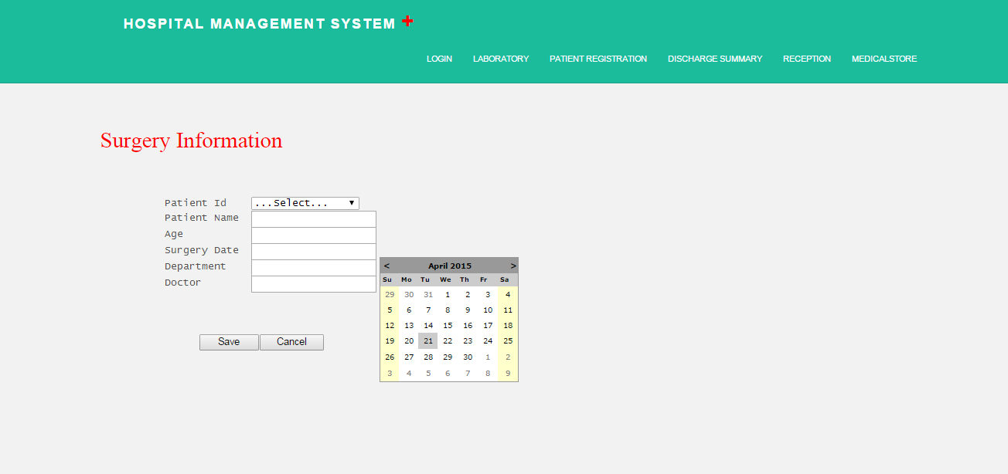

**Source**

<%@ Page Language="VB" MasterPageFile="~/MasterPage.master" AutoEventWireup="true" CodeFile="surgeries.aspx.vb" Inherits="surgeries" Title="Untitled Page" %>

<asp:Content ID="Content1" ContentPlaceHolderID="ContentPlaceHolder1" Runat="Server">

<asp:Label ID="Label1" runat="server" Font-Bold="False" Font-Names="Modern" Font-Size="24pt"

ForeColor="White" Style="z-index: 100; left: 146px; position: absolute; top: 184px; color: red;"

Text="Surgery Information "></asp:Label>

<table style="width: 306px; z-index: 101; left: 239px; position: absolute; top: 289px; font-family: 'Lucida Console'; height: 113px;">

<tr>

<td style="width: 682px; height: 20px">

Patient Id

</td>

<td style="width: 115px; height: 20px">

<asp:DropDownList ID="pidddl" runat="server" Width="155px" AutoPostBack="True" OnSelectedIndexChanged="pidddl_SelectedIndexChanged" >

</asp:DropDownList>

</td>

</tr>

<tr>

<td style="width: 682px; height: 20px">

Patient Name</td>

<td style="width: 115px; height: 20px">

<asp:TextBox ID="pntxt" runat="server"></asp:TextBox>

</td>

</tr>

<tr>

<td style="width: 682px; height: 20px">

Age

</td>

<td style="width: 115px; height: 20px">

<asp:TextBox ID="agtxt" runat="server"></asp:TextBox>

</td>

</tr>

<tr>

<td style="width: 682px; height: 6px">

Surgery Date

</td>

<td style="width: 115px; height: 6px">

<asp:TextBox ID="sdtxt" runat="server"></asp:TextBox>

</td>

</tr>

<tr>

<td style="width: 682px; height: 20px">

Department

</td>

<td style="width: 115px; height: 20px">

<asp:TextBox ID="deptxt" runat="server"></asp:TextBox>

</td>

</tr>

<tr>

<td style="width: 682px; height: 20px">

Doctor

</td>

<td style="width: 115px; height: 20px">

<asp:TextBox ID="doctxt" runat="server"></asp:TextBox>

</td>

</tr>

</table>

<table style="z-index: 102; left: 289px; position: absolute; top: 485px">

<tr>

<td style="width: 82px; height: 26px">

<asp:Button ID="Button1" runat="server" Text="Save" Width="85px" OnClick="Button1_Click" />

</td>

<td style="width: 67px; height: 26px">

<asp:Button ID="Button2" runat="server" Text="Cancel" Width="92px" OnClick="Button2_Click" />

</td>

</tr>

</table>

<asp:Calendar ID="Calendar1" runat="server" style="z-index: 102; left: 548px; position: absolute; top: 376px" BackColor="White" BorderColor="#999999" CellPadding="4" DayNameFormat="Shortest" Font-Names="Verdana" Font-Size="8pt" ForeColor="Black" Height="180px" OnSelectionChanged="Calendar1_SelectionChanged" Width="200px">

<SelectedDayStyle BackColor="#666666" Font-Bold="True" ForeColor="White" />

<TodayDayStyle BackColor="#CCCCCC" ForeColor="Black" />

<SelectorStyle BackColor="#CCCCCC" />

<WeekendDayStyle BackColor="#FFFFCC" />

<OtherMonthDayStyle ForeColor="#808080" />

<NextPrevStyle VerticalAlign="Bottom" />

<DayHeaderStyle BackColor="#CCCCCC" Font-Bold="True" Font-Size="7pt" />

<TitleStyle BackColor="#999999" BorderColor="Black" Font-Bold="True" />

</asp:Calendar>

</asp:Content>

**Code Behind**

Imports System.Data

Imports System.Configuration

Imports System.Collections

Imports System.Web

Imports System.Web.Security

Imports System.Web.UI

Imports System.Web.UI.WebControls

Imports System.Web.UI.WebControls.WebParts

Imports System.Web.UI.HtmlControls

Imports System.Data.SqlClient

Public Partial Class surgeries

Inherits System.Web.UI.Page

Private cn As New SqlConnection("server=DEEP-PC;Integrated Security = True;database=Hospitalmanagement")

Protected Sub Page_Load(sender As Object, e As EventArgs)

If Not Page.IsPostBack Then

filldrop()

pidddl.Items.Insert(0, "...Select...")

End If

End Sub

Private Sub filldrop()

cn.Open()

Dim qry As String

qry = "select patientid from hospital_inpatient"

Dim da As New SqlDataAdapter(qry, cn)

Dim ds As New DataSet()

da.Fill(ds, "hospital_inpatient")

pidddl.DataSource = ds

pidddl.DataTextField = "patientid"

pidddl.DataBind()

cn.Close()

End Sub

Protected Sub Calendar1_SelectionChanged(sender As Object, e As EventArgs)

sdtxt.Text = Calendar1.SelectedDate.ToShortDateString()

End Sub

Protected Sub pidddl_SelectedIndexChanged(sender As Object, e As EventArgs)

cn.Open()

Dim cmd As New SqlCommand()

cmd.CommandType = CommandType.StoredProcedure

cmd.CommandText = "sp_hospital_patientinfo"

cmd.Connection = cn

Dim p As New SqlParameter("@pid", SqlDbType.Int)

p.Value = pidddl.Text

cmd.Parameters.Add(p)

Dim p1 As New SqlParameter("@patientname", SqlDbType.VarChar, 20)

p1.Direction = ParameterDirection.Output

cmd.Parameters.Add(p1)

Dim p2 As New SqlParameter("@age", SqlDbType.Int)

p2.Direction = ParameterDirection.Output

cmd.Parameters.Add(p2)

Dim p3 As New SqlParameter("@department", SqlDbType.VarChar, 20)

p3.Direction = ParameterDirection.Output

cmd.Parameters.Add(p3)

cmd.ExecuteReader()

pntxt.Text = cmd.Parameters("@patientname").Value.ToString()

agtxt.Text = cmd.Parameters("@age").Value.ToString()

deptxt.Text = cmd.Parameters("@department").Value.ToString()

cn.Close()

End Sub

Protected Sub Button1_Click(sender As Object, e As EventArgs)

cn.Open()

Dim cmd As New SqlCommand()

cmd.CommandType = CommandType.StoredProcedure

cmd.CommandText = "sp_hospital_surgeryinfo"

cmd.Connection = cn

Dim pd As New SqlParameter("@pid", SqlDbType.VarChar, 20)

pd.Value = pidddl.SelectedItem.Text

cmd.Parameters.Add(pd)

Dim pname As New SqlParameter("@patientname", SqlDbType.VarChar, 20)

pname.Value = pntxt.Text

cmd.Parameters.Add(pname)

Dim age As New SqlParameter("@age", SqlDbType.Int)

age.Value = agtxt.Text

cmd.Parameters.Add(age)

Dim dep As New SqlParameter("@department", SqlDbType.VarChar, 20)

dep.Value = deptxt.Text

cmd.Parameters.Add(dep)

Dim doct As New SqlParameter("@doctor", SqlDbType.VarChar, 20)

doct.Value = doctxt.Text

cmd.Parameters.Add(doct)

Dim sdate As New SqlParameter("@surgerydate", SqlDbType.DateTime)

sdate.Value = sdtxt.Text

cmd.Parameters.Add(sdate)

cmd.ExecuteNonQuery()

cn.Close()

Response.Redirect("receptionhome.aspx")

End Sub

Protected Sub Button2_Click(sender As Object, e As EventArgs)

Response.Redirect("receptionhome.aspx")

End Sub

End Class

**Pharmacy**

**Design**

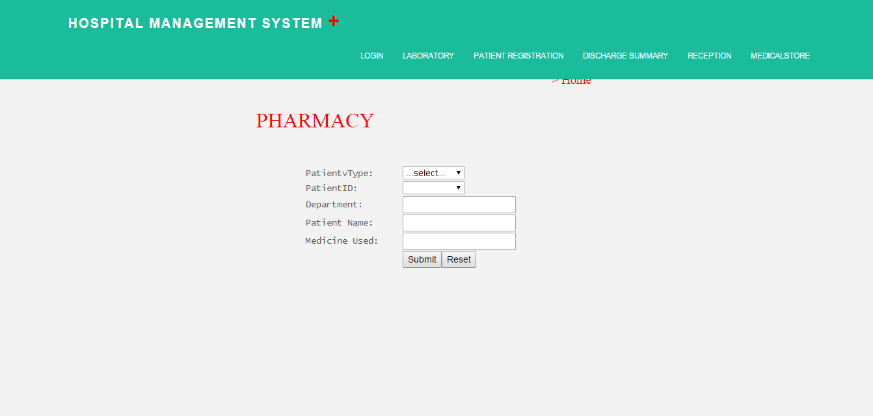

**Source**

<%@ Page Language="VB" MasterPageFile="~/MasterPage.master" AutoEventWireup="true" CodeFile="pharmacy.aspx.vb" Inherits="pharmacy" Title="Untitled Page" %>

<asp:Content ID="Content1" ContentPlaceHolderID="ContentPlaceHolder1" Runat="Server">

&nbsp;

<asp:Label ID="Label1" runat="server" Font-Bold="False" Font-Names="Modern" Font-Size="24pt"

ForeColor="Red" Style="z-index: 101; left: 394px; position: absolute; top: 166px"

Text="PHARMACY"></asp:Label>

<table style="z-index: 101; left: 469px; position: absolute; top: 258px">

<tr>

<td style="width: 149px">

<span style=" font-family: Lucida Console">PatientvType:</span></td>

<td style="width: 100px">

<asp:DropDownList ID="ptntyp" runat="server" AutoPostBack="True" Width="96px" OnSelectedIndexChanged="DropDownList3_SelectedIndexChanged">

<asp:ListItem>...select...</asp:ListItem>

<asp:ListItem>In-Patient</asp:ListItem>

<asp:ListItem>Out-Patient</asp:ListItem>

</asp:DropDownList></td>

</tr>

<tr>

<td style="width: 149px">

<span style=" font-family: Lucida Console">PatientID:</span></td>

<td style="width: 100px">

<asp:DropDownList ID="ptntid" runat="server" AutoPostBack="True" Width="96px" OnSelectedIndexChanged="DropDownList1_SelectedIndexChanged">

</asp:DropDownList></td>

</tr>

<tr>

<td style="width: 149px">

<span style=" font-family: Lucida Console">Department:</span></td>

<td style="width: 100px">

<asp:TextBox ID="dpt" runat="server"></asp:TextBox></td>

</tr>

<tr>

<td style="width: 149px">

<span style=" font-family: Lucida Console">Patient Name:</span></td>

<td style="width: 100px">

<asp:TextBox ID="ptntname" runat="server"></asp:TextBox></td>

</tr>

<tr>

<td style="width: 149px">

<span style=" font-family: Lucida Console">Medicine Used:</span></td>

<td style="width: 100px">

<asp:TextBox ID="mdcnusd" runat="server"></asp:TextBox></td>

</tr>

<tr>

<td style="width: 149px">

</td>

<td style="width: 100px">

<asp:Button ID="Button1" runat="server" OnClick="Button1_Click" Text="Submit" />

<asp:Button ID="Button2" runat="server" OnClick="Button2_Click" Text="Reset" style="position: absolute" /></td>

</tr>

</table>

<asp:Menu ID="Menu1" runat="server" Font-Names="Modern" Font-Size="14pt" ForeColor="Red"

Style="z-index: 103; left: 848px; position: absolute; top: 112px">

<Items>

<asp:MenuItem NavigateUrl="~/emphome.aspx" Text="&gt; Home" Value="&gt; Home"></asp:MenuItem>

</Items>

</asp:Menu>

</asp:Content>

**Code Behind**

Imports System.Data

Imports System.Configuration

Imports System.Collections

Imports System.Web

Imports System.Web.Security

Imports System.Web.UI

Imports System.Web.UI.WebControls

Imports System.Web.UI.WebControls.WebParts

Imports System.Web.UI.HtmlControls

Imports System.Data.SqlClient

Public Partial Class pharmacy

Inherits System.Web.UI.Page

Private cn As New SqlConnection("server=DEEP-PC;Integrated Security = True;database=Hospitalmanagement")

Protected Sub Page_Load(sender As Object, e As EventArgs)

End Sub

Protected Sub Button1_Click(sender As Object, e As EventArgs)

cn.Open()

Dim cmd As New SqlCommand()

cmd.CommandType = CommandType.StoredProcedure

cmd.CommandText = "sp_hospital_pharmacy"

cmd.Connection = cn

Dim p As New SqlParameter("@patienttype", SqlDbType.VarChar, 20)

p.Value = ptntyp.Text

cmd.Parameters.Add(p)

Dim p1 As New SqlParameter("@patientid", SqlDbType.Int)

p1.Value = ptntid.Text

cmd.Parameters.Add(p1)

Dim p2 As New SqlParameter("@department", SqlDbType.VarChar, 20)

p2.Value = dpt.Text

cmd.Parameters.Add(p2)

Dim p3 As New SqlParameter("@patientname", SqlDbType.VarChar, 20)

p3.Value = ptntname.Text

cmd.Parameters.Add(p3)

Dim p4 As New SqlParameter("@medicine", SqlDbType.VarChar, 20)

p4.Value = mdcnusd.Text

cmd.Parameters.Add(p4)

cmd.ExecuteNonQuery()

cn.Close()

End Sub

Protected Sub DropDownList3_SelectedIndexChanged(sender As Object, e As EventArgs)

cn.Open()

If ptntyp.SelectedItem.Value = "In-Patient" Then

Dim qry As String = "select patientid from hospital_inpatient"

'qry = qry + " union all select '...select...' order by 1";

Dim da As New SqlDataAdapter(qry, cn)

Dim ds As New DataSet()

da.Fill(ds, "hospital_inpatient")

ptntid.DataSource = ds

ptntid.DataTextField = "patientid"

ptntid.DataBind()

ptntid.Items.Insert(0, "...Select...")

ElseIf ptntyp.SelectedItem.Value = "Out-Patient" Then

Dim qry As String = "select patientid from hospital_outpatient"

Dim da As New SqlDataAdapter(qry, cn)

Dim ds As New DataSet()

da.Fill(ds, "hospital_outpatient")

ptntid.DataSource = ds

ptntid.DataTextField = "patientid"

ptntid.DataBind()

ptntid.Items.Insert(0, "...Select...")

ElseIf ptntyp.SelectedItem.Value = "...Select..." Then

Response.Redirect("pharmacy.aspx")

End If

cn.Close()

End Sub

Protected Sub DropDownList1_SelectedIndexChanged(sender As Object, e As EventArgs)

If ptntyp.SelectedItem.Value = "In-Patient" Then

cn.Open()

Dim Cmd As New SqlCommand("select department,patientname from hospital_inpatient WHERE patientid ='" + ptntid.SelectedValue & "'", cn)

Dim dr As SqlDataReader = Cmd.ExecuteReader()

If dr.Read() Then

dpt.Text = dr(0).ToString()

ptntname.Text = dr(1).ToString()

End If

dr.Close()

cn.Close()

ElseIf ptntyp.SelectedItem.Value = "Out-Patient" Then

cn.Open()

Dim Cmd As New SqlCommand("select department,patientname from hospital_outpatient WHERE patientid ='" + ptntid.SelectedValue & "'", cn)

Dim dr As SqlDataReader = Cmd.ExecuteReader()

If dr.Read() Then

dpt.Text = dr(0).ToString()

ptntname.Text = dr(1).ToString()

End If

dr.Close()

cn.Close()

End If

End Sub

Protected Sub Button2_Click(sender As Object, e As EventArgs)

Response.Redirect("pharmacy.aspx")

End Sub

End Class

**Doctor’s Panel**

**Design**

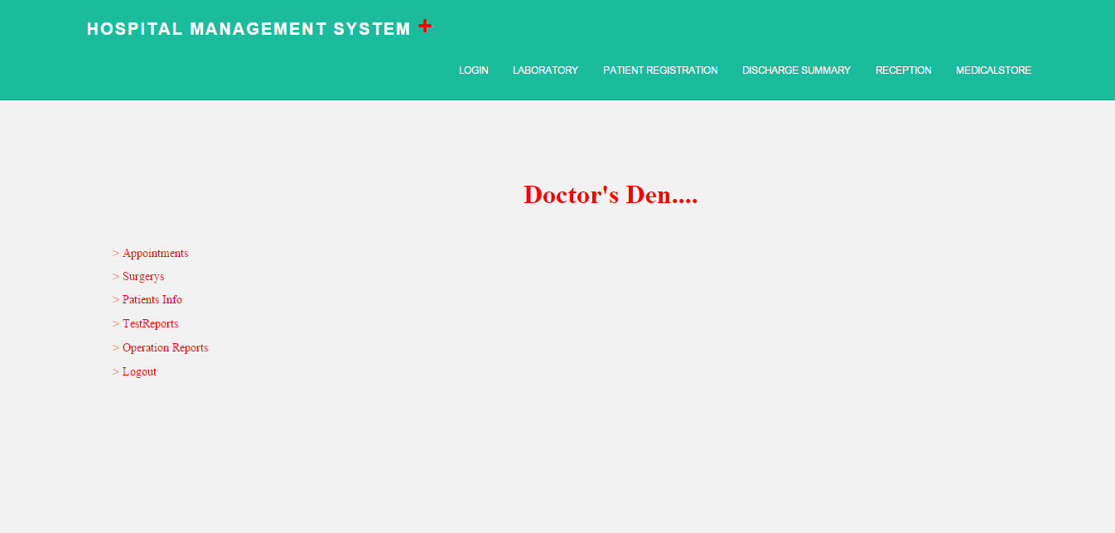

**Source**

<%@ Page Language="VB" MasterPageFile="~/MasterPage.master" AutoEventWireup="true" CodeFile="doctorsden.aspx.vb" Inherits="doctorsden" Title="Untitled Page" %>

<asp:Content ID="Content1" ContentPlaceHolderID="ContentPlaceHolder1" Runat="Server">

<asp:Label ID="Label1" runat="server" Font-Bold="True" Font-Names="Modern" Font-Size="24pt"

ForeColor="Red" Style="z-index: 102; left: 632px; position: absolute; top: 216px"

Text="Doctor's Den...."></asp:Label>

<asp:Menu ID="Menu1" runat="server" Font-Names="Modern" ForeColor="Red" Height="172px"

Style="z-index: 104; left: 136px; position: absolute; top: 296px" Width="112px">

<Items>

<asp:MenuItem Text="&gt; Appointments" Value="&gt;Appointments" NavigateUrl="~/viewappointments.aspx"></asp:MenuItem>

<asp:MenuItem Text="&gt; Surgerys" Value="&gt;Surgerys" NavigateUrl="~/viewsurgeries.aspx"></asp:MenuItem>

<asp:MenuItem Text="&gt; Patients Info" Value="&gt;Patients Info" NavigateUrl="~/patientinfo.aspx"></asp:MenuItem>

<asp:MenuItem Text="&gt; TestReports" Value="&gt; Logout" NavigateUrl="~/viewtests.aspx">

</asp:MenuItem>

<asp:MenuItem Text="&gt; Operation Reports" Value="&gt; Logout" NavigateUrl="~/viewoperations.aspx">

</asp:MenuItem>

<asp:MenuItem NavigateUrl="~/doctorlogin.aspx" Text="&gt; Logout" Value="&gt; Logout">

</asp:MenuItem>

</Items>

</asp:Menu>

</asp:Content>

**Code Behind**

Imports System.Data

Imports System.Configuration

Imports System.Collections

Imports System.Web

Imports System.Web.Security

Imports System.Web.UI

Imports System.Web.UI.WebControls

Imports System.Web.UI.WebControls.WebParts

Imports System.Web.UI.HtmlControls

Public Partial Class doctorsden

Inherits System.Web.UI.Page

Protected Sub Page_Load(sender As Object, e As EventArgs)

End Sub

End Class

**Employee Panel**

**Design**

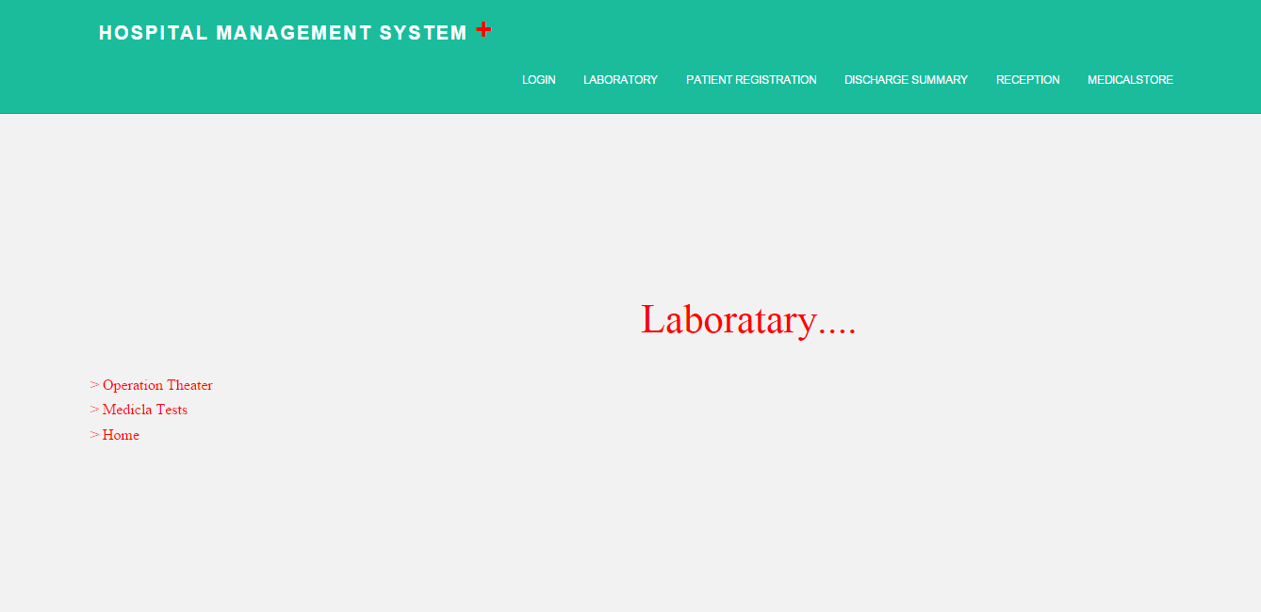

**Source**

<%@ Page Language="VB" MasterPageFile="~/MasterPage.master" AutoEventWireup="true" CodeFile="laborataries.aspx.vb" Inherits="laborataries" Title="Untitled Page" %>

<asp:Content ID="Content1" ContentPlaceHolderID="ContentPlaceHolder1" Runat="Server">

<asp:Label ID="Label1" runat="server" Text="Laboratary...." style="z-index: 100; left: 680px; position: absolute; top: 312px" Font-Names="Modern" Font-Size="32pt" ForeColor="Red"></asp:Label>

&nbsp;

<asp:Menu ID="Menu1" runat="server" style="z-index: 101; left: 96px; position: absolute; top: 400px" Font-Names="Modern" Font-Size="12pt" ForeColor="Red" Height="80px" Width="128px">

<Items>

<asp:MenuItem Text="&gt; Operation Theater" Value="New Item" NavigateUrl="~/operationth.aspx"></asp:MenuItem>

<asp:MenuItem Text="&gt; Medicla Tests" Value="&gt; Medicla Tests" NavigateUrl="~/medicaltests.aspx"></asp:MenuItem>

<asp:MenuItem Text="&gt; Home" Value="&gt; Home"></asp:MenuItem>

</Items>

</asp:Menu>

</asp:Content>

**Code Behind**

Imports System.Data

Imports System.Configuration

Imports System.Collections

Imports System.Web

Imports System.Web.Security

Imports System.Web.UI

Imports System.Web.UI.WebControls

Imports System.Web.UI.WebControls.WebParts

Imports System.Web.UI.HtmlControls

Public Partial Class laborataries

Inherits System.Web.UI.Page

Protected Sub Page_Load(sender As Object, e As EventArgs)

End Sub

End Class

**12. TESTING METHODOLOGIES & TESTING STRATEGY**

**12.1** **TESTING METHODOLOGIES**

**Recovery Testing**

In this test the system is tested by forcing it to fail in a Varity of ways and verifies that the recovery is properly performed. The re-initialization, data recovery, and restart are each evaluated for correctness.

**Stress Testing**

In this test the application is tested in a manner that the application is demanding resources in an abnormal manner. The application is tested for maximum memory usage.

**Performance testing**

Performance testing for the application is performed for finding the actual run-time performance. Time taken for search and locate the required data is tested. The data conversion accuracy and speed for the converter tool is also tested.

**System feasibility**

In this phase, we consider the various aspects of the targeted business process, find out which aspects are worth incorporating into a system, and evaluate various approaches to building the required software.

**Requirement analysis**

In this phase, we capture software requirements in such a way that they can be translated into actual use cases for the system. The requirements can derive from use cases, performance goals, target deployment, and so on.

**System design**

In this phase, we identify the interacting components that make up the system. We define the exposed interfaces, the communication between the interfaces, key algorithms used, and the sequence of interaction. An architecture and design review is conducted at the end of this phase to ensure that the design conforms to the previously defined requirements.

**Integration and system testing**

In this phase, we integrate all of the modules in the system and test them as a single system for all of the use cases, making sure that the modules meet the requirements.

**Deployment and maintenance**

In this phase, we deploy the software system in the production environment. We then correct any errors that are identified in this phase, and add or modify functionality based on the updated requirements.

**12.2** **TESTING STRATEGY**

Testing strategy integrates software test case design methods into a well-planned series of steps that results in the successful construction of software.

**Unit Testing:**

Unit testing is concerned with knowledge about testing a program unit, to determine that it is free of data, logic or standard errors. At this level white box testing are used. This unit includes knowledge of dynamic analysis. In this unit testing individual components or models are tested. It relatively focuses in the small segments of the code and the aims to exercise a high percentage of internal paths.

**Integration Testing**:

Integration testing is concern with knowledge about validating that software component, which have been unit tested separately, interact correctly when they are put together to perform higher order function. In this application bottom up integration testing is done.

**Bottom-Up Testing:**

Bottom-up integration testing begins construction and testing with atomic models are integrated from bottom up, processing require for models are subordinate to a given level is always available and need for stubs is eliminated.

**Functional Testing:**

Functional tests are programs or script configured to test that application met external requirements and achieve goals, such as performance, also known as black box testing because source code is not needed.

**Scenario Testing:**

Scenario testing is similar to, but not the same as session-based testing, which is more closely related to exploratory based testing and session –based test.

**13. CONCLUSION AND FUTURE ENHANCEMENT**

**13.1 Conclusion**

The project Hospital Management System (HMS) is for computerizing the working in a hospital. The software takes care of all the requirements of an average hospital and is capable to provide easy and effective storage of information related to patients that come up to the hospital. It generates test reports; provide prescription details including various tests, diet advice, and medicines prescribed to patient and doctor. It also provides injection details and billing facility on the basis of patient’s status whether it is an indoor or outdoor patient. The system also provides the facility of backup as per the requirement.

**13.2 Future Enhancements:**

This project was developed to fulfill user requirement; however there are lots of scope to improve the performance of the Hospital Management System in the area of user interface, database performance, and query processing time. Etc. So there are many things for future enhancement of this project.

**14. BIBLIOGRAPHY**

**14.1 Websites**

* [www.w3schools.com](http://www.w3schools.com)
* [www.msdn.microsoft.com](http://www.msdn.microsoft.com/)
* [www.dotnetperls.com](http://www.dotnetperls.com)
* [www.csharp.net-informations.com](http://www.csharp.net-informations.com)
* [www.homeandlearn.co.uk/csharp/csharp.html](http://www.homeandlearn.co.uk/csharp/csharp.html)
* [www.stackoverflow.com](http://www.stackoverflow.com)
* [www.dbforums.com](http://www.dbforums.com)
* [www.en.wikipedia.org](http://www.en.wikipedia.org)
* [www.tutorialspoint.com](http://www.tutorialspoint.com)

**14.2 Search Engine**

* [www.google.com](http://www.google.com)

**14.3 Books**

* .NET 3.5 Programming Black Book
* Comdex .NET Programming Course Kit by Vikas Gupta
* SQL, PL/SQL the Programming Language of Qracle 3rd Revision Edition by Ivan Bayross.