**DAYANANDA SAGAR COLLEGE OF ENGINEERING**

(An Autonomous Institute affiliated to VTU Belagavi, Approved by AICTE & ISO 9001:2008 Certified)

Accredited by National Assessment & Accreditation Council (NAAC) with ‘A’ grade, Shivige

Malleshwara Hills, Kumaraswamy Layout, Bengaluru -560078



Mini Project Report

on

**STUDENT MENTORSHIP**

Submitted by

**SANJEEV S 1DS17CS427**

**SANKET P B 1DS17CS428**

**SUPRITH S 1DS17CS432**

**THARUNN L 1DS17CS433**

[Sixth Semester B.E (CSE)]

in

**INTERNET AND WEB TECHNOLOGY**

Under the guidance of

**Dr. Deepak G**

Associative Professor

Dept. of CSE

DSCE, Bengaluru

**DAYANANDA SAGAR COLLEGE OF ENGINEERING**

**Abstract**

In each and every organization maintaining records of its day to day process is essential. Here we’ve considered the education institutions where the records of all the students and faculties are maintained and their performance is stored.

To accomplish the above task, we use a database. As it is used educational institutions, we called it a student database. There will be many departments in an educational institution and all these departments provide various records regarding students. Most of these information needs to be maintained as these information will be the general details like student name, performance etc, which is extremely useful in completion of course of a student.

This saves time and huge paper work. The HOD can get a clear status of what is going on in the department and act accordingly. He/she even gets to know who is the proctor of a particular student.

**Table of Contents**

**Introduction -4**

**Design/Implements -5**

**Testing/Result and Analysis -7**

**Conclusion and future enhancements -9**

**References in standard IEEE format -10**

**Introduction**

An organized and systematic office solution is essential for all universities and organizations.

There are many departments of administration for the maintenance of college information and student databases in any institution. All these departments provide various records regarding students. Most of these track records need to maintain information about the students. This information could be the general details like student name, address, performance, attendance etc or specific information related to departments like collection of data.

All the modules in a college a department is interdependent. They are maintained manually. So, they need to be automated and centralized because information from one module will be needed by other modules.

With that in mind, we made **Student Mentorship** which solve the problem of maintaining records and which keeps the data Safe and secure.

Administrators using the system will find that the process of recording and retrieving student’s information and managing their details is easy. In general, this project aims to enhance efficiency and at the same time maintain information accurateness.

**Design/Implementation**

No hardware components are used in the project.

Programming Language: - HTML, PHP, SQL

For Front-End we will be using HTML

For Back-End we will be using PHP and SQL

**HOME PAGE**

**SIGN UP**

**SIGN IN**

**STUDENT**

**FACULTY**

**HOD**

ALLOCATES

MANAGES

**FACULTIES**

**STUDENT INFO**

**HOD**

**FACULTY**

STUDENT 3

STUDENT 1

STUDENT 2

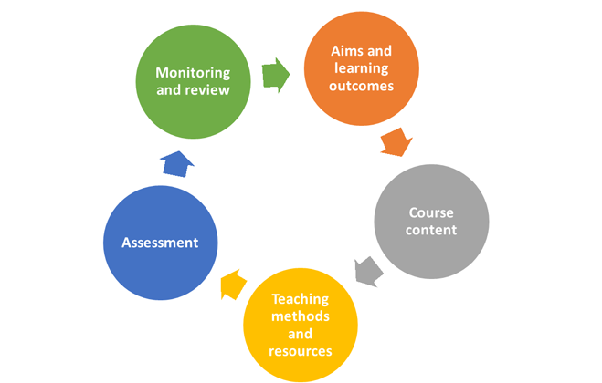

**Testing/Result and Analysis**

**LOGIN PAGE**

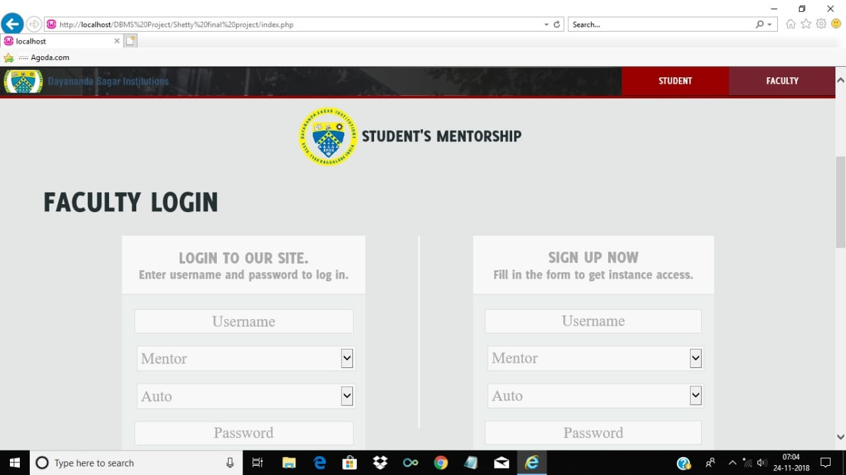

**STUDENT REGISTER**

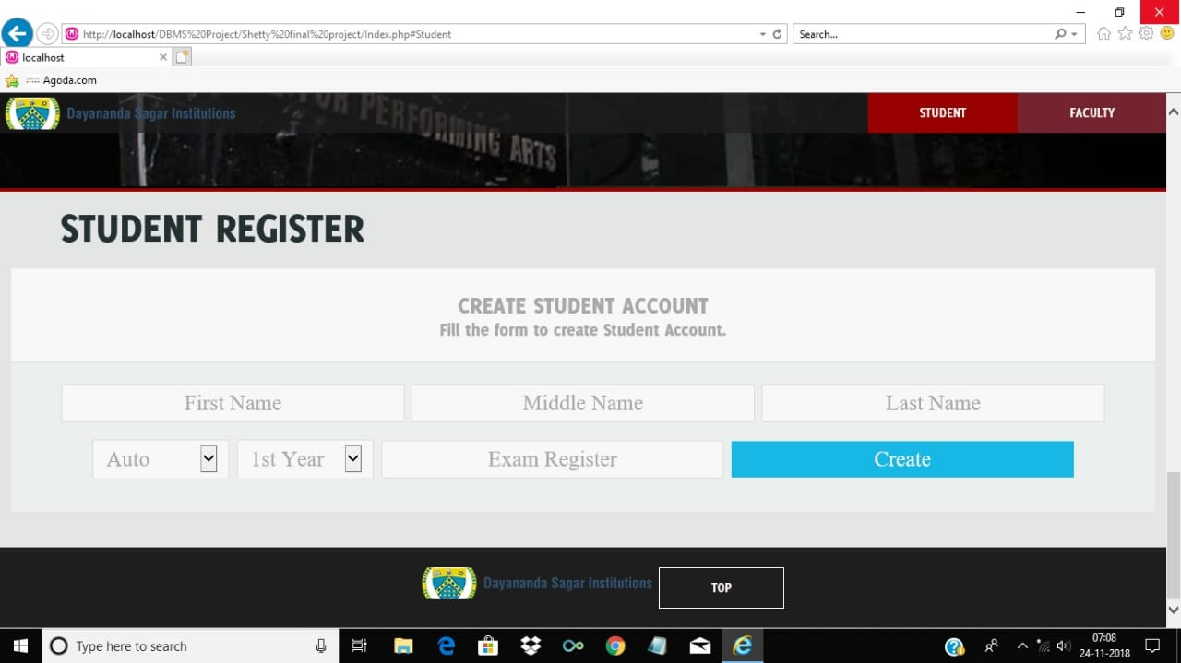

**HOD PANEL**

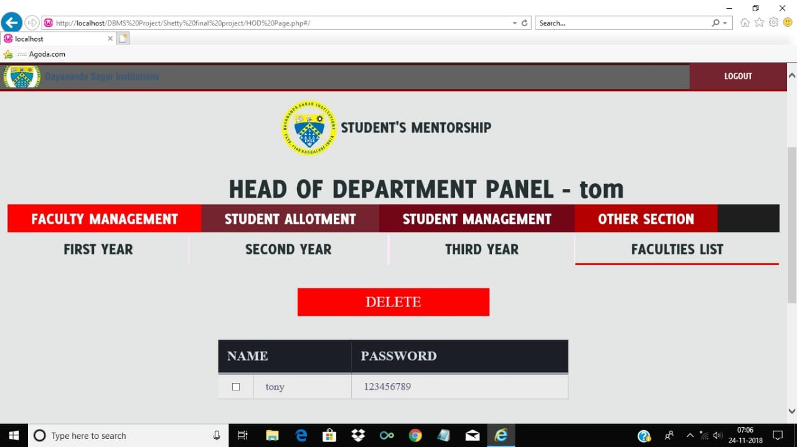

**FACULTY PANEL**

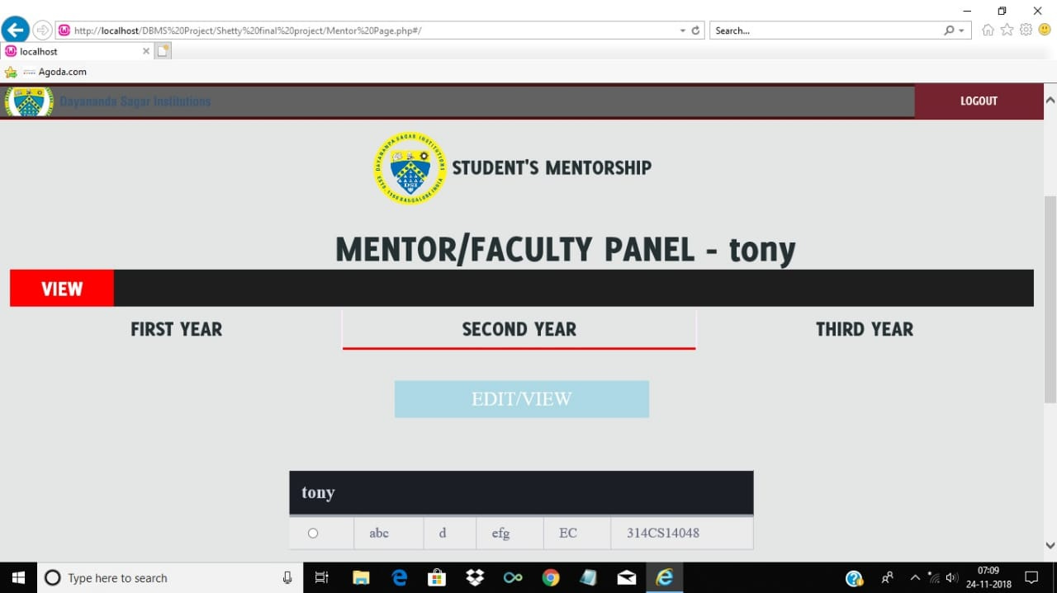

**Conclusion and future enhancement**

In a nutshell, it can be summarized that the future scope of the project circles around maintaining information regarding:

* We can add printer in future
* We can give more advance software for **Student Mentorship**

more facilities

* We will host the platform on online servers to make it accessible worldwide
* Create the master and slave database to reduce the overload of the database queries
* Implement the backup mechanism for taking backup of codebase and database and on regular basis on different servers

The above-mentioned points are the enhancements which can be done to increase he applicability and usage of this project. Here we can maintain the records of Students

We have left all the options open so that if there is any other future requirement in the system by the user for the enhancement of the system it is possible to implement them.

**References – in standard IEEE format**

* <http://www.sql.com/>org
* <http://php.net/manual/en/index.php>
* <http://developer.mozilla.org/>