**Fake news detection using NLP**

**ALGORITHM**

**Objective**:

Detecting Fake news using Natural Language Processing (NLP) involves several objective steps:

Step 1: Data collection

-Gather a broad dataset of news stories that have been classified as either true or fraudulent.

Step 2: Text preprocessing

- Remove HTML tags, special characters, and stopwords from the text data.

- Break up the text into words or subwords using word embedding or byte-pair encoding techniques.

Step3: Text Data Numerical Feature Extraction

- Convert the text data into numerical features that machine learning algorithms may use. Word embeddings like Word2Vec or GloVe and TF-IDF (Term Frequency-Inverse Document Frequency) are popular techniques.

Step 4: Model Selection

- Select a machine learning model that is appropriate for classifying text. Typical options include:

Nash Bayes

Inverse Logistic Regression

Rough Forest

- SVMs, or Support Vector Machines

- Neural networks (LSTM, CNN, BERT, for example)

Step 5: Model Training

- On the labeled dataset, train the chosen model using a piece for training and a different portion for validation.

Step 6: Model Evaluation

- Determine the effectiveness of the model by analyzing its accuracy, precision, recall, F1-score, and confusion matrix metrics.

Step 7: Feature engineering

- To enhance model performance, experiment with other features, NLP methods, or adjust hyperparameters.

Step 8: Handling Unbalanced Data

- Address the problem of datasets that are unbalanced, with one class (such as fake news) possibly being underrepresented in comparison to another (such as legitimate news). The use of specialized loss functions, oversampling, or undersampling techniques can be beneficial.

Step 9: Post-processing

- Depending on the particular use case, employ post-processing techniques to weed out probable false positives or false negatives.

Step 10: Deployment

- Use the trained model to analyze and categorize news articles as authentic or fraudulent in a real-time or batch processing context.

Step 11: Continuous Monitoring

- Keep an eye on the model’s performance constantly and update it as necessary with fresh information to account for changing fake news trends.

Step 12: User Interface (Optional)

- Design an intuitive interface that would allow users to enter news articles for categorization.

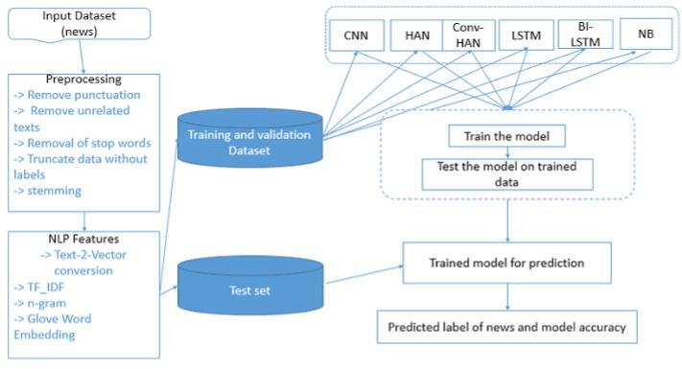**FLOWCHART**