Experiment 4

Ellipse Generation Algorithm

Using Midpoint ellipse generation algorithm which is a variant of Bresenham's line algorithm, write a C- Program to generate pixel activation list for drawing a ellipse?
Aim: To implement the Ellipse Generation Algorithm for drawing an ellipse of given center(x, y) and radius r_{x}
and r_{y}.

Description:
Basic Concept: In Ellipse,
Symmetry between quadrants exists
Not symmetric between the two octants of a quadrant
Thus, we must calculate pixel positions along the elliptical arc through one quadrant and then we obtain positions in the remaining 3 quadrants by symmetry
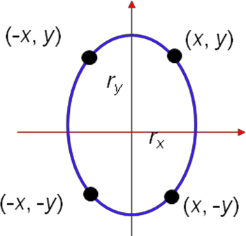
The next pixel is chosen based on the decision parameter. The required conditions are given in following algorithm.

Algorithm:
- Input r_{x}, r_{y}, and ellipse center (x_{c}, y_{c}), and obtain the first point on an ellipse centered on the origin as
(x₀, y₀) = (0, r_{y})

- Calculate the initial parameter in region 1 as
p1 = r 2 − r 2 r + ¹ r 2
0 y x y 4 x
- At each x_{i} position, starting at i = 0, if p1_{i} < 0, the next point along the ellipse centered on (0, 0) is (x_{i} + 1, y_{i}) and
p1 = p1 + 2 r² x + r²
i + 1 i y i +1 y

Otherwise, the next point is (x_{i} + 1, y_{i} – 1) and

p1 = p1 + 2 r ²x − 2 r² y + r²
i +1 i y i +1 x i +1 y
and continue until 2 r²y x ≥ 2 r² y
x

- (x₀, y₀) is the last position calculated in region 1. Calculate the initial parameter in region 2 as

p 2 =
r ² ( x
+ 1 ) 2
+ r ² ( y
− 1) 2 − r 2 r 2

0 y 0 2 x 0 x y

- At each y_{i} position, starting at i = 0, if p2_{i} > 0, the next point along the ellipse centered on (0, 0) is (x_{i}, y_{i} – 1) and

p 2 = p 2 − 2 r² y + r²
i + 1 i x i + 1 x

Otherwise, the next point is (x_{i} + 1, y_{i} – 1) and
p 2
i + 1 = p 2
+ 2 r²y x i + 1 − 2 r²x
y i + 1 + r²x

Use the same incremental calculations as in region 1. Continue until y = 0.
i

- For both regions determine symmetry points in the other three quadrants.

- Move each calculated pixel position (x, y) onto the elliptical path centered on (x_{c}, y_{c}) and plot the coordinate values
x = x + x_{c} , y = y + y

