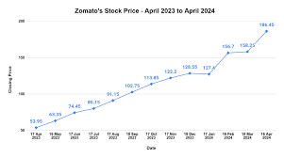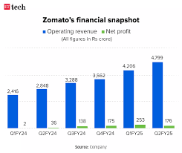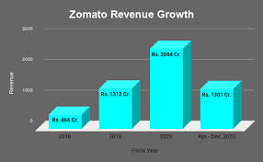

**Product Dissection for Zomato By Manoj**

**Company Overview:**

Zomato is a leading Indian quick commerce (Q-commerce) company, founded in 2008 by DeepinderGoyal and Pankaj Chaddah. Initially known as Zomato Media Pvt Ltd (formerly known as **Foodiebay Pvt Ltd**), the company rebranded to Zomato in 2021 to emphasize its commitment to ultra-fast delivery services. Headquartered in Gurugram, Haryana, Zomato specializes in delivering food, dining options, and daily items within 10-15 minutes through its mobile app and website.

Zomato is a global food-tech company that primarily operates as a restaurant discovery and food delivery platform. It helps users discover dining options, read reviews, and order food from restaurants via its website and mobile apps. Zomato started as a restaurant listing and review site, but over the years, it has expanded its services to include food delivery, table reservations, and a premium membership program. The company's mission is to "help people discover better places to eat, with a focus on providing them with the best possible experience.

In 2021, Zomato went public with an Initial Public Offering (IPO) and listed on the National Stock Exchange (NSE) and Bombay Stock Exchange (BSE) in India. Zomato faces stiff competition from other Q-commerce giants such as Uber Eats, Swiggy DoorDash, and Grubhub. Despite this, the company continues to grow rapidly, focusing on technological advancements like AI-driven demand forecasting to optimize inventory management and improve delivery efficiency.

Zomato started in India but expanded quickly into international markets. As of 2025, Zomato operates in multiple countries, including: India, USA, Australia, UAE, South Africa, Canada, United Kingdom. It has built a significant presence in many parts of Asia, the Middle East, and other regions, providing local restaurant discovery and food delivery services.

Zomato success lies in its ability to adapt to changing consumer behaviours, providing convenience, speed, and reliability in the fast-paced world of quick delivery.

Top restaurant chain in India:

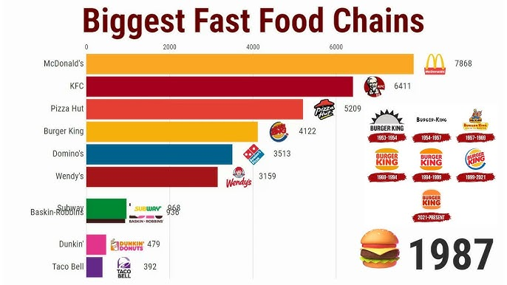

**Product Dissection and Real-World Problems Solved by Zomato:**

Zomato effectively tackles a range of real-world challenges through its innovative platform design, focusing on speed, efficiency, and customer satisfaction.

* **Ultra-Fast Delivery**: Zomato revolutionizes the traditional grocery shopping experience by addressing the time constraints faced by urban consumers. Through optimized supply chain logistics, intelligent route planning, and dynamic rider management, the platform ensures food items are delivered within 10 minutes, eliminating the need for time-consuming store visits.
* **Real-Time Inventory Management**: Unlike traditional retail models prone to stock discrepancies, Zomato maintains accurate inventory levels by synchronizing data across multiple warehouses and the mobile app. This real-time tracking system minimizes the risk of out-of-stock situations, always ensuring food availability for customers
* **Smart Cart and Personalized Recommendations:** Leveraging AI and machine learning algorithms, Zomato enhances user convenience by offering smart cart features and personalized product suggestions. These recommendations are tailored based on users’ purchase history, browsing behaviour, and preferences, creating a more intuitive and efficient shopping experience.
* **Seamless Payment Integration:** To address common transaction-related issues, Zomato supports a wide range of secure payment options, including UPI, credit/debit cards, and digital wallets. The platform also features instant refund mechanisms, reducing payment friction and enhancing user trust.
* **Efficient Delivery Partner Management**: Zomato robust delivery management system automates rider assignments based on real-time data, including location tracking, workload distribution, and traffic conditions. This ensures optimal delivery efficiency, reducing delays and improving service reliability.
* **Customer Loyalty Programs:** To foster long-term customer relationships, Zomato implements loyalty programs that include rewards, referral incentives, and targeted promotional campaigns. These strategies help increase customer retention and encourage repeat purchase.

Collectively, these features significantly improve the overall user experience by solving critical issues such as delayed deliveries, stock unavailability, payment inefficiencies, and the lack of personalized shopping. The database schema will be designed to reflect these functionalities through dedicated modules for user management, orders, payments, inventory control, logistics optimization, and promotional activities.

**Case Study on Real-World Problems and Zomato Approach to Solving Them:**

Zomato is an Indian multinational food delivery and restaurant discovery platform. Founded in 2008 by Deepinder Goyal and Pankaj Chaddah, Zomato has transformed how people discover and enjoy food. The platform provides users with information about restaurants, their menus, ratings, reviews, and allows them to place food delivery orders. Zomato operates in multiple countries and has become a major player in the global food tech industry.

1. **Food Delivery Logistics and Last-Mile Delivery Challenges.**

**Problem:**

Delays in food delivery, especially during peak hours, due to high traffic or bad weather conditions. Maintaining food quality during delivery, such as keeping the food hot or fresh. Optimizing delivery routes and managing a fleet of delivery personnel.

**Zomato Solution:**

Zomato uses AI and machine learning algorithms to optimize delivery routes. The platform analyses traffic patterns, historical delivery times, and real-time data to adjust delivery routes, reducing delays. Zomato works with a combination of in-house delivery agents and gig workers who are familiar with local routes, helping them overcome last-mile challenges. This helps ensure quick and reliable delivery.

**Schema Impact:**

* **Order Management:** Real-time tracking with timestamps for order placement and delivery.
* **Rider Assignment:** Tables for rider availability, live locations, and optimized routes.
* **Warehouse Inventory:** Real-time updates to ensure accurate stock information.

1. **Restaurant Partner Management and Engagement:**

**Problem:**

Ensuring that restaurant partners provide high-quality food and timely service, even during peak demand. Managing communication with numerous restaurant partners, handling disputes, and ensuring smooth coordination. Helping restaurant partners grow their businesses through Zomato's platform, especially in a competitive market.

**Zomato Solution:**

Zomato introduced a platform for restaurant partners, where they can update their menu, track orders, manage reviews, and understand performance metrics like delivery times and customer ratings. To drive more business for partner restaurants, Zomato introduced its loyalty programs like Zomato Gold and Zomato Pro

**Schema Impact:**

* **Inventory Tables:** Real-time stock updates with SKU tracking.
* **Product Catalog:** Manages product details and availability status.
* **Order Validation:** Ensures stock availability before order food confirmation.

**3. Payment Processing Issues**

**Problem:**  
Failed transactions, delayed refunds, and limited payment options are common pain points in e-commerce, affecting customer trust.

**Zomato Solution:**  
Zomato integrates multiple secure payment gateways, including UPI, cards, and wallets, with real-time transaction monitoring and automated refund processes for failed payments.

**Schema Impact:**

* **Payment Tables:** Track transactions, statuses, and payment methods.
* **Refund Management:** Automates refund initiation and tracking.
* **Transaction Logs:** For monitoring payment issues and audit purposes.

1. **Consumer Trust and Food Safety Concerns:**

**Problem:**

Concerns around the hygiene and safety of food during the delivery process. Customer dissatisfaction arising from issues like incorrect orders, delayed deliveries, or missing items.

**Zomato Solution:**

Zomato ensure Food Safety Standards, Customer Feedback and Dispute Resolution, Delivery Safety Protocols, Contactless Delivery Option.

**Schema Impact:**

* **User Activity Tracking:** Captures purchase history and behaviour data.
* **Recommendation Engine:** Generates personalized suggestions.
* **Customer Segmentation:** For targeted marketing and promotions.

**5. Delivery Delays Due to Inefficient Rider Management**

**Problem:**  
Manual rider assignments and poor route optimization often cause delivery delays, especially during peak hours.

**Zomato Solution:**  
Zomato uses automated systems to assign orders based on rider proximity, workload, and real-time traffic conditions, ensuring timely deliveries.

**Schema Impact:**

* **Rider Performance:** Tracks efficiency, delivery times, and feedback.
* **Dynamic Routing:** Optimizes delivery routes with live traffic data.
* **Delivery Logs:** For performance analysis and continuous improvement.

**Key Takeaways for Schema Design:**

Zomato ability to address these real-world problems is supported by a robust database schema comprising:

* **User Management:** Storing user profiles and activity data.
* **Order & Inventory Management:** Ensuring real-time tracking and stock updates.
* **Payment Processing:** Handling secure transactions and refunds.
* **Food and safety concern:** Powering AI-driven recommendations.
* **Logistics & Rider Management:** Optimizing deliveries and tracking performance.

This schema design ensures operational efficiency, scalability, and an enhanced user experience, aligning with Zomato core business objectives.

**Top Features of Zomato:**

1. **Restaurant Discovery and Reviews-**

* **Description:** Zomato allows users to discover restaurants based on location, cuisine, price range, and ratings.
* **Impact:**  This feature makes Zomato a go-to platform for anyone looking for new dining options or insights into restaurant quality, taste, and ambiance.

**2. Real-Time Inventory Management-**

* **Description:** The app shows live stock availability, ensuring that customers only order items that are currently in stock.
* **Impact:** Reduces order cancellations due to stockouts and improves supply chain efficiency.

**3. Seamless User Experience-**

* **Description:** The app features an intuitive interface with easy navigation, quick search, and personalized recommendations based on purchase history.
* **Impact:** Increases user engagement and retention through a smooth, hassle-free shopping experience.

**4. Wide Product Range-**

* **Description:** Zomato offers a vast selection of groceries, personal care products, household items, and more, catering to diverse customer needs.
* **Impact:** Encourages customers to rely on Zomato as a one-stop shop for daily essentials.

**5. Efficient Order Tracking-**

* **Description:** Real-time order tracking allows customers to monitor the status of their deliveries from preparation to doorstep arrival.
* **Impact:** Builds trust and transparency, reducing customer anxiety around delivery timelines.

**6. Multiple Payment Options-**

* **Description:** Supports various payment methods, including UPI, credit/debit cards, net banking, and wallets.
* **Impact:** Offers flexibility, catering to different customer preferences for secure transactions.

**7. Hyperlocal Warehousing Model-**

* **Description:** Utilizes dark stores strategically located in high-demand areas to fulfil orders quickly.
* **Impact:** Reduces delivery time and operational costs while maintaining product freshness.

**8. Personalized Recommendations and Offers-**

* **Description:** AI-driven algorithms suggest products based on browsing and purchase history, along with personalized discounts.
* **Impact:** Enhances the shopping experience and drives higher conversion rates.

**9. Scheduled Deliveries-**

* **Description:** Allows users to schedule deliveries at their convenience, in addition to instant delivery options.
* **Impact:** Provides flexibility for customers who prefer to plan their orders in advance.

**10. Robust Customer Support-**

* **Description:** 24/7 customer support through chat and call to address queries, complaints, and issues promptly.

**Impact:** Ensures quick resolution of problems, improving customer satisfaction and loyalty.

**Schema Description:**

The schema design for Zomato is structured to support its fast delivery model, focusing on real-time order processing, inventory management, and efficient logistics. The schema reflects the relationships between key entities involved in the Zomato ecosystem, such as users, products, orders, payments, and deliveries.

**Key Entities and Attributes:**

**1. Users Entity**

The **Users** entity stores customer information required for placing orders, receiving deliveries, and communication.

* **Attributes:**
  + user_id (Primary Key): Unique identifier for each user.
  + name: Full name of the user.
  + email: Email address for communication.
  + phone: Contact number of the user.
  + address: Default delivery address of the user.
  + registration_date: Date when the user signed up on the platform.

**2. Products Entity**

The **Products** entity contains details of all items available for purchase.

* **Attributes:**
  + product_id (Primary Key): Unique identifier for each product.
  + name: Name of the product.
  + category: Category to which the product belongs.
  + price: Cost of the product per unit.
  + description: Brief details about the product.

**3. Inventory Entity**

The **Inventory** entity helps track product availability across warehouses.

* **Attributes:**
  + inventory_id (Primary Key): Unique identifier for inventory records.
  + product_id (Foreign Key): Links to the **Products** table.
  + stock_quantity: Number of units available.
  + warehouse_location: Storage location of the product.

**4. Orders Entity**

The **Orders** entity logs every purchase made by a user and its status.

* **Attributes:**
  + order_id (Primary Key): Unique identifier for each order.
  + user_id (Foreign Key): Links to the **Users** table.
  + order_date: Timestamp when the order was placed.
  + status: Current status of the order (e.g., Processing, Delivered, Cancelled).

**5. Order Items Entity**

The **Order Items** entity connects products with specific orders, as each order may contain multiple products.

* **Attributes:**
  + order_item_id (Primary Key): Unique identifier for each order item.
  + order_id (Foreign Key): Links to the **Orders** table.
  + product_id (Foreign Key): Links to the **Products** table.
  + quantity: Number of units ordered.
  + price: Price per unit at the time of purchase.

**6. Payments Entity**

The **Payments** entity records transaction details for orders.

* **Attributes:**
  + payment_id (Primary Key): Unique identifier for each payment.
  + order_id (Foreign Key): Links to the **Orders** table.
  + payment_method: Mode of payment (e.g., UPI, Card, Wallet, COD).
  + payment_status: Status of payment (e.g., Successful, Pending, Failed).
  + transaction_date: Timestamp of payment processing.

**7. Riders Entity**

The **Riders** entity holds information about delivery personnel.

* **Attributes:**
  + rider_id (Primary Key): Unique identifier for each rider.
  + name: Full name of the rider.
  + phone: Contact number of the rider.
  + assigned_area: Geographic location where the rider operates.

**8. Deliveries Entity**

The **Deliveries** entity tracks the delivery status of each order.

* **Attributes:**
  + delivery_id (Primary Key): Unique identifier for each delivery.
  + order_id (Foreign Key): Links to the **Orders** table.
  + rider_id (Foreign Key): Links to the **Riders** table.
  + delivery_status: Status of the delivery (e.g., Out for Delivery, Delivered).

delivery_time: Timestamp when the order was delivered.

**Relationships:**

* **Users ↔ Orders:** One-to-Many (A user can place multiple orders).
* **Orders ↔ Order_Items:** One-to-Many (An order can contain multiple items).
* **Products ↔ Order_Items:** One-to-Many (A product can appear in multiple order items).
* **Orders ↔ Payments:** One-to-One (Each order has one payment transaction).
* **Orders ↔ Deliveries:** One-to-One (Each order is associated with a delivery).
* **Riders ↔ Deliveries:** One-to-Many (A rider can handle multiple deliveries).
* **Products ↔ Inventory:** One-to-Many (A product can be stocked in multiple warehouses).

**ER Diagram:**

Let's construct an ER diagram that vividly portrays the relationships and attributes of the entities within the Zomato schema. This ER diagram will serve as a visual representation, shedding light on the pivotal components of Zomato’s data model. By employing this diagram, By analysing Zomato core features, user interactions, and operational workflows, we designed a relational schema that supports efficient order processing, real-time inventory management, secure payment handling, and optimized delivery tracking.

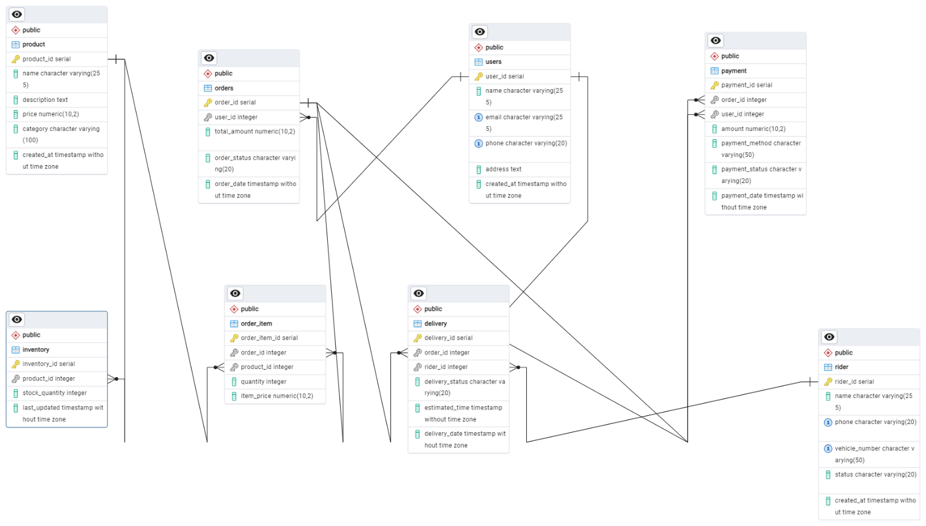

Now, let's discuss how the database design effectively addresses real-world challenges faced by Zomato.

1. **Handling Large Scale User Base and Diverse User Roles:**

The Users table includes a user_type column, which differentiates between customers, restaurant owners, and admin staff. Admins can control backend operations, restaurant owners manage their menus and reviews, and customers have access to features like ordering, reviewing, and saving favourites.

**2. Real-Time Inventory Management:**  
 The Inventory table is directly linked to the Products table, allowing Zomato to track stock levels across different warehouses. This design helps prevent stockouts or overselling by updating product quantities automatically after each purchase, ensuring accurate inventory visibility for both customers and the company.

**3. Optimized Delivery Tracking:**  
 The Deliveries table, linked with both Orders and Riders, helps assign delivery tasks efficiently based on rider availability and location. By tracking the delivery_status and delivery_time, Zomato can monitor real-time delivery progress, optimize routes, and maintain its promise of delivering within 10 minutes.

**4. Secure and Streamlined Payments:**  
 The Payments table is connected to the Orders table, capturing details like payment methods, statuses, and transaction timestamps. This structure ensures secure payment processing, easy reconciliation of transactions, and quick resolution of payment-related issues, enhancing customer trust.

**5. Data Integrity and Scalability:**  
 Finally, the use of primary and foreign keys enforces data integrity, ensuring relationships between tables remain consistent. The schema is also designed to be scalable, allowing Zomato to handle increasing user data, product catalogs, and transactions as the business grows.

**Conclusion:**

The database schema addresses key challenges of a Zomato-like platform by creating a well-structured, normalized design that caters to various users, handles large volumes of data, ensures data integrity, supports efficient order management, and enables personalized experiences for customers. Additionally, it allows for growth, flexibility, and enhanced reporting capabilities, making it a robust foundation for a food delivery and restaurant review platform.

The Entity-Relationship Diagram (ERD) effectively captured key entities such as **Users, Orders, Products, Inventory, Payments, Riders,** and **Deliveries**, illustrating their attributes and relationships. This schema not only ensures data integrity and consistency but also supports scalability to accommodate Zomato rapid growth and evolving business needs.

Through this project, we gained valuable insights into how robust database design plays a crucial role in enhancing platform performance, improving user experiences, and solving real-world challenges in the fast delivery ecosystem.