Task 1

Q. Read chapter 2 of the book "Artificial Intelligence: A Modern Approach" by Russel & Norvig
and create a mind map about its content.
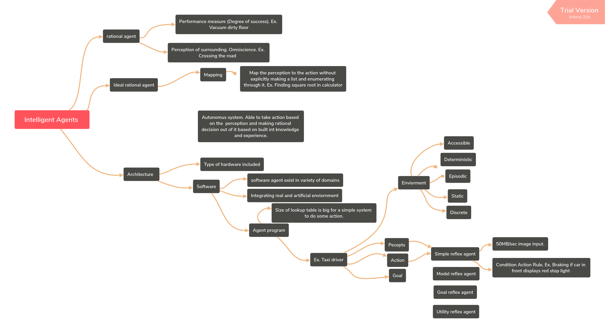
Reference

1. Artificial_Intelligence: A Modern Approach by Stuart J. Russell and Peter Norvig.

Task 2

Reflex based agents

In this type of agents a action is performed based on the feedback given by the system i.e sudden response to the present condition. Input to the agent is received from its surrounding environment through sensors and certain action is performed based on the mapping of condition action rule by controlling the actuators. Fig 1.1 shows the simple reflex agent. Let us take a example of a autonomous car which need to stop ones the car in front of it applies brake. Through the car’s camera sensor the image is obtained and checked for the condition whether the back light of a car in front of it is in on condition or not. Based on the computation result actuation is given to the effectors.

Surrounding Enviorment

Sensors Check the condition Actuators

System

Model based agents

Model based agent can handle a partially visible surroundings to do some action by maintaining a internal state inside the agent by taking data from percept history for a surrounding which is not visible to the agent. This agent model the world around it by some kind of structure based on the internal state that is why the name model based agent. Updating the internal state require two kind of information. Firstly, we need information about the world which changes independently of the agent. Secondly we need to have information about world response for the agent action.

Surrounding Enviorment

Sensors Actuators

State, How the world evolve, what my action do Check the condition
What the world
Is like now
What action I
should do now

Goal based agents

In a environment it is not enough to just do some action but it’s necessary to reach a target by doing a action. This is where goal based agent comes into picture. Here it needs to choose one action from list of possible action to reach a goal. A action is performed based on the sequence generated by search and planning. When a car sees the brake light in front of it, it can achieve the goal of not hitting the car by applying the brake. And it can update the correct environment condition to look for a new action which makes the agent reach it’s goal.

Surrounding Enviorment

Sensors Actuators

State, How the world evolve, what my action do Goal
What will happen
to the world if I
do this action
What the world
Is like now
What action I
should do now

Utility based agents

Goal can be achieved in multiple way but the goal achieved is with high safer, quicker , reliable and cheaper way? This is where utility based agent comes into picture. A agent which achieve the goal by choosing a action from the list of possible action such that it result in a quicker, reliable and cheaper way is said to have high utility fro the agent. This agent choose action based on a preference for each possible state. A utility maps the perception into a action such that the it achieve high degree of utility.
Surrounding Enviorment
Sensors Actuators

State, How the world evolve, what my action do Utility
What the world
Is like now
What will happen
to the world if I
do this action
How happy I
Will be in such
state
What action I
should do now

Reference:

1. https://en.wikipedia.org/wiki/Intelligent_agent

Task 3

Q. What is a Braitenberg vehicle? How would you classify Braitenberg vehicles? Are they reflex,
model-, goal- or utility-based agents?

Braitenberg vehicle

It is a vehicle concept developed by Valentino Braitenberg that behaves autonomously based on the input from the sensors. Perception is done by the sensors and actuation is implemented by the motors attached to the wheels.

Braitenberg vehicle can be classified based on the behavior it exhibit. Behavior can be fear, aggression, love and liking.

Fear
When the vehicle is configured in such a way that it try to avoid the environment it is in by turning away from the situation it is uncomfortable with is said to have fear behavior.

Aggression
In this type of behavior, vehicle moves faster and crashes with the target.

Liking
Liking vehicle like the company of the environment by staying more time in that current environment, whenever the values of senor changes it changes it’s course and look for other favorable environment making it a likable or exploring vehicle.

Love
This kind of vehicle try to move faster towards the target and as the target approaches it slows down and then stops.

Braitenberg vehicle is a goal based agent. Different behavior can be achieved by choosing from the different configuration of senors and the actuators. Ultimately behavior of a agent is defined by the goal of the agent it need to achieve.

Reference

1. https://en.wikipedia.org/wiki/Braitenberg_vehicle

Task4

Q(a). Think of one iteration as the sequence of loading the boat, rowing over the river and
unloading the passengers. What information is required to fully describe the state of the
problem before/after each iteration?

A: a. Number of missionaries and cannibals on left side and right side of the river. And number of
cannibals shouldn’t exceed the number of missionaries on both side of river.
b. Position of boat (on left or right).
c. Check whether the current state is similar to the state it was before. If so just ignore the
current state.

Q(b). Find a solution to the problem manually.

A: Let M are the three missionaries and C be three cannibals

Iteration Left side of river River Right side of river

1 MMM
BOAT
CCC
2 MMM CC
C
3 MMM C
CC
4 MMM CCC

5 MMM CC
C
6 M MM
C CC
7 MM M
CC C
8 CC MMM
C
9 CCC MMM

10 C MMM
CC
11 CC MMM
C
12 MMM
CCC

Q(c). Illustrate the complete state-space of the problem as a tree (a mind map tool will come in
handy here as well!). The root node represents the initial configuration: all six individuals
and the boat are on the left side of the river. Each edge represents a shipment of at most two
persons to the other side. Add nodes for disallowed configurations, mark them accordingly
and do not expand them further. Is it wise to check for repeated states? Why (not)?



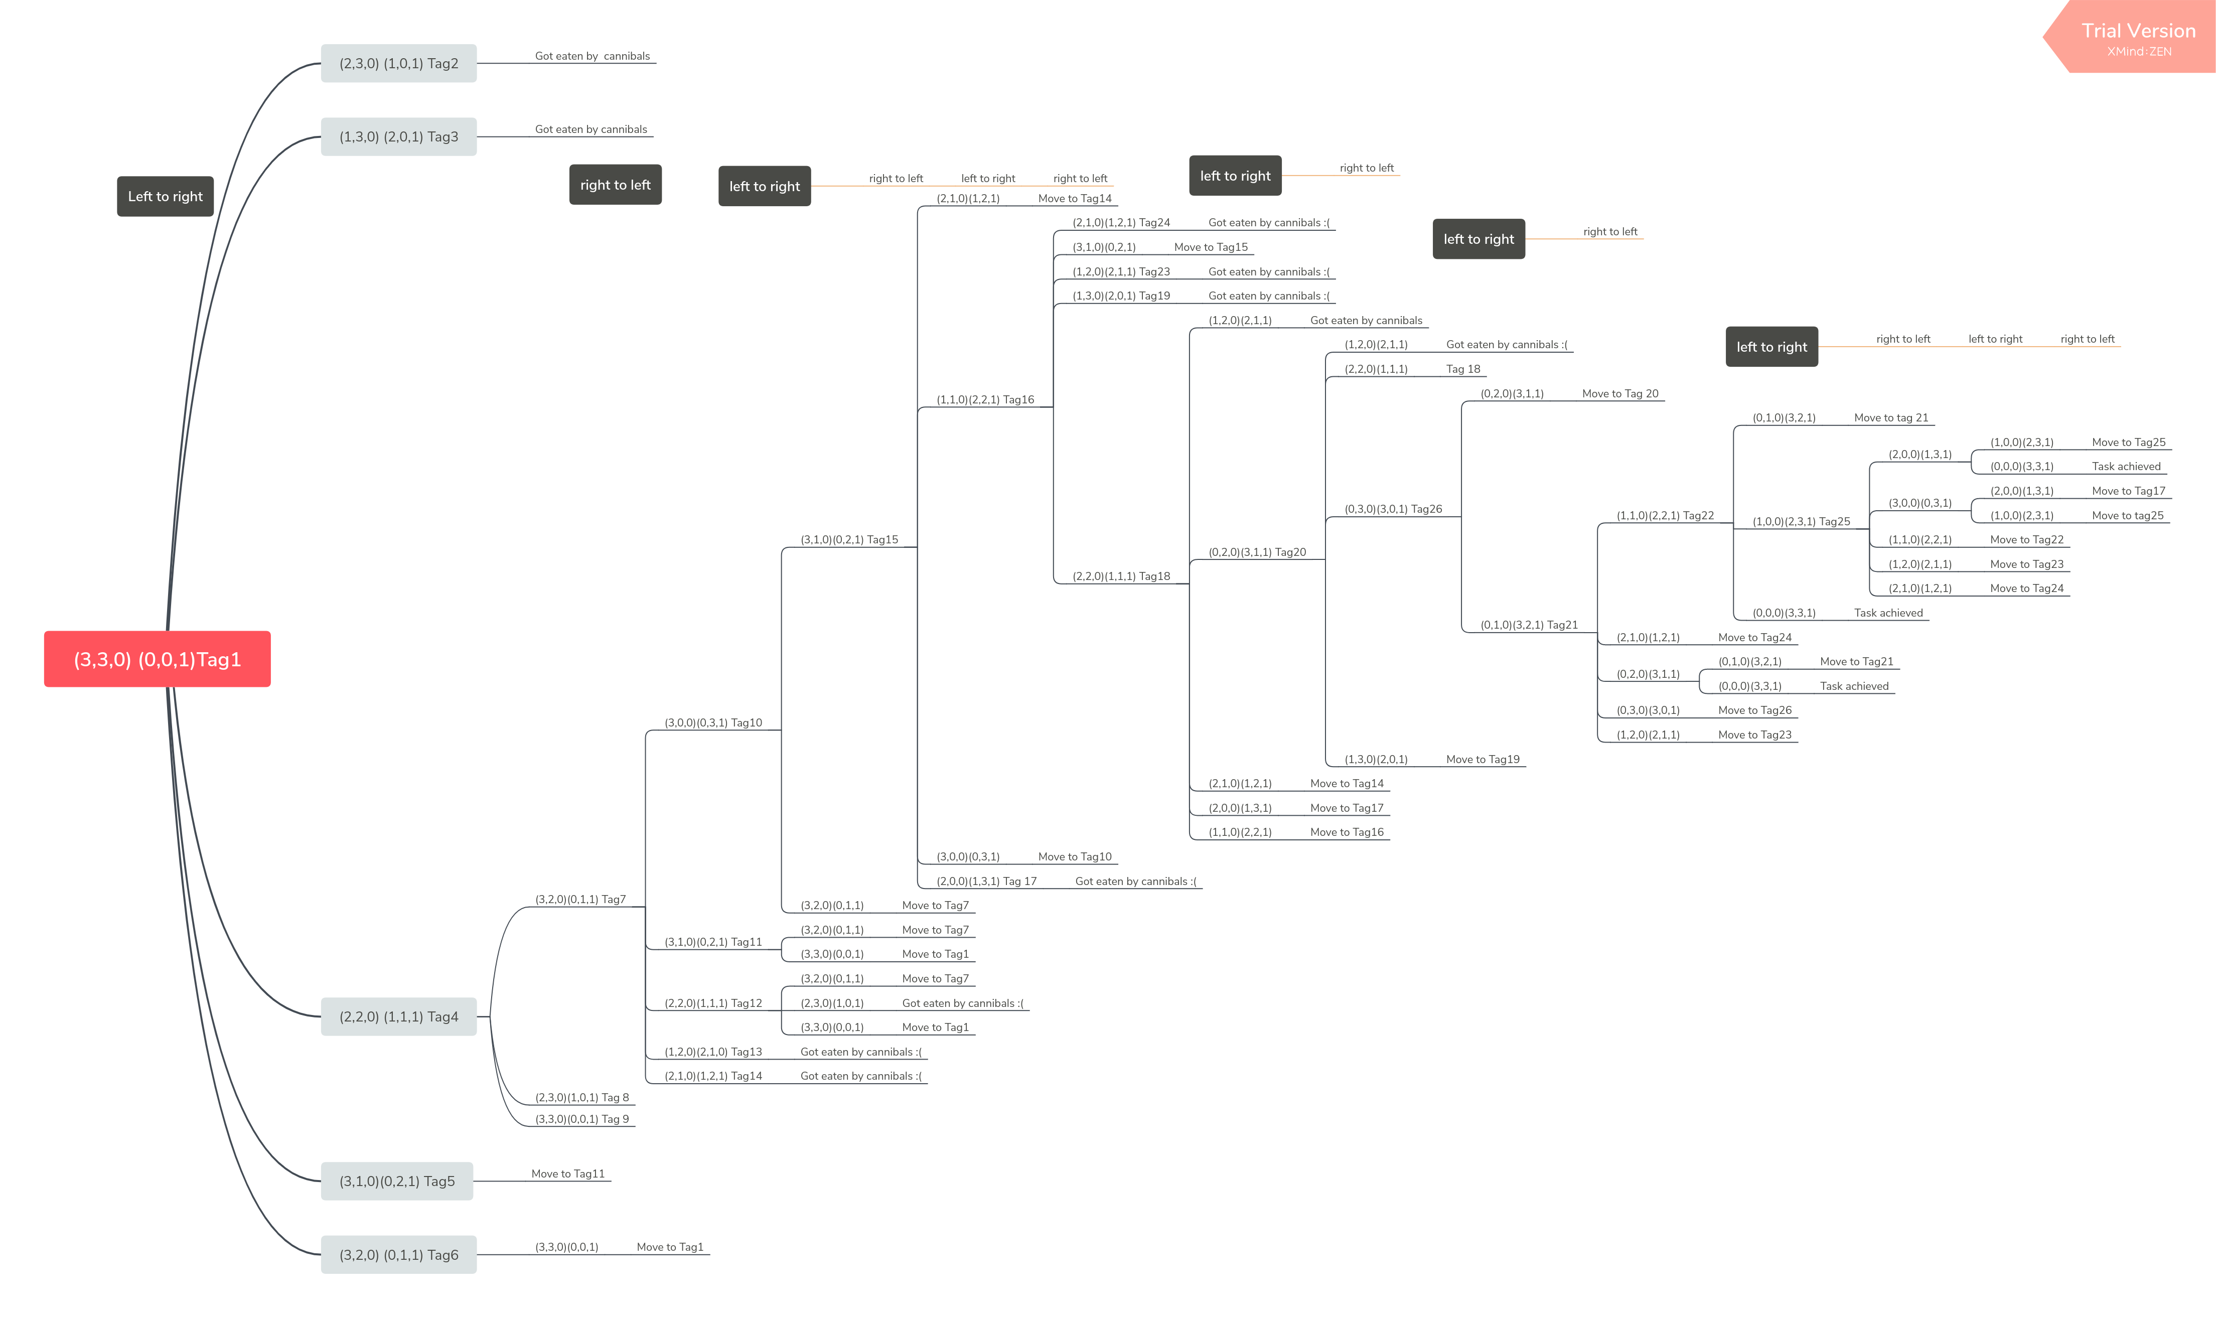
A: (M,C,B) where
M – number of missionaries. Eg. 1,2,3
C – number of cannibals. Eg . 1,2,3
B – Boat position. ‘0’ for boat on the left side of river and ‘1’ for boat on the right side of river.

Task: Start (3,3,0)(0,0,1) → Destination(0,0,0)(3,3,1)

It is not wise to check for the repeated state-space since it cost computationaly expensive by both
time and space complexity.

