1. Why is a special notation needed to classify algorithms? Doesn’t it suffice to merely measure the
runtime in seconds? Explain.

Algorithmic complexity measures the performance of the given algorithm mainly in terms of time and space mainly. Complexity is defined as a numerical function (T(n)) time versus the input size n. T(n) doesn’t depend on the implementation. But time taken by a algorithm to run depend on implementation. Depending on the processor speed; instruction set, disk speed and etc a algorithm takes different amount of time to run on the same input. So we need some kind of notation that can give information about the time taken by a algorithm to run based on the input size. We consider time T(n) as the number of steps such that each such step takes constant amount of time.
Let us take a classic example of adding two integer digit by digit. Addition of two n digit integer takes n number of steps to add digit by digit. Consequently, time taken by a algorithm to add this two n digit integer will be T(n) = c*n, where c is the time taken add two digits. Different computer take different amount of time to add two digits say c1 and c2. Computational time for the two computers to run n size data will be T1(n) = c1*n and T2(n) = c2*n respectively. Below Fig 1.0 shows the example of big-O notation for condition f(x) belongs to O(g(x)) as c>0 and x0 such that f(x) ≤ cg(x) whenever x ≥ x0.

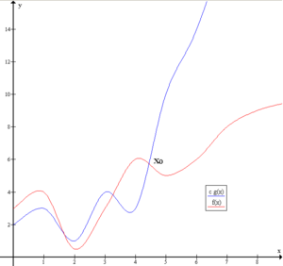

Fig 1.0

Finding runtime in seconds doesn’t give information about the amount of data has been processed. It gives information about time it takes to run a program. In order to find the amount of data being processed by a computer we represented the complexity by finding the numerical equation that depends on the input size n.

2. Let g : N → R+ be an arbitrary function. The set of functions f : N → R+ , which do not
grow faster than the function g after a specific point n 0 , is denoted as O(g(n)). More
specifically: O(g(n)) := f (n)| ∃ c # R and ∃ n 0 # N : 0 ≤ f (n) ≤ cg(n) ∀ n ≥ n 0.

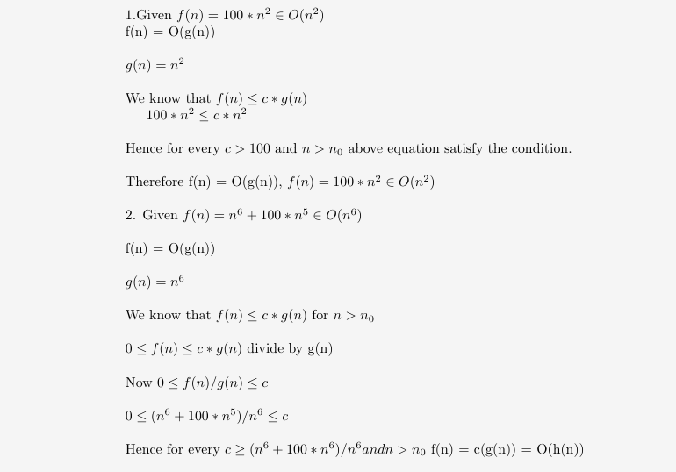

3. What is the running time of the following python-code in O-Notation? Assume, that
ANY_CONST is an arbitrary constant in your program, which receives a 2d array arr as
parameter.
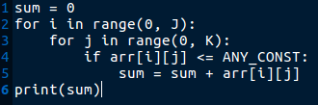

Worst case Scenario:
Line number 1 and 6 takes one step of iteration. Line 4 and 5 will run for K times and for loop in line 3 will run for J times.

So O(n) = (J*(2K) +2) = JK

4. For each function f (n) and time t in the following table, determine the largest size n of
problem that can be solved in time t, assuming that the algorithm to solve the problem takes f (n)
microseconds. Please briefly mention how you do the calculations for items: log(n), 2 n , and n
log(n).

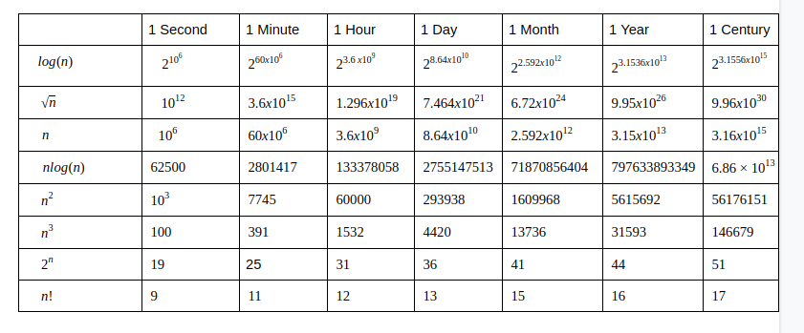
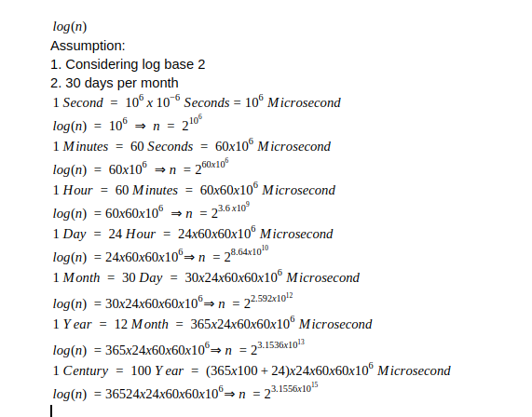
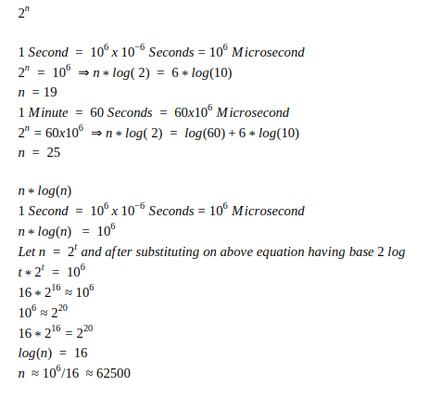

Reference

1. https://math.stackexchange.com/questions/406707/elegant-way-to-solve-n-log-2n-le-106
2. https://en.wikipedia.org/wiki/Big_O_notation

