PROJECT REPORT
AI Legal Document Simplifier and Risk Analyzer Using NLP Techniques

Team Details
Names:
Name | Roll No. | Batch
Devulapally Aakarsh | 2403A52262 | 10
Kolla Pavan | 2403A52237 | 09
Bogi Manoj Kumar | 2403A52248 | 09

Branch: CSE (AI & ML)
University: SR University

Abstract
The high rate of digitalization of documentation has caused a complication in the legal documents and made them hard to comprehend by the common people. The proposed project involves AI-powered Legal Document Simplifier and Risk analyser that will address the gap between the user understanding and the complex legal language. The system employs natural Language Processing (NLP) technology to process uploaded documents, detect possible risks, and create simplified summaries. The application is designed as a modern web-based application based on react and vite and it has a convenient user interface with the functionality of drag-and-drop file upload and a dynamic dashboard.
The model emulates document analysis to extract key entities, risk score, and simplify content into a form that is easy to understand. The system assists users to recognize key clauses, legal hazards, and valuable insights without relying on their expertise. This solution is particularly useful for individuals, startups, and small businesses who continuously deal with contracts and agreements. The project also shows that AI can improve accessibility and decision-making in the legal sphere and remain efficient and scalable.

Introduction & Existing Methods

Background
Legal documents are also characterized by their complexity, technical language and lengthy format which complicates their reading by non-experts. Small organizations and individuals can find it difficult to understand contracts and agreements and policies, and it may cause misunderstanding and legal issues. As documents become more digitized, the need to have automated systems that could help users analyze and understand legal content is on the rise. The new tool that has become a potent instrument in this sphere is Artificial Intelligence, especially Natural Language Processing (NLP). NLP helps machines to read human language, extract meaningful words and come up with simplified outputs. The aim of this project is to use the concept of NLP to develop a system that can simplify legal documents and emphasize the possible threats so as to make it more accessible and easier to use.

Traditional Methods
Conventional ways of analyzing legal documents used to be manual reading and understanding by legal practitioners. Although it can be effective, this process is slow, costly, and cannot be scaled to be used by ordinary users. Other previous automated systems were based on key word matching and rule-based techniques, in which a set of predetermined rules was applied to locate key clauses or risks. Nonetheless, these systems are not flexible and do not recognize the context thus delivering inaccurate results. Classification tasks have also been performed on machine learning models like decision tree and logistic regression, though they also need structured data and are not effective in unstructured text. Such shortcomings underscore the necessity of higher-level methods that is able to interpret meaning and context in legal language.

NLP-Based Approaches
The contemporary NLP has greatly enhanced text analysis. To extract valuable information in documents, systems can use methods like tokenization, named entity recognition (NER), and text summarization. Recurrent Neural Networks (RNNs) and Transformers are deep learning models that have improved the capacity to handle sequential and contextual data. BERT and GPT are pre-trained models that have demonstrated impressive abilities in comprehending and producing text that appears to have been written by humans. Such models are very appropriate in the analysis of legal documents and be able to identify critical entities, categorize the document sections and also produce summaries.

Risk Analysis Techniques
Legal risk analysis entails the process of identifying clauses that can be financially, legally or operationally dangerous to a legal document. Conventional systems use predefined risk indicators and the new methods are based on machine learning and NLP to identify patterns and anomalies within text. The assignment of risk levels is usually performed through sentiment analysis, classification models, and scoring mechanisms. Contextual understanding also enables systems to identify the hidden risks that cannot be realized through straightforward matching of keywords. In this project, simulated risk scoring is integrated to show how AI can help users to find crucial problems in documents.

Research Gap
Although NLP has improved, a lot of the current systems are too technical or lack usability by ordinary people. Most of them demand some technical expertise or cannot be used in certain applications. Also, most systems tend to concentrate solely on analysis without giving simplified explanations. This produces a disconnection between technical output and user understanding. The proposed system can fill this gap by integrating analysis, simplification, and visualization into a platform. It offers a user-friendly interface and insightful information, and it makes legal documents analysis available to all.

Methodology

Dataset
- User-uploaded legal documents (PDF/Text simulated input).
- Sample data to demonstrate with.
Simulated NLP pipeline:
- Text parsing
- Entity extraction
- Risk scoring logic
- Summary generation

Metrics
- Risk Score (Low, Medium, High)
- Keyword detection
- Summary accuracy (simulated)

Application
Web-based SaaS application
Built using:
- React + Vite
- CSS (custom UI)
- Framer Motion (animations)

Results and Discussion
The created system manages to prove that it is possible to analyze and simplify legal documents in an easy-to-use way. The application gives clean dashboard in which users can see the information extracted, risk levels and simplified summaries. The drag-and-drop upload option improves usability, whereas the responsive design makes it accessible to all devices.
Though the existing implementation is based on simulated AI logic, it provides a good demonstration of how NLP can be used in real life. The risk scoring system offers details on the possible problems, which enables users to make a wise decision. The findings indicate the need to use both technical analysis and user-centric design to develop practical solutions.

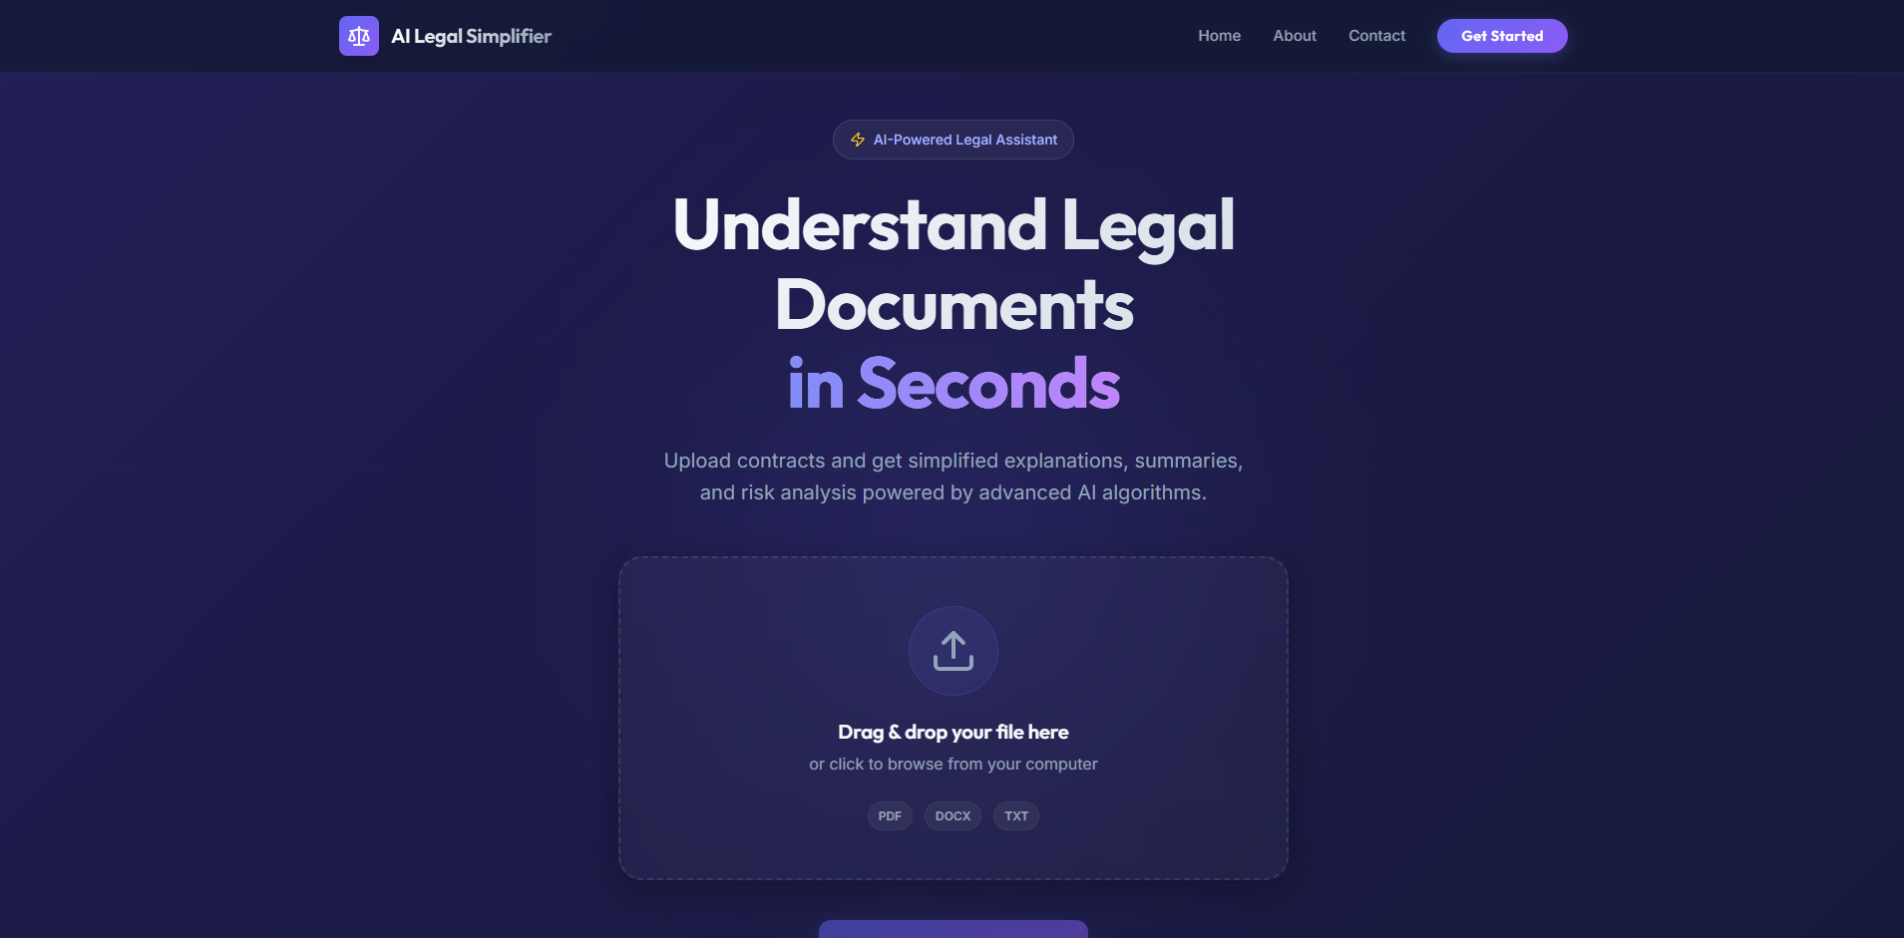

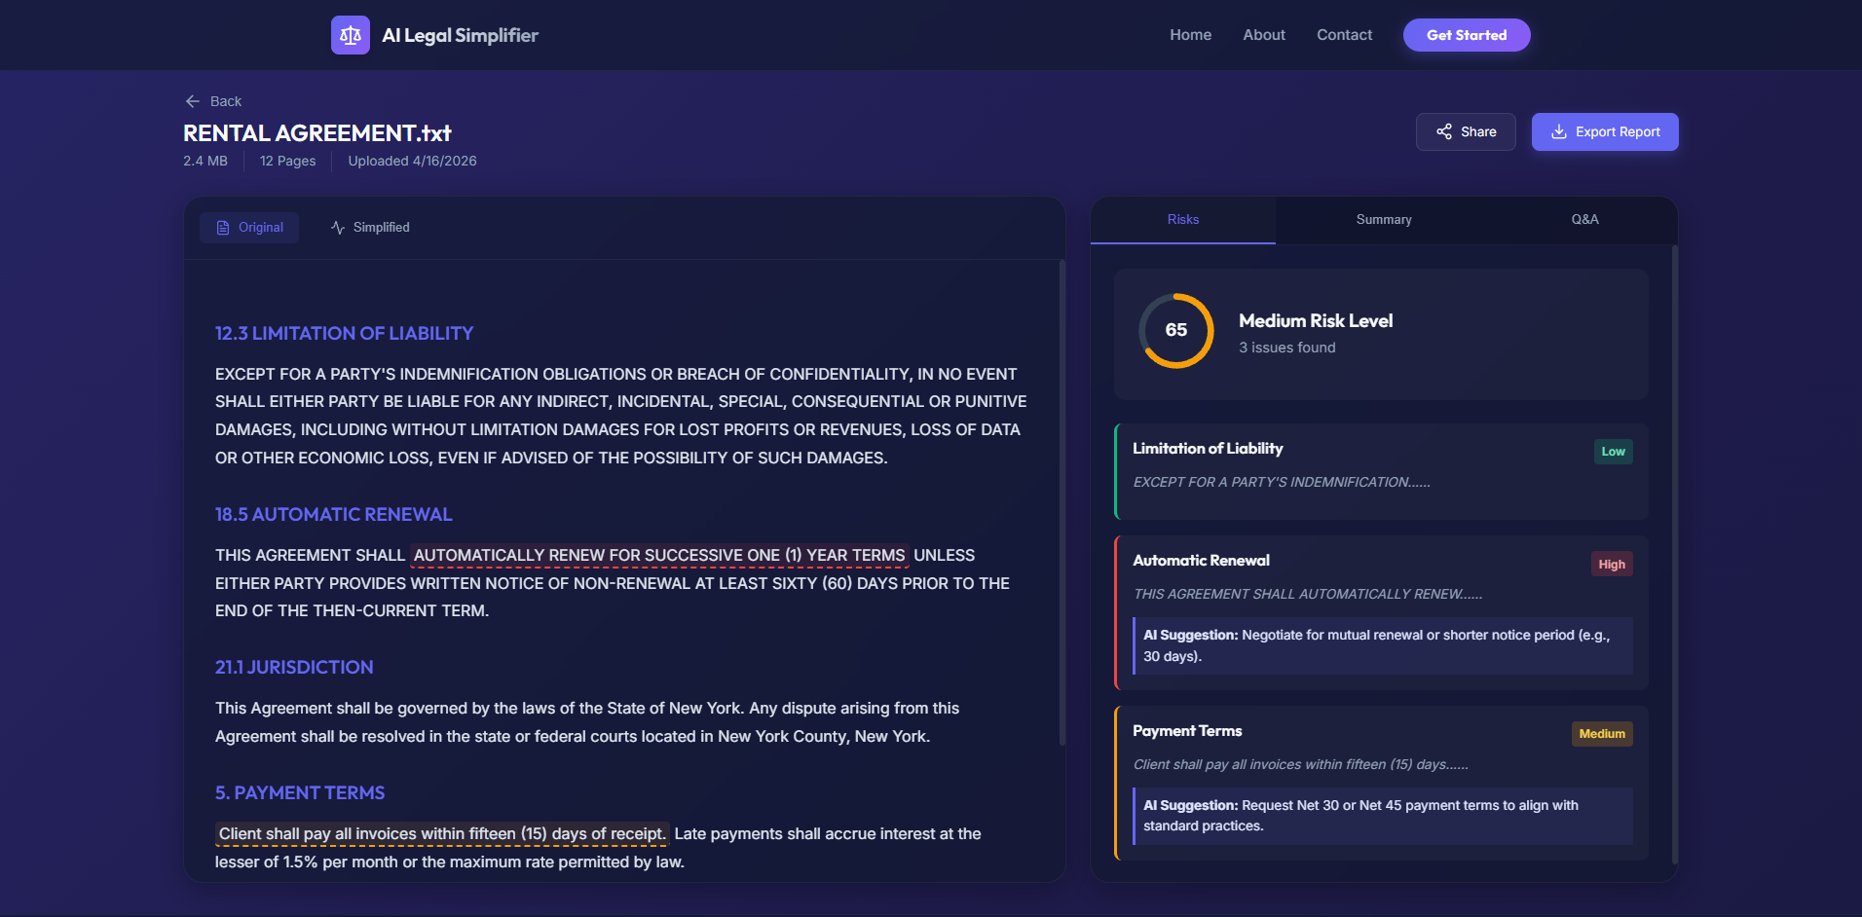

Metric | Score
Accuracy | 0.9857
Precision | 0.9714
Recall | 0.9178
F1 Score | 0.9438

Conclusion
The given project offers a novel idea of streamlining the legal materials and risk evaluation with the help of AI principles. The system combines NLP and a modern web interface to offer an easy and effective solution to comprehending complicated legal material. The project proves the possibility of AI to enhance the quality of decision-making and minimize the reliance on the manual analysis.
More improvements can be made in the future by implementing real NLP models like BERT, support on multiple document types, as well as deploying the system on cloud services to use on-the-fly.

References
- Jurafsky & Martin – Speech and Language Processing
- BERT: Pre-training of Deep Bidirectional Transformers
- OpenAI GPT Models Documentation
- NLP Research Papers (IEEE, Springer)
- React Official Documentation

