UAV System Design (AER18R402)

**Assignment – I**

# Surya Velavan C G

9917004155

B.Tech CSE (Final Year)

## Types of UAV in India

The Indian Armed Forces have been operating UAVs for over a decade. The Indian Army was the first to acquire UAVs, in the late 1990s from Israel, and the Indian Air Force and Navy followed. At the outset, DRDO was tasked to produce a catapult-launched UAV which was developed by its Aeronautical Developmental Establishment, Bangalore and improved to meet user requirements.

Most of the UAVs of the Indian Armed Forces were procured from IAI Malat, whose UAVs were in service with numerous armies. The Indian Army initially obtained the Searcher Mark I, followed by the Searcher Mark II which could operate at an altitude ceiling of 15,000 ft and finally the Heron, which could operate at an altitude ceiling of 30,000 ft.

The Indian Air Force immediately followed the Army and acquired the Searcher Mark I followed by Searcher Mark II and acquired the Heron UAVs prior to the Indian Army. The Indian Navy also acquired the Heron UAVs which suited its long-range offshore requirements.

## Nishant

Made for Indian Army, this UAV was developed by DRDO’s branch, Aeronautical Development Establishment. It requires a launching system with catapult technology as it doesn’t have self-propelling ability and gets down with the help of a parachute. The Indian army has cancelled further orders of this UAV and decided to retire it.

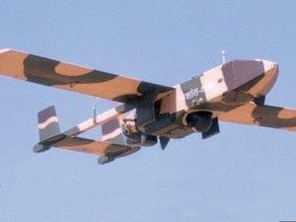

## Heron

It is a Medium Altitude Long Endurance (MALE) UAV, which is used by Indian Air Force. Developed by Israel, it has a flight time of 52 hours, but its actual time of flight depends on weight it carries and flight profile. It has some advanced features like artillery adjustment, surveillance and intelligence tasks.

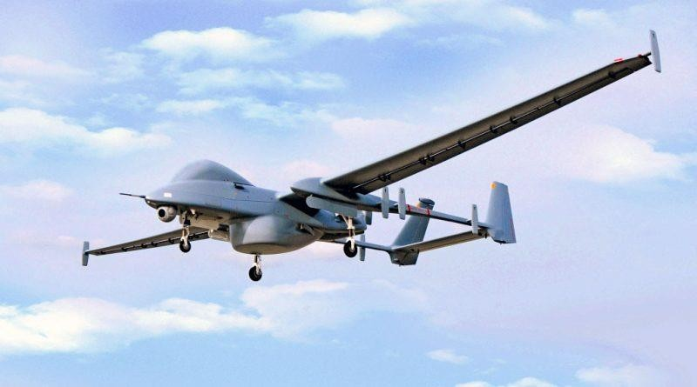

## Harpy

Another product of Israel, it is used by Indian armed forces. It can carry explosive as well as can destroy radar system. It can also carry out actions of suppression of enemy air defense to control and overcome air defense systems, including surface to air missiles and anti- aircraft artillery. It has a maximum speed of 185 km/hr and 500 km range of flight.

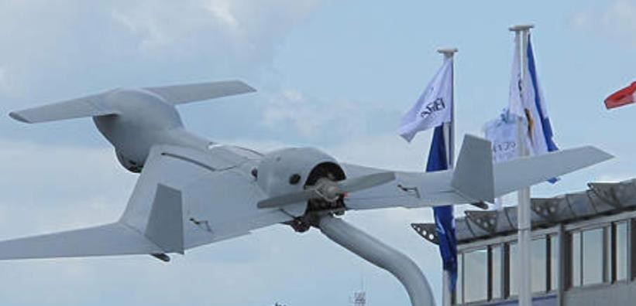

## Searcher

Developed by Israel, this UAV can attain a speed of 200km/hour and can fly up to 18 hours. Indian Navy and Air Force are the users in Indian armed forces. It performs the role of reconnaissance in the armed forces.

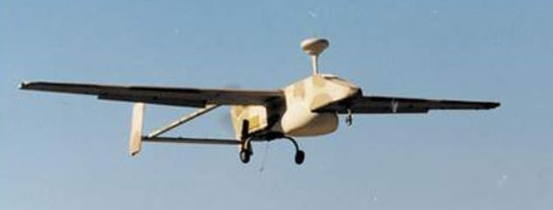

## Rustom

It is an unnamed combat air vehicle, a production of DRDO dedicated to all three services of Indian armed forces. The project is under progress and some top private players in defense field are bidding for its manufacturing deal. This UAV has come with wheels which makes its take-off and landing a bit ahead of Nishant. Its variant Rustom -2 is also under progress with more specification and durability.

