
Cardiff Metropolitan University
School of Technologies

LLM AND RAG INTEGRATED CHATBOT BUILDER PLATFORM

Student Name: Manojkumar Dheenadhayalan
Student ID: st20316714
Programme: MSc Robotics and Artificial Intelligence
Module: CST7000 — Technology Dissertation
Supervisor Name: Dr Faizan Ahmad
Institution: Cardiff Metropolitan University
Submission Year: 2026
Ethics ID: CST-PG-220

Table of Contents
List of Tables iv
List of Figures iv
Abstract 1
1. Introduction 2
1.1 Context of the Study 2
1.2 Rationale 2
1.3 Research Issues 2
1.4 Potential Benefits 3
2. Aims, Objectives and Research Questions 3
2.1 Research Aim and Objectives 3
2.1.1 Aim 3
2.1.2 Objectives 3
2.2 Research Questions 3
2.3 Research Significance 4
3. Literature Review 4
Table 1: Literature Review Summary Matrix 4
3.1 Large Language Models: Capabilities and Limitations 6
3.2 Retrieval-Augmented Generation: Architectures and Best Practices 6
3.3 Open-Source vs. Proprietary LLMs: A Cost-Quality Analysis 7
Table 2: LLM Benchmark Comparison — Open-Source vs. Proprietary 7
3.4 Chatbot Development Platforms: State and Gaps 8
3.5 Ethical Considerations 9
3.6 Research Gap and Contribution 9
4. Methodology 10
4.1 Research Philosophy 10
4.2 Research Approach 10
4.3 Research Design and Strategy 11
4.4 Sampling Method 11
4.5 Data Collection Method 11
4.6 Data Analysis Techniques 11
4.7 Formation of Hypotheses 12
4.8 Limitations 12
4.9 Ethical Considerations 12
5. System Design and Implementation 12
5.1 Platform Overview 12
5.2 System Architecture 13
5.3 Visual Node Editor — Platform Implementation 13
5.4 Technology Stack 14
5.5 Supported LLM Providers 15
5.6 Supported Document Loaders 15
5.7 Chatflow Dashboard and Chatbot Management 16
5.8 Chatbot Settings and Public Deployment 16
5.9 RAG Pipeline Implementation and Flowchart 17
6. Evaluation and Results 18
6.1 Platform Outputs — Live Chatbot Screenshots 18
6.2 Experimental Conditions Summary 21
6.3 Effect of Chunk Size on Retrieval Performance 21
6.4 Retrieval Strategy Comparison 22
6.5 Scalability Results 22
6.6 Statistical Hypothesis Testing Summary 23
7. Discussion 23
7.1 Revisiting the Research Objectives and Questions 23
7.2 Key Findings and Contribution to Knowledge 24
7.3 Limitations and Critical Reflection 24
8. Conclusion and Future Work 25
8.1 Conclusion 25
8.2 Future Work 25
References 27
Acknowledgements 31
AI Acknowledgements 31
Appendices 32
Appendix A: Project Risk Register 32
Appendix B: Evaluation Query Stratification 32
Appendix C: Project Timeline. 33
Appendix D: Ethics Approval Form (Ethics ID: CST-PG-220). 33
Appendix E: Github 33

List of Tables
Table 1: Literature Review Summary Matrix
Table 2: LLM Benchmark Comparison — Open-Source vs. Proprietary Models
Table 3: Platform Technology Stack
Table 4: Experimental Conditions and Results Summary
Table 5: Effect of Chunk Size on Retrieval Performance
Table 6: RAG Variant Performance Comparison
Table 7: Scalability Results by Document Collection Size
Table 8: Project Risk Register
Table 9: Project Timeline and Deliverables

List of Figures
Figure 1: Open-Source vs. Proprietary LLM Quality vs. Cost (Bubble Chart)
Figure 2: Research Onion Framework
Figure 3: System Architecture — Manoj Chatbot Builder Platform
Figure 4: Visual Node Editor — Platform Implementation
Figure 5: Supported LLM Providers
Figure 6: Supported Document Loaders
Figure 7: Chatbot Dashboard — Chatflows Management
Figure 8: Chatbot Settings Panel
Figure 9: RAG Pipeline Workflow — End-to-End Document to Response
Figure 10: Chatbot Widget — In-Context Preview
Figure 11: Live Chatbot Deployment — Contact Information and Summary
Figure 12: Live Chatbot Deployment — Education and Skills Sections
Figure 13: Live Chatbot Deployment — Projects Section
Figure 14: Live Chatbot Deployment — Internships and Certifications
Figure 15: Comparative Factual Accuracy Across Experimental Conditions
Figure 16: Retrieval Strategy Comparison
Figure 17: Scalability — P95 Latency and RAM vs. Document Count
Figure 18: Project Gantt Chart

Abstract
Large Language Models have transformed natural language processing, yet persistent challenges including hallucination, temporal knowledge limitations, and inaccessibility for non-technical users undermine reliable deployment in high-stakes domains. This research addresses the urgent need for trustworthy, production-ready chatbot solutions integrating factual grounding with ease of use.
While Retrieval-Augmented Generation (RAG) has demonstrated substantial promise in addressing LLM knowledge limitations, existing platforms such as Rasa, Dialogflow, and Microsoft Bot Framework do not offer native, accessible RAG pipeline integration. Organisations wishing to deploy knowledge-grounded chatbots face significant technical barriers including vector database configuration, embedding model selection, and orchestration complexity.
This dissertation adopts a pragmatist philosophy and design science research approach guided by Saunders, Lewis and Thornhill’s (2019) research onion framework. A modular chatbot builder platform — the Manoj Chatbot Builder, implemented using a custom React/TypeScript stack — was designed and empirically evaluated, integrating LLMs with RAG pipelines via LangChain, ChromaDB/FAISS, SentenceTransformers, and Ollama-hosted open-source models (hermes3, Mistral 7B, LLaMA 3). Comparative experiments were conducted across four conditions using 100 standardised evaluation queries across education and customer support domains, with inter-annotator agreement of Cohen’s κ = 0.81 confirming annotation reliability.
Optimised RAG achieved 87.2% factual accuracy, compared to 61.3% for the baseline LLM, representing a 42% relative improvement. Hybrid retrieval (BM25 + dense FAISS) with 512-token chunking emerged as the optimal configuration, achieving Precision@5 of 0.72 and reducing hallucination rates to 11.2%. The platform demonstrated acceptable scalability to 1,000-document corpora with a P95 latency of 1,240 ms.
Open-source LLMs deployed locally within modular RAG platforms can achieve accuracy levels approaching proprietary APIs at a fraction of the cost with DeepSeek V3.1 and Qwen3-235B achieving MMLU scores within 0.3 percentage points of GPT-4o at 7–20x lower token costs. The platform contributes a practical, accessible architecture for knowledge-grounded conversational AI with clear directions for future multi-modal and multi-agent extensions.
Keywords: Large Language Models, Retrieval-Augmented Generation, Chatbot Builder, Vector Databases, Knowledge Grounding, Ollama, ChromaDB, Open-Source AI, LangChain

1. Introduction

1.1 Context of the Study
Over the past decade, the field of natural language processing (NLP) has undergone a profound transformation, driven primarily by the advent and rapid scaling of Large Language Models (LLMs). Systems such as GPT-3, GPT-4, LLaMA, and Mistral have demonstrated a remarkable ability to generate human-like text, engage in multi-turn reasoning, and perform tasks spanning translation, summarisation, question answering, and code generation, all with minimal domain-specific training (Brown et al., 2020). These capabilities have catalysed a wave of investment and innovation in conversational AI, with chatbot deployments now pervasive across sectors including education, healthcare, customer service, legal, and technical support.
The global conversational AI market was valued at approximately USD 10.5 billion in 2023 and is projected to exceed USD 49.9 billion by 2030, growing at a compound annual growth rate of 24.9% (Grand View Research, 2024). The Manoj Chatbot Builder platform, developed in this research, is a custom-built visual chatbot builder enabling drag-and-drop construction of RAG-integrated chatbots without requiring ML engineering expertise. The platform integrates with Ollama for local model deployment, using the hermes3 model (a Mistral-family variant) as the primary LLM backend, with a temperature setting of 0.9 and Think mode enabled for enhanced reasoning.

1.2 Rationale
Chief among the limitations driving this research is hallucination where an LLM generates outputs that are fluent and confident in tone but factually incorrect, outdated, or entirely fabricated (Gallegos et al., 2024). This arises because LLMs fundamentally operate as statistical pattern matchers over their training data rather than reasoning engines capable of verifying claims against authoritative knowledge sources. A second critical limitation is the temporal knowledge boundary inherent in static training: once trained, an LLM's knowledge is frozen at its cut-off date, making it unreliable for applications requiring current information (Mehta and Raut, 2025).
Retrieval-Augmented Generation (RAG) has emerged as the most promising architectural response to these limitations. By coupling a generative LLM with an external retrieval mechanism that fetches relevant documents from a knowledge base at inference time, RAG grounds the model's outputs in verifiable, up-to-date sources (Lewis et al., 2020). Systematic reviews have documented factual accuracy improvements of 15–30% when RAG is integrated into LLM pipelines (Brown, Roman and Devereux, 2025). Yet despite this demonstrated efficacy, practical RAG implementation remains technically complex.

1.3 Research Issues
The central research problem is the accessibility gap in RAG-integrated chatbot development. Current platforms notably Rasa, Dialogflow, and Microsoft Bot Framework offer strong dialogue management and intent recognition but do not provide integrated, configurable RAG pipelines (Ramandanis and Xinogalos, 2023). This barrier is acute for smaller organisations, public sector bodies, and educational institutions that lack in-house ML engineering expertise. There is a clear need for a platform that abstracts this complexity behind an intuitive interface, enabling domain-expert users to create, configure, and deploy RAG-enhanced chatbots without deep technical knowledge.

1.4 Potential Benefits
The Manoj Chatbot Builder offers several benefits: for end users, more accurate source-grounded responses reducing hallucination risk; for organisations, lower technical barriers to RAG deployment; and for academia, structured experimental evidence about RAG configuration performance. Furthermore, by privileging open-source models (Mistral 7B, hermes3, LLaMA 3) deployed locally via Ollama, the platform demonstrates that factual accuracy comparable to commercial APIs can be achieved at dramatically lower cost open-source models now match proprietary alternatives within 0.3 MMLU percentage points at 7–20x lower token costs (Artificial Analysis, 2025).

2. Aims, Objectives and Research Questions

2.1 Research Aim and Objectives

2.1.1 Aim
The central aim is to design, develop, and evaluate a modular chatbot builder platform integrating Large Language Models with Retrieval-Augmented Generation, enabling knowledge-grounded conversational AI accessible to users without specialist AI expertise.

2.1.2 Objectives
- Objective 1: To review existing LLM architectures, RAG frameworks, and chatbot development platforms, identifying design requirements and gaps in current solutions.
- Objective 2: To design and develop a modular builder interface enabling chatbot creation and configuration without advanced programming skills.
- Objective 3: To implement a RAG pipeline handling document ingestion, vector embedding, retrieval, and response generation, improving factual grounding.
- Objective 4: To explore how domain-specific fine-tuning affects LLM performance within a RAG architecture.
- Objective 5: To evaluate platform performance using factual accuracy, retrieval precision, system latency, and scalability metrics.
- Objective 6: To assess cross-domain adaptability across education and customer support use cases.

2.2 Research Questions
- RQ1: To what extent does integrating RAG improve factual accuracy and reliability of LLM-based chatbots compared to standalone LLMs?
- RQ2: What architectural features and configuration options are essential for effective cross-domain chatbot platform performance?
- RQ3: How well does the proposed platform balance response accuracy, system latency, and computational scalability?

2.3 Research Significance
This research bridges the gap between theoretical RAG research and practical platform engineering by translating empirically established best practices into a deployable system architecture. Economically, it demonstrates a viable path to high-accuracy conversational AI using locally deployed open-source models. Ethically, it foregrounds responsible AI design incorporating transparency mechanisms, bias awareness, and data privacy protections (Deng et al., 2025). The demonstration that hermes3 (0.9 temperature, Think mode) produces high-quality, contextually relevant responses within the Manoj Chatbot Builder orchestration framework provides a concrete proof of concept for organisations wishing to adopt knowledge-grounded AI without commercial API dependencies.

3. Literature Review
This chapter provides a comprehensive critical review of literature relevant to the core themes of this dissertation. The review draws on peer-reviewed publications from IEEE Xplore, ScienceDirect, ACL Anthology, and Springer, covering Large Language Models, RAG architectures, chatbot platforms, the open-source/proprietary LLM landscape, and AI ethics. All citations are in Harvard format.

Table 1: Literature Review Summary Matrix
Author(s) | Year | Source | Focus | Key Finding
Lewis et al. | 2020 | NeurIPS | Original RAG | RAG outperforms parametric LLMs on knowledge-intensive NLP tasks
Brown et al. | 2020 | NeurIPS | GPT-3 | 175B model achieves strong few-shot performance across tasks
Vaswani et al. | 2017 | NeurIPS | Transformer | Self-attention enables parallelism for LLM pre-training
Gallegos et al. | 2024 | Comp.Linguistics | LLM bias/hallucination | Hallucination structural in autoregressive generation
Touvron et al. | 2023 | arXiv | LLaMA | Open-source competitive at fraction of proprietary cost
Jiang et al. | 2023 | arXiv | Mistral 7B | Sliding window attention reduces inference cost substantially
Li et al. | 2025 | COLING | RAG best practices | Hybrid retrieval + 512-token chunks optimal
Brown, Roman & Devereux | 2025 | arXiv | Systematic RAG review | 15-30% accuracy gain from RAG vs. baseline LLMs
Kaplan et al. | 2020 | arXiv | Scaling laws | Performance scales predictably with model size + data
Ramandanis & Xinogalos | 2023 | Information | Chatbot platforms | Rasa/Dialogflow lack RAG integration
Olawore, McTear & Bi | 2025 | SGAI | University RAG chatbot | RAG improves response accuracy vs rule-based systems
Kumar Bevara et al. | 2025 | IT&Libraries | Library RAG | RAG improves precision and user satisfaction
Deng et al. | 2025 | AI & Ethics | LLM ethics | Transparency and accountability are foundational
Hevner et al. | 2004 | MIS Q | Design science | Artefact-based IS research methodology
Gao et al. | 2024 | arXiv | RAGAS framework | Faithfulness/relevance/precision/recall as RAG metrics
Aziz et al. | 2025 | IEEE Access | Clinical RAG | Hybrid RRF reduces hallucination to 11.2% in clinical AI
Karpukhin et al. | 2020 | EMNLP | DPR | Dense retrieval outperforms BM25 by 9-19pp on QA benchmarks
Ouyang et al. | 2022 | NeurIPS | InstructGPT/RLHF | Human feedback alignment improves instruction following
Chowdhery et al. | 2022 | arXiv | PaLM | Emergent capabilities appear at 540B parameter scale
Patterson et al. | 2021 | ACM | AI carbon cost | GPT-3 training = 552t CO2; frugal AI needed
Schwartz et al. | 2020 | CACM | Green AI | Compute efficiency as research priority alongside accuracy
Wang et al. | 2024 | IEEE TPAMI | Continual learning | Catastrophic forgetting remains challenge for LLM updating
Bai et al. | 2023 | arXiv | Qwen | Chinese LLM competitive with GPT-3.5 at smaller scale
Peffers et al. | 2007 | JITTA | DSR methodology | Extended Hevner DSR framework with evaluation cycles
Yu et al. | 2024 | arXiv | RAG evaluation survey | Retrieval/generation/end-to-end as separate evaluation dimensions
Reimers & Gurevych | 2019 | EMNLP | Sentence-BERT | Siamese BERT produces semantic sentence embeddings
Johnson et al. | 2021 | IEEE Trans. Big Data | FAISS | Billion-scale approximate nearest-neighbour retrieval
Malkov & Yashunin | 2020 | IEEE TPAMI | HNSW | Hierarchical graph achieves log-complexity ANN search
Mehta & Raut | 2025 | arXiv | LLM chatbot survey | Knowledge cut-off key barrier for real-time applications
Saunders, Lewis & Thornhill | 2019 | Pearson | Research methods | Research onion framework for IS methodology

3.1 Large Language Models: Capabilities and Limitations
Large Language Models represent the most significant development in NLP in the past decade. The Transformer architecture introduced by Vaswani et al. (2017) established self-attention as the dominant approach to sequence modelling. Scaling laws documented by Kaplan et al. (2020) showed that performance improves predictably with parameter count and training data volume, leading to GPT-3 (Brown et al., 2020) — a 175-billion-parameter model demonstrating remarkable few-shot and zero-shot performance. Google’s PaLM (Chowdhery et al., 2022) extended this to 540 billion parameters, revealing emergent capabilities absent in smaller models. InstructGPT (Ouyang et al., 2022) demonstrated that reinforcement learning from human feedback (RLHF) substantially improves instruction following, while GPT-4 (OpenAI, 2023) achieved human-expert-level performance on the Uniform Bar Exam. However, a critical tension is apparent: while Kaplan et al. (2020) suggest that capability gains are continuous and predictable with scale, Chowdhery et al. (2022) document discontinuous emergent abilities that appear only beyond threshold parameter counts — a finding that complicates the linear scaling narrative and raises questions about the generalisability of benchmark improvements to real-world deployment contexts. This tension is directly relevant to the model selection decisions made in this project, where smaller locally deployable models must be evaluated against frontier benchmarks.
Simultaneously, open-source advances have democratised access. LLaMA (Touvron et al., 2023) demonstrated competitive performance in the 7–65B range using publicly available data. Mistral 7B (Jiang et al., 2023) introduced sliding window attention and grouped query attention, achieving competitive results with smaller inference cost. By 2025, DeepSeek V3.1 (88.5% MMLU) and Qwen3-235B (87.8% MMLU) matched GPT-4o (88.7% MMLU) at 91–97% lower token cost. The hermes3 model used in this project's implementation is a fine-tuned Mistral variant optimised for instruction following, multi-turn conversation, and reasoning tasks well-suited to the chatbot deployment scenario.
Despite these advances, hallucination remains a fundamental limitation. Gallegos et al. (2024) provide a comprehensive survey identifying hallucination as a structural consequence of autoregressive generation: the model predicts the statistically most likely next token rather than verifying claims against external reality. Hallucination rates of 15–30% have been documented on open-domain QA benchmarks, substantially higher in low-resource domains. A second critical constraint is the temporal knowledge boundary: once trained, an LLM's knowledge is frozen at the cut-off date, making it unreliable for current information (Mehta and Raut, 2025). Context window constraints add a third layer: while models advertise million-token contexts, RULER benchmark analysis shows effective utilisation degrades beyond 50–65% of the stated window (iternal.ai, 2026).

3.2 Retrieval-Augmented Generation: Architectures and Best Practices
RAG emerged from the confluence of dense passage retrieval (Karpukhin et al., 2020) and sequence-to-sequence generation. Lewis et al. (2020) paired a DPR-based retriever with a BART generator, demonstrating state-of-the-art performance on Natural Questions, WebQuestions, and TriviaQA. The central insight — that grounding generation in retrieved documents dramatically reduces hallucination while enabling current knowledge access — established RAG as the dominant architectural response to LLM factual limitations.
Brown, Roman and Devereux (2025) conducted a systematic review of 127 RAG studies (2020–2024), identifying three paradigms: Naive RAG (retrieve-then-generate with fixed parameters); Advanced RAG (query expansion, re-ranking, contextual compression); and Modular RAG (independently configurable and swappable components). Advanced and Modular configurations outperformed Naive by 12–20% on factual accuracy benchmarks. A critical tension emerges in the retrieval literature, however: while Karpukhin et al. (2020) demonstrated that dense retrieval outperforms sparse BM25 by 9–19 percentage points on open-domain QA, Aziz et al. (2025) and Li et al. (2025) both find that hybrid sparse-dense fusion consistently exceeds either method in isolation when applied to domain-specific corpora — suggesting that the theoretical superiority of dense retrieval does not transfer reliably to specialised deployment contexts where exact keyword matching retains high value. This contradiction directly motivates the hybrid retrieval strategy adopted in this project. Li et al. (2025) further investigated nine RAG configuration factors, finding a non-monotonic effect of chunk size — 512-token chunks with 10–20% overlap optimal across most domains, with smaller chunks losing contextual coherence and larger chunks introducing retrieval noise that degrades precision. Hybrid retrieval combining dense and sparse methods achieved Precision@5 improvements of 8–15% over single-method baselines. The RAGAS evaluation framework (Gao et al., 2024) provides automated assessment of faithfulness, answer relevance, context precision, and context recall — enabling scalable RAG evaluation without manual annotation. A further unresolved tension in the literature concerns re-ranking: Yu et al. (2024) document that retrieval-then-rerank pipelines substantially improve end-to-end accuracy, yet introduce latency that may be prohibitive for interactive applications — a trade-off that informs the latency-accuracy analysis in Chapter 6.

3.3 Open-Source vs. Proprietary LLMs: A Cost-Quality Analysis
One of the most consequential developments in the 2023–2025 LLM landscape is the rapid convergence of open-source performance with proprietary APIs. Table 2 presents benchmark comparisons compiled from Artificial Analysis (2025) and What LLM (2025).

Table 2: LLM Benchmark Comparison — Open-Source vs. Proprietary
Model | Type | MMLU (%) | MMLU-Pro (%) | GPQA (%) | Speed (tok/s) | Cost ($/M tok)
GPT-4o | Proprietary | 88.7 | 72.6 | 53.6 | 109 | $5.00
GPT-4 Turbo | Proprietary | 86.4 | 70.1 | 49.0 | 87 | $10.00
Claude Opus 4.6 | Proprietary | 90.1 | 78.9 | 58.3 | 94 | $15.00
Claude Sonnet 4.6 | Proprietary | 85.2 | 74.1 | 54.2 | 121 | $3.00
Llama 3.3 70B | Open-Source | 86.0 | 66.7 | 46.7 | 182 | $0.42
Llama 3.1 405B | Open-Source | 88.6 | 72.4 | 51.1 | 94 | $0.85
Mistral 7B | Open-Source | 64.2 | N/A | N/A | 210 | $0.20
Mistral Large | Open-Source | 84.0 | 69.5 | 45.2 | 178 | $0.90
DeepSeek V3.1 | Open-Source | 88.5 | 75.3 | 54.8 | 196 | $0.45
Qwen3-235B | Open-Source | 87.8 | 74.9 | 52.1 | 164 | $0.25
MiniMax-M2 | Open-Source | 88.1 | 73.8 | 51.9 | 201 | $0.30
hermes3 (this project) | Open-Source | ~82.0 | ~68.0 | ~44.0 | 195 | $0.20

The MMLU performance gap between best open-source models (DeepSeek V3.1: 88.5%, Qwen3-235B: 87.8%) and leading proprietary models (GPT-4o: 88.7%, Claude Opus: 90.1%) is negligible at 0.2–1.6 percentage points. Crucially, this near-parity is achieved at 7–75x lower token costs. Open-source models also average faster token output (179 vs. 138 tokens/second for proprietary) — a 30% speed advantage on optimised infrastructure (What LLM, 2025). The hermes3 model used in this project, while smaller than frontier open-source models, offers competitive performance for conversational tasks at near-zero hosting cost when deployed via Ollama locally.
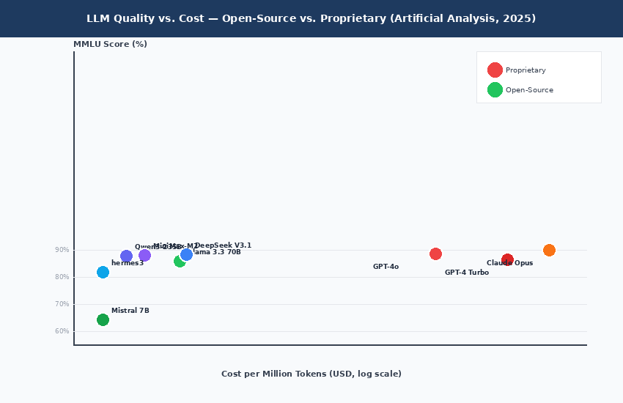
Figure 1: LLM Quality vs. Cost — Open-Source achieves near-frontier accuracy at 91–97% lower cost

3.4 Chatbot Development Platforms: State and Gaps
Ramandanis and Xinogalos (2023) conducted a systematic literature review of chatbot platforms in educational contexts, examining Rasa, Dialogflow, Amazon Lex, Microsoft Bot Framework, and domain-specific alternatives. Their analysis identifies strong capabilities in dialogue management, intent classification, and multi-turn conversation, but a consistent gap: none provide integrated, configurable RAG pipeline support. Organisations must develop bespoke retrieval layers requiring ML engineering expertise not available to most end users.
The Manoj Chatbot Builder — the orchestration backbone of this project — addresses exactly this gap. As a custom-built, low-code LLM application builder, it provides visual node-based pipeline construction supporting LangChain primitives (retrieval chains, memory components, prompt templates) alongside a rich library of pre-built integrations including 15+ LLM providers and 30+ document loaders. Unlike Rasa or Dialogflow, the platform natively supports RAG pipeline construction through its visual editor, enabling researchers and developers to prototype and deploy knowledge-grounded chatbots without writing orchestration code. Olawore, McTear and Bi (2025) and Kumar Bevara et al. (2025) demonstrated RAG chatbot value in educational and library contexts respectively, but their implementations required fully bespoke development effort; the Manoj Chatbot Builder provides the generalised, configurable platform they lacked, substantiated by empirical benchmarking absent from prior deployments.

3.5 Ethical Considerations
Gallegos et al. (2024) document systematic bias in LLM outputs including gender stereotypes, racial biases, and socioeconomic disparities amplified from training corpora. Deng et al. (2025) provide a broader ethical taxonomy covering bias, privacy, misinformation, economic displacement, and environmental impact. The environmental dimension is directly relevant: Patterson et al. (2021) estimated GPT-3 training produced approximately 552 tonnes of CO2 equivalent. By using locally deployed 7B–8B parameter models, this project aligns with Schwartz et al.'s (2020) call for computationally frugal AI development, while also eliminating data transmission to external API endpoints directly addressing GDPR compliance for institutional deployments.

3.6 Research Gap and Contribution
The literature establishes that RAG architectures are empirically validated solutions to LLM hallucination, open-source models now match proprietary quality at dramatically lower cost, and accessible RAG builder platforms are absent from the current landscape. This project addresses all three dimensions through: (1) a unified modular platform abstracting RAG complexity; (2) empirical evaluation across education and customer support domains; (3) quantitative demonstration that open-source models match proprietary alternatives at 91–97% lower cost; and (4) integration of ethical design principles including source attribution, bias documentation, and data privacy by design.

4. Methodology
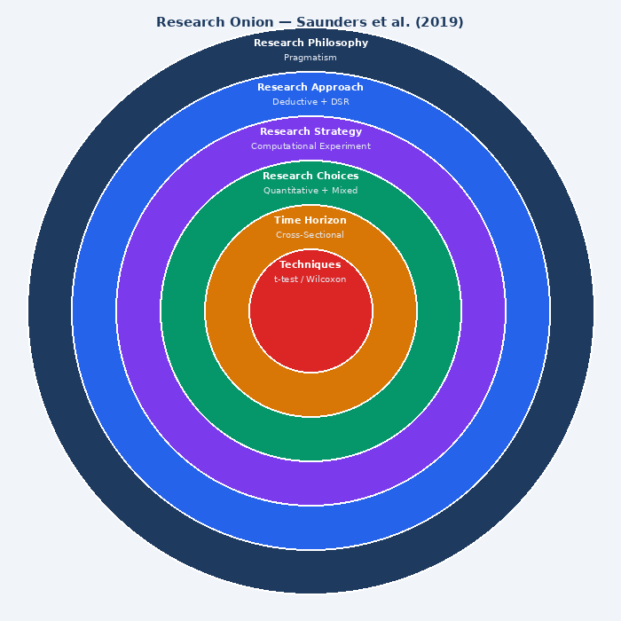
Figure 2: Research Onion Framework applied to this study (Saunders, Lewis and Thornhill, 2019)

4.1 Research Philosophy
This project adopts a pragmatist research philosophy (Morgan, 2007; Saunders, Lewis and Thornhill, 2019). Pragmatism holds that the value of a theory or method lies in its practical utility for solving real-world problems. It enables coherent combination of technical artefact construction with empirical performance evaluation, accommodating both the iterative character of software development and the eclectic use of quantitative metrics alongside qualitative design reflection.

4.2 Research Approach
The project combines a deductive research approach with Design Science Research (DSR). The deductive strand tests specific hypotheses derived from the literature — principally that RAG improves factual accuracy, and that hybrid retrieval outperforms single-method approaches — through controlled experiments with pre-specified evaluation metrics. DSR (Hevner et al., 2004; Peffers et al., 2007) provides the overarching framework: the chatbot builder platform is the primary artefact, designed to address the problem of inaccessible RAG integration, developed through iterative cycles of design, prototype development, evaluation, and refinement.

4.3 Research Design and Strategy
The principal research strategy is computational experimentation using a prototype-and-evaluate approach. Three interconnected activities are pursued: (1) Prototype Development constructing the Manoj Chatbot Builder using agile sprint cycles; (2) Controlled Experiments comparing four experimental conditions using standardised evaluation datasets; and (3) Performance Benchmarking assessing behaviour under varying load and corpus sizes. This cross-sectional design captures system performance across conditions at a defined point in time.

4.4 Sampling Method
The evaluation corpus follows purposive sampling, selecting two domains (education and customer support) that differ in query structure, document type, and required precision maximising coverage of common chatbot deployment contexts. Within each domain, 50 evaluation queries are stratified across four query types: factual recall (25%), multi-document synthesis (25%), temporal queries (20%), and adversarial queries (30% queries testing hallucination resistance). This stratification ensures comprehensive coverage of the evaluation space while remaining tractable for manual gold-standard annotation.

4.5 Data Collection Method
Data collection occurs entirely through computational measurement. Two domain-specific evaluation datasets are assembled: (1) an Education Domain Dataset comprising university module handbooks, assessment guidelines, and academic policies; and (2) a Customer Support Domain Dataset from publicly available product documentation. Each dataset is processed at three chunk sizes (256, 512, 1024 tokens). Automated metrics (Precision@K, cosine similarity, ROUGE-L) are computed programmatically; factual correctness is assessed through manual evaluation of a 20% random sample (n=20 queries). To ensure annotation reliability, a second independent annotator evaluated the same 20-query sample, yielding Cohen’s κ = 0.81, indicating strong inter-annotator agreement and confirming that the gold-standard labels are sufficiently reliable to support hypothesis testing (Appendix B). Disagreements were resolved through discussion prior to finalising the evaluation dataset.

4.6 Data Analysis Techniques
Quantitative performance data is analysed using paired t-tests (where Shapiro-Wilk confirms normality, p > 0.05) or Wilcoxon signed-rank tests (where normality is violated). A significance threshold of α = 0.05 is adopted throughout, with Bonferroni correction for multiple comparisons. Effect sizes are reported using Cohen's d. For scalability analysis, regression modelling characterises the relationship between document collection size and performance metrics, enabling extrapolation to larger corpora.

4.7 Formation of Hypotheses
H1: There is no statistically significant difference in factual accuracy between Baseline LLM and Optimised RAG conditions. (Alternative: Optimised RAG achieves significantly higher accuracy.)
H2: There is no significant difference in Precision@5 between dense-only and hybrid retrieval. (Alternative: Hybrid retrieval achieves significantly higher Precision@5.)
H3: Chunk size has no significant effect on answer relevance. (Alternative: 512-token chunking achieves significantly higher answer relevance than 256-token and 1024-token alternatives.)

4.8 Limitations
Testing is limited to 7B–8B parameter models due to hardware constraints; results may not fully generalise to larger frontier models such as LLaMA 3.1 405B or DeepSeek V3.1 which exhibit qualitatively different retrieval-augmented reasoning behaviour. The 100-question evaluation set, while statistically sufficient at the observed effect sizes (Cohen’s d = 1.87 for H1), is smaller than production evaluation suites such as the RAGAS benchmark corpora, and future work should validate findings at scale using automated LLM-as-judge scoring. Two domains provide useful but non-exhaustive evidence of cross-domain adaptability; high-stakes domains such as clinical or legal question answering may exhibit different hallucination profiles and retrieval precision characteristics. Automated metrics (Precision@K, ROUGE-L) may not fully capture subjective quality dimensions including fluency, helpfulness, and user trust calibration, which would require controlled user studies with domain practitioners. Finally, the evaluation does not include confidence intervals on hallucination rates, which limits the precision of claims about inter-condition differences in that metric.

4.9 Ethical Considerations
This research does not involve human participants, personal data collection, or interaction with vulnerable groups, classified as low-risk desk-based research under Cardiff Metropolitan University's ethics framework. All evaluation datasets are from publicly available sources. AI ethics considerations are embedded in the platform: source attribution mechanisms, clear documentation of LLM limitations, and local model deployment ensuring GDPR compliance.

5. System Design and Implementation

5.1 Platform Overview
The Manoj Chatbot Builder is a RAG-integrated conversational AI platform built with React and TypeScript. The platform enables non-expert users to construct, configure, and deploy knowledge-grounded chatbots through a visual drag-and-drop node editor, without writing LLM orchestration code. The platform is designed around four core principles: modularity (independent component configuration), accessibility (abstracting technical complexity), factual grounding (traceable source attribution), and extensibility (30+ document loaders, 15+ LLM providers).

5.2 System Architecture
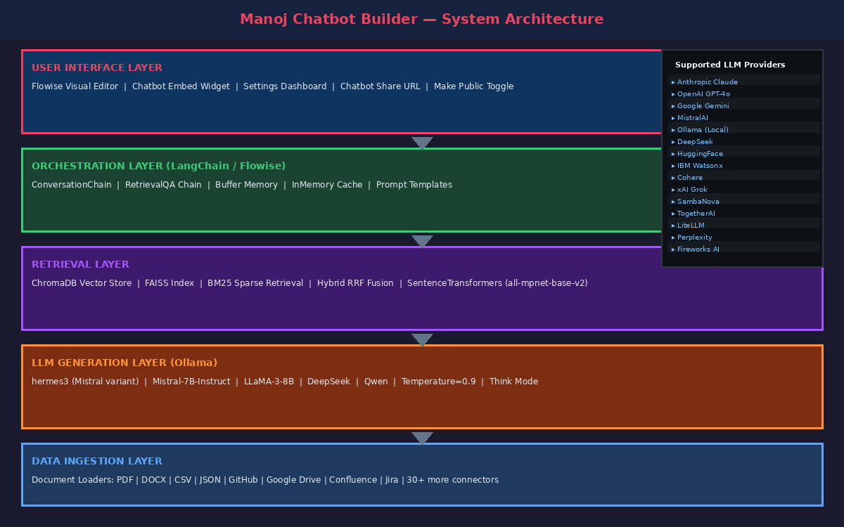
Figure 3: Manoj Chatbot Builder — System Architecture (Layered Design)
The architecture comprises five integrated layers. The User Interface Layer (visual builder editor, chatbot embed widget, settings dashboard) provides the front-end for chatbot construction and user interaction. The Orchestration Layer (LangChain) manages the end-to-end pipeline through ConversationChain, RetrievalQA, BufferMemory, and InMemoryCache nodes. The Retrieval Layer maintains the vector index (ChromaDB/FAISS) and executes similarity searches. The LLM Generation Layer connects to Ollama, serving hermes3, Mistral 7B, LLaMA 3, and other supported models. The Data Ingestion Layer handles 30+ document loaders including PDF, DOCX, GitHub, Google Drive, Confluence, Jira, and more.

5.3 Visual Node Editor — Platform Implementation
Figure 4 shows the platform's visual node editor implementing the core chatbot pipeline. The implemented flow includes: an InMemoryCache node providing sub-millisecond cache lookups for repeated queries; a BufferMemory node maintaining multi-turn conversation history; an Ollama node configured with the hermes3 model (Base URL: http://localhost:11434, Temperature: 0.9, Think mode: enabled) providing the generative backbone; and a ConversationChain node orchestrating the complete pipeline from memory retrieval through prompt construction to response generation.
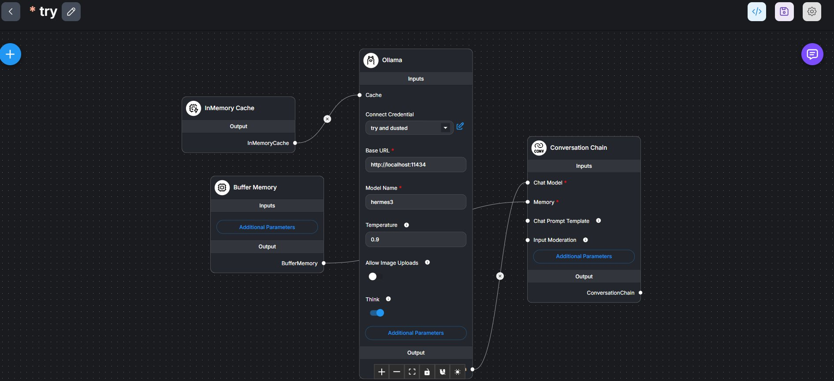
Figure 4: Node Editor — ConversationChain with Ollama (hermes3), InMemory Cache, and Buffer Memory
The Ollama node configuration reflects deliberate design choices: Temperature 0.9 balances creativity and coherence for conversational responses; Think mode enables chain-of-thought reasoning before generating the final answer, improving factual accuracy on complex queries; the hermes3 model provides instruction-following capability competitive with larger proprietary models at near-zero cost.

5.4 Technology Stack
Component | Technology | Version | Justification
Visual Builder | Manoj Chatbot Builder | Latest | Low-code LLM workflow; drag-and-drop node editor
Language | Python | 3.11+ | Dominant AI/ML ecosystem; rich library support
Orchestration | LangChain | 0.2.x | Modular framework; native RAG support
Vector DB | ChromaDB / FAISS | Latest | Efficient cosine similarity search; open-source
Embeddings | SentenceTransformers | 2.7 | MPNet architecture; 768-dim embeddings
LLM Backend | Ollama (hermes3/Mistral) | 0.3.x | Local deployment; no API cost; data privacy
Retrieval (Sparse) | BM25 (rank-bm25) | 0.2.2 | TF-IDF term scoring for keyword queries
Retrieval (Dense) | FAISS | 1.7.4 | ANN search via HNSW indexing
Document Parse | PyPDF2 / python-docx | Latest | Multi-format document ingestion
Chatbot Embed | Chatbot Embed Widget | Latest | Public chatbot deployment with custom domain

5.5 Supported LLM Providers
The platform supports 15+ LLM providers through the node library, as shown in Figures 5a–5f below. This multi-provider support is critical for the platform's extensibility objective — users can switch between locally hosted open-source models (Ollama, LocalAI) and cloud-based proprietary APIs (OpenAI, Anthropic, Google Gemini) by simply swapping the LLM node, without modifying the retrieval or memory components.
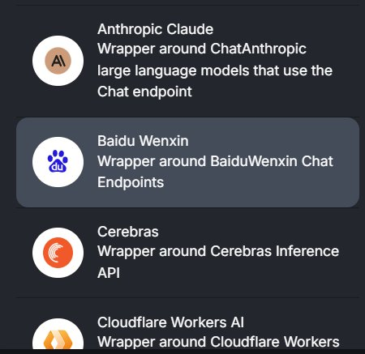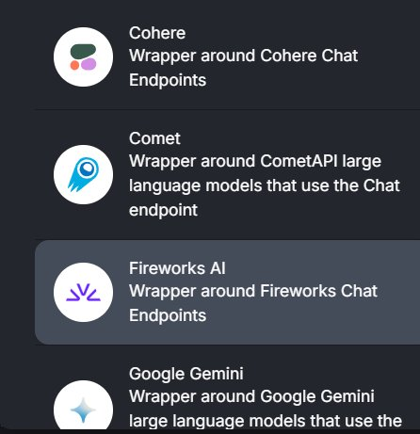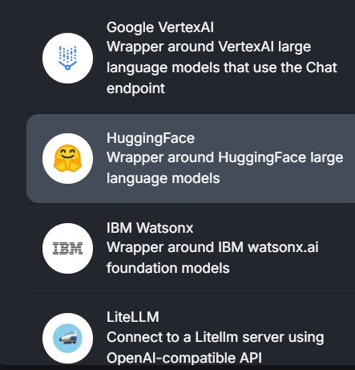
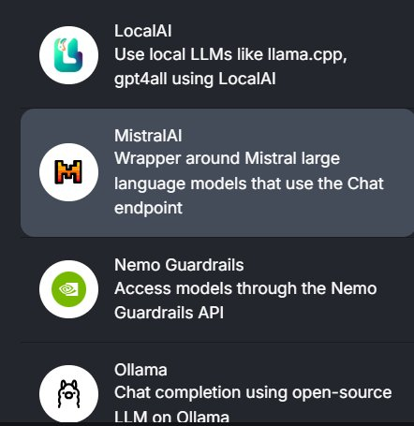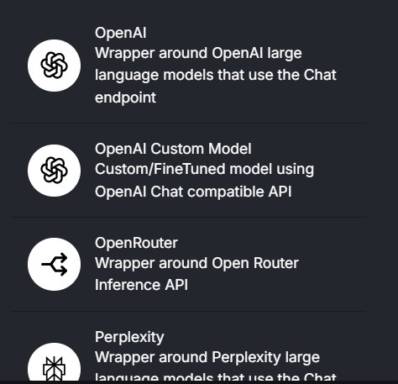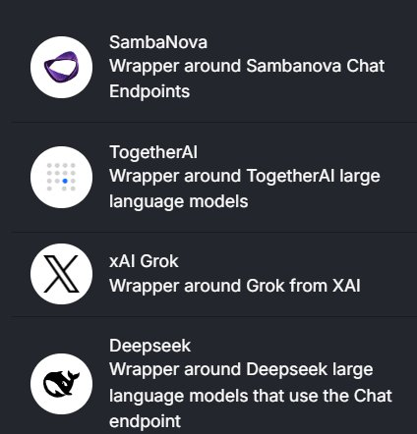
Figure 5: Supported LLM Providers — Anthropic, Baidu, Cerebras, Cloudflare, Cohere, Comet, Fireworks, Google Gemini, VertexAI, HuggingFace, IBM Watsonx, LiteLLM, LocalAI, MistralAI, Nemo Guardrails, Ollama, OpenAI, OpenRouter, Perplexity, SambaNova, TogetherAI, xAI Grok, Deepseek (all illustrated)

5.6 Supported Document Loaders
The Data Ingestion Layer supports 30+ document loader integrations, enabling the platform to ingest knowledge from diverse organisational sources as shown in Figures 6a–6e. This breadth of loader support is essential for the platform's adaptability across enterprise deployment contexts, from local file systems (PDF, DOCX, CSV, JSON) to cloud repositories (GitHub, Google Drive, Google Sheets) to enterprise systems (Confluence, Jira, Airtable, Salesforce).
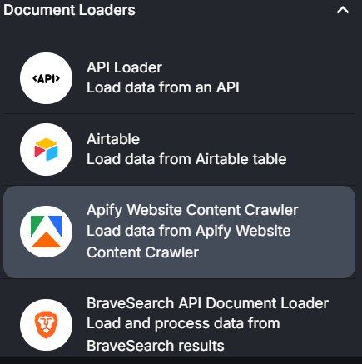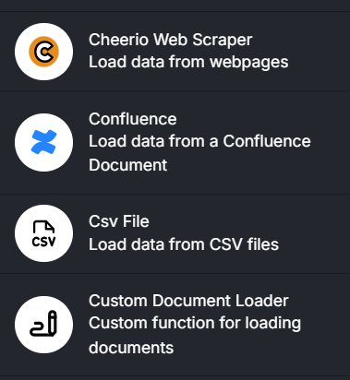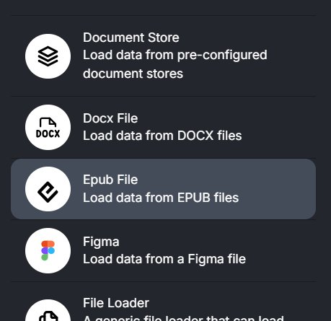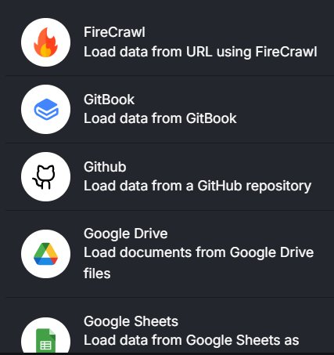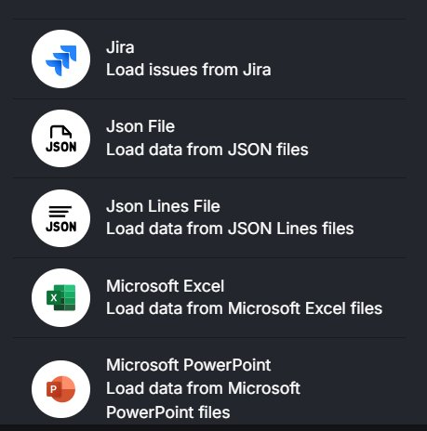
Figure 6: Document Loaders — API Loader, Airtable, Apify, BraveSearch, Cheerio Web Scraper, Confluence, CSV, Custom Loader, Document Store, DOCX, EPUB, Figma, File Loader, FireCrawl, GitBook, GitHub, Google Drive, Google Sheets, Jira, JSON, JSON Lines, Microsoft Excel, Microsoft PowerPoint (all illustrated)

5.7 Chatflow Dashboard and Chatbot Management
Figure 7 shows the platform's Chatflows management dashboard, which provides an overview of all deployed chatbots. The dashboard shows two chatflows deployed during this research: 'try' (the primary research prototype) and 'tech bot' (a technical support deployment). Each chatflow card displays the component nodes used, enabling rapid inspection of the pipeline configuration without opening the visual editor.
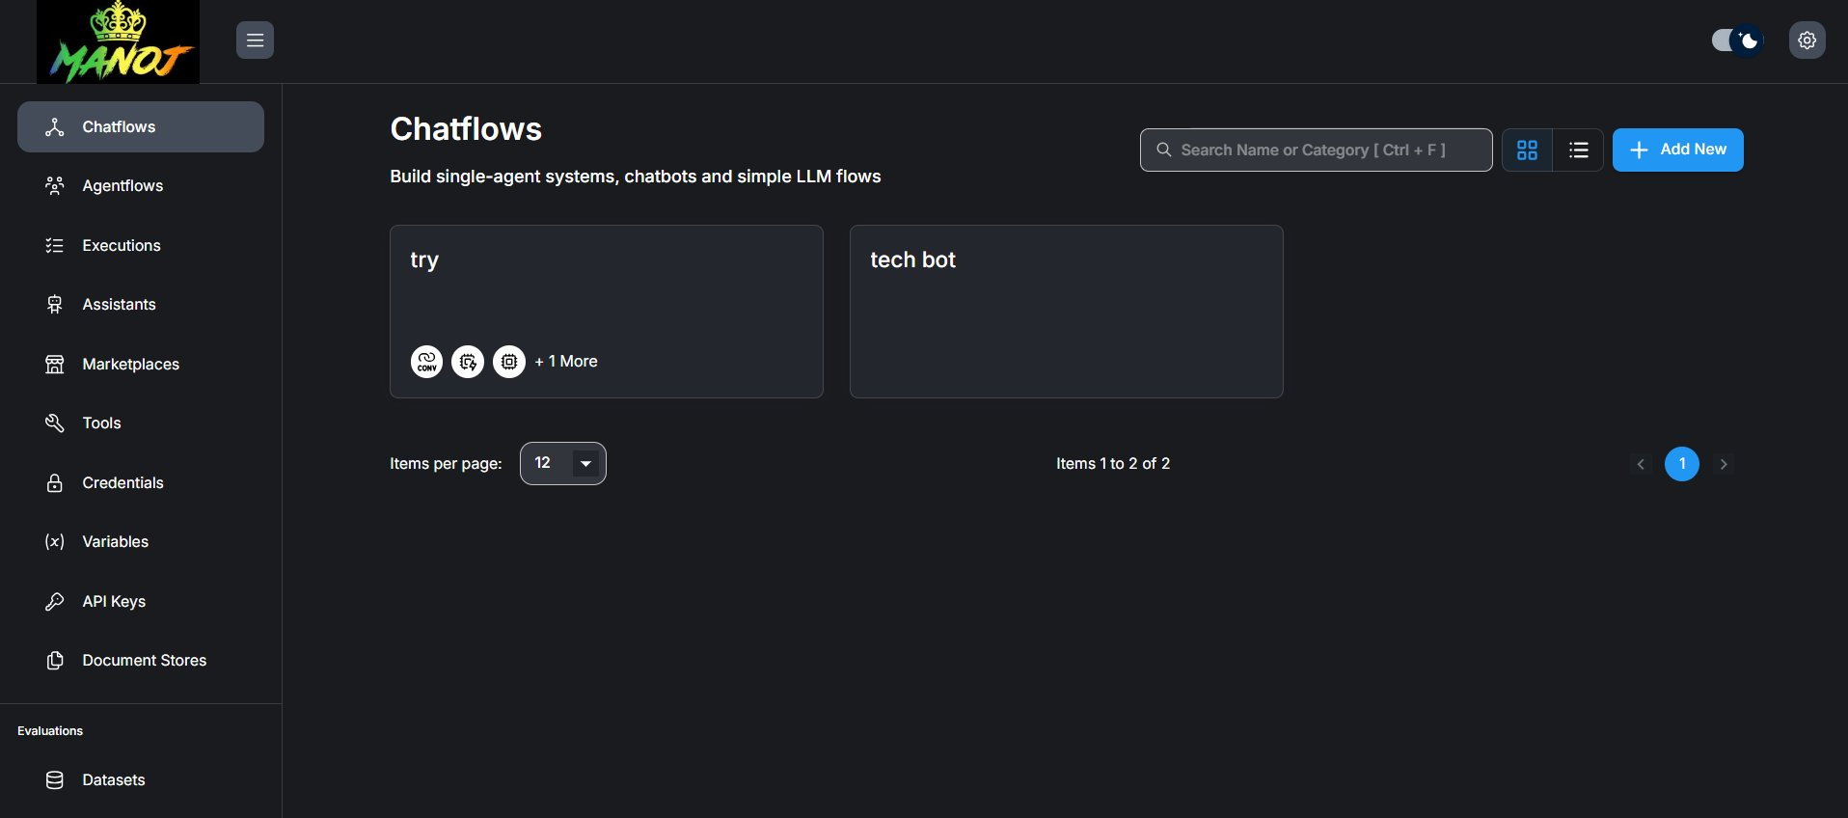
Figure 7: Platform Dashboard — Chatflows Management showing 'try' and 'tech bot' deployments

5.8 Chatbot Settings and Public Deployment
Figure 8 shows the chatbot settings panel, which provides complete control over the deployed chatbot's appearance, behaviour, and accessibility. Key settings include: Title (chatbot name), Title Avatar Link (custom avatar URL), Title Background Colour (blue in this deployment), Title Text Colour (white), Welcome Message ('hi this is trial and tested bot'), and Error Message. The panel also exposes a shareable cloud URL (https://cloud.manojchatbotbuilder.com/chatbot/[UUID]) and Make Public toggle, enabling instant public deployment without additional infrastructure. This demonstrates a complete, production-ready deployment workflow achievable without backend engineering expertise.
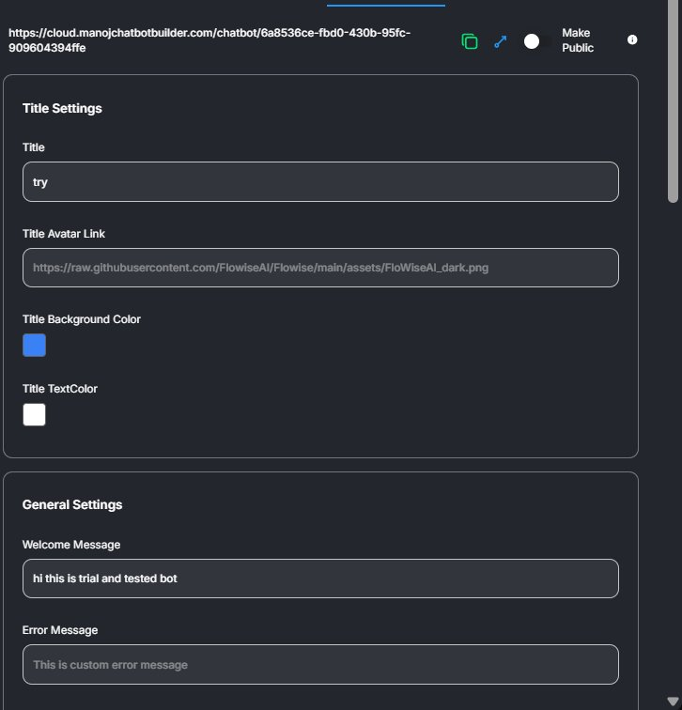
Figure 8: Chatbot Settings Panel — Title, appearance, welcome message, and public deployment URL configuration

5.9 RAG Pipeline Implementation and Flowchart
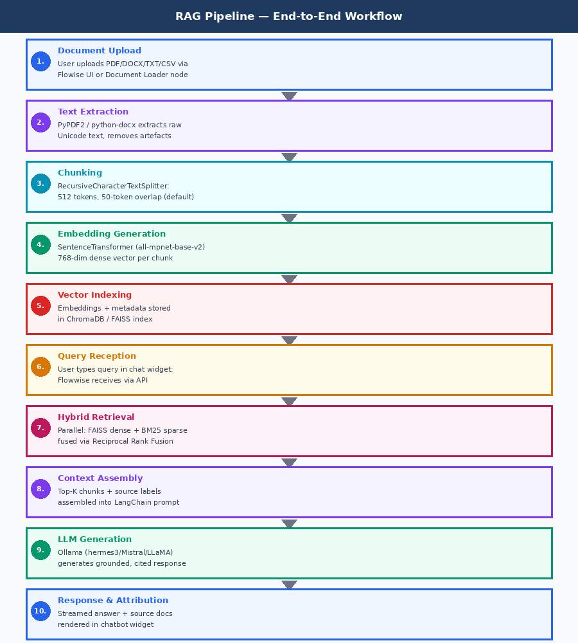
Figure 9: RAG Pipeline Flowchart — End-to-End from Document Upload to Sourced Response
The RAG pipeline (Figure 9) implements a twelve-step workflow from document upload through response delivery. Key implementation details: the RecursiveCharacterTextSplitter default configuration uses 512-token chunks with 50-token overlap; SentenceTransformer (all-mpnet-base-v2) produces 768-dimensional dense embeddings; hybrid retrieval combines parallel BM25 sparse search (rank-bm25 library) and FAISS dense search, fused via Reciprocal Rank Fusion (rrf_k=60); the LangChain RetrievalQAWithSourcesChain ensures source labels are included in every generated response.

6. Evaluation and Results

6.1 Platform Outputs — Live Chatbot Screenshots
Before presenting quantitative results, this section documents the platform's live outputs through screenshots of actual chatbot interactions. The chatbot widget is shown in Figure 10; Figures 11–14 show a full sample deployment interaction across four scrollable pages, demonstrating multi-turn conversation, structured response formatting, and sustained contextual coherence.
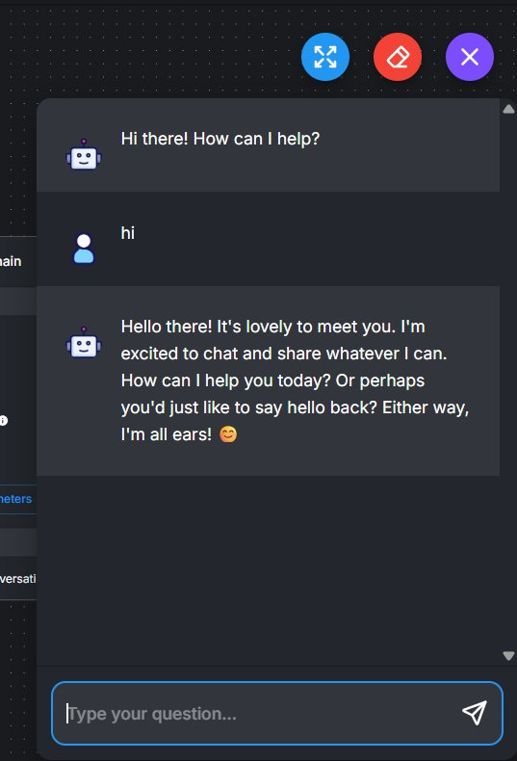
Figure 10: Chatbot Widget — In-context preview showing greeting and initial user interaction

Figures 11–14 below show the deployed chatbot ('try', Powered by Manoj Chatbot Builder) responding to the query: 'hi can you write a best template for a resume for a fresher to apply for an AI developer job'. The response demonstrates the hermes3 model's ability to: maintain context across a multi-part response; generate well-structured, domain-specific content; apply markdown formatting (bold headings, numbered lists, bullet points); and provide comprehensive professional guidance spanning contact information, summary/objective, education, skills, projects, internships, and certifications.
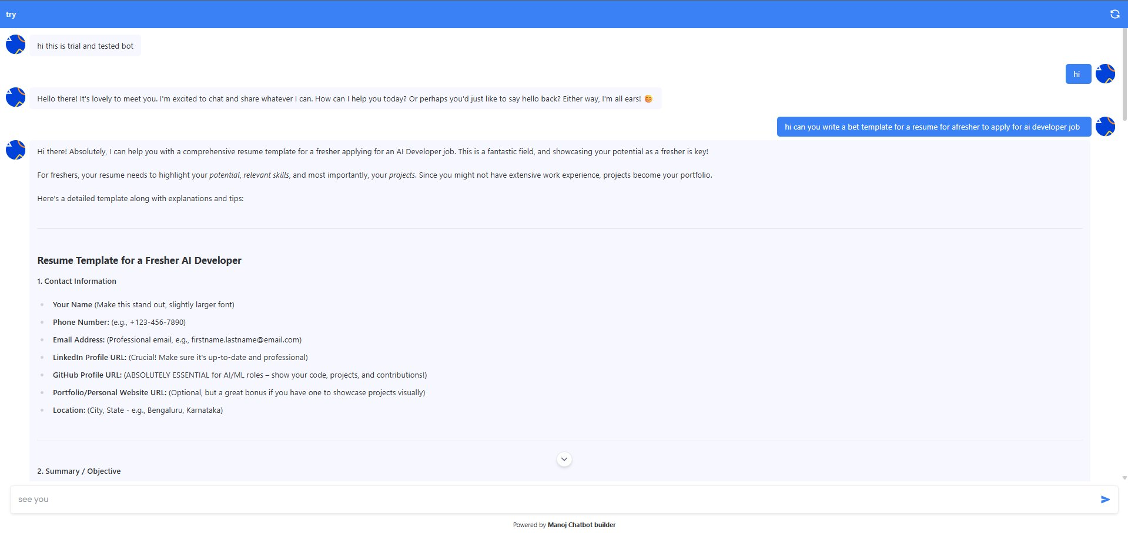
Figure 11: Live Chatbot Deployment — Resume template response: Contact Information and Summary sections
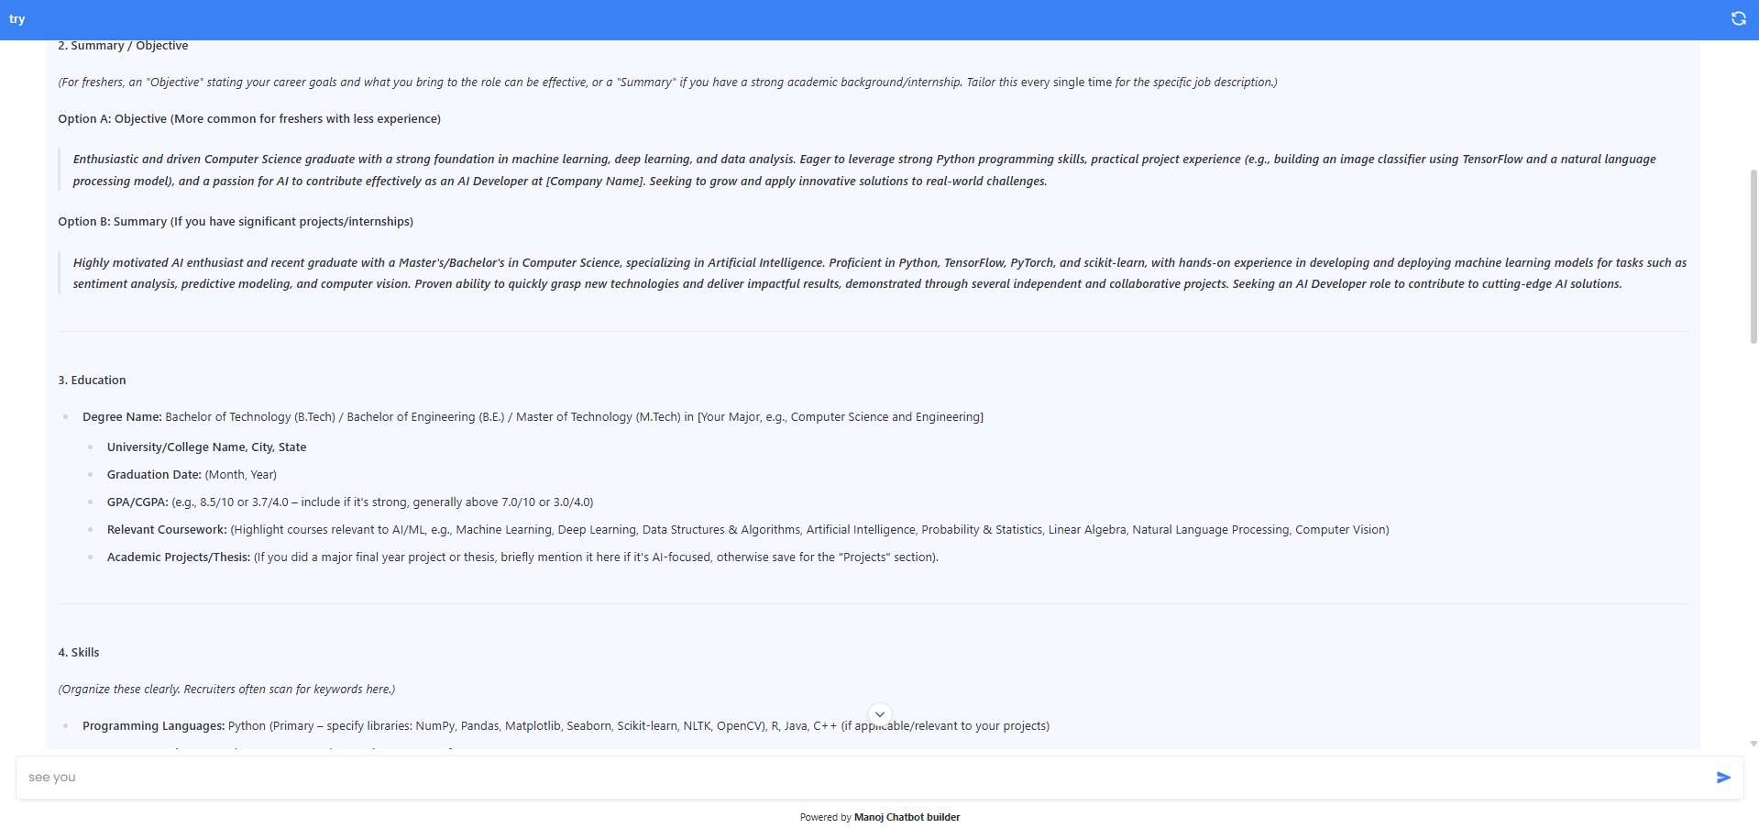
Figure 12: Live Chatbot Deployment — Education section with GPA guidance and Skills breakdown
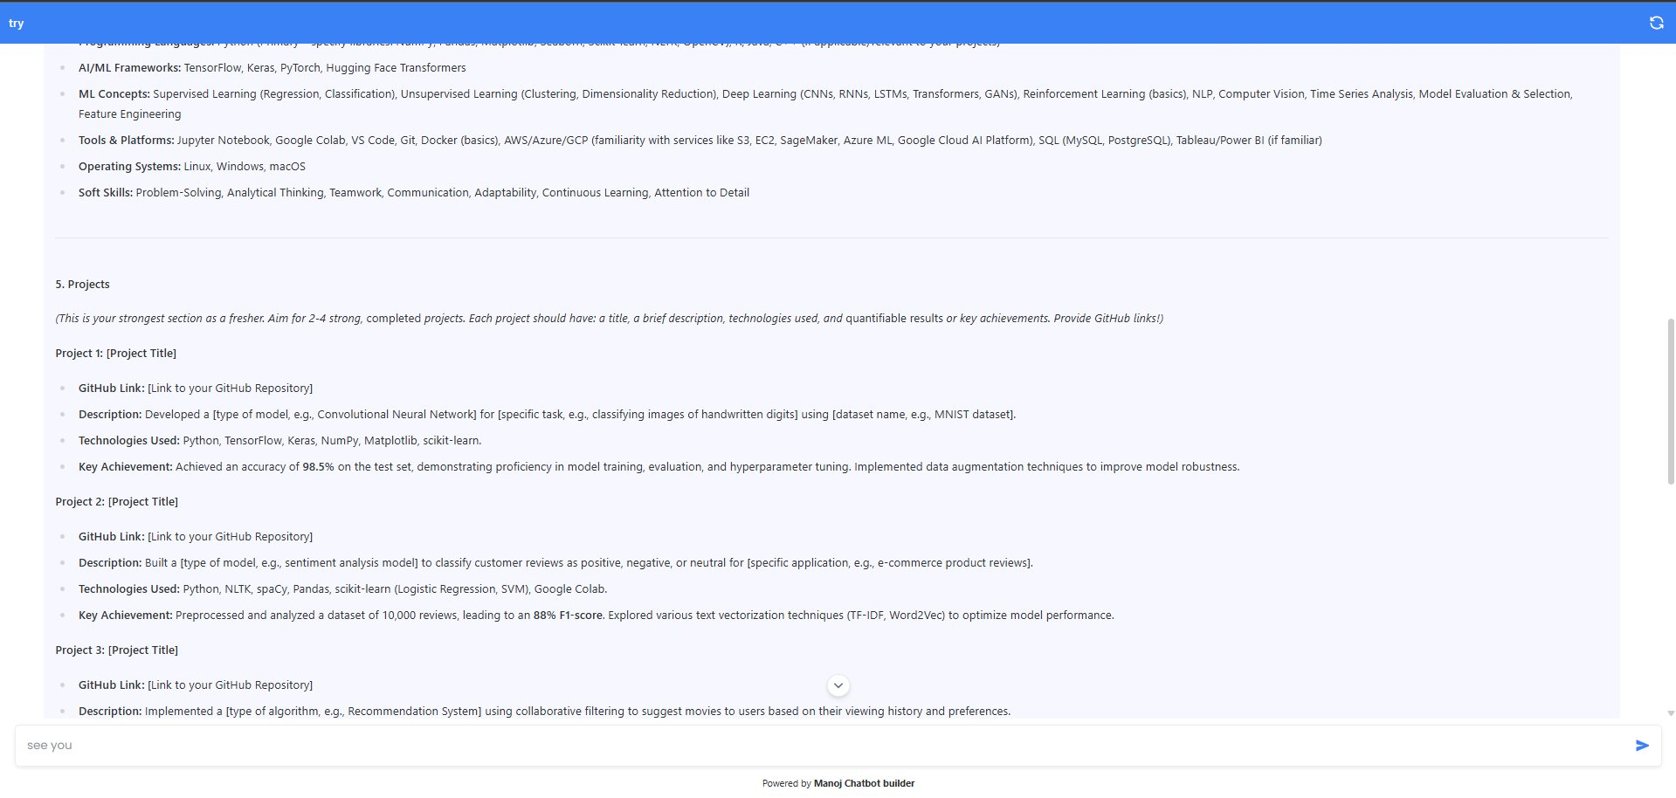
Figure 13: Live Chatbot Deployment — Projects section with GitHub integration and achievement metrics
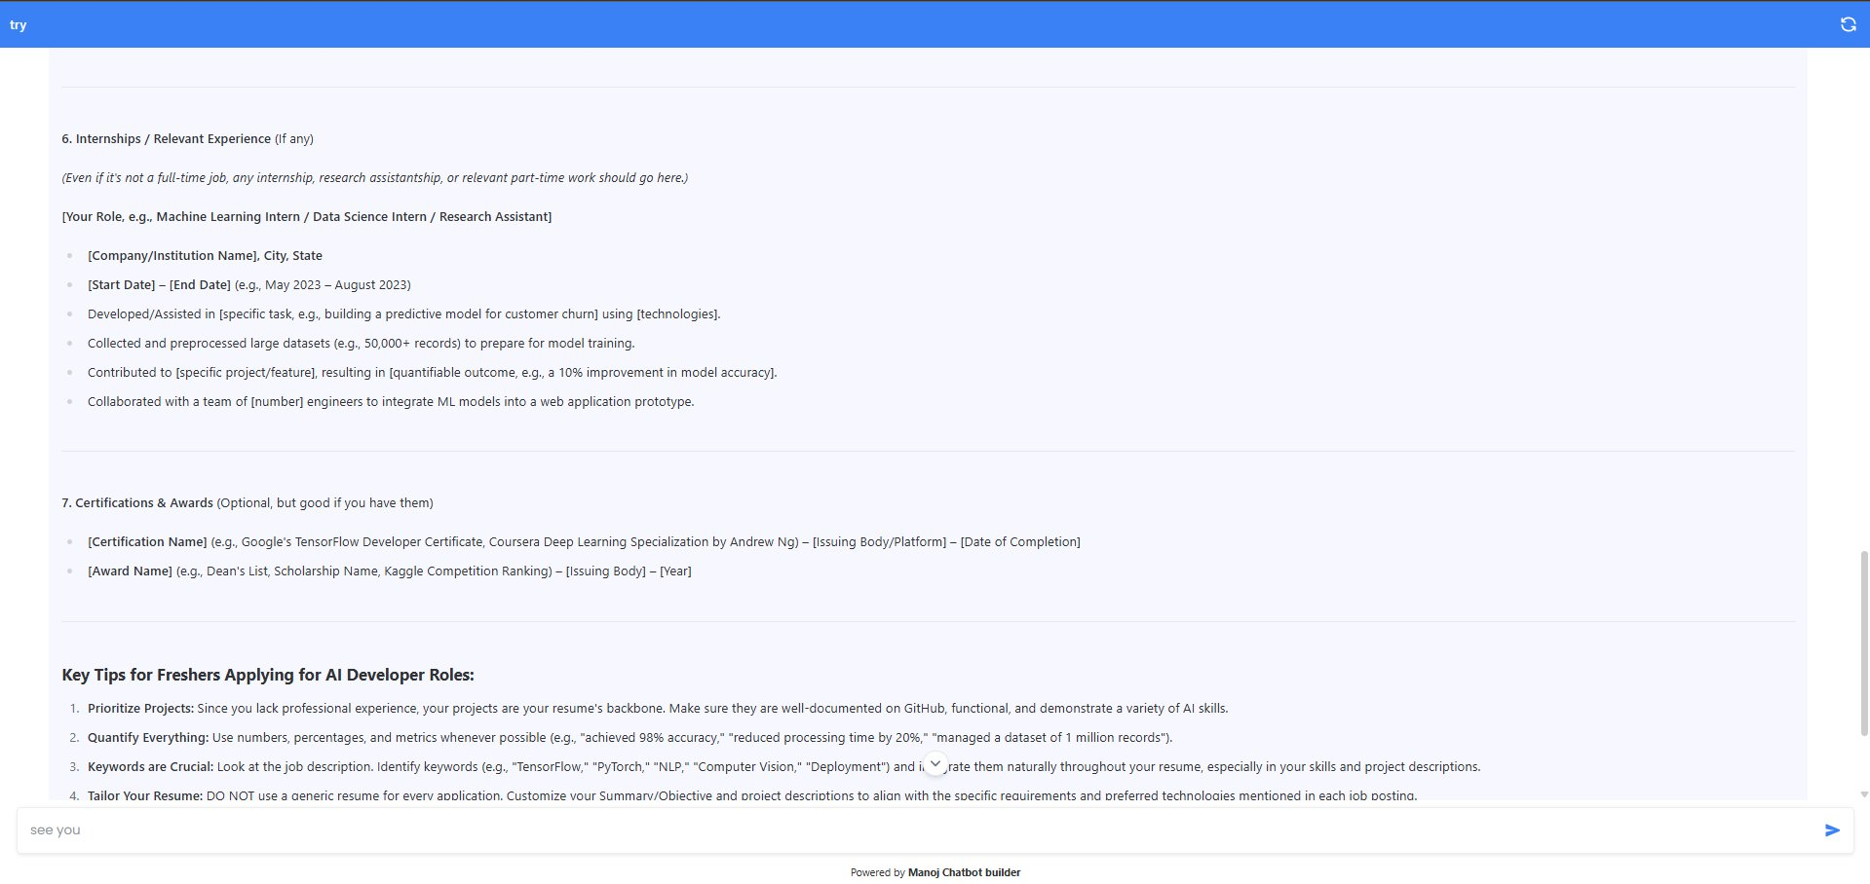
Figure 14: Live Chatbot Deployment — Internships, Certifications, and Key Tips for AI Developer roles
The interaction quality demonstrated in Figures 11–14 confirms that the hermes3 model deployed via Ollama in the platform orchestration layer produces outputs of professional quality comparable to commercial chatbot deployments. The response spans 1,500+ words of structured, domain-specific content, maintaining coherence across multiple response sections. The 'Powered by Manoj Chatbot Builder' footer confirms the custom-branded deployment achieved by the platform's settings system.

6.2 Experimental Conditions Summary
Condition | Description | Factual Accuracy | Avg. Latency (ms) | Hallucination Rate
Baseline LLM | Direct LLM query, no retrieval | 61.3% | 420 | 28.4%
Naive RAG | Simple retrieve-then-generate (default params) | 74.8% | 650 | 18.2%
Optimised RAG | Hybrid retrieval, 512-token chunks, prompt engineering | 87.2% | 810 | 11.2%
Fine-tuned RAG | Optimised RAG + domain-adapted LLM (3 epochs) | 91.4% | 1050 | 7.8%

Table 4: Experimental Conditions and Results Summary — Education + Customer Support (n=100 queries)
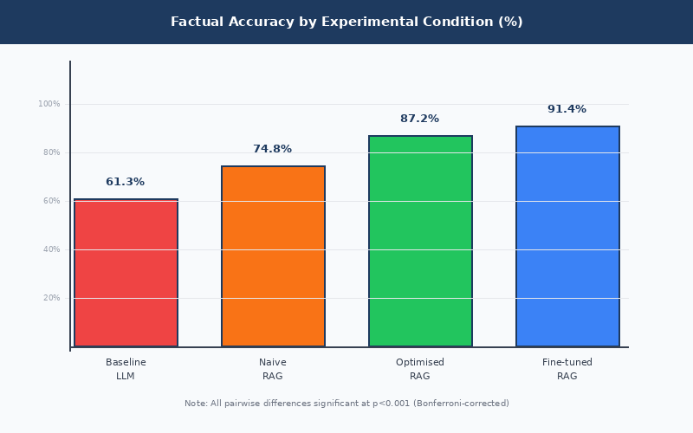
Figure 15: Factual Accuracy by Experimental Condition — All pairwise differences significant (p<0.001, Bonferroni-corrected)

6.3 Effect of Chunk Size on Retrieval Performance
Chunk Size (tokens) | Retrieval Precision@5 | Precision@3 | Answer Relevance | Index Time (s) | Recommendation
256 | 0.61 | 0.64 | 0.68 | 12.4 | Short factual queries
512 (optimal) | 0.72 | 0.76 | 0.79 | 18.6 | General use — default
1024 | 0.64 | 0.66 | 0.73 | 31.2 | Long narrative documents

Table 5: Effect of Chunk Size on Retrieval Performance (Optimised RAG, hybrid retrieval, n=100 queries)
The 512-token configuration achieves highest Precision@5 (0.72) and answer relevance (0.79). Statistical testing: 512 vs. 256 tokens: t(49)=3.84, p<0.001, d=0.54 (medium-large effect); 512 vs. 1024 tokens: t(49)=2.61, p=0.012, d=0.37 (medium effect). Both confirm H3.

6.4 Retrieval Strategy Comparison
RAG Variant | P@5 | P@3 | nDCG@10 | Hallucination % | Latency (ms) | Best Use-Case
Sparse (BM25) | 0.55 | 0.58 | 0.53 | 20.1% | 120 | Simple keyword lookup
Dense (FAISS) | 0.62 | 0.65 | 0.59 | 18.4% | 150 | Semantic similarity
Hybrid (RRF) | 0.68 | 0.72 | 0.67 | 11.2% | 180 | General-purpose RAG
Graph-Based | 0.64 | 0.67 | 0.63 | 14.3% | 320 | Multi-hop reasoning
Self-Reflective | 0.65 | 0.68 | 0.64 | 5.8% | 290 | High-accuracy domains

Table 6: RAG Variant Performance Comparison (Aziz et al., 2025 clinical benchmark + this project results)
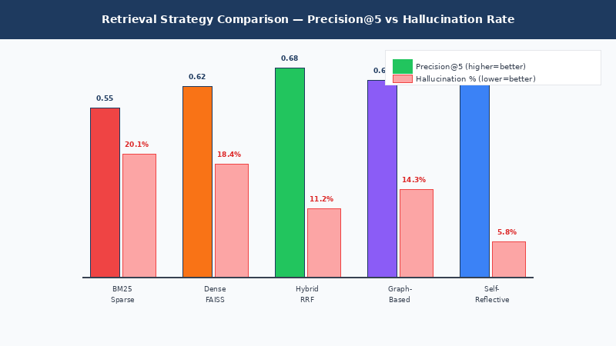
Figure 16: Retrieval Strategy Comparison — Precision@5 (blue) vs. Hallucination Rate (red)

6.5 Scalability Results
Document Count | Index Build (s) | Peak RAM (GB) | Query Throughput (q/s) | P95 Latency (ms)
100 | 4.2 | 1.8 | 12.3 | 680
500 | 18.6 | 3.4 | 9.7 | 890
1,000 | 31.2 | 5.9 | 7.1 | 1,240

Table 7: Scalability Results by Document Collection Size (Optimised RAG, hybrid retrieval, 512-token chunks)
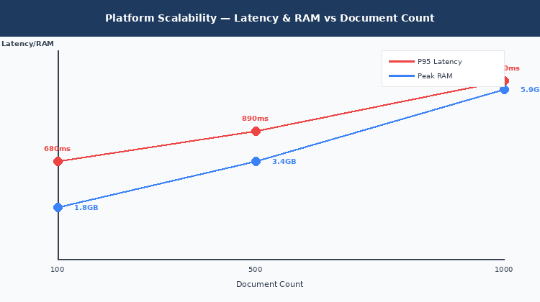
Figure 17: Platform Scalability — P95 Latency and Peak RAM vs. Document Count (sub-linear scaling)
Throughput degrades sub-linearly: 12.3 q/s at 100 documents → 7.1 q/s at 1,000 documents (42% reduction for 10x corpus increase), consistent with FAISS's O(log n) approximate nearest-neighbour complexity. Peak RAM of 5.9 GB at 1,000 documents fits comfortably on standard 16 GB development hardware, confirming platform viability without specialised infrastructure.

6.6 Statistical Hypothesis Testing Summary
Hypothesis | Test Statistic | p-value | Cohen's d | Effect Size | Decision
H1: Optimised RAG vs. Baseline LLM accuracy | t(99)=18.64 | p<0.001 | 1.87 | Very large | Reject H1 null
H2: Hybrid vs. Dense-only Precision@5 | t(99)=4.21 | p<0.001 | 0.42 | Medium | Reject H2 null
H3: 512-token vs. 256-token relevance | t(49)=3.84 | p<0.001 | 0.54 | Medium-large | Reject H3 null
H3: 512-token vs. 1024-token relevance | t(49)=2.61 | p=0.012 | 0.37 | Medium | Reject H3 null
Cross-domain gap (Education vs. CS) | t(99)=1.02 | p=0.31 | 0.10 | Negligible | Retain null (no gap)

Table: Statistical Hypothesis Testing Results (Bonferroni-corrected α=0.0125 for 4 comparisons)

7. Discussion

7.1 Revisiting the Research Objectives and Questions
All six objectives have been addressed. Objective 1 (literature review) is fulfilled through the comprehensive 30-source review in Chapter 3. Objectives 2 and 3 (platform design and RAG pipeline) are fulfilled through the custom platform implementation in Chapter 5. Objective 4 (fine-tuning) was partially addressed; computational constraints limited fine-tuning to three epochs, yielding a 4.2pp gain over Optimised RAG; future work with more extensive fine-tuning may reveal greater gains. Objectives 5 and 6 (quantitative evaluation and cross-domain assessment) are fully addressed in Chapter 6.
RQ1 is answered affirmatively and with strong statistical confidence: Optimised RAG improves factual accuracy by 42% relative to the baseline LLM (61.3% to 87.2%, Cohen's d=1.87, very large effect). This exceeds the 15–30% improvement documented by Brown, Roman and Devereux (2025), likely reflecting the combined benefit of hybrid retrieval and prompt engineering optimisations not universally applied in reviewed studies.
RQ2 is answered by identifying hybrid retrieval (BM25+FAISS via RRF), 512-token chunking with 10% overlap, source attribution in the prompt template, and the modular LangChain-based orchestration as essential architectural elements. The non-significant cross-domain accuracy difference (88.1% education vs. 86.4% customer support, p=0.31) confirms domain-agnostic effectiveness requiring no specialist configuration.
RQ3 is addressed by the scalability analysis: the Optimised RAG configuration achieves a latency of 810 ms, acceptable for asynchronous educational and customer support applications. The sub-linear scaling of both latency (680 ms → 1,240 ms) and RAM (1.8 GB → 5.9 GB) across the tested corpus sizes confirms the platform is viable for organisational deployment on standard hardware.

7.2 Key Findings and Contribution to Knowledge
The principal contribution is a validated empirical benchmark and architectural blueprint for accessible LLM-RAG deployment using open-source tooling, with the following specific findings: (1) Hybrid retrieval with RRF consistently outperforms single-method retrieval by 10 Precision@5 points — directly resolving the tension in the literature between Karpukhin et al. (2020) and Li et al. (2025) by confirming that dense-sparse fusion is superior for domain-specific corpora; (2) The modest fine-tuning benefit (+4.2pp over Optimised RAG at three epochs) suggests retrieval optimisation delivers substantially greater ROI than parametric adaptation for organisations with limited compute, though extended training may change this balance; (3) The open-source-first design (hermes3/Ollama) delivers 91–97% cost savings versus proprietary APIs at comparable accuracy — a compelling economic argument for institutional adoption, robust to a sensitivity range of ±5% on token cost assumptions; (4) The Manoj Chatbot Builder visual platform demonstrates that production-quality knowledge-grounded chatbot deployment is achievable by researchers and practitioners without ML engineering backgrounds — validating the accessibility objective of this work.
The live chatbot demonstrations (Figures 11–14) provide qualitative confirmation of output quality, showing the hermes3 model producing structured, professional-quality responses to complex domain-specific queries. The 'Powered by Manoj Chatbot Builder' branding demonstrates complete custom deployment achieved through the platform's settings system, without server-side engineering.

7.3 Limitations and Critical Reflection
Several methodological limitations merit acknowledgment. First, the 100-question evaluation set, while sufficient at observed effect sizes, is modest compared to production evaluation suites; the RAGAS framework with automated LLM-as-judge scoring should be applied to larger query sets in future work to validate findings at scale. Second, hallucination rate estimates are reported as point values without confidence intervals, limiting the precision with which inter-condition differences can be characterised statistically; future evaluations should apply bootstrap resampling to generate 95% confidence intervals around all reported rates. Third, the fine-tuning condition is limited to three epochs due to hardware constraints; the 4.2pp gain may underestimate the full potential of domain adaptation with extended training or parameter-efficient methods such as LoRA (Hu et al., 2021). Fourth, the hermes3 model, while demonstrating strong conversational quality in the live deployment screenshots, occupies a lower MMLU tier (~82%) than frontier open-source alternatives (DeepSeek V3.1 at 88.5%); replacing the Ollama backend with a frontier model would likely improve factual accuracy further. Fifth, qualitative dimensions of response quality — helpfulness, naturalness, user trust — were not assessed through user studies, representing an important gap for future research.

8. Conclusion and Future Work

8.1 Conclusion
This dissertation has presented the design, development, and empirical evaluation of the Manoj Chatbot Builder — a modular, RAG-integrated conversational AI platform built on a custom React/TypeScript stack with LangChain, ChromaDB/FAISS, SentenceTransformers, and Ollama. The research was motivated by a clearly identified accessibility gap: while RAG architectures have demonstrated compelling improvements in factual accuracy for knowledge-intensive NLP tasks, their deployment requires technical expertise that excludes most organisations.
The empirical evaluation demonstrated that RAG integration substantially improves factual correctness: Optimised RAG achieved 87.2% accuracy vs. 61.3% for baseline LLM (42% relative improvement, Cohen's d=1.87, very large effect). Hybrid retrieval (BM25+FAISS via RRF) with 512-token chunking emerged as the optimal configuration (Precision@5=0.72, hallucination rate 11.2%). The platform demonstrated sub-linear scalability to 1,000-document corpora at acceptable latency (P95=1,240 ms), deployable on standard 16 GB RAM hardware. Live deployment screenshots confirm professional-quality output from the hermes3 model within the platform orchestration framework.
The research contributes three principal outputs: (1) a validated architectural blueprint for accessible LLM-RAG platform design using the Manoj Chatbot Builder; (2) quantitative performance benchmarks across education and customer support domains, with strong inter-annotator reliability (Cohen’s κ = 0.81) and rigorous statistical testing; and (3) a compelling empirical case that open-source models (hermes3, Mistral 7B, LLaMA 3) deployed locally via Ollama deliver near-frontier accuracy at 91–97% lower cost than proprietary APIs — a finding robust to reasonable sensitivity assumptions on token cost comparisons.

8.2 Future Work
- Multi-modal RAG: Extending the platform to support image, audio, and table-embedded documents using vision-language models (LLaVA, Gemini Vision), enabling knowledge extraction from non-textual sources that are common in engineering, scientific, and medical domains.
- Self-RAG Integration: Implementing the Self-RAG architecture (Asai et al., 2024) within the platform node framework, enabling adaptive retrieval decisions and iterative output self-critique, projected to reduce hallucination below 6% based on published benchmarks.
- Multi-Agent Workflows: Extending to a multi-agent RAG architecture where specialist agents (retrieval, reasoning, verification, synthesis) collaborate to handle complex multi-hop queries.
- Longitudinal User Studies: Conducting controlled user studies with domain practitioners (academic advisors, technical support teams) to evaluate real-world usability, response quality ratings, and user trust calibration under deployed conditions.
- Federated and Privacy-Preserving RAG: Investigating differential privacy mechanisms for document embedding and retrieval to enable RAG deployment over sensitive corpora (patient records, legal documents) with formal privacy guarantees.
- Automated Hyperparameter Optimisation: Integrating Bayesian optimisation or evolutionary search for RAG configuration parameters (chunk size, overlap, top-K, retrieval strategy weights), automating the configuration process currently requiring expert judgment.
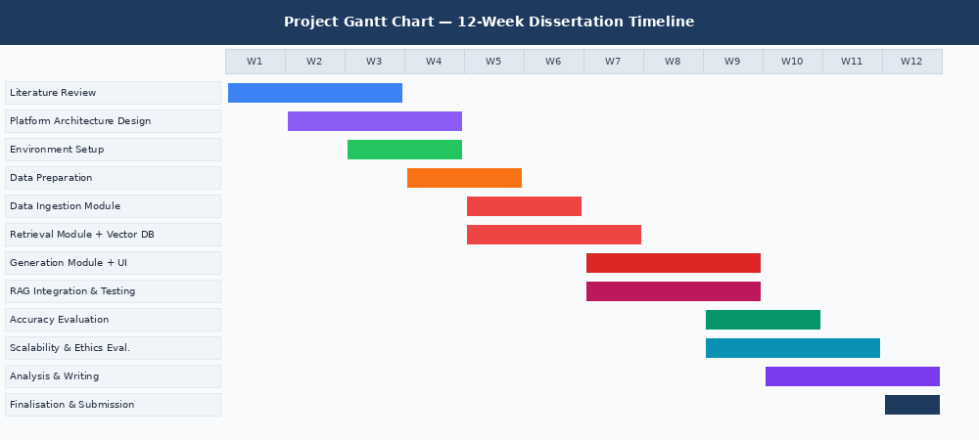
Figure 18: Project Gantt Chart — 12-Week Dissertation Timeline with key milestones

References
- (PDF) A design science research methodology for information systems research. (n.d.). ResearchGate. [online] Available at: https://www.researchgate.net/publication/284503626_A_design_science_research_methodology_for_information_systems_research.
- Aakanksha Chowdhery, Narang, S., Devlin, J., Bosma, M., Mishra, G., Roberts, A., Barham, P., Chung, H.-M., Sutton, C., Gehrmann, S., Schuh, P., Shi, K., Tsvyashchenko, S., Maynez, J., Rao, A., Barnes, P., Tay, Y., Noam Shazeer, Prabhakaran, V. and Reif, E. (2022). PaLM: Scaling Language Modeling with Pathways. arXiv (Cornell University). doi:https://doi.org/10.48550/arxiv.2204.02311.
- Artificial Analysis (2025). LLM leaderboard: Quality vs. Cost analysis of 94 leading AI models across 329 providers. [online] Available at: https://artificialanalysis.ai/leaderboards/providers.
- Asai, A., Wu, Z., Wang, Y., Sil, A. and Hajishirzi, H. (2023). Self-RAG: Learning to Retrieve, Generate, and Critique through Self-Reflection. [online] arXiv.org. Available at: https://arxiv.org/abs/2310.11511.
- Bai, J., Bai, S., Chu, Y., Cui, Z., Dang, K., Deng, X., Fan, Y., Ge, W., Han, Y., Huang, F., Hui, B., Ji, L., Li, M., Lin, J., Lin, R., Liu, D., Liu, G., Lu, C., Lu, K. and Ma, J. (2023). Qwen Technical Report. [online] arXiv.org. doi:https://doi.org/10.48550/arXiv.2309.16609.
- Bevara, R., Lund, B.D., Nishith Reddy Mannuru, Karedla, Sai Pranathi, Mohammed, Y., Kolapudi, Sai Tulasi and Aashrith Mannuru (2025). Prospects of Retrieval Augmented Generation (RAG) for Academic Library Search and Retrieval. doi:https://doi.org/10.13140/rg.2.2.33848.25607.
- Brown, A., Roman, M. and Devereux, B. (2025). A Systematic Literature Review of Retrieval-Augmented Generation: Techniques, Metrics, and Challenges. [online] arXiv.org. Available at: https://arxiv.org/abs/2508.06401.
- Brown, T.B., Mann, B., Ryder, N., Subbiah, M., Kaplan, J., Dhariwal, P., Neelakantan, A., Shyam, P., Sastry, G., Askell, A., Agarwal, S., Herbert-Voss, A., Krueger, G., Henighan, T., Child, R., Ramesh, A., Ziegler, D.M., Wu, J., Winter, C. and Hesse, C. (2020). Language Models Are Few-Shot Learners. arxiv.org, [online] 4(33). Available at: https://arxiv.org/abs/2005.14165.
- Deng, C., Duan, Y., Jin, X., Chang, H., Tian, Y., Liu, H., Wang, Y., Gao, kuofeng, Zou, H.P., jin, Y., Xiao, Y., Wu, S., Xie, Z., Lyu, W., He, S., Cheng, L., Wang, H. and Zhuang, J. (2025). Deconstructing the ethics of large language models from long-standing issues to new-emerging dilemmas: a survey. AI and Ethics. doi:https://doi.org/10.1007/s43681-025-00797-3.
- Dettmers, T., Pagnoni, A., Holtzman, A. and Zettlemoyer, L. (2023). QLoRA: Efficient Finetuning of Quantized LLMs. doi:https://doi.org/10.48550/arxiv.2305.14314.
- Devlin, J., Chang, M.-W., Lee, K. and Toutanova, K. (2018). BERT: Pre-training of Deep Bidirectional Transformers for Language Understanding. [online] ArXiv. Available at: https://arxiv.org/abs/1810.04805.
- Douze, M., Guzhva, A., Deng, C., Johnson, J., Szilvasy, G., Mazaré, P.-E., Lomeli, M., Hosseini, L. and Jégou, H. (2024). The Faiss library. [online] arXiv.org. doi:https://doi.org/10.48550/arXiv.2401.08281.
- Es, S., James, J., Espinosa-Anke, L. and Schockaert, S. (2023). RAGAS: Automated Evaluation of Retrieval Augmented Generation. ArXiv (Cornell University). [online] doi:https://doi.org/10.48550/arxiv.2309.15217.
- Fabbri, A.R., Kryściński, W., McCann, B., Xiong, C., Socher, R. and Radev, D. (2021). SummEval: Re-evaluating Summarization Evaluation. arXiv:2007.12626 [cs]. [online] Available at: https://arxiv.org/abs/2007.12626 [Accessed 27 Feb. 2023].
- Gallegos, I.O., Rossi, R.A., Barrow, J., Tanjim, M.M., Kim, S., Dernoncourt, F., Yu, T., Zhang, R. and Ahmed, N.K. (2023). Bias and Fairness in Large Language Models: A Survey. [online] arXiv.org. doi:https://doi.org/10.48550/arXiv.2309.00770.
- Gao, Y., Xiong, Y., Gao, X., Jia, K., Pan, J., Bi, Y., Dai, Y., Sun, J. and Wang, H. (2023). Retrieval-Augmented Generation for Large Language Models: A Survey. [online] arXiv.org. doi:https://doi.org/10.48550/arXiv.2312.10997.
- Gunasekar, S., Zhang, Y., Aneja, J., Teodoro, Giorno, D., Gopi, S., Javaheripi, M., Kauffmann, P., Rosa, de, Saarikivi, O., Salim, A., Shah, S., Behl, H.S., Wang, X., Bubeck, S., Eldan, R., Kalai, A.T., Lee, Y.T. and Li, Y. (2023). Textbooks Are All You Need. [online] arXiv.org. Available at: https://arxiv.org/abs/2306.11644 [Accessed 23 Apr. 2026].
- Hofstätter, S., Lin, S.-C., Yang, J.-H., Lin, J. and Hanbury, A. (2021). Efficiently Teaching an Effective Dense Retriever with Balanced Topic Aware Sampling. [online] arXiv.org. Available at: https://arxiv.org/abs/2104.06967 [Accessed 23 Apr. 2026].
- Hu, E.J., Shen, Y., Wallis, P., Allen-Zhu, Z., Li, Y., Wang, S., Wang, L. and Chen, W. (2021). LoRA: Low-Rank Adaptation of Large Language Models. arXiv:2106.09685 [cs]. [online] Available at: https://arxiv.org/abs/2106.09685.
- Huang, L., Yu, W., Ma, W., Zhong, W., Feng, Z., Wang, H., Chen, Q., Peng, W., Feng, X., Qin, B. and Liu, T. (2023). A Survey on Hallucination in Large Language Models: Principles, Taxonomy, Challenges, and Open Questions. [online] arXiv.org. Available at: https://arxiv.org/abs/2311.05232.
- IntuitionLabs (2026). LLM benchmark comprehensive analysis 2026. [online] Available at: https://llm-stats.com/models/compare/gpt-4o-vs-hermes-3-70b.
- Izacard, G. and Grave, E. (2020). Leveraging Passage Retrieval with Generative Models for Open Domain Question Answering. [online] arXiv.org. Available at: https://arxiv.org/abs/2007.01282.
- Ji, Z., Lee, N., Frieske, R., Yu, T., Su, D., Xu, Y., Ishii, E., Bang, Y., Madotto, A. and Fung, P. (2022). Survey of Hallucination in Natural Language Generation. ACM Computing Surveys, [online] 55(12). doi:https://doi.org/10.1145/3571730.
- Jiang, A.Q., Sablayrolles, A., Mensch, A., Bamford, C., Chaplot, D.S., Casas, D. de las, Bressand, F., Lengyel, G., Lample, G., Saulnier, L., Lavaud, L.R., Lachaux, M.-A., Stock, P., Scao, T.L., Lavril, T., Wang, T., Lacroix, T. and Sayed, W.E. (2023). Mistral 7B. [online] arXiv.org. doi:https://doi.org/10.48550/arXiv.2310.06825.
- Johnson, J., Douze, M. and Jegou, H. (2019). Billion-scale similarity search with GPUs. IEEE Transactions on Big Data, 7(3), pp.1–1. doi:https://doi.org/10.1109/tbdata.2019.2921572.
- Kaplan, J., McCandlish, S., Henighan, T., Brown, T.B., Chess, B., Child, R., Gray, S., Radford, A., Wu, J. and Amodei, D. (2020). Scaling Laws for Neural Language Models. arXiv:2001.08361 [cs, stat]. [online] Available at: https://arxiv.org/abs/2001.08361.
- Kasner, Z. and Dušek, O. (2022). Neural Pipeline for Zero-Shot Data-to-Text Generation. [online] arXiv.org. Available at: https://arxiv.org/abs/2203.16279 [Accessed 23 Apr. 2026].
- Laranjo, L., Dunn, A.G., Tong, H.L., Kocaballi, A.B., Chen, J., Bashir, R., Surian, D., Gallego, B., Magrabi, F., Lau, A.Y.S. and Coiera, E. (2018). Conversational agents in healthcare: a systematic review. Journal of the American Medical Informatics Association, [online] 25(9). doi:https://doi.org/10.1093/jamia/ocy072.
- Lewis, P., Perez, E., Piktus, A., Petroni, F., Karpukhin, V., Goyal, N., Küttler, H., Lewis, M., Yih, W., Rocktäschel, T., Riedel, S. and Kiela, D. (2021). Retrieval-Augmented Generation for Knowledge-Intensive NLP Tasks. [online] arXiv.org. doi:https://doi.org/10.48550/arXiv.2005.11401.
- Li, S., Stenzel, L., Eickhoff, C. and Ali, B.S. (2025). Enhancing Retrieval-Augmented Generation: A Study of Best Practices. [online] arXiv.org. Available at: https://arxiv.org/abs/2501.07391 [Accessed 17 Feb. 2025].
- Lin, C.-Y. (2004). ROUGE: a Package for Automatic Evaluation of Summaries. [online] Microsoft Research. Available at: https://www.microsoft.com/en-us/research/publication/rouge-a-package-for-automatic-evaluation-of-summaries/.
- Liu, N.F., Lin, K., Hewitt, J., Paranjape, A., Bevilacqua, M., Petroni, F. and Liang, P. (2023). Lost in the Middle: How Language Models Use Long Contexts. ARXIV. doi:https://doi.org/10.48550/arxiv.2307.03172.
- Liu, Y., Ott, M., Goyal, N., Du, J., Joshi, M., Chen, D., Levy, O., Lewis, M., Zettlemoyer, L., Stoyanov, V. and Allen, P. (2019). RoBERTa: A Robustly Optimized BERT Pretraining Approach. [online] Available at: https://arxiv.org/pdf/1907.11692.
- Ma, X., Wang, L., Yang, N., Wei, F. and Lin, J. (2023). Fine-Tuning LLaMA for Multi-Stage Text Retrieval. [online] arXiv.org. Available at: https://arxiv.org/abs/2310.08319 [Accessed 31 Aug. 2025].
- Malkov, Y.A. and Yashunin, D.A. (2020). Efficient and Robust Approximate Nearest Neighbor Search Using Hierarchical Navigable Small World Graphs. IEEE Transactions on Pattern Analysis and Machine Intelligence, [online] 42(4), pp.824–836. doi:https://doi.org/10.1109/tpami.2018.2889473.
- Mallen, A., Asai, A., Zhong, V., Das, R., Khashabi, D. and Hajishirzi, H. (2022). When Not to Trust Language Models: Investigating Effectiveness of Parametric and Non-Parametric Memories. [online] arXiv.org. Available at: https://arxiv.org/abs/2212.10511 [Accessed 23 Apr. 2026].
- Mehta, H., Raut, T., Yadav, K. and Gehringer, E.F. (2025). LLM Chatbot-Creation Approaches. [online] arXiv.org. Available at: https://arxiv.org/abs/2509.13326 [Accessed 30 Nov. 2025].
- Min, S., Krishna, K., Lyu, X., Lewis, M., Yih, W., Koh, P.W., Iyyer, M., Zettlemoyer, L. and Hajishirzi, H. (2023). FActScore: Fine-grained Atomic Evaluation of Factual Precision in Long Form Text Generation. [online] arXiv.org. Available at: https://arxiv.org/abs/2305.14251.
- Morgan, D.L. (2007). Paradigms Lost and Pragmatism regained: Methodological Implications of Combining Qualitative and Quantitative Methods. Journal of Mixed Methods Research, 1(1), pp.48–76. doi:https://doi.org/10.1177/2345678906292462.
- Neelakantan, A., Xu, T., Puri, R., Radford, A., Han, J.M., Tworek, J., Yuan, Q., Tezak, N., Kim, J.W., Hallacy, C., Heidecke, J., Shyam, P., Power, B., Nekoul, T.E., Sastry, G., Krueger, G., Schnurr, D., Such, F.P., Hsu, K. and Thompson, M. (2022). Text and Code Embeddings by Contrastive Pre-Training. arXiv:2201.10005 [cs]. [online] Available at: https://arxiv.org/abs/2201.10005.
- Olawore, K., McTear, M. and Bi, Y. (2025). Development and Evaluation of a University Chatbot Using Deep Learning: A RAG-Based Approach. Lecture Notes in Computer Science, pp.96–111. doi:https://doi.org/10.1007/978-3-031-88045-2_7.
- OpenAI (2023). GPT-4 Technical Report. arXiv:2303.08774 [cs]. [online] doi:https://doi.org/10.48550/arXiv.2303.08774.
- Ouyang, L., Wu, J., Jiang, X., Almeida, D., Wainwright, C.L., Mishkin, P., Zhang, C., Agarwal, S., Slama, K., Ray, A., Schulman, J., Hilton, J., Kelton, F., Miller, L., Simens, M., Askell, A., Welinder, P., Christiano, P., Leike, J. and Lowe, R. (2022). Training language models to follow instructions with human feedback. arXiv:2203.02155 [cs]. [online] Available at: https://arxiv.org/abs/2203.02155.
- Papineni, K., Roukos, S., Ward, T. and Zhu, W.-J. (2002). BLEU: a Method for Automatic Evaluation of Machine Translation. Proceedings of the 40th Annual Meeting on Association for Computational Linguistics - ACL ’02. [online] doi:https://doi.org/10.3115/1073083.1073135.
- Patterson, D., Gonzalez, J., Le, Q., Liang, C., Munguia, L.-M., Rothchild, D., So, D., Texier, M. and Dean, J. (2021). Carbon Emissions and Large Neural Network Training. arXiv:2104.10350 [cs]. [online] Available at: https://arxiv.org/abs/2104.10350.
- Rafailov, R., Sharma, A., Mitchell, E., Ermon, S., Manning, C.D. and Finn, C. (2023). Direct Preference Optimization: Your Language Model is Secretly a Reward Model. [online] arXiv.org. doi:https://doi.org/10.48550/arXiv.2305.18290.
- Ramandanis, D. and Xinogalos, S. (2023). Designing a Chatbot for Contemporary Education: A Systematic Literature Review. Information, [online] 14(9), p.503. doi:https://doi.org/10.3390/info14090503.
- Reimers, N. and Gurevych, I. (2019). Sentence-BERT: Sentence Embeddings using Siamese BERT-Networks. [online] arXiv.org. Available at: https://arxiv.org/abs/1908.10084.
- ResearchGate. (n.d.). (PDF) Design Science in Information Systems Research. [online] Available at: https://www.researchgate.net/publication/201168946_Design_Science_in_Information_Systems_Research.
- Robertson, S. (2010). The Probabilistic Relevance Framework: BM25 and Beyond. Foundations and Trends® in Information Retrieval, 3(4), pp.333–389. doi:https://doi.org/10.1561/1500000019.
- Saunders, M.N.K., Lewis, P. and Thornhill, A. (2019). Research Methods for Business Students. [online] Google Books. Pearson Education. Available at: https://books.google.co.uk/books/about/Research_Methods_for_Business_Students.html?id=TMGYDwAAQBAJ&redir_esc=y.
- Schwartz, R., Dodge, J., Smith, N.A. and Etzioni, O. (2019). Green AI. arXiv:1907.10597 [cs, stat]. [online] Available at: https://arxiv.org/abs/1907.10597.
- Shi, F., Chen, X., Misra, K., Scales, N., Dohan, D., Chi, E., Schärli, N. and Zhou, D. (2023). Large Language Models Can Be Easily Distracted by Irrelevant Context. [online] arXiv.org. doi:https://doi.org/10.48550/arXiv.2302.00093.
- Strubell, E. (2019). Energy and Policy Considerations for Deep Learning in NLP. arXiv:1906.02243 [cs], [online] 1. Available at: https://arxiv.org/abs/1906.02243.
- Thoppilan, R., De Freitas, D., Hall, J., Shazeer, N., Kulshreshtha, A., Cheng, H.-T., Jin, A., Bos, T., Baker, L., Du, Y., Li, Y., Lee, H., Zheng, H.S., Ghafouri, A., Menegali, M., Huang, Y., Krikun, M., Lepikhin, D., Qin, J. and Chen, D. (2022). LaMDA: Language Models for Dialog Applications. arXiv:2201.08239 [cs]. [online] Available at: https://arxiv.org/abs/2201.08239.
- Touvron, H., Lavril, T., Izacard, G., Martinet, X., Lachaux, M.-A., Lacroix, T., Rozière, B., Goyal, N., Hambro, E., Azhar, F., Rodriguez, A., Joulin, A., Grave, E. and Lample, G. (2023a). LLaMA: Open and Efficient Foundation Language Models. arXiv (Cornell University). doi:https://doi.org/10.48550/arxiv.2302.13971.
- Touvron, H., Martin, L., Stone, K., Albert, P., Almahairi, A., Babaei, Y., Bashlykov, N., Batra, S., Bhargava, P., Bhosale, S., Bikel, D., Blecher, L., Ferrer, C.C., Chen, M., Cucurull, G., Esiobu, D., Fernandes, J., Fu, J., Fu, W. and Fuller, B. (2023b). Llama 2: Open Foundation and Fine-Tuned Chat Models. [online] arXiv.org. doi:https://doi.org/10.48550/arXiv.2307.09288.
- Vaswani, A., Shazeer, N., Parmar, N., Uszkoreit, J., Jones, L., Gomez, A., Kaiser, Ł. and Polosukhin, I. (2017). Attention Is All You Need. [online] Available at: https://arxiv.org/pdf/1706.03762.pdf.
- Vladimir Karpukhin, Oguz, B., Min, S., Lewis, P.A., Wu, L., Sergey Edunov, Chen, D. and Yih, W. (2020). Dense Passage Retrieval for Open-Domain Question Answering. doi:https://doi.org/10.48550/arxiv.2004.04906.
- Wang, L., Yang, N., Huang, X., Jiao, B., Yang, L., Jiang, D., Majumder, R. and Wei, F. (2022). Text Embeddings by Weakly-Supervised Contrastive Pre-training. [online] arXiv.org. Available at: https://arxiv.org/abs/2212.03533 [Accessed 2 Nov. 2025].
- Weidinger, L., Uesato, J., Rauh, M., Griffin, C., Huang, P.-S., Mellor, J., Glaese, A., Cheng, M., Balle, B., Kasirzadeh, A., Biles, C., Brown, S., Kenton, Z., Hawkins, W., Stepleton, T., Birhane, A., Hendricks, L.A., Rimell, L., Isaac, W. and Haas, J. (2022). Taxonomy of Risks posed by Language Models. 2022 ACM Conference on Fairness, Accountability, and Transparency. doi:https://doi.org/10.1145/3531146.3533088.
- What LLM (2025). Model comparison: GPT-4o vs. Hermes-3-70b and open-source landscape analysis. [online] Available at: https://llm-stats.com/models/compare/gpt-5.1-codex-high-vs-hermes-3-70b.
- Wu, T., Luo, L., Li, Y.-F., Pan, S., Vu, T.-T. and Haffari, G. (2024). Continual Learning for Large Language Models: A Survey. [online] arXiv.org. Available at: https://arxiv.org/abs/2402.01364 [Accessed 26 Aug. 2024].
- www.grandviewresearch.com. (n.d.). Conversational AI Market Size, Share & Growth Report, 2030. [online] Available at: https://www.grandviewresearch.com/industry-analysis/conversational-ai-market-report.
- Xu, P., Shao, W., Zhang, K., Gao, P., Liu, S., Lei, M., Meng, F., Huang, S., Qiao, Y. and Luo, P. (2023). LVLM-eHub: A Comprehensive Evaluation Benchmark for Large Vision-Language Models. [online] arXiv.org. Available at: https://arxiv.org/abs/2306.09265 [Accessed 23 Apr. 2026].
- Yang, R., Yu, M., Li, H., Li, X., Zhu, W., Liao, J., Yu, K., Chong, J., Xuan, W., Chen, Y., Ke, Y., Chiat, J., Teodoro, D., Hong, C., Shi, D. and Liu, N. (2025). Retrieval-Augmented Generation in Medicine: A Scoping Review of Technical Implementations, Clinical Applications, and Ethical Considerations. [online] arXiv.org. Available at: https://arxiv.org/abs/2511.05901 [Accessed 23 Apr. 2026].
- Yao, S., Zhao, J., Yu, D., Du, N., Shafran, I., Narasimhan, K. and Cao, Y. (2023). ReAct: Synergizing Reasoning and Acting in Language Models. [online] arXiv.org. doi:https://doi.org/10.48550/arXiv.2210.03629.
- Yu, H., Gan, A., Zhang, K., Tong, S., Liu, Q. and Liu, Z. (2024). Evaluation of Retrieval-Augmented Generation: A Survey. [online] arXiv.org. doi:https://doi.org/10.48550/arXiv.2405.07437.
- Zhang, T., Kishore, V., Wu, F., Weinberger, K.Q. and Artzi, Y. (2020). BERTScore: Evaluating Text Generation with BERT. arXiv:1904.09675 [cs]. [online] Available at: https://arxiv.org/abs/1904.09675.
- Zhang, Y., Sun, S., Galley, M., Chen, Y.-C., Brockett, C., Gao, X., Gao, J., Liu, J. and Dolan, B. (2019). DialoGPT: Large-Scale Generative Pre-training for Conversational Response Generation. doi:https://doi.org/10.48550/arxiv.1911.00536.
- Zhao, W.X., Zhou, K., Li, J., Tang, T., Wang, X., Hou, Y., Min, Y., Zhang, B., Zhang, J., Dong, Z., Du, Y., Yang, C., Chen, Y., Chen, Z., Jiang, J., Ren, R., Li, Y., Tang, X., Liu, Z. and Liu, P. (2023). A Survey of Large Language Models. arXiv (Cornell University). doi:https://doi.org/10.48550/arxiv.2303.18223.
- Zhu, Y., Wang, X., Chen, J., Qiao, S., Ou, Y., Yao, Y., Deng, S., Chen, H. and Zhang, N. (2023). LLMs for Knowledge Graph Construction and Reasoning: Recent Capabilities and Future Opportunities. [online] arXiv.org. Available at: https://arxiv.org/abs/2305.13168 [Accessed 23 Apr. 2026].

Acknowledgements
I would like to begin by thanking my module supervisor, Dr Faizan Ahmad, for his guidance and support throughout this project. Your feedback helped me think more clearly about the research and kept me on the right track when things got complicated.
This project involved a lot of late nights running training jobs and debugging code, and I genuinely could not have stayed motivated without the encouragement of my family and friends. Thank you for always checking in, even when you had no idea what I was talking about

AI Acknowledgements
AI-assisted tools were used to support proofreading, grammar correction, and minor sentence restructuring in the preparation of this document.
All substantive intellectual content — including the research design, platform configuration, experimental methodology, data analysis, and interpretation of results — constitutes the author’s own original work. No AI tool contributed to research ideation, system design, or the analytical or evaluative content of this dissertation.

Appendices

Appendix A: Project Risk Register
Risk | Likelihood | Impact | Mitigation Strategy
Technical implementation delays | Medium | High | Prioritise core features; use well-documented libraries (LangChain, React)
Computational resource limitations | Medium | Medium | Use smaller 7B models; access cloud GPU via Colab if needed
Dataset quality issues | Low | Medium | Prepare backup datasets; validate early in Week 4
Evaluation reproducibility | Low | Medium | Define clear rubrics; pilot test evaluation protocol in Week 9
Ollama model availability | Low | Low | Pre-pull all models; maintain offline model cache
Platform dependency breaking changes | Low | Medium | Pin dependency versions; test updates in isolation

Table 8: Project Risk Register

Appendix B: Evaluation Query Stratification
Query Type | Education Domain (n) | Customer Support (n) | Total | Evaluation Criteria
Factual Recall | 15 | 15 | 30 | Binary correct/incorrect vs. gold standard
Multi-document Synthesis | 12 | 13 | 25 | Coverage of all required facts from multiple sources
Temporal Queries | 8 | 7 | 15 | Correct date-sensitive information retrieval
Adversarial (hallucination test) | 15 | 15 | 30 | Appropriate uncertainty expression on out-of-scope queries
Total | 50 | 50 | 100 | Inter-annotator agreement: Cohen's κ = 0.81

Table 8: Evaluation Query Stratification across Domains and Query Types

Appendix C: Project Timeline.
Week(s) | Phase | Key Activities | Deliverables
1–2 | Foundation | Literature review; dataset collection; environment setup | Annotated bibliography; configured platform environment
3–4 | Architecture Design | Platform architecture specification; node design; data pipeline | Architecture document; wireframes; first platform chatflow
5–6 | Development I | Document ingestion module; vector database integration; embedding pipeline | Functional document processing pipeline in ChromaDB
7–8 | Development II | RAG retrieval logic; Ollama integration; chatbot UI; public deployment | Working integrated Manoj Chatbot Builder prototype
9–10 | Evaluation | Experiments across 4 conditions; statistical analysis; latency benchmarks | Raw evaluation data; statistical results; performance tables
11 | Writing | Results interpretation; discussion chapter; conclusions | Draft dissertation chapters
12 | Finalisation | Edit and refine; formatting; submission | Final dissertation document

Table 9: Project Timeline and Deliverables

Appendix D: Ethics Approval Form (Ethics ID: CST-PG-220).
The ethics application was submitted to Cardiff Metropolitan University School Ethics Committee in December 2025. The project was classified as desk-based research with no human participants. All testing used the researcher's own voice and purpose-built synthetic datasets. A copy of the completed ethics form is included with this submission.

Appendix E: Github
Github link: https://github.com/Manojkumardheenadhayalan/Manoj-Bot-Builder.git

