LAB Logbook

Lab 1

Lab 2
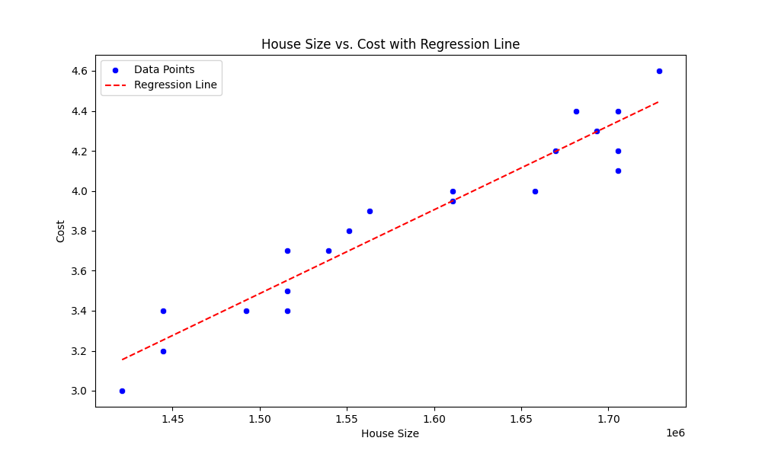

Lab 3
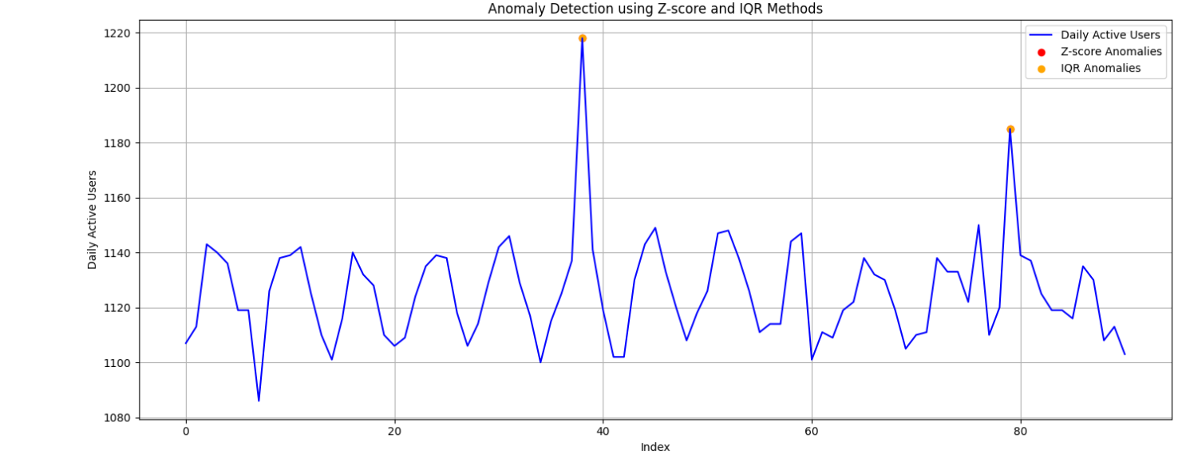

Lab 4
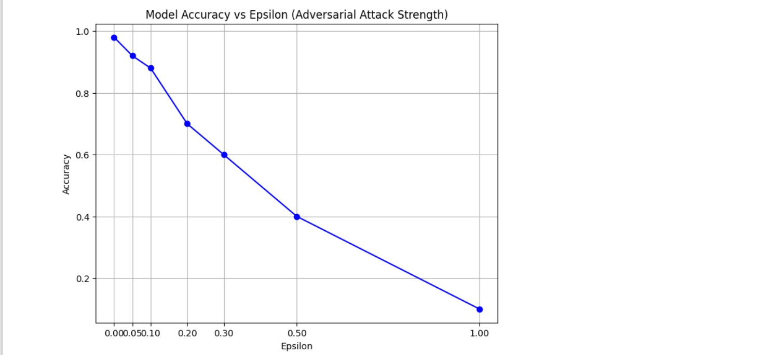
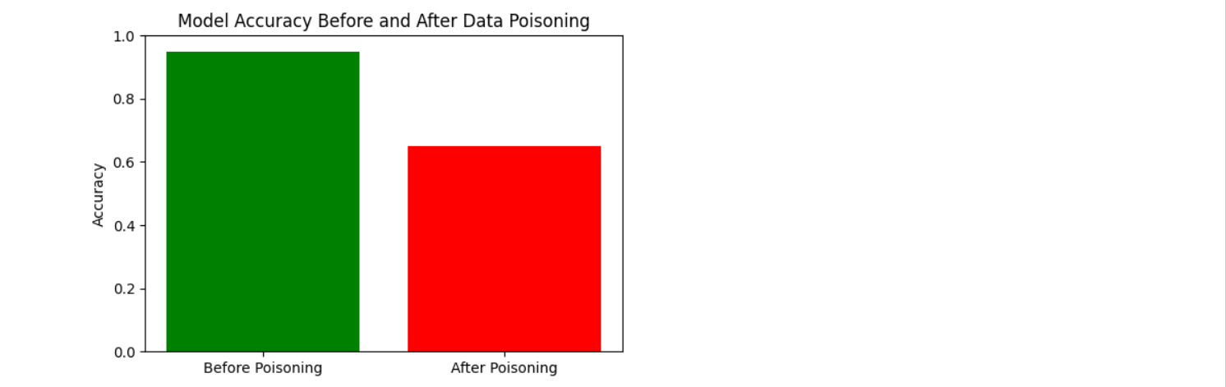
Lab 5
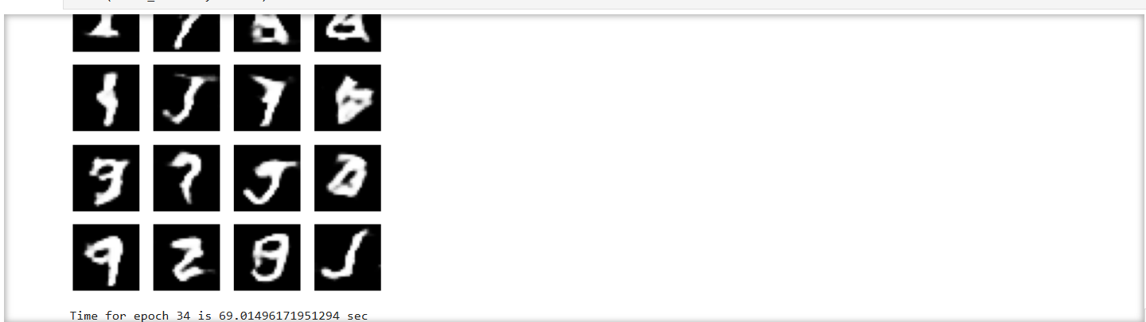
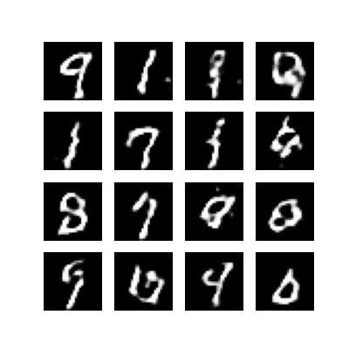

Lab 6
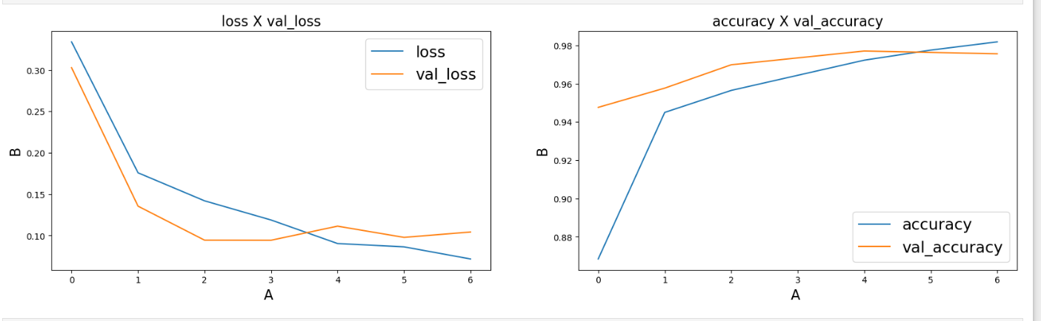
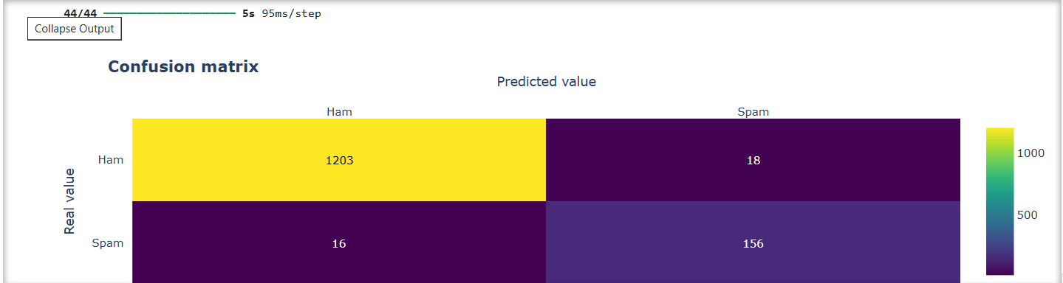
Lab 7
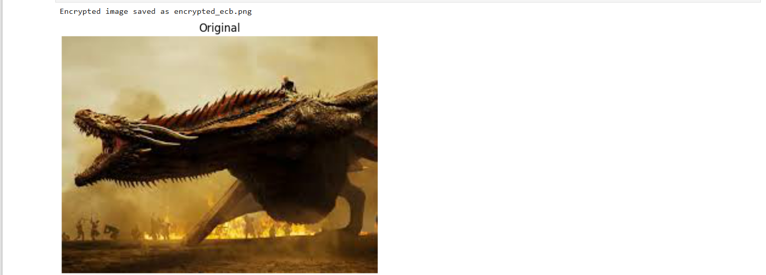
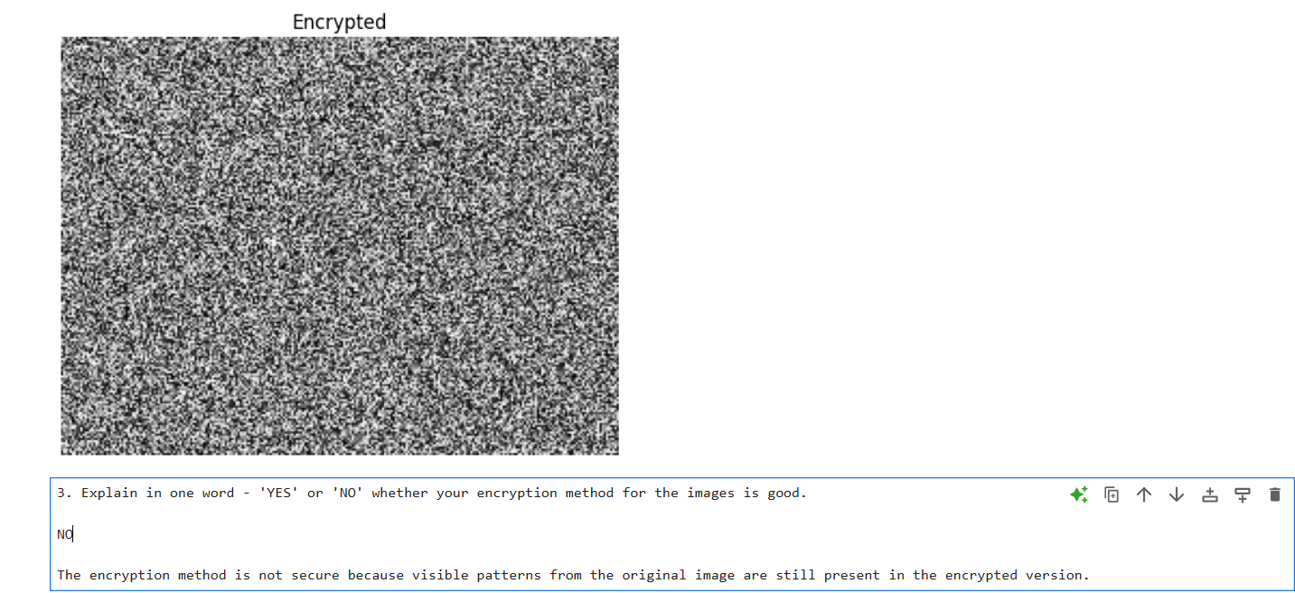

Lab 8
- Partner's Name: Azad
- Public Values:
- p = 23
- g = 5
- My Private Key: a = 6

Lab 9
Attack Type Chosen: Log4j Vulnerability Exploit (2021)
Key Website/Research Link:
https://www.cisa.gov/news-events/cybersecurity-advisories/aa21-356a

Lab 10
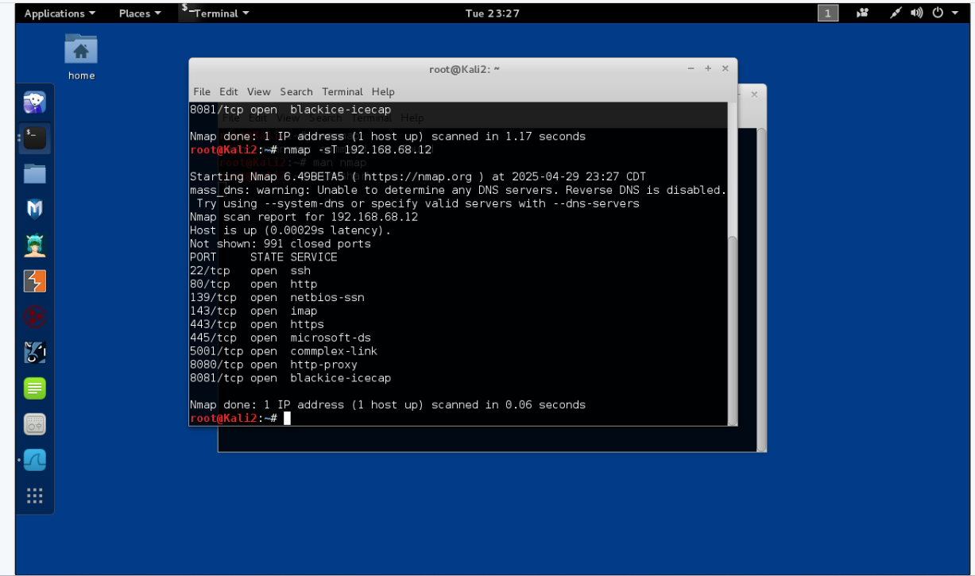
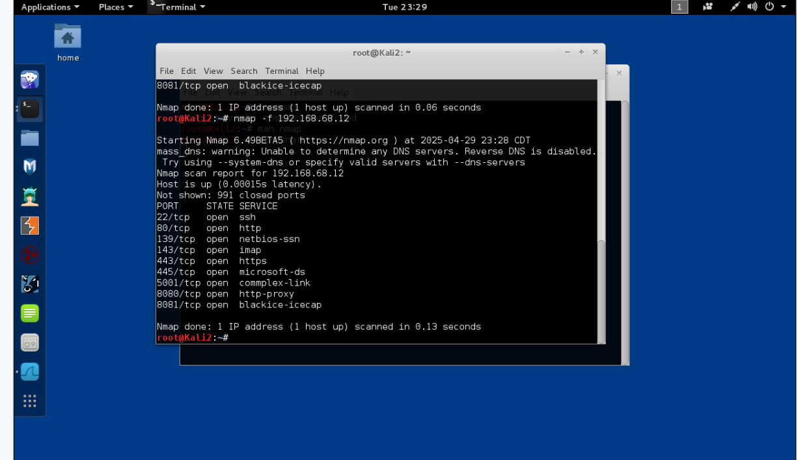
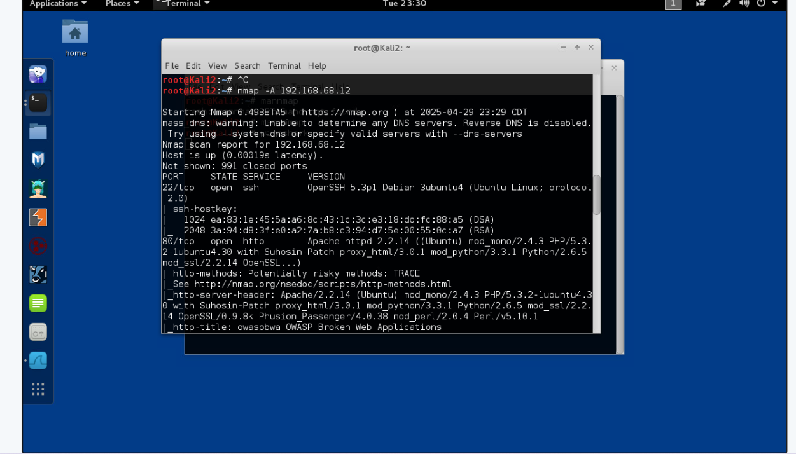
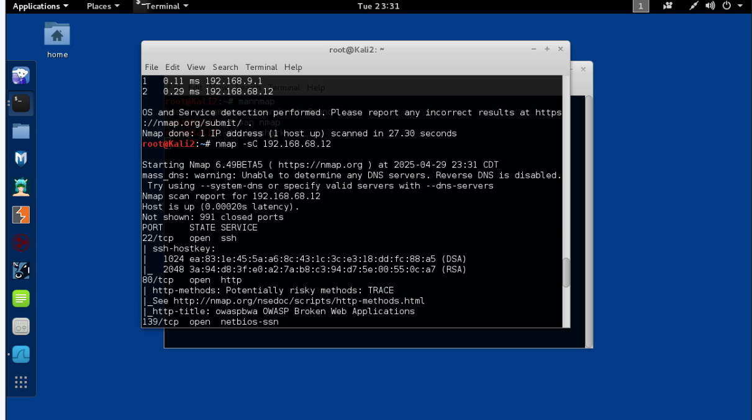

Lab 11
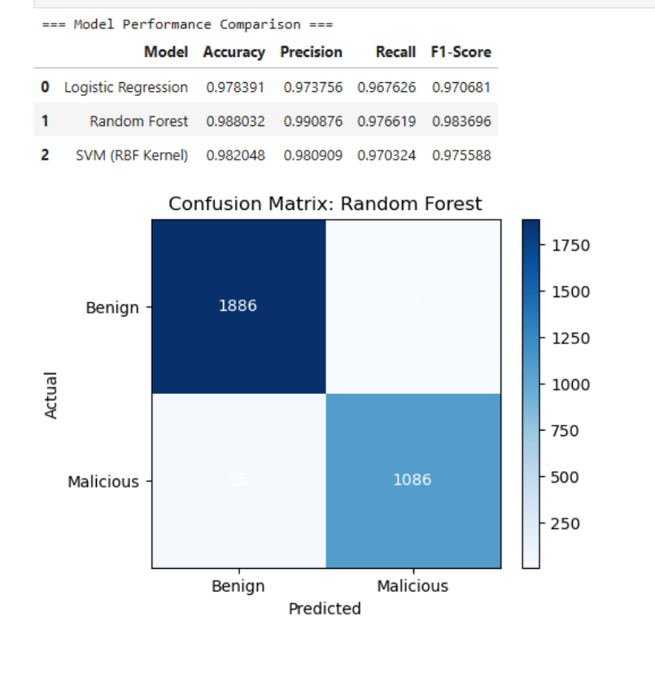

Lab 12

